Supplementary Information for
Stabilizing ruthenium dioxide with cation-anchored sulfate for durable oxygen evolution in PEMWE

Yanrong Xue,^{1,2,6} Jiwu Zhao,^{1,2,6} Liang Huang,^{1,2} Ying-Rui Lu,³ Abdul Malek,^{1,2} Ge Gao,^{1,2} Zhongbin Zhuang,⁴ Dingsheng Wang,⁵ Xu Lu^{1,2}*
¹ CCRC, Division of Physical Science and Engineering (PSE), King Abdullah University of Science and Technology (KAUST), Thuwal, 23955-6900, Kingdom of Saudi Arabia.
² KAUST Solar Center (KSC), PSE, KAUST.
³ National Synchrotron Radiation Research Center, Hsinchu 300, Taiwan.
⁴ State Key Lab of Organic-Inorganic Composites, Beijing University of Chemical Technology, 100029 Beijing, China.
⁵ Department of Chemistry, Tsinghua University, Beijing 100084, China.
⁶ These authors contributed equally.
* Corresponding author. Email: Xu Lu (xu.lu@kaust.edu.sa).

Table of contents

Supplementary Figures 1-21 Page 3-23
Supplementary Notes 1-3 Page 3, 6, 22
Supplementary Tables 1-6 Page 24-29
Supplementary References 1-15 Page 30

Supplementary Figures

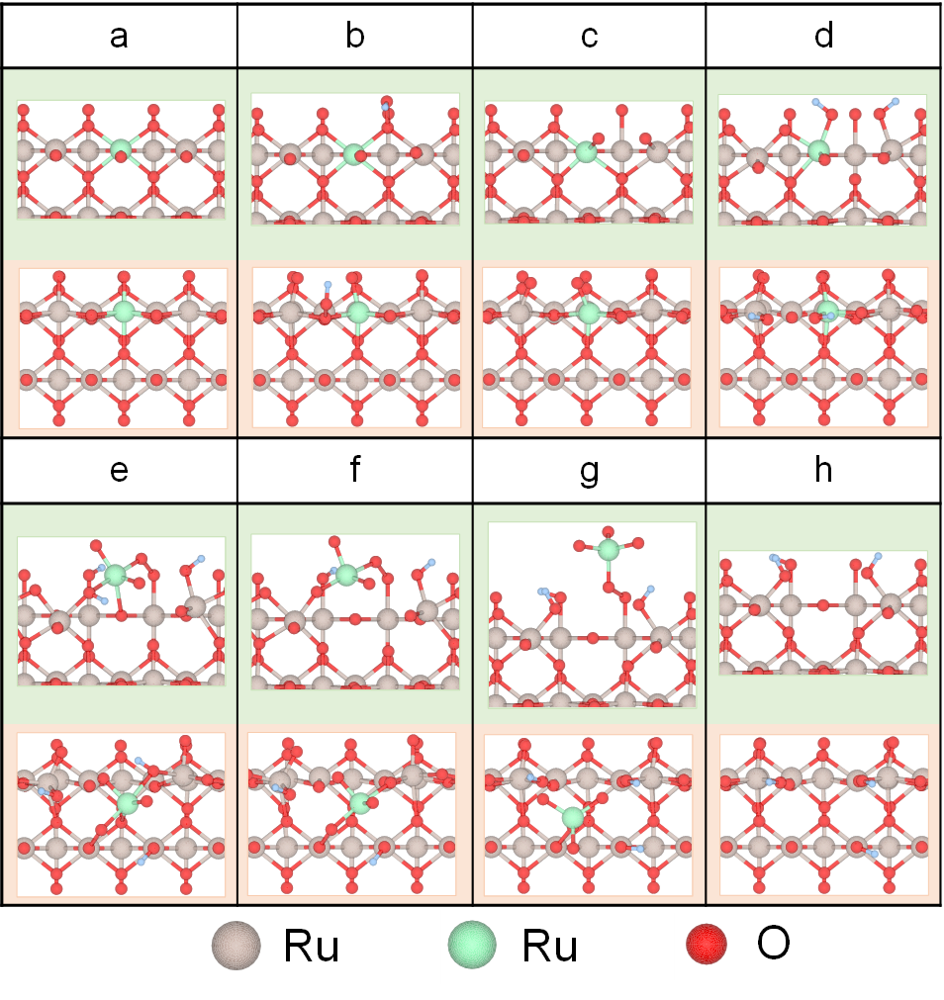
Supplementary Figure 1 Atomic structure of RuO₂ and intermediates during Ru dissolution. Of note, the green ball represents the Ru atom on the grain edge.

Supplementary Notes

Supplementary Note 1: In this model, the dissolution of RuO₂ undergoes the continuous adsorption of water and deprotonation on the 1f-cus Ru active sites. Then, the lattice O near the 1f-cus Ru active sites on the grain edges is over-oxidized and cracks. Finally, a soluble RuO₄ is formed and lost from the grain edge.

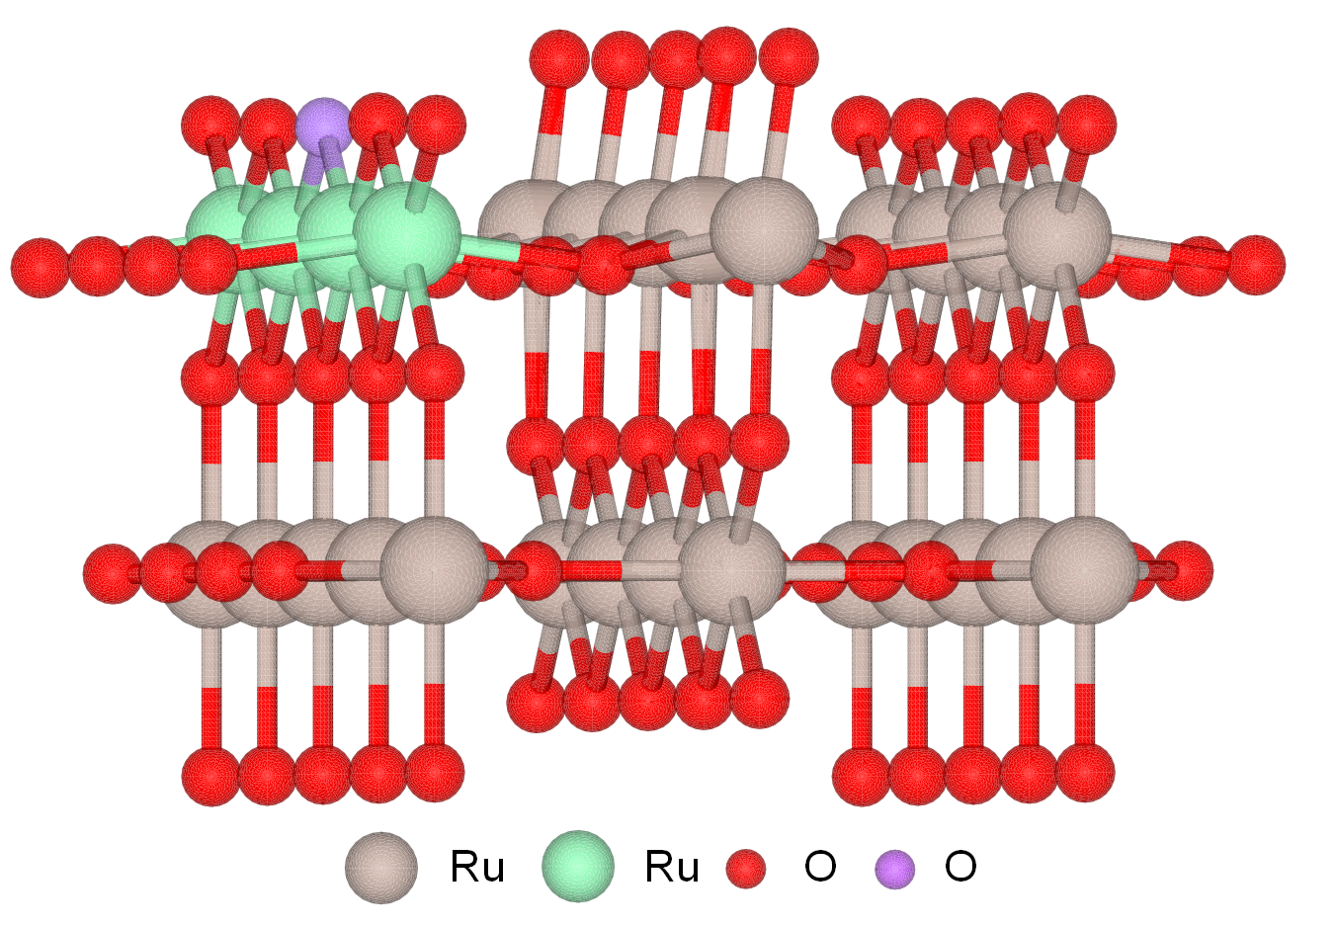
Supplementary Figure 2 Ball-and-stick model of the RuO₂ (110) plane. Of note, the green and purple balls represent Ru and O atoms, respectively, on the grain edges.

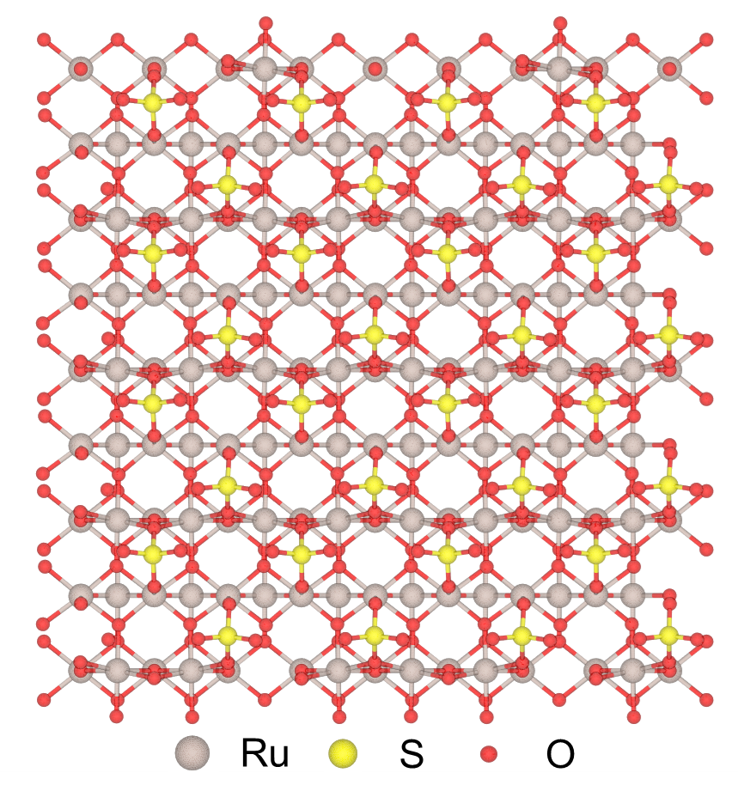
Supplementary Figure 3 Ball-and-stick model of sulfate bound with RuO₂ (110) facet.

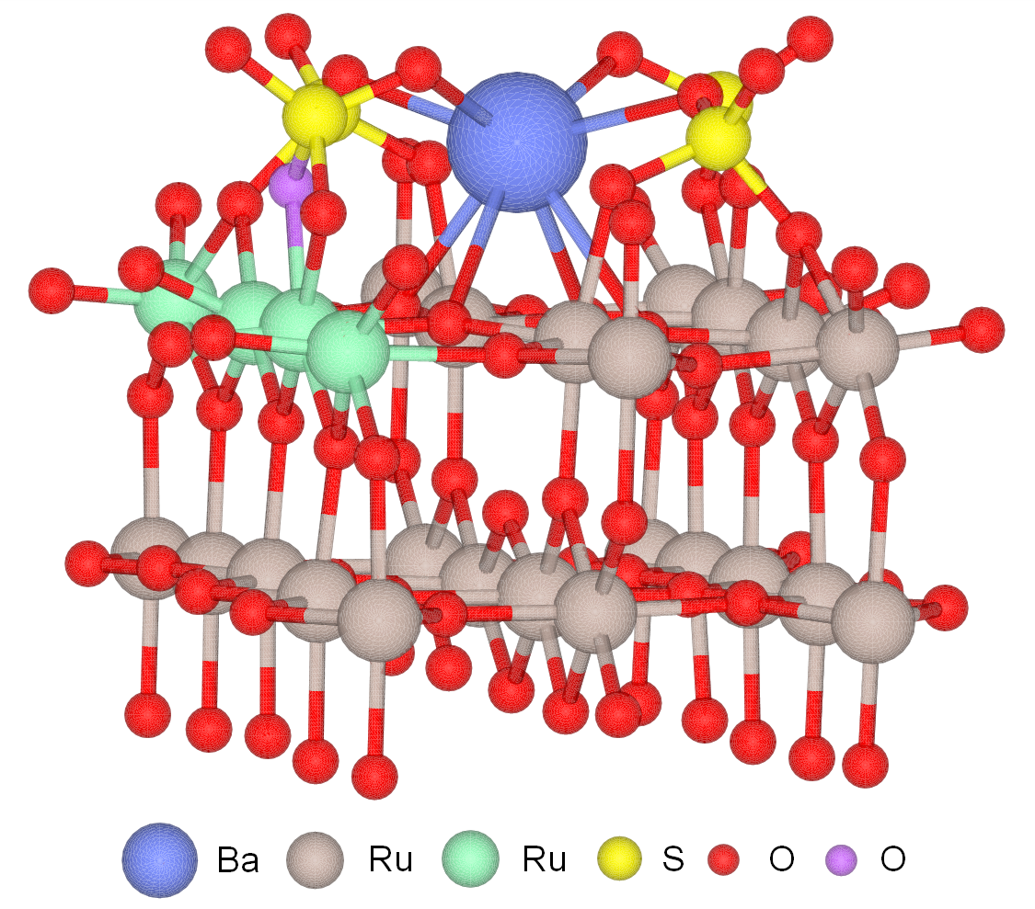
Supplementary Figure 4 Ball-and-stick model of Ba-anchored sulfate on the RuO₂ (110) plane. Of note, the green and purple balls represent Ru and O atoms, respectively, on the grain edges.

Supplementary Note 2: In this model, two O atoms of a sulfate bond to Ru atoms to form coordination-saturated lattice O, and Ba atom bonds with one O atom of sulfate to fix the sulfate on the RuO₂ (110) plane. When calculating the binding energy of sulfate with other metal cations, Ba was replaced by other elements.

Supplementary Figure 5 XRD pattern of Ba_{0.3}(SO₄)_{δ}W_{0.2}Ru_{0.5}O_{2−δ}.

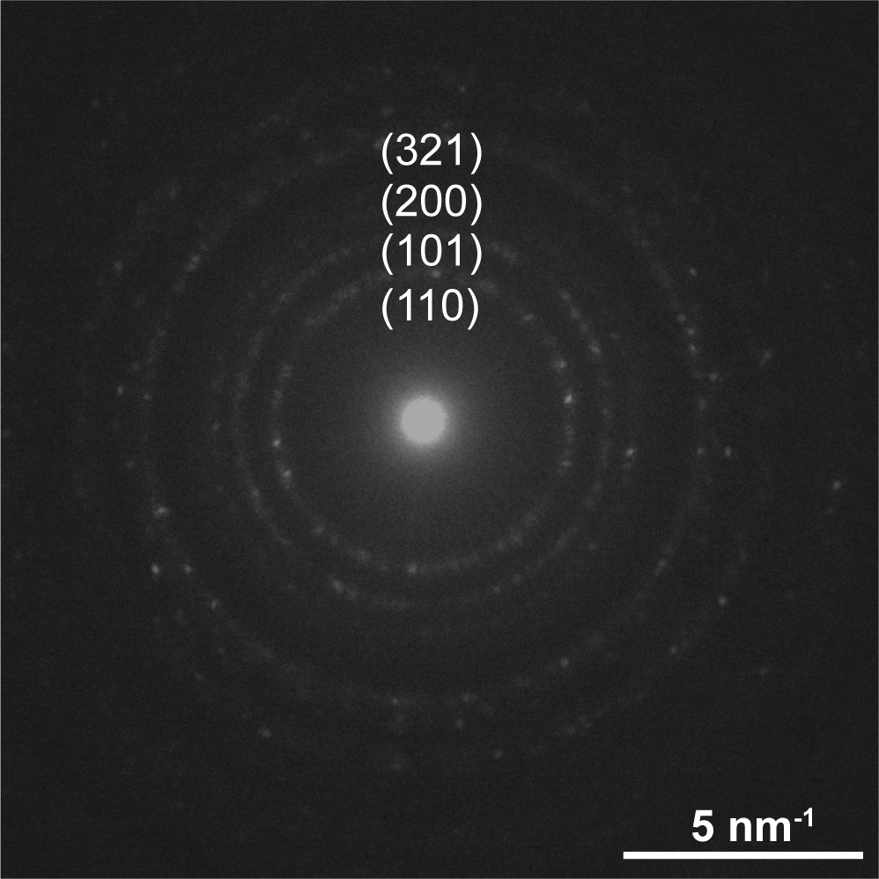
Supplementary Figure 6 SAED pattern of the Ba_{0.3}(SO₄)_{δ}W_{0.2}Ru_{0.5}O_{2−δ}.

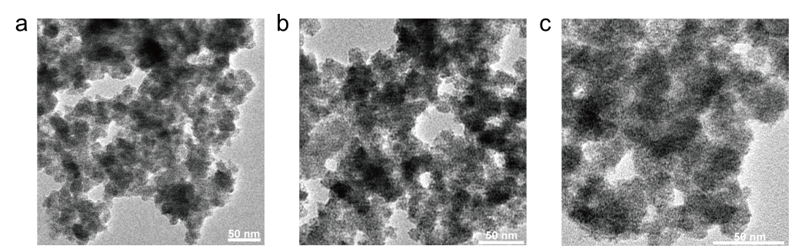
Supplementary Figure 7 a-c, TEM images of (a) Ba_{0.2}(SO₄)_{δ}W_{0.1}Ru_{0.7}O_{2−δ}, (b) Ba_{0.4}(SO₄)_{δ}W_{0.2}Ru_{0.4}O_{2−δ}, and (c) Ba_{0.4}(SO₄)_{δ}W_{0.3}Ru_{0.3}O_{2−δ}.

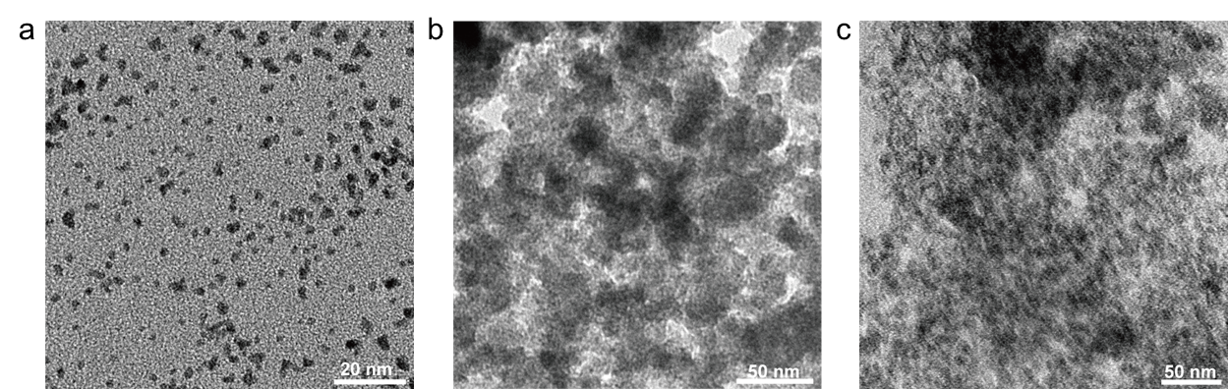
Supplementary Figure 8 a-c, TEM images of (a) W_{0.3}Ru_{0.7}O₂, (b) (SO₄)_{δ}RuO_{2−δ}, and (c) Ba_{0.4}(SO₄)_{δ}Ru_{0.6}O_{2−δ}.

Supplementary Figure 9 XRD patterns of W_{0.3}Ru_{0.7}O₂, (SO₄)_{δ}RuO_{2−δ}, and Ba_{0.4}(SO₄)_{δ}Ru_{0.6}O_{2−δ}.

Supplementary Figure 10 OER polarization curves of Ba_{0.2}(SO₄)_{δ}W_{0.1}Ru_{0.7}O_{2−δ}, Ba_{0.3}(SO₄)_{δ}W_{0.2}Ru_{0.5}O_{2−δ}, Ba_{0.4}(SO₄)_{δ}W_{0.2}Ru_{0.4}O_{2−δ}, and Ba_{0.4}(SO₄)_{δ}W_{0.3}Ru_{0.3}O_{2−δ}.

Supplementary Figure 11 Nyquist plots of commercial RuO₂, W_{0.3}Ru_{0.7}O₂, (SO₄)_{δ}RuO_{2−δ}, Ba_{0.4}(SO₄)_{δ}Ru_{0.6}O_{2−δ}, and Ba_{0.3}(SO₄)_{δ}W_{0.2}Ru_{0.5}O_{2−δ}.

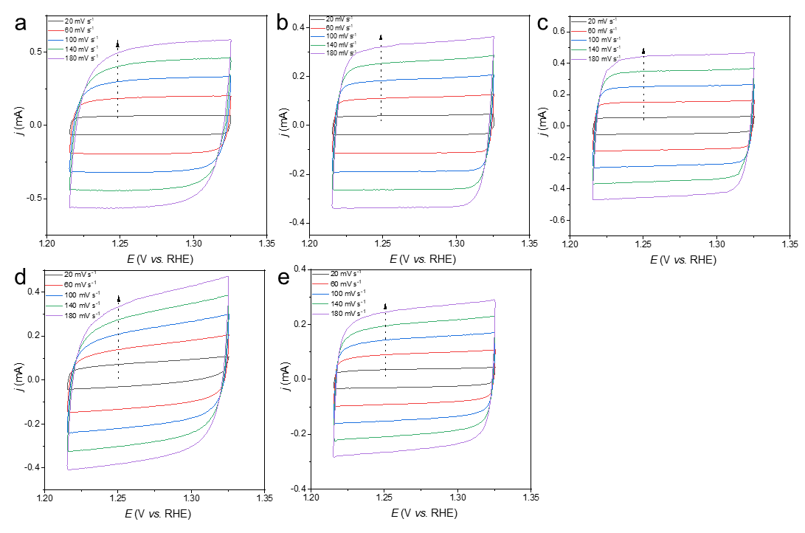
Supplementary Figure 12 a-e, Cyclic voltammograms of (a) commercial RuO₂, (b) W_{0.3}Ru_{0.7}O₂, (c) (SO₄)_{δ}RuO_{2−δ}, (d) Ba_{0.4}(SO₄)_{δ}Ru_{0.6}O_{2−δ}, and (e) Ba_{0.3}(SO₄)_{δ}W_{0.2}Ru_{0.5}O_{2−δ} at scan rates of 20, 60, 100, 140, and 180 mV s⁻¹.
Supplementary Figure 13 Chronopotentiogram of (SO₄)_{δ}RuO_{2−δ} and Ba_{0.4}(SO₄)_{δ}Ru_{0.6}O_{2−δ} at 10 mA cm⁻² in 0.1 M HClO₄.

Supplementary Figure 14 OER polarization curves of commercial RuO₂ and Ba_{0.3}(SO₄)_{δ}W_{0.2}Ru_{0.5}O_{2−δ} before and after 100,000 cycles.

Supplementary Figure 15 Cyclic voltammograms of commercial RuO₂, Ba_{0.4}(SO₄)_{δ}Ru_{0.6}O_{2−δ}, and Ba_{0.3}(SO₄)_{δ}W_{0.2}Ru_{0.5}O_{2−δ} in Ar-saturated 0.5 M H₂SO₄ at a scan rate of 50 mV s⁻¹.

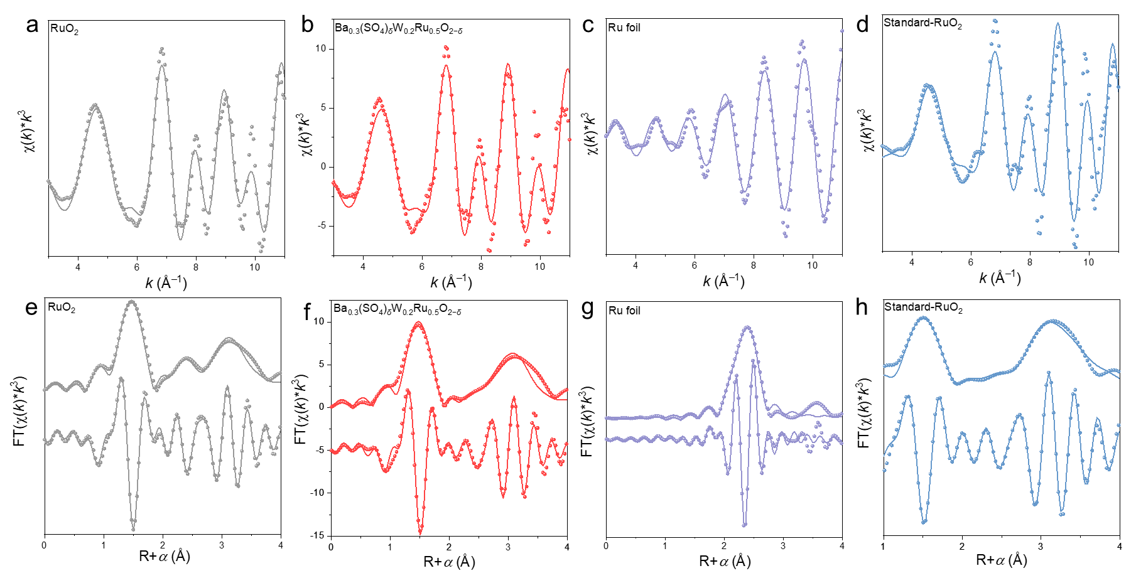
Supplementary Figure 16 a-d, Ru K-edge EXAFS (points) and the curvefit (line) for (a) RuO₂, (b) Ba_{0.3}(SO₄)_{δ}W_{0.2}Ru_{0.5}O_{2−δ}, (c) Ru foil, and (d) standard-RuO₂, shown in k³weighted k-space. e-h, Ru K-edge EXAFS (points) and the curvefit (line) for (e) RuO₂, (f) Ba_{0.3}(SO₄)_{δ}W_{0.2}Ru_{0.5}O_{2−δ}, (g) Ru foil, and (h) standard-RuO₂, shown in R-space (FT magnitude and imaginary component). The data are k³-weighted and not phase-corrected.

Supplementary Figure 17 High-resolution O 1s XPS spectra of RuO₂, (SO₄)_{δ}RuO_{2−δ}, and Ba_{0.3}(SO₄)_{δ}W_{0.2}Ru_{0.5}O_{2−δ} before and after OER.

Supplementary Figure 18 Time-resolved in-situ XRD patterns of RuO₂ during 200 min acidic OER at 1.55 V.

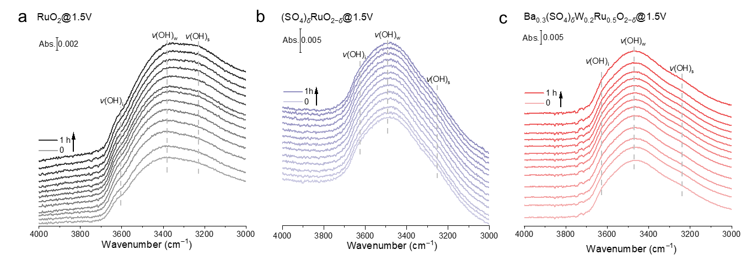
Supplementary Figure 19 a-c, Time-resolved in-situ ATR-SEIRAS spectra of (a) RuO₂, (b) (SO₄)_{δ}RuO_{2−δ}, and (c) Ba_{0.3}(SO₄)_{δ}W_{0.2}Ru_{0.5}O_{2−δ} over the course of 1 h acidic OER at 1.5 V.

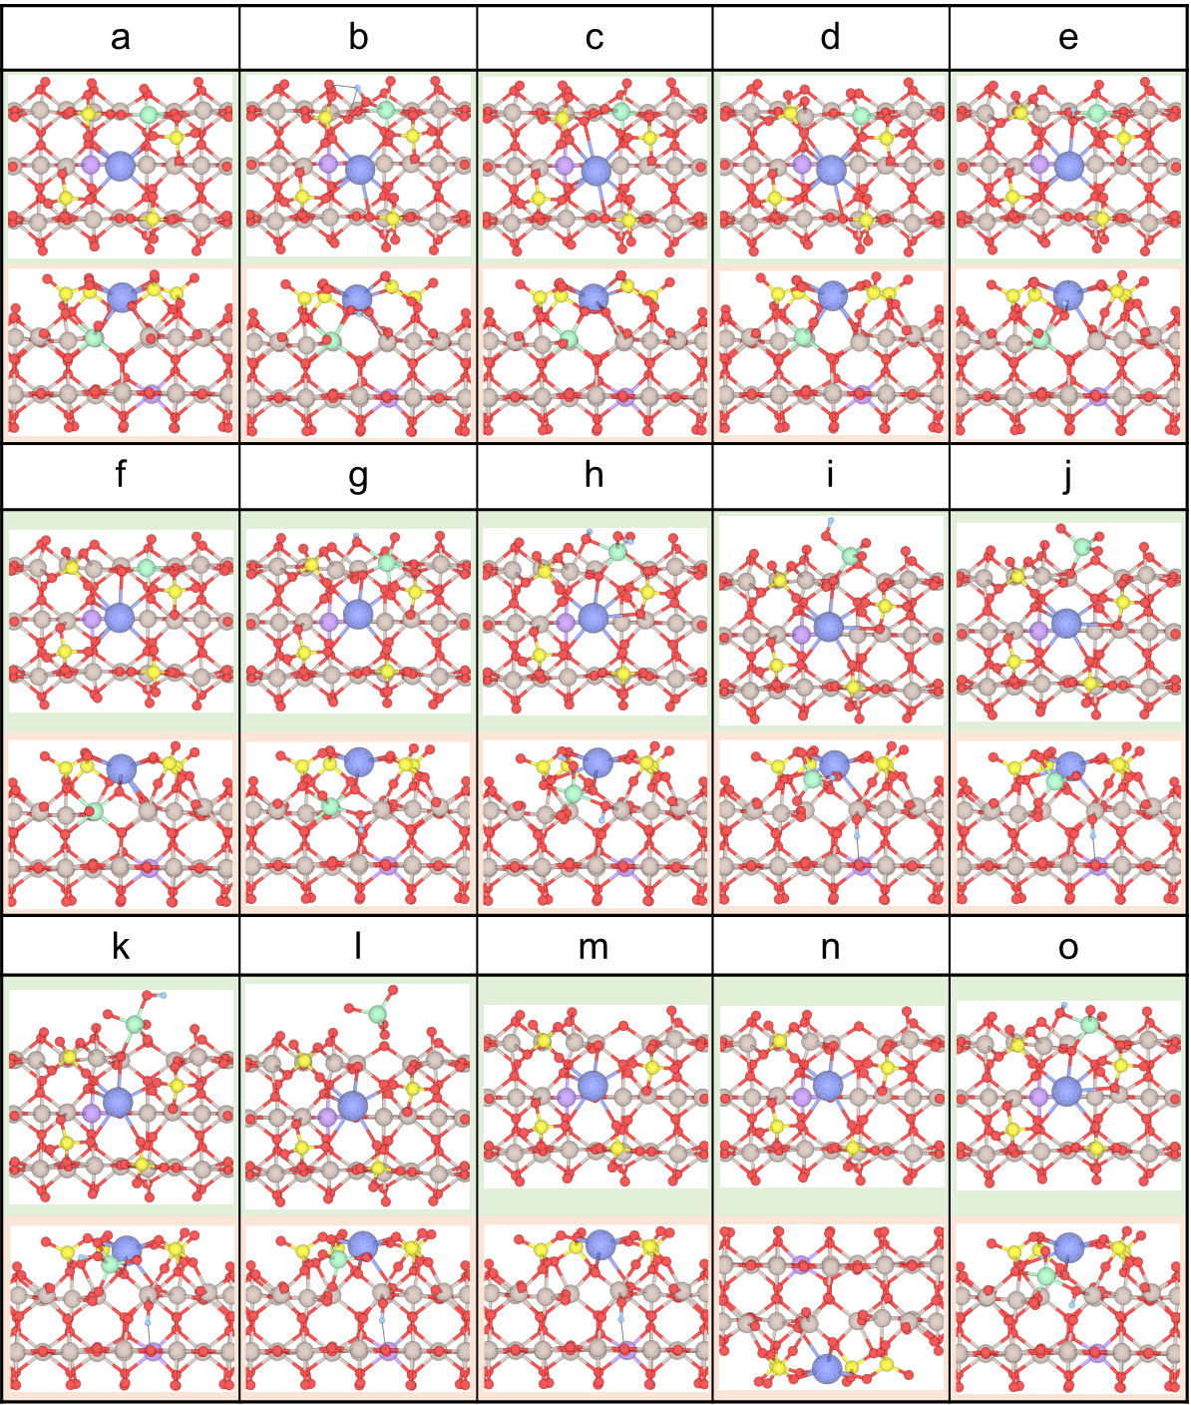
Supplementary Figure 20 Atomic structures of catalysts and intermediates during Ru dissolution on Ba_{0.3}(SO₄)_{δ}W_{0.2}Ru_{0.5}O_{2−δ}.

Supplementary Note 3: In the most possible thermodynamic deactivation pathway of Ba_{0.3}(SO₄)_{δ}W_{0.2}Ru_{0.5}O_{2−δ}, the adsorption and deprotonation of water are optimized on the most energetically favorable sites. Benefiting from the protection of Ba-anchored sulfate, the deactivation of Ba_{0.3}(SO₄)_{δ}W_{0.2}Ru_{0.5}O_{2−δ} needs to overcome two positive free energy difference in the steps from a to b and k to l, respectively, while that of RuO₂ is almost spontaneous – that means, it is more difficult and sluggish for Ba_{0.3}(SO₄)_{δ}W_{0.2}Ru_{0.5}O_{2−δ} to deactivate than RuO₂.

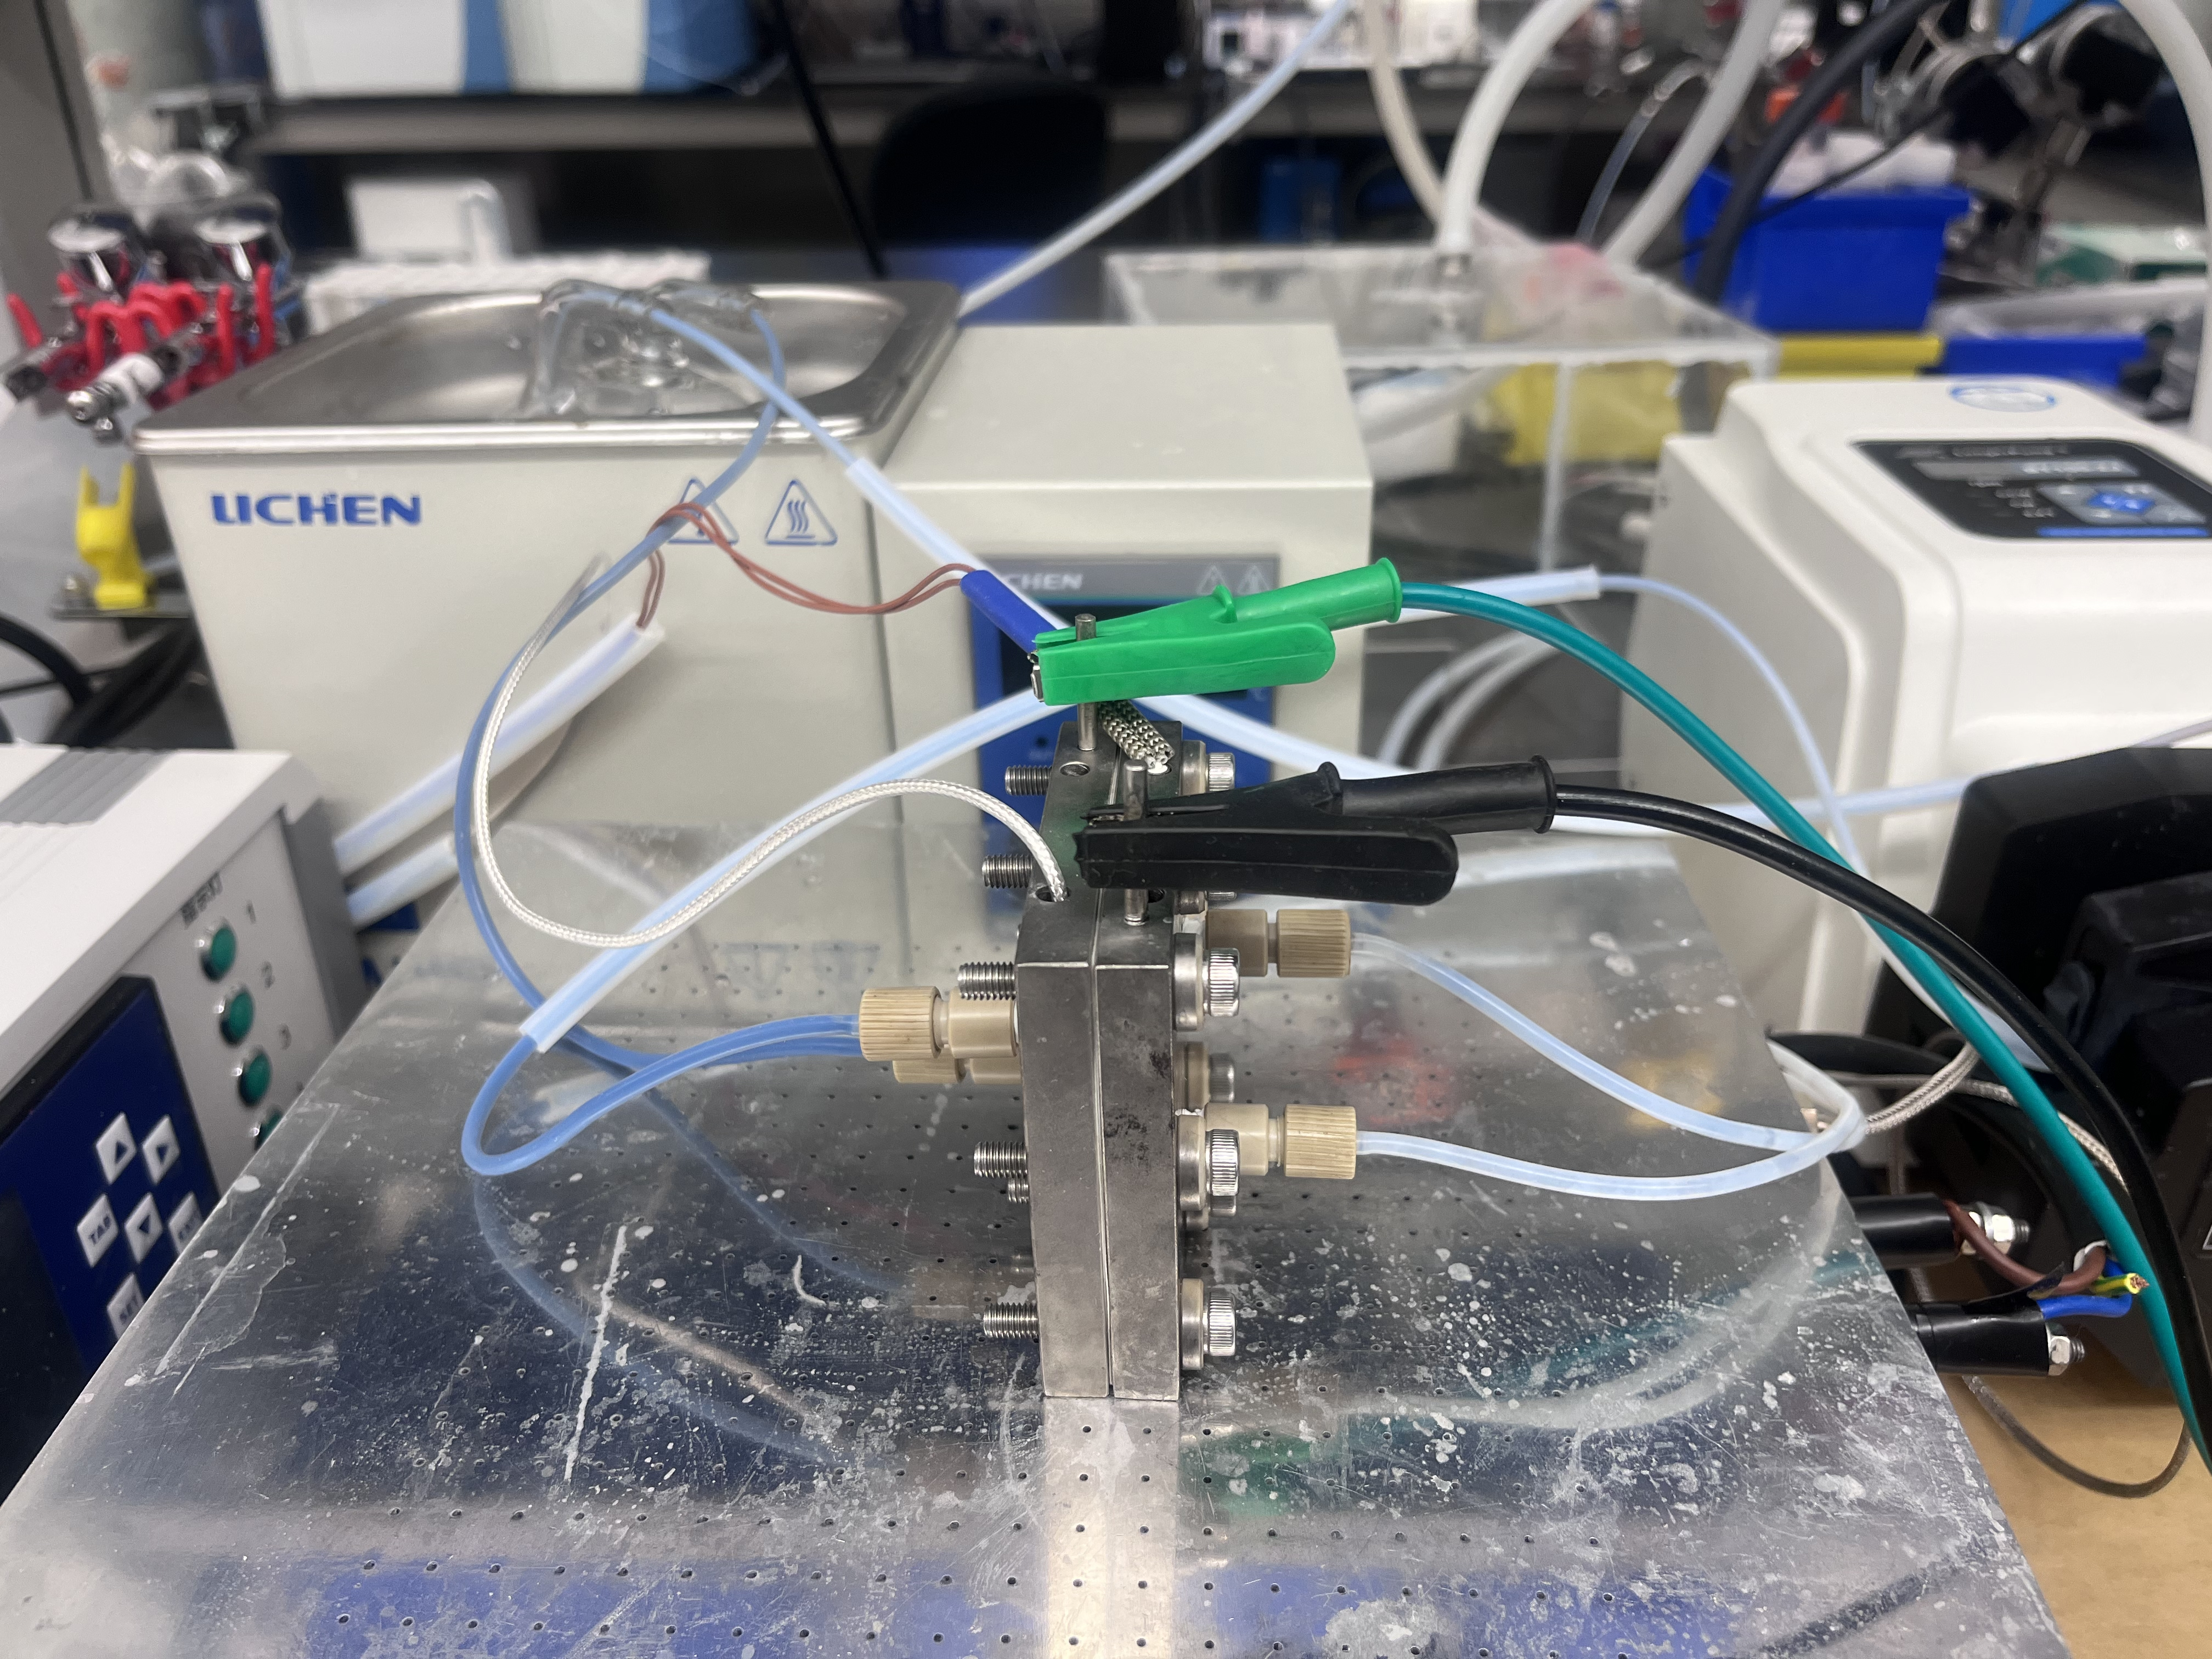
Supplementary Figure 21 Photograph of the PEMWE.

Supplementary Tables

Supplementary Table 1. The binding energy of various metal cations with sulfate on the surface of RuO₂ (110) plane.
Metal | Binding Energy (eV) | Metal |  | Binding Energy (eV) | Metal | Binding Energy (eV) | Metal | Binding Energy (eV)
Au | -3.26 | Te | -7.01 |  | Al | -8.65 | Re | -14.5
Ag | -4.03 | Ni | -7.11 |  | Fe | -8.82 | V | -14.6
Cd | -4.8 | Ge | -7.23 |  | Mg | -8.94 | Sc | -14.8
Se | -5.15 | Pt | -7.33 |  | Ir | -9.5 | Ti | -15.3
Ga | -5.17 | Sn | -7.36 |  | Be | -10.2 | Pr | -15.6
Zn | -5.49 | Sb | -7.51 |  | Sr | -10.4 | Y | -15.9
Cu | -5.63 | Pb | -7.56 |  | Ca | -10.5 | La | -16
Pd | -5.81 | In | -7.78 |  | Ru | -10.5 | Mo | -16
Na | -5.92 | Co | -7.85 |  | Ba | -10.8 | Ce | -17.1
K | -6.04 | Bi | -7.93 |  | Eu | -11.4 | Gd | -17.1
Li | -6.52 | Rh | -8.01 |  | Cr | -12.1 | Zr | -18.6
As | -6.87 | Mn | -8.6 |  | Nd | -14.5 | Nb | -19
W | -19.19 | Hf | -19.3 |  | Ta | -20.2

Supplementary Table 2. OER performances of the Ru-based catalysts in this work.
Catalysts | Loading  (μg cm^{–2}) | ECSA (cm²_{oxide}) | Overpotential (V) @  10 mA cm^{–2} | j_{m} @ 1.45 V  (A mg^{–1}_{oxide}) | j_{s} @ 1.45 V  (mA cm^{–2}_{oxide})
RuO₂ | 125 | 83.4 | 279 | 0.015 | 0.004
W_{0.3}Ru_{0.7}O₂ | 125 | 52.3 | 216 | 0.103 | 0.048
(SO₄)_{δ}RuO_{2-δ} | 125 | 71.1 | 225 | 0.068 | 0.023
Ba_{0.4}(SO₄)_{δ}Ru_{0.6}O_{2-δ} | 125 | 54.6 | 233 | 0.051 | 0.023
Ba_{0.3}(SO₄)_{δ}W_{0.2}Ru_{0.5}O_{2-δ} | 125 | 39.7 | 208 | 0.144 | 0.089

Supplementary Table 3. The amount of dissolved Ru for various catalysts after OER.
Catalyst | Amount of dissolved Ru  (%)
RuO₂ | 35.6
W_{0.3}Ru_{0.7}O₂ | 24.1
(SO₄) _{δ}RuO_{2-δ} | 19.2
Ba_{0.4}(SO₄) _{δ}Ru_{0.6}O_{2-δ} | 11.5
Ba_{0.3}(SO₄) _{δ}W_{0.2}Ru_{0.5}O_{2-δ} | 7.1

Supplementary Table 4. Summary of the reported Ru-based OER catalysts under acidic conditions.
Catalyst | Loading  (μg cm^{–2}) | Electrolyte | Overpotential @10 mA cm^{–2}  (mV) | Stability  @10 mA cm^{–2}  (h) | Ref.
Ni-RuO₂ | 400 | 0.1 M HClO₄ | 214 | 200 | 1
Co-RuIr | 50 | 0.1 M HClO₄ | 235 | 25 | 2
Faceted Ru | 127 | 0.1 M HClO₄ | 180 | 4 | 3
Ru₁-Pt₃Cu | 21 | 0.1 M HClO₄ | 220 | 28 | 4
Bi_{x}Er_{2-x}Ru₂O₇ | 830 | 0.1 M HClO₄ | 180 | 100 | 5
Cu-doped RuO₂ | 275 | 0.5 M H₂SO₄ | 188 | 8 | 6
CaCu₃Ru₄O₁₂ | 250 | 0.5 M H₂SO₄ | 171 | 24 | 7
Cr_{0.6}Ru_{0.4}O₂ | 283 | 0.5 M H₂SO₄ | 178 | 10 | 8
W_{0.2}Er_{0.1}Ru_{0.7}O_{2-δ} | 330 | 0.5 M H₂SO₄ | 168 | 500 | 9
Li_{0.52}RuO₂ | 637 | 0.5 M H₂SO₄ | 156 | 70 | 10
Y_{1.7}Sr_{0.3}Ru₂O₇ | 71 | 0.5 M H₂SO₄ | 264 | 28 | 11
RuNi₂©G-250 | 320 | 0.5 M H₂SO₄ | 227 | 3 | 12
Ba_{0.3}(SO₄)_{δ}W_{0.2}Ru_{0.5}O_{2−δ} | 125 | 0.5 M H₂SO₄ | 208 | 1,000 | This work

Supplementary Table 5. Curvefit parametersª for Ru K-edge EXAFS for various samples.
Catalyst | Path | R(Å)ª | N^{b} | $σ^{2} ({\text{10}}^{-3}Å^{2})$^{c} | ${∆E}_{0}$ (eV)^{d} | R factor
RuO₂ | Ru-O | 1.97 | 4.4 | 2.4 | −1.32 | 0.016
RuO₂ | Ru-Ru | 2.7 | 1 | 1.2 | −1.32 | 0.016
RuO₂ | Ru-O | 3.16 | 2.5 | 3.5 | −1.32 | 0.016
 | Ru-O | 1.97 | 4 | 0.6
Ba_{0.3}(SO₄) _{δ}W_{0.2}Ru_{0.5}O_{2-δ} | Ru-Ru | 2.69 | 1 | 4.2 | −1.71 | 0.019
 | Ru-O | 3.15 | 2 | 11.4
Ru foil | Ru-Ru | 2.67 | 12 | 3.6 | 3.59 | 0.013
Standard RuO₂ | Ru-O | 1.96 | 6 | −0.3 |  | 0.018
Standard RuO₂ | Ru-Ru | 2.66 | 6 | −1.5 | −0.32 | 0.018
Standard RuO₂ | Ru-O | 0.317 | 2 | 4.9 |  | 0.018
ªR: Bond distance; ^{b}N: coordination numbers; ^{c}$σ^{2}$: Debye-Waller factors; ^{d}${∆E}_{0}$: the inner potential correction. R factor: goodness of fit.

Supplementary Table 6. Summary of the reported PEMWE stability using different Ru-based OER catalysts.
Anode catalyst | Mass loading  (mg cm^{–2}) | PEM | Cell temperature (°C) | Electrolyte | Current density  ( A cm^{–2}) | Stability  (h) | Ref.
PtCo–RuO₂/C | 2.5 | N212 | 80 | Distilled water | 1 | 24 | 13
RuO₂/SnO₂ | 3 | N115 | 30 | Distilled water | 0.25 | 235 | 14
RuO₂ NS | 1.2 | N212 | 90 | Distilled water | 1 | 10 | 15
Ni-RuO₂ | ~3.1 | N117 | Room temperature | 0.1 M HClO₄ | 0.2 | 1,000 | 1
W_{0.2}Er_{0.1}Ru_{0.7}O_{2−δ} | Not Given | N117 | Room temperature | 0.5 M H₂SO₄ | 0.1 | 120 | 9
Ba_{0.3}(SO₄)_{δ}W_{0.2}Ru_{0.5}O_{2−δ} | 3 | N115 | 80 | 0.5 M H₂SO₄ | 0.5 | 300 | This work

Supplementary References
1 Wu, Z. Y. et al. Non-iridium-based electrocatalyst for durable acidic oxygen evolution reaction in proton exchange membrane water electrolysis. Nat. Mater. 22, 100-108 (2023).
2 Shan, J., Ling, T., Davey, K., Zheng, Y. & Qiao, S. Z. Transition-metal-doped RuIr bifunctional nanocrystals for overall water splitting in acidic environments. Adv. Mater. 31, e1900510 (2019).
3 Poerwoprajitno, A. R. et al. Formation of branched ruthenium nanoparticles for improved electrocatalysis of oxygen evolution reaction. Small 15, e1804577 (2019).
4 Yao, Y. et al. Engineering the electronic structure of single atom Ru sites via compressive strain boosts acidic water oxidation electrocatalysis. Nat. Catal. 2, 304-313 (2019).
5 Zhou, G. et al. Spin-related symmetry breaking induced by half-disordered hybridization in Bi_{x}Er_{2-x}Ru₂O₇ pyrochlores for acidic oxygen evolution. Nat. Commun. 13, 4106 (2022).
6 Su, J. et al. Assembling ultrasmall copper-doped ruthenium oxide nanocrystals into hollow porous polyhedra: Highly robust electrocatalysts for oxygen evolution in acidic media. Adv. Mater. 30, 1801351 (2018).
7 Miao, X. et al. Quadruple perovskite ruthenate as a highly efficient catalyst for acidic water oxidation. Nat. Commun. 10, 3809 (2019).
8 Lin, Y. et al. Chromium-ruthenium oxide solid solution electrocatalyst for highly efficient oxygen evolution reaction in acidic media. Nat. Commun. 10, 162 (2019).
9 Hao, S. et al. Dopants fixation of ruthenium for boosting acidic oxygen evolution stability and activity. Nat. Commun. 11, 5368 (2020).
10 Qin, Y. et al. RuO₂ electronic structure and lattice strain dual engineering for enhanced acidic oxygen evolution reaction performance. Nat. Commun. 13, 3784 (2022).
11 Zhang, N. et al. Metal substitution steering electron correlations in pyrochlore ruthenates for efficient acidic water oxidation. ACS Nano 15, 8537-8548 (2021).
12 Cui, X. et al. Robust interface Ru centers for high-performance acidic oxygen evolution. Adv. Mater. 32, e1908126 (2020).
13 Jin, H. et al. Safeguarding the RuO₂ phase against lattice oxygen oxidation during acidic water electrooxidation. Energy Environ. Sci. 15, 1119 (2022).
14 Lim, J. Y. et al. Highly stable RuO₂/SnO₂ nanocomposites as anode electrocatalysts in a PEM water electrolysis cell. Int. J. Energy Res. 38, 875-883 (2014).
15 Huang, H. et al. Structure engineering defective and mass transfer-enhanced RuO₂ nanosheets for proton exchange membrane water electrolyzer. Nano Energy 88, 106276 (2021).

