Supplementary Information

Inclusion unlocks the creative potential of gender diversity in teams
Balázs Vedres, Orsolya Vásárhelyi

Content
Supplementary Text
Figs. S1 to S5
Tables S1 to S12
Data S1
Code S1

Accuracy of Gender Inferring
To quantify the error in our algorithm we randomly selected 200-200 team members whose gender was inferred as male, female and unknown and manually inferred their gender. Since these people re professionals, we look-up their profiles on LinkedIn and labelled them based on their pictures, bio, and recommendations (if the text used gendered language aka, He or She). If we could not find any LinkedIn user with the same name or based on the picture or the text it was not possible to decide whether the given individual is a male or female, we labelled them as unknown.
Furthermore, we ran another widely used gender inferring method on our database gender-guesser (https://pypi.org/project/gender-guesser/) to compare how well our method performed. Figure S1. shows the accuracy of the used gender inferring method and the Gender Guesser Python package in comparison with the manually created baseline. Precision measures how many contributors were assigned to the correct gender label according to our baseline. Recall measures how many of the contributors were correctly identified. F-score takes the harmonic average of these two metrics. Our method has a higher precision for females and males, but lower recall for male. Table S3. Shows that our method is also better identifying unknowns than the Gender-Guesser default python package, but worse in identifying male contributors.

Impact of Gender Robustness on Modelling
To account for the potential bias that inferred gender could introduce to results, we adopt various robustness checks. Although the precision of our name-based gender inferring method was nearly perfect for men and women, we accounted much lower precision for unknowns (50%). Although we excluded teams with more than 50% of unknowns from our analysis, there is still bias that team members with unknown gender can add to our results. Statistics on female representation in the video game industry indicate that most of the unknowns are more likely to be male. Therefore, we randomly select 25 or 50 percent of unknown gendered team members in each game and re-label them as males and re-calculate all diversity and inclusion metrics. We repeat this process 100 times and take the average of the resulting inclusion metrics for each game. (Figure S3, in SI shows the distribution of newly calculated gender diversity and inclusion metrics with 25 and 50 percent of relabeled data compared to original data). Then we rerun game-level OLS models to predict games’ distinctiveness based on the 25 and 50 percent relabeled diversity and inclusion metrics. The interaction between gender diversity and bonding stays significant even if 50 percent of unknown gendered team members are labelled as males. Similarly, to bonding, combined inclusion’s interaction with gender diversity is robust to gender relabeling, while mixing and incorporating lose their significance if at least 25 percent of unknowns turn out to be male. (See the Distribution of gender swapped diversity and inclusion metrics at Figure S4 and Point estimates of distinctiveness based on OLS models ran on relabelled gender data at Figure S5)

Figure S1.

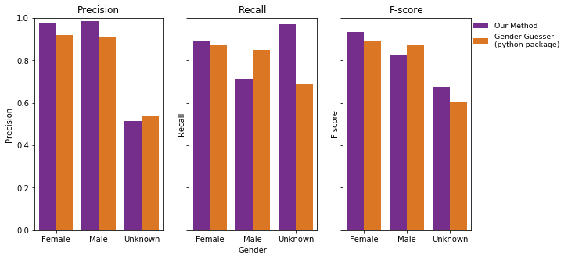
Gender Inferring Accuracy. Precision, Recall and F-score of our gender inferring method and the Gender Guesser Python package in comparison with the manually created baseline. Precision measures how many contributors were assigned to the correct gender label according to our manually created baseline. Recall measures how many of the contributors were correctly identified. F-score takes the harmonic average of these two metrics

Figure S2.

Point estimates of distinctiveness in four model specifications. Point estimates of distinctiveness with 95% CI for gender diversity, four variables of inclusion, and their interactions with gender diversity. Markers are numbered according to OLS models; coefficients are for one SD change in distinctiveness because of one SD change in independent variables. Panel a) shows the point estimates of different inclusion models based on the baseline game-level OLS models shown in the manuscript. Panel b) shows estimates for game-level OLS models with Random Effects for firms to estimate the effect of game specific characteristics and Panel c) with Fixed-Effects for firms to account for firm-level specific effects. Point estimates from models visualized in Panel d) are coming from firm-level aggregated data, where each variable is the average of all games produced by a given firm.

Figure S3.

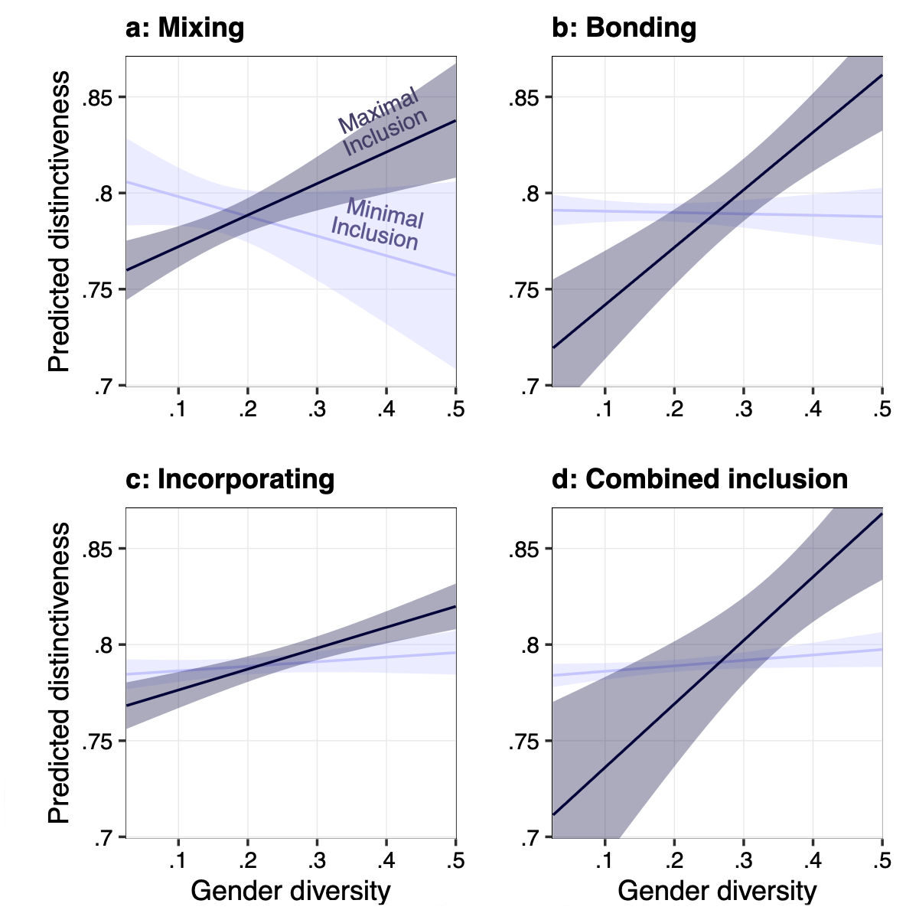
Marginal predictions for all four inclusion variables Game level OLS models’ predicted distinctiveness by by gender diversity at minimal and maximal levels of mixing inclusion with 95% CI, keeping all controls at their means.

Figure S4.

Distribution of gender swapped diversity and inclusion metrics. To assess the bias that name-based gender inferring method can introduce to our independent variables we randomly re-labelled 25 and 50 percent of unknown gendered team members to male in each game, and calculated Gender Diversity, Mixing, Bonding, Incorporating and Combined Inclusion. We repeated this process 100 times for each game and calculated the average of the resulting diversity and inclusion metrics. Blue histogram shows the original distribution, orange distribution is based on 25 percent re-labelled data, and green is based on 50 percent. Distributions indicate that Mixing and Incorporating are more sensitive to re-labelling than Bonding and the Combined Index.

Figure S5.

Point estimates of distinctiveness based on OLS models ran on relabelled gender data. To assess the impact of unknowns in project teams, we re-calculated our diversity and inclusion metrics 100 times by randomly relabelling 25 and 50 of unknown gendered team members to male. Blue indicates original point estimates of distinctiveness with 95% CI for gender diversity, yellow 25 percent of unknowns relabelled to male, and green 50.

Table S1.
Number of games | 8,617
Years | 1993-2009
Number of developers | 630,420
Women | 119,826 (19%)
Men | 397,520 (63%)
Unknowns | 113,074 (18%)
Descriptive Statistics of original data collected from mobygames.com We collected data from the video game industry, relying on MobyGames.com. Our dataset contains 8,617 unique video games, with a list of each game’s developer teams, critic’s reviews, and stylistic elements such as genres, perspective (e.g., first-person shooter, role-playing) and the platforms it can be played on (e.g., PlayStation, Nintendo Switch, etc.). We also record each game’s developer studio, publishing house, and the year of the first release.

Table S2.
Filtering Criteria | N
All games | 8,617
Published between 1993 and 2009 | 7,931
1<number of edges in the network <2000 | 4,771
Ratio of unknowns in team < 0.5 | 4,654
Number of women in team network >=1 | 4,011
Applied filtering criteria on our game dataset. For our analysis we only considered games which were published between 1993 and 2009, and had less than 2000 connection among team members, had at least one female team member, and less than 50% of team members gender could have been inferred. We excluded all re-released and mobile games. Since gender diversity is a key interest of our study, we had to exclude all those video games from our analysis which did not list team members’ full name and used only initials instead of first names. Our resulting database contains 4,011 video games.

Table S3.
Gender Guesser | Female | Male | Unknown
Our Method
Female | 0.895 | 0.04 | 0.065
Male | 0.005 | 0.96 | 0.035
Unknown | 0.135 | 0.29 | 0.575

Ratio of matching gender categories by Our method and Gender-Guesser. Female contributors matched in 89.5%, and male contributors 96% of our sample.

Table S4.
 | Distinctiveness
 | OLS Models
 | Std rob SE | Dev firm RE | Dev firm FE dummies | Dev firm level std
 | (1) | (2) | (3) | (4)
Diversity | 0.040* | 0.033 | 0.032 | 0.043
 | (0.021) | (0.022) | (0.025) | (0.038)
Combined Inclusion | -0.115** | -0.137** | -0.136** | -0.173*
 | (0.051) | (0.054) | (0.061) | (0.097)
Diversity: Combined Inclusion | 0.048*** | 0.049*** | 0.032* | 0.073***
 | (0.016) | (0.017) | (0.019) | (0.028)
Team Size | -0.001*** | -0.001*** | -0.001*** | -0.001**
 | (0.0002) | (0.0002) | (0.0003) | (0.0004)
Newbies ratio | 0.158 | 0.149 | 0.179 | 0.082
 | (0.115) | (0.114) | (0.134) | (0.238)
Games tenure | 0.038* | 0.009 | 0.008 | 0.025
 | (0.023) | (0.024) | (0.033) | (0.044)
Star developer | 0.135 | 0.305 | 0.340 | -0.349
 | (0.310) | (0.382) | (0.306) | (0.239)
Single-firm production | 0.050 | 0.006 | -0.003 | -0.021
 | (0.034) | (0.038) | (0.052) | (0.069)
Ratio of core | 0.200** | 0.210** | 0.230** | 0.384
 | (0.100) | (0.096) | (0.114) | (0.235)
Number of countries | -0.033*** | -0.029*** | -0.024*** | -0.040***
 | (0.006) | (0.005) | (0.007) | (0.014)
N | 4,011 | 4,011 | 3,368 | 1,354
R² | 0.112 | 0.225 | 0.475 | 0.165
Adjusted R² | 0.105 | 0.219 | 0.327 | 0.146
Note: | *p<0.1; **p<0.05; ***p<0.0

Predicting Creativity with Mixing. Table shows key variables and main controls (except year and platform dummies). Model 1) Baseline Model with standardized variables Model 2) Developer firms Random-Effects 3) Developer firms with Fixed-effects (as dummies) 4) Developer firm level aggregated models
Table S5.
 | Distinctiveness
 | OLS Models
 | Std rob SE | Dev firm RE | Dev firm FE dummies | Dev firm level std
 | (1) | (2) | (3) | (4)
Diversity | -0.010 | -0.004 | 0.049 | -0.092
 | (0.032) | (0.031) | (0.039) | (0.058)
Bonding | -0.134*** | -0.134*** | -0.103** | -0.172**
 | (0.040) | (0.041) | (0.048) | (0.071)
Diversity: Bonding | 0.057*** | 0.051*** | 0.018 | 0.094***
 | (0.015) | (0.015) | (0.017) | (0.024)
Team Size | -0.001*** | -0.001*** | -0.001*** | -0.001**
 | (0.0002) | (0.0002) | (0.0003) | (0.0004)
Newbies ratio | 0.169 | 0.154 | 0.176 | 0.087
 | (0.115) | (0.113) | (0.133) | (0.237)
Games tenure | 0.038* | 0.009 | 0.012 | 0.027
 | (0.023) | (0.024) | (0.033) | (0.043)
Star developer | 0.146 | 0.307 | 0.327 | -0.327
 | (0.307) | (0.386) | (0.305) | (0.229)
Single-firm production | 0.050 | 0.005 | -0.005 | -0.029
 | (0.034) | (0.038) | (0.052) | (0.068)
Ratio of core | 0.216** | 0.184** | 0.113 | 0.457**
 | (0.087) | (0.082) | (0.096) | (0.206)
Number of countries | -0.032*** | -0.028*** | -0.024*** | -0.038***
 | (0.006) | (0.006) | (0.007) | (0.014)
N | 4,011 | 4,011 | 3,368 | 1,354
R² | 0.113 | 0.225 | 0.475 | 0.170
Adjusted R² | 0.106 | 0.219 | 0.327 | 0.151
Note: | *p<0.1; **p<0.05; ***p<0.01

Predicting Creativity with Bonding. Table shows key variables and main controls (except year and platform dummies). Model 1) Baseline Model with standardized variables Model 2) Developer firms Random-Effects 3) Developer firms with Fixed-effects (as dummies) 4) Developer firm level aggregated models

Table S6.
 | Distinctiveness
 | OLS Models
 | Std rob SE | Dev firm RE | Dev firm FE dummies | Dev firm level std
 | (1) | (2) | (3) | (4)
Diversity | 0.033 | 0.027 | 0.012 | 0.060
 | (0.026) | (0.026) | (0.029) | (0.048)
Incorporating | -0.073* | -0.069* | -0.052 | -0.091
 | (0.038) | (0.039) | (0.042) | (0.073)
Diversity: Incorporating | 0.038** | 0.033** | 0.020 | 0.043*
 | (0.015) | (0.016) | (0.016) | (0.025)
Team Size | -0.001*** | -0.001*** | -0.001*** | -0.001**
 | (0.0002) | (0.0002) | (0.0003) | (0.0004)
Newbies ratio | 0.160 | 0.146 | 0.158 | 0.094
 | (0.115) | (0.113) | (0.133) | (0.242)
Games tenure | 0.037 | 0.008 | 0.009 | 0.019
 | (0.023) | (0.024) | (0.033) | (0.044)
Star developer | 0.114 | 0.293 | 0.328 | -0.358
 | (0.312) | (0.381) | (0.309) | (0.245)
Single-firm production | 0.050 | 0.006 | -0.008 | -0.019
 | (0.034) | (0.038) | (0.052) | (0.069)
Ratio of core | 0.186 | 0.182* | 0.153 | 0.398
 | (0.122) | (0.109) | (0.135) | (0.291)
Number of countries | -0.033*** | -0.029*** | -0.024*** | -0.042***
 | (0.006) | (0.006) | (0.007) | (0.014)
N | 4,011 | 4,011 | 3,368 | 1,354
R² | 0.111 | 0.224 | 0.474 | 0.159
Adjusted R² | 0.104 | 0.218 | 0.326 | 0.139
Note: | *p<0.1; **p<0.05; ***p<0.01

Predicting Creativity with Incorporating. Table shows key variables and main controls (except year and platform dummies). Model 1) Baseline Model with standardized variables Model 2) Developer firms Random-Effects 3) Developer firms with Fixed-effects (as dummies) 4) Developer firm level aggregated models.
Table S7.
 | Distinctiveness
 | OLS Models
 | Std rob SE | Dev firm RE | Dev firm FE dummies | Dev firm level std
 | (1) | (2) | (3) | (4)
Diversity | 0.040* | 0.033 | 0.032 | 0.043
 | (0.021) | (0.022) | (0.025) | (0.038)
Combined Inclusion | -0.115** | -0.137** | -0.136** | -0.173*
 | (0.051) | (0.054) | (0.061) | (0.097)
Diversity: Combined Inclusion | 0.048*** | 0.049*** | 0.032* | 0.073***
 | (0.016) | (0.017) | (0.019) | (0.028)
Team Size | -0.001*** | -0.001*** | -0.001*** | -0.001**
 | (0.0002) | (0.0002) | (0.0003) | (0.0004)
Newbies ratio | 0.158 | 0.149 | 0.179 | 0.082
 | (0.115) | (0.114) | (0.134) | (0.238)
Games tenure | 0.038* | 0.009 | 0.008 | 0.025
 | (0.023) | (0.024) | (0.033) | (0.044)
Star developer | 0.135 | 0.305 | 0.340 | -0.349
 | (0.310) | (0.382) | (0.306) | (0.239)
Single-firm production | 0.050 | 0.006 | -0.003 | -0.021
 | (0.034) | (0.038) | (0.052) | (0.069)
Ratio of core | 0.200** | 0.210** | 0.230** | 0.384
 | (0.100) | (0.096) | (0.114) | (0.235)
Number of countries | -0.033*** | -0.029*** | -0.024*** | -0.040***
 | (0.006) | (0.005) | (0.007) | (0.014)
N | 4,011 | 4,011 | 3,368 | 1,354
R² | 0.112 | 0.225 | 0.475 | 0.165
Adjusted R² | 0.105 | 0.219 | 0.327 | 0.146
Note: | *p<0.1; **p<0.05; ***p<0.0

Predicting Creativity with Combined Inclusion. Table shows key variables and main controls (except year and platform dummies). Model 1) Baseline Model with standardized variables Model 2) Developer firms Random-Effects 3) Developer firms with Fixed-effects (as dummies) 4) Developer firm level aggregated models

Table S8.
 | Global Annual Sales (log)
 | OLS Models
 | (1) | (2) | (3)
Review Score | 0.174*** | 0.158*** | 0.099*
 | (0.050) | (0.050) | (0.052)
Diversity |  | -0.029 | 0.162
 |  | (0.277) | (0.277)
Combined Inclusion |  | -0.009* | -0.013**
 |  | (0.005) | (0.005)
Diversity:Combined Inclusion |  | 0.014 | 0.023
 |  | (0.016) | (0.016)
Team Size |  |  | 0.001***
 |  |  | (0.0002)
Newbies ratio |  |  | 0.412***
 |  |  | (0.158)
Games tenure |  |  | 0.128***
 |  |  | (0.029)
Star developer |  |  | 0.110
 |  |  | (0.325)
Single-firm production |  |  | 0.226***
 |  |  | (0.042)
Ratio of core |  |  | 0.361***
 |  |  | (0.134)
Number of countries |  |  | 0.010
 |  |  | (0.007)
Constant | 4.004*** | 4.081*** | 3.524***
 | (0.045) | (0.078) | (0.180)
Controls added | No | No | Yes
Observations | 1,484 | 1,484 | 1,484
R² | 0.008 | 0.014 | 0.119
Adjusted R² | 0.007 | 0.012 | 0.099
Note: | *p<0.1; **p<0.05; ***p<0.01

Predicting Annual Sales with Review Score, Combined Inclusion and Diversity. Table shows key variables and main controls (except year and platform dummies). Model 1) Baseline Model only with Review Score Model 2) Baseline Model without controls 3) Full model with controls.

Table S9.

 | Review Score
 | Heckman |  | OLS
 | Selection | Outcome | Ols
 | 1 | 2 | 3
Diversity | -2.041***
 | (0.290)
Distinctiveness |  | 0.974*** | 0.838***
 |  | (0.133) | (0.135)
Diversity:  Combined Inclusion |  | -0.012 | -0.036***
 |  | (0.012) | (0.012)
Team Size | 0.008*** | 0.0003** | 0.001***
 | (0.001) | (0.0001) | (0.0001)
Games tenure |  | 0.021** | 0.024**
 |  | (0.010) | (0.010)
Star developer | 0.820 | 0.118 | 0.208
 | (0.590) | (0.174) | (0.164)
Number of countries | 0.284***
 | (0.019)
Single-firm production |  | 0.134*** | 0.120***
 |  | (0.020) | (0.020)
Ratio of core |  | 0.188*** | 0.201***
 |  | (0.057) | (0.059)
Controls added | No | No | No
Observations | 4,011 | 4,011 | 2,677
R² | 0.119 | 0.119 | 0.095
Adjusted R² | 0.111 | 0.111 | 0.088
rho | -0.633 | -0.633
Inverse Mills Ratio | -0.312*** (0.038) | -0.312*** (0.038)
Note: | *p<0.1; **p<0.05; ***p<0.0

Predicting Game Review Score, with Heckman outcome model and OLS model. Table shows key variables and main controls (except year and platform dummies).

Table S10.
Kotaku
Position | Name | Gender
editor-in-chief | Stephen Totilo | Male
deputy editor | Maddy Myers | Female
editor-at-large | Riley MacLeod | Male
news editor | Jason Schreier | Male
features editor | Chris Kohler | Male
senior editor | Natalie Degraffinried | Female
senior writer (nights) | Brian Ashcraft | Male
senior writer (nights) | Luke Plunkett | Male
senior reporter | Michael Fahey | Male
senior reporter | Nathan Grayson | Male
senior writer | Heather Alexandra | Female
staff writer | Ethan Gach | Male
staff writer | Ari Notis | Male
staff writer | Ian Walker | Male
weekend editor | Zack Zwiezen | Male
senior video producer | Chris Person | Male
video producer | Paul Tamayo | Male
contributor | GB Burford | Unknown
contributor | Kevin Wong | Male
contributor | Joshua Calixto | Male
contributor | S.E. Doster | Unknown
contributor | Lee Yancy | Unknown
contributor | Kate Gray | Female
contributor | Harris O’Malley | Male
contributor | Kirk Hamilton | Male
art director | Jim Cooke | Male
staff illustrator | Angelica Alzona | Female
staff illustrator | Chelsea Beck | Female
staff illustrator | Elena Scotti | Female
List of publicly available employees including game reviewers at Kotaku (https://kotaku.com/)

Table S11.
Gaminformer
Position | Name | Gender
editor-in-chief | Andy McNamara | Male
executive editor | Andrew Reine | Male
senior reviews editor | Joe Jubel | Male
senior previews editor | Matt Miller | Male
digital editor | Brian Shea | Male
pc editor | Daniel Tack | Male
features editor | Kimberley Wallace | Female
senior editor | Matthew Kato | Male
senior editor | Jeff Cork | Male
senior editor | Ben Reeves | Male
video producer | Leo Vader | Male
video editor | Alex Stadnik | Male
advertising manager | Janey Stringer | Female
marketing coordinator | Rachel Castle | Female
circulation services | Ted Katzung | Male
fulfillment specialist | Michelle Biros | Female
office manager | Sarah Hansen | Female
creative director | Jeff Akervik | Male
senior production director | Curtis Fung | Male
senior graphic designer | Laleh Tobin | Male
graphic designer | Jen Vinson | Female
web designer/programmer | Margaret Andrews | Female
web designer/programmer | Kristin Williams | Female
software engineer | Shawn Gilligan | Male
List of publicly available employees including game reviewers at Gaminformer (https://www.gameinformer.com/)

Table S12.
Eurogamer
Position | Name | Gender
editor | Oli Welsh | Male
deputy editor | Wesley Yin-Poole | Male
feature and reviews editor | Martin Robinson | Male
news editor | Tom Phillips | Male
features editor | Christian Donlan | Male
guides editor | Matthew Reynolds | Male
senior staff writer | Robert Purchese | Male
staff writer | Chris Tapsell | Male
reporter | Matt Wales | Male
reporter | Emma Kent | Female
video team | Ian Higton | Male
video team | Johnny Chiodini | Male
video team | Aoife Wilson | Female
technology editor, digital foundry | Richard Leadbetter | Male
senior staff writer, digital foundry | Tom Morgan | Male
staff writer, digital foundry | John Linneman | Male
audience development director | Jon Hicks | Male

List of publicly available employees including game reviewers at Eurgamer (https://www.eurogamer.net/reviews)

Data S1. (available online)
Csv file used in analysis with all calculated variables on game level available here: https://github.com/velf/moby_data

Code S1. (available online)
Codebase used in analysis available here: https://github.com/velf/moby_data

