Supplementary Materials to
One dimensional regional shear velocity structure from joint inversion of fundamental mode group velocity dispersion measurements of Love and Rayleigh waves-application to the Uttarakhand Himalaya
Abhishek Kumar Gupta^{1, 2*}, Prantik Mandal², D. Srinagesh², Kalachand Sain¹, Ajay paul¹ ,Anil Tiwari¹

This supplemental material includes two figures (Fig. S1 and S2) showing results of fundamental mode average group velocity dispersion curves for Rayleigh and Love waves.

Figure Captions

Fig. S1 Fundamental mode group velocity dispersion curves for Rayleigh waves at 9 bb stations in the Uttarakhand Himalaya.
Fig. S2 Fundamental mode group velocity dispersion curves for Love waves at 12 bb stations in the Uttarakhand Himalaya.

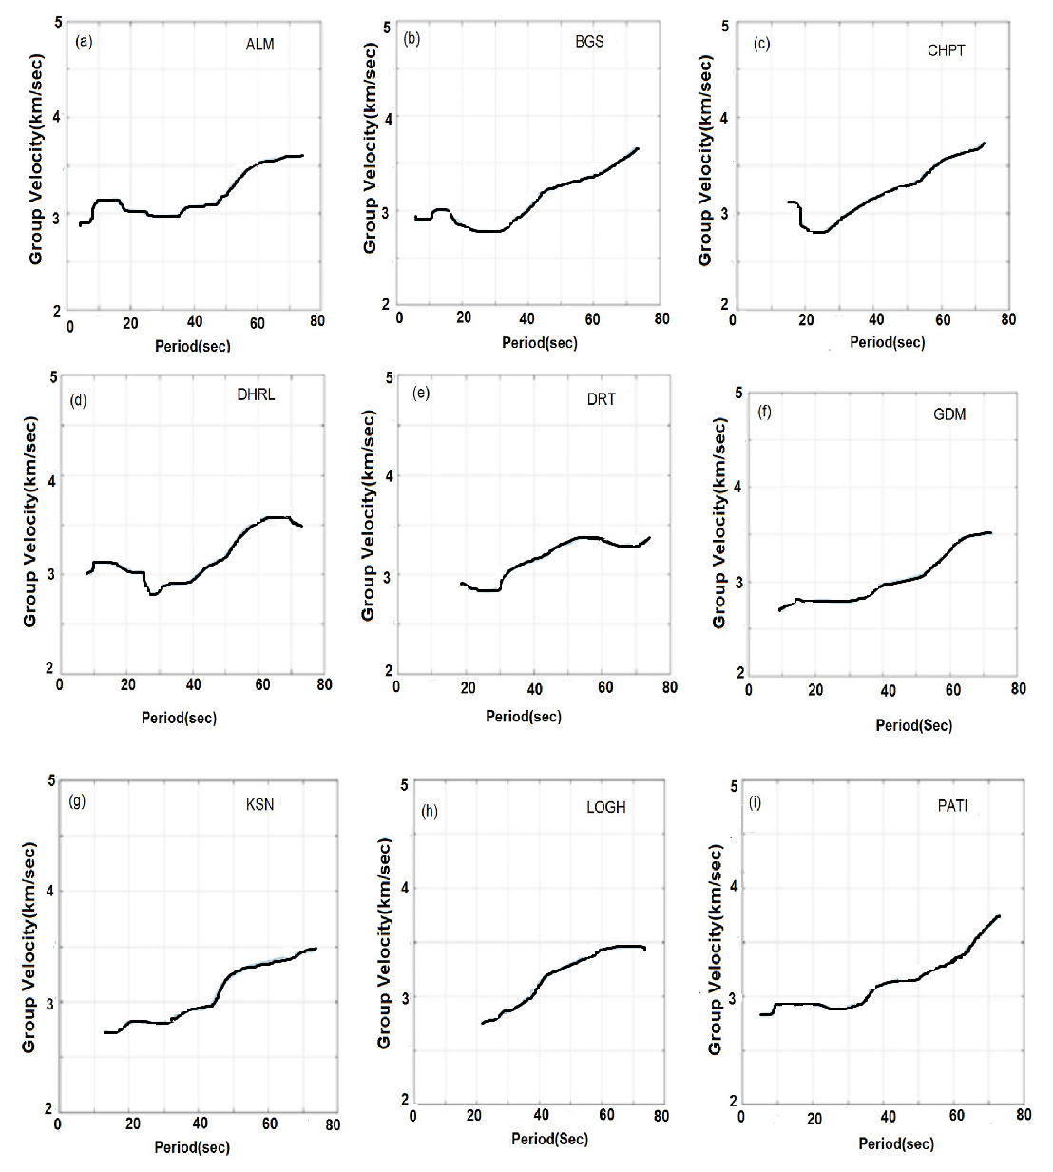
Fig. S1 Fundamental mode group velocity dispersion curves for Rayleigh waves at 9 bb stations in the Uttarakhand Himalaya.

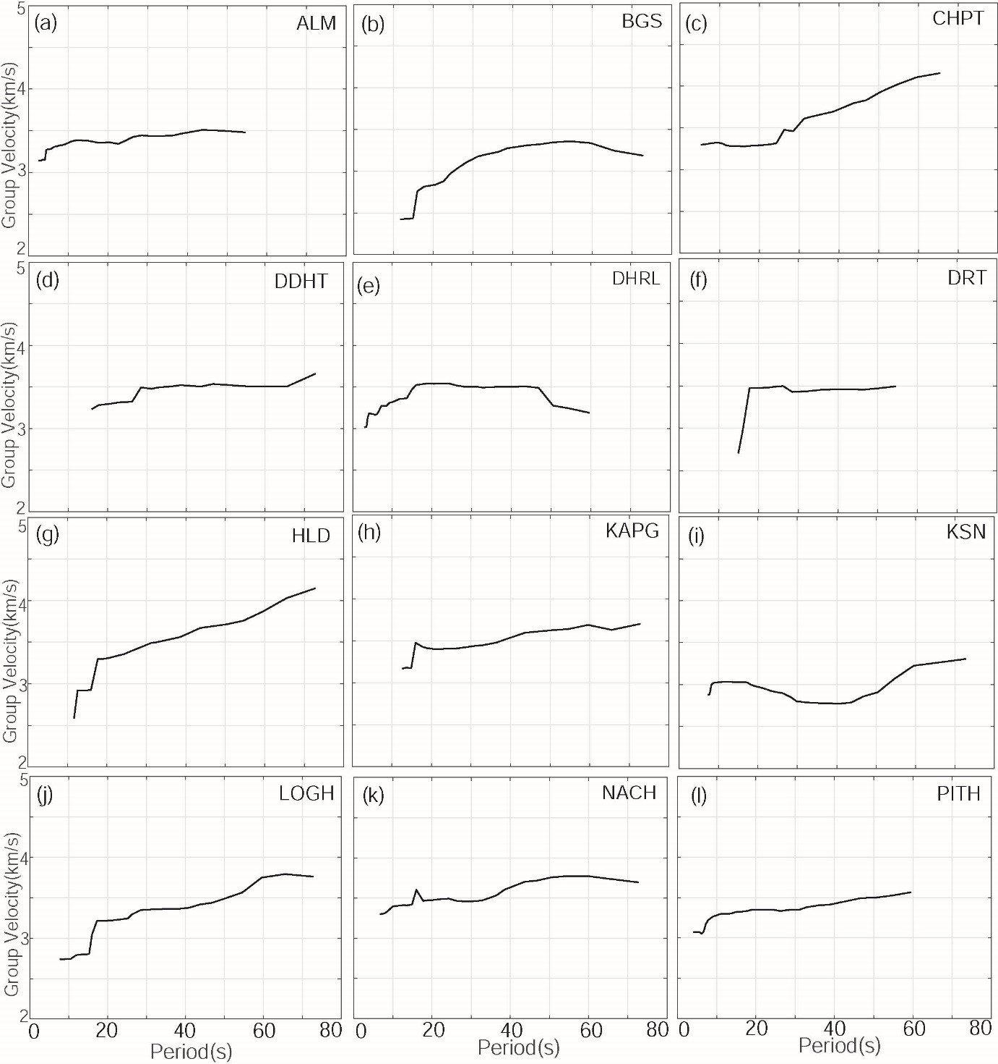

Fig. S2 Fundamental mode group velocity dispersion curves for Love waves at 12 bb stations in the Uttarakhand Himalaya.

