Nature Communications
Supplementary Information

Pioneering the Early Diagnosis of Alzheimer’s Disease: Aβ Oligomers-Sensing Probe for Cerebrospinal Fluid Analysis in Patients
Jusung An,ª Kyeonghwan Kim,^{b,c} Ho Jae Lim,^{d} Jinwoo Shin,ª In Wook Park,^{b,c} Illhwan Cho,^{b,c} Hyeong Yun Kim,^{b} Sunghoon Kim,^{b,e,f,}* YoungSoo Kim,^{b,c,}* Kun Ho Lee^{c,g,h,}* and Jong Seung Kim^{a,i}*

ª Department of Chemistry, Korea University, Seoul 02841, Korea.
^{b} Department of Pharmacy, College of Pharmacy, Yonsei University, Incheon 21983, Korea.
^{c} Yonsei Institute of Pharmaceutical Sciences, College of Pharmacy, Yonsei University, Incheon 21983, Korea.
^{d} Department of Biomedical Science, Chosun University, Gwangju 61452, Korea.
^{e} Medicinal Bioconvergence Research Center, Institute for Artificial Intelligence and Biomedical Research, Gangnam Severance Hospital, Yonsei University, Incheon 21983, Korea.
^{f} College of Pharmacy, College of Medicine, Interdisciplinary Biomedical Center, Gangnam Severance Hospital, Yonsei University, Incheon 21983, Korea.
^{g} Gwangju Alzheimer’s Disease and Related Dementia Cohort Research Center, Chosun University, Gwangju 61452, Korea.
^{h} Department of Neural Development and Disease, Korea Brain Research Institute, Daegu 41062, Korea.
^{i} TheranoChem Co., Ltd, Seoul 02841, Korea.

Corresponding Author
Jong Seung Kim (jongskim@korea.ac.kr)
Kun Ho Lee (leekh@chosun.ac.kr)
YoungSoo Kim (y.kim@yonsei.ac.kr)
Sunghoon Kim (sunghoonkim@yonsei.ac.kr)
Supporting Materials and Methods
General materials and instrumentation for synthetic studies and characterization
All chemical reagents and solvents used for synthesis were purchased from commercial suppliers (Sigma-Aldrich [Merck], Thermo-Fisher, TCI-Korea, Samchun, and Duksan) and used as received. Column chromatography was used with silica gel 100 (Merck) as a stationary phase for purification purposes of all synthetic compounds. To monitor the synthesis progress, thin layer chromatography (TLC) was used with Merck 60 F₂₅₄ (pre-coated sheets, 0.25 mm thick) plates. Moisture-sensitive reactions were carried out under an inert atmosphere (high purity grade Argon gas), and anhydrous solvents were prepared with distilling filters. ¹H and ¹³C nuclear magnetic resonance (NMR) spectral analysis was performed for the characterization of synthesized compounds on a 500 MHz Bruker NMR spectrometer at room temperature using deuterated chloroform-d (CDCl₃) with tetramethylsilane (TMS) as an internal standard (NMR spectra are presented by chemical shifts in ppm values and coupling constants in Hz). Mass spectroscopy (MS) was conducted on a Shimadzu LCMS-2020 electrospray ionization (ESI) mass spectrometer. UV/Vis spectra were recorded on a Jasco V-750 spectrometer, and fluorescence spectra were obtained using a Jasco FP-8500 spectrofluorometer. Circular dichroism (CD) spectra were measured on a Jasco J-1500 spectrometer (Korea Basic Science Institute, KBSI, Ochang, Korea). Time course fluorescence intensity was recorded using a Hidex Sense Microplate Reader with a 96-well black plate (SPL, Korea) and adhesive optical sealing film (Bioneer Inc., Korea). Various organic solvents for photophysical analysis were used with HPLC-grade solvents purchased from J. T. Baker. Aβ_{1–42} was prepared by synthesizing and purchasing HFIP-pretreated Aβ_{1–42} (Human) peptides (purity = 95.47%), and Aβ_{1–40} was prepared by purchasing HFIP-pretreated Aβ_{1–40} (Human) peptides (purity > 95%) from GenicBio Synthetic Peptide (Shanghai, China).

Compound synthesis
Synthesis of 1. A pressure seal tube was equipped with 2-chloro-6-bromoquinoline and Me₂NH [2 M in tetrahydrofuran (THF), 11 mL, 22 mmol] and stirred at 90°C for 40 h. The reaction mixture was cooled down to room temperature, subsequently quenched with H₂O and concentrated under reduced pressure. The residue was extracted using ethyl acetate (3 × 100 mL), washed with brine, and the organic layer was dried over anhydrous Na₂SO₄, filtered, and concentrated in vacuo. The crude was purified by silica gel column chromatography (ethyl acetate/hexane, 1:9) to afford compound 1 (yield: 89%). ¹H NMR (500 MHz, CDCl₃) δ 7.58 (m, J = 1.3 Hz, 1H), 7.54 (d, J = 9.1 Hz, 1H), 7.51 (d, J = 1.5 Hz, 2H), 3.09 (s, 6H) ppm. ¹³C NMR (125 MHz, CDCl₃) δ 157.55, 146.92, 136.01, 132.40, 129.25, 128.15, 123.61, 114.09, 109.79, 37.96 ppm.
Synthesis of 2. To a solution of compound 1 (0.50 g, 2.0 mmol) in anhydrous THF (5 mL) at −78°C under argon atmosphere was added n-butyl lithium (2.5 M in hexanes, 0.96 mL, 2.39 mmol). After the mixture was stirred for 30 min, N,N-dimethylformamide (DMF) was added, and the mixture was stirred for a further 2 h at 0°C. The reaction mixture was quenched by the dropwise addition of saturated NH₄Cl solution (10 mL) over 10 min. Next, the reaction mixture was extracted with ethyl acetate (3 × 100 mL), and the combined organic layers were dried over anhydrous Na₂SO₄, filtered, and concentrated under reduced pressure. The residue was purified by silica gel column chromatography (ethyl acetate/hexane, 1:3) to afford compound 2 (yield: 82%). ¹H NMR (500 MHz, CDCl₃) δ 10.01 (s, 1H), 8.07 (d, J = 1.9 Hz, 1H), 8.00 (dd, J = 8.7, 1.9 Hz, 1H), 7.94 (d, J = 9.1 Hz, 1H), 7.71 (d, J = 8.7 Hz, 1H), 6.94 (d, J = 9.2 Hz, 1H), 3.28 (s, 6H) ppm. ¹³C NMR (125 MHz, CDCl₃) δ 191.29, 158.80, 152.11, 138.12, 133.22, 130.08, 127.57, 127.06, 121.44, 109.86, 37.96 ppm.
Synthesis of Q-OB. To a solution of 6-methylheptane-2,4-dione (0.041 mL, 0.26 mmol) in anhydrous DMF (0.5 mL) at 65°C under argon atmosphere was added boron trifluoride etherate (0.049 mL, 0.40 mmol). After the reaction mixture was stirred for 30 min, compound 2 (50 mg, 0.26 mmol), tributyl borate (0.14 mL, 0.53 mmol), and n-BuNH₂ (20 mol %) were added and then stirred at 90°C for 4 h. The reaction mixture was cooled down to room temperature, and all solvents were removed in vacuo. The residue was purified by silica gel column chromatography (ethyl acetate/hexane, 1:2) to afford compound Q-OB (yield: 46%). ¹H NMR (500 MHz, CDCl₃) δ 8.17 (d, J = 15.4 Hz, 1H), 7.86 (d, J = 9.2 Hz, 1H), 7.79 – 7.75 (m, 2H), 7.65 (d, J = 9.4 Hz, 1H), 6.91 (d, J = 9.2 Hz, 1H), 6.63 (d, J = 15.4 Hz, 1H), 5.95 (s, 1H), 3.27 (s, 6H), 2.40 (d, J = 7.2 Hz, 2H), 2.30–2.15 (sept, 1H), 1.01 (d, J = 6.6 Hz, 6H) ppm. ¹³C NMR (125 MHz, CDCl₃) δ 192.78, 180.54, 158.53, 150.99, 148.85, 137.80, 132.15, 127.78, 127.40, 127.05, 122.17, 117.48, 109.90, 101.41, 46.60, 38.06, 27.27, 22.51 ppm. ESI-MS: C₂₀H₂₃BF₂N₂O₂ [M+H]⁺, m/z calcd 373.2246, found 373.15; [M–H]–, m/z calcd 371.2092, found 371.05; [M–BF₂+H]⁺ m/z calcd 325.4242, found 325.10.

Quantum yield and determination of fluorescence emission and wavelength maxima
To avoid the inner filter effect during the measurement of fluorescence emission, the spectra were recorded with an absorbance lower than 0.1 at wavelengths longer or equal to the excitation wavelength with HPLC grade solvents, including 1,2-dichlorobenzene, 1-butanol, 1-propanol, 2-methoxy ethanol, acetone, acetonitrile, chloroform, diethyl ether, ethyl acetate, ethylene glycol dimethyl ether, ethanol, methanol, THF, or toluene). The fluorescence quantum yield of Q-OB was measured versus 4-(Dicyanomethylene)-2-methyl-6-(4-dimethylaminostyryl)-4H-pyran (DCM) in acetonitrile (Ф_{Fl} = 0.43)¹, using a previously reported procedure².

Spectroscopy in a solvent with increasing viscosity
The fluorescence emission spectra of Q-OB and Thioflavin T (ThT) (10 μM) in the various v/v % of ethylene glycol and glycerol (30, 50, 60, 70, and 80% of glycerol in ethylene glycol) at 25°C were recorded. Q-OB and ThT stock solutions were prepared in dimethyl sulfoxide (DMSO), respectively, and all solutions contained a final concentration of 1% DMSO.

Solubility of Q-OB in aqueous solution
The absorbance of Q-OB was recorded at 460 nm in phosphate buffered saline (PBS) (10 mM, pH = 7.4) containing 1% DMSO at various concentrations in the 0$-$50 μM range.

pH dependent absorbance of Q-OB
The absorbance and fluorescence spectra of Q-OB (10 μM) were recorded in deionized water (DW) containing 1% DMSO with the pH adjusted by hydrochloric acid or sodium hydroxide to the pH 1 to 11.

Photostability
A solution of Q-OB with an absorbance of 1.0 at the maximum absorbance wavelength was prepared in DMSO and 1% DMSO/PBS (10 mM, pH = 7.4). A 3100 K halogen lamp (Olympus LG-PS2; 12 V, 100 W) was used for light irradiation (irradiation distance = 30 cm), and the absorbance was recorded at 1 h intervals for 12 h.

Theoretical calculations
Density functional theory (DFT) calculations were performed using the Gaussian 16 software package³. The structures of Q-OB were optimized using the ωB97XD functional at the N07D level of theory, with the default IEFPCM solvation model of acetonitrile^{4,5}. The molecular orbital was visualized using Gaussview 6.1. To determine the amount of intramolecular charge transfer (ICT) character upon vertical excitation to the first excited state, a calculation based on the differences in electron density was used⁶, and results were analyzed using Multiwfn 3.8⁷. For these calculations, the molecular structure was recalculated at the CAM-B3LYP/N07D level of theory⁸, using the IEFPCM model of water, and time-dependent density functional theory (TDDFT) vertical excitations were performed using the same solvation model, and the optimized structure of the ground state.

Circular dichroism spectroscopy
CD measurements of Aβ_{1–42} species were conducted in PBS (10 mM, pH = 7.4). The concentration of the protein sample was 10 μM and the CD spectra were measured from 200 to 260 nm using a 1 mm path length quartz cuvette with a spectral bandwidth of 1 nm, a signal averaging time of 1 s, and a data interval of 0.5 nm at 37°C. The spectra presented are the average of three measurements and corrected using a control solution lacking Aβ.

Aβ_{1–40} in vitro kinetics assay
Prepared 46.2 mL Aβ_{1–40} DMSO stock solution (5 mM) was diluted with 4.6 mL PBS (20 mM, pH = 7.4) (working concentration was 50 μM of Aβ_{1–40} containing 1% DMSO). Eight set of the diluted solution was incubated at an orbital shaker (37°C, 300 rpm), and 2970 μL was collected every 12 h for 7 days. 30 μL of Q-OB DMSO solution (100 μM) (or 1 mM of ThT DMSO solution) was added to the collected PBS, and fluorescence spectra were measured (λ_{ex} = 460 nm for Q-OB and λ_{ex} = 440 nm for ThT, respectively) (slit 2.5/2.5, n = 3).

Thioflavin T assay
To examine the aggregation of Aβ_{1–42}, a ThT assay was conducted. ThT was dissolved in 50 mM glycine buffer (pH 8.5). For the assay, 25 μL of the aforementioned Aβ_{1–42} solution was seeded on the 96-half-well black plate, and 75 μL of 5 μM ThT solution was added. After shaking, fluorescence intensity was measured at λ_{ex}/λ_{em} = 450/480 nm with a microplate reader.

Parallel artificial membrane permeability assay
Parallel artificial membrane permeability assay (PAMPA)-blood-brain barrier (BBB) studies were performed using the PAMPA-BBB kit (BioAssay Systems, PAMPA-096) according to the manufacturer’s instructions. 5 mM of the Q-OB and controls stock solutions were prepared in DMSO, which were then diluted with PBS (10 mM, pH = 7.4) to a final concentration of 250 µM. The mimics cell membranes on each donor plate well were coated by adding 5 μL of the 4% Lecithin. Then, 200 µL of the Q-OB and controls were added to each well of the donor plate (n = 2), and each well of the acceptor plate was filled with 300 µL of PBS. The donor plate was placed on the acceptor plate to form a sandwich, and in separate tubes prepared equilibrium standards for Q-OB and controls; the sandwich and equilibrium standards were incubated at 37°C for 18 h without stirring. 100 μL of equilibrium standard, acceptor, and donor solutions were transferred to UV plates, and the absorbance spectrum of the solutions was measured from 200 nm to 500 nm in 10 nm intervals using a plate reader (SpectraMax M2e). Effective permeability (Pe) for samples was calculated using the data analysis equation specified in the manufacturer’s instructions of BioAssay Systems. High permeability control (promazine hydrochloride), medium permeability control (clonidine), and low permeability control (diclofenac) were utilized as positive controls and negative controls for this assay. Based on their measured effective permeability –log P_{e}, compounds are categorized as either BBB permeable (CNS+) or BBB impermeable (CNS–). Compounds were classified as CNS+ if their –log P_{e} value is below the low permeability control –log P_{e} value.

Organ distribution ex vivo imaging
To observe the distribution of Q-OB in mice, 200 μL Q-OB was intravenously injected to 2-month-old wild-type B6 mice. After 1 h, isoflurane was given to the mice through inhalation, and they were then sacrificed after being fully anesthetized. Their brain, liver, heart, and kidneys were extracted and washed with saline to remove blood from the surfaces. The prepared organs were located on the stage in the IVIS® Spectrum In Vivo Imaging System (Perkin-Elmer, USA) and fluorescence intensity was measured (λ_{ex}/λ_{em} = 500/620 nm).

Supporting Tables and Figures
Table S1. Reported small molecule probes for amyloid beta oligomers.
Probe name | Chemical structure | Max. λ_{abs}/λ_{em} (nm) | K_{d} (nmol/L) for Aβ species | I_{oAβ}/  I_{mAβ} | I_{oAβ}/  I_{iAβ} | Target oligomer | Potential clinical application | ref.
BD-Oligo | 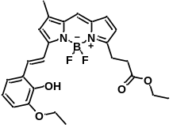 | 530/585 | 480 (Aβ₄₀ oligomer) | ~4.0-folds | ~2.6-folds | Aβ₄₀ Trimer (putative) | - | 9
CRANAD-3 | 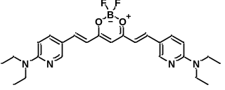 | 600/730 | 23 $±$ 5.7 (Aβ₄₀ monomer);  21 $±$ 2.3 (Aβ₄₀ fibril);  24 $±$ 1.6 (Aβ₄₂ monomer);  16 $±$ 6.7 (Aβ₄₂ dimer);  27 $±$ 15.8 (Aβ₄₂ oligomer) | ~0.55-folds | ~0.88-folds | undefined Aβ₄₂ oligomer | - | 10
CRANAD-58 | 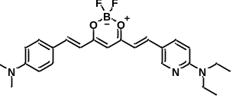 | ~630/  ~700 | 105.8 (Aβ₄₀ fibril);  45.8 (Aβ₄₂ fibril) | n.d. | n.d. | Aβ₄₀ dimer and undefined oligomer | - | 11
CRANAD-102 | 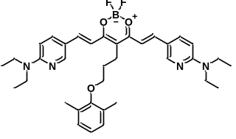 | ~580/  ~750 | 7.5 $±$ 10.0  (Aβ₄₂ oligomer);  505.9 $±$ 275.9  (Aβ₄₂ fibril); | ~0.66-folds | 1.2-folds | Aβ₄₂ dimer and undefined oligomer | - | 12
F-CRANAD-101 | 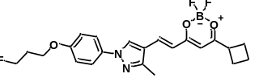 | ~420/  ~550 | 592.3 $±$ 123.2  (Aβ₄₂ oligomer)  188.5 $±$ 104.4  (Aβ₄₂ fibril) | ~2.1-folds | n.d. | Aβ₄₂ dimer and undefined Aβ₄₂ oligomer | PET imaging | 13
PTO-29 | 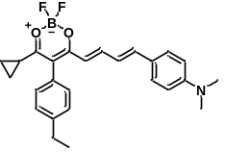 | 570/660 | 2703 $±$ 639  (Aβ₄₂ oligomer)  248 $±$ 48  (Aβ₄₂ fibril); | ~4.2-folds | ~3.8-folds | Aβ₄₂ Trimer (putative) | - | 14
AD-1 | 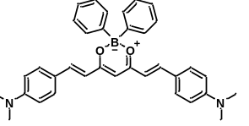 | 550/  ~650 | 1040 $±$ 335.2  (Aβ₄₂ monomer);  769.4 $±$ 221.5  (Aβ₄₂ oligomer);  356.1 $±$ 112.7  (Aβ₄₂ fibril) | ~1.1-folds | ~2.0-folds | Aβ₄₂ Trimer (putative) | - | 15
AN-SP | 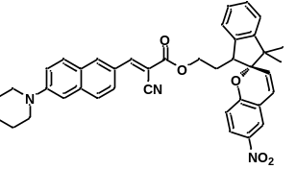 | 430/557 | 1700 (Aβ₄₂ oligomer) | ~3.8-folds | ~10.1-folds | undefined Aβ₄₂ oligomer | - | 16
F-SLOH | 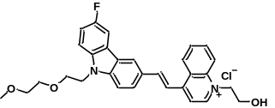 | 488/620 | 3220 (Aβ₄₀ monomer);  660 (Aβ₄₀ oligomer);  1900 (Aβ₄₀ fibril) | ~5.0-folds | ~2.5-folds | Aβ₄₀ Trimer (putative) | - | 17
DCM-AN | 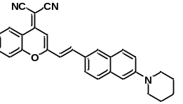 | ~500/  ~650 | 850 (Aβ₄₂ oligomer) | ~3.7-folds | ~3.7-folds | Aβ₄₂ Trimer (putative) | - | 18
Eth-BF | 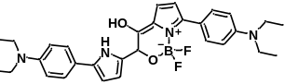 | 850/  1015 | 6.16 $±$ 2.18  (Aβ₄₂ oligomer);  58.68 $±$ 36.2 (Aβ₄₂ fibril) | n.d. | ~2.6-folds | Aβ₄₂ Trimer | - | 19
Aza-BODIPY | 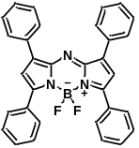 | ~600/  ~670 | n.d. | n.d. | ~2.6-folds | undefined Aβ₄₂ oligomer | - | 20
LS-4 | 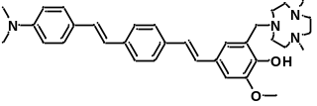 | ~380/  ~475 | 50 $±$ 9 (Aβ₄₂ oligomer);  58 $±$15 (Aβ₄₂ fibril) | n.d. | ~2.0-folds | Aβ₄₂ oligomer embedded in a lipid bilayer (putative) | PET imaging | 21
Q-OB | 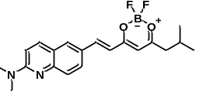 | 460/580 | 4745.18 $±$ 722.36  (Aβ₄₂ monomer);  302.63 $±$ 94.75  (Aβ₄₂ oligomer);  5667.33 $±$ 1801.53  (Aβ₄₂ aggregate) | 4.38-folds | 2.51-folds | 100 kDa over Aβ₄₂ oligomers | In vitro early AD diagnosis & PET imaging | -
Data were obtained from the reported references. The abbreviated words are amyloid-β (Aβ), Aβ monomers (mAβ), Aβ oligomers (oAβ), insoluble Aβ fibril (iAβ), Alzheimer’s disease (AD), positron emission tomography (PET), and K_{d} value indicates dissociation constant. Not available data marked as n.d. Additional information is available in the reported article²².

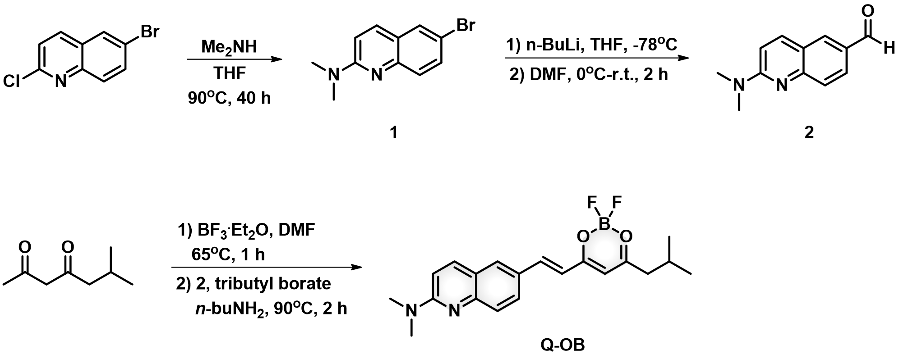

Scheme S1. Synthetic route for compound 1, 2, and Q-OB.

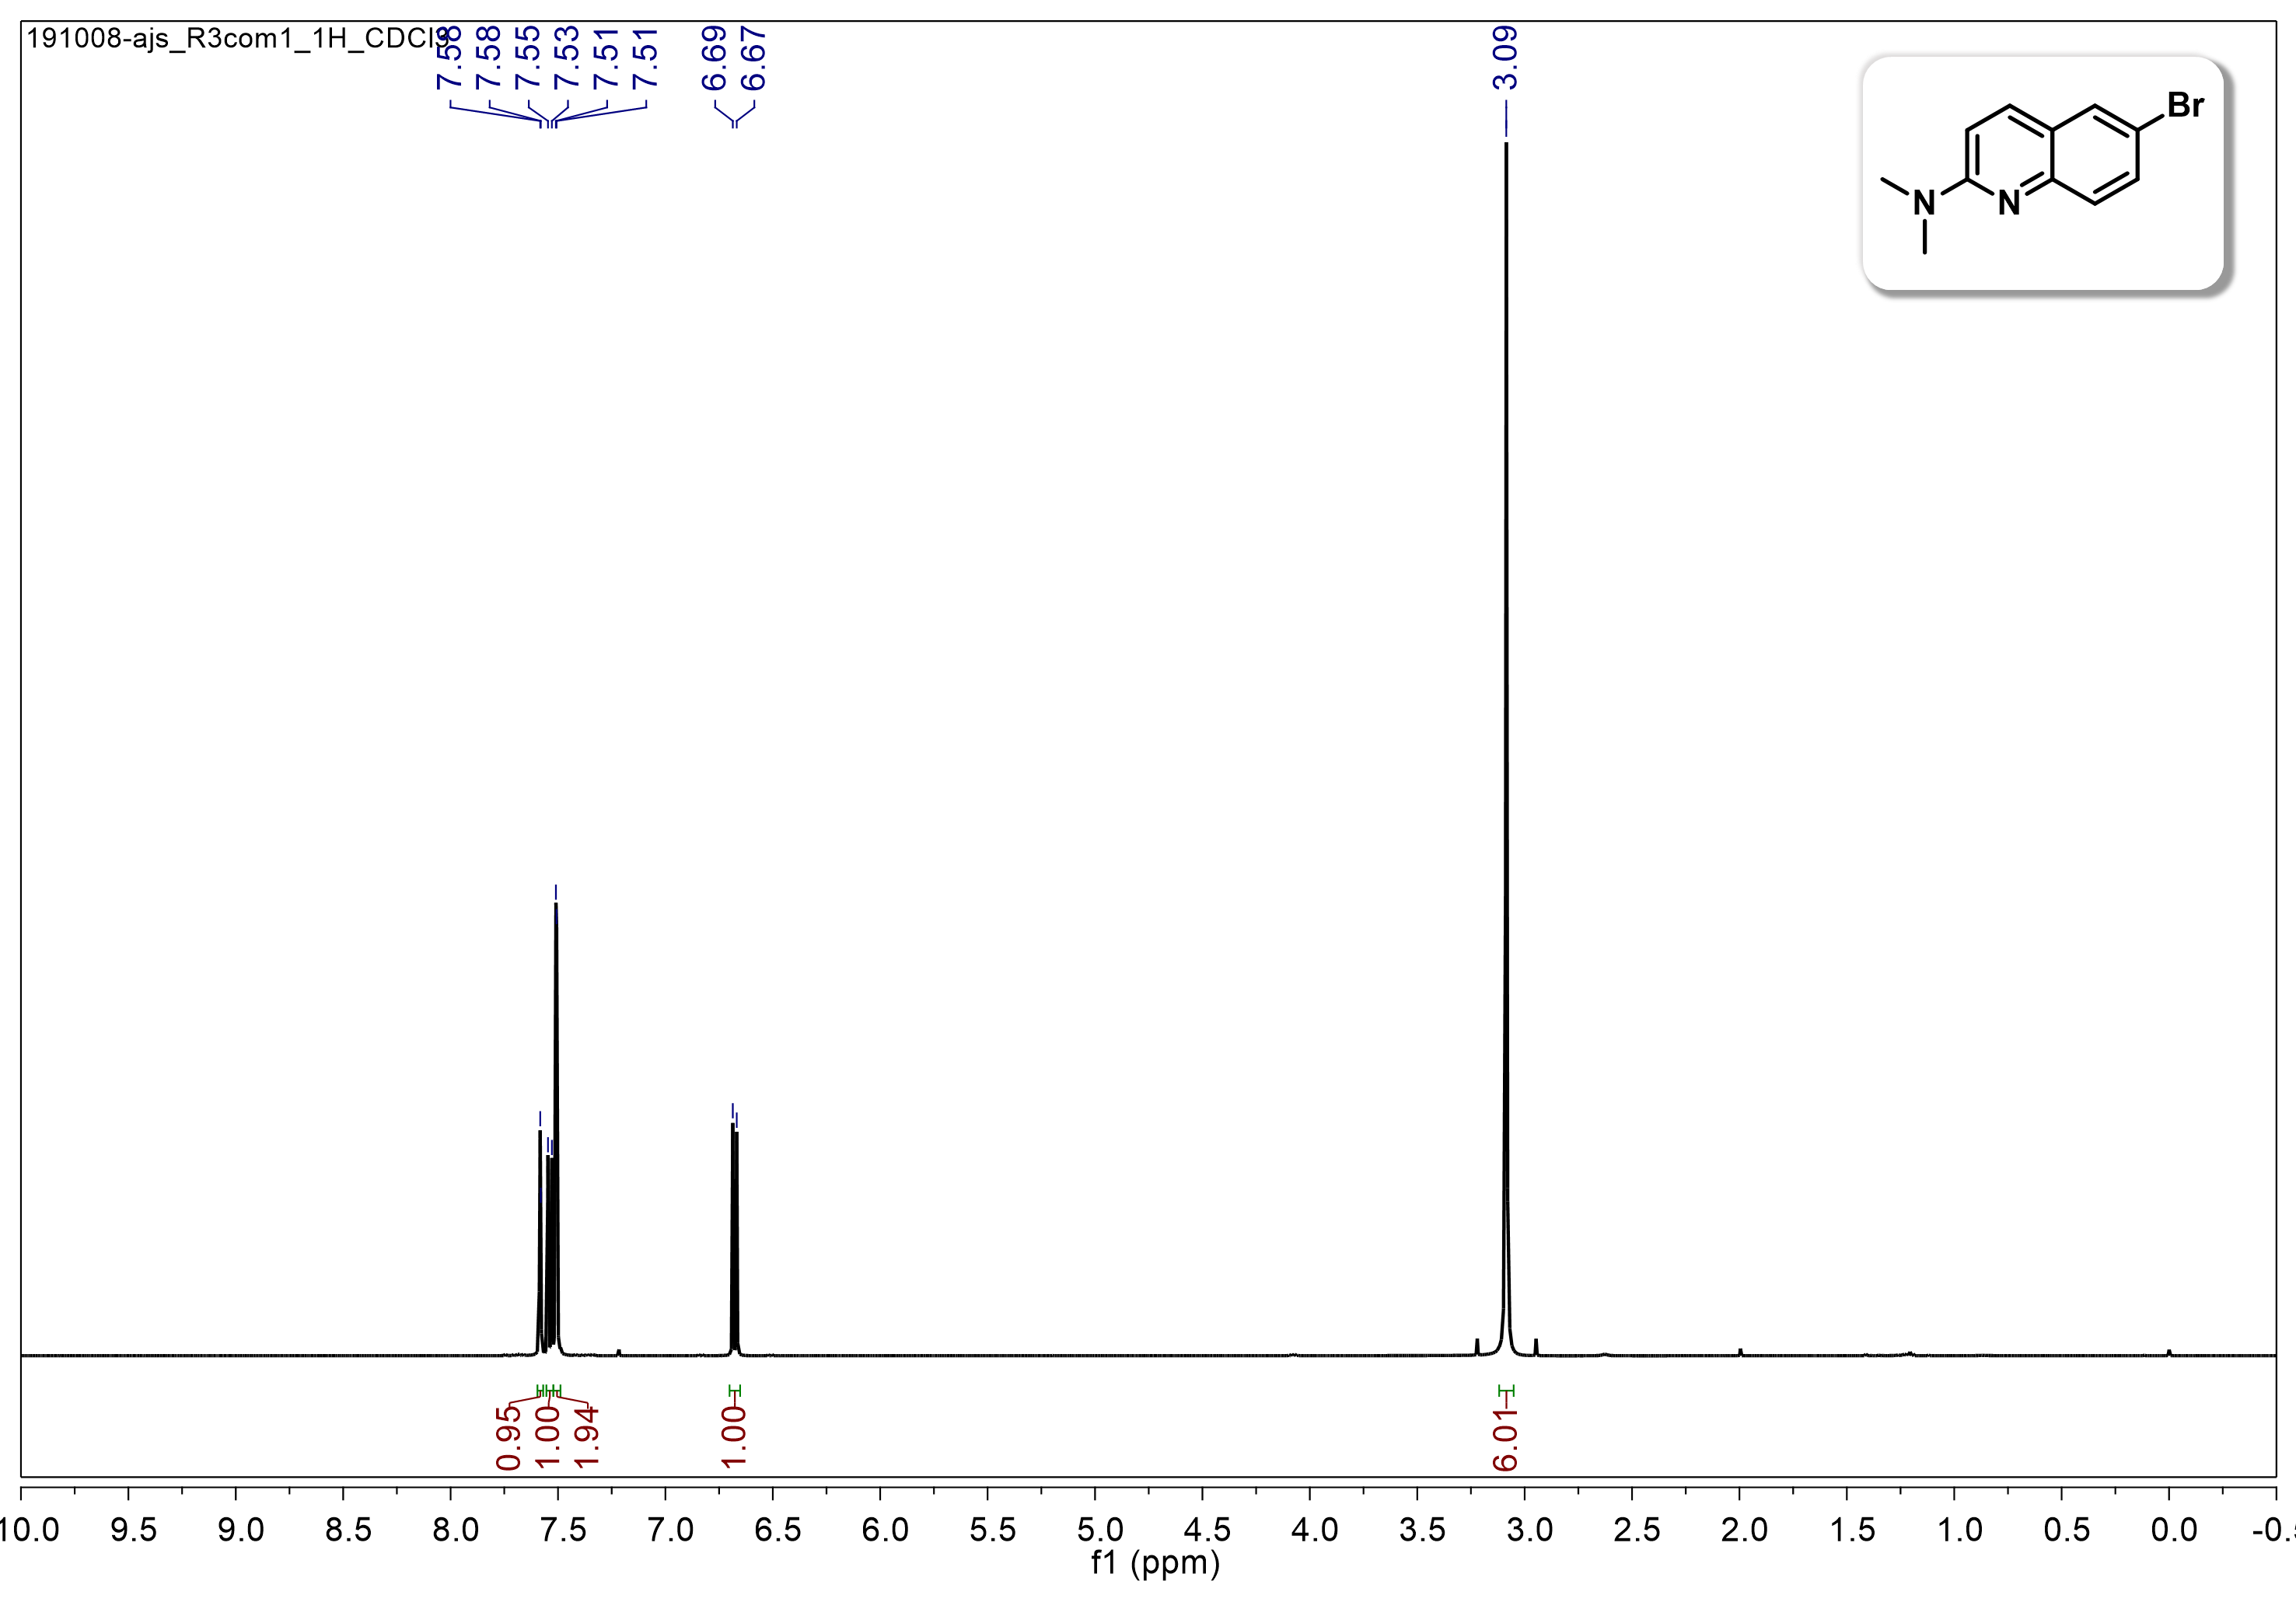
Figure S1. ¹H NMR spectrum (500 MHz) of compound 1 in CDCl₃.
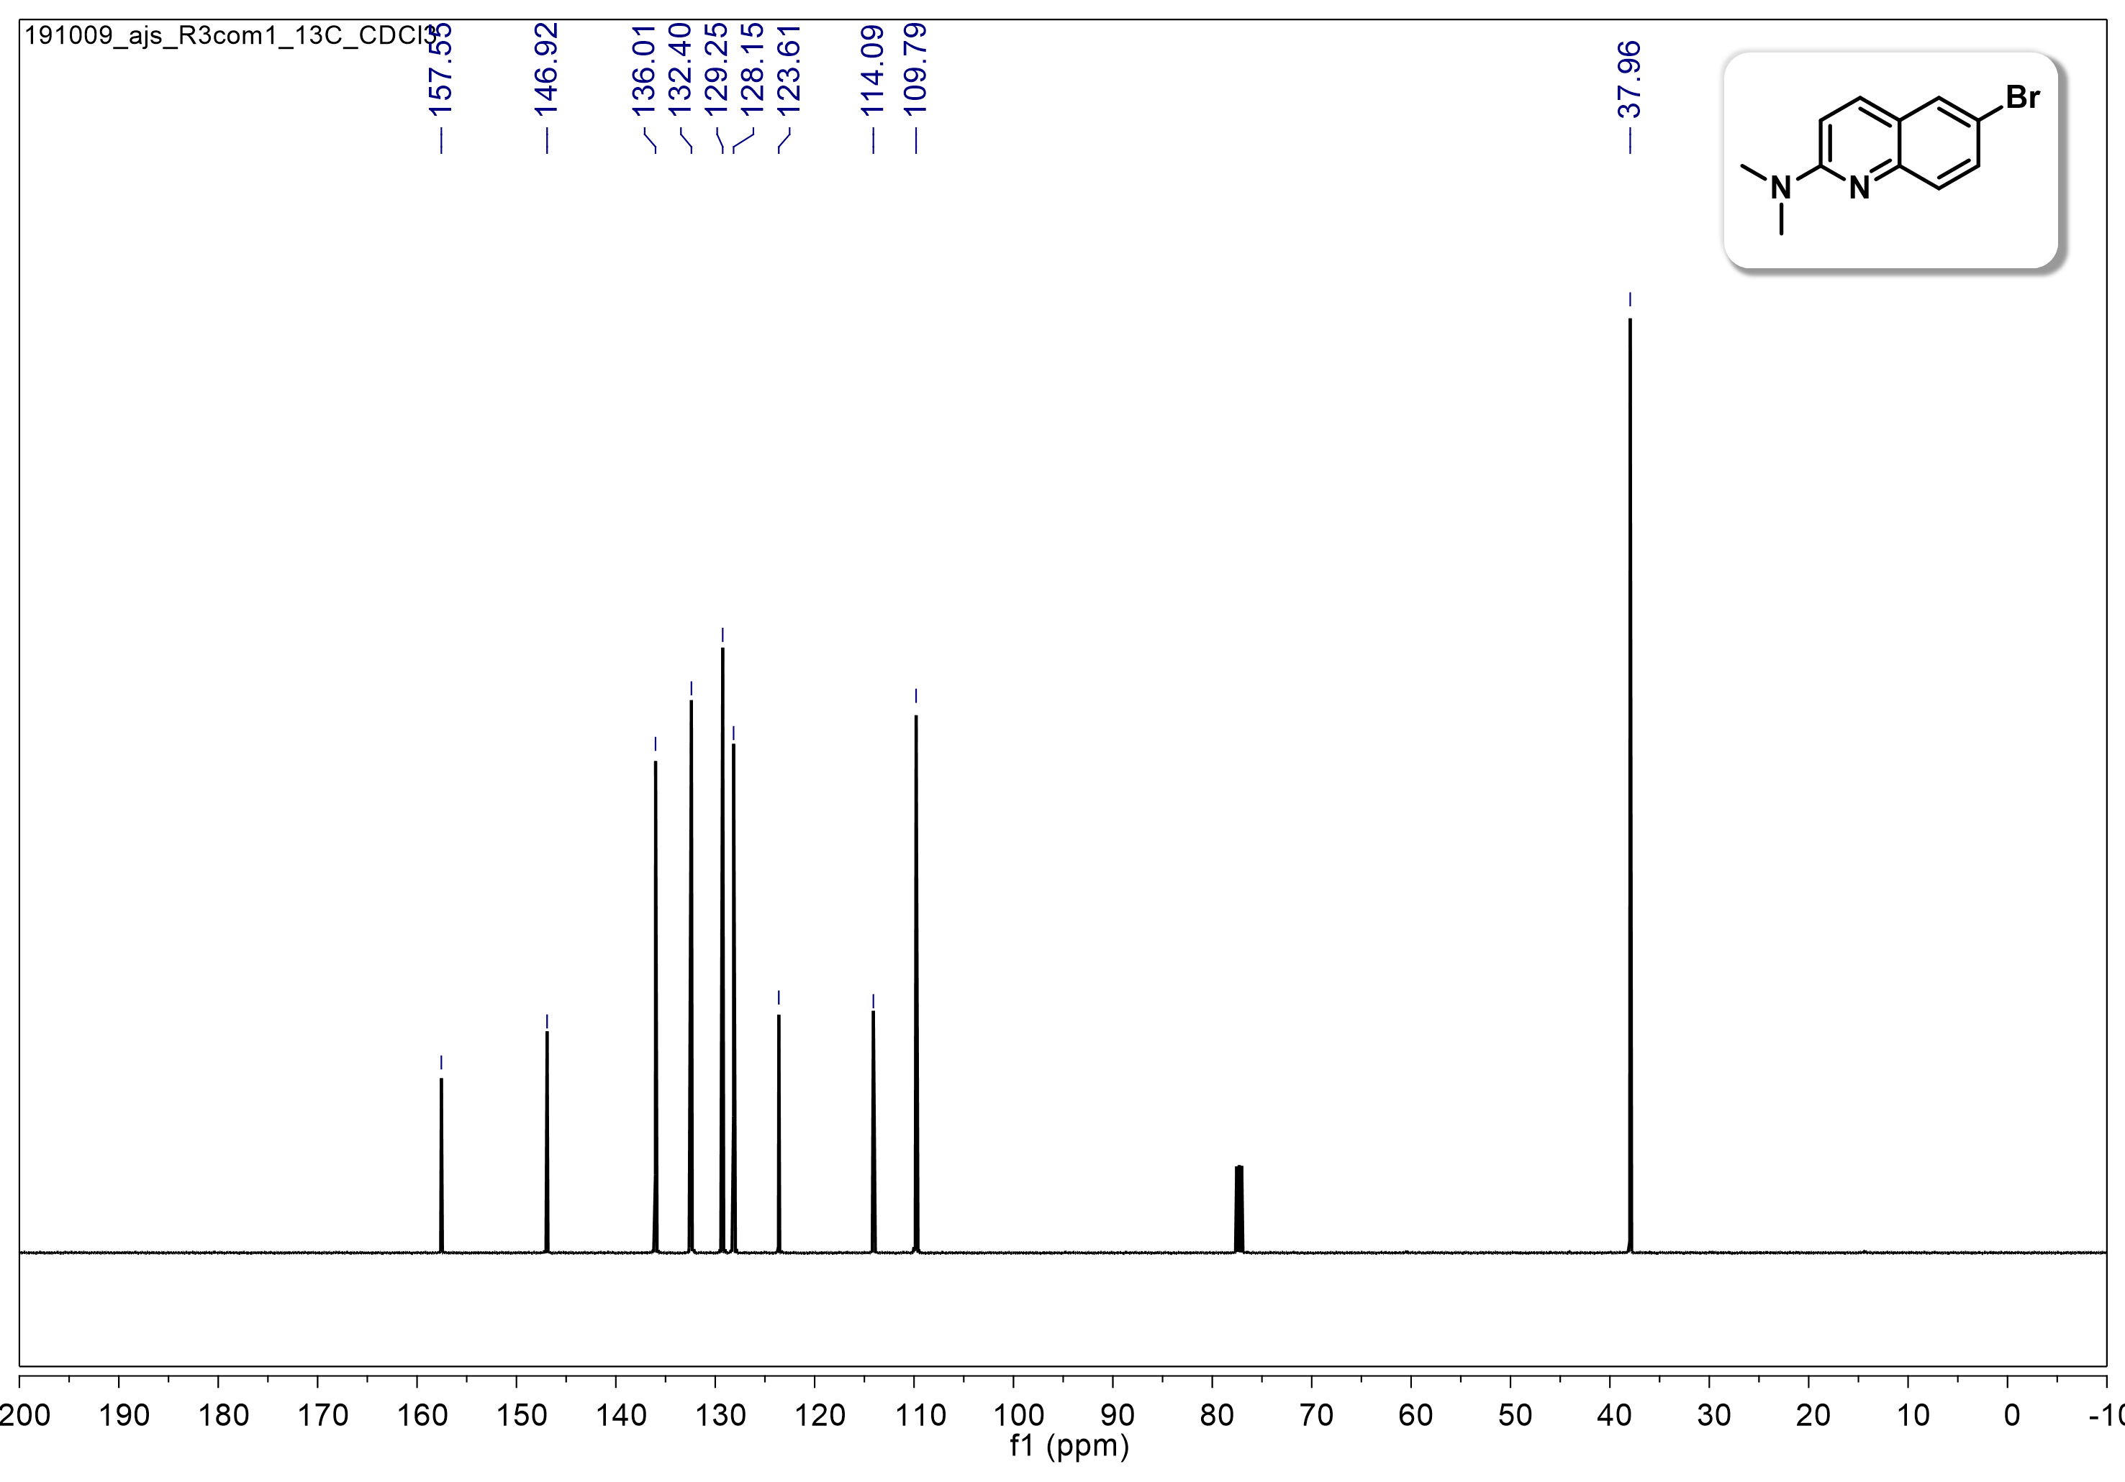
Figure S2. ¹³C NMR spectrum (125 MHz) of compound 1 in CDCl₃.

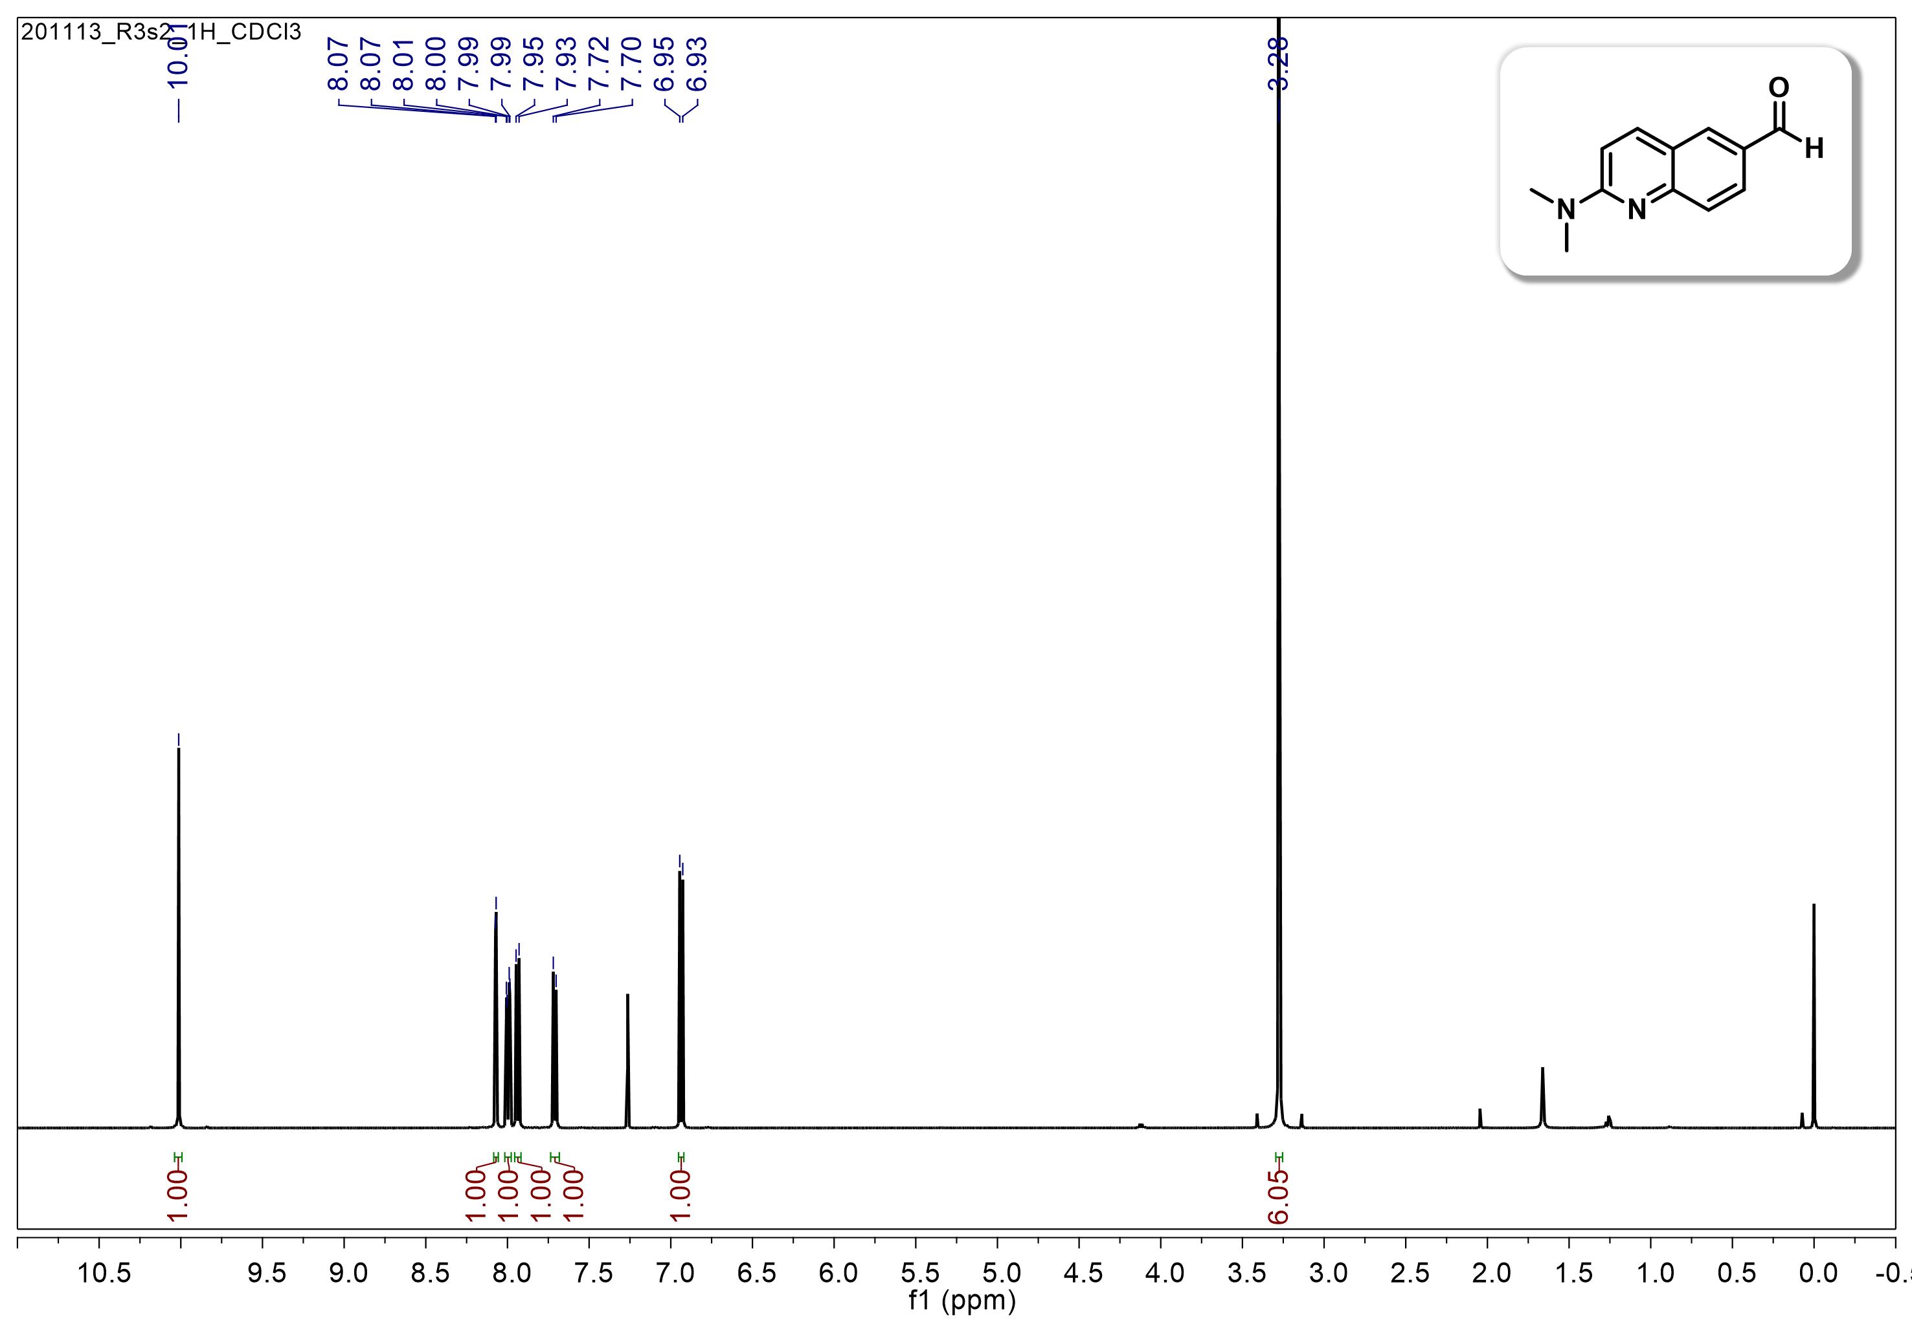
Figure S3. ¹H NMR spectrum (500 MHz) of compound 2 in CDCl₃.
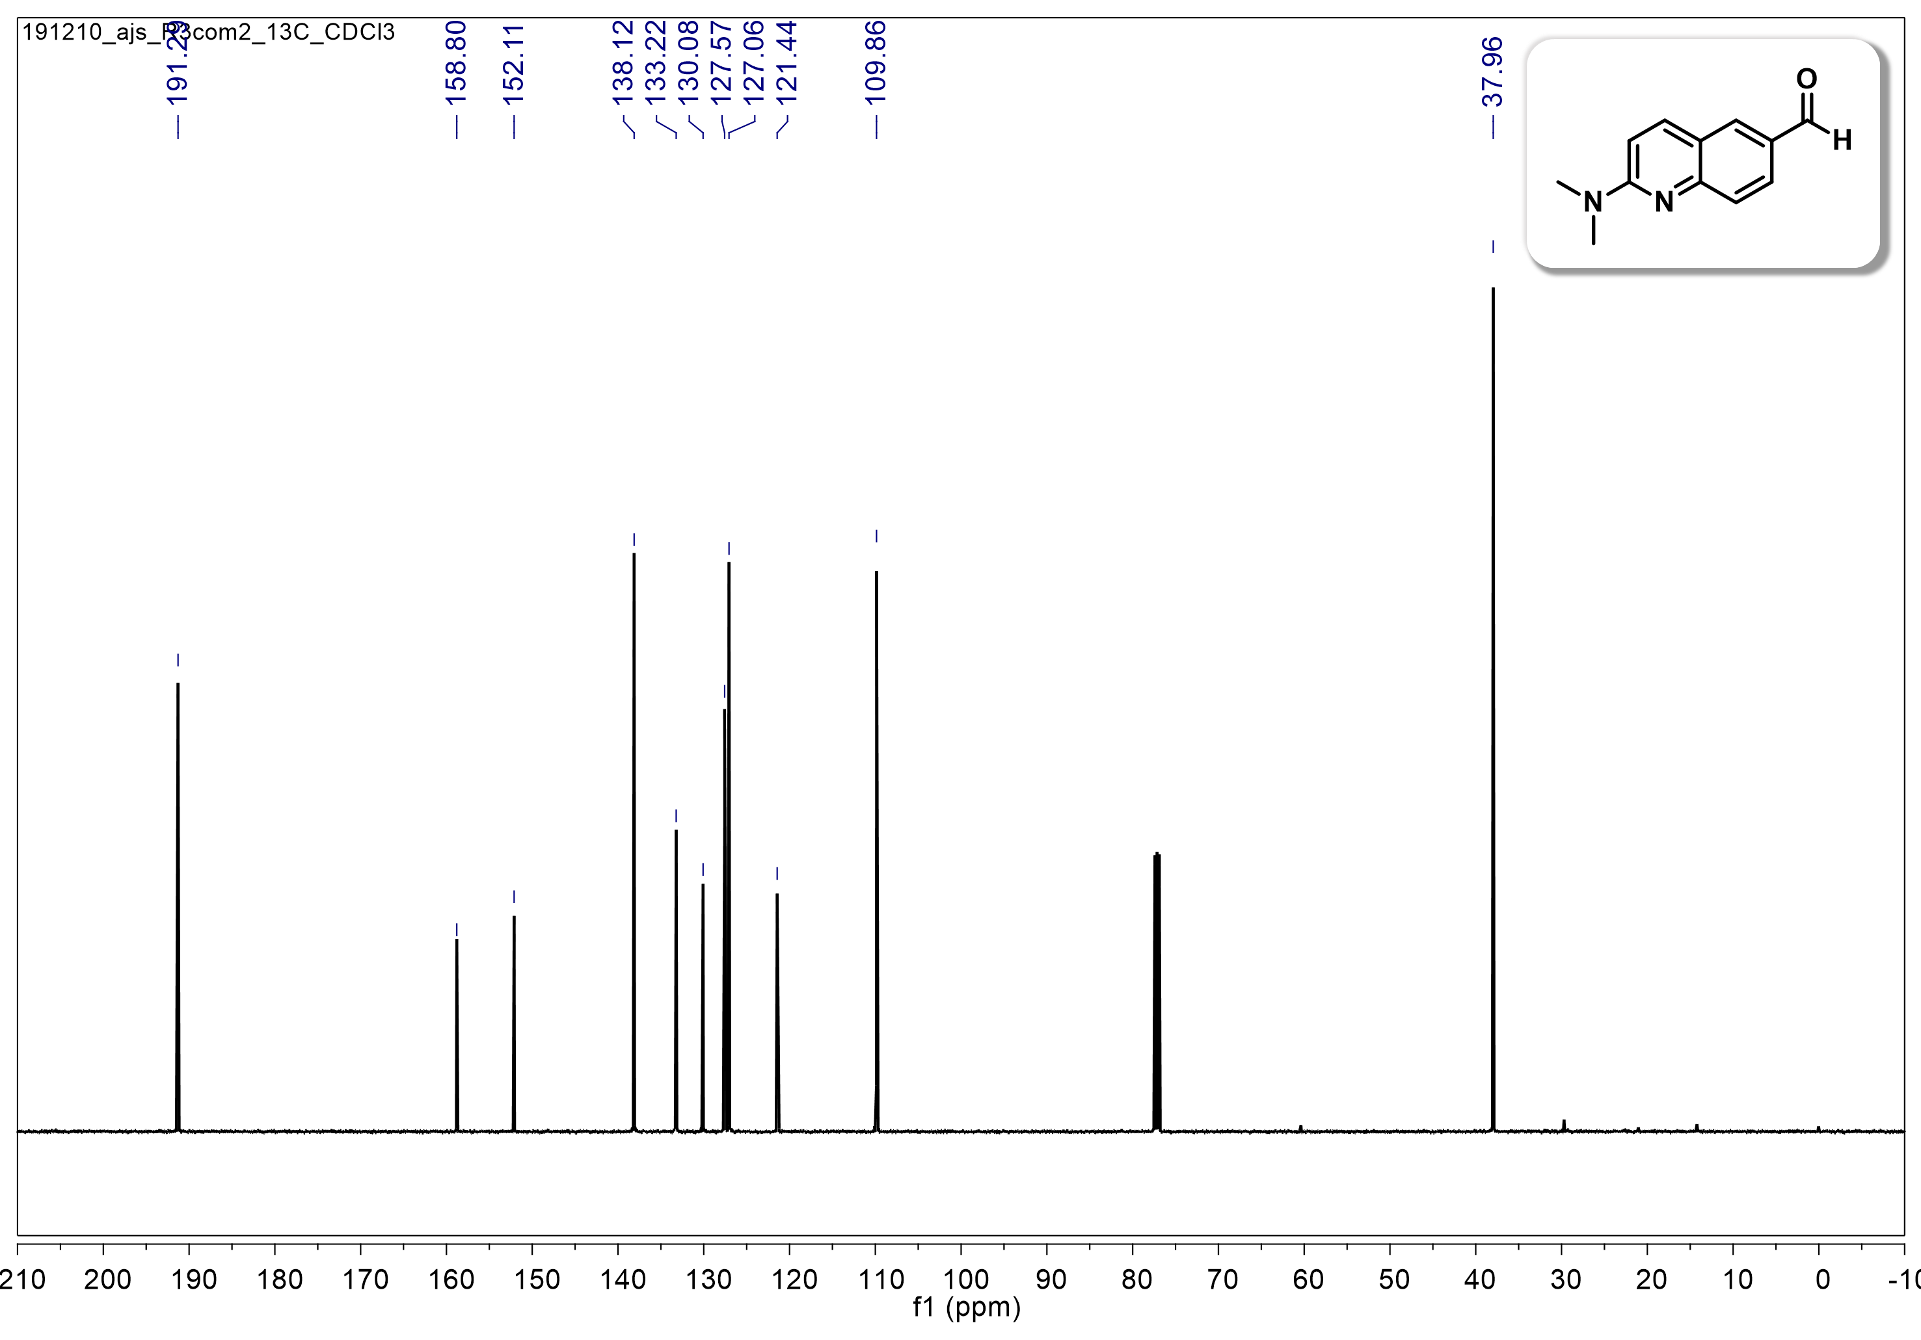
Figure S4. ¹³C NMR spectrum (125 MHz) of compound 2 in CDCl₃.

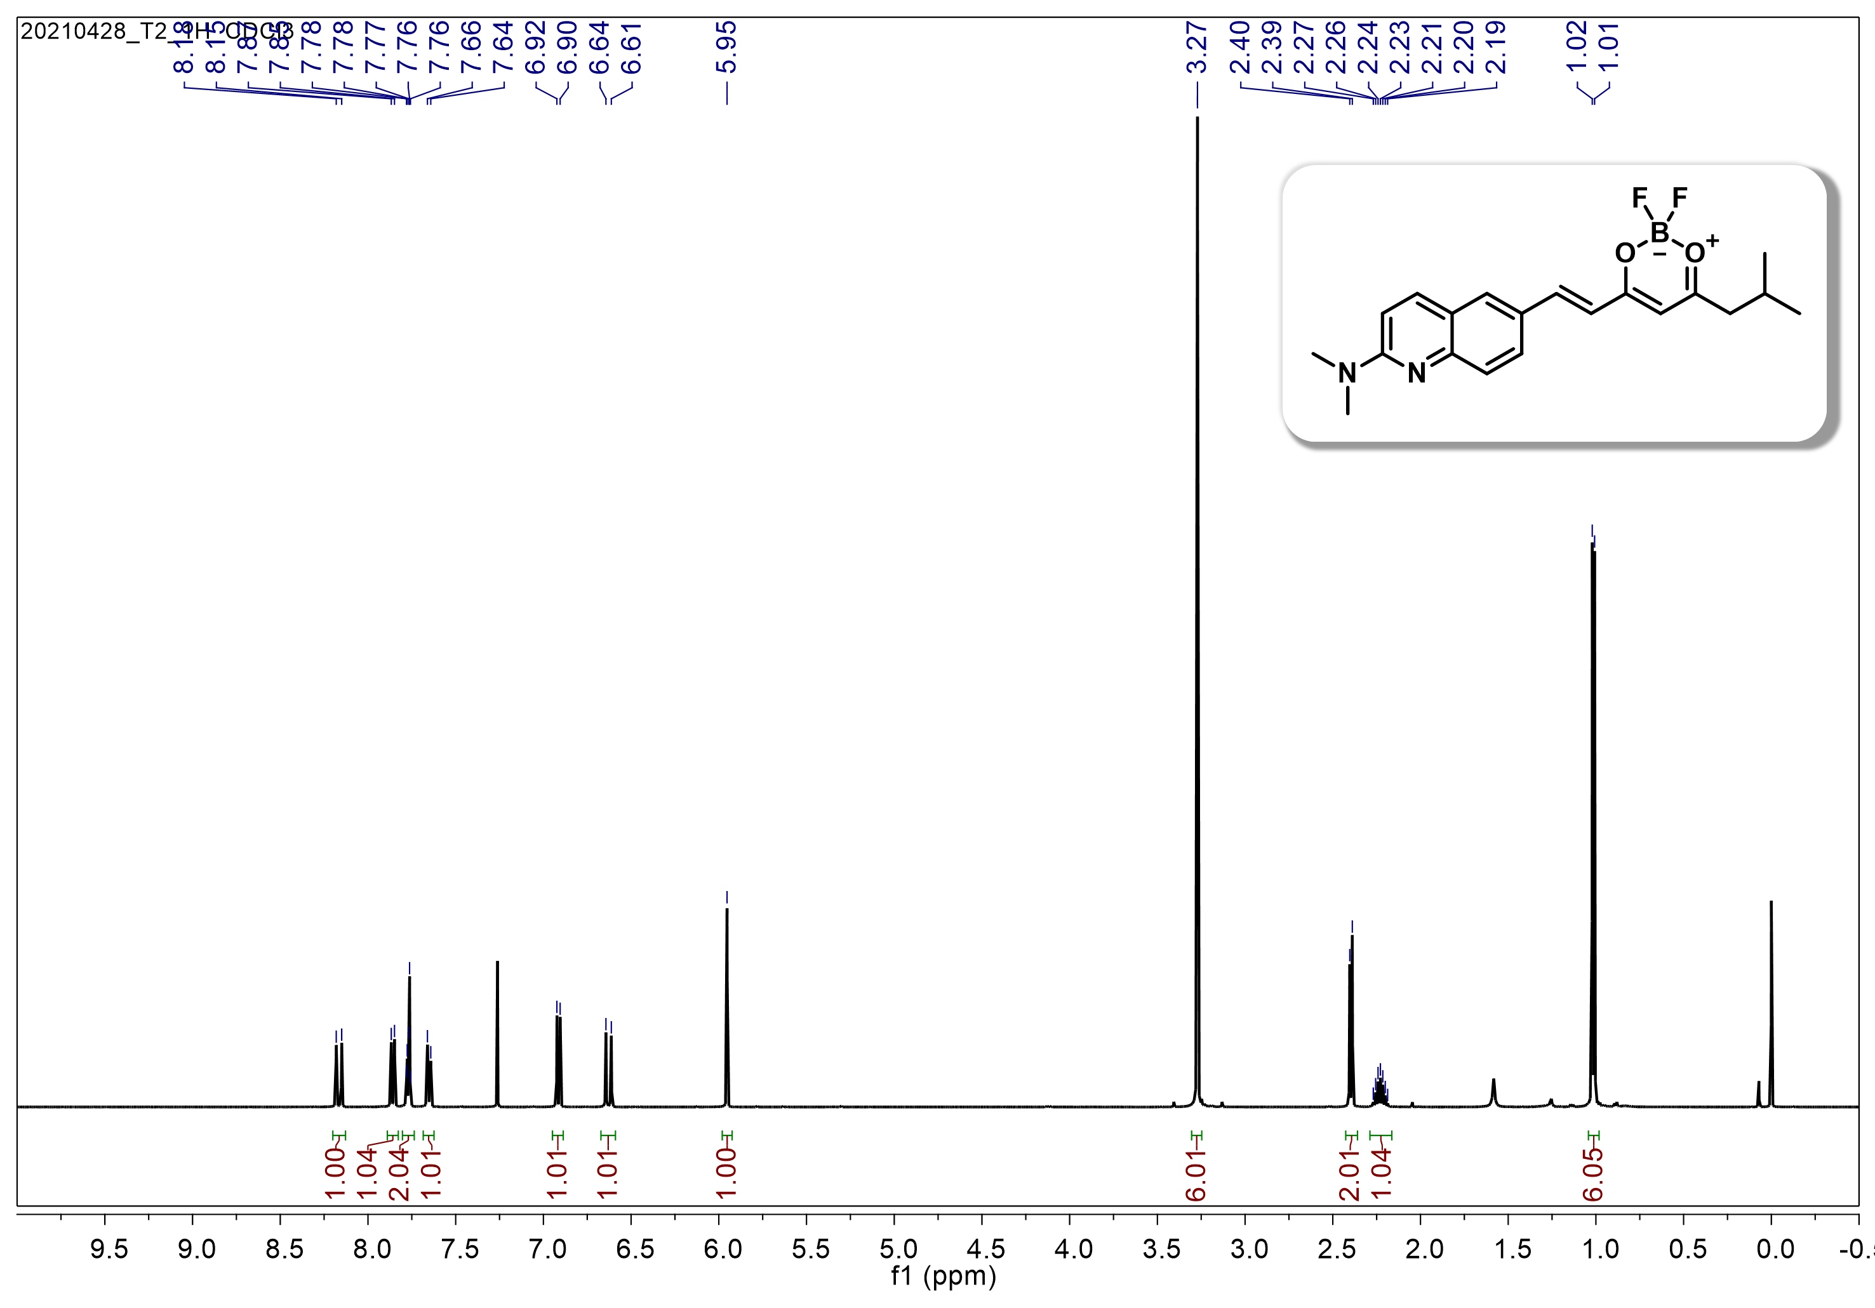
Figure S5. ¹H NMR spectrum (500 MHz) of Q-OB in CDCl₃.
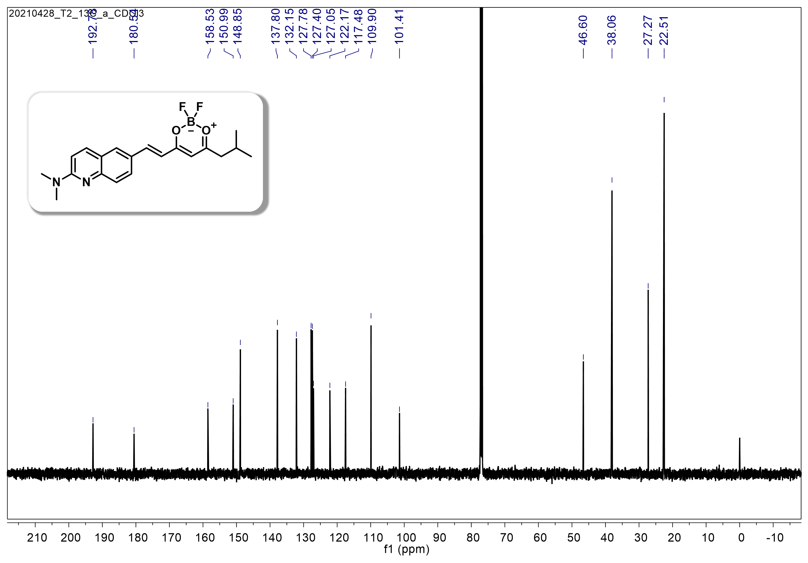
Figure S6. ¹³C NMR spectrum (125 MHz) of Q-OB in CDCl₃.

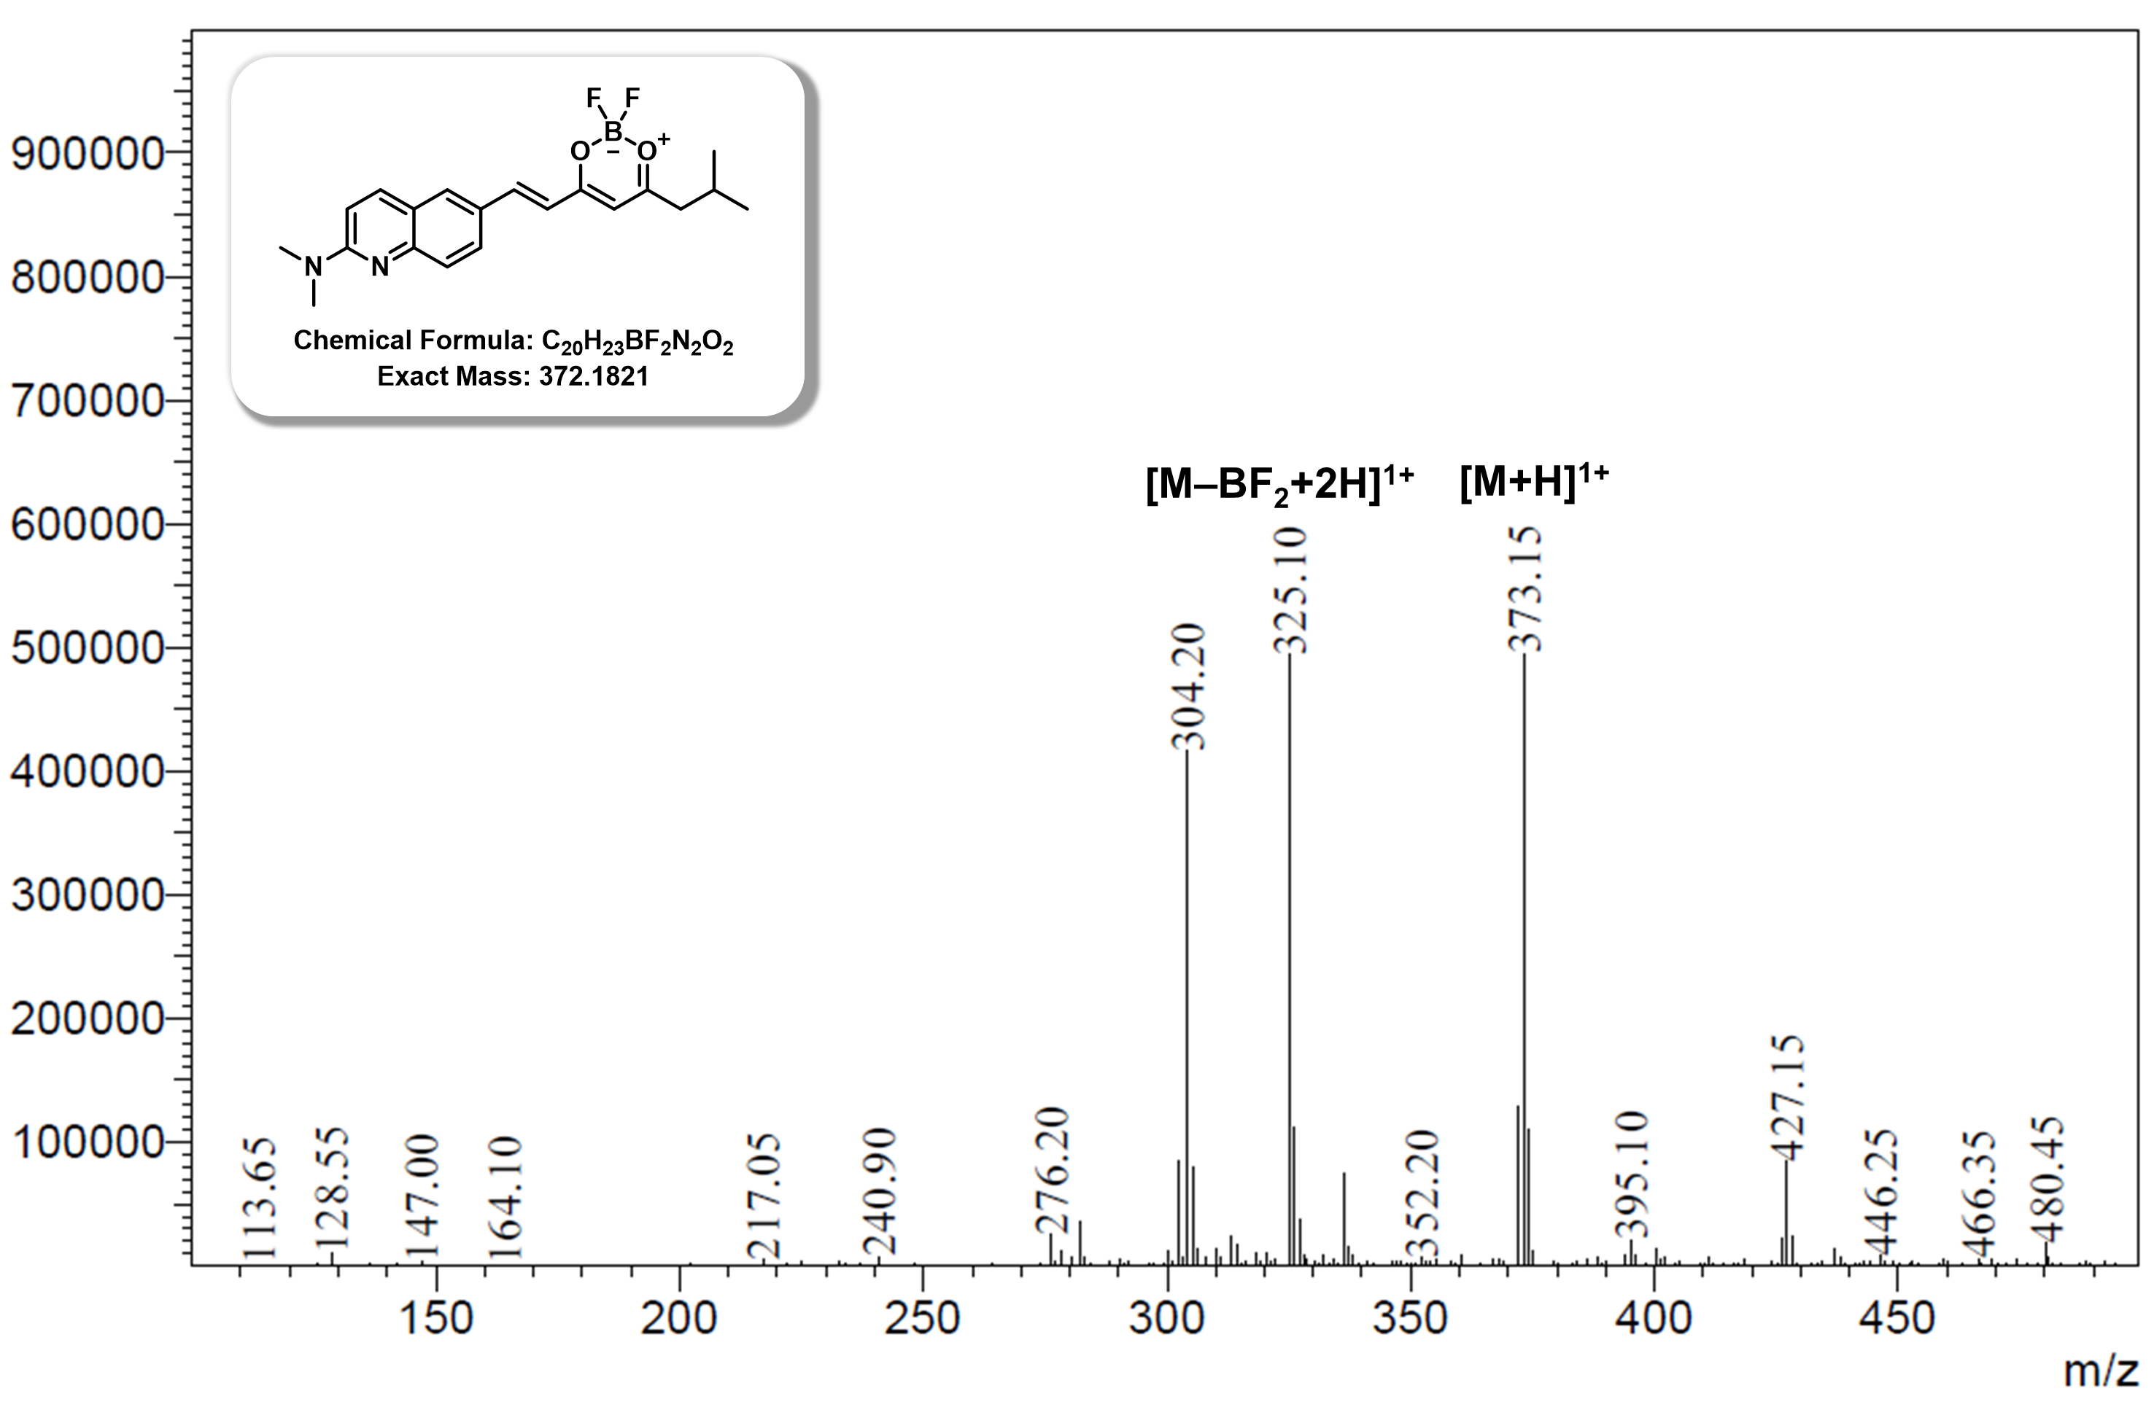
Figure S7. ESI-MS spectrum (positive range) of Q-OB.

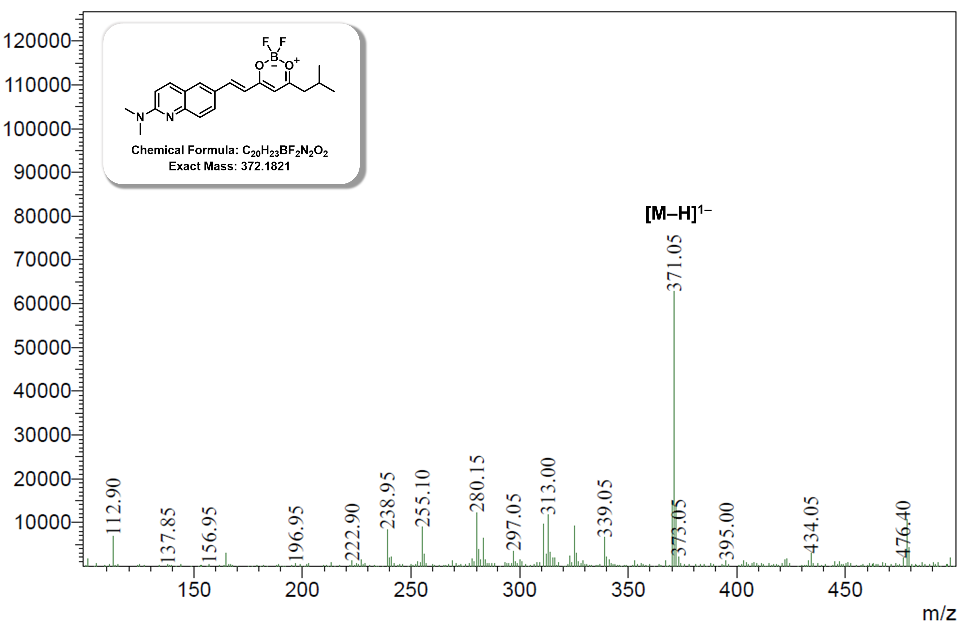
Figure S8. ESI-MS spectrum (negative range) of Q-OB.

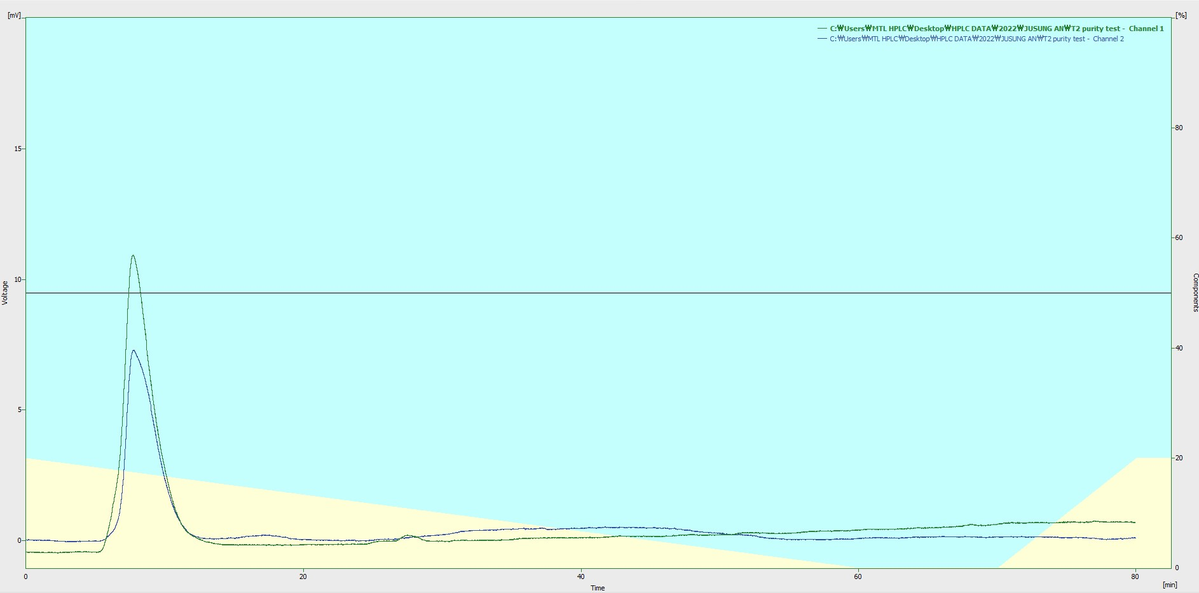

Figure S9. HPLC spectrum of Q-OB.

Table S2. Photophysical properties for Q-OB in various organic solvents.
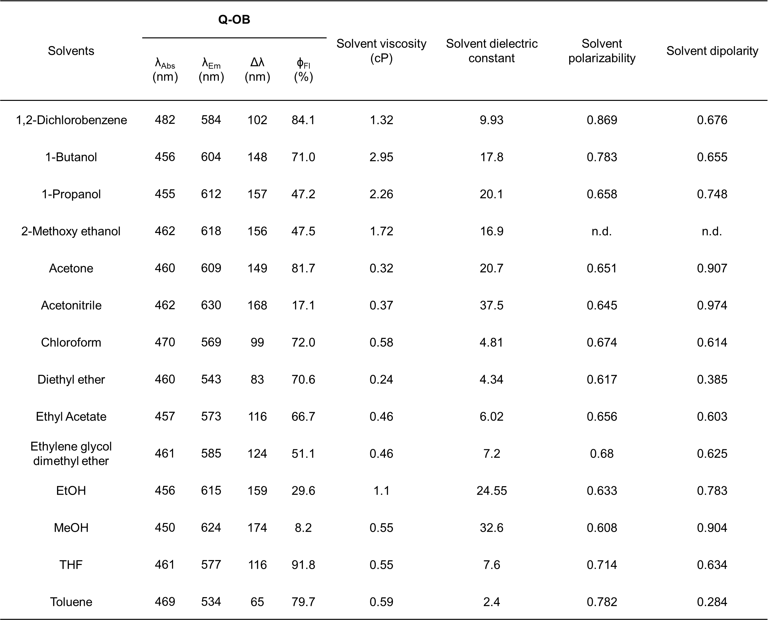
Fluorescence quantum yields were determined vs. 4-(dicyanomethylene)-2-methyl-6-(4-dimethylaminostyryl)-4H-pyran in acetonitrile¹.

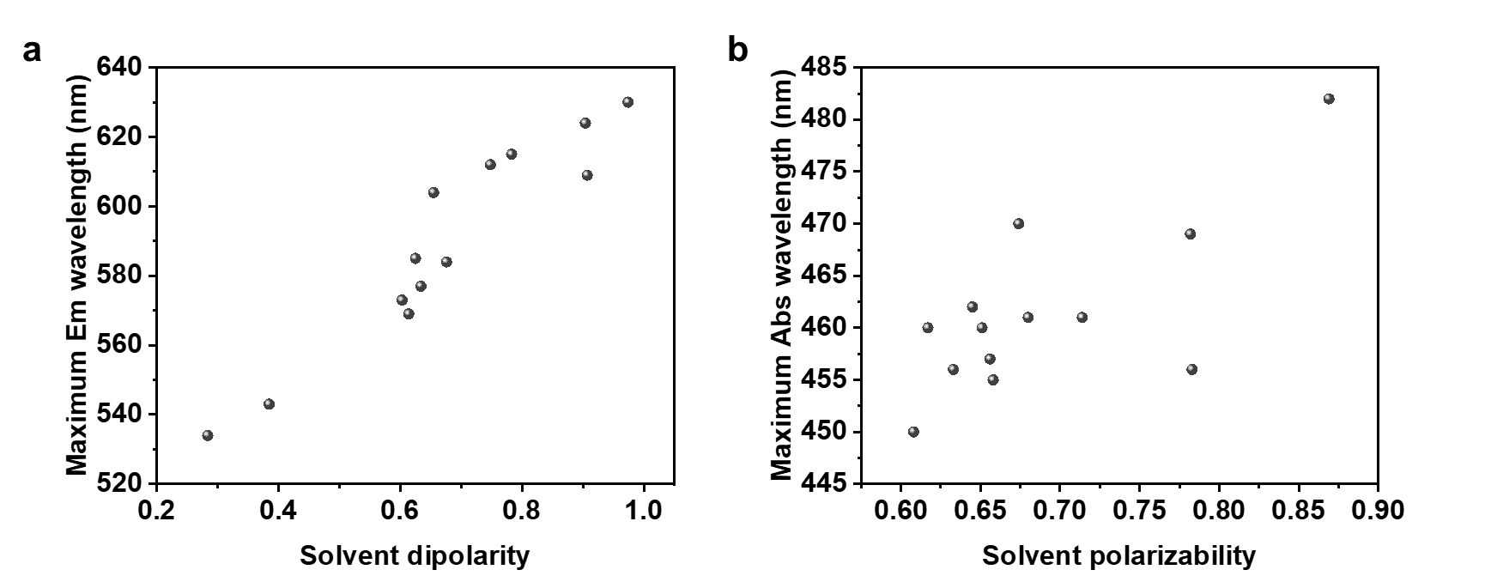
Figure S10. Photophysical properties as an intramolecular charge transfer (ICT). a) The relationship between the maximum absorbance wavelength of Q-OB plotted versus the solvent polarizability parameters and (b) The relationship between the maximum emission wavelength of Q-OB plotted versus the solvent dipolarity parameters. The various solvent (1,2-dichlorobenzene, 1-butanol, 1-propanol, acetone, acetonitrile, chloroform, diethyl ether, ethyl acetate, ethylene glycol dimethyl ether, ethanol, methanol, tetrahydrofuran, and toluene) referred to the Catalán dataset.

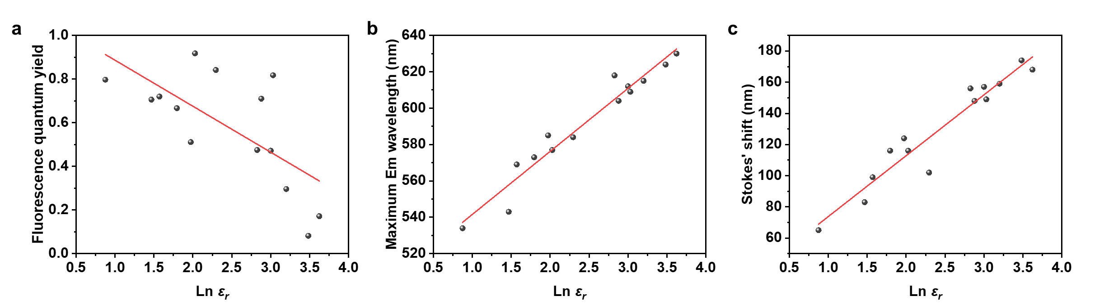
Figure S11. The relation between the natural logarithm of the solvent dielectric constant and the (a) fluorescence quantum yield, (b) maximum emission wavelength, or (c) Stokes’ shift of Q-OB with various solvents (1,2-dichlorobenzene, 1-butanol, 1-propanol, 2-methoxy ethanol, acetone, acetonitrile, chloroform, diethyl ether, ethyl acetate, ethylene glycol dimethyl ether, ethanol, methanol, tetrahydrofuran, or toluene).

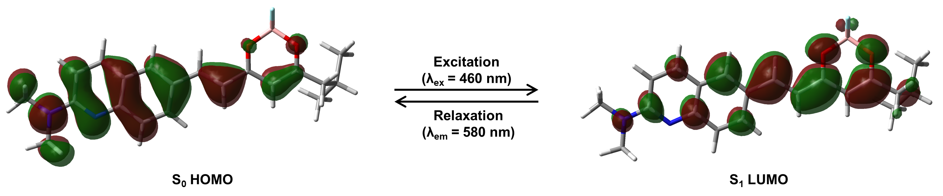

Figure S12. Calculated molecular frontier orbitals of Q-OB.

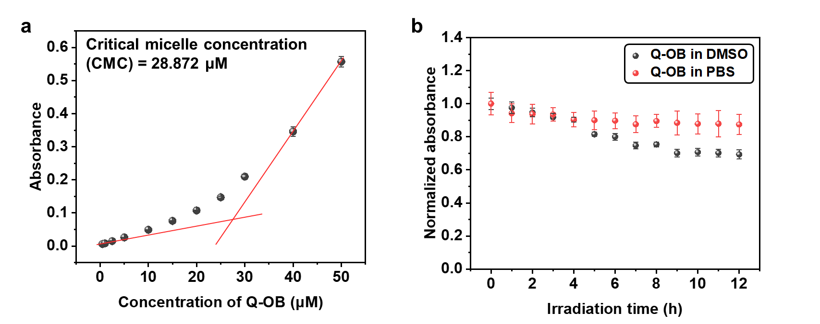

Figure S13. Physicochemical properties of Q-OB. a) Absorbance of Q-OB at various concentrations (0$-$50 μM) in PBS (10 mM, pH = 7.4) containing 1% DMSO. A critical micelle concentration (CMC) was observed for Q-OB concentrations at 28.872 μM. b) Photostability of Q-OB in DMSO and PBS (containing 1% DMSO). A 3100 K halogen lamp (Olympus LG-PS2, 12 V, 100 W) was used for irradiation, and the absorbance was recorded at 12 h intervals for 1 h. The normalized absorbance changes were plotted. Error bars indicate standard deviation, n $=$ 3.

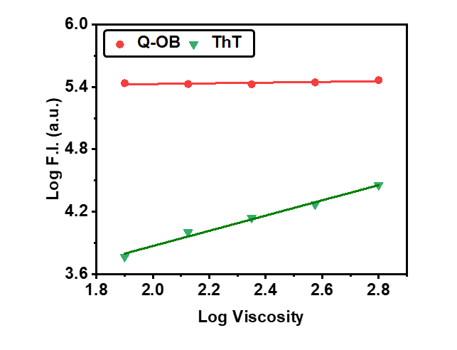
Figure S14. Viscosity sensitivity of Q-OB and thioflavin T (ThT). Viscosity sensitivity calculated based on the fluorescence intensity in ethylene glycol and glycerol mixture. Experimental procedures followed the reported methods²³.

Table S3. Photophysical properties of fluorophores measured in glycerol containing 1% DMSO.
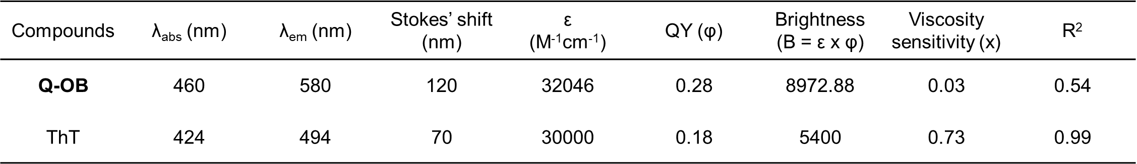

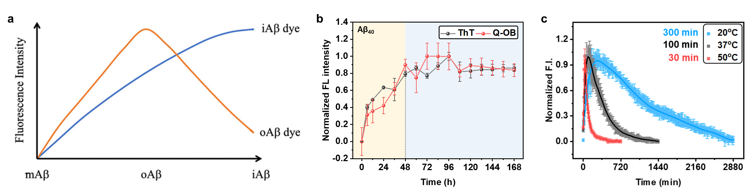

Figure S15. a) Hypothetical pattern of fluorescence intensities of Aβ-specific fluorophores in kinetic assay reported in our previous work²². The fluorescence intensity of aqueous-insoluble Aβ fibrils (iAβ) and Aβ oligomers (oAβ) fluorophores during Aβ self-aggregation with iAβ concentration increasing from Aβ monomers (mAβ), while oAβ levels increase then disappearing as they aggregate into matured fibrils. b) Time-dependent plot indicated the change in the fluorescence intensity of Q-OB and ThT in the presence of Aβ_{1–40} for 168 h. c) Identification of Aβ_{1–42} aggregation kinetics by Q-OB under coincubation (λ_{ex}/λ_{em} = 460/580 nm) at 20, 37, and 50°C (full-time range of Figure 2e in main manuscript).

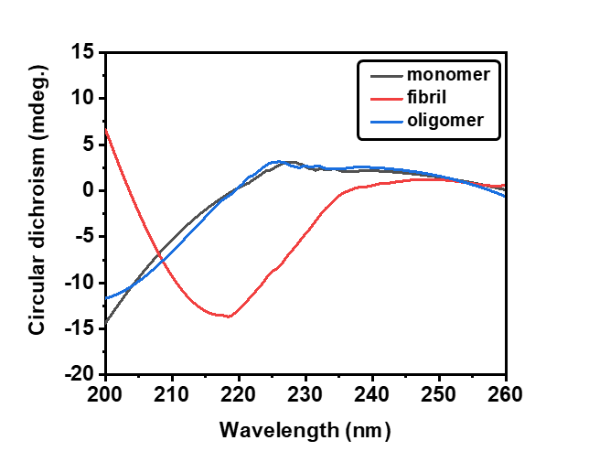

Figure S16. Biophysical characterization of Aβ_{1–42} species, including mAβ_{1–42}, oAβ_{1–42}, and iAβ_{1–42}, by circular dichroism (CD) spectra.

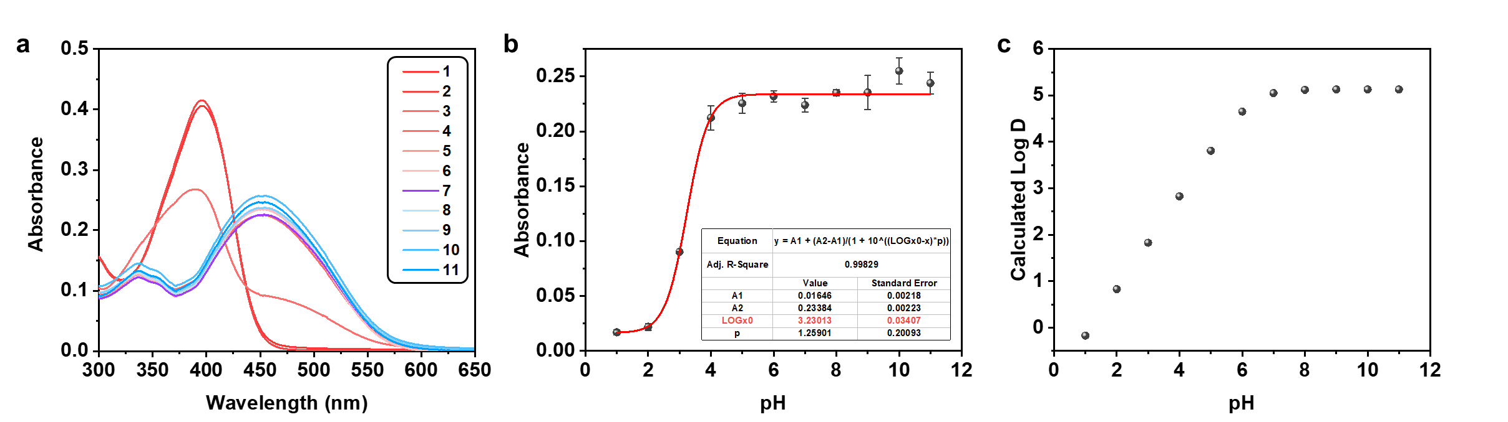

Figure S17. pH-dependent absorbance changes. a) Absorbance spectra of Q-OB at various pH levels (pH = 1–11). b) The pH-dependent absorbance at 460 nm, with non-linear pK_{a} fitting. c) pH-dependent calculated Log D values. Log D was calculated using the general equation for bases: $Log D=Log P-Log[1+{10}^{\left({pK}_{a}-pH\right)}]$, with calculated pK_{a} = 6.3 from Molinspiration cheminformatics applet (https://www.molinspiration.com/) and Log P = 5.13.

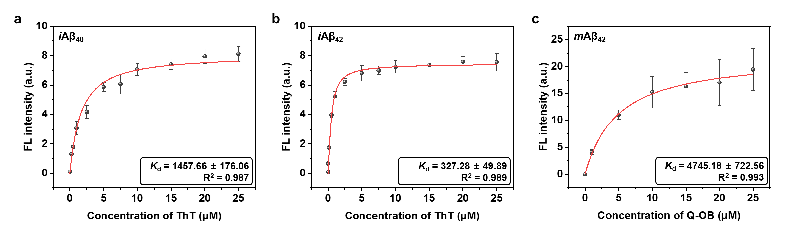

Figure S18. Saturation binding curved of (a) iAβ_{1–40} and (b) iAβ_{1–42} as a function of ThT (0–25 μM) as a control, and (c) mAβ_{1–42} as a function of Q-OB (0–25 μM). Error ranges represent SD (n = 3), slit 2.5/2.5.

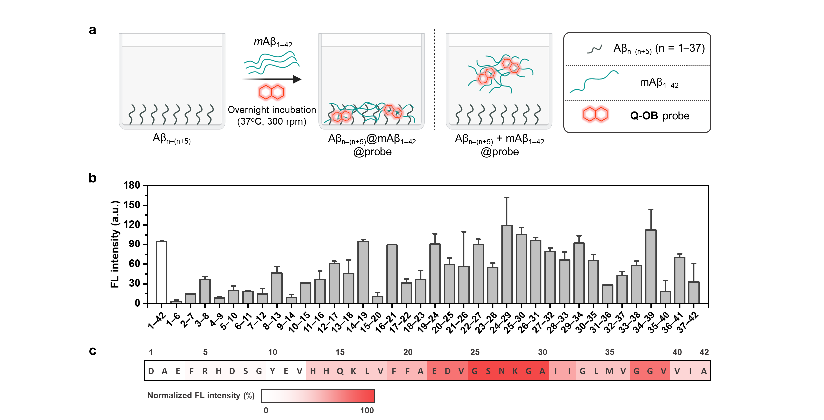

Figure S19. Identification of binding residues of Q-OB. a) Experimental scheme for identification of Q-OB binding site for Aβ_{n–(n+5)} fragments of Aβ_{1–42}, with additional full-length Aβ_{1–42}²⁴. b) The data of fluorescent values of Q-OB and (c) the heatmap displays the spectrum of binding intensity on Aβ_{n–(n+5)} sequence (white to red, 0–100%) (λ_{ex}/λ_{em} = 500/620 nm).

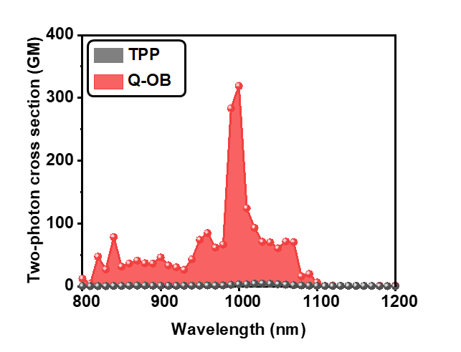

Figure S20. Two-photon action spectra of Q-OB (10 μM) and tetraphenylporphyrin (TPP) (10 μM) as a reference compound acquired in 1,2-dichlorobenzene to demonstrate the possibility of two-photon in vivo imaging.
Note: We were able to obtain two-photon in vivo imaging to monitor the oAβ because of instrument limitation, even though Q-OB has significant two-photon action cross-section (TPACS) values.

Table S4. Comparison of Q-OB properties with blood-brain barrier (BBB) penetrability selection rules.
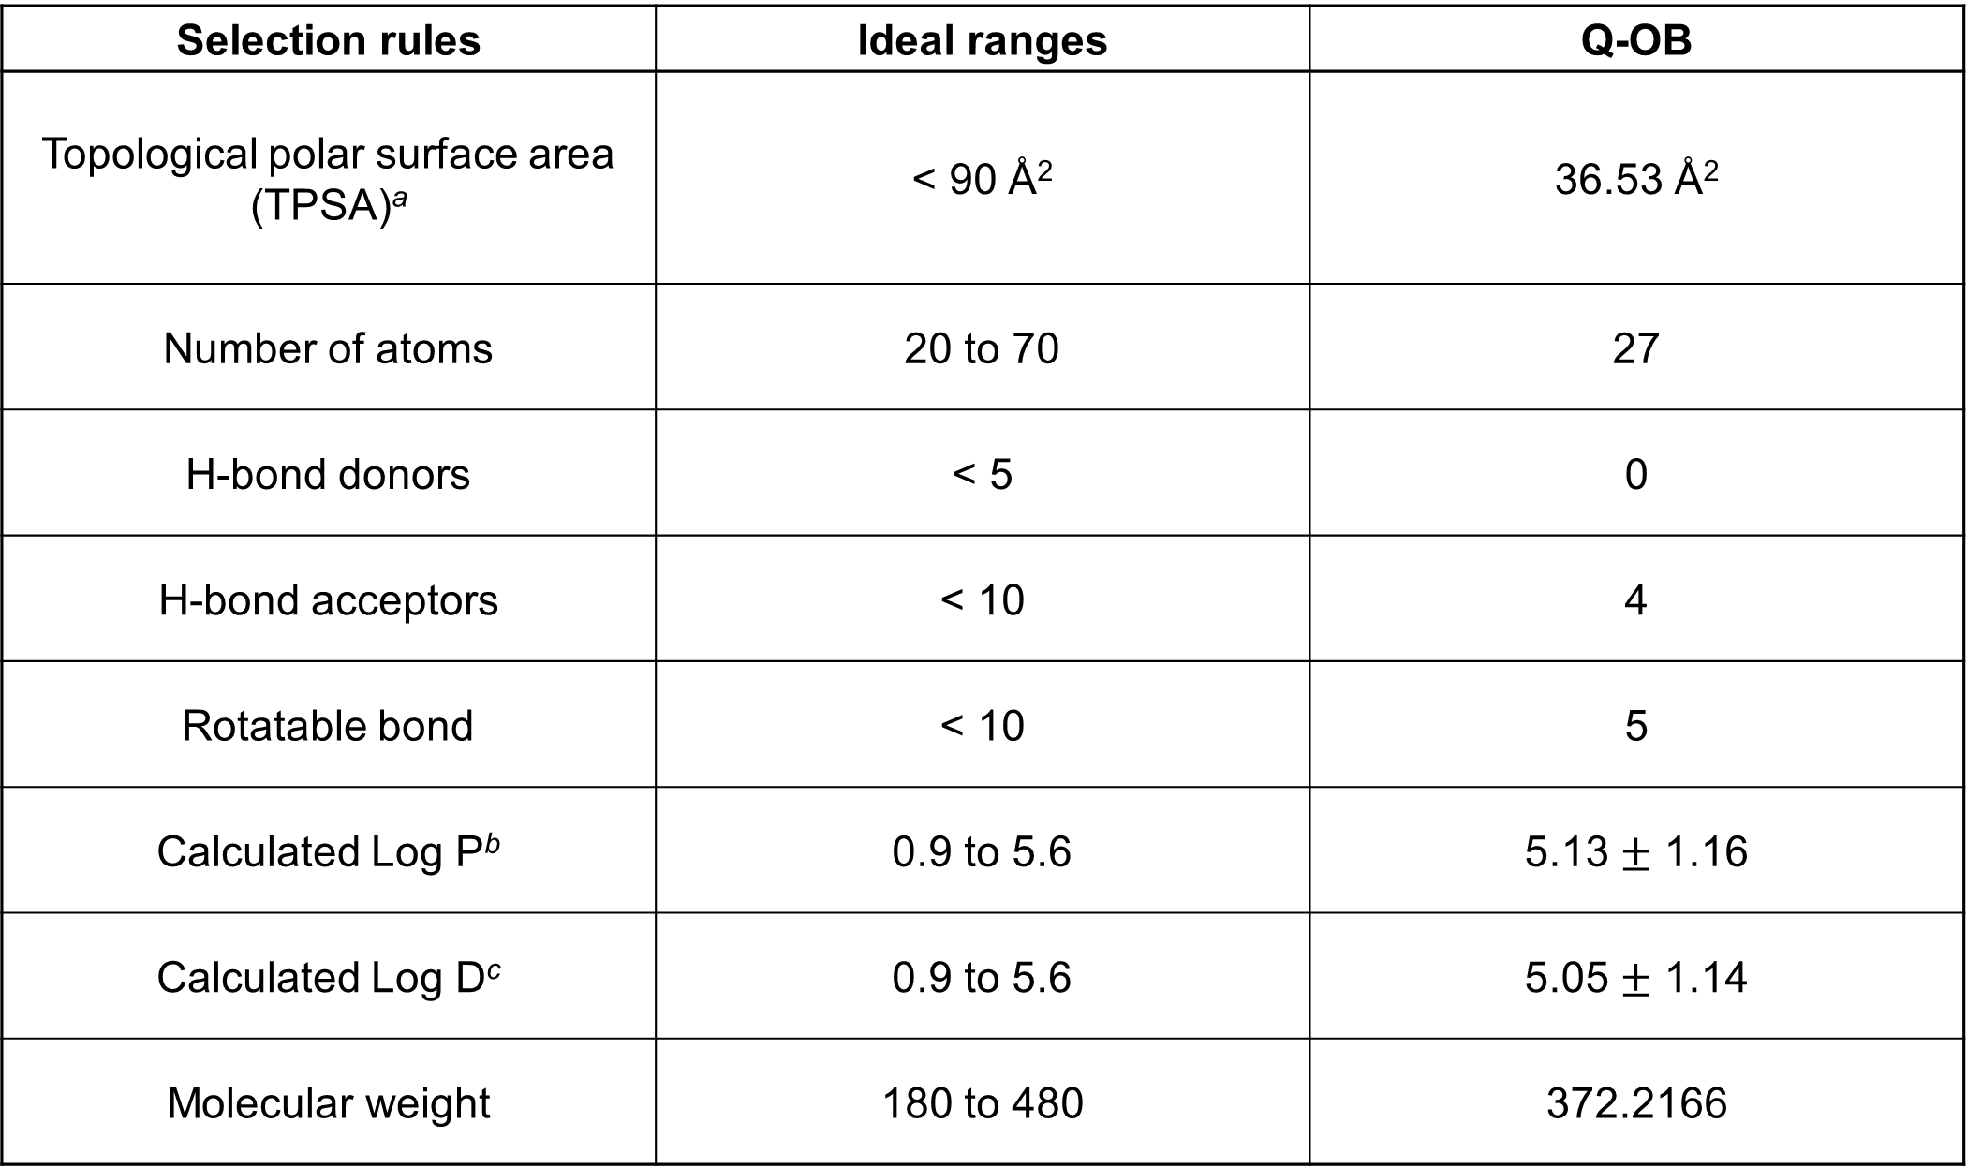
ªCalculated using the Molinspiration cheminformatics applet (https://www.molinspiration.com/), and ^{b}calculated from pooled log P data, as implemented by the ALOGPS 2.1 applet (http://www.vcclab.org/lab/alogps/). ^{c}Q-OB is neutral at physiological pH (see Figure S17), thus Log D ≈ Log P.

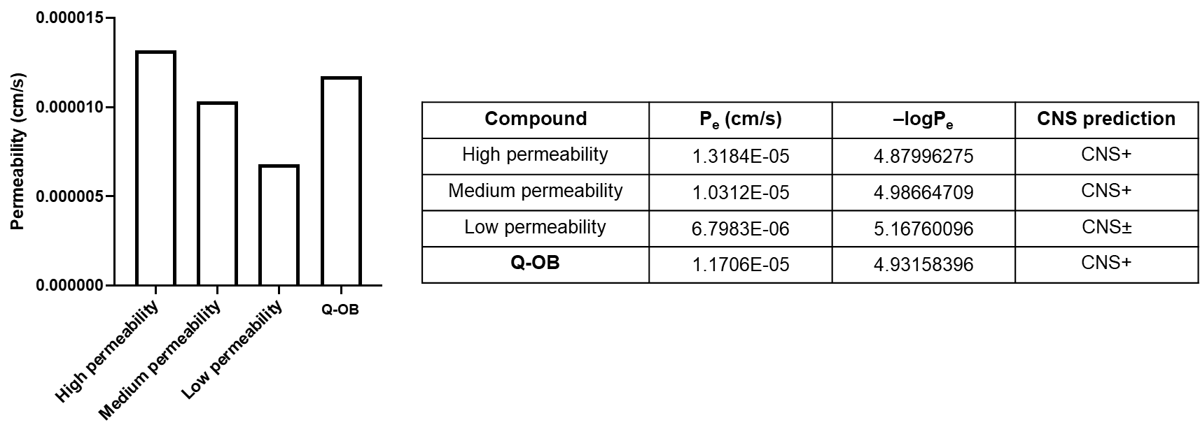

Figure S21. Parallel artificial membrane permeability assay (PAMPA) BBB penetrability assay of Q-OB compared to reference compounds.

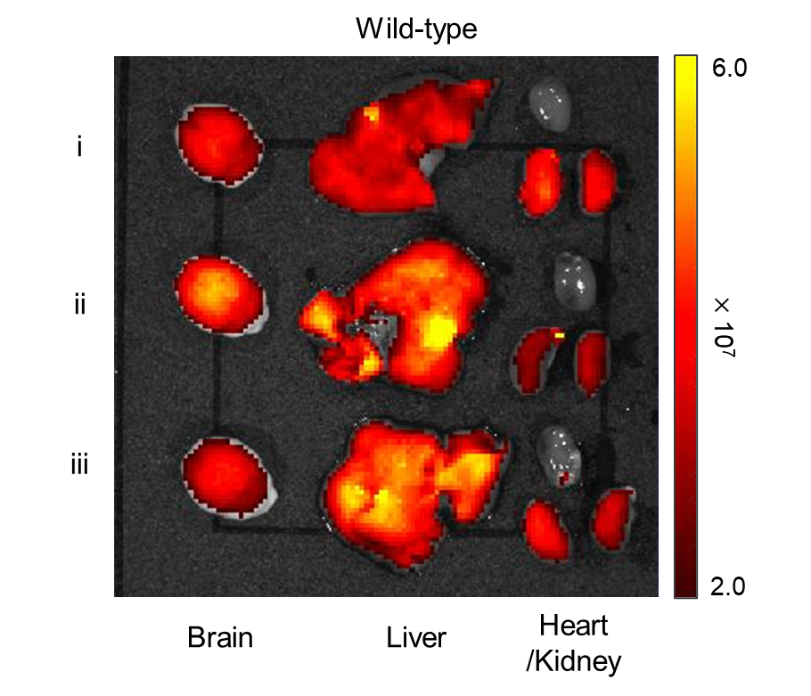
Figure S22. Ex vivo fluorescence imaging of major organs (brain, liver, heart, and kidney) of 2-month-old B6 wild-type mice (n = 3). The fluorescence images were captured using excitation at 500 nm, and the emission was monitored at 620 nm.

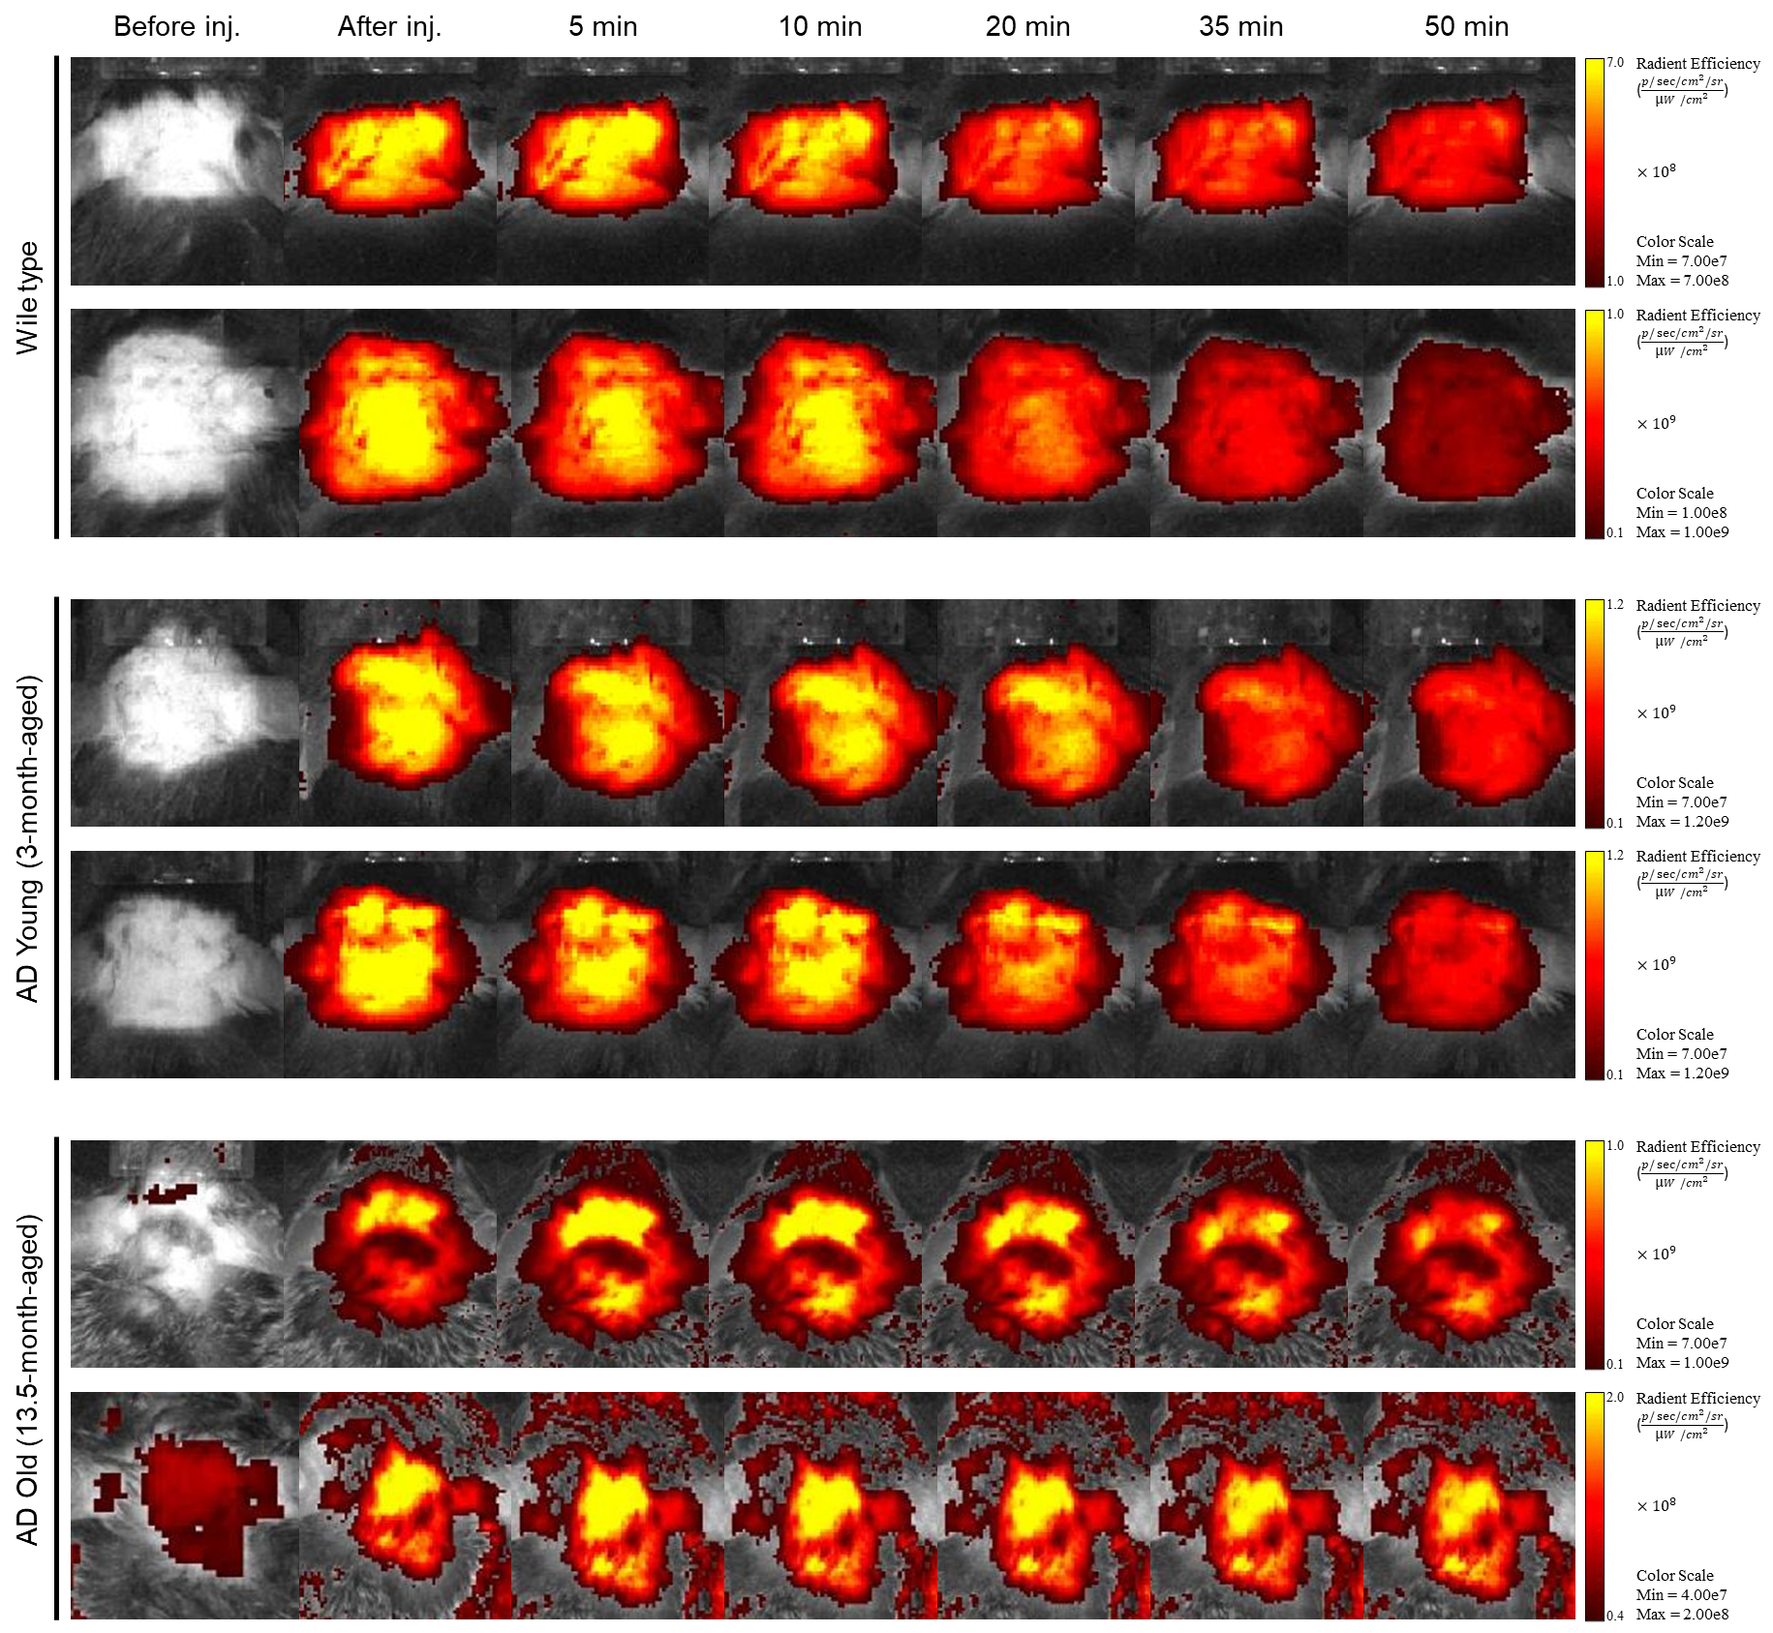
Figure S23. In vivo fluorescence imaging of 5xFAD transgenic AD-model and B6 wildtype mouse brains. The fluorescence signal of in vivo imaging, 50 min after tail vein injection of Q-OB. The fluorescence images were collected using excitation at 500 nm, and the emission was monitored at 620 nm.
Table S5. Clinical data and sample information of patients’ cerebrospinal fluid (CSF) biomarkers in AD continuum.
No | Diagnosis | Object ID | Sex | APOE | PET | SUVR | Q-OB I/I₀ | Q-OB  Log (I/I₀) | ELISA_CSF Aβ_{1–42} | Procartaplex_CSF p-Tau₁₈₁ | ELISA_CSF NFL
1 | CN | 1456 | F | 3/3 | Negative | 1.04 | 1.69 | 0.228 | 1247.4 | 6.29 | 623.3
2 | CN | 1482 | M | 3/4 | Negative | 0.98 | 2.26 | 0.355 | 1206.2 | 8.75 | 448.0
3 | CN | 3346 | M | 2/3 | Negative | 1.09 | 1.59 | 0.202 | 1055.7 | 9.30 | 561.8
4 | CN | 4192 | M | 3/4 | Negative | 0.94 | 2.06 | 0.315 | 1197.4 | 7.95 | 784.5
5 | CN | 5192 | M | 3/3 | Negative | 1.01 | 1.92 | 0.283 | 1253.8 | 8.56 | 447.9
6 | CN | 5300 | F | 2/3 | Negative | 1.00 | 1.73 | 0.237 | 1180.2 | 11.74 | 739.4
7 | CN | 5838 | F | 3/3 | Negative | 0.99 | 1.78 | 0.250 | 1064.5 | 8.38 | 518.5
8 | CN | 6327 | M | 2/2 | Negative | 0.94 | 1.83 | 0.262 | 1012.4 | 8.43 | 330.5
9 | CN | 6428 | F | 3/3 | Negative | 0.96 | 2.78 | 0.444 | 1243.6 | 9.01 | 420.1
10 | CN | 6509 | F | 3/3 | Negative | 0.98 | 2.09 | 0.319 | 1597.0 | 16.81 | 407.3
11 | CN | 6161 | M | 3/3 | Negative | 0.98 | 1.97 | 0.294 | 1123.0 | 15.59 | 1196.8
12 | CN | 6751 | M | 3/3 | Negative | 0.92 | 1.98 | 0.297 | 1268.3 | 12.21 | 764.9
13 | CN | 2898 | M | 3/3 | Negative | 0.93 | 1.99 | 0.299 | 1390.4 | 8.00 | 315.7
14 | CN | 6010 | F | 3/3 | Negative | 0.99 | 1.53 | 0.184 | 1295.1 | 6.03 | 354.7
15 | CN | 6160 | F | 3/3 | Negative | 0.98 | 2.52 | 0.401 | 1082.5 | 5.66 | 289.2
16 | CN | 5486 | F | 3/3 | Negative | 1.08 | 2.45 | 0.388 | 1445.2 | 8.58 | 617.7
17 | CN | 5441 | F | 3/4 | Negative | 1.04 | 5.22 | 0.718 | 1190.7 | 9.07 | 783.9
18 | CN | 3385 | M | 3/3 | Negative | 0.99 | 3.42 | 0.534 | 1402.3 | 13.35 | 528.2
19 | CN | 5675 | F | 3/3 | Negative | 0.98 | 2.92 | 0.466 | 1033.8 | 13.47 | 740.7
20 | CN | 6425 | F | 3/3 | Negative | 0.99 | 2.81 | 0.449 | 1058.2 | 11.17 | 658.8
21 | CN | 3946 | F | 3/3 | Negative | 0.98 | 2.27 | 0.356 | 1303.0 | 9.71 | 683.6
22 | CN | 8180 | M | 3/4 | Negative | 0.90 | 1.41 | 0.149 | 1136.1 | 8.50 | 446.0
23 | MCI | 91 | M | 3/4 | Positive | 1.44 | 2.23 | 0.348 | 374.5 | 14.02 | 304.0
24 | MCI | 174 | M | 3/3 | Positive | 1.25 | 1.23 | 0.091 | 452.9 | 35.00 | 1043.1
25 | MCI | 2043 | F | 3/3 | Positive | 1.49 | 1.15 | 0.059 | 342.1 | 18.15 | 570.2
26 | MCI | 2952 | M | 2/3 | Positive | 1.49 | 2.10 | 0.323 | 280.5 | 31.13 | 631.9
27 | MCI | 5246 | M | 3/4 | Positive | 1.41 | 1.54 | 0.187 | 152.7 | 20.18 | 637.3
28 | MCI | 5979 | M | 3/4 | Positive | 1.29 | 2.95 | 0.470 | 487.3 | 6.77 | 460.5
29 | MCI | 6512 | M | 3/4 | Positive | 1.31 | 1.22 | 0.086 | 514.8 | 23.50 | 1005.2
30 | MCI | 6930 | F | 4/4 | Positive | 1.34 | 1.15 | 0.060 | 354.3 | 28.33 | 385.3
31 | MCI | 7043 | F | 3/3 | Positive | 1.20 | 1.29 | 0.112 | 352.2 | 36.21 | 2112.1
32 | MCI | 7321 | M | 3/3 | Positive | 1.46 | 1.41 | 0.149 | 271.0 | 23.30 | 633.4
33 | MCI | 7645 | M | 3/3 | Positive | 1.33 | 1.10 | 0.042 | 329.3 | 17.36 | 455.6
34 | MCI | 7730 | M | 3/4 | Positive | 1.54 | 1.18 | 0.073 | 198.5 | 44.58 | 978.0
35 | MCI | 7997 | F | 4/4 | Positive | 1.58 | 1.81 | 0.257 | 166.9 | 46.51 | 755.9
36 | MCI | 8105 | F | 4/4 | Positive | 1.53 | 1.24 | 0.093 | 220.6 | 29.46 | 546.6
37 | MCI | 8143 | F | 2/3 | Positive | 1.59 | 1.30 | 0.115 | 563.7 | 36.69 | 979.7
38 | MCI | 8152 | M | 3/3 | Positive | 1.55 | 1.50 | 0.177 | 459.7 | 28.76 | 800.5
39 | MCI | 10587 | F | 3/4 | Positive | 1.31 | 1.83 | 0.262 | 458.0 | 16.94 | 1118.9
40 | MCI | 10863 | F | 3/4 | Positive | 1.34 | 1.18 | 0.073 | 499.3 | 19.93 | 562.8
41 | MCI | 11245 | F | 4/4 | Positive | 1.20 | 1.36 | 0.135 | 465.8 | 30.54 | 592.4
42 | MCI | 12711 | F | 3/4 | Positive | 1.47 | 1.48 | 0.172 | 408.5 | 18.02 | 489.3
43 | MCI | 13720 | M | 3/4 | Positive | n.d. | 1.01 | 0.005 | 467.5 | 13.01 | 428.0
44 | ADD | 3205 | M | 3/3 | Positive | 1.40 | 2.64 | 0.422 | 335.8 | 19.37 | 798.9
45 | ADD | 4036 | M | 3/4 | Positive | 1.36 | 1.25 | 0.095 | 412.2 | 18.77 | 809.1
46 | ADD | 5577 | M | 4/4 | Positive | 1.28 | 1.29 | 0.111 | 364.0 | 15.50 | 1174.6
47 | ADD | 5621 | F | 3/4 | Positive | 1.37 | 1.33 | 0.123 | 468.2 | 16.38 | 679.3
48 | ADD | 5716 | F | 3/4 | Positive | 1.48 | 1.31 | 0.116 | 443.4 | 24.38 | 797.6
49 | ADD | 5945 | F | 3/4 | Positive | 1.48 | 1.33 | 0.123 | 311.5 | 25.72 | 1926.0
50 | ADD | 5961 | F | 3/3 | Positive | 1.37 | 1.17 | 0.070 | 422.8 | 18.34 | 741.9
51 | ADD | 6005 | F | 2/3 | Positive | 1.55 | 1.73 | 0.239 | 382.5 | 18.83 | 883.3
52 | ADD | 6216 | M | 3/3 | Positive | 1.43 | 1.20 | 0.078 | 527.1 | 36.29 | 870.5
53 | ADD | 7239 | F | 3/4 | Positive | 1.33 | 1.14 | 0.055 | 495.5 | 29.60 | 1204.0
54 | ADD | 7627 | F | 3/3 | Positive | 1.45 | 1.33 | 0.125 | 373.9 | 25.73 | 1259.5
55 | ADD | 6670 | F | 3/4 | Positive | 1.42 | 1.05 | 0.021 | 376.9 | 18.63 | 791.1
56 | ADD | 6979 | M | 3/4 | Positive | 1.49 | 0.98 | -0.007 | 413.9 | 25.47 | 1741.7
57 | ADD | 12997 | F | 3/4 | Positive | 1.2 | 1.21 | 0.083 | 471.5 | 21.03 | 1030.2
58 | ADD | 6808 | F | 2/4 | Positive | 1.43 | 1.54 | 0.189 | 355.0 | 17.56 | 511.5
59 | ADD | 9761 | F | 3/4 | Positive | 1.49 | 1.73 | 0.238 | 346.1 | 13.49 | 499.3
60 | ADD | 8354 | M | 3/3 | Positive | 1.46 | 1.47 | 0.166 | 198.7 | 22.25 | 1212.6
61 | ADD | 12813 | M | 3/4 | Positive | 1.14 | 1.32 | 0.122 | 159.7 | 12.45 | 1034.6
Written informed consent was obtained from each participant or their legal guardian. Object ID was designated by Gwangju Alzheimer’s Disease and Related Dementias Cohort Center). The abbreviated words are apolipoprotein E (APOE), positron emission tomography (PET), standardized uptake value ratio (SUVR), enzyme-linked immunosorbent assay (ELISA), amyloid-β (Aβ), cerebrospinal fluid (CSF), phosphorylated tau (p-Tau), neurofilament light chain (NFL), Cognitive normal (CN), Mild cognitive impairment (MCI), Alzheimer’s disease dementia (ADD), Female (F), Male (M). Not available data was marked as n.d.

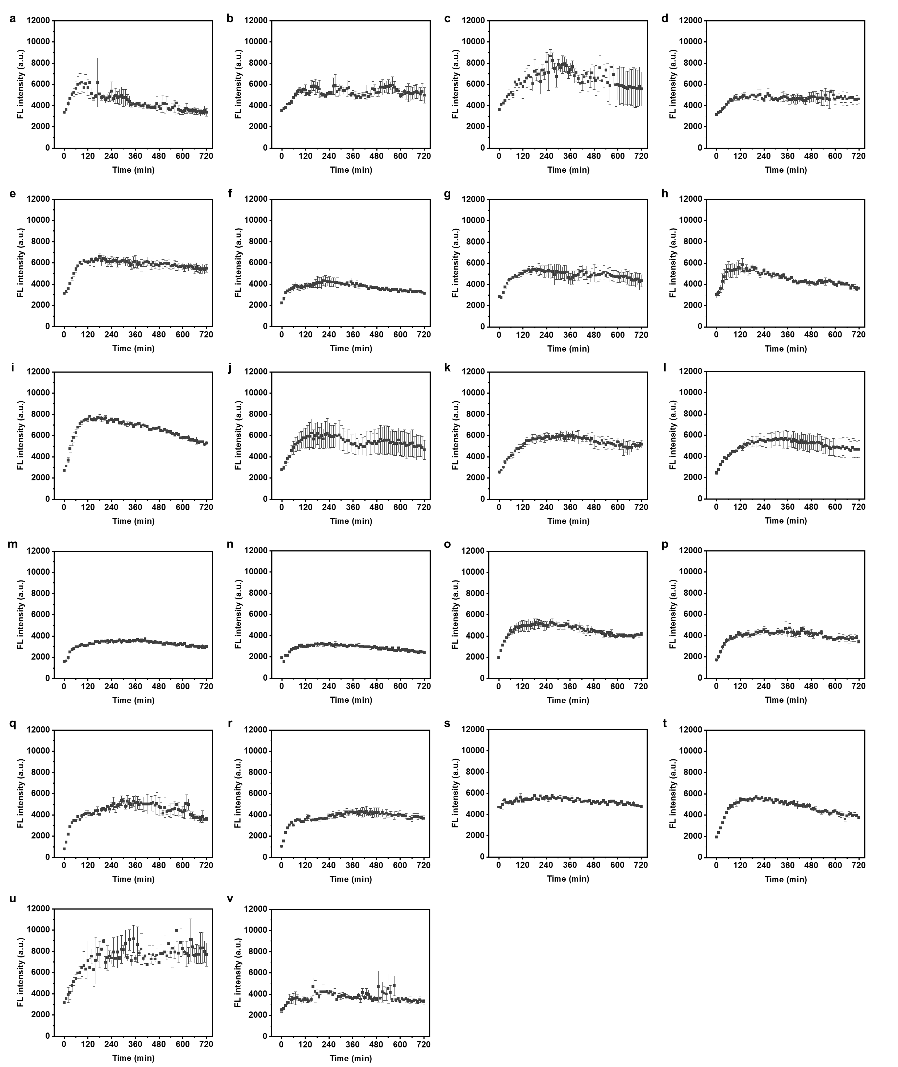

Figure S24. In vitro Q-OB assay results for early AD diagnosis using patients’ CSF samples. Time-dependent fluorescence intensity change of Q-OB (1 μM)-treated cognitive normal (CN) CSF samples during coincubation (37°C, 200 rpm, for 12 h) with exogenously added mAβ_{1–42} (10 μM) from sample number 1 to 22 in Table S5 (a to v, respectively).

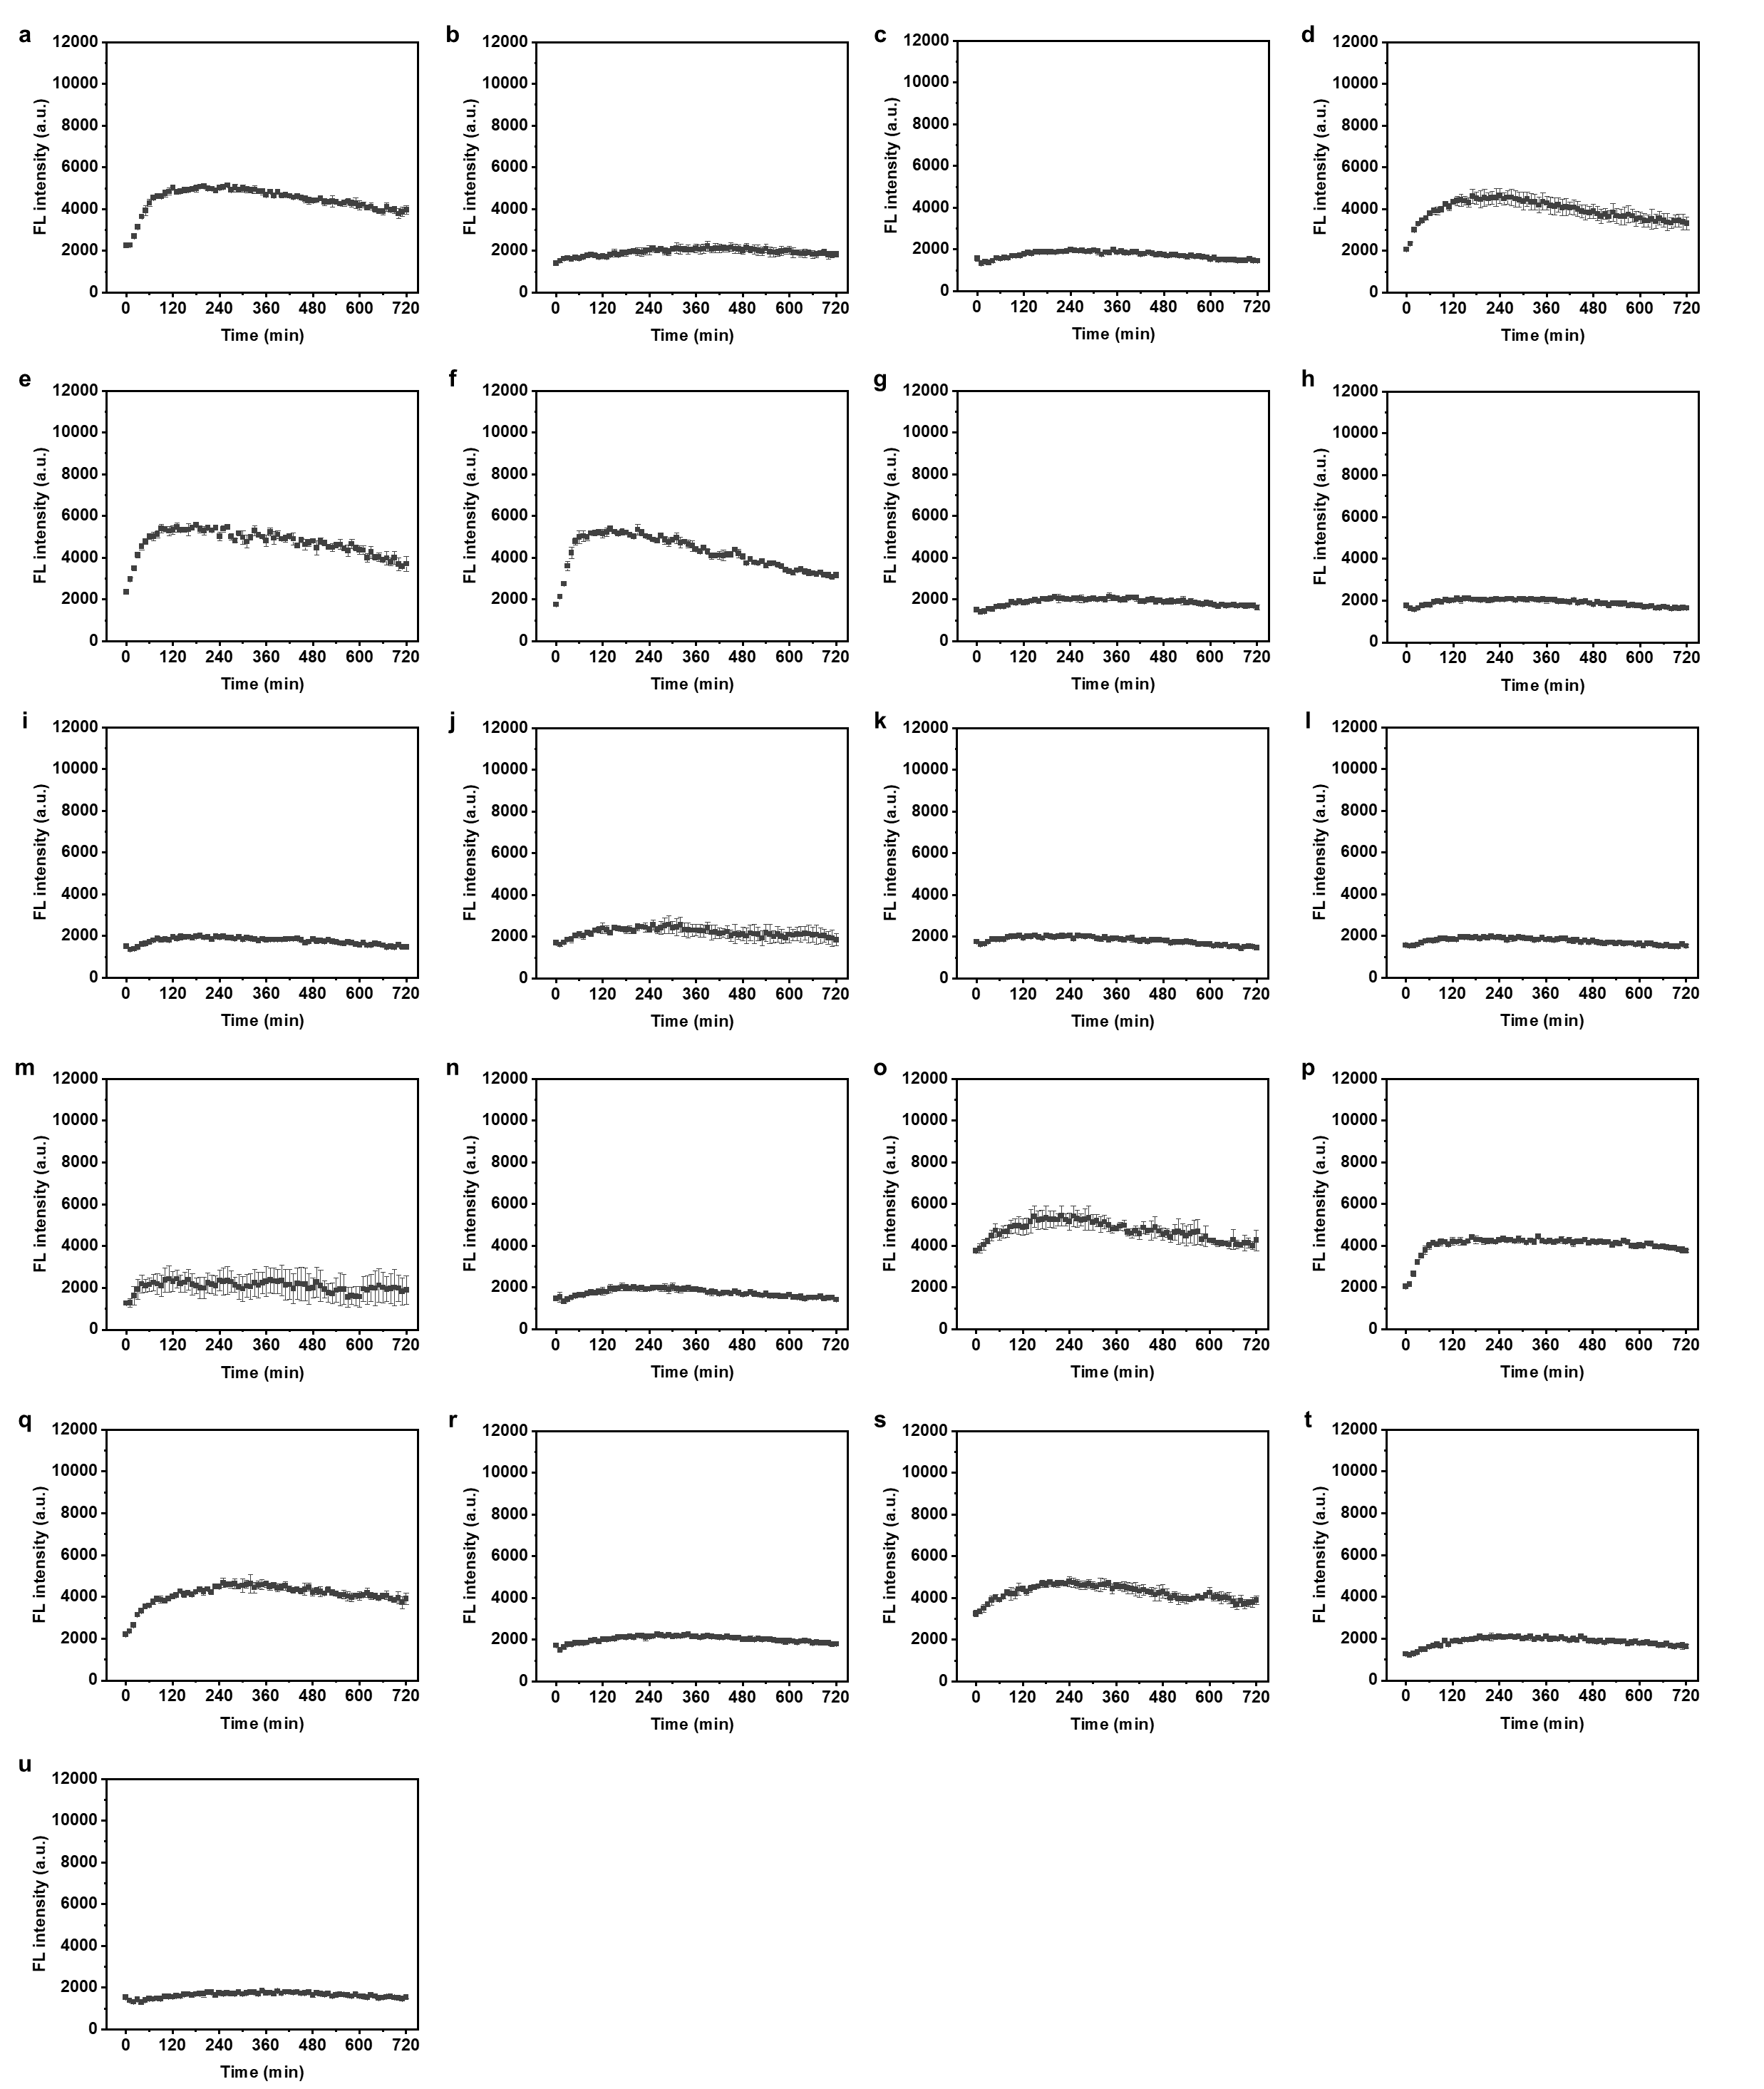

Figure S25. In vitro Q-OB assay results for early AD diagnosis using patients’ CSF samples. Time-dependent fluorescence intensity change of Q-OB (1 μM)-treated mild cognitive impairment (MCI) CSF samples during coincubation (37°C, 200 rpm, for 12 h) with exogenously added mAβ_{1–42} (10 μM) from sample number 23 to 43 in Table S5 (a to u, respectively).

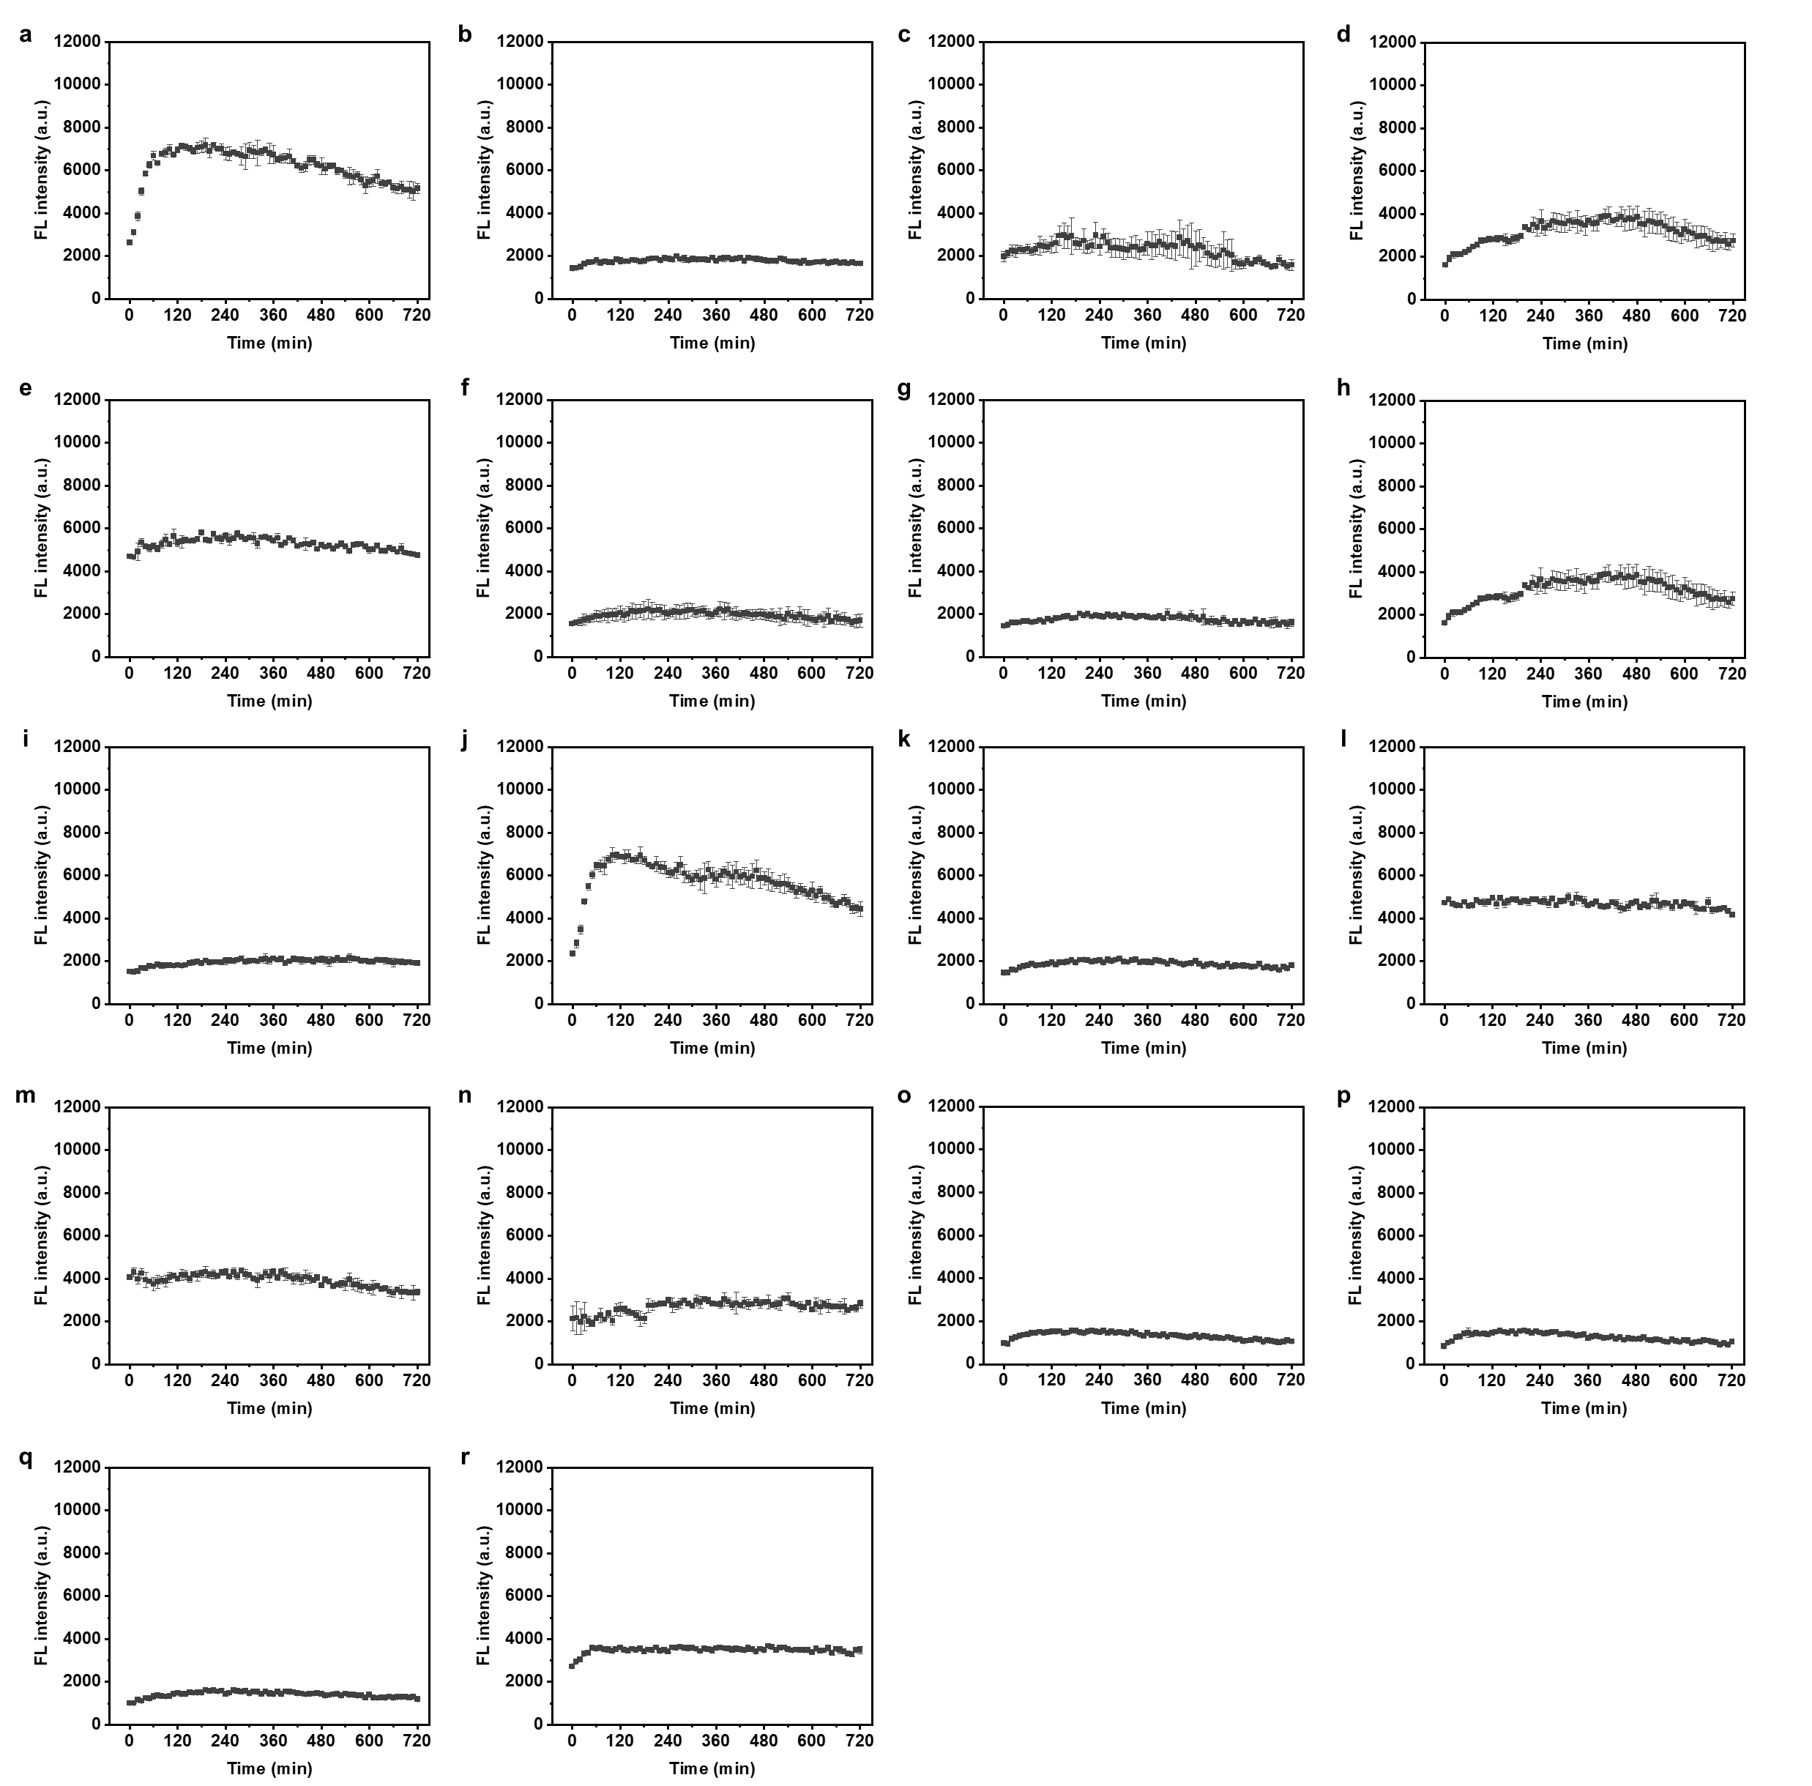

Figure S26. In vitro Q-OB assay results for early AD diagnosis using patients’ CSF samples. Time-dependent fluorescence intensity change of Q-OB (1 μM)-treated AD dementia (ADD) CSF samples during coincubation (37°C, 200 rpm, for 12 h) with exogenously added mAβ_{1–42} (10 μM) from sample number 44 to 61 in Table S5 (a to r, respectively).

Supporting Information References
1 Drake, J. M., Lesiecki, M. L. & Camaioni, D. M. Photophysics and cis-trans isomerization of DCM. Chem. Phys. Lett. 113, 530–534, doi:https://doi.org/10.1016/0009-2614(85)85026-0 (1985).
2 Brouwer, A. M. Standards for photoluminescence quantum yield measurements in solution (IUPAC Technical Report). 83, 2213–2228, doi:doi:10.1351/PAC-REP-10-09-31 (2011).
3 Gaussian 16 Rev. C.01 (Wallingford, CT, 2016).
4 Chai, J.-D. & Head-Gordon, M. Long-range corrected hybrid density functionals with damped atom–atom dispersion corrections. Phys. Chem. Chem. Phys. 10, 6615–6620, doi:10.1039/B810189B (2008).
5 Barone, V., Cimino, P. & Stendardo, E. Development and Validation of the B3LYP/N07D Computational Model for Structural Parameter and Magnetic Tensors of Large Free Radicals. J. Chem. Theory Comput. 4, 751–764, doi:10.1021/ct800034c (2008).
6 Le Bahers, T., Adamo, C. & Ciofini, I. A Qualitative Index of Spatial Extent in Charge-Transfer Excitations. J. Chem. Theory Comput. 7, 2498–2506, doi:10.1021/ct200308m (2011).
7 Lu, T. & Chen, F. Multiwfn: A multifunctional wavefunction analyzer. J. Comput. Chem. 33, 580–592, doi:https://doi.org/10.1002/jcc.22885 (2012).
8 Yanai, T., Tew, D. P. & Handy, N. C. A new hybrid exchange–correlation functional using the Coulomb-attenuating method (CAM-B3LYP). Chem. Phys. Lett. 393, 51–57, doi:https://doi.org/10.1016/j.cplett.2004.06.011 (2004).
9 Teoh, C. L. et al. Chemical Fluorescent Probe for Detection of Aβ Oligomers. J. Am. Chem. Soc. 137, 13503–13509, doi:10.1021/jacs.5b06190 (2015).
10 Zhang, X. et al. Near-infrared fluorescence molecular imaging of amyloid beta species and monitoring therapy in animal models of Alzheimer’s disease. Proc. Natl. Acad. Sci. U. S. A. 112, 9734–9739, doi:10.1073/pnas.1505420112 (2015).
11 Zhang, X. et al. Design and Synthesis of Curcumin Analogues for in Vivo Fluorescence Imaging and Inhibiting Copper-Induced Cross-Linking of Amyloid Beta Species in Alzheimer’s Disease. J. Am. Chem. Soc. 135, 16397–16409, doi:10.1021/ja405239v (2013).
12 Li, Y. et al. Tuning the stereo-hindrance of a curcumin scaffold for the selective imaging of the soluble forms of amyloid beta species. Chem. Sci. 8, 7710–7717, doi:10.1039/C7SC02050C (2017).
13 Yang, J. et al. Half-curcumin analogues as PET imaging probes for amyloid beta species. Chem. Commun. 55, 3630–3633, doi:10.1039/C8CC10166C (2019).
14 Yang, J. et al. Highly specific detection of Aβ oligomers in early Alzheimer's disease by a near-infrared fluorescent probe with a “V-shaped” spatial conformation. Chem. Commun. 56, 583–586, doi:10.1039/C9CC08894F (2020).
15 Ge, Y. et al. Curcumin Complex Analogues as Near-Infrared Fluorescent Probes for Monitoring all Aβ Species in the Early Alzheimer’s Disease Model. ACS Chem. Neurosci. 12, 3683–3689, doi:10.1021/acschemneuro.1c00419 (2021).
16 Lv, G. et al. A spiropyran-based fluorescent probe for the specific detection of β-amyloid peptide oligomers in Alzheimer's disease. Chem. Commun. 52, 8865–8868, doi:10.1039/C6CC02741E (2016).
17 Li, Y. et al. Fluoro-substituted cyanine for reliable in vivo labelling of amyloid-β oligomers and neuroprotection against amyloid-β induced toxicity. Chem. Sci. 8, 8279–8284, doi:10.1039/C7SC03974C (2017).
18 Lv, G. et al. A novel near-infrared fluorescent probe for detection of early-stage Aβ protofibrils in Alzheimer's disease. Chem. Commun. 56, 1625–1628, doi:10.1039/C9CC09233A (2020).
19 Li, H. et al. Detection of Aβ oligomers in early Alzheimer’s disease diagnose by in vivo NIR-II fluorescence imaging. Sens. Actuator B-Chem. 358, 131481, doi:https://doi.org/10.1016/j.snb.2022.131481 (2022).
20 Jameson, L. P. & Dzyuba, S. V. Aza-BODIPY: Improved synthesis and interaction with soluble Aβ1–42 oligomers. Bioorg. Med. Chem. Lett. 23, 1732–1735, doi:https://doi.org/10.1016/j.bmcl.2013.01.065 (2013).
21 Sun, L. et al. Amphiphilic Distyrylbenzene Derivatives as Potential Therapeutic and Imaging Agents for Soluble and Insoluble Amyloid β Aggregates in Alzheimer’s Disease. J. Am. Chem. Soc. 143, 10462–10476, doi:10.1021/jacs.1c05470 (2021).
22 Lee, D., Kim, S. M., Kim, H. Y. & Kim, Y. Fluorescence Chemicals To Detect Insoluble and Soluble Amyloid-β Aggregates. ACS Chem. Neurosci. 10, 2647–2657, doi:10.1021/acschemneuro.9b00199 (2019).
23 An, J. et al. Picomolar-sensitive β-amyloid fibril fluorophores by tailoring the hydrophobicity of biannulated π-elongated dioxaborine-dyes. Bioact. Mater. 13, 239–248, doi:https://doi.org/10.1016/j.bioactmat.2021.10.047 (2022).
24 Cho, I. et al. Immobilized Amyloid Hexamer Fragments to Map Active Sites of Amyloid-Targeting Chemicals. ACS Chem. Neurosci. 14, 9–18, doi:10.1021/acschemneuro.2c00449 (2023).

