Extended Data Figures

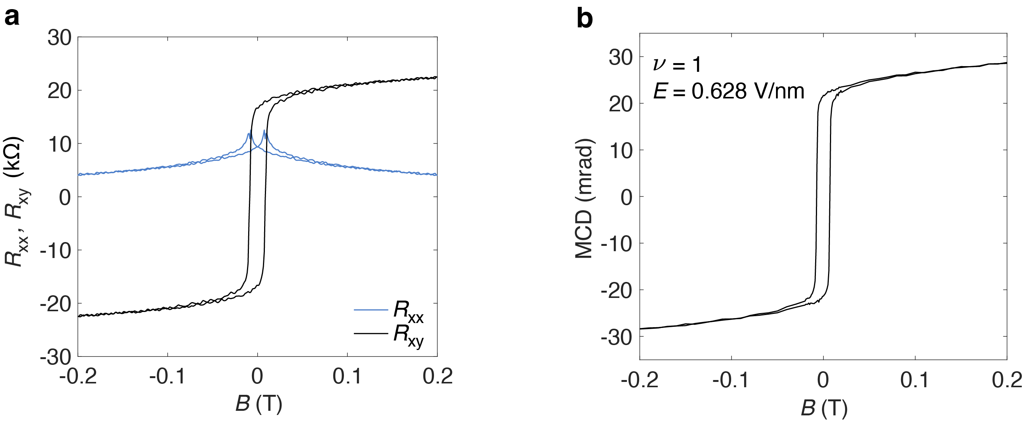

Extended Data Figure 1 | Basic characterization for the Chern insulator. a, Magnetic-field dependence of $R_{xx}$ and $R_{xy}$ at 1.6 K for the Chern insulating state ($V_{tg}$=-4.693V, $V_{bg}$=3.528V). Nearly quantized $R_{xy}$ and vanishing $R_{xx}$are observed at magnetic fields higher than 0.2 T. b, The corresponding magnetic-field dependent MCD. A hysteresis is observed, consistent with the transport results and with the emergence of a ferromagnetic state.

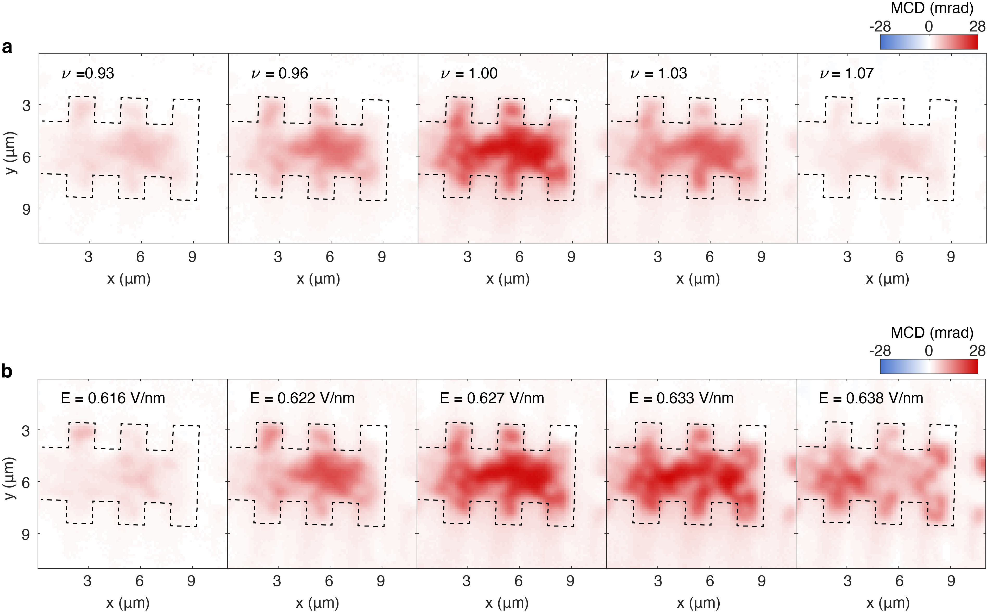

Extended Data Figure 2 | Zero-bias MCD images at varying fillings and electric fields. a, b, Zero-bias spontaneous MCD images at varying filling factors and fixed $E=0.628$ V/nm (a) and at varying electric fields and fixed $ν=1$ (b). Temperature is at 1.6 K. Black dashed lines mark the sample boundaries. Strongest MCD is observed at the Chern insulating state ($ν=1$ and $E=0.633$ V/nm); the MCD signal decreases with detuned $ν$ and $E$. MCD inhomogeneity originating from strain and/or twist angle disorders is also observed.

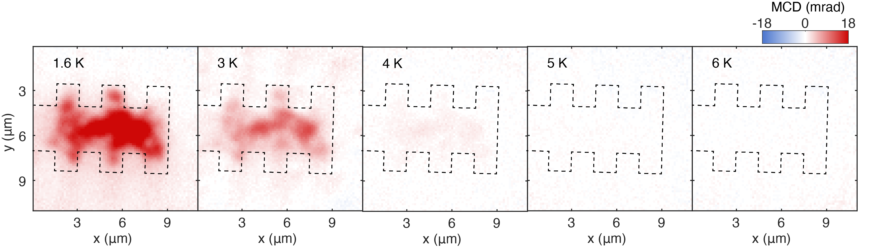

Extended Data Figure 3 | Temperature dependent spontaneous MCD. Zero-bias spontaneous MCD images at varying temperatures for the Chern insulating state ($V_{tg}$=-4.693V, $V_{bg}$=3.528V). Spontaneous MCD is observed below about 5 K. Black dashed lines mark the sample boundaries.

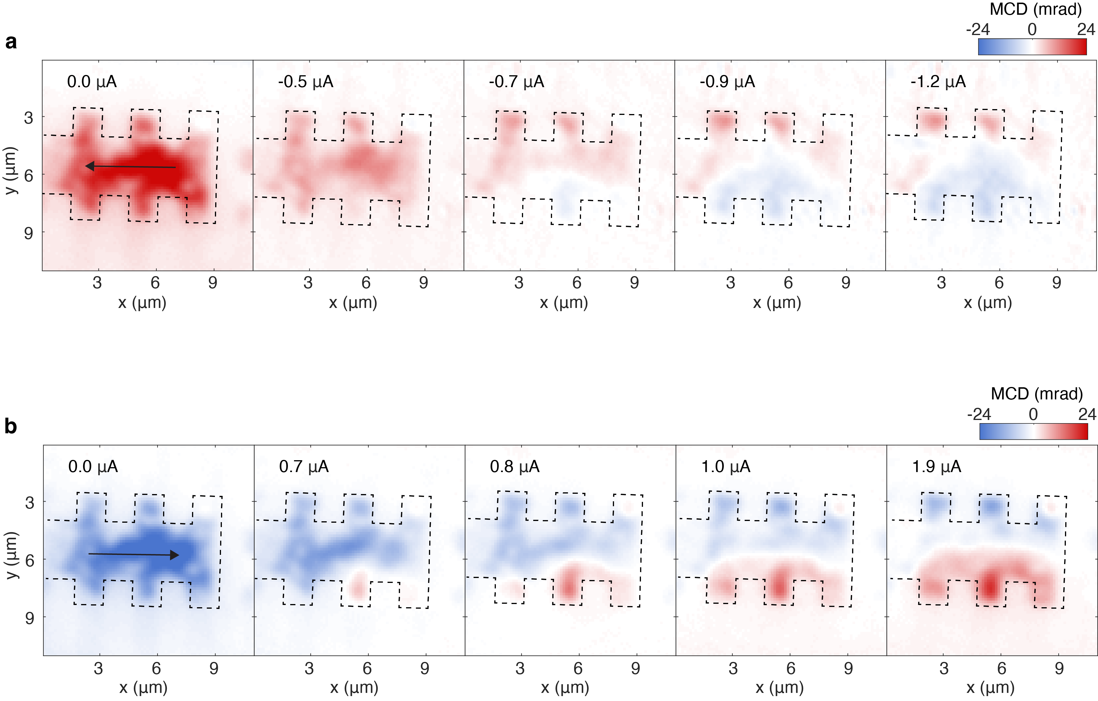

Extended Data Figure 4 | Dependence of the SHE on the directions of bias current and spontaneous magnetization. a, MCD images at 1.6 K under reversed bias current compared to Fig. 2b. Positive spontaneous MCD is prepared at zero bias. The current-induced edge MCD has opposite signs compared to Fig. 2b, consistent with the bulk SHE beyond QAH breakdown. b, MCD images at 1.6 K with spontaneous MCD opposite to that in Fig. 2b. The same current-induced MCD images are observed at high bias, demonstrating that the SHE is independent of the spontaneous magnetization direction.

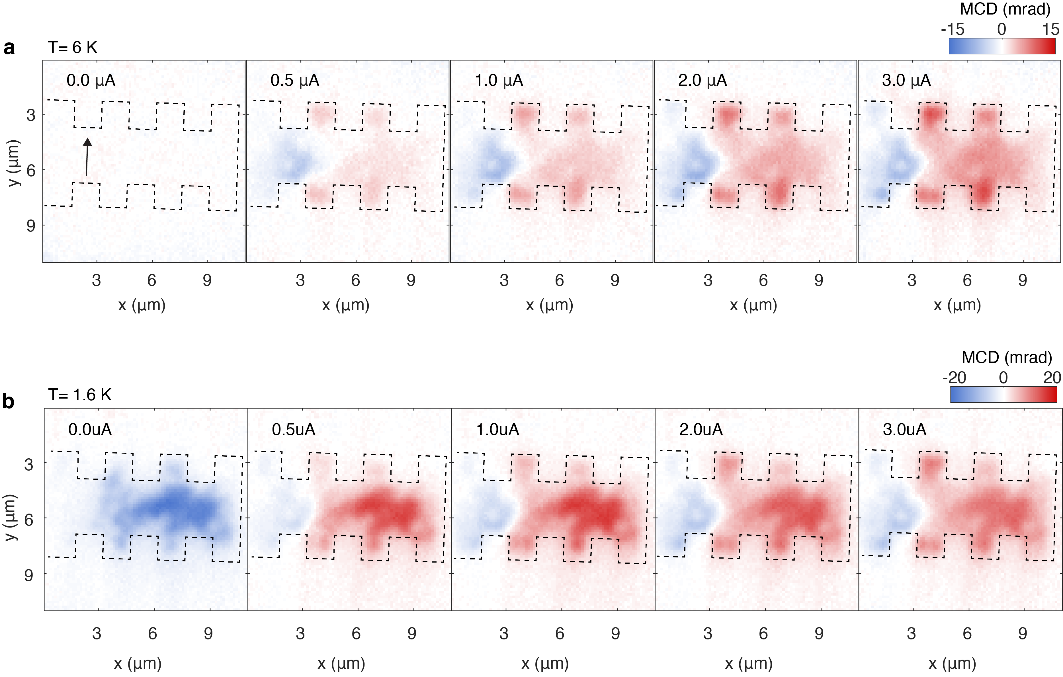

Extended Data Figure 5 | SHE with currents biased along the short axis. MCD images at 6 K (a) and 1.6 K (b) under varying bias currents. The bias current is along the short axis near one end of the Hall bar. The current is confined to a small region near the tip of the electrodes. Opposite magnetizations are observed on two sides of the current and the magnitude increases with increasing bias current. The current path, identified from zero MCD, deviates from a straight line due to sample inhomogeneities. Spontaneous MCD is also observed at 1.6 K under zero bias. The spontaneous MCD is quenched beyond the QAH breakdown. The 1.6 K and 6 K MCD images are nearly identical under high bias.

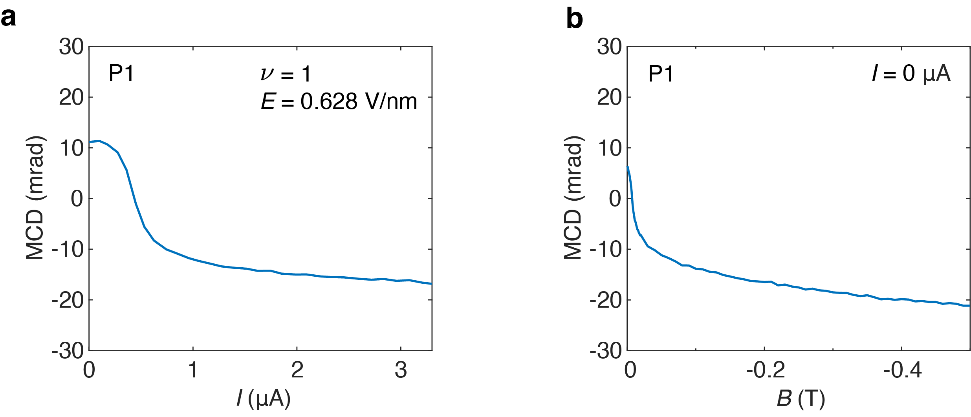

Extended Data Figure 6 | Giant spin accumulation at high bias. a, Bias current-dependent edge MCD at 1.6 K for the Chern insulating state (at P1 in Fig. 2a). A QAH breakdown is observed near 0.5 µA, where the MCD switches sign. b, The corresponding magnetic field dependent zero-bias MCD at the same sample location. We can see that the current-induced MCD at high bias (a) is as strong as the zero-bias MCD near magnetic saturation at 0.5 T (b). The results demonstrate the giant spin accumulation on sample edges due to the SHE.

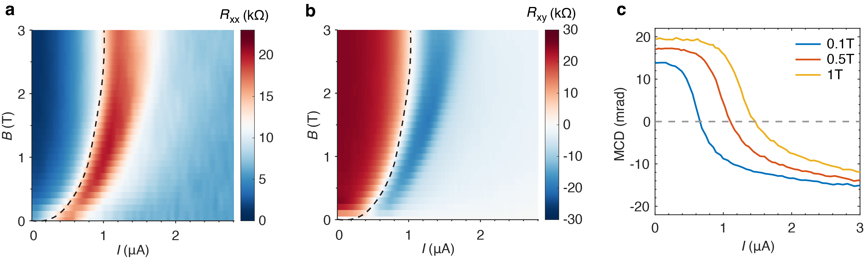

Extended Data Figure 7 | Magnetic field dependent QAH breakdown. a, b, Dependence of $R_{xx}$ (a) and $R_{xy}$ (b) on the bias current and magnetic field at 1.6 K for the Chern insulating state. QAH breakdown is signified by rapid changes in both $R_{xx}$ and $R_{xy}$ (the dashed lines). The critical current for the QAH breakdown increases with magnetic field. c, Corresponding bias current-dependent edge MCD (at P1 in Fig. 2a) at representative magnetic fields. The MCD switches sign at the QAH breakdown critical current, which increases with magnetic field, consistent with the transport results.

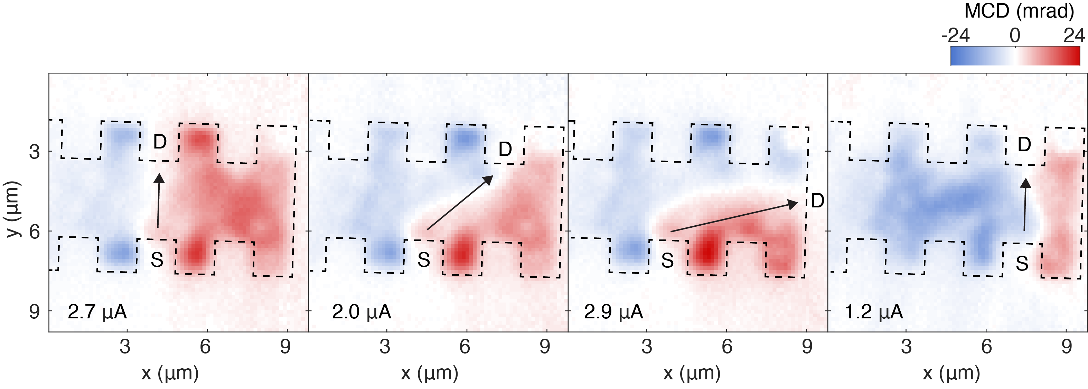

Extended Data Figure 8 | SHE with different bias current path. MCD images at 1.6 K and $ν=1$ using different pairs of Hall probes as the source (S) and drain (D). The bias current is shown in each panel. Black dashed lines mark the sample boundaries; and arrows show the bias current direction. Due to the SHE, the sample is split into two domains of opposite MCD according to the bias current path. The current path centerline, where the MCD is zero, deviates from a straight line connecting S and D due to sample inhomogeneity.

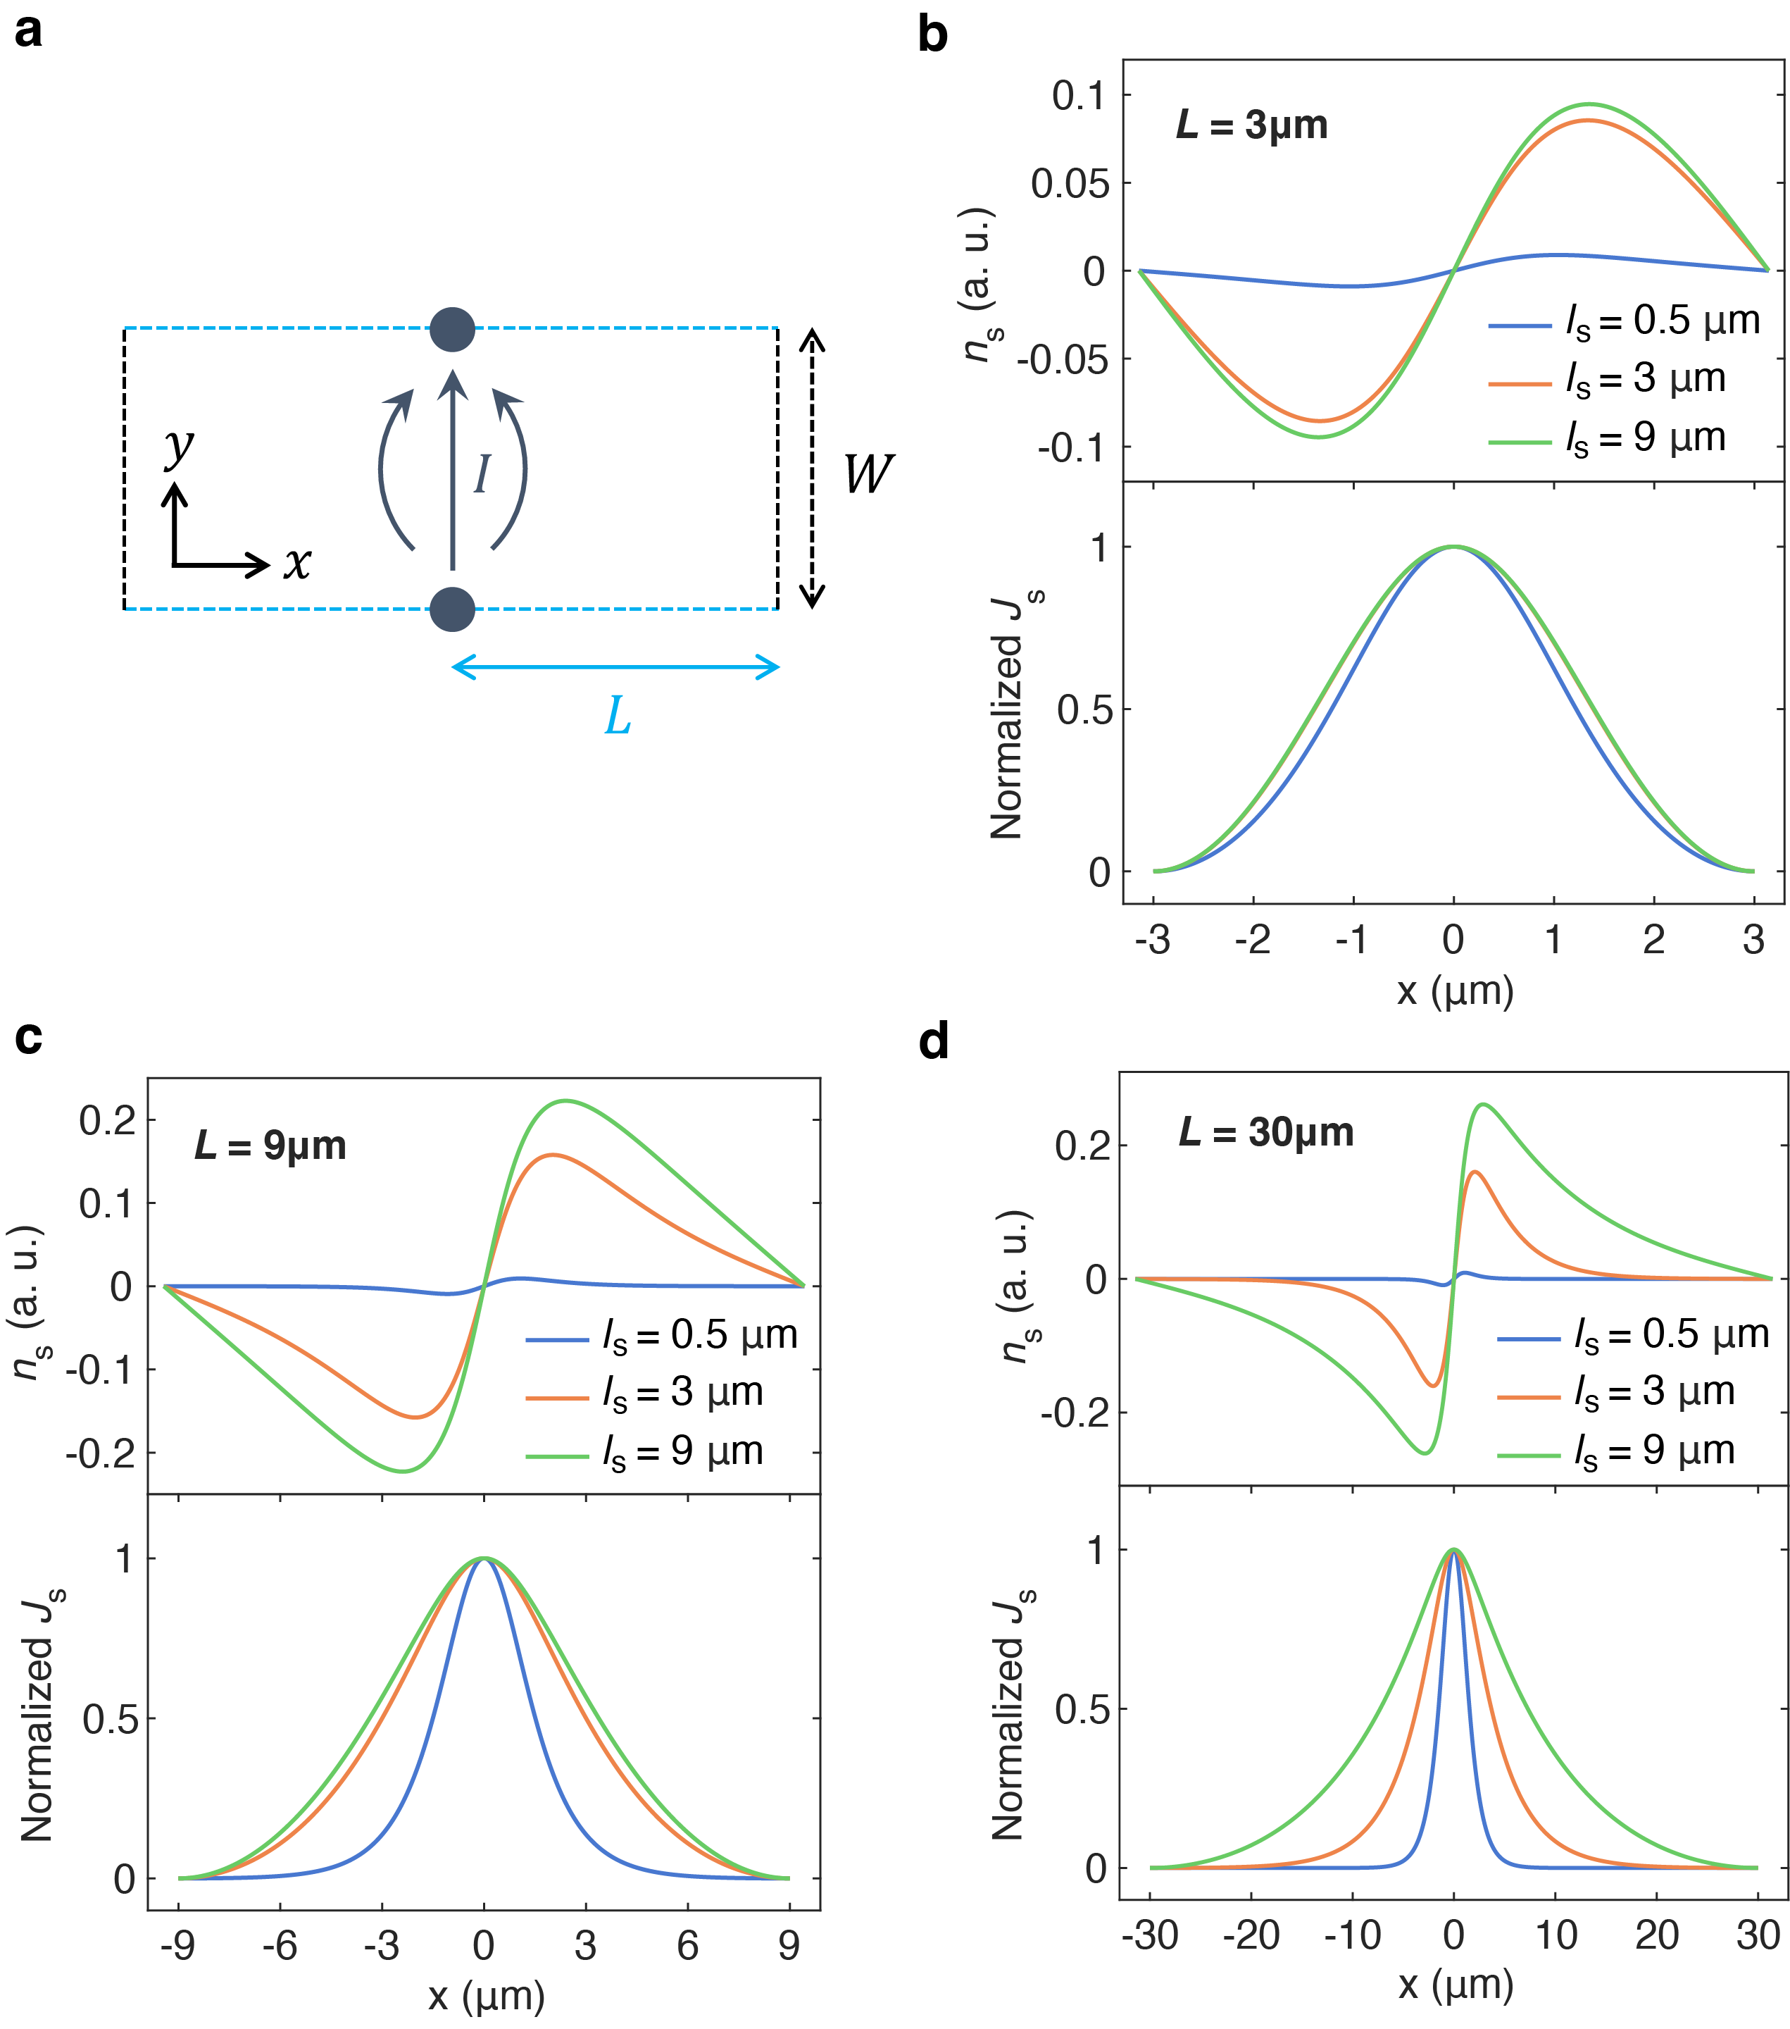

Extended Data Figure 9 | Steady state drift-diffusion model in non-local geometry. a, Schematic sample geometry with half-length $L$ and width $W$. The coordinate system is set up such that the sample center is at the origin. Current ejection/extraction points are marked by dark blue disks at $x=0, y=±W/2$. b, c, d, Spin density $n_{s}$ and spin current density $J_{s}$ profile at $y=0$ for representative spin diffusion lengths with sample geometry $L=3μm$(b), $9μm$(c), $30μm$(d) and fixed $W=3μm$. A Hall angle of $π/6$ is used in all cases. With increasing $L$, the spin density becomes more localized around the current centerline and the spin current density $J_{s}$shows stronger dependence on the spin diffusion length.

