SUPPORTING INFORMATION
Virtual flavonoids screening identifies potent compounds against enterovirus A71 and coxsackievirus A16
Amita Sripattarphan¹, Kamonpan Sanachai², Warinthorn Chavasiri³, Peter Wolschann⁵, Thierry Langer⁴, Siwaporn Boonyasuppayakorn^{6,*}, and Thanyada Rungrotmongkol^{1,7,*}
¹ Center of Excellence in Structural and Computational Biology, Department of Biochemistry, Faculty of Science, Chulalongkorn University, Bangkok 10330, Thailand.
² Department of Biochemistry, Faculty of Science, Khon Kaen University, Khon Kaen 40002, Thailand.
³ Center of Excellence in Natural Products Chemistry, Department of Chemistry, Faculty of Science, Chulalongkorn University, Bangkok 10330, Thailand.
⁴ Department of Pharmaceutical Chemistry, Faculty of Life Sciences, University of Vienna, Althanstraße 14, A-1090 Vienna, Austria.
⁵ Institute of Theoretical Chemistry, University of Vienna, Vienna 1090, Austria.
⁶ Applied Medical Virology Research Unit, Department of Microbiology, Faculty of Medicine, Chulalongkorn University, Bangkok 10330, Thailand.
⁷ Program in Bioinformatics and Computational Biology, Graduate School, Chulalongkorn University, Bangkok 10330, Thailand.
* Corresponding author. Tel: +66 2 2185426; Fax: +66 2 2185418; E-mail: thanyada.r@chula.ac.th

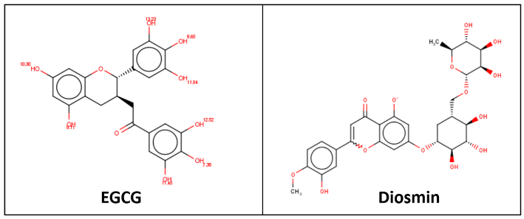
Fig S1. The protonation states of the potent ligands (EGCG and diosmin) were predicted at physiological pH 7.4 by MarvinSketch.

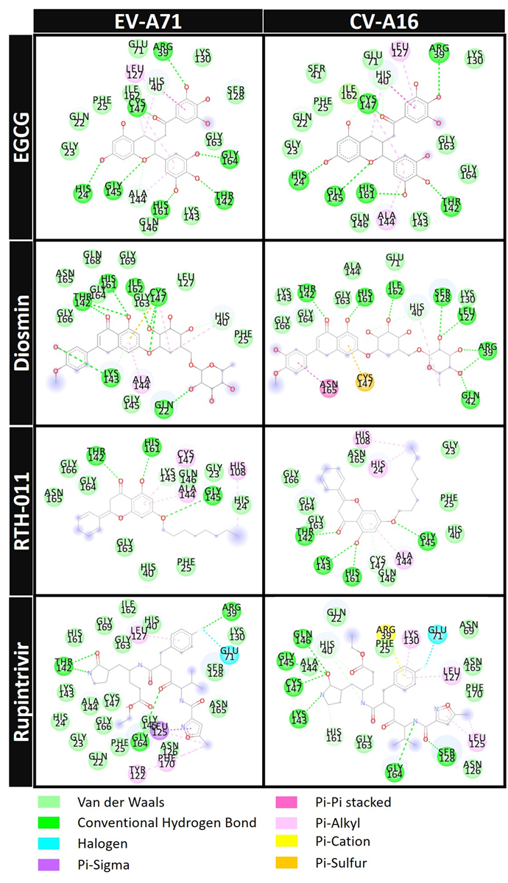
Fig S2. 2D interactions of potent compounds and rupintrivir in EV-A71 and CV-A16 3Cpro complexes.

Table S1. The cytotoxicity, inhibitory activity and selective index of diosmin and EGCG toward RD cell infection by EV-A71 andCV-A16.
Compounds | CC₅₀ | EV-A71 |  | CV-A16
Compounds | CC₅₀ | EC₅₀ | SI | EC₅₀ | SI
Diosmin | >500 | 21.02±1.57µM | 23.80 | 30.68±3.25 µM | 16.30
EGCG | >100 | 12.86±1.30 µM | 7.77 | 15.54±1.50 µM | 6.43
Rupintrivir | >100 | 47.33±8.04 nM | 2112.97 | 49.33±7.3 nM | 2027.16

