Table 1. List of hit compounds with their pharmacophore fit and fitness scores with EV-A71 and CV-A16 3Cpro.
Compound | Structure | Pharmacophore fit score |  | Fitness score
Compound | Structure | EV-A71 | CV-A16 | EV-A71 | CV-A16
Diosmin | 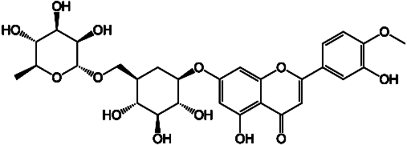 | 47.7 | 47.9 | 69.3 | 64.0
EGCG | 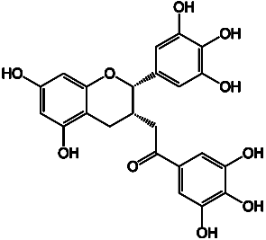 | 47.6 | 47.7 | 60.6 | 60.5
RTH-011 | 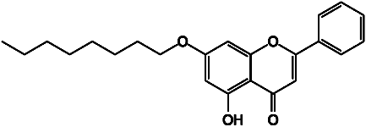 | 47.0 | 47.4 | 56.2 | 53.9
RTH-010 | 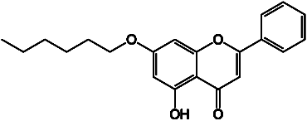 | - | 45.5 | - | -
RTH-012 | 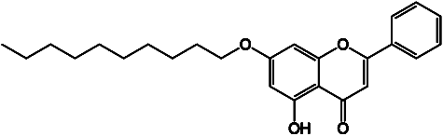 | - | 45.5 | - | -
Rupintrivir  (reference) | 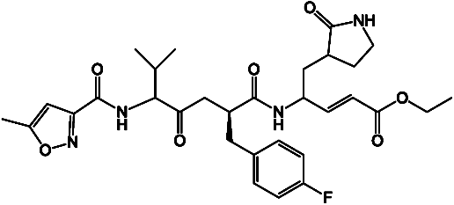 | 46.8 | 46.9 | 84.9 | 65.0

