AUTHOR BIOGRAPHY
Preeti Sehrawat [1] and Mridul Chawla [2]
[1] preeti.sehrawat89@gmail.com
[2] mridulchawla.ece@dcrustm.org
[1] Department of ECE, D.C.R.U.S.T. Murthal & Department of ECE, M.S.I.T. New Delhi
[2] Department of ECE, D.C.R.U.S.T. Murthal

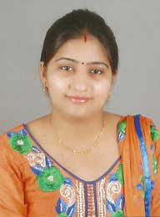
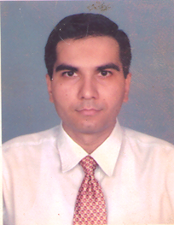Preeti Sehrawat received B.E. and M.Tech from M.D.U. Rohtak and currently pursuing her Ph.D. from DCRUST Murthal in the area of vehicular networking and wireless communication under the guidance of Dr. Mridul Chawla. She is particularly interested in vehicular communication in 5G. Currently working as an Assistant Professor in Maharaja Surajmal Institute of Technolgy, Janakpuri (New Delhi).

Dr. Mridul Chawla received Ph.D (Electronics and Communication Engineering) M. E. (Electronics Product Design and Technology) B. E. (Electronics and Telecommunication) and current he is working as Associate Professor DCRUST Murthal (ECE Department).

