Table 1: Functional analysis of the DEG clusters. The first column gives the snapshot of the PPI network of each of the 4 clusters built with the DEGs (Supp. Fig. 1-4 contain the zoomed-in figure for each cluster). The second column gives the number of participating genes (of the DEGs). The third and fourth columns are the overlapping DEGs with differential chromatin domains (DCDs) and differentially methylated regions (DMRs), respectively. Finally, the fifth column provides a summary of the studied functional categories that the genes in the cluster have been linked to.

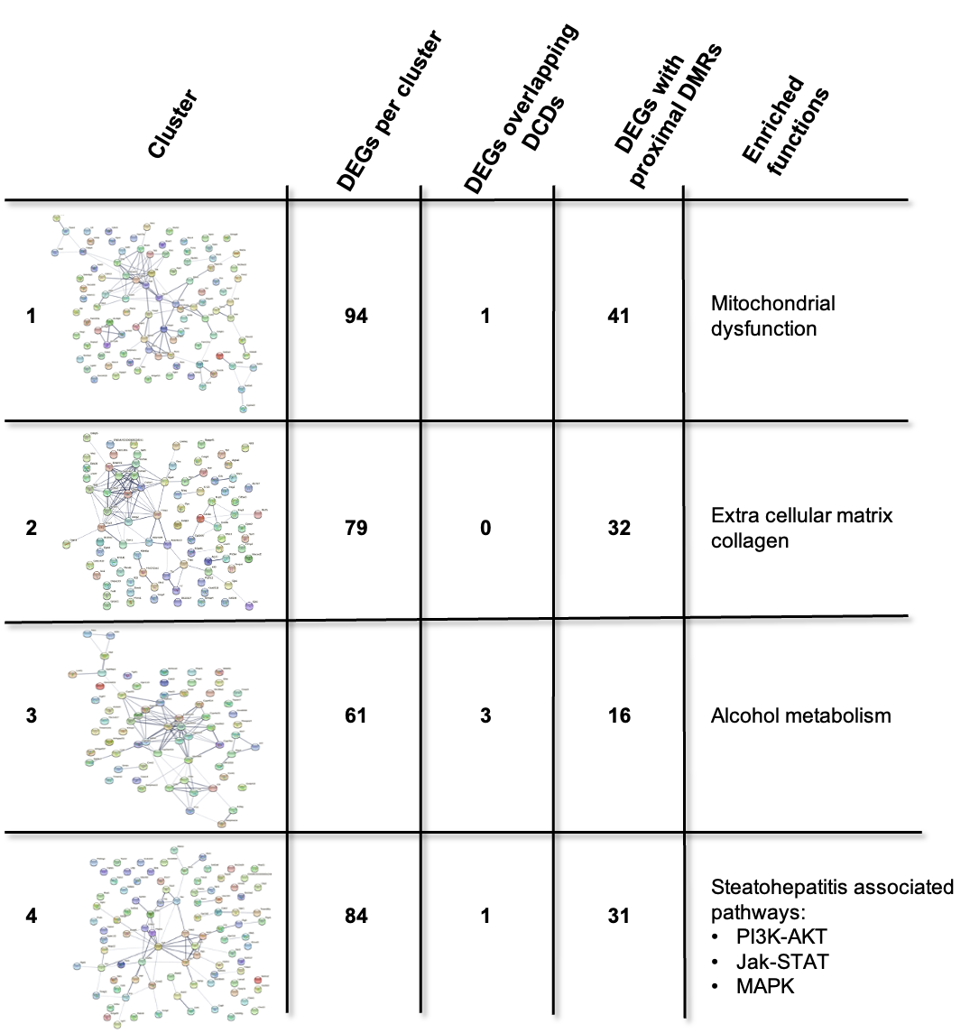

Table 2: Experiments for investigating CpG methylation status based on conditions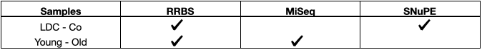

Table 3: Investigated CpGs with association to genetic age. The first, second and third columns give the position and the associated annotation of the respective CpG. The fourth column denotes if a CpG was discovered as a new locus or reported before [13]. mm10 was used as the reference genome.
Position | Gene | Annotation | Source
chr 4: 141251015 - 141251016 | Arhgef19 | (+) exon 13 | new loci
chr 15 : 11383946 - 11383947 | Tars | (+) 3’UTR | new loci
chr 9: 85324737 - 85324738 | Tent5a | (+) exon 3 | new loci
chr 15: 76457712 - 76457713 | Scx | (+) exon 1 | new loci
chr 6: 94667253 - 94667254 | Lrig1 | (+) intron | Stubbs et al., 2017 [13]
chr 5: 33729707 - 33729708 | Fgfr3 | (+) exon 5 | Stubbs et al., 2017 [13]
chr 16: 30260867 - 30260868 | Cpn2 | (-) exon 2 | Stubbs et al., 2017 [13]
chr 1: 73959153 - 73959154 | Tns1 | (-) intron | Stubbs et al., 2017 [13]
chr 14: 51908372 - 51908373 | Ndrg2 | (-) exon 9 | Stubbs et al., 2017 [13]
chr 19: 26640521 - 26640522 | Smarca2 | (+) intron | Stubbs et al., 2017 [13]
chr 5: 92364789 - 92364790 | Art3 | (+) intron | Stubbs et al., 2017 [13]
chr 4: 154557099 - 154557100 | Prdm16 | (-) exon / intron | Stubbs et al., 2017 [13]
chr 7: 139559949 - 139559950 | Inpp5a | (+) intron | Stubbs et al., 2017 [13]

