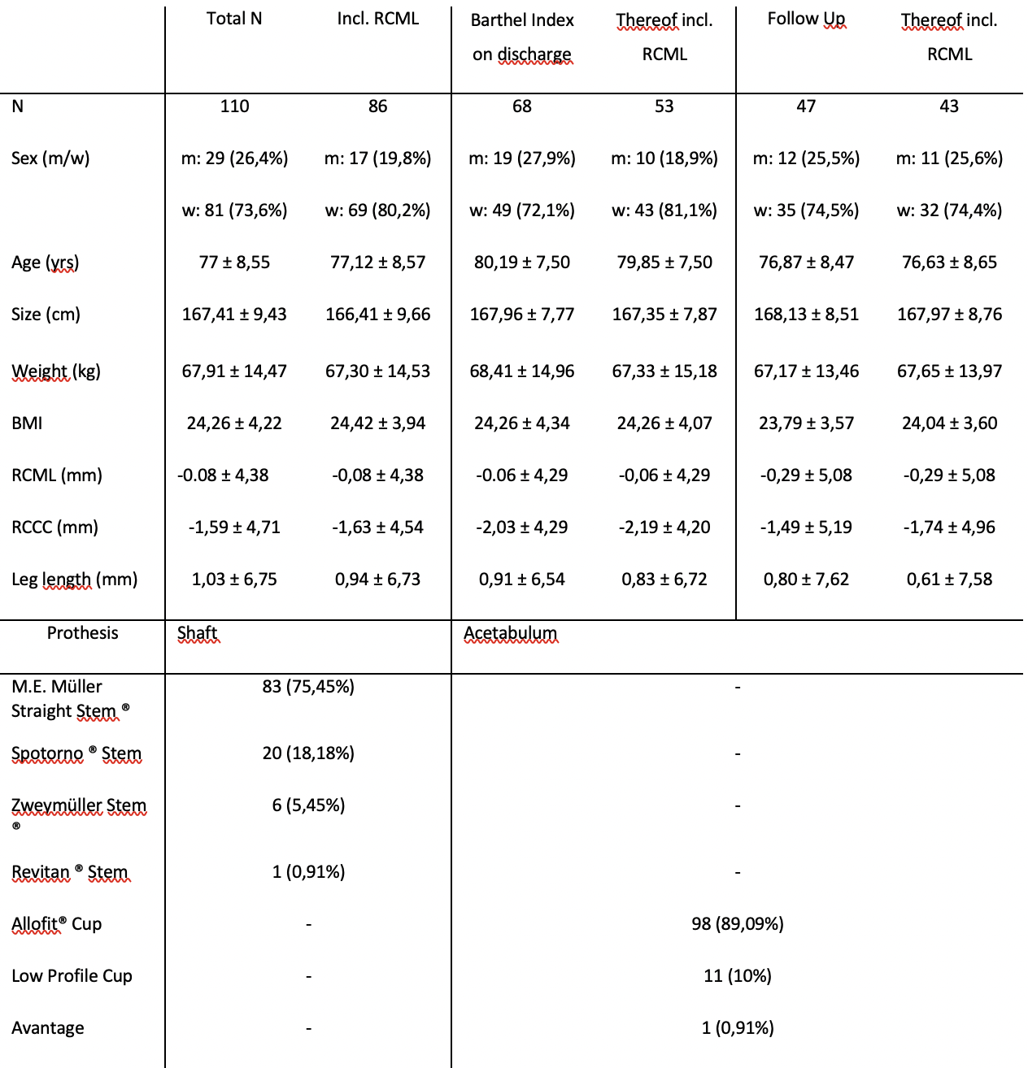
Table 1: Overview of all variables collected including case numbers of the different endpoints and standard deviations and of all total endoprostheses used in the patient collective (Zimmer Biomet).

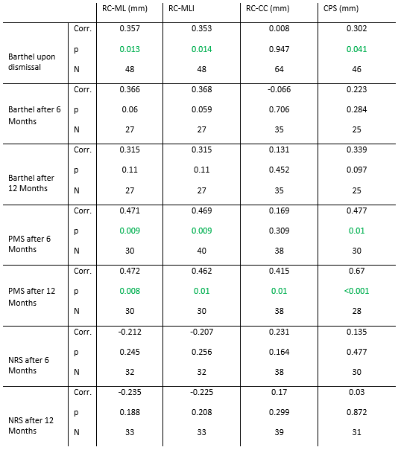
Table 2: Spearman Correlations of COR-reconstruction with Barthel's Index, PMS and NRS

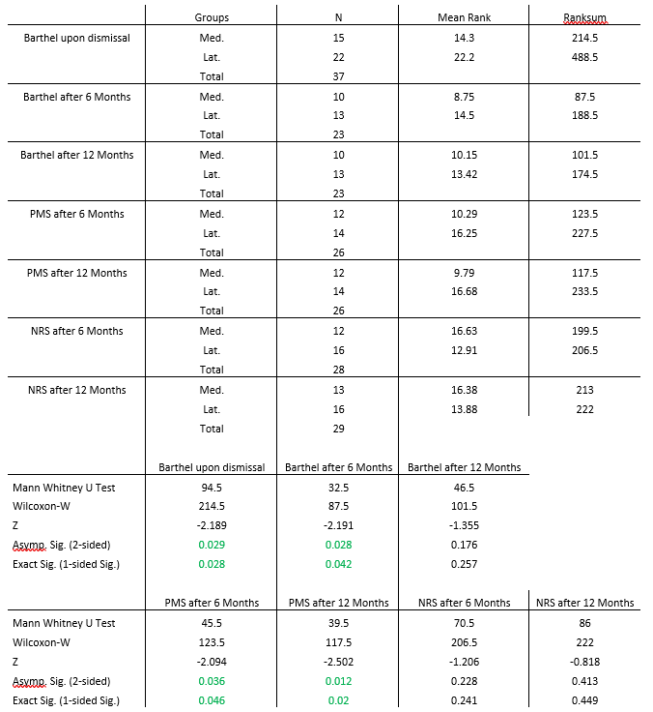

Table 3: Mann-Whitney U-Test between groups medialized (Med.) and lateralized (Lat.) COR's by more than 2 mm

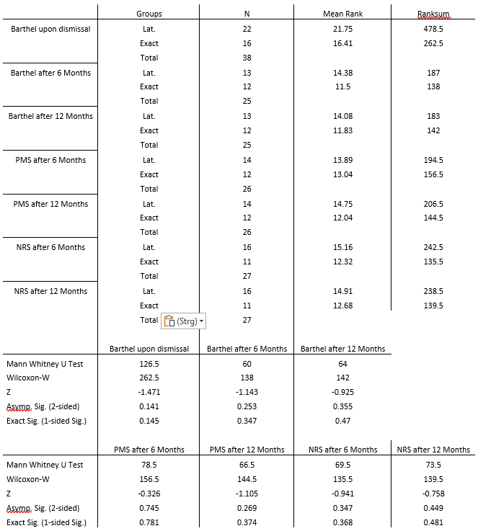

Table 4: Mann-Whitney U-Test between groups lateralized (Lat.) by more than 2 mm and with exact (Exact) COR-Reconstruction within +- 2 mm

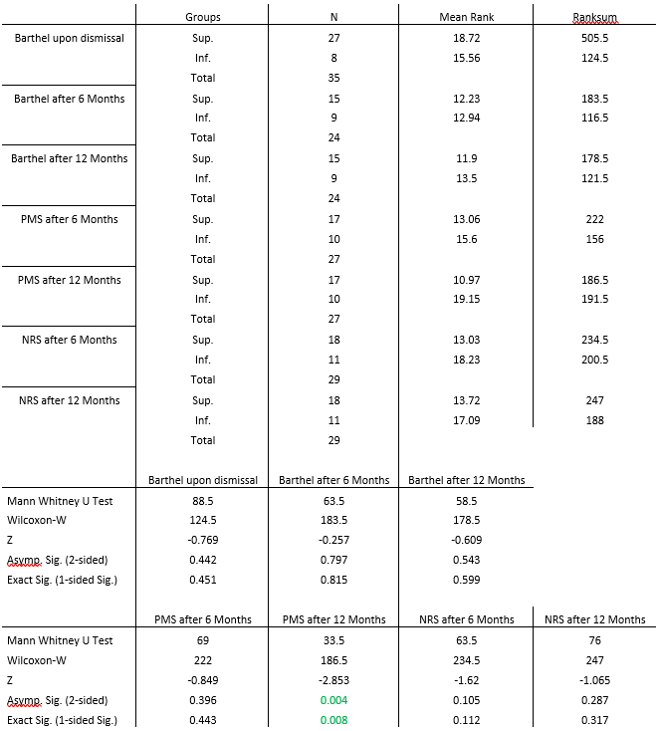

Table 5: Mann-Whitney U-Test between groups with superior COR placement (Sup.) and inferior COR placement (Inf.) COR by more than 2 mm

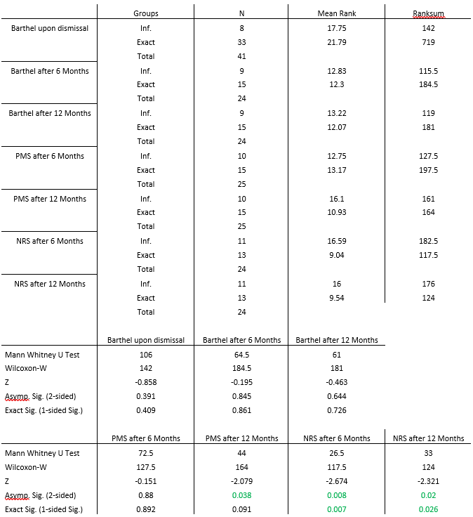

Table 6: Mann-Whitney U-Test between groups with inferior COR placement (Inf.) by more than 2 mm and exact COR-Reconstruction (Exact) within +- 2 mm

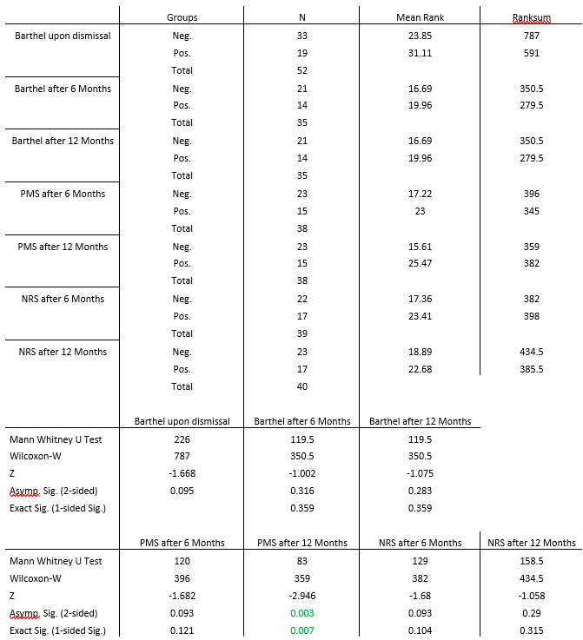

Table 7: Mann-Whitney U-Test between groups with positive (Pos.) and negative (Neg.) CPS

