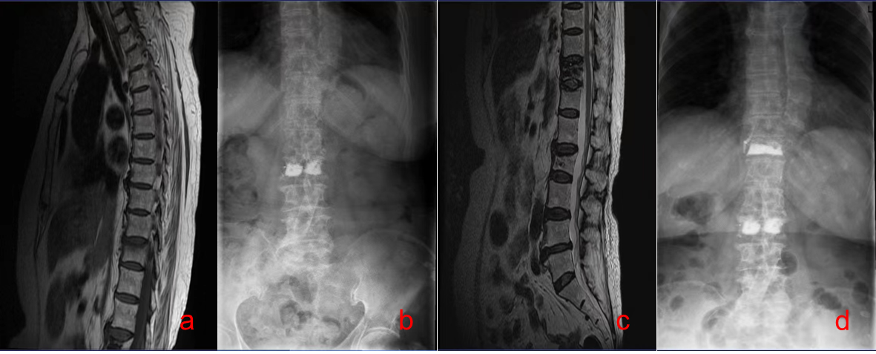
a 74-year-old woman with a history of diabetes, first vertebral fracture (a) and postoperative imaging findings(b). The patient had poor glycemic control and developed another vertebral fracture 3 months later (c). Postoperative X-ray examination (d) was performed.

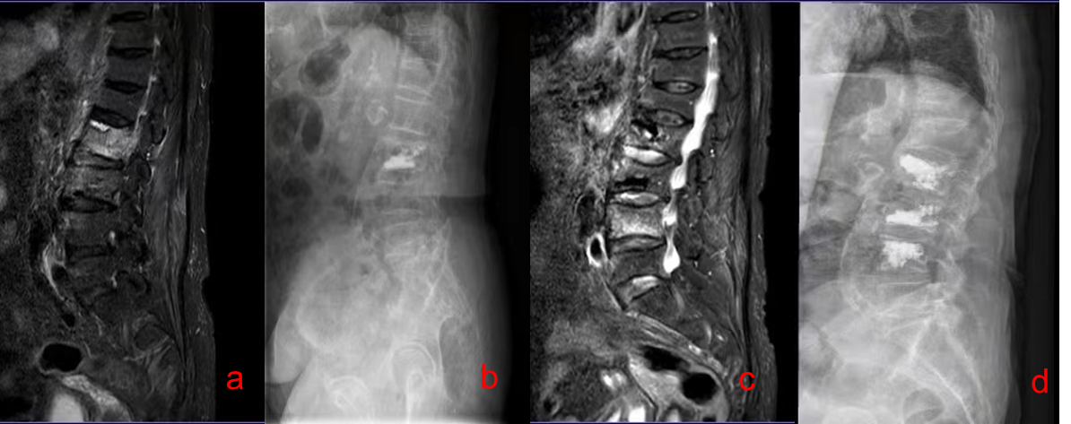
Imaging results of first vertebral fracture (a) and postoperative (b) in a 70-year-old woman with no previous history of diabetes. The patient's blood glucose was well controlled, and vertebral fracture occurred again 27 months later (c). Postoperative X-ray examination (d) was performed.

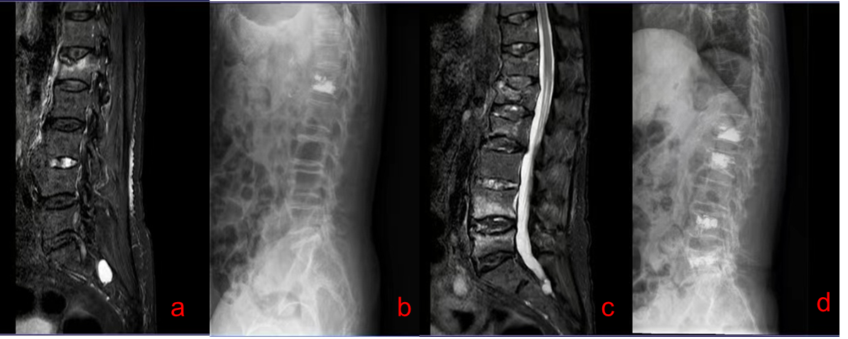

Imaging results of first vertebral fracture (a) and postoperative (b) in an 80-year-old man with a history of diabetes. The patient's blood glucose was well controlled, and vertebral fracture occurred again 13 months later (c). Postoperative X-ray examination (d) was performed.

