Supplementary Materials
Table S1 ICD10 codes of cardiometabolic diseases
Table S2 Full names and field IDs of variables for the construction of biological ages.
Table S3 Description and field IDs of frailty.
Table S4 Calculation of the Framingham risk score and SCORE2 algorithm in the UK Biobank.
Table S5 Correlation matrix of the accelerated biological aging.
Table S6 Associations of the accelerated biological aging with the risks of first cardiometabolic disease, cardiometabolic multimorbidity, and mortality using Cox model.
Table S7 Associations and Overall Harrell’s and Uno’s C-statistics of Framingham risk score and SCORE2 with the trajectories of cardiometabolic multimorbidity using multi-state model.
Table S8 Associations of the accelerated biological aging with the trajectories of cardiometabolic multimorbidity of pattern A using multi-state model excluding participants older than 70 years.
Table S9 Associations of the accelerated biological aging with the trajectories of cardiometabolic multimorbidity of pattern A using multi-state model in white participants.
Table S10 Associations of the accelerated biological aging with the trajectories of cardiometabolic multimorbidity of pattern A using multi-state model by the age of the onset of first cardiometabolic disease.
Table S11 Associations of the accelerated biological aging with the trajectories of cardiometabolic multimorbidity of pattern A using multi-state model, stratified by smoking status.
Table S12 Associations of the accelerated biological aging with the trajectories of cardiometabolic multimorbidity of pattern A using multi-state model, stratified by alcohol drinking status.
Table S13 Associations of the accelerated biological aging with the trajectories of cardiometabolic multimorbidity of pattern A using multi-state model, stratified by physical activity.
Table S14 Associations of the accelerated biological aging with the trajectories of cardiometabolic multimorbidity of pattern A using multi-state model, stratified by sex.
Figure S1 Flowchart of participant selection
Figure S2 Associations of the accelerated biological aging with the risks of first cardiometabolic disease, cardiometabolic multimorbidity, and death after the first cardiometabolic disease of pattern B using multi-state model
Figure S3 Dose-response curves (smoothed by RCS function with three knots of frailty and the accelerated biological aging with the transition from baseline to FCMD and from FCMD to CMM of pattern A
Solid lines: point estimates; Shadows: 95% confidence limits;

Table S1 ICD10 codes of cardiometabolic diseases
Diseases | Classification of diseases | ICD10 codes
IHD | Angina pectoris | I20
IHD | Acute myocardial infarction | I21
IHD | Subsequent myocardial infarction | I22
IHD | Certain current complications following acute myocardial infarction | I23
IHD | Other acute ischaemic heart diseases | I24
IHD | Chronic ischaemic heart disease | I25
Stroke | Subarachnoid haemorrhage | I60
Stroke | Intracerebral haemorrhage | I61
Stroke | Other nontraumatic intracranial haemorrhage | I62
Stroke | Cerebral infarction | I63
Stroke | Stroke, not specified as haemorrhage or infarction | I64
Stroke | Occlusion and stenosis of precerebral arteries, not resulting in cerebral infarction | I65
Stroke | Occlusion and stenosis of cerebral arteries, not resulting in cerebral infarction | I66
Stroke | Other cerebrovascular diseases | I67
Stroke | Cerebrovascular disorders in diseases classified elsewhere | I68
Stroke | Sequelae of cerebrovascular disease | I69
T2D | Non-insulin-dependent diabetes mellitus | E11

Table S2 Full names and field IDs of variables for the construction of biological ages.
Employed to construct KDM‐BA | Employed to construct PhenoAge | Labels in the current study | Full name in UK Biobank data dictionary | Field ID
√ |  | FEV₁ (L) | Forced expiratory volume in 1-second (FEV₁) | 3063
√ |  | SBP (mm Hg) | Systolic blood pressure, automated reading | 4080
√ |  | Total Cholesterol (mg/dL) | Cholesterol | 30690
√ |  | Glycated hemoglobin (%) | Glycated haemoglobin (HbA1c) | 30750
√ |  | Blood urea nitrogen (mg/dL) | Urea | 30670
 | √ | Lymphocyte (%) | Lymphocyte percentage | 30180
 | √ | Mean cell volume (fL) | Mean sphered cell volume | 30270
 | √ | Serum glucose (mg/dL) | Glucose | 30740
 | √ | Red cell distribution width (%) | Red blood cell (erythrocyte) distribution width | 30070
 | √ | White blood cell count (1000 cells/uL) | White blood cell (leukocyte) count | 30000
√ | √ | Albumin (g/dL) | Albumin | 30600
√ | √ | Creatinine (mg/dL) | Creatinine | 30700
√ | √ | C-reactive protein (mg/dL) | C-reactive protein | 30710
√ | √ | Alkaline phosphatase (U/L) | Alkaline phosphatase | 30610

Individuals component | Frailty | Field ID
Weight loss | Self-reported: “Compared with one year ago, has your weight changed?”  Options:  Yes: weight loss in the previous year.  No: another option. | 2306
Tiredness or lack of energy | Self-reported: “Over the past two weeks, how often have you felt tired or had little energy?”  Options:  Yes: more than half time or every day  No: another option | 20519
Low physical activity levels | Self-reported: UK Biobank physical activity questionnaire. We classified the responses into: none (no physical activity in the last 4 weeks), low (light DIY activity [eg, pruning, watering the lawn] only in the past 4 weeks), medium (heavy DIY activity [eg, weeding, lawn mowing, carpentry and digging], walking for pleasure, or other exercises in the past 4 weeks), and high (strenuous sports in the past 4 weeks) (response: none or light activity with a frequency of once per week or less=1, medium or heavy activity, or light activity more than once per week=0 | 6164
Low grip strength | No: another option." Measured grip strength expressed in kg by ethnicity-and BMI adjusted cut-off points.  Cut-off points:  Men  If BMI ≤24 & grip strength ≤ 29  If BMI 24·1 - 26 & grip strength ≤ 30  If BMI 26·1 - 28 & grip strength ≤ 30  If BMI >28 & grip strength ≤ 32  Women  If BMI ≤23 & grip strength ≤ 17  If BMI 23·1 - 26 & grip strength ≤ 17·3  If BMI 26·1 - 29 & grip strength ≤ 18  If BMI >29 & grip strength ≤ 21 | 46
Slow gait speed | Self-reported: How do you describe your usual walking pace? (a proxy for gait speed)  Options:  Yes: slow  No: average or brisk pace | 47

Table S3 Description and field IDs of frailty.

Table S4 Calculation of the Framingham risk score and SCORE2 algorithm in the UK Biobank.
Risk factor (units) | Transformation  equation | Log SHR |  | Calculation of 10-year cumulative incidence
Risk factor (units) | Transformation  equation | Male | Female | Male |  | Female
Framingham risk score
Age (yrs) | log(age) | 3.06117 | 2.32888 | $\sum{β }$=  3.06117 * log(age)  + (1.93303 * (1-trtbp)  +1.99881*trtbp)*log (sbp)  +1.1237*log ( tchol*38.665)  + (-0.93263) * log (hdl)  +0.65451*smoking  10-yr risk = 1-0.8843^exp($\sum{β}x-23.9388)$  Predicted risk = 10-yr risk * 100% | $\sum{β }$=  2.32888 * log(age)  + (2.76157 * (1-trtbp)  +2.82263* trtbp) * log (sbp)  +1.2090 * log (tchol*38.665)  + (-0.70833) * log (hdl)  +0.52873*smoking  10-yr risk = 1-0. 94833^exp($\sum{β}x-26.0145)$  Predicted risk = 10-yr risk * 100%
Smoking (current vs. other) |  | 0.65451 | 0.52873
Diabetes (yes vs. no) |  | 0.57367 | 0.69154
Treated and untreated Systolic Blood Pressure | trtbp | 1.99881 (treated)  1.93303  (untreated) | 2.82263  (treated)  2.76157  (untreated)
Systolic Blood Pressure (SBP, mm Hg) | sbp | - | -
Total cholesterol (mg/dL) | log (tchol) | 1.12370 | 1.20904
HDL cholesterol (mg/dL) | log (hdl) | -0.93263 | -0.70833
SCORE2
Age (yrs) | cage = (age - 60)/5 | 0.3742 | 0.4648 | $\sum{β(x-x_{cen})}$ = 0.3742* cage  + 0.1458 * ctchol  -0.2698* chdl  + 0.2777* csbp  + 0.6457* diabetes  + 0.6012* smoking  -0.0281* cage * ctchol  +0.0426* cage * chdl  -0.0255* cage * csbp  -0.0983* cage * diabetes  -0.0755* cage * smoking  10-yr risk = 1-0.9605^exp($\sum{β}(x-x_{cen}))$  Predicted risk = 10-yr risk * 100% | $\sum{β(x-x_{cen})}$ = 0.4648* cage  + 0.1002 * ctchol  -0.2606* chdl  + 0.3131* csbp  + 0.6457* diabetes  + 0.8096* smoking  -0.0226* cage * ctchol  +0.0613* cage * chdl  -0.0277* cage * csbp  -0.1272* cage * diabetes  -0.1088* cage * smoking  10-yr risk = 1-09776^exp($\sum{β}(x-x_{cen}))$  Predicted risk = 10-yr risk * 100%
Smoking (current vs. other) | Current = 1, other = 0 | 0.6012 | 0.7744
Systolic blood pressure (SBP, mm Hg) | csbp = (sbp - 120)/20 | 0.2777 | 0.3131
Diabetes (yes vs. no) | Yes = 1, no = 0 | 0.6457 | 0.8096
Total cholesterol (mmol/L) | ctchol = (tchol - 6)/1 | 0.1458 | 0.1002
HDL cholesterol (mmol/L) | chdl = (hdl - 1.3)/0.5 | -0.2698 | -0.2606
Smoking * age interaction | cage * smoking | -0.0755 | -0.1088
SBP * age interaction | cage * csbp | -0.0255 | -0.0277
Total cholesterol * age interaction | cage * ctchol | -0.0281 | -0.0226
HDL cholesterol * age interaction | cage * chdl | 0.0426 | 0.0613
Diabetes *age interaction | cage * diabetes | -0.0983 | -0.1272
Note: For risk prediction in the target population of individuals without diabetes this risk factor will always be 0, meaning the coefficient can effectively be ignored.

Table S5 Correlation matrix of the accelerated biological aging.
Characteristic | Pearson correlation coefficients
Characteristic | KDM-BA acceleration | PhenoAge acceleration | Frailty status
KDM‐BA acceleration | 1 | 0.140 | 0.142
PhenoAge acceleration | 0.140 | 1 | 0.147
Frailty status | 0.142 | 0.147 | 1

Note: All coefficients have a p-value <0.0001

Table S6 Associations of the accelerated biological aging with the risks of first cardiometabolic disease, cardiometabolic multimorbidity, and mortality using Cox model.
Characteristic | First cardiometabolic disease |  | Cardiometabolic multimorbidity |  | Mortality
Characteristic | HR (95% CI) | p-values | HR (95% CI) | p-values | HR (95% CI) | p-values
KDM‐BA acceleration | 1.019 (1.017, 1.020) | <0.0001 | 1.024 (1.019, 1.029) | <0.0001 | 1.035 (1.032, 1.037) | <0.0001
PhenoAge acceleration | 1.042 (1.040, 1.044) | <0.0001 | 1.062 (1.056, 1.067) | <0.0001 | 1.064 (1.061, 1.066) | <0.0001
Frailty status
non-frail | Ref. |  | Ref. |  | Ref.
pre-frail | 1.367 (1.333, 1.403) | <0.0001 | 1.634 (1.500, 1.780) | <0.0001 | 1.359 (1.307, 1.413) | <0.0001
frail | 2.132 (2.035, 2.234) | <0.0001 | 2.496 (2.172, 2.868) | <0.0001 | 2.332 (2.170, 2.506) | <0.0001
Notes: Models adjusted for age, sex, ethnicity, BMI, years of education, smoking status, moderate alcohol intake, high-level physical activity, total household income, and employment status. Estimates of KDM‐BA acceleration and PhenoAge acceleration were demonstrated per SD increase.

Table S7 Associations and Overall Harrell’s and Uno’s C-statistics of Framingham risk score and SCORE2 with the trajectories of cardiometabolic multimorbidity using multi-state model.
 | HR (95%CI) | p-values | Harrell's C-statistics  HR (95%CI) | Uno's C-statistics  HR (95%CI)
Framingham risk score
Pattern A
Baseline→FCMD | 1.09 (1.07, 1.10) | <0.0001 | 0.6322  (0.6295, 0.6350) | 0.6370  (0.6324, 0.6415)
Baseline→Death | 0.98 (0.95, 1.01) | 0.142 | 0.6322  (0.6295, 0.6350) | 0.6370  (0.6324, 0.6415)
FCMD→CMM | 1.09 (1.04, 1.14) | <0.001 | 0.6322  (0.6295, 0.6350) | 0.6370  (0.6324, 0.6415)
FCMD→Death | 0.98 (0.93, 1.02) | 0.352 | 0.6322  (0.6295, 0.6350) | 0.6370  (0.6324, 0.6415)
CMM→Death | 0.98 (0.88, 1.09) | 0.746 | 0.6322  (0.6295, 0.6350) | 0.6370  (0.6324, 0.6415)
Pattern B
Baseline→IHD | 1.16 (1.14, 1.19) | <0.0001 | 0.6322  (0.6295, 0.6348) | 0.6366  (0.6321, 0.6412)
Baseline→T2D | 0.99 (0.96, 1.01) | 0.33 | 0.6322  (0.6295, 0.6348) | 0.6366  (0.6321, 0.6412)
Baseline→Stroke | 1.24 (1.18, 1.30) | <0.0001 | 0.6322  (0.6295, 0.6348) | 0.6366  (0.6321, 0.6412)
Baseline→Death | 0.98 (0.95, 1.00) | 0.103 | 0.6322  (0.6295, 0.6348) | 0.6366  (0.6321, 0.6412)
IHD→CMM | 1.05 (0.97, 1.13) | 0.266 | 0.6322  (0.6295, 0.6348) | 0.6366  (0.6321, 0.6412)
IHD→Death | 0.95 (0.89, 1.02) | 0.132 | 0.6322  (0.6295, 0.6348) | 0.6366  (0.6321, 0.6412)
T2D→CMM | 1.21 (1.15, 1.28) | <0.0001 | 0.6322  (0.6295, 0.6348) | 0.6366  (0.6321, 0.6412)
T2D→Death | 1.07 (0.99, 1.16) | 0.071 | 0.6322  (0.6295, 0.6348) | 0.6366  (0.6321, 0.6412)
Stroke→CMM | 1.00 (0.85, 1.17) | 0.957 | 0.6322  (0.6295, 0.6348) | 0.6366  (0.6321, 0.6412)
Stroke→Death | 0.88 (0.79, 0.97) | 0.012 | 0.6322  (0.6295, 0.6348) | 0.6366  (0.6321, 0.6412)
CMM→Death | 0.99 (0.89, 1.09) | 0.8 | 0.6322  (0.6295, 0.6348) | 0.6366  (0.6321, 0.6412)
SCORE2
Pattern A
Baseline→FCMD | 1.08 (1.06, 1.10) | <0.0001 | 0.6535  (0.6509, 0.6562) | 0.6604  (0.6559, 0.6648)
Baseline→Death | 0.99 (0.96, 1.02) | 0.899 | 0.6535  (0.6509, 0.6562) | 0.6604  (0.6559, 0.6648)
FCMD→CMM | 1.10 (1.05, 1.16) | <0.0001 | 0.6535  (0.6509, 0.6562) | 0.6604  (0.6559, 0.6648)
FCMD→Death | 0.98 (0.93, 1.04) | 0.436 | 0.6535  (0.6509, 0.6562) | 0.6604  (0.6559, 0.6648)
CMM→Death | 0.97 (0.85, 1.11) | 0.746 | 0.6535  (0.6509, 0.6562) | 0.6604  (0.6559, 0.6648)
Pattern B
Baseline→IHD | 1.12 (1.10, 1.15) | <0.0001 | 0.6533  (0.6508, 0.6559) | 0.6596  (0.6552, 0.6641)
Baseline→T2D | 1.01 (0.98, 1.04) | 0.64 | 0.6533  (0.6508, 0.6559) | 0.6596  (0.6552, 0.6641)
Baseline→Stroke | 1.27 (1.21, 1.34) | <0.0001 | 0.6533  (0.6508, 0.6559) | 0.6596  (0.6552, 0.6641)
Baseline→Death | 0.99 (0.96, 1.02) | 0.394 | 0.6533  (0.6508, 0.6559) | 0.6596  (0.6552, 0.6641)
IHD→CMM | 1.06 (0.97, 1.17) | 0.207 | 0.6533  (0.6508, 0.6559) | 0.6596  (0.6552, 0.6641)
IHD→Death | 0.94 (0.86, 1.02) | 0.132 | 0.6533  (0.6508, 0.6559) | 0.6596  (0.6552, 0.6641)
T2D→CMM | 1.23 (1.15, 1.31) | <0.0001 | 0.6533  (0.6508, 0.6559) | 0.6596  (0.6552, 0.6641)
T2D→Death | 1.07 (0.97, 1.17) | 0.178 | 0.6533  (0.6508, 0.6559) | 0.6596  (0.6552, 0.6641)
Stroke→CMM | 0.90 (0.74, 1.09) | 0.266 | 0.6533  (0.6508, 0.6559) | 0.6596  (0.6552, 0.6641)
Stroke→Death | 0.86 (0.76, 0.96) | 0.01 | 0.6533  (0.6508, 0.6559) | 0.6596  (0.6552, 0.6641)
CMM→Death | 0.98 (0.86, 1.12) | 0.77 | 0.6533  (0.6508, 0.6559) | 0.6596  (0.6552, 0.6641)

Notes: The multistate models adjusted for age, sex, ethnicity, BMI, years of education, smoking status, moderate alcohol intake, high-level physical activity, total household income, and employment status. Estimates of Framingham risk score and SCORE2 were demonstrated per SD increase. For overall Harrell’s and Uno’s C-statistics, no covariates were adjusted in the predictive performance analysis.

Table S8 Associations of the accelerated biological aging with the trajectories of cardiometabolic multimorbidity of pattern A using multi-state model excluding participants older than 70 years.
 | HR (95%CI) | p-values
KDM‐BA acceleration
Baseline→FCMD | 1.24 (1.22, 1.26) | <0.0001
Baseline→Death | 1.46 (1.41, 1.51) | <0.0001
FCMD→CMM | 1.16 (1.10, 1.23) | <0.0001
FCMD→Death | 1.25 (1.17, 1.32) | <0.0001
CMM→Death | 1.38 (1.20, 1.59) | <0.0001
PhenoAge acceleration
Baseline→FCMD | 1.25 (1.23, 1.26) | <0.0001
Baseline→Death | 1.38 (1.36, 1.40) | <0.0001
FCMD→CMM | 1.16 (1.12, 1.20) | <0.0001
FCMD→Death | 1.21 (1.17, 1.25) | <0.0001
CMM→Death | 1.25 (1.16, 1.34) | <0.0001
Frailty status
Baseline→FCMD
non-frail | Ref.
pre-frail | 1.42 (1.38, 1.46) | <0.0001
frail | 2.25 (2.14, 2.36) | <0.0001
Baseline→Death
non-frail | Ref.
pre-frail | 1.36 (1.30, 1.42) | <0.0001
frail | 2.33 (2.14, 2.55) | <0.0001
FCMD→CMM
non-frail | Ref.
pre-frail | 1.29 (1.18, 1.41) | <0.0001
frail | 1.39 (1.21, 1.61) | <0.0001
FCMD→Death
non-frail | Ref.
pre-frail | 1.14 (1.04, 1.25) | 0.006
frail | 1.42 (1.22, 1.66) | <0.0001
CMM→Death
non-frail | Ref.
pre-frail | 0.81 (0.64, 1.03) | 0.082
frail | 0.86 (0.61, 1.22) | 0.393

Notes: Models adjusted for age, sex, ethnicity, BMI, years of education, smoking status, moderate alcohol intake, high-level physical activity, total household income, and employment status. Estimates of accelerated biological aging was demonstrated per SD increase.

Table S9 Associations of the accelerated biological aging with the trajectories of cardiometabolic multimorbidity of pattern A using multi-state model in white participants.
 | HR (95%CI) | p-values
KDM‐BA acceleration
Baseline→FCMD | 1.22 (1.20, 1.24) | <0.0001
Baseline→Death | 1.47 (1.42, 1.52) | <0.0001
FCMD→CMM | 1.11 (1.05, 1.17) | <0.001
FCMD→Death | 1.24 (1.18, 1.31) | <0.0001
CMM→Death | 1.46 (1.27, 1.69) | <0.0001
PhenoAge acceleration
Baseline→FCMD | 1.25 (1.23, 1.26) | <0.0001
Baseline→Death | 1.38 (1.36, 1.40) | <0.0001
FCMD→CMM | 1.16 (1.12, 1.19) | <0.0001
FCMD→Death | 1.22 (1.18, 1.26) | <0.0001
CMM→Death | 0.84 (0.50, 1.4) | 0.50
Frailty status
Baseline→FCMD
non-frail | Ref.
pre-frail | 1.37 (1.33, 1.40) | <0.0001
frail | 2.14 (2.04, 2.25) | <0.0001
Baseline→Death
non-frail | Ref.
pre-frail | 1.36 (1.30, 1.42) | <0.0001
frail | 2.41 (2.21, 2.62) | <0.0001
FCMD→CMM
non-frail | Ref.
pre-frail | 1.20 (1.09, 1.31) | <0.0001
frail | 1.23 (1.06, 1.42) | 0.006
FCMD→Death
non-frail | Ref.
pre-frail | 1.12 (1.02, 1.23) | 0.015
frail | 1.40 (1.20, 1.63) | <0.0001
CMM→Death
non-frail | Ref.
pre-frail | 0.89 (0.71, 1.12) | 0.32
frail | 1.03 (0.73, 1.45) | 0.855

Notes: Models adjusted for age, sex, ethnicity, BMI, years of education, smoking status, moderate alcohol intake, high-level physical activity, total household income, and employment status. Estimates of accelerated biological aging was demonstrated per SD increase.

Table S10 Associations of the accelerated biological aging with the trajectories of cardiometabolic multimorbidity of pattern A using multi-state model by the age of the onset of first cardiometabolic disease.
Characteristic | Age of FCMD onset
Characteristic | <60 years |  | ≥60 years |  | p-values of interaction
Characteristic | HR (95%CI) | p-values | HR (95%CI) | p-values | p-values of interaction
KDM‐BA acceleration | 1.2116 (1.0790, 1.361)  a) | 0.001 | 1.1029 (1.0344, 1.1758) | 0.002 | 0.99
PhenoAge acceleration | 1.1960 (1.1274, 1.269) | <0.0001 | 1.1470 (1.1056, 1.1900) | <0.0001 | 0.31
Frailty status
non-frail | Ref.
pre-frail | 1.6001 (1.3158, 1.9458) | <0.0001 | 1.2183 (1.1012, 1.3479) | 0.0001 | 0.07
frail | 1.6356 (1.2162, 2.1997) | 0.001 | 1.3653 (1.1607, 1.6060) | 0.0001 | 0.96
Notes: Models adjusted for age, sex, ethnicity, BMI, years of education, smoking status, moderate alcohol intake, high-level physical activity, total household income, and employment status. Estimates were demonstrated per one SD increase. Interaction p-values were retrieved from models with the interaction term of age group and accelerated biological aging /frailty status.

Table S11 Associations of the accelerated biological aging with the trajectories of cardiometabolic multimorbidity of pattern A using multi-state model, stratified by smoking status.
 | Never-smoking |  | Ever-smoking |  | p-interaction
 | HR (95%CI) | p-values | HR (95%CI) | p-values | p-interaction
KDM‐BA acceleration
Baseline→FCMD | 1.26 (1.22, 1.30) | <0.0001 | 1.24 (1.22, 1.27) | <0.0001 | 0.134
Baseline→Death | 1.39 (1.31, 1.46) | <0.0001 | 1.55 (1.49, 1.61) | <0.0001 | 0.015
FCMD→CMM | 1.17 (1.07, 1.29) | <0.001 | 1.17 (1.09, 1.25) | <0.0001 | 0.815
FCMD→Death | 1.24 (1.11, 1.38) | <0.001 | 1.29 (1.20, 1.39) | <0.0001 | 0.238
CMM→Death | 1.70 (1.28, 2.26) | <0.001 | 1.33 (1.13, 1.55) | <0.001 | 0.342
PhenoAge acceleration
Baseline→FCMD | 1.22 (1.20, 1.24) | <0.0001 | 1.28 (1.26, 1.30) | <0.0001 | 0.006
Baseline→Death | 1.36 (1.33, 1.39) | <0.0001 | 1.42 (1.39, 1.44) | <0.0001 | 0.195
FCMD→CMM | 1.14 (1.09, 1.20) | <0.0001 | 1.18 (1.13, 1.23) | <0.0001 | 0.624
FCMD→Death | 1.18 (1.11, 1.25) | <0.0001 | 1.26 (1.22, 1.31) | <0.0001 | 0.086
CMM→Death | 1.40 (1.22, 1.61) | <0.0001 | 1.22 (1.12, 1.32) | <0.0001 | 0.066
Frailty status
Baseline→FCMD
non-frail | Ref.
pre-frail | 1.42 (1.36, 1.47) | <0.0001 | 1.44 (1.39, 1.49) | <0.0001 | 0.83
frail | 2.36 (2.19, 2.54) | <0.0001 | 2.26 (2.12, 2.40) | <0.0001 | 0.152
Baseline→Death
non-frail | Ref.
pre-frail | 1.30 (1.21, 1.39) | <0.0001 | 1.45 (1.36, 1.54) | <0.0001 | 0.054
frail | 2.16 (1.86, 2.50) | <0.0001 | 2.64 (2.37, 2.95) | <0.0001 | 0.065
FCMD→CMM
non-frail | Ref.
pre-frail | 1.30 (1.13, 1.51) | <0.001 | 1.29 (1.15, 1.44) | <0.0001 | 0.614
frail | 1.27 (1.00, 1.61) | 0.048 | 1.51 (1.26, 1.80) | <0.0001 | 0.536
FCMD→Death
non-frail | Ref.
pre-frail | 1.18 (1.01, 1.39) | 0.036 | 1.14 (1.02, 1.29) | 0.024 | 0.716
frail | 1.46 (1.11, 1.91) | 0.006 | 1.51 (1.25, 1.82) | <0.0001 | 0.812
CMM→Death
non-frail | Ref.
pre-frail | 0.80 (0.51, 1.24) | 0.32 | 0.82 (0.63, 1.08) | 0.163 | 0.945
frail | 0.66 (0.31, 1.40) | 0.279 | 0.94 (0.63, 1.39) | 0.743 | 0.451
Notes: Models adjusted for age, sex, ethnicity, BMI, years of education, moderate alcohol intake, high-level physical activity, total household income, and employment status. Estimates of accelerated biological aging was demonstrated per SD increase.

Table S12 Associations of the accelerated biological aging with the trajectories of cardiometabolic multimorbidity of pattern A using multi-state model, stratified by alcohol drinking status.
 | High alcohol intake |  | Low alcohol intake |  | p-interaction
 | HR (95%CI) | p-values | HR (95%CI) | p-values | p-interaction
KDM‐BA acceleration
Baseline→FCMD | 1.24 (1.21, 1.27) | <0.0001 | 1.24 (1.21, 1.27) | <0.0001 | <0.0001
Baseline→Death | 1.43 (1.37, 1.50) | <0.0001 | 1.48 (1.41, 1.55) | <0.0001 | 0.273
FCMD→CMM | 1.15 (1.07, 1.23) | <0.001 | 1.17 (1.08, 1.28) | <0.001 | 0.951
FCMD→Death | 1.26 (1.17, 1.36) | <0.0001 | 1.21 (1.10, 1.33) | <0.001 | 0.96
CMM→Death | 1.44 (1.21, 1.71) | <0.0001 | 1.29 (1.03, 1.62) | 0.026 | 0.66
PhenoAge acceleration
Baseline→FCMD | 1.27 (1.25, 1.29) | <0.0001 | 1.22 (1.20, 1.24) | <0.0001 | 0.002
Baseline→Death | 1.40 (1.37, 1.43) | <0.0001 | 1.36 (1.33, 1.39) | <0.0001 | 0.174
FCMD→CMM | 1.16 (1.11, 1.21) | <0.0001 | 1.16 (1.10, 1.21) | <0.0001 | 0.972
FCMD→Death | 1.22 (1.17, 1.28) | <0.0001 | 1.20 (1.14, 1.26) | <0.0001 | 0.417
CMM→Death | 1.27 (1.16, 1.39) | <0.0001 | 1.23 (1.09, 1.39) | <0.001 | 0.761
Frailty status
Baseline→FCMD
non-frail | Ref.
pre-frail | 1.46 (1.40, 1.51) | <0.0001 | 1.37 (1.32, 1.43) | <0.0001 | 0.005
frail | 2.29 (2.15, 2.44) | <0.0001 | 2.17 (2.01, 2.35) | <0.0001 | 0.033
Baseline→Death
non-frail | Ref.
pre-frail | 1.36 (1.27, 1.44) | <0.0001 | 1.36 (1.27, 1.46) | <0.0001 | 0.999
frail | 2.36 (2.11, 2.63) | <0.0001 | 2.28 (1.97, 2.63) | <0.0001 | 0.516
FCMD→CMM
non-frail | Ref.
pre-frail | 1.22 (1.08, 1.38) | 0.001 | 1.37 (1.20, 1.56) | <0.0001 | 0.26
frail | 1.47 (1.23, 1.75) | <0.0001 | 1.18 (0.92, 1.52) | 0.191 | 0.079
FCMD→Death
non-frail | Ref.
pre-frail | 1.17 (1.03, 1.33) | 0.019 | 1.10 (0.96, 1.26) | 0.177 | 0.567
frail | 1.47 (1.21, 1.79) | <0.0001 | 1.30 (1.00, 1.70) | 0.05 | 0.357
CMM→Death
non-frail | Ref.
pre-frail | 0.91 (0.66, 1.23) | 0.528 | 0.69 (0.48, 0.99) | 0.045 | 0.225
frail | 0.86 (0.56, 1.33) | 0.506 | 0.88 (0.47, 1.66) | 0.701 | 0.781
Notes: Models adjusted for age, sex, ethnicity, BMI, years of education, smoking status, high-level physical activity, total household income, and employment status. Estimates of accelerated biological aging was demonstrated per SD increase.

Table S13 Associations of the accelerated biological aging with the trajectories of cardiometabolic multimorbidity of pattern A using multi-state model, stratified by physical activity.
 | High-level physical activity |  | Low-level physical activity |  |  | p-interaction
 | HR (95%CI) | p-values |  | HR (95%CI) | p-values | p-interaction
KDM‐BA acceleration
Baseline→FCMD | 1.22 (1.19, 1.26) | <0.0001 |  | 1.24 (1.21, 1.27) | <0.0001 | 0.284
Baseline→Death | 1.53 (1.45, 1.61) | <0.0001 |  | 1.42 (1.36, 1.48) | <0.0001 | 0.002
FCMD→CMM | 1.12 (1.03, 1.22) | 0.009 |  | 1.19 (1.11, 1.28) | <0.0001 | 0.832
FCMD→Death | 1.26 (1.14, 1.38) | <0.0001 |  | 1.24 (1.14, 1.34) | <0.0001 | 0.463
CMM→Death | 1.62 (1.32, 1.99) | <0.0001 |  | 1.23 (1.02, 1.48) | 0.032 | 0.006
PhenoAge acceleration
Baseline→FCMD | 1.27 (1.25, 1.29) | <0.0001 |  | 1.23 (1.22, 1.25) | <0.0001 | 0.267
Baseline→Death | 1.44 (1.41, 1.47) | <0.0001 |  | 1.35 (1.32, 1.37) | <0.0001 | 0.015
FCMD→CMM | 1.13 (1.08, 1.19) | <0.0001 |  | 1.18 (1.13, 1.23) | <0.0001 | 0.055
FCMD→Death | 1.25 (1.19, 1.32) | <0.0001 |  | 1.19 (1.14, 1.24) | <0.0001 | 0.714
CMM→Death | 1.40 (1.24, 1.59) | <0.0001 |  | 1.19 (1.08, 1.30) | <0.001 | 0.038
Frailty status
Baseline→FCMD
non-frail | Ref.
pre-frail | 1.40 (1.33, 1.47) | <0.0001 |  | 1.42 (1.37, 1.46) | <0.0001 | 0.124
frail | 2.21 (2.06, 2.37) | <0.0001 |  | 2.31 (2.15, 2.48) | <0.0001 | 0.008
Baseline→Death
non-frail | Ref.
pre-frail | 1.41 (1.30, 1.53) | <0.0001 |  | 1.34 (1.27, 1.42) | <0.0001 | 0.413
frail | 2.52 (2.23, 2.84) | <0.0001 |  | 2.07 (1.80, 2.39) | <0.0001 | 0.044
FCMD→CMM
non-frail | Ref.
pre-frail | 1.30 (1.11, 1.52) | 0.001 |  | 1.28 (1.15, 1.43) | <0.0001 | 0.804
frail | 1.30 (1.05, 1.60) | 0.015 |  | 1.52 (1.24, 1.87) | <0.0001 | 0.325
FCMD→Death
non-frail | Ref.
pre-frail | 1.15 (0.97, 1.37) | 0.105 |  | 1.14 (1.02, 1.28) | 0.022 | 0.923
frail | 1.54 (1.23, 1.92) | <0.001 |  | 1.28 (1.01, 1.62) | 0.044 | 0.286
CMM→Death
non-frail | Ref.
pre-frail | 0.78 (0.53, 1.16) | 0.225 |  | 0.83 (0.62, 1.11) | 0.208 | 0.891
frail | 0.79 (0.48, 1.30) | 0.349 |  | 0.88 (0.52, 1.50) | 0.647 | 0.844
Notes: Models adjusted for age, sex, ethnicity, BMI, years of education, smoking status, moderate alcohol intake, total household income, and employment status. Estimates of accelerated biological aging was demonstrated per SD increase.

Table S14 Associations of the accelerated biological aging with the trajectories of cardiometabolic multimorbidity of pattern A using multi-state model, stratified by sex.
 | Male |  | Female |  | p-interaction
 | HR (95%CI) | p-values | HR (95%CI) | p-values | p-interaction
KDM‐BA acceleration
Baseline→FCMD | 1.16 (1.13, 1.18) | <0.0001 | 1.19 (1.17, 1.21) | <0.0001 | <0.0001
Baseline→Death | 1.16 (1.12, 1.19) | <0.0001 | 1.36 (1.32, 1.40) | <0.0001 | 0.002
FCMD→CMM | 1.18 (1.11, 1.26) | <0.0001 | 1.10 (1.05, 1.15) | <0.0001 | 0.003
FCMD→Death | 1.14 (1.07, 1.22) | <0.001 | 1.18 (1.12, 1.24) | <0.0001 | 0.041
CMM→Death | 1.27 (1.08, 1.49) | 0.004 | 1.28 (1.14, 1.45) | <0.0001 | 0.051
PhenoAge acceleration
Baseline→FCMD | 1.28 (1.26, 1.31) | <0.0001 | 1.22 (1.21, 1.24) | <0.0001 | <0.0001
Baseline→Death | 1.34 (1.31, 1.38) | <0.0001 | 1.39 (1.36, 1.41) | <0.0001 | <0.001
FCMD→CMM | 1.22 (1.15, 1.29) | <0.0001 | 1.14 (1.10, 1.18) | <0.0001 | 0.562
FCMD→Death | 1.15 (1.08, 1.22) | <0.0001 | 1.24 (1.19, 1.29) | <0.0001 | 0.012
CMM→Death | 1.22 (1.08, 1.38) | 0.001 | 1.26 (1.16, 1.38) | <0.0001 | 0.547
Frailty status
Baseline→FCMD
non-frail | Ref.
pre-frail | 1.47 (1.41, 1.54) | <0.0001 | 1.39 (1.35, 1.44) | <0.0001 | 0.025
frail | 2.47 (2.30, 2.65) | <0.0001 | 2.07 (1.94, 2.22) | <0.0001 | <0.0001
Baseline→Death
non-frail | Ref.
pre-frail | 1.28 (1.19, 1.37) | <0.0001 | 1.42 (1.34, 1.51) | <0.0001 | 0.009
frail | 2.17 (1.91, 2.46) | <0.0001 | 2.48 (2.20, 2.81) | <0.0001 | 0.025
FCMD→CMM
non-frail | Ref.
pre-frail | 1.12 (0.94, 1.34) | 0.202 | 1.34 (1.21, 1.49) | <0.0001 | 0.049
frail | 1.13 (0.89, 1.45) | 0.312 | 1.55 (1.30, 1.85) | <0.0001 | 0.013
FCMD→Death
non-frail | Ref.
pre-frail | 1.01 (0.85, 1.20) | 0.872 | 1.20 (1.07, 1.34) | 0.002 | 0.06
frail | 1.18 (0.91, 1.52) | 0.208 | 1.60 (1.32, 1.95) | <0.0001 | 0.009
CMM→Death
non-frail | Ref.
pre-frail | 0.79 (0.49, 1.27) | 0.328 | 0.82 (0.62, 1.07) | 0.139 | 0.958
frail | 0.78 (0.41, 1.49) | 0.456 | 0.92 (0.61, 1.41) | 0.715 | 0.673
Notes: Models adjusted for age, sex, ethnicity, BMI, years of education, smoking status, moderate alcohol intake, high-level physical activity, total household income, and employment status. Estimates of accelerated biological aging was demonstrated per SD increase.

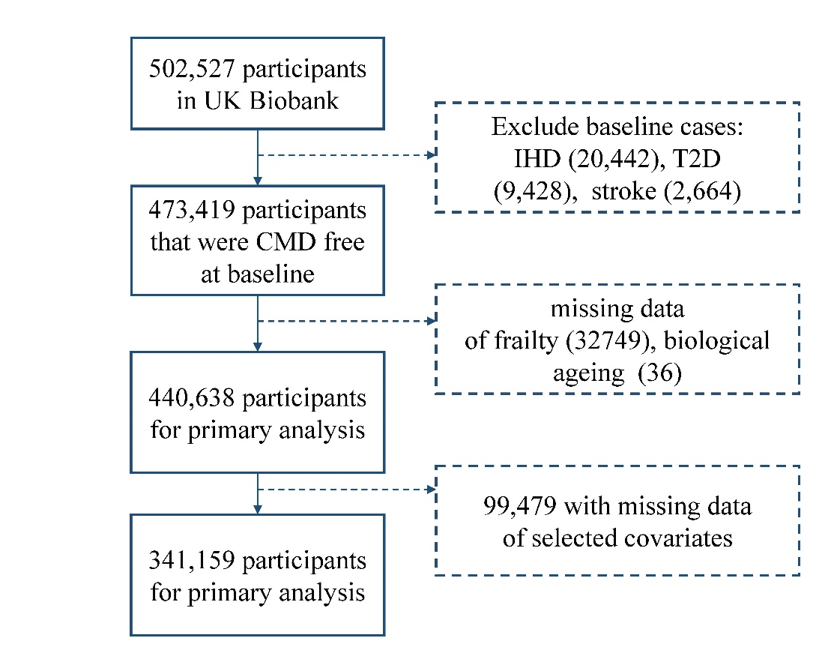
Figure S1 Flowchart of participant selection.

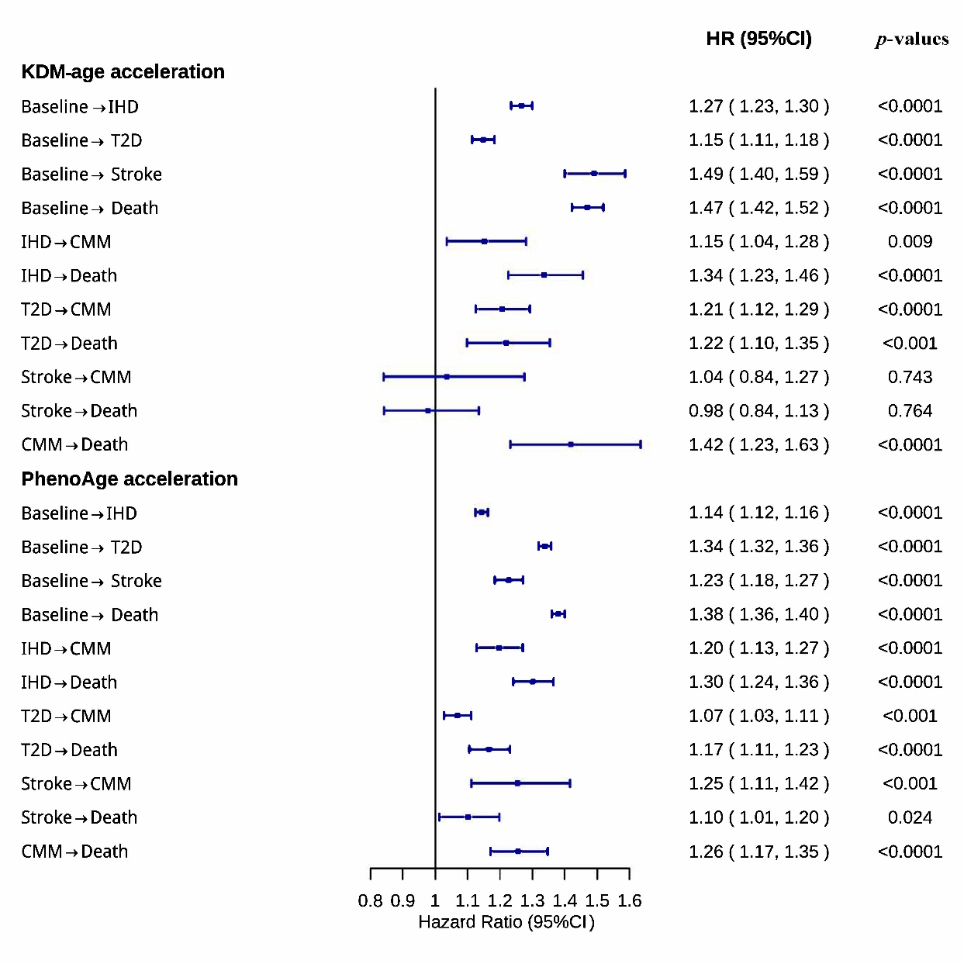
Figure S2 (A) Associations of the accelerated biological aging with the risks of first cardiometabolic disease, cardiometabolic multimorbidity, and death after the first cardiometabolic disease of pattern B using multi-state model.

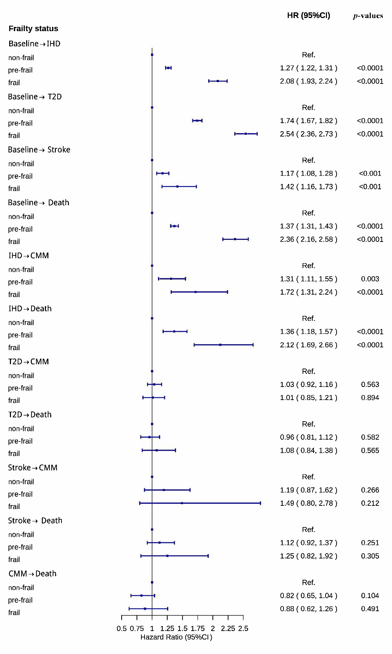
Figure S2 (B) Associations of the accelerated biological aging with the risks of first cardiometabolic disease, cardiometabolic multimorbidity, and death after the first cardiometabolic disease of pattern B using multi-state model.

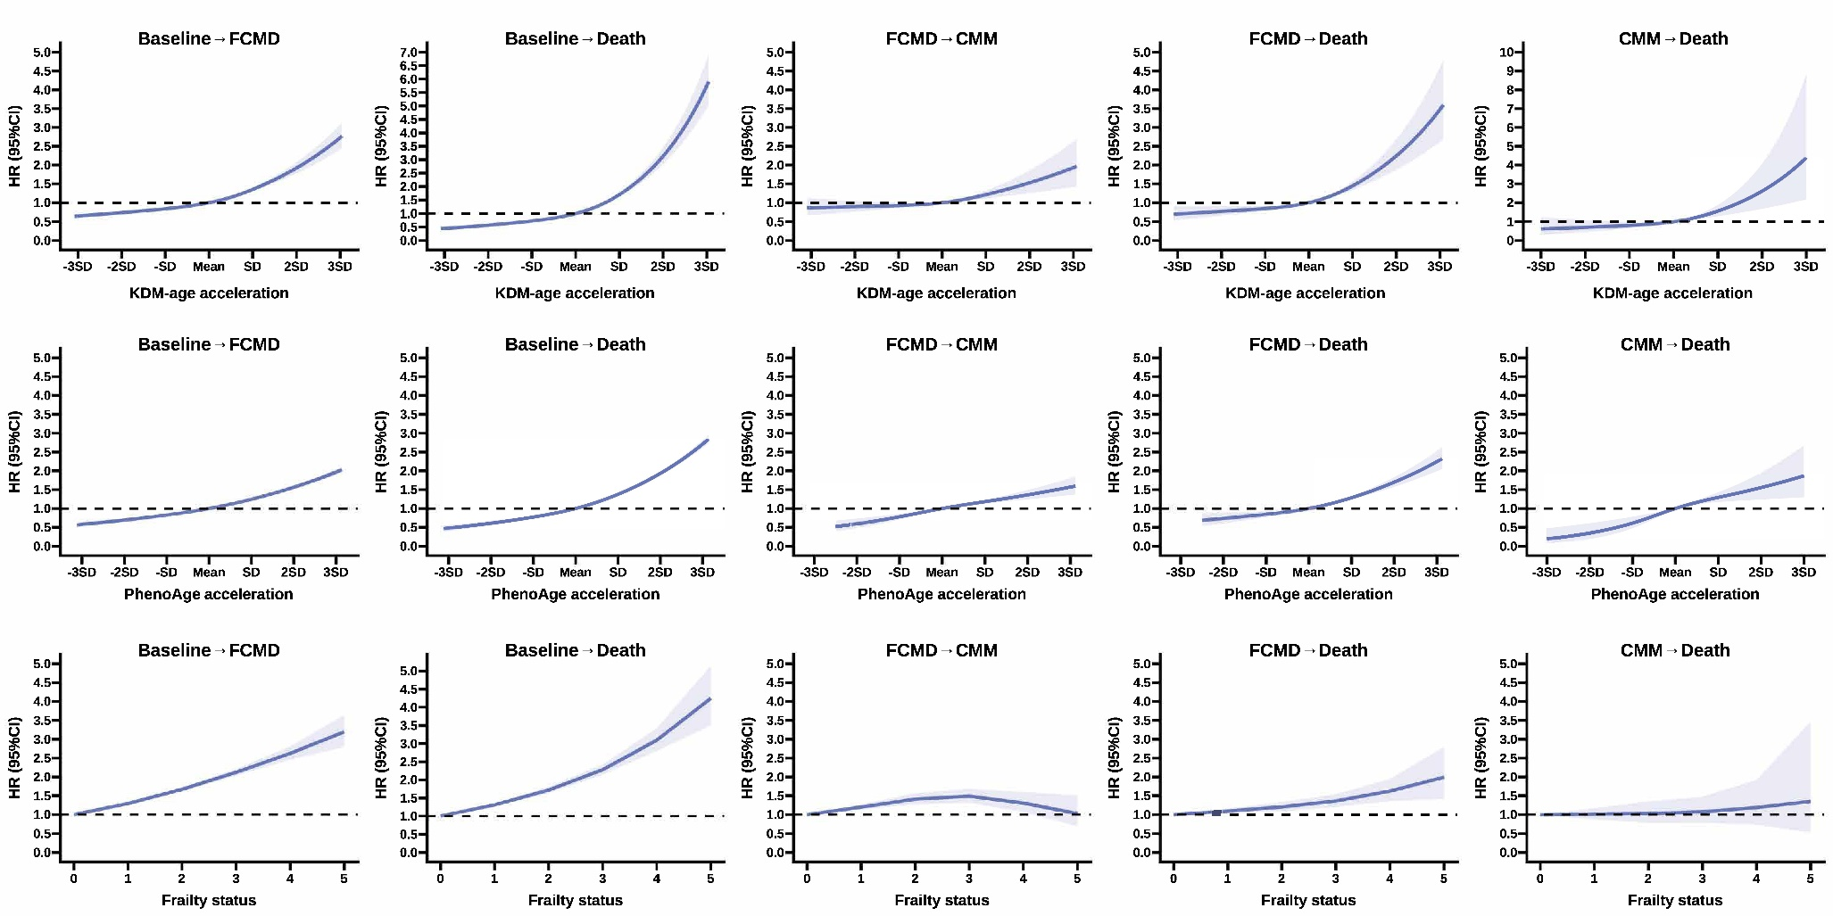
Figure S3 Dose-response curves (smoothed by RCS function with three knots of frailty and the accelerated biological aging with the transition from baseline to FCMD and from FCMD to CMM of pattern A.
Solid lines: point estimates; Shadows: 95% confidence limits.

