Supplementary Material
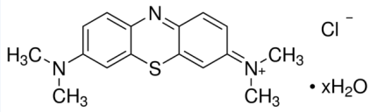

Fig. S1. The chemical structure of MB dye.

Table S1. Characteristics of MB dye
Dye Molecular formula |  | Molecular weight (g/mol) λ_{max}(nm)
Methylene blue C₁₆H₁₈ClN₃. xH₂O |  | 319.85 666

