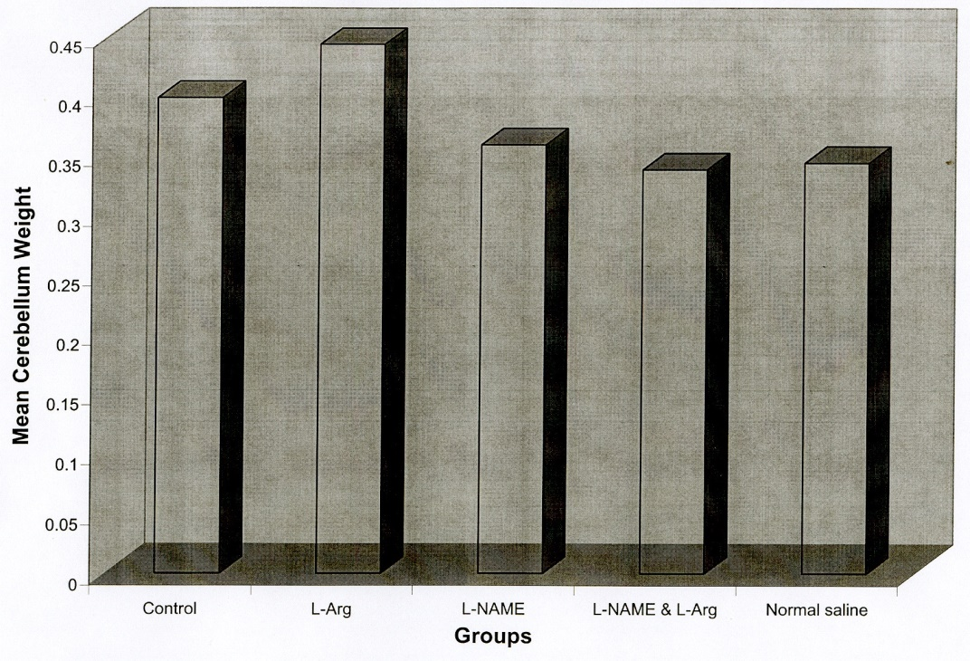

Table 2: Bar chart of mean cerebellar weight in 5 control groups: L-Arg, L-NAME, L-Arg + L-NAME and normal saline.

Table 3: Boxplot graph of cerebellar weight in control, L-Arg, L-NAME, L-Arg + L-NAME and normal saline.

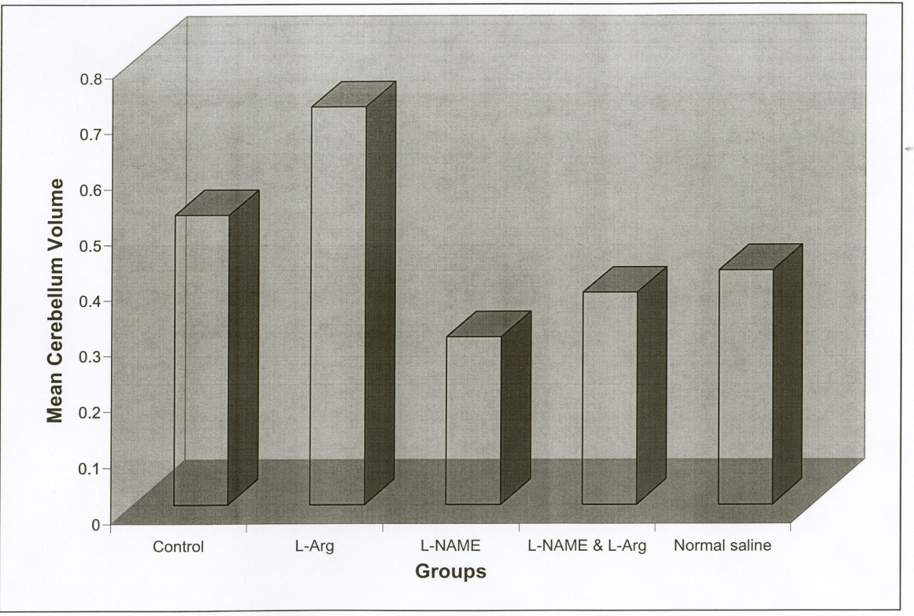
Table 5: table of mean cerebellar volume in 5 control groups: L-Arg, L-NAME, L-Arg + L-NAME and normal saline

Table 6: Boxplot diagram of cerebellum volume in control groups, L-Arg, L-NAME, L-Arg + L-NAME and normal saline

