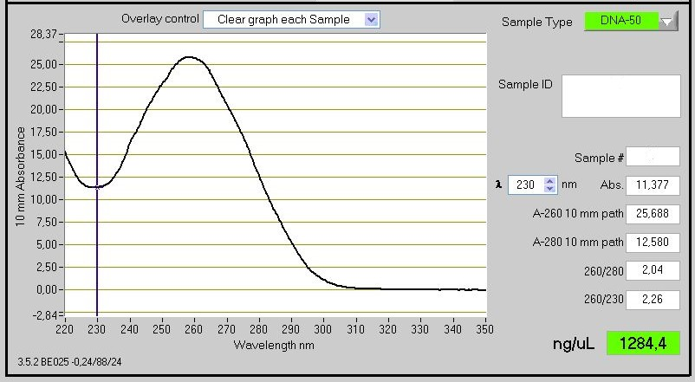

Fig. S1: UV spectra of nucleic acids isolated from purified IBs by phenol-chloroform extraction and precipitation with ethanol. The probe was analysed by NanoDrop®.

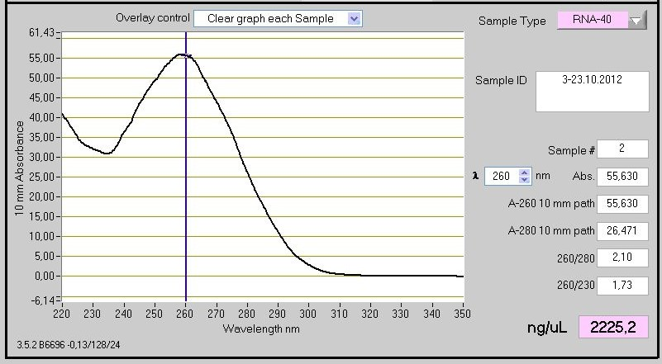

Fig. S2: UV spectra of RNA isolated from purified IBs by TRIzol® and analysed by NanoDrop®.

