Supplementary Figure 1
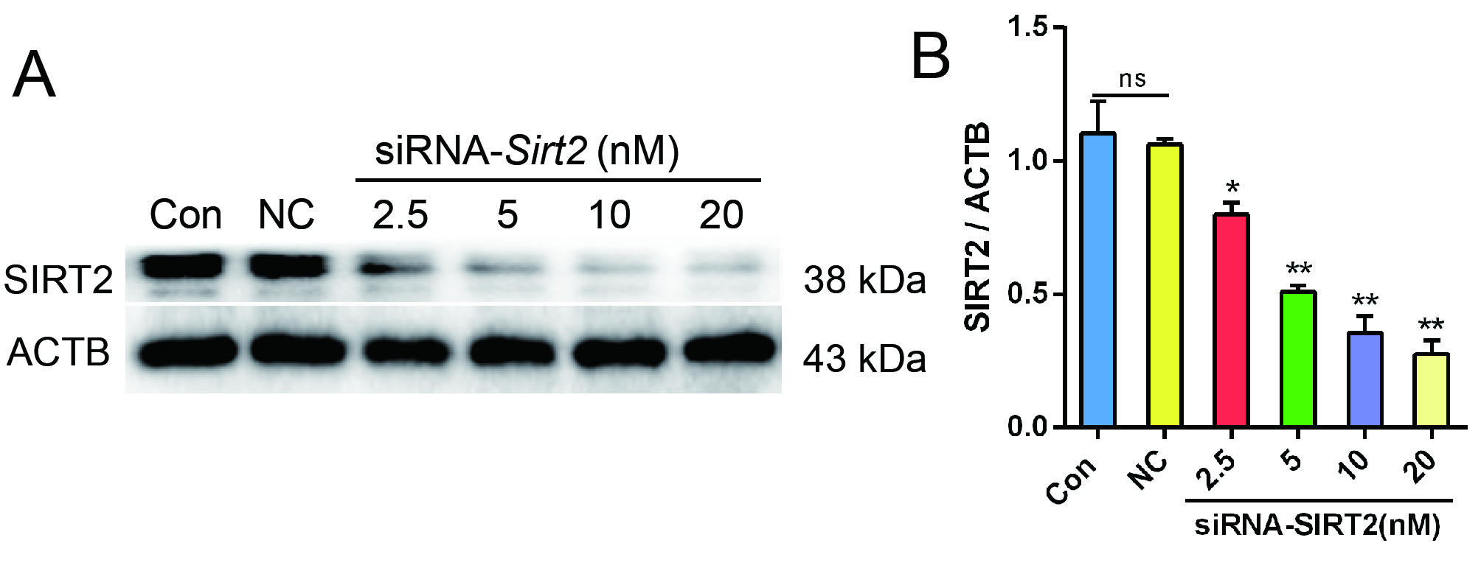
Supplementary Figure 1 siRNA-Sirt2 knockdowns SIRT2 expression. Western blotting results of SIRT2 (A, B). Data represent mean ± SD. ## P < 0.01 vs. Con group; * P < 0.05, ** P < 0.01 vs. NC group.

