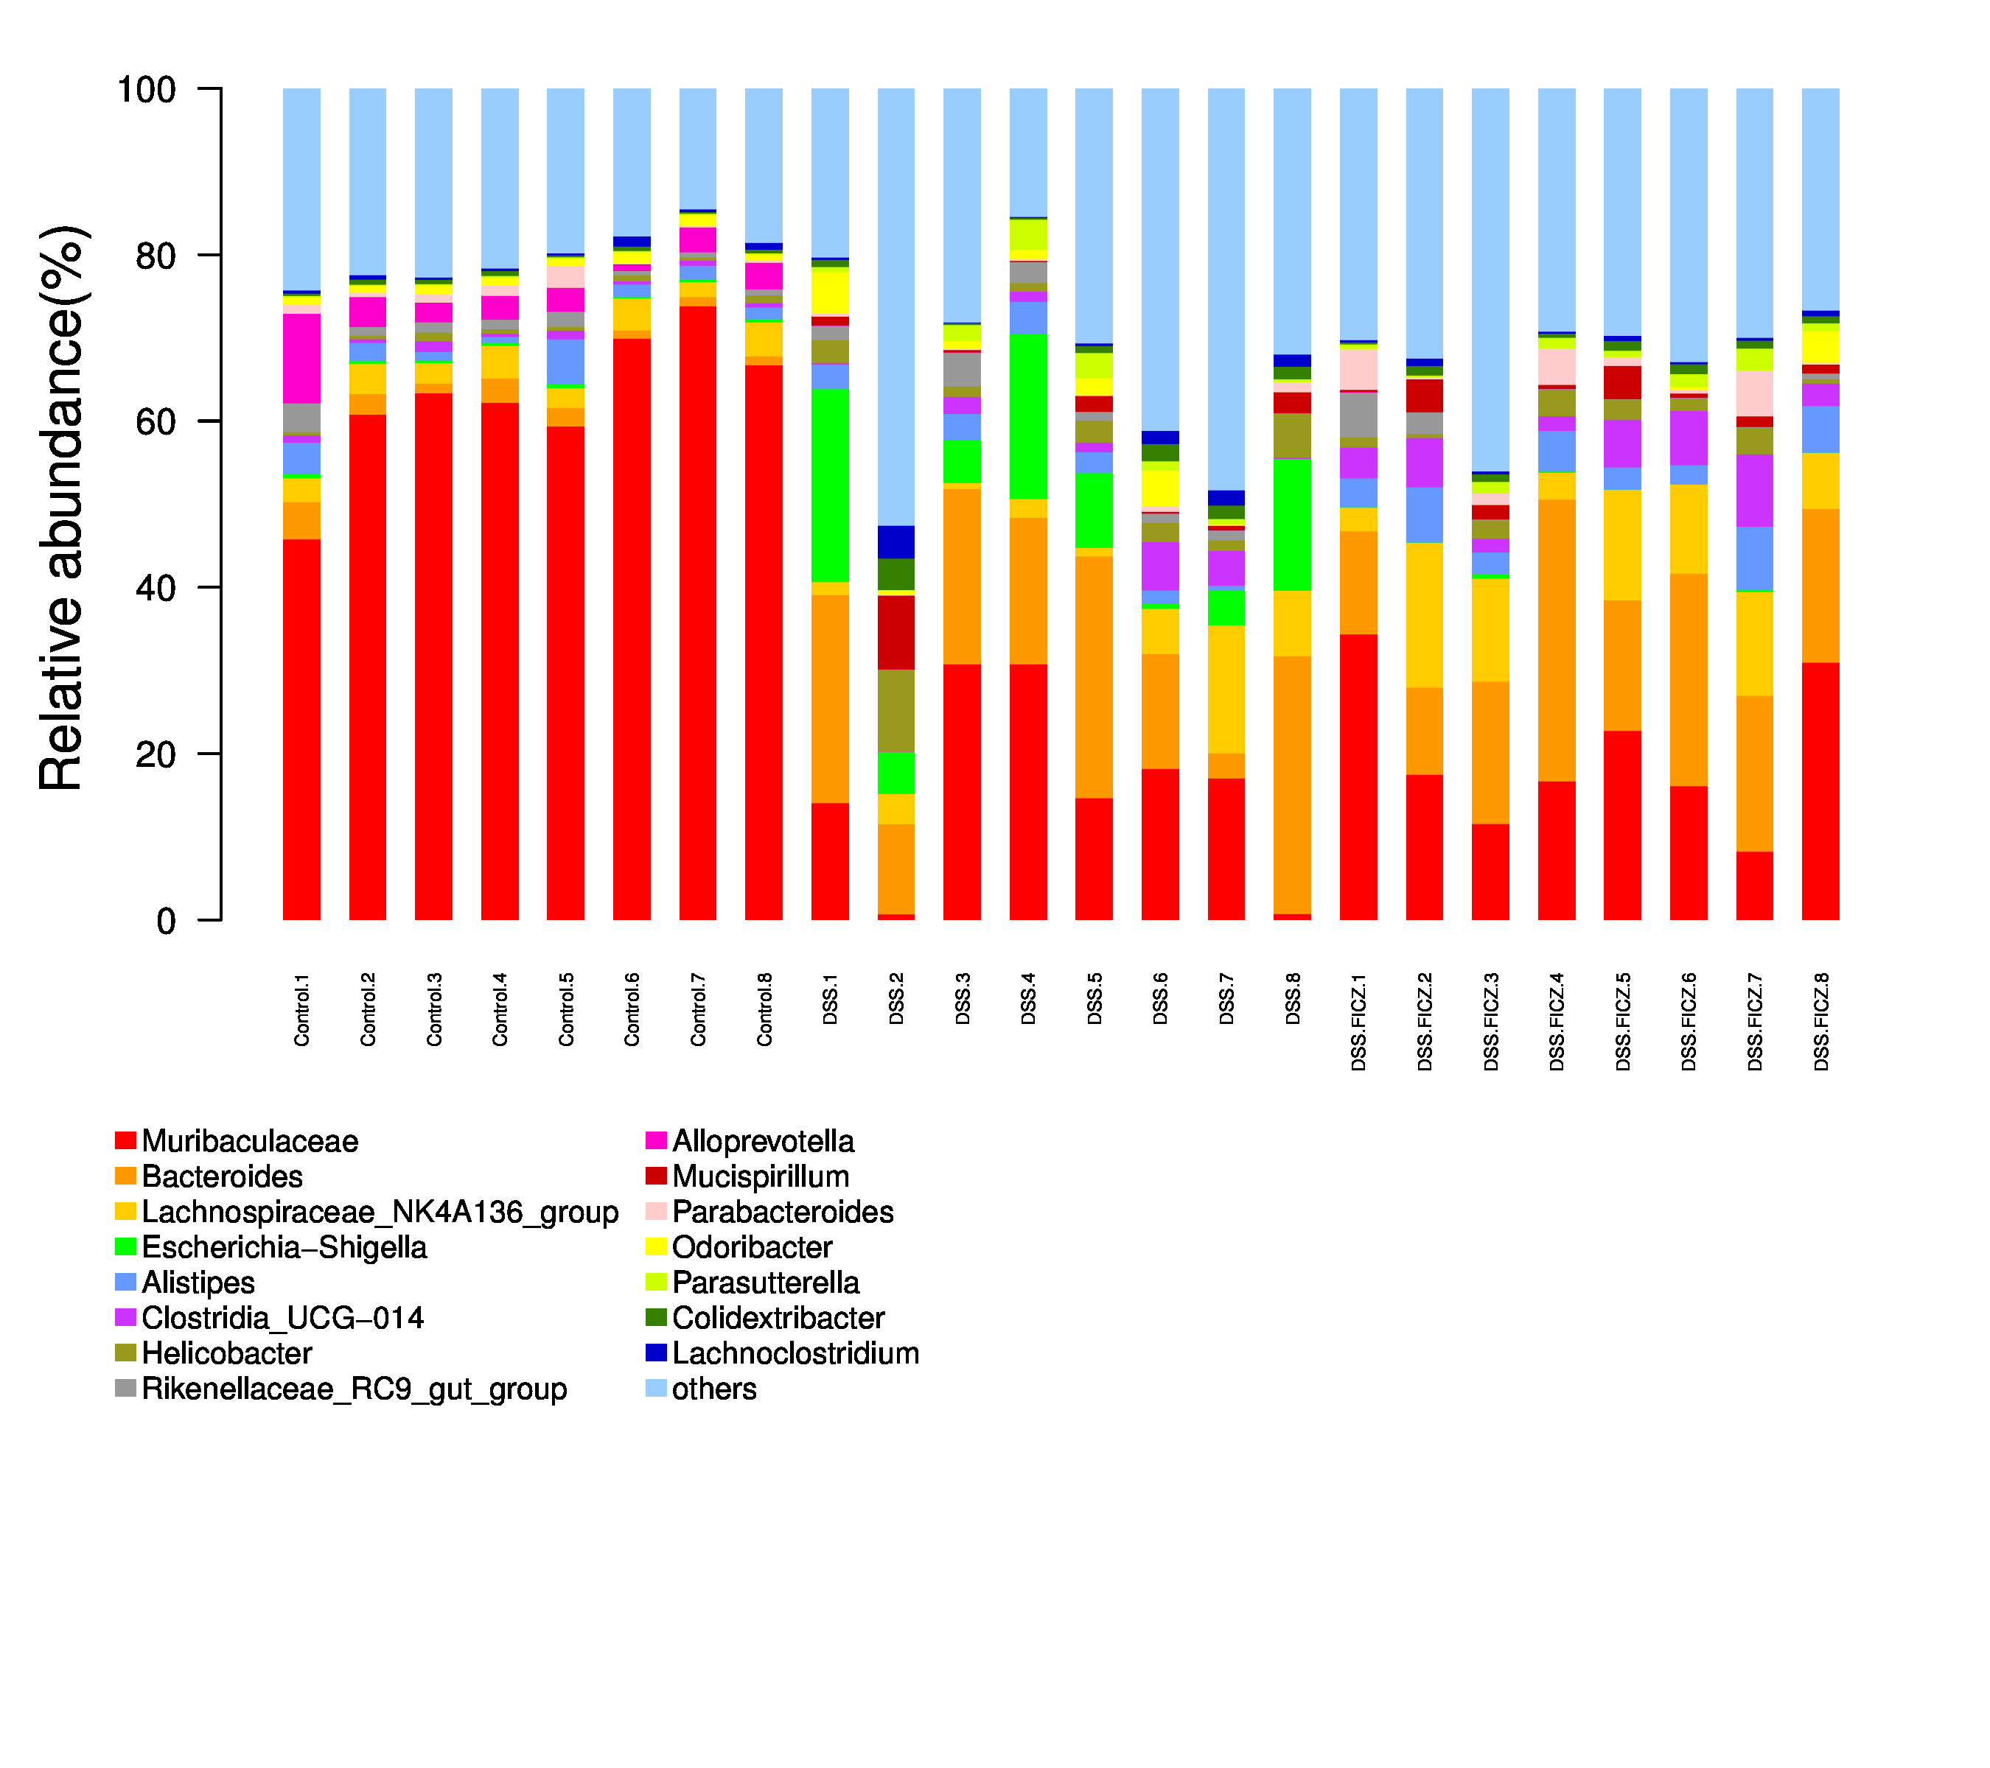
Figure 1S. the relative abundance of the top 15 bacterial.

