High efficient and green micro/nano cellulose preparation with micro-nano bubbles from mild alkaline pretreated bagasse

Qian Yu¹; Ping Tiantian¹; Huang He¹; Xing Huiying¹; Liu Mengke¹; Feng Xin¹; Lu Xiaohua¹ ; Zhang Lilong^{1*}; Zhu Jiahua^{1*}
¹State Key Laboratory of Materials-Oriented Chemical Engineering,
College of Chemical Engineering, Nanjing Tech University,
*Corresponding authors:
Zhang Lilong (zhanglilong@njtech,edu.cn);
Zhu Jiahua (jhzhu@njtech.edu.cn).

Support Infomation
- Method detail.
- Figure and Table captures.
- Cost estimate of preparation micro/nano cellulose
- Method detail.
1.1 Composition
Acid insoluble lignin evaluation was performed according to the protocol presented by previous work. In brief, approximately 300 mg of dry PMES material (in three repetitions) were placed in 50 mL test tubes and hydrolyzed with 3 mL sulfuric acid (72% v/v) at 30 ºC in a water bath. After hydrolysis, the samples were autoclaved at 121 ºC for 1 h. The diluted hydrolyzed samples were then vacuum filtered. The Whatman fifilter papers and their solid content were then dried overnight in an oven at 105 ºC. The total weight was recorded, and the samples were placed in a furnace at 575 ºC for 4 h and cooled in a desiccator for an additional 1 h. The final weight was then recorded again or the determination of the total insoluble lignin.
The sugars in the supernatant from hydrolysis were quantitated by HPLC equipped with a refractive index detector (Showa Denko K.K., Japan) and a BioRad-HPX-87 P column (Bio-Rad Laboratories, Hercules, CA). Ultrapure water was used as the mobile phase at a flow rate of 0.6 mL/min and the column temperature was set to 65 ºC.
Ash content was analyzed according to the protocol presented by TAPPI (2002). Briefly, the samples were weighed and then heated in a furnace at 525 ± 25 °C for 360 min. They were then cooled slightly and placed in a desiccator containing indicator-grade anhydrous alumina. When cooled to room temperature, the samples were weighed again.
1.2 Crystallinity Measurements
To examine and compare the crystalline structure of both the untreated and alkaline-treated samples, X-ray diffraction (XRD) was performed on an Empyrean diffractometer (PANalytical B.V, Almelo, Holland) with CuKα radiation that had a wavelength (λ) (Kα 1) of 0.15406 nm generated at 40 kV and 40 mA. The samples were dried in a vacuum oven with P₂O₅ at 35 °C for 48 h. The scans were obtained from 2θ values of 10° to 90° at a scanning speed of 1° per min.
1.3 Thermogravimetric analysis (TGA) and FTIR
After designated treatment, the wet solid samples were dehydrated at 50 °C overnight in an oven. TGA analyses were performed with a high sensitivity thermogravimetric analyzer (Qs650 TGA, TA Instruments) operating from ambient temperature to 800 °C at a heating rate of 10 °C min⁻¹ , with 99.99% nitrogen purging. FTIR analysis was conducted using Fourier transform infrared (ATR-FTIR) spectroscopy (Tensor 27-IR, Bruker, USA).
1.4 Scanning Electron Microscopy (SEM)

Imaging with scanning electron microscopy (VEGA3-SBH, TESCAN) was performed. Samples were air-dried prior to imaging and mounted on aluminum stubs using conductive carbon tape. The stubs were then sputter-coated with approximately 10 nm of gold sputter coater (SBC-12,KYKY Technology Co., Ltd, Beijing, China). The imaging was performed with a beam accelerating voltage of 10 kV.
1.5 Atomic force microscope (AFM)
Three-dimensional morphology characterization of cellulose samples were conducted by atomic force microscope (AFM, Bruker, Germany). The cellulose samples suspensions (concentration 1wt%) were ultrasonicated in ethanol solution for 4 h, then dropped on a single-sided polished silicon wafer (10 mm×10 mm), dried in an oven for 1 h, and then taken out. The morphologies of the three fillers were characterized by tapping mode of RTESP-300 (300 kHz, 40 N/m) probe.
1.6 Preparation of cellulose paper
The different volumes of the cellulose pulp were adjusted to 20 mL with water and then completely mixed by ultrasonic treatment with a power of 300 W for 5 min. To prevent cellulose loss during the membrane production process, a sintered glass filter with a nanofiltration membrane (D = 4 cm, 0.45 μm PE) and then suctioned under 0.05 MPa vacuum to prepare cellulose composite papers according to 30g/m².
1.7 Tensile test
Tensile strength of the cellulose paper was examined by an (C24.104, Xinsansi Co., Ltd, Shanghai, China) testing machine following the TAPPI standard method (TAPPI T497). The tensile test experiment was carried out under a temperature of 25 °C with a relative humidity (RH) of 50 %. The initial distance between the two clamps was set to 20 mm and the cross head speed was maintained at 5 mm/min. The cellulose paper were cut into 1 cm × 5 cm segments. Before testing, the paper were placed at the conditions of 50 % RH and 25 °C for 24 h. Five measurements were made for each CNP sample and the data averaged to obtain a mean value.
1.8 Vertical light transmittance of the cellulose samples paper
The vertical light transmittance of the cellulose films are analyzed by a UV/Vis spectroscopic instrument (UV8453, Agilent, USA). In detail, the clean and smooth composite film was placed vertically in the middle of the light path. Then, Irradiated the film by the light at the wavelength range of 400-900 nm and recorded the decrement signature of vertical light transmitted intensity (i.e., absorbance).

- Figure and Table captures.
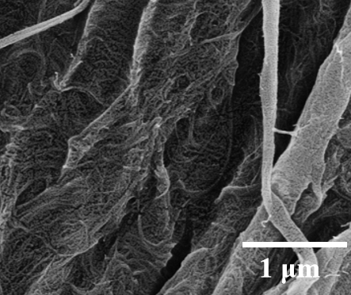
Fig.S1 the SEM images of the 3# cellulose samples
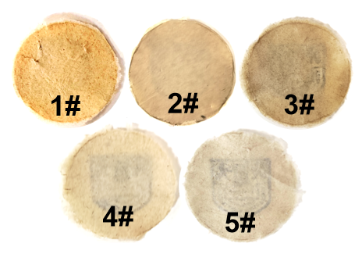
Fig. S2 the photograph of the pulp cellulose samples
- Cost estimate of preparation micro/nano cellulose
Table S1. Theoretical calculation of energy consumption and cost during mild alkaline pretreatment and micro-nano bubbles process
Processing section | Energy consumption (MJ/kg CNFs) ^{c} | Chemical reagent (kg) | Cost (USD/kg CNFs)
Alkali-pretreatment ª | 0.11 | 0.0005 | 0.0087
MNB treatment ^{b} | 1.38 | 0.0069^{d} | 0.043
ª The energy consumption was calculated on the basis of 1kg bagasse, under the reaction condition at 110 ºC, 1h 10%wt alkali concentration
^{b} The energy consumption was calculated on the basis of 73%CNFs, under the reaction condition at 4h MNB treatment
^{c} Energy consumption was calculated by the maximum power of mechanical, oil bath pot power is 30W；MNB power is 96W；for commercial power cost 0.154USD/kWh.
^{d} Chemical reagent was calculated by O₂ quality, the flow rate and density of O₂ are 20ml/min and 1.429g/L, respectively; for tonnage oxygen cost 57.682USD/ton.

