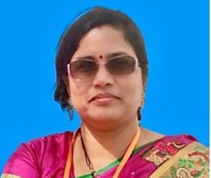
Dr. Ruby Mishra Ph.D. (Machine design) is an Associate Professor, Mechanical Engineering at KIIT Deemed University. She has rich experience in teaching and has published research works in international journals and has patented. She is a member of the Institute of Engineers and the Indian Science Congress Association.
Email: rubymishrafme@kiit.ac.in

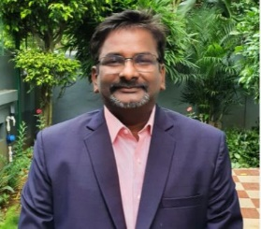
Dr.PrasantKumar Pattnaik, Ph.D. (Computer Science), Professor, Computer science department at KIIT Deemed University. He has done immense work in the area of cloud computing, machine learning, routing networks etc. He is a senior member of IEEE.
Email: patnaikprashantfcs@kiit.ac.in

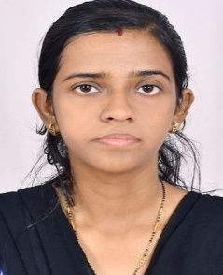
RituMaity is a Ph.D. scholar in the Mechanical department. She obtained her Mtech from IIT, Bhubaneswar in 2014 in Machine design. She has recently published 4 articles and has five patents. She is working as Senior Engineer is the MSME tool room, Bhubaneswar.
Email: maity.ritu07@gmail.com

