Table 1: Victim Characteristics

Characteristics of the Victims | Associated Theoretical Models
Attractiveness of the Victim | VIVA model, Opportunity model of predatory victimization, Routine activity theory
Capability of Offender | Persuasion Model
Absence of trusted Guardian | Routine Activity Model

Table 2: Descriptions and measures of independent variables

Features | Description | Measure | Indicators
Age | Age of Investor | Continuous
Income Generation | Income of Investor | Continuous
Exploitation | Victim exploitation | Binary | 1:- YES. 0:- NO
Gender | Gender of Investor | Categorical | 1:- Male 2:- Female
Employed | Employment status | Binary | 1:- YES. 0:- NO
Unemployed | Religious identification | Binary | 1:- YES. 0:- NO
Fund education |  | Binary | 1:- YES. 0:- NO
Fund retirement | Retirement funds | Binary | 1:- YES. 0:- NO
Income generation |  | Binary | 1:- YES. 0:- NO
Relationship to client | Acquaintance |  | 1:- YES. 0:- NO
Relationship to client | Long-term | Binary | 1:- YES. 0:- NO
Relationship to client | Relatives | Binary | 1:- YES. 0:- NO
Investment knowledge | Good | Binary | 1:- YES. 0:- NO
Investment knowledge | Moderate | Binary | 1:- YES. 0:- NO
Investment knowledge | Poor | Binary | 1:- YES. 0:- NO
Borrowed funds | Invest to retire | Binary | 1:- YES. 0:- NO
Windfall | Large unexpected cash | Binary | 1:- YES. 0:- NO
Savings | Investors' savings | Binary | 1:- YES. 0:- NO
Total net worth | Consolidated net worth | Continuous
Risk Tolerance | Investor risk profile | Categorical | Low, Medium, High
Account type | Account base on priority | Categorical | Cash, Registered , Margin

Table 3: Numerical Features
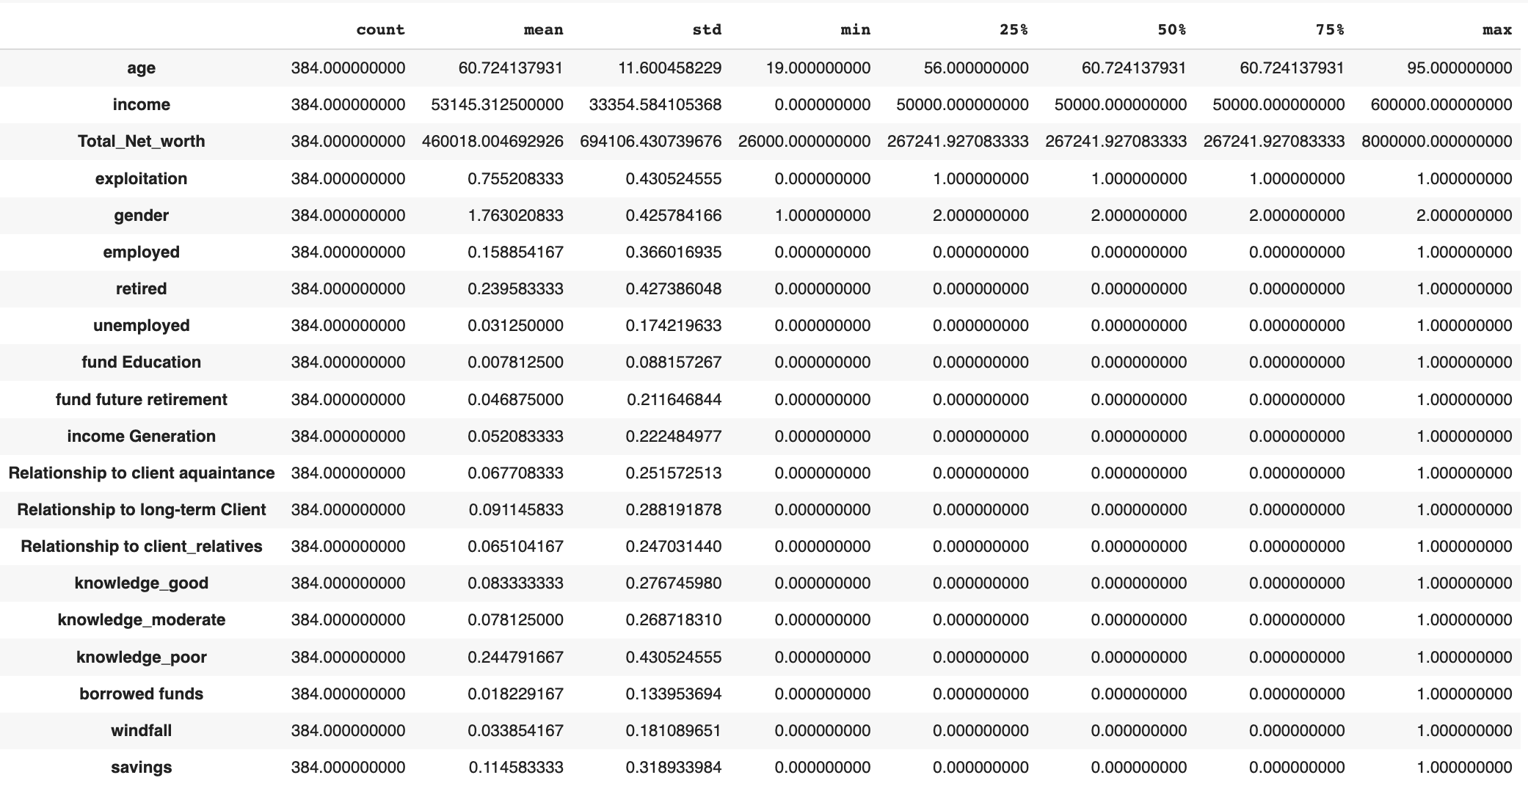

Table 4: Categorical Features


Table 5: Performance Accuracy of the Classification Algorithms

Algorithm | Performance Accuracy
 | Training Score | Testing Score
Logistic regression | 0.77 | 0.79
Random forest with GridSearchCV | 0.86 | 0.78
Random forest with RFE | 0.85 | 0.74

Table 6: The score for Classification Report
Algorithm | Sensitivity/Recall | Specificity | Precision | F-measure
Logistic regression | 0.7 | 0.88 | 0.85 | 0.77
Random forest with GridSearchCV | 0.71 | 0.84 | 0.82 | 0.76
Random forest with RFE | 0.67 | 0.82 | 0.79 | 0.73

