Extended Data Figures
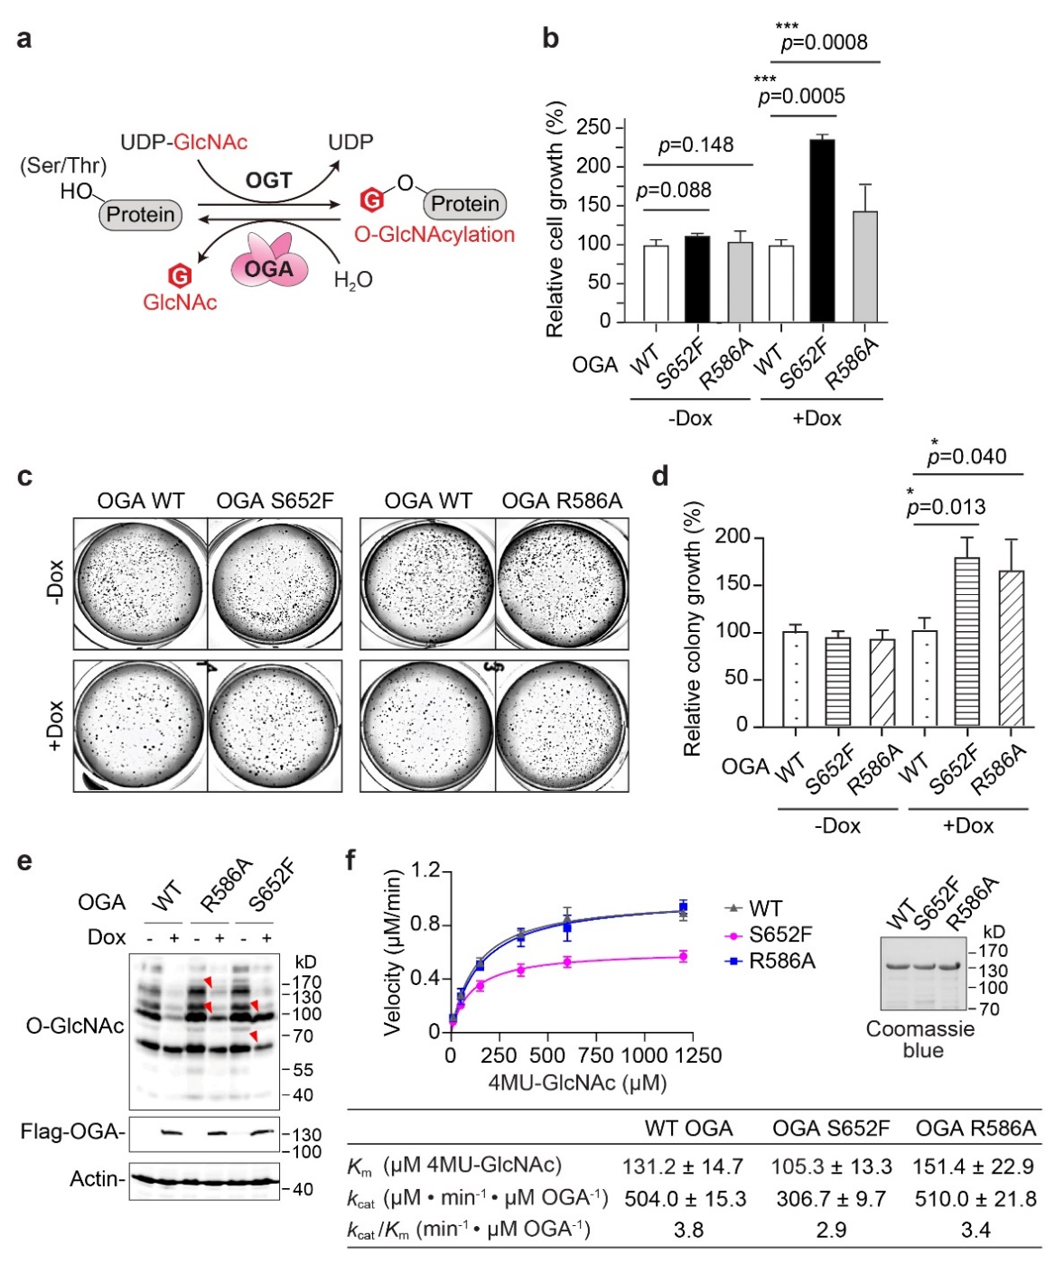
Extended Data Fig. 1. The impacts of OGA stalk domain mutations on cell growth, global O-GlcNAcylation, and enzymatic activity. a, Reversible O-GlcNAcylation is catalyzed by O-GlcNAc transferase (OGT) and O-GlcNAcase (OGA). b, Relative cell growth of T-REx-293 cells expressing WT OGA or stalk domain mutant (40 h doxycycline (dox) induction) detected by resazurin assay (n = 4). c, Soft agar assay of T-REx-293 cells with dox-induced expression of Flag-OGA (WT or mutant). d, Relative quantitation of the colony growth from c (n = 3). e, Western blot showing the global O-GlcNAcylation in T-REx-293 cells with dox-induced expression of Flag-OGA (WT/mutant) for 24 h. O-GlcNAcylation was detected by CTD110.6 antibody. Red arrows highlight the protein bands differentially regulated in OGA mutant cells. f, Kinetic analysis of recombinantly purified WT OGA and mutants using 4MU-GlcNAc assay. Protein purity was shown in the Coomassie blue stained gel (right). All quantified data are presented as mean ± s.d. *, p < 0.05; ***, p < 0.001. P-values were determined by one-tailed student’s unpaired (b) or paired (d) t-test.
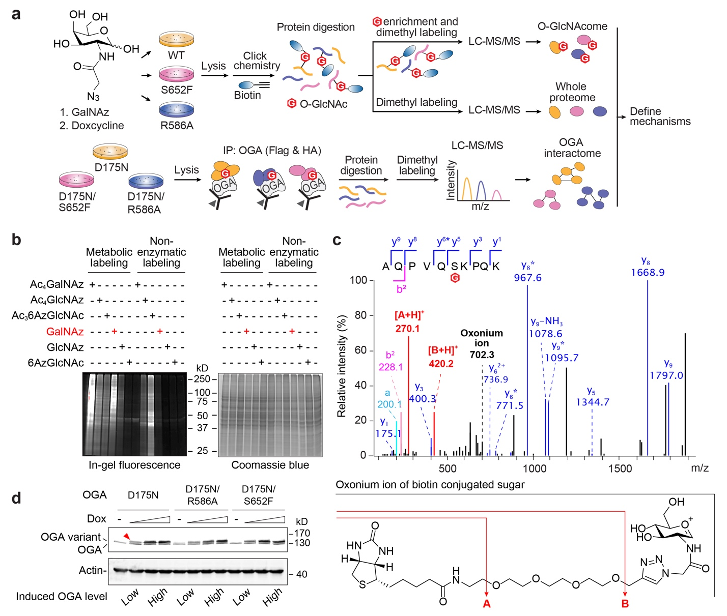

Extended Data Fig. 2. Quantitative proteomic analyses of OGA stalk domain mutants. a, Flow-chart of the integrative proteomic analyses of T-REx-293 cells with doxycycline (dox)-induced expression of Flag-OGA (WT or mutant). IP, immunoprecipitation. b, In-gel fluorescence showing the metabolic and in vitro non-enzymatic labeling efficiency of different sugar analogues in HEK293 cells. Total protein loading was shown by Coomassie blue staining of the same gel. c, Top, a representative HCD MS/MS spectrum of glycosylated PDLIM7 peptide. The diagnostic peaks used for HCD-triggered EThcD were highlighted in red. Bottom, the hypothetical fragmentation of biotin-conjugated oxonium ion. d, Western blot analysis of dox-induced expression of each OGA-D175N variant in T-REx-293 cells. Conditions labeled with “low” and “high” in induced OGA level were selected for OGA interactome analysis. Red arrow highlights the band of OGA variant.

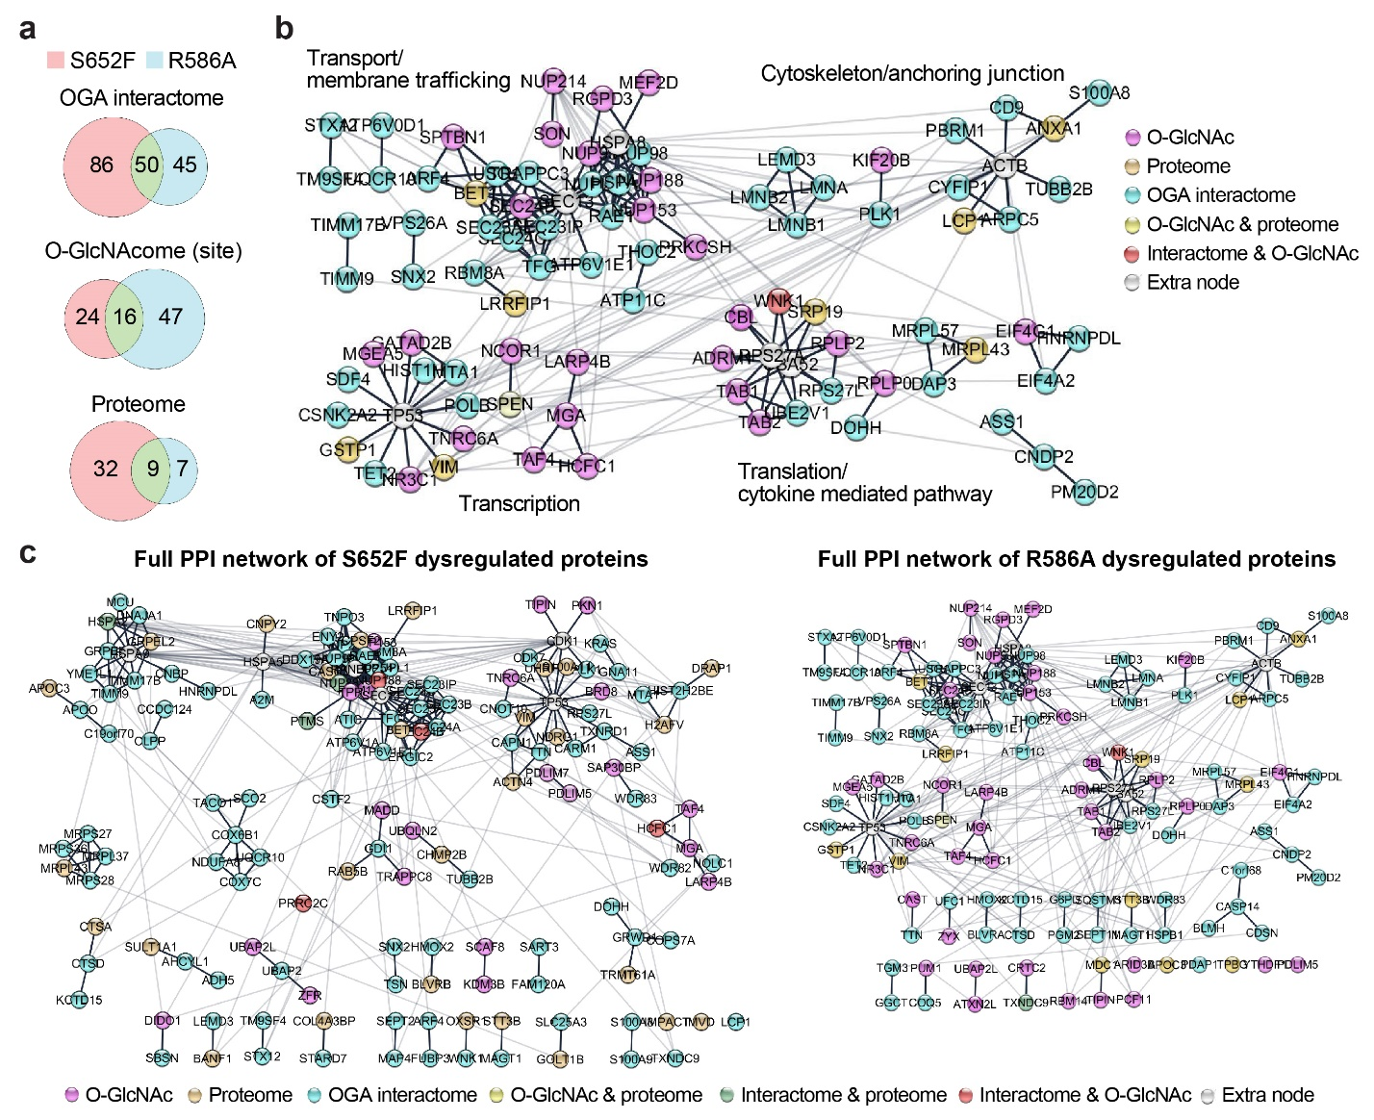
Extended Data Fig. 3. Dysregulated protein networks of OGA stalk domain mutants. a, Overlap of OGA S652F and R586A dysregulated proteins as identified from different proteomic analyses. b, The major protein association networks and their representative functions dysregulated by OGA R586A. Proteins identified from different proteomes were shown as indicated nodes. c, The full protein association networks dysregulated by OGA S652F or R586A mutant. Proteins with no protein interaction information in STRING database were not shown.

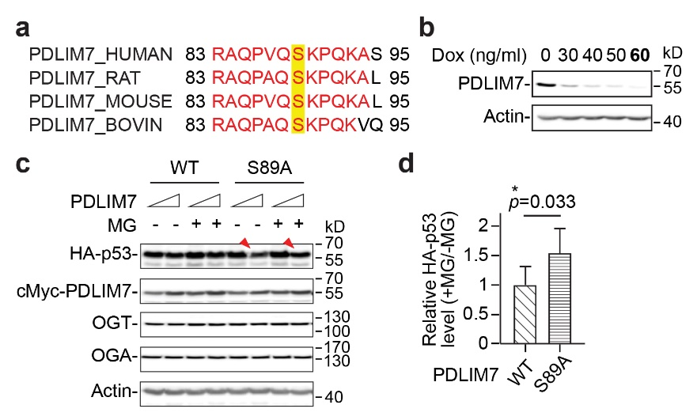
Extended Data Fig. 4. O-GlcNAylation of PDLIM7 at S89 affected p53 stability in cells. a, The major O-GlcNAc site of PDLIM7 at S89 residue (yellow highlighted) is conserved in mammals. b, Western blot analysis of the endogenous PDLIM7 knockdown in H1299 cells induced by doxycycline (dox) at the indicated concentrations. The dox concentration used for cellular analyses was bolded. c, Western blot analysis of p53 degradation in MG132 (MG)-treated HEK293 cells. Cells were transiently co-expressed with cMyc-PDLIM7 (WT/S89A) and HA-p53 for 48 h prior to MG treatment. Red arrows highlight the p53 bands from PDLIM7 S89A cells with or without MG treatment. d, The relative protein level of HA-p53 (+MG/-MG) from c (n = 5). All quantified data are presented as mean ± s.d. *, p < 0.05. P-values were determined by one-tailed student’s paired t-test.

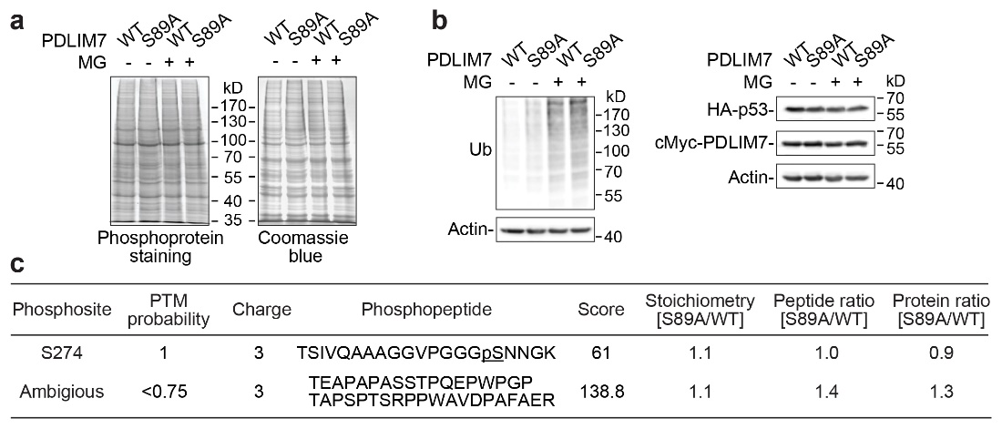
Extended Data Fig. 5. Phosphorylation of WT PDLIM7 and S89A mutant in cells. a, Global phosphorylation of the HEK293 cells that transiently expressed cMyc-PDLIM7 (WT/S89A), HA-p53, and ubiquitin for 48 h prior to MG132 (MG) treatment. Total protein loading was shown by Coomassie blue staining of the same gel. b, Western blot analysis of the global ubiquitination and protein expression from the same samples used for phosphoprotein staining in a. c, LC-MS/MS identified PDLIM7 phosphopeptides from T-REx-293 cells with doxycycline (dox)-induced knockdown of endogenous PDLIM7. The co-expression of cMyc-PDLIM7 (WT/S89A), HA-p53 and ubiquitin were performed similarly as in a. Cells were treated with dox 24 h prior to cell harvesting.

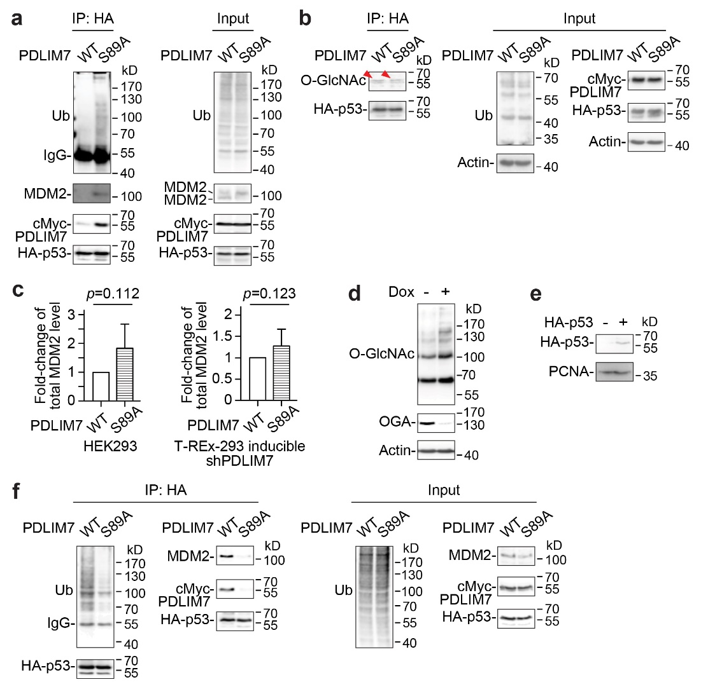
Extended Data Fig. 6. The effects of PDLIM7 deglycosylation on p53 ubiquitination and p53-MDM2 axis in cells. a, Western blot analysis of the ubiquitination (Ub) of the immunoprecipitated (IP) HA-p53 complex in H1299 cells with stable expression of cMyc-PDLIM7 (WT/S89A) and doxycycline (dox)-induced knockdown of endogenous PDLIM7. Cells were transiently expressed with HA-p53 and ubiquitin for 48 h prior to 27 h of dox and 3 h of MG132 (MG) treatments. b, Western blot analysis of the O-GlcNAcylation of the immunoprecipitated HA-p53 from H1299 cells with dox-induced cMyc-PDLIM7 (WT/S89A) expression and endogenous PDLIM7 knockdown. The co-expression of HA-p53 and ubiquitin, and dox treatment were performed similarly as in a. Red arrows indicate the O-GlcNAcylated p53 under PDLIM7 (WT/S89A) expression. O-GlcNAcylation was detected by CTD110.6 antibody. c, Relative quantitation of the total MDM2 level in HEK293 (left, n = 3) and T-REx-293 cells with dox-induced endogenous PDLIM7 knockdown (right, n = 4). The co-expression of cMyc-PDLIM7 (WT/S89A), HA-p53, and ubiquitin, and the treatment of dox and MG were performed similarly as in a. d, Western blot analysis of the global O-GlcNAcylation and endogenous OGA level in T-REx-293 cells with 24 h of dox-induced knockdown of endogenous OGA. O-GlcNAcylation was detected by RL2 antibody. e, Western blot analysis of the nuclear extracts of H1299 cells with or without stably expressed HA-p53. To enhance the detection efficiency, cells were treated with 3 h of MG prior to cell harvesting. f, Western blot analysis of the ubiquitination of the immunoprecipitated HA-p53 complex from HEK293T cells. The co-expression of HA-p53, cMyc-PDLIM7 (WT/S89A) and ubiquitin, and the MG treatment were performed similarly as in a. All quantified data are presented as mean ± s.d. *, p < 0.05. P-values were determined by one-tailed student’s paired t-test.

