Supporting Information
Metal oxide stabilized zirconia modified bio-derived carbon nanosheets as efficient electrocatalysts for oxygen evolution reaction
Menna M. Abo-Zeidª, Muhammad G. Abd El-Moghny^{b}, H. Shawkey^{c}, A. M. Daherª,
Amr M. Abdelkader^{d}, and Mohamed S. El-Deab^{b}
a Nuclear Materials Authority, Cairo, Egypt
b Department of Chemistry, Faculty of Science, Cairo University, Cairo, Egypt
c Department of Microelectronics, Electronics Research Institute (ERI), Giza, Egypt
d Department of Design and Engineering, Bournemouth University, UK

Corresponding authors:
E-mail: msaada68@yahoo.com (M. S. El-Deab)

Effect of temperature of YSZ/MCNSs composites:
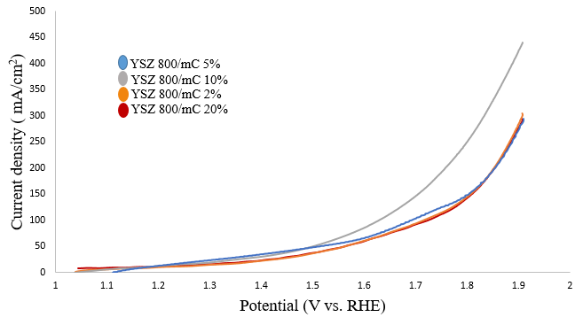
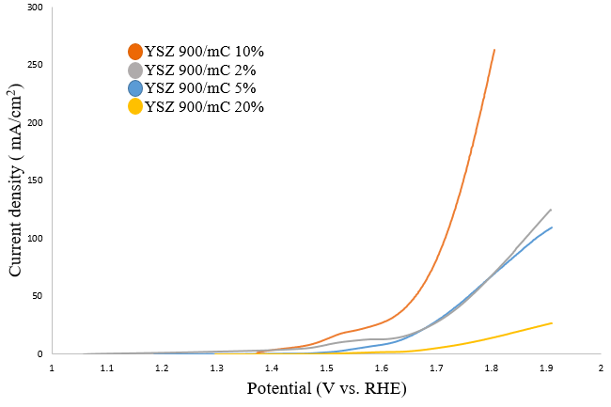
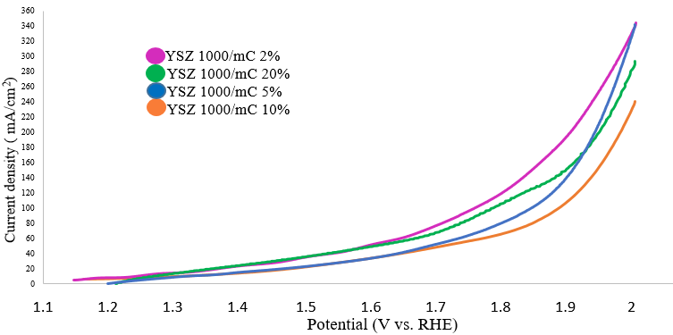
(a)
(b)
(c)

Fig. S1 polarization curves of YSZ/molasses CNSs annealed at 800, 900 and 1000 ˚C with different molasses weight ratios a YSZ/MCNSs annealed at 800 ˚C b YSZ/MCNSs annealed at 900 ˚C and c YSZ/MCNSs annealed at 1000 ˚C
According to the polarization curves of each group of YSZ/MCNSs electrocatalysts annealed at 800, 900 and 1000 ˚C shown in Fig. S1, it was found that the best electrocatalytic sample of the YSZ/MCNSs electrocatalysts annealed at 800 ˚C was YSZ 800/mC 5% electrocatalyst with 5 wt% of molasses carbon. And the best electrocatalytic sample of the YSZ/MCNSs electrocatalysts annealed at 900 ˚C was YSZ 900/mC 10% with 10 wt% of molasses carbon. Also, the best electrocatalytic sample of the YSZ/MCNSs electrocatalysts annealed at 1000 ˚C was YSZ 1000/mC 2% with 2 wt% of molasses carbon. The best electrocatalytic samples of each group were compared with each other and the electrocatalyst YSZ 800/mC 5% was found to be the best one with overpotential of 79 mV to drive a current density of 20 mA/cm². This electrocatalyst was compared with the blank sample with carbon black instead of molasses carbon and annealed at 800 ˚C. It was found that overpotential of YSZ 800/mC 5% electrocatalyst is 391 mV lower than the blank YSZ 800/CB annealed at 800 ºC, indicating the role of the bio-derived nanosheets in enhancing the catalytic reaction.
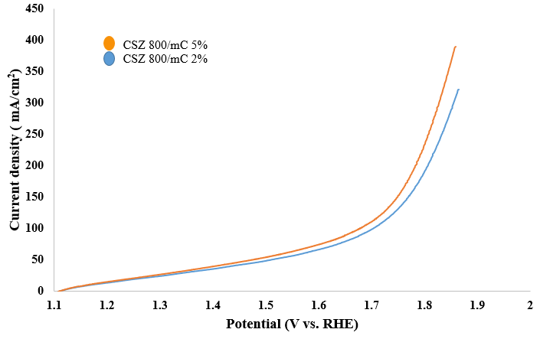
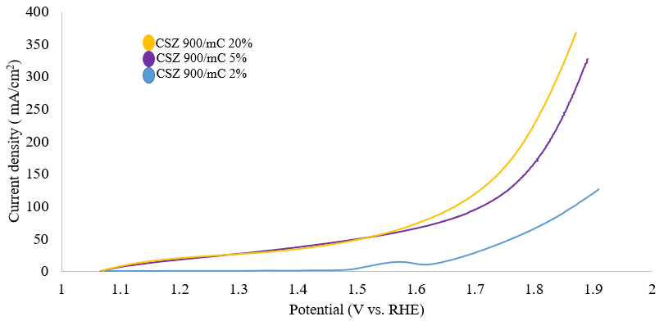
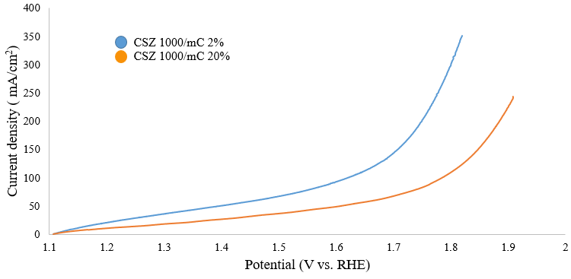
Effect of temperature of CSZ/MCNSs composites:
(a)
(b)
(c)

Fig. S2 polarization curves of CSZ/molasses CNSs annealed at 800, 900 and 1000 ˚C with different molasses weight ratios a CSZ/MCNSs annealed at 800 ˚C b CSZ/MCNSs annealed at 900 ˚C and c CSZ/MCNSs annealed at 1000 ˚C
Similarly, According to the polarization curves of each group of CSZ/MCNSs electrocatalysts annealed at 800, 900 and 1000 ˚C shown in Fig. S2, it was found that the best electrocatalytic sample of the CSZ/MCNSs electrocatalysts annealed at 800 ˚C was CSZ 800/mC 5% electrocatalyst with 5 wt% of molasses carbon. And the best electrocatalytic sample of the CSZ/MCNSs electrocatalysts annealed at 900 ˚C was CSZ 900/mC 20% with 20 wt% of molasses carbon. Also, the best electrocatalytic sample of the CSZ/MCNSs electrocatalysts annealed at 1000 ˚C was CSZ 1000/mC 2% with 2 wt% of molasses carbon. The best electrocatalytic samples of each group were compared with each other and the electrocatalyst CSZ 1000/mC 2% was found to be the best one with overpotential of 160 mV to drive a current density of 50 mA/cm². This electrocatalyst was compared with the blank sample with carbon black instead of molasses carbon and annealed at 1000 ˚C. It was found that overpotential of CSZ 1000/mC 2% electrocatalyst is 210 mV lower than the blank CSZ 1000/CB annealed at 1000 ºC, indicating the role of the bio-derived nanosheets in enhancing the catalytic reaction.
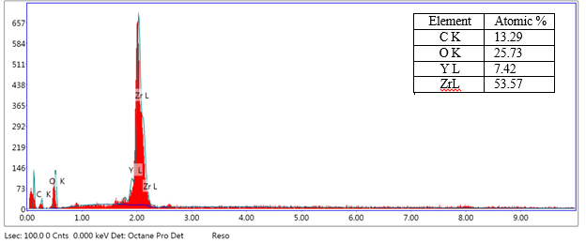
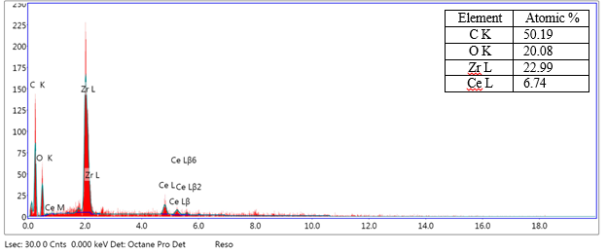
(a)
(b)
Fig. S3 EDX spectra of a YSZ/MCNSs and b CSZ/MCNSs after annealing under Ar

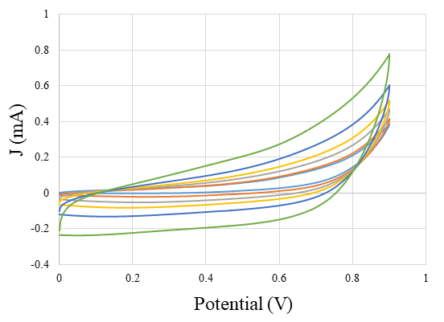
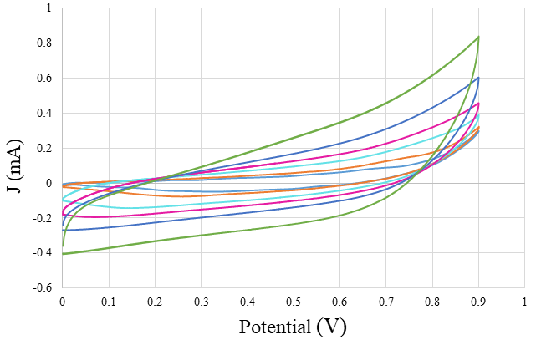
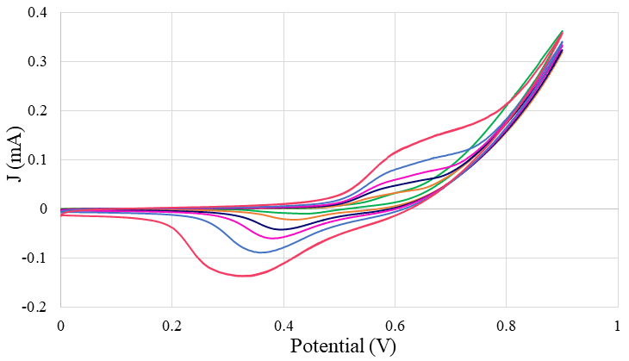
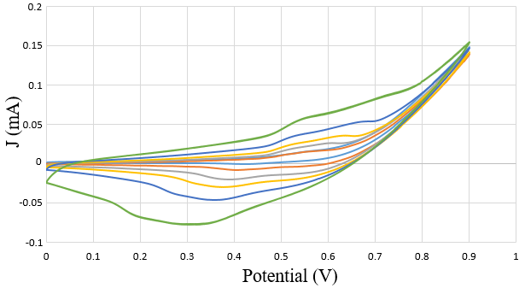
(a)
(b)
(c)
(d)
Fig. S4 Electrochemical measurements of the double-layer capacitance C_{dl} of a YSZ 800/mC 5% b YSZ 1000/mC 2% c YSZ 900/mC 10% and d YSZ 800/CB electrocatalysts at the potential window (0-0.9 V vs. Ag/AgCl) with various scan rates of 5, 10, 20, 30, 50 and 100 mV/s in 0.1 M KOH

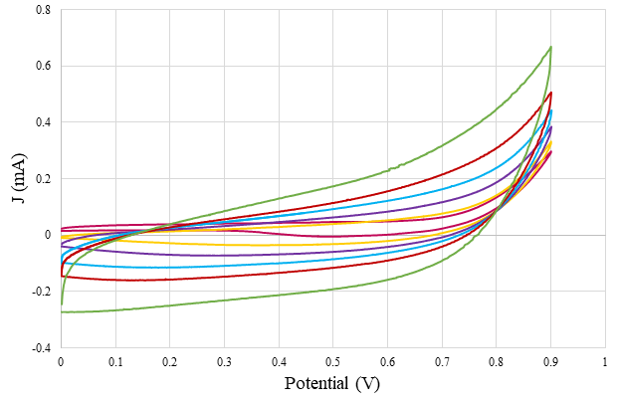
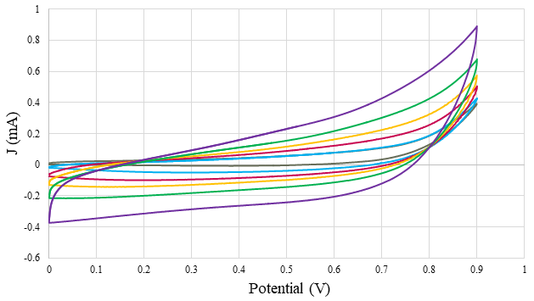
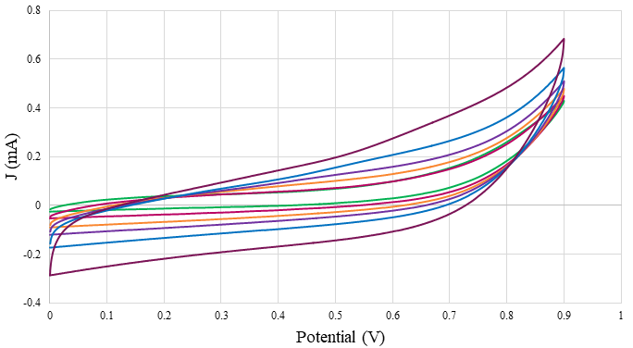
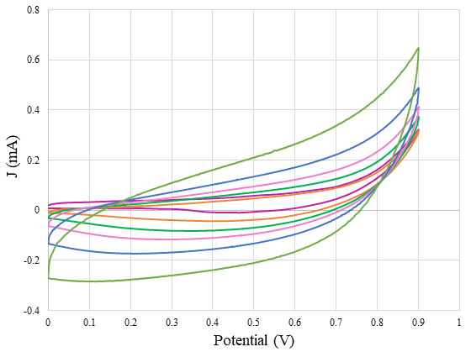
(a)
(b)
(c)
(d)
Fig. S5 Electrochemical measurements of the double-layer capacitance C_{dl} of a CSZ 1000/mC 2% b CSZ 800/mC 5% c CSZ 900/mC 20% and d Blank CSZ 1000/CB electrocatalysts at the potential window (0-0.9 V vs. Ag/AgCl) with various scan rates of 5, 10, 20, 30, 50 and 100 mV/s in 0.1 M KOH

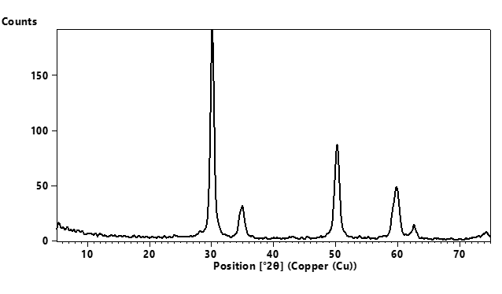
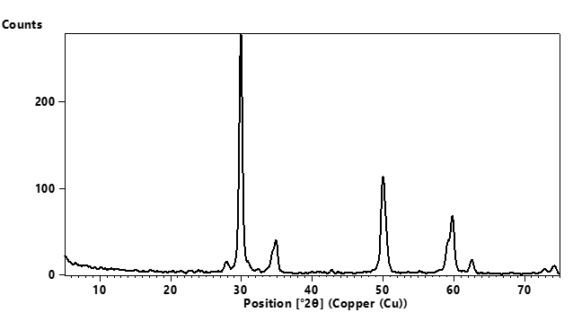
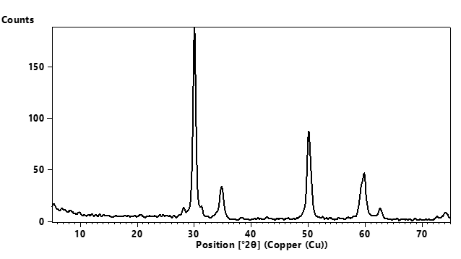
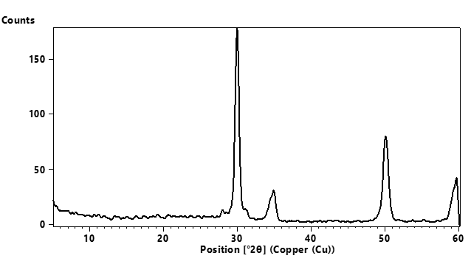
(a)
(b)
(c)
(d)
Fig. S6 XRD patterns of a YSZ 800/mC 5% b YSZ 1000/mC 2% c YSZ 900/mC 10% and d YSZ 800/CB catalysts

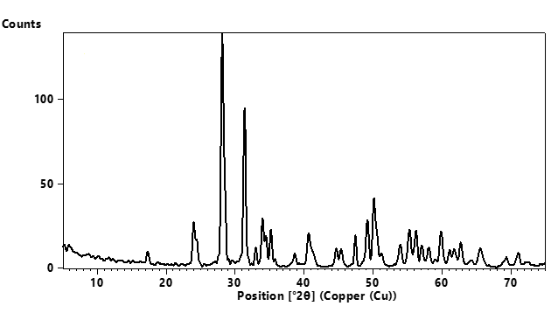
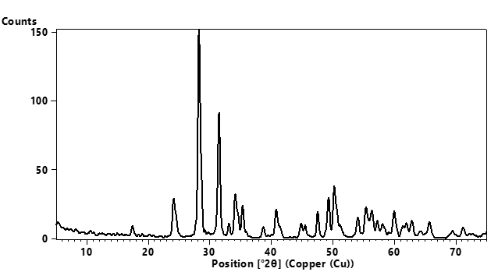
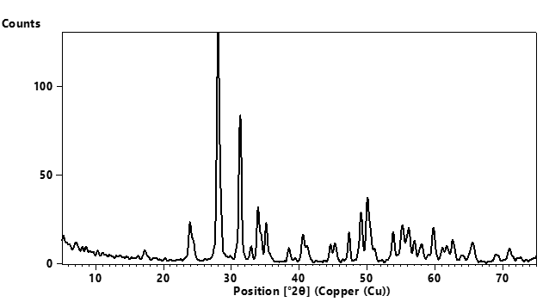
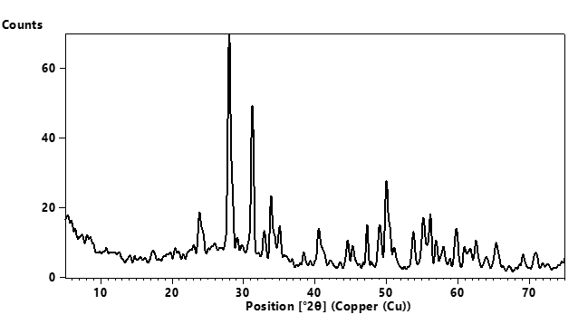
(a)
(b)
(c)
(d)
Fig. S7 XRD patterns of a CSZ 1000/mC 2% b CSZ 800/mC 5% c CSZ 900/mC 20% and d CSZ 1000/CB

