List of Supplemental Material

Table S1. Calculated values of spectral parameters, geometric parameters, electronic parameters and physicochemical parameters of OPFR molecules before molecular modification
Table S2. The 32 orthogonal experimental groups of CFS generated by Taguchi experiment design
Figure S1. The force field diagram of OPFRs docked with JTR. (A) Absence of recommended CFS; (B) Presence of recommended CFS

Table S1. Calculated values of spectral parameters, geometric parameters, electronic parameters and physicochemical parameters of OPFR molecules before molecular modification
Parameters\OPFRs |  | TCEP | TCIPP | TCPP | TDCIPP | T13DCIPP | TPHP | EHDPP | TEP | TBOEP | TEHP | TPrP | BdPhP | TMP | TiBP | TPeP | TnPP | TmTP | TiPP | CDPP | IDPP
G_{bind} (kJ/mol) |  | -72.98 | -108.36 | -117.59 | -142.80 | -147.36 | -89.48 | -132.64 | -100.37 | -8864 | -96.64 | -121.60 | -96.43 | -124.44 | -93.40 | -97.37 | -105.58 | -103.46 | -87.78 | -75.88 | -126.53
Spectral | PF | 18.43 | 19.55 | 16.37 | 26.49 | 22.16 | 22.89 | 29.63 | 18.33 | 22.11 | 25.33 | 26.19 | 29.36 | -12.31 | 18.57 | 23.65 | 20.39 | 16.32 | 19.84 | 26.39 | 23.18
Spectral | IR-(C-O)svf | 1763.66 | 1947.38 | 1649.07 | 1595.68 | 1629.62 | 1592.40 | 1993.26 | 1895.66 | 1646.88 | 1539.21 | 1894.19 | 1288.32 | 1419.56 | 1376.36 | 1416.06 | 1636.28 | 1883.92 | 1622.13 | 1113.81 | 1771.29
Spectral | IR-brbvf | 1416.91 | 1568.66 | 1363.26 | 1165.86 | 1182.63 | 1069.39 | 1019.31 | 1029.76 | 986.56 | 1036.39 | 1513.19 | 1801.65 | 1263.68 | 1649.69 | 1161.95 | 1062.82 | 1096.61 | 628.98 | 1636.69 | 1180.48
Spectral | IR-mbvf | 693.39 | 986.86 | 794.14 | 398.65 | 1395.72 | 838.33 | 341.21 | 911.96 | 1093.38 | 896.26 | 1828.58 | 664.98 | 1229.63 | 1263.87 | 1291.69 | 826.16 | 1336.42 | 1126.13 | 1836.23 | 997.32
Spectral | Raman-(C-O)svf | 9.83 | 10.36 | 10.66 | 10.93 | 11.85 | 9.16 | 13.53 | 10.69 | 8.28 | 12.26 | 13.85 | 8.38 | 10.36 | 9.29 | 11.81 | 11.66 | 10.96 | 14.95 | 6.13 | 11.25
Spectral | Raman-brsvf | 12.95 | 11.39 | 9.86 | 18.28 | 11.26 | 11.24 | 15.95 | 10.31 | 12.91 | 16.63 | 10.65 | 8.23 | 10.39 | 12.18 | 11.83 | 16.83 | 6.99 | 19.83 | 10.28 | 11.36
Spectral | Raman-msvf | 13.86 | 9.38 | 6.31 | 9.21 | 10.66 | 8.54 | 9.85 | 8.34 | 6.63 | 9.87 | 10.69 | 6.76 | 8.08 | 13.32 | 6.29 | 1.64 | 8.69 | 19.93 | 10.86 | 8.03
Geometric | QXX | -129.34 | -121.12 | -149.86 | -128.96 | -148.12 | -121.26 | -163.05 | -112.18 | -196.23 | -126.86 | -82.37 | -68.89 | -106.33 | -86.98 | -91.39 | -135.69 | -143.62 | -146.12 | -102.82 | -127.04
Geometric | QYY | -132.98 | -108.89 | -112.68 | -128.95 | -129.17 | -116.46 | -139.46 | -121.36 | -143.62 | -126.31 | -128.43 | -12.80 | -116.12 | -161.96 | -149.26 | -129.94 | -126.39 | -191.26 | -169.49 | -134.36
Geometric | QZZ | 143.29 | -126.38 | -142.69 | -123.16 | -138.64 | -119.16 | -122.34 | -119.72 | -164.86 | -126.69 | -136.23 | -136.55 | 137.41 | -123.88 | -169.16 | -126.22 | -126.31 | -169.82 | -166.68 | -129.68
Geometric | QXY | 31.18 | -19.94 | -23.89 | -19.26 | 20.67 | 22.19 | 21.85 | 29.48 | 27.34 | -20.63 | 17.69 | 13.26 | -20.61 | -26.46 | 21.95 | 21.90 | 26.27 | -11.61 | 11.88 | -26.42
Geometric | QYZ | 1.32 | -1.22 | -1.32 | -2.24 | 1.62 | 2.33 | 2.67 | 1.61 | -1.92 | -8.54 | 1.89 | -3.68 | 1.13 | -1.73 | 3.21 | -3.19 | 2.43 | -6.43 | 2.96 | -3.82
Geometric | MR | 136.28 | 79.21 | 68.27 | 85.36 | 89.36 | 89.30 | 85.11 | 65.31 | 136.91 | 86.26 | 61.82 | 58.39 | 66.83 | 83.81 | 136.86 | 89.64 | 86.39 | 136.21 | 132.62 | 86.98
Geometric | Mol Wt | 184.36 | 168.85 | 128.13 | 195.13 | 176.23 | 186.92 | 188.28 | 191.86 | 206.33 | 159.30 | 189.13 | 285.93 | 223.62 | 286.33 | 196.30 | 231.56 | 265.30 | 281.50 | 209.40 | 324.23
Electronic | TE | -1231.29 | -1236.38 | -1185.64 | -1228.86 | -1384.15 | -1128.84 | -1129.37 | -1035.29 | -1121.86 | -998.81 | -1321.32 | -828.41 | -1357.19 | -1366.95 | -1132.68 | -1395.82 | -1627.68 | -1183.29 | -1119.67 | -1110.31
Electronic | q+ | 1.23 | 1.23 | 1.22 | 1.22 | 1.24 | 1.25 | 1.24 | 1.22 | 1.23 | 1.23 | 1.22 | 1.22 | 1.24 | 1.23 | 1.22 | 1.24 | 1.25 | 1.23 | 1.25 | 1.23
Electronic | q- | -0.59 | -0.58 | -0.58 | -0.58 | -0.58 | -0.59 | -0.58 | -0.58 | -0.58 | -0.58 | -0.58 | -0.59 | -0.58 | -0.59 | -0.59 | -0.58 | -0.58 | -0.59 | -0.58 | -0.58
Electronic | E_{LUMO}(eV) | -0.16 | -0.03 | 0.16 | -0.34 | -0.26 | 1.15 | -0.28 | -0.45 | 1.32 | 1.69 | 1.75 | -0.16 | -0.68 | 1.12 | 1.24 | 1.73 | -0.17 | 1.61 | -0.33 | -0.67
Electronic | EG(eV) | 6.31 | 7.99 | 8.21 | 7.74 | 7.34 | 7.98 | 6.19 | 6.27 | 8.35 | 9.28 | 9.22 | 6.31 | 5.43 | 7.03 | 7.99 | 9.17 | 6.09 | 9.09 | 6.19 | 6.30
Physical and Chemical | BP | 1329.92 | 831.51 | 863.61 | 825.68 | 864.48 | 861.75 | 842.66 | 864.26 | 1365.42 | 863.62 | 823.36 | 863.52 | 862.25 | 869.13 | 1352.82 | 895.37 | 896.78 | 1398.25 | 1374.36 | 928.83
Physical and Chemical | MP | 729.65 | 867.26 | 881.62 | 859.68 | 906.39 | 886.46 | 905.29 | 793.96 | 792.57 | 849.31 | 883.89 | 912.38 | 821.19 | 931.84 | 832.53 | 982.39 | 821.15 | 835.64 | 816.93 | 783.54
Physical and Chemical | CT | 897.69 | 832.25 | 828.59 | 827.26 | 863.19 | 813.61 | 836.89 | 863.51 | 871.61 | 866.95 | 839.76 | 835.37 | 853.63 | 861.37 | 864.34 | 863.19 | 824.44 | 1326.63 | 1358.32 | 942.87
Physical and Chemical | CV | 913.83 | 826.09 | 894.40 | 832.36 | 813.60 | 837.78 | 806.50 | 795.42 | 1136.58 | 965.33 | 945.63 | 864.30 | 932.63 | 859.96 | 891.83 | 883.30 | 899.50 | 1327.60 | 1205.60 | 1054.26
Physical and Chemical | logP | 2.64 | 1.32 | 2.19 | 2.82 | 1.16 | 1.92 | 2.96 | 2.15 | 1.92 | 3.61 | 3.63 | 3.91 | 1.26 | 1.62 | 1.61 | 1.16 | 1.63 | 1.68 | 1.11 | 3.64
Physical and Chemical | HL | 1.64 | 1.21 | 1.45 | 1.82 | 1.86 | 1.34 | 1.96 | 1.62 | 1.33 | 2.08 | 1.37 | 2.18 | 2.28 | 1.26 | 1.81 | 1.69 | 2.43 | 1.47 | 2.12 | 1.86
Physical and Chemical | HF | -624.95 | -539.51 | -548.18 | -942.86 | -629.24 | -689.36 | -863.22 | -729.37 | -723.39 | -721.98 | -429.86 | -639.86 | -438.36 | -663.56 | -649.62 | -617.29 | -623.37 | -624.36 | -609.26 | -468.21
Physical and Chemical | GE | -87.18 | -68.85 | 11.61 | -68.16 | -82.50 | -38.32 | 39.28 | 23.62 | -87.43 | 39.60 | 183.39 | -108.30 | 129.33 | 26.36 | -102.86 | 92.49 | -83.36 | 13.19 | -98.34 | -126.54

Table S2. The 32 orthogonal experimental groups of CFS generated by Taguchi experiment design
No. | Milk | Egg | Orange | Spinach | Grape | Jujube | Apple | Kiwi fruit
1 | 1 | 1 | 1 | 1 | 1 | 1 | 1 | 1
2 | 1 | 1 | 1 | 1 | 0 | 1 | 0 | 0
3 | 1 | 1 | 1 | 0 | 1 | 0 | 1 | 0
4 | 1 | 1 | 1 | 0 | 0 | 0 | 0 | 1
5 | 1 | 1 | 0 | 1 | 1 | 0 | 0 | 1
6 | 1 | 1 | 0 | 1 | 0 | 0 | 1 | 0
7 | 1 | 1 | 0 | 0 | 1 | 1 | 0 | 0
8 | 1 | 1 | 0 | 0 | 0 | 1 | 1 | 1
9 | 1 | 0 | 1 | 1 | 1 | 0 | 0 | 0
10 | 1 | 0 | 1 | 1 | 0 | 0 | 1 | 1
11 | 1 | 0 | 1 | 0 | 1 | 1 | 0 | 1
12 | 1 | 0 | 1 | 0 | 0 | 1 | 1 | 0
13 | 1 | 0 | 0 | 1 | 1 | 1 | 1 | 0
14 | 1 | 0 | 0 | 1 | 0 | 1 | 0 | 1
15 | 1 | 0 | 0 | 0 | 1 | 0 | 1 | 1
16 | 1 | 0 | 0 | 0 | 0 | 0 | 0 | 0
17 | 0 | 1 | 1 | 1 | 1 | 0 | 0 | 0
18 | 0 | 1 | 1 | 1 | 0 | 0 | 1 | 1
19 | 0 | 1 | 1 | 0 | 1 | 1 | 0 | 1
20 | 0 | 1 | 1 | 0 | 0 | 1 | 1 | 0
21 | 0 | 1 | 0 | 1 | 1 | 1 | 1 | 0
22 | 0 | 1 | 0 | 1 | 0 | 1 | 0 | 1
23 | 0 | 1 | 0 | 0 | 1 | 0 | 1 | 1
24 | 0 | 1 | 0 | 0 | 0 | 0 | 0 | 0
25 | 0 | 0 | 1 | 1 | 1 | 1 | 1 | 1
26 | 0 | 0 | 1 | 1 | 0 | 1 | 0 | 0
27 | 0 | 0 | 1 | 0 | 1 | 0 | 1 | 0
28 | 0 | 0 | 1 | 0 | 0 | 0 | 0 | 1
29 | 0 | 0 | 0 | 1 | 1 | 0 | 0 | 1
30 | 0 | 0 | 0 | 1 | 0 | 0 | 1 | 0
31 | 0 | 0 | 0 | 0 | 1 | 1 | 0 | 0
32 | 0 | 0 | 0 | 0 | 0 | 1 | 1 | 1
1 represents the presence of complementary food; 0 represents the absence.

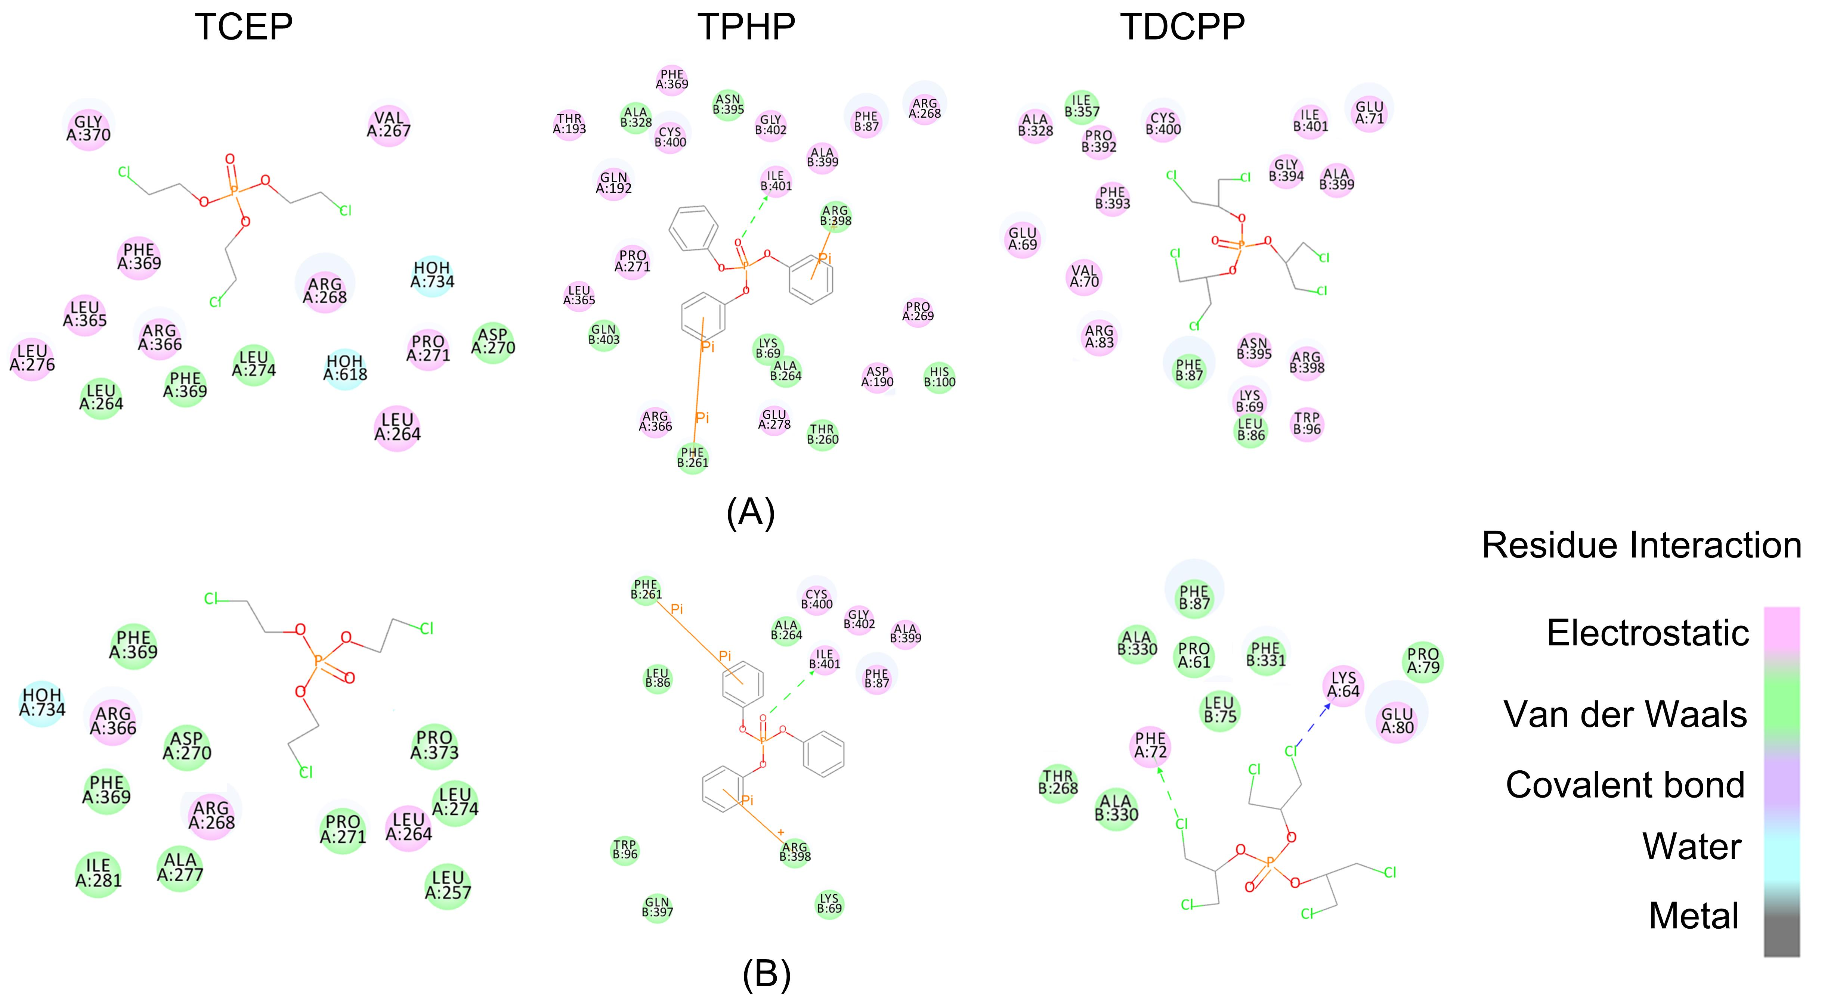

Fig. S1. The force field diagram of OPFRs docked with JTR. (A) Absence of recommended CFS; (B) Presence of recommended CFS

