Supplementary Materials

1. Supplementary Results

1.1 Validation analysis
Using a 15-TR window size, two recurring brain functional states were defined. The centroids were shown in Figure S. Across all participants, state 1 was characterized by weak connectivity between ICs, and the occurrence proportion of state 1 was 70%; state 2 was characterized by stronger and mostly positive connectivity in general, and the occurrence proportion of state 2 was 30%.
Group comparisons of state transition metrics showed similar results with the main results, children with TS showed decreased fractional time in state 1 (P < 0.001, P_{FDR} < 0.001), and increased fractional time in state 2 (P_{FDR} = 0.000) compared with TDC. We also found that children with TS exhibited lower dwell time in state 1 (P < 0.001, P_{FDR} < 0.001), and higher dwell time in state 2 (P = 0.002, P_{FDR} = 0.003) than TDC. Moreover, we observed higher number of transitions of children with TS than TDC (P = 0.015, P_{FDR} = 0.015).

2. Supplementary Figures

Figure S1. K-means clustering analysis assessing the reoccurring dynamic functional connectivity patterns. According to the maximum silhouette coefficient, the optimal cluster number was determined to be two.
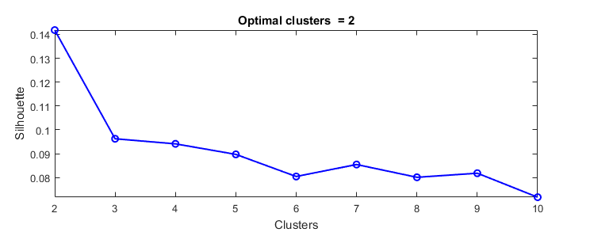

Figure S2. Group specific cluster centroids. (A) Cluster centroids for state 1 in Tourette’s syndrome (TS) group. (B) Cluster centroids for state 2 in TS group. (C) Cluster centroids for state 1 in typically developing children (TDC) group. (D) Cluster centroids for state 2 in TDC group.
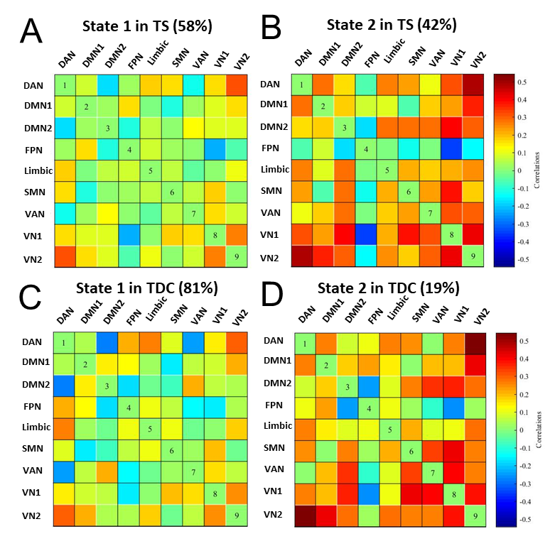

Figure S3. The validation analysis using 15-TR window size showed similar results with the main results. (A) We obtained two states under 15-TR window size, the cluster centroids for the two states were similar to that of 20-TR window size. (B) Group comparisons of state transition metrics under 15-TR window size. The “**” represents P_{FDR} < 0.05.
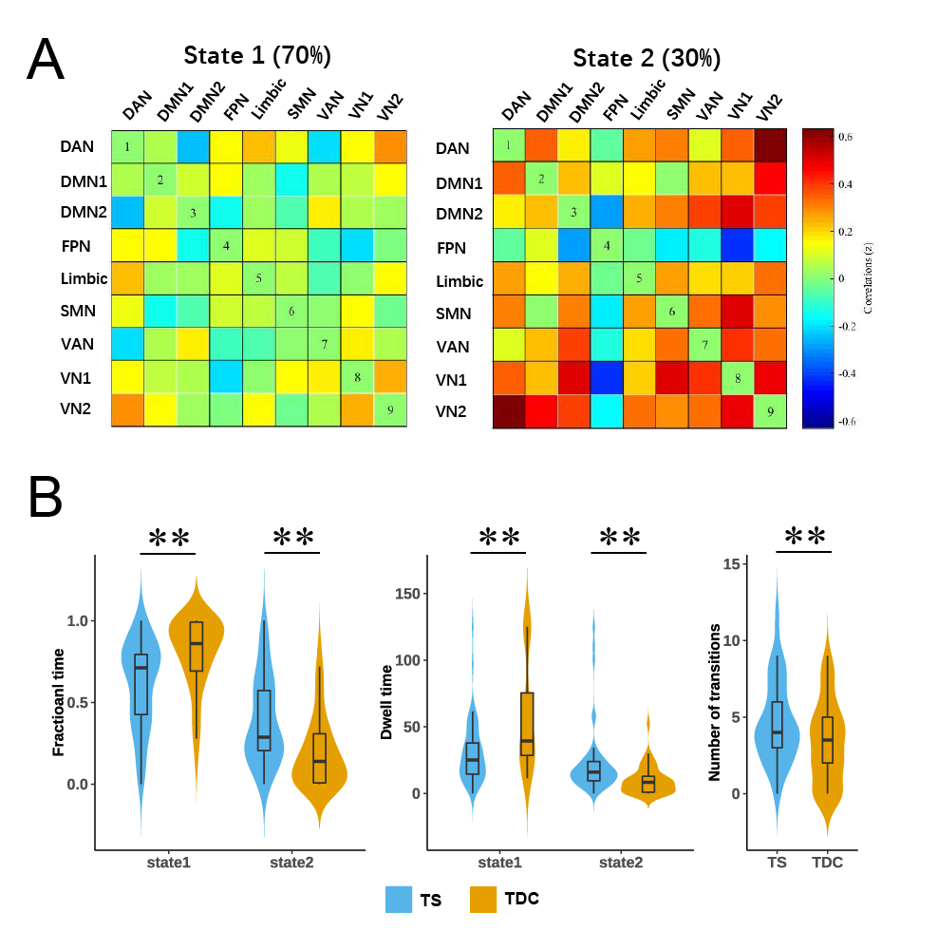

Figure S4. Effective connectivity among the nine ICs in the groups of TS (A, B, C) and TDC (D, E, F). (A, D) The significant positive causal influence in TS and TDC groups, respectively (one-sample t-test, P < 0.05). (B, E) The significant negative causal influence in TS and TDC groups, respectively (one-sample t-test, P < 0.05). (C, F) The group mean Granger causality strength map in TS and TDC groups, respectively. Cells colored in warm colors represent positive causal influence, across nodes (column to row), while cells colored in cold colors represent negative causal influence.
