APPENDIX A
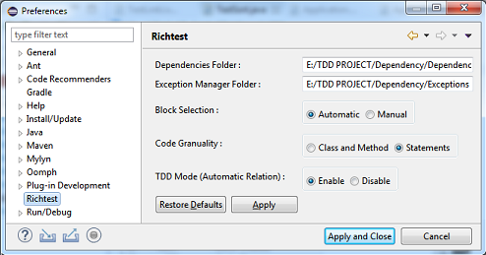
Fig. 16 illustrates the Preferences window of RichTest. The developers could set block selection mode and the level of block granularity as well as enable TDD mode there.
Fig. 16 Preferences Window

Fig. 17 until Fig. 23 represent RichTest views. These figures are related to selectionSort project. Fig. 17 is BlockInfo View and illustrates that test case “ta009” is the only test block that is connected to the “Ca005” code block. The “Manage” key lets the developers manage the relation manually. As seen in Fig. 18 Manual Management Window of BlockInfo View. Fig. 18, the developer can link/unlink each test block to the “Ca005” code block manually.
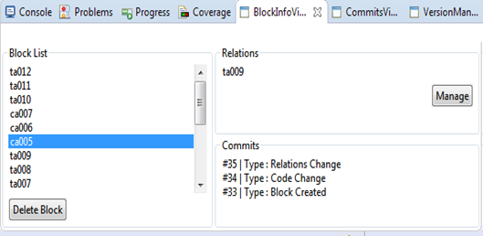
Fig. 17 Block Info View

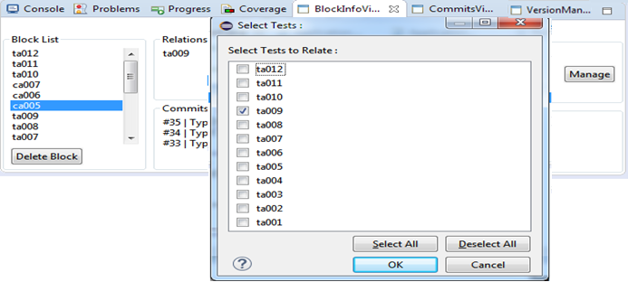
Fig. 18 Manual Management Window of BlockInfo View

Fig. 19 illustrates the Commit View. The developers can see the type of modification and block content. Fig. 20 illustrates the Version Manager View that shows all versions of the project as well as creates a new version. Fig. 21 illustrates Regression Test View. Two test cases, 'Ta011' and 'Ta012' have been selected and run successfully (green color, means pass and red color means fail), required time and test results have been shown.

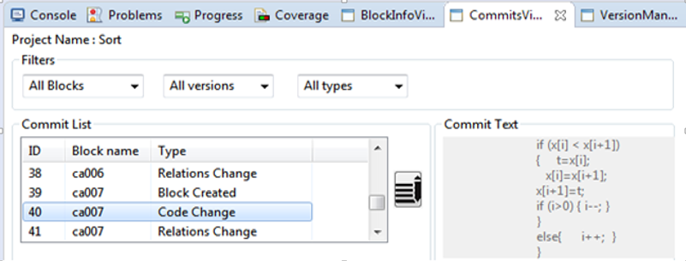
Fig. 19 Commit View

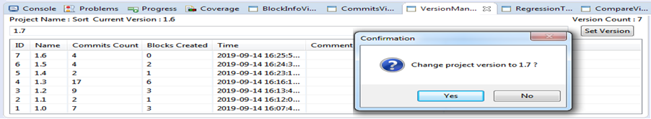
Fig. 20 Version Manager View

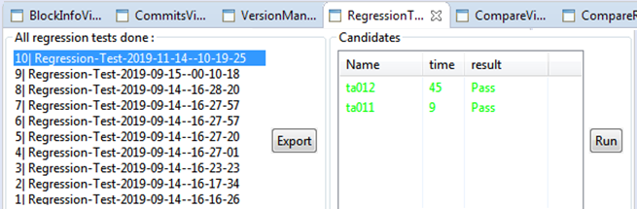
Fig. 21 Regression Test View

Fig. 22 shows Compare View. The developer selects the desired code block (Ca003) to see the history of its changes and then selects two commits for comparison (Commit #21 and Commit #42). Fig. 23 shows the comparison result. The orang box shows the changed part from Commit #21 to Commit #42.

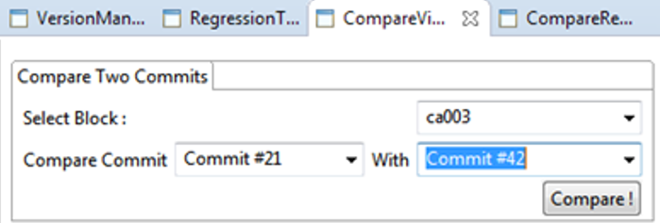
Fig. 22 Compare View

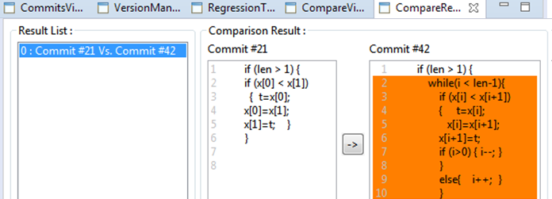
Fig. 23 Compare V

