Supporting Information
Nanostructured Ce/CeO2-rGO: Highly Sensitive and Selective Electrochemical Hydrogen Sulphide Sensor
Shivsharan M. Maliª,Shankar S. Narwadeª, Balaji B. Mulik^{ac},Vijay S. Sapnerª,Shubham J. Annadateªand Bhaskar R. Sathe^{ab}*

Figure S1: The SEM of Ce/CeO₂ NPs:
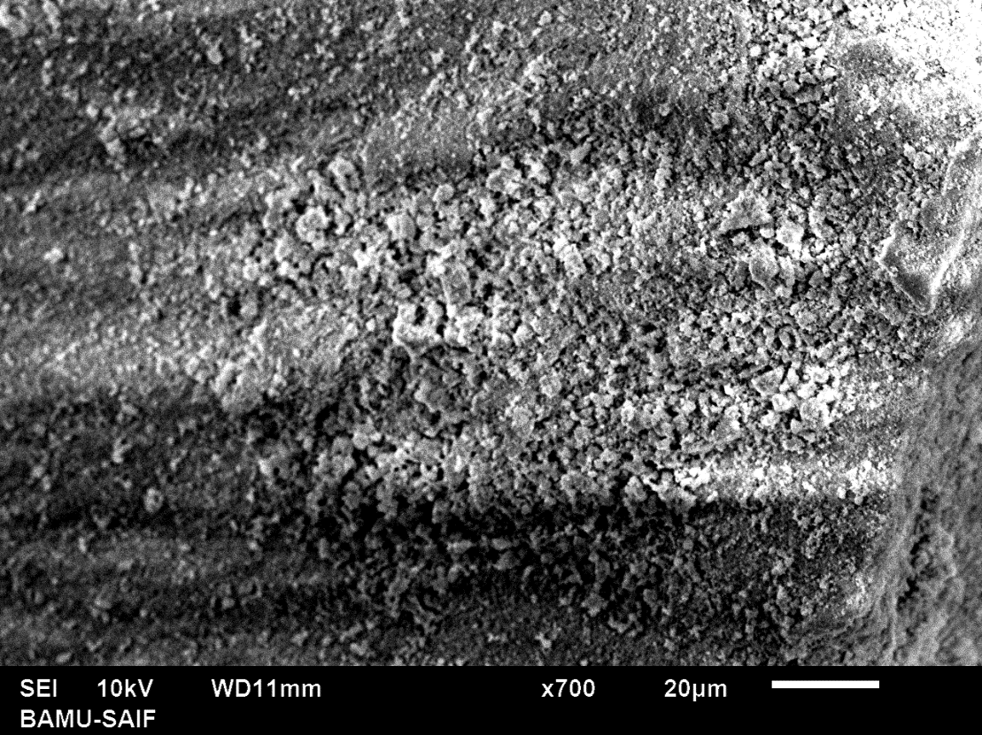

S2: FTIR spectrum:
Figure. S2: FTIR spectra of Ce/CeO₂nanoparticles.
The FTIR spectra of Ce/CeO₂ obtained using KBr pellet method, are shown in Figure. The band at 3500 cm⁻¹ corresponds to δ (OH) vibration. Absorption peaks corresponding (1500-600 cm⁻¹) to residual water and hydroxyl groups are usually detected in the FTIR spectrum of as prepared CeO₂ nanoparticles regardless of the synthesis method [1, 2]. Large absorption band around 421 cm⁻¹ is due to the υ(O–Ce–O) vibration.

FigureS3: Linearity data at Ce/CeO₂-rGO for different H₂S concentrations:

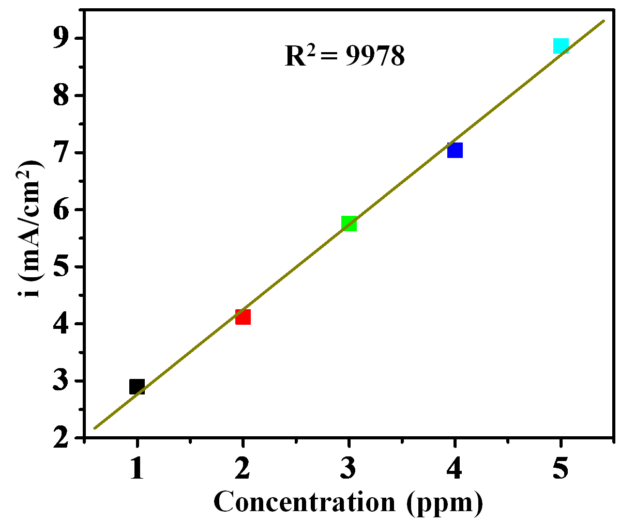
FigureS3: Linearity data at Ce/CeO₂-rGO for different H₂S concentrations between 1 ppm to 5 ppm.

FigureS4: Linearity data at Ce/CeO₂-rGO for different H₂S concentrations Error bar between 1 ppm to 5 ppm (a) and (b) graph.

Table S1: Comparative study of electrochemical H₂S sensing
Sr.no. | Modified Electrodes | Type | LOD (µM) | Ref.
1 | magnetic CNT/Co/MoS₂ | Amperometry | 0.12 μM | 3
2 | Ti₃C₂ TxMXene | Amperometry | 0.016 μM | 4
3 | Cu₂O − CuO@AuNIs ODH | Amperometry | 0.7 μM | 5
4 | GO/MB/Ag-NPs/GCE | DPV | 23.88 μM | 6
5 | PDMS/ITO | Amperometry | 0.17μM | 7
6 | ABFC/GO/GCE | DPV | 0.32 µM | 8
7 | Ce/CeO₂-rGO | LSV | 1 ppm | Present  work

References:
- D.W. Wheeler, I. Khan, Vib. Spectrosc.70, 200 (2014).
- G. Jayakumar, A. A. Irudayaraj, A. D. Raj, Applied Physics A,125, 742 (2019)
- C. Li, D. Zhang, J. Wang, P. Hu, Z. Jiang, Anal. Chim.Acta. 975, 61 (2017).
- X. Liu, L. He, P. Li, X. Li, P. Zhang, ChemElectroChem.8,3658 (2021).
- M. Asif, A. Aziz, G. Ashraf, Z. Wang, J. Wang, M.Azeem, X. Chen, F. Xiao, H. Liu, ACS Appl. Mater. Interfaces.10, 36675 (2018).
- H. Shang, H. Xu, C. Wang, C. Chen, C. Wang, L. Jin, Y. Du, J. Nanopart. Res. 22, 1 (2020).
- S. Wang, X. Liu, M. Zhang, Anal. Chem. 89, 5382 (2017).
- K. Manibalan, V. Mani, P. C. Chang, C. H. Huang, S. T. Huang, K. Marchlewicz, S. Neethirajan, Biosens. Bioelectron. 96, 233 (2017).

