Supplementary Material

Acute ischemic stroke leading to a diagnosis of Marfan syndrome: Case report and systematic review
Licong Chen^{1†}, Quanquan Zhang^{1†}, Qian Geng², Hongru Zhao¹, Jianhua Jiang¹, Dapeng Wang¹, Yuan Liu^{3*} and Qi Fang^{1*}
¹Department of Neurology, The First Affiliated Hospital of Soochow University, Suzhou, Jiangsu, China
²Emergency Department, Huazhong University of Science and Technology Union Shenzhen Hospital (Nanshan Hospital), Shenzhen, Guangdong, China
³Department of Neurology, Suzhou Ninth People’s Hospital, Suzhou, Jiangsu, China
†Licong Chen and Quanquan Zhang contributed equally to this work.
*Correspondence:
Yuan Liu
liuyuan_sz1981@163.com
Qi Fang
fangqi_008@126.com

Supplementary Figures and Tables
Figure legends
Figure 1. Radiologic findings, physical examination, and gene test results of the patient. A. CTP showed ischemic perfusion in the blood supply territory of the A4 segment of the right anterior cerebral artery, with a volume mismatch of 82%. B. Axial cerebral CT scan image showing hyperdensities in the right occipital lobe and subarachnoid hemorrhage. C. Skin lesions were painless hemorrhagic erythema on both lower limbs. D. Clubbing of toes. E. Echocardiogram revealed vegetations in the mitral valve. F. NGS results for the patient and his mother; both had a heterozygous mutation of c.1177A>G on chr15-48808530.
Figure 2. Radiologic findings and gene tests of the patient. A, B. Hyperintense signals on MRI were detected in the brainstem and left cerebellar hemispheres. C. High-resolution vessel wall imaging (HRVW) MRI showed fenestration of the V4 segment of the left vertebral artery. D. HRVW MRI showed vertebral artery dissection of the V3 segment with possible intramural hematoma. E. Results of NGS for the patient. The patient had a heterozygous mutation on chr15-48903141.
Figure 3. CT perfusion in the acute phase. A, B. CTP showed a volume mismatch of up to 22 ml between the ischemic core and hypoperfusion area.
Table 1. Baseline characteristics of cases of ischemic stroke caused by MFS reported in the literature
Patient  (Reference) | Year | Age/  sex | Known MFS | Presentation | Intravenous thrombolysis | Mechanical thrombectomy | Hemorrhagic complications | Possible mechanism of IS | Outcome
1  (Souirti 2011) | 2011 | 17/M | No | Right hemiparesis, brachiofacial dominance, hemihypoesthesia, and Broca’s aphasia | No | No | No | Cardioembolic origin (infectious endocarditis) | Complete improvement
2  (Malek 2019) | 2019 | 44/M | Yes | Sudden onset of left-sided weakness and slurred speech | Yes | No | No | Chronic aortic dissection | Near-complete recovery
3  (Maski 2011) | 2011 | 19/M | Yes | Severe, throbbing frontal headache, then ataxia and an audible bruit at the base of his skull | No | No | Yes | Dissection within the V4 segment of the right vertebral artery | Complete improvement
4  (Ozawa 2018) | 2018 | 32/M | Yes | Right hemiparesis and slurred speech | No | No | No | Dissection of the right middle cerebral artery | Complete improvement
5  (Anton 2006) | 2006 | 27/M | Yes | Left-sided mild weakness, dysphasia, right frontal headache | No | No | No | Cardioembolic mechanism (two bioprosthetic heart valve surgeries and no evidence of aortic or carotid dissection) | Complete improvement
6  (Micelli 2018) | 2018 | 16/M | No | Sudden weakness of right arm and leg, dysarthria | No | No | Yes | Embolic stroke (left atrial myxoma) | Improvement
7  (Gójska-Grymajło 2014) | 2014 | 34/M | Yes | Sudden onset of double vision and right face and tongue paresthesia | Yes | No | No | Probable cardio-embolic etiology | Complete improvement
8  (Chembala 2012) | 2012 | 54/M | Yes | Sudden onset of right arm and leg weakness and slurred speech | Yes | No | Yes | Cardioembolic (poor left ventricular function and prosthetic valves) | Improvement
9  (Zhu 2022) | 2022 | 18/M | No | Right hemiparesis, aphasia, and impaired consciousness | Yes | Yes | No | Embolism of the basilar artery that may originate from aortic root aneurysm | Near-complete recovery
10  (Wang 2019) | 2019 | 32/M | No | Sudden onset of right arm and leg weakness and slurred speech | Yes | Yes | No | Probable cardioembolic etiology (prior history of definite heart valve replacement) | Improvement
IS, ischemic stroke; M, male; MFS, Marfan syndrome.
Figure 1
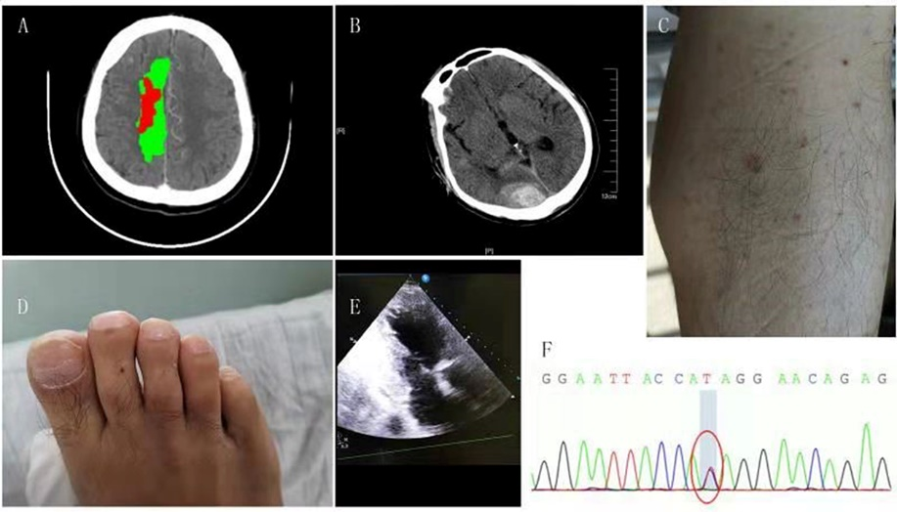
Figure 2
Figure 3

