ANNEX 1
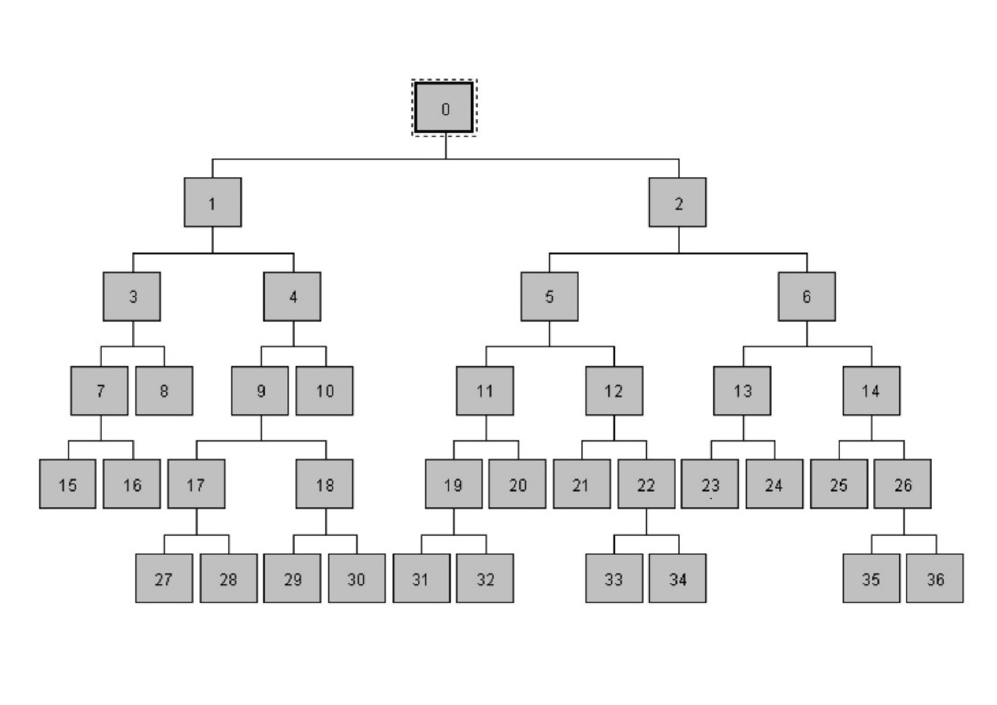
Fig. 7 Regression tree schema

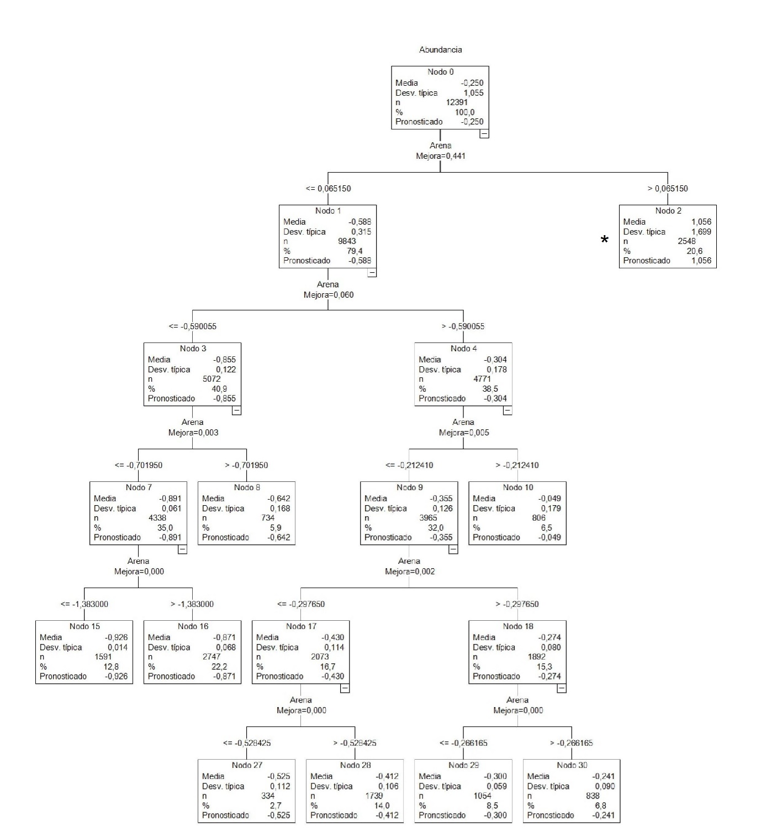
Fig. 8 Node 1 derivation of the regression tree

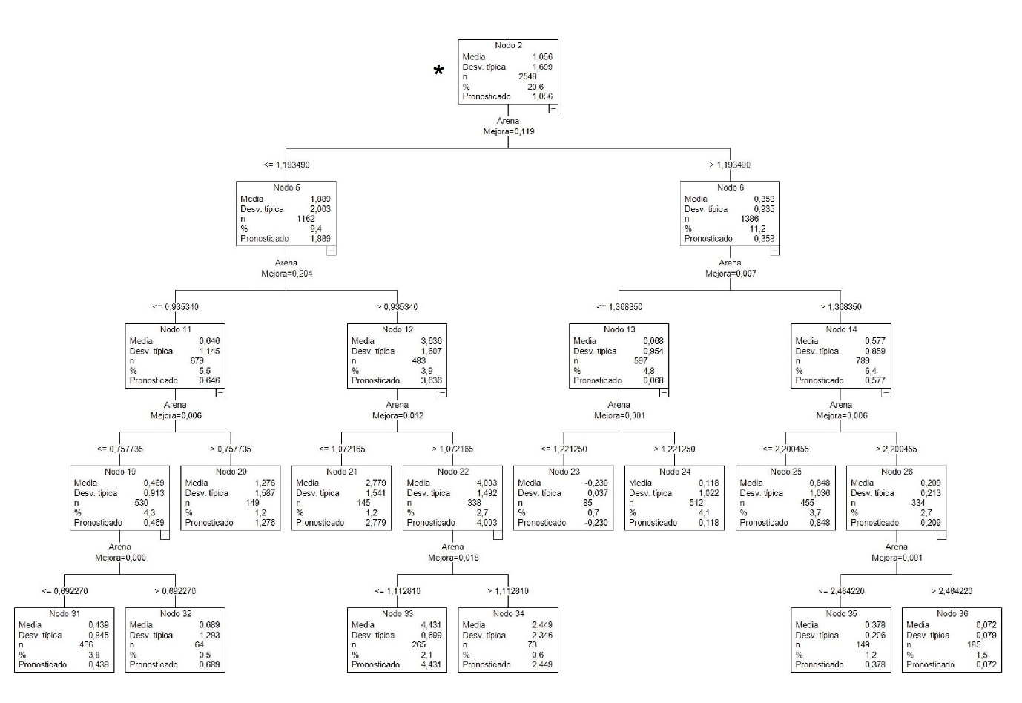
Fig. 9 Node 2 derivation of the regression tree

Annex 2
Table 1 Results of dispersion analysis in each of the spatialized node. . *Negative lineal relationship. **Negative quadratic relationship. ***No relationship detected. ****Positive lineal relationship.
Node | SubNodes | R | Line | N of pixels
36 | 1 | 0,84 | * y = -1,5765x + 4,1105 | 185
35 | 2 | 0,9586 | * y = -2,5906x + 6,7188 | 55
 |  | 0,9806 | * y = -0,5588x + 1,5542 | 96
25 | 2 | 0,9934 | * y = -3,1401x + 7,8686 | 128
 |  | 0,9855 | ** -0,6319x² + 2,4913x - 2,1112 | 328
24 | 3 | 0,9231 | * y = -3,5505x + 8,4807 | 34
 |  | 0,8729 | ** -13,573x² + 36,506x - 24,464 | 33
 |  | 0,1287 | *** y = -0,017x - 0,2333 | 254
23 | 1 | 0,092 | *** y = 1,6224x - 2,1953 | 86
34 | 2 | 0,9651 | * y = -4,8295x + 10,024 | 43
 |  | 0,6458 | **** y = 0,0521x - 0,321 | 32
33 | 1 | 0,0002 | *** y = -0,3998x + 4,9596 | 261
21 | 2 | 0,967 | **** y = 5,3245x - 1,859 | 116
 |  | 0,74 | **** y = 0,0497x - 0,3168 | 30
32 | 2 | 0,9832 | **** y = 3,5315x - 0,1465 | 23
 |  | 0,0138 | **** y = -0,0465x - 0,2378 | 41
31 | 2 | 0,9972 | **** y = 2,9303x + 0,2185 | 221
 |  | 0,7398 | **** y = 0,0746x - 0,318 | 245
30 | 4 | 0,0275 | *** y = 0,0176x - 0,359 | 117
 |  | 0,994 | **** y = 2,4746x + 0,2652 | 261
 |  | 0,811 | **** y = 0,0718x - 0,3198 | 103
 |  | 0,7191 | *** y = 3,1549x + 0,5545 | 1158
29 | 6 | 0,0872 | *** y = 2,171x + 0,3092 | 1054
 |  | 0,5114 | *** y = 2,2161x + 0,2072 | 47
 |  | 0,0683 | *** y = 0,0672x - 0,3222 | 14
 |  | 0,0244 | *** y = 0,6348x - 0,071 | 160
 |  | 0,8684 | **** y = 1,672x + 0,343 | 19
 |  | 0,1457 | *** y = 1,9155x + 0,2525 | 138
28 | 5 | 0,597 | *** y = 1,1297x + 0,0632 | 203
 |  | 0,9785 | **** y = 2,9622x + 0,456 | 567
 |  | 0,5221 | *** y = 0,3556x - 0,1719 | 592
 |  | 0,9968 | **** y = 1,6723x + 0,3435 | 115
 |  | 0,5487 | *** y = 0,764x - 0,0932 | 259
27 | 3 | 0,0636 | *** y = 0,9993x - 0,0109 | 71
 |  | 0,1482 | *** y = 0,1081x - 0,294 | 91
 |  | 0,8898 | **** y = 1,7321x + 0,379 | 78
 |  | 0,9276 | **** y = 1,9138x + 0,4634 | 68
 |  | 0,9667 | **** y = 2,2002x + 0,6856 | 26
10 | 4 | 0,0016 | *** y = -0,0963x - 0,0614 | 807
 |  | 0,9913 | **** y = 2,503x + 0,2669 | 196
 |  | 0,7797 | **** y = 0,0814x - 0,3196 | 84
 |  | 0,8508 | *** y = 2,367x + 0,4335 | 451
15 |  | 0,8143 | **** y = 0,1604x - 0,6851 | 1585
16 |  | 0,8208 | **** y = 0,2163x - 0,5222 | 605
 |  | 0,917 | **** y = 0,591x - 0,3332 | 405
 |  | 0,0858 | *** y = 0,0349x - 0,8755 | 1756
 |  | 0,9789 | **** y = 0,2657x - 0,5282 | 111
8 | 4 | 0,8837 | **** y = 0,1042x - 0,2975 | 170
 |  | 0,4655 | *** y = 0,8862x - 0,1362 | 180
 |  | 0,9891 | **** y = 2,0541x + 0,5448 | 198
 |  | 0,9483 | **** y = 2,1251x + 0,6412 | 40

