Case Study 2 – Video Cone Test (VCT) PLUS Laboratory Assay
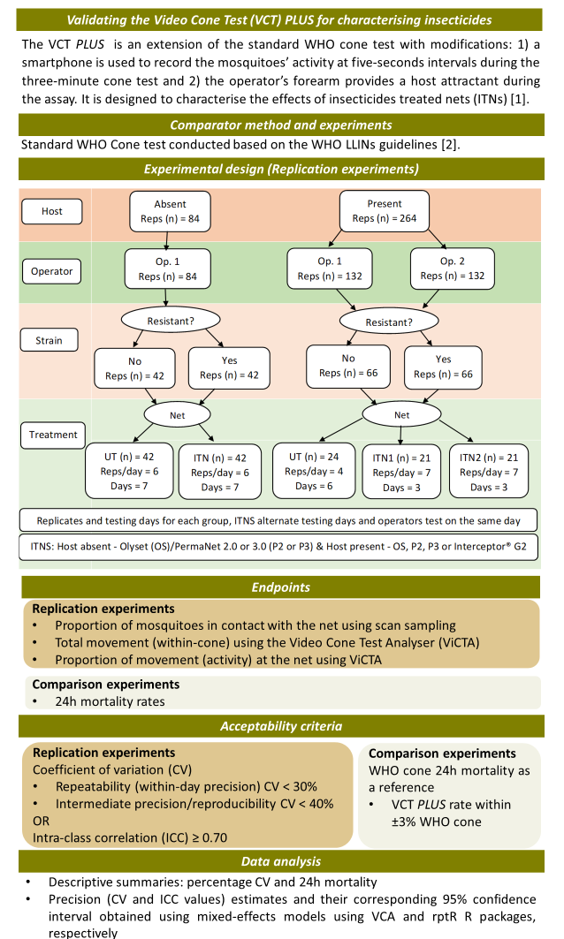
References
- Hughes A, Matope A, Emery M, Steen K, Murray G, Ranson H, et al. A closer look at the WHO cone bioassay: video analysis of the hidden effects of a human host on mosquito behaviour and insecticide contact. Malar J. BioMed Central Ltd; 2022;21:1–11. https://doi.org/10.1186/s12936-022-04232-4.
- WHO, WHO Pesticide Evaluation Scheme. Guidelines for laboratory and field testing of long-lasting insecticidal nets (No. WHO/HTM/NTD/WHOPES/2013.1). 2013.

