Supplementary Information

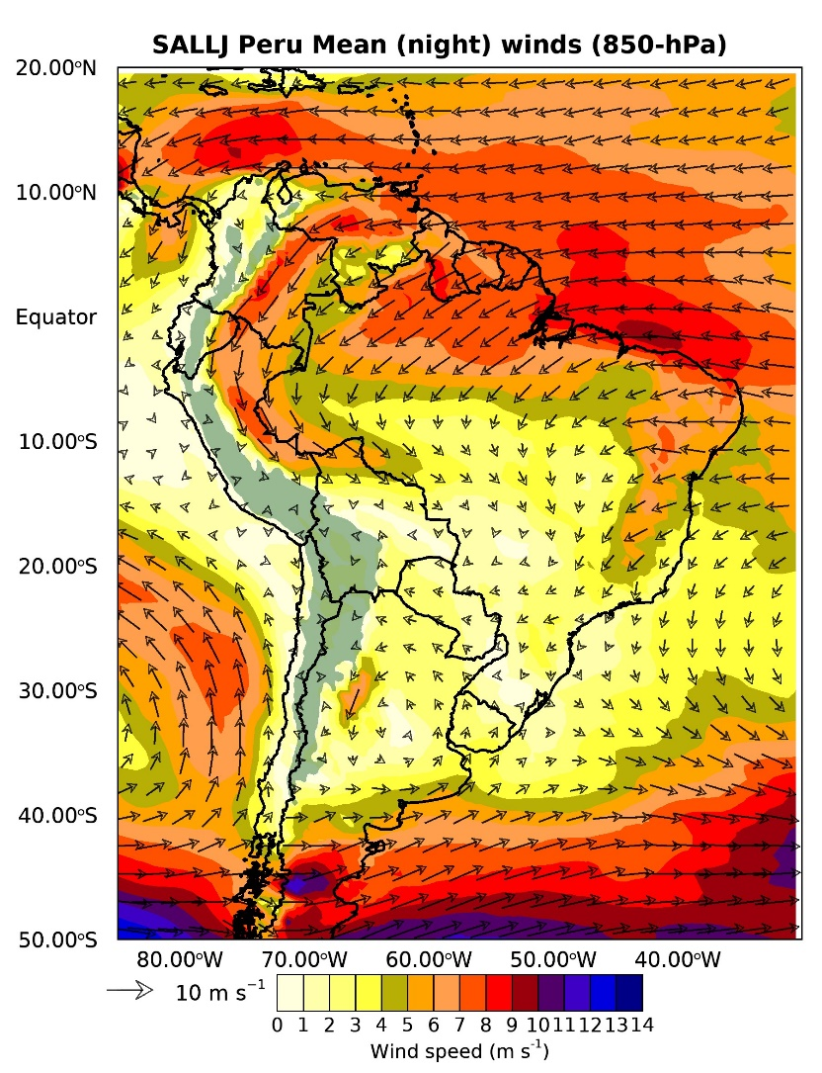

Figure S1. Composite of winds at 850-hPa during Peru SALLJ types.

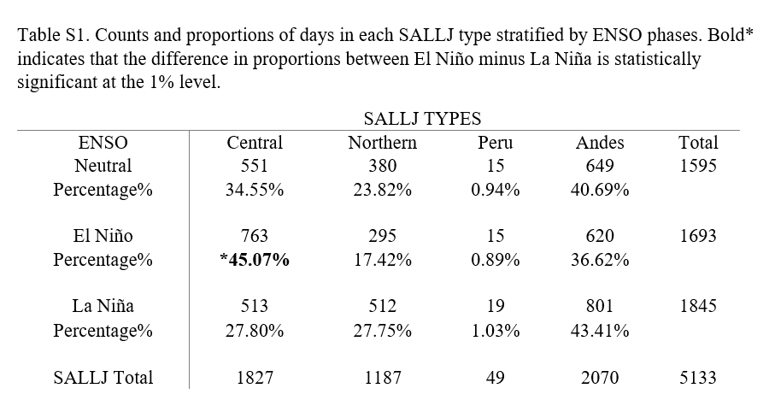

Figure S2. Composites of outgoing longwave radiation (OLR) anomalies (W m-2).
