Synthesis of Cu and CuO Nanoparticles from E-waste and Evaluation of Their Antibacterial and Photocatalytic Properties
Sabah M. Abdelbasir^{1,*}, Diaa A. Rayan^{1,3}, Mahmoud M. Ismail²
¹Central Metallurgical R& D Institute (CMRDI), P.O. Box 87 Helwan 11421, Cairo, Egypt
²Physics Dept., Faculty of Science, Al-Azhar Unversity, Nasr City, Cairo 11884, Egypt
³Basic Science Department, Deraya University, Plot No 3 Ard El Gameaat, New Minya, Minya, Egypt

*Corresponding author: sfoda20@hotmail.com
Tel.: +202 27142011; +201151195565; fax: +202 27142451.
ORCID/ 0000-0003-2698-2041

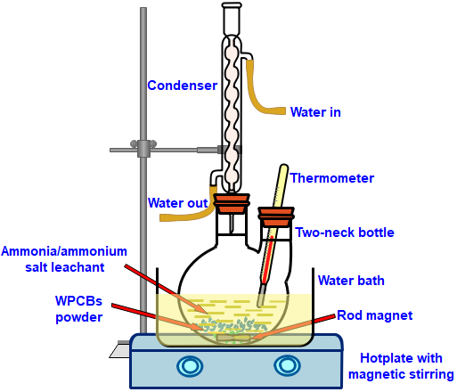

Fig. S1. a schematic drawing of the used leaching system.

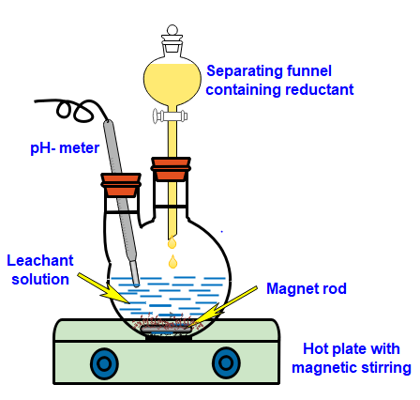
Fig. S2. System used for nanoparticles’ synthesis.

Materials Characterization

X-ray diffractometer (XRD) “Bruker AXS- D8, Germany” in the range 2θ from 20 to 70º using CuKα as a radiation source (λ = 1.54 Å). Fourier Transform Infrared Spectroscopy (FT-IR) was accomplished by means of JASCO-3600 spectrometer over the wavenumber spans from 4000-400 cm⁻¹. Transmission electron microscope (TEM) “JEOL-JEM1230” was used for microscopic structural and morphology investigation of the synthesized nanoparticles. The absorbance spectra of the prepared particles were distinguished by a UV/Vis spectrophotometer Varian Cary 100 Scan system at 190–2200 nm with BaSO₄ as a reference.

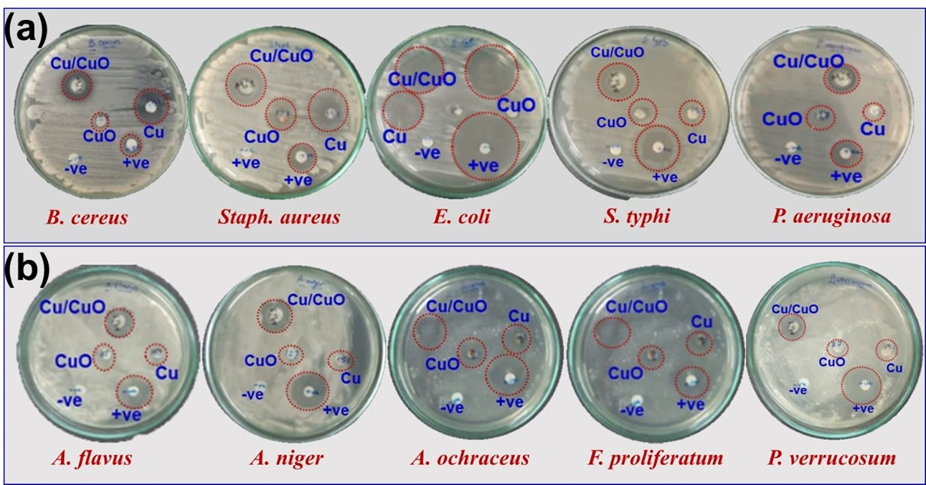
Fig. S3. Bactericidal activity of Cu, CuO and Cu/CuO NPs against (a) five pathogenic bacteria (using DMSO, ceftriaxone as negative and positive controls), and (b) five mycotoxigenic fungi (using DMSO and miconazol as negative and positive controls).

