Supplementary Materials for
Traveling Salesman Problem solution using Magnonic Combinatorial Device
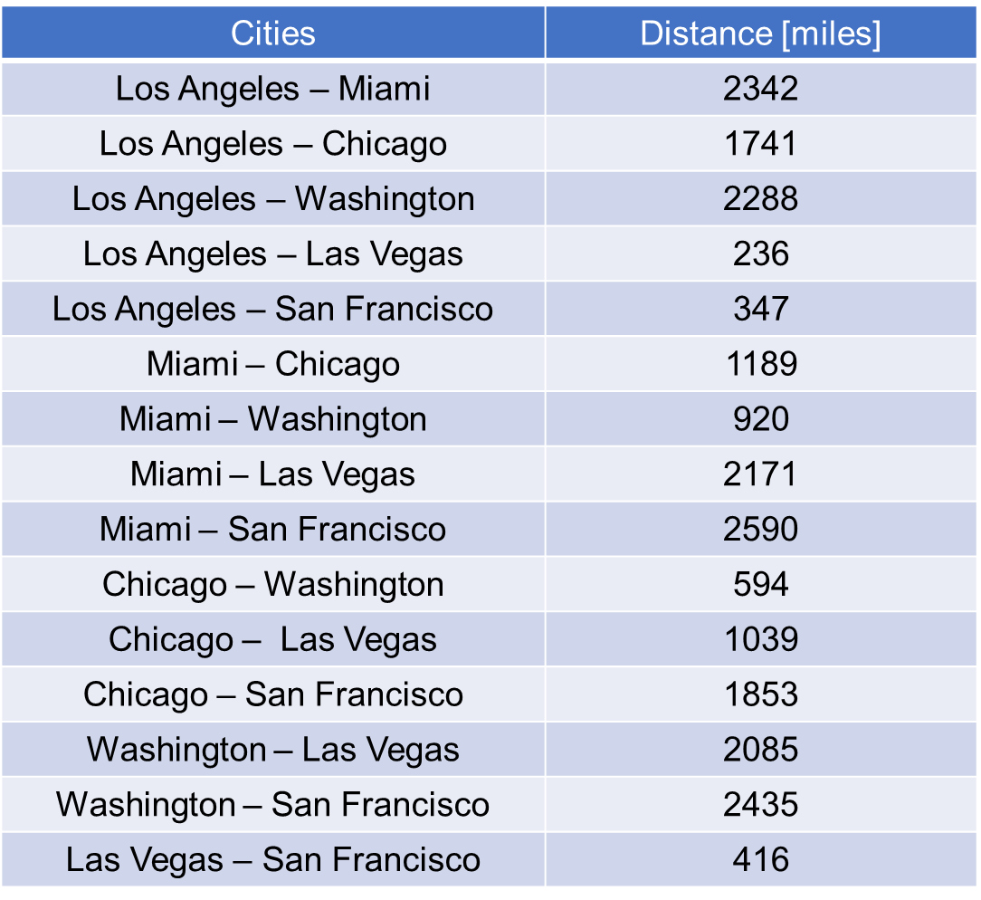

Table [s1] with city-to-city distances used in numerical simulations. The distances between the cities are taken from the Google Map application.

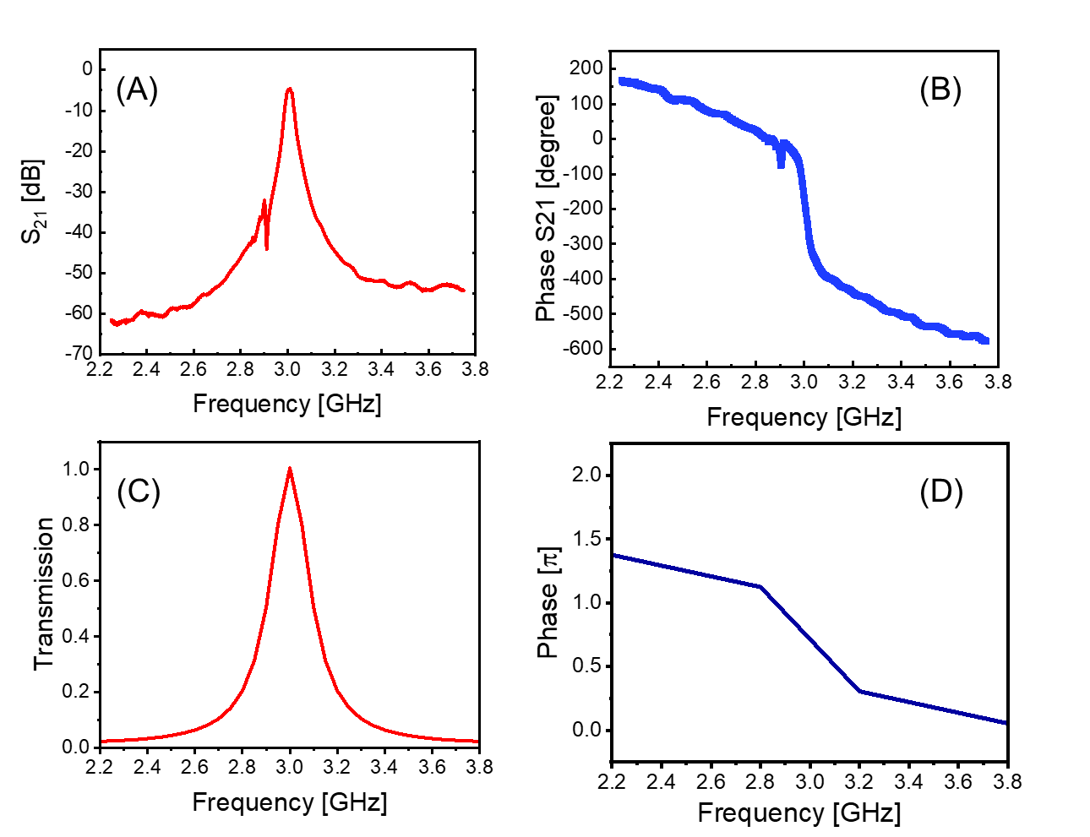
Figure [s1]: YIG-based frequency filter produced by Micro Lambda Wireless, Inc, model MLFD-40540. (A) Experimental data: S21 parameter (amplitude) of the commercial filter. (B) Experimental data: S21 parameter (phase shift) of the commercial filter. (C) Results of numerical fitting: transmission of the spin wave element. (D) Results of numerical fitting: phase shift produced by the spin wave element. The data are shown in the frequency range from 2.2 GHz to 3.8 GHz.

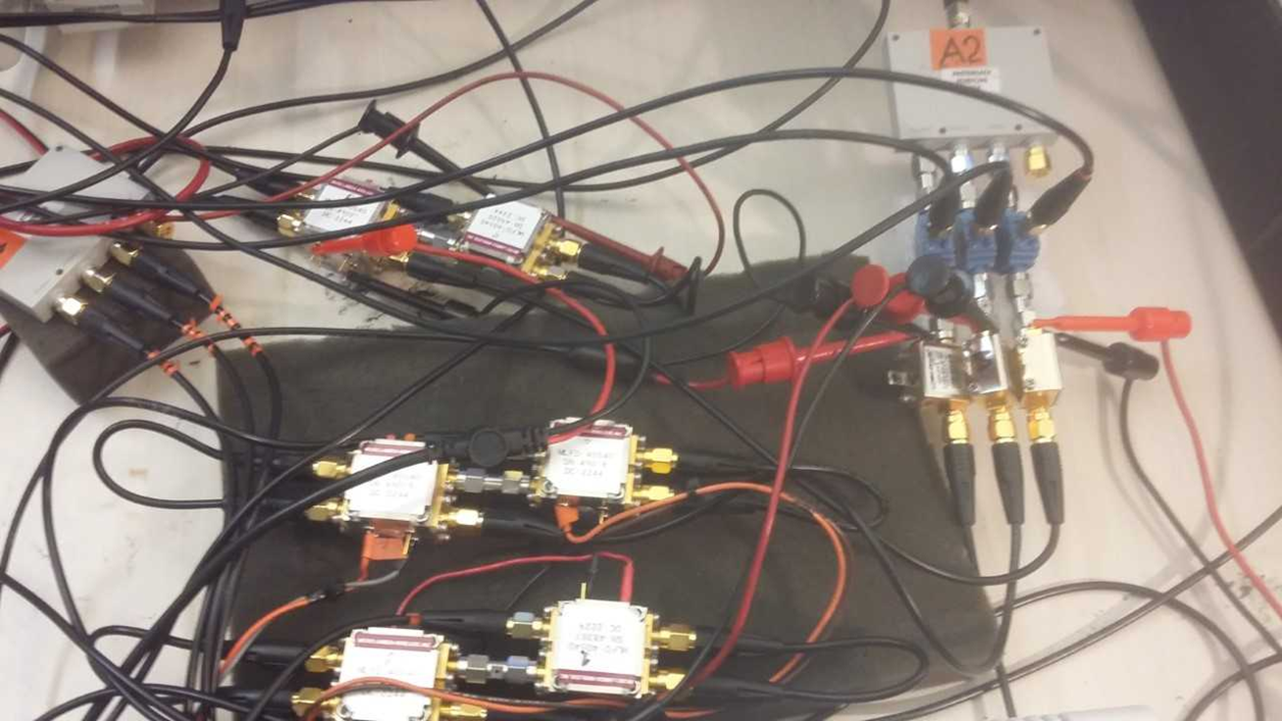
Figure [s2]: Photo of the prototype device. The prototype is built of YIG-based frequency filters produced by Micro Lambda Wireless, Inc, model MLFD-40540 connected by coaxial cables through the set of splitters and combiners.

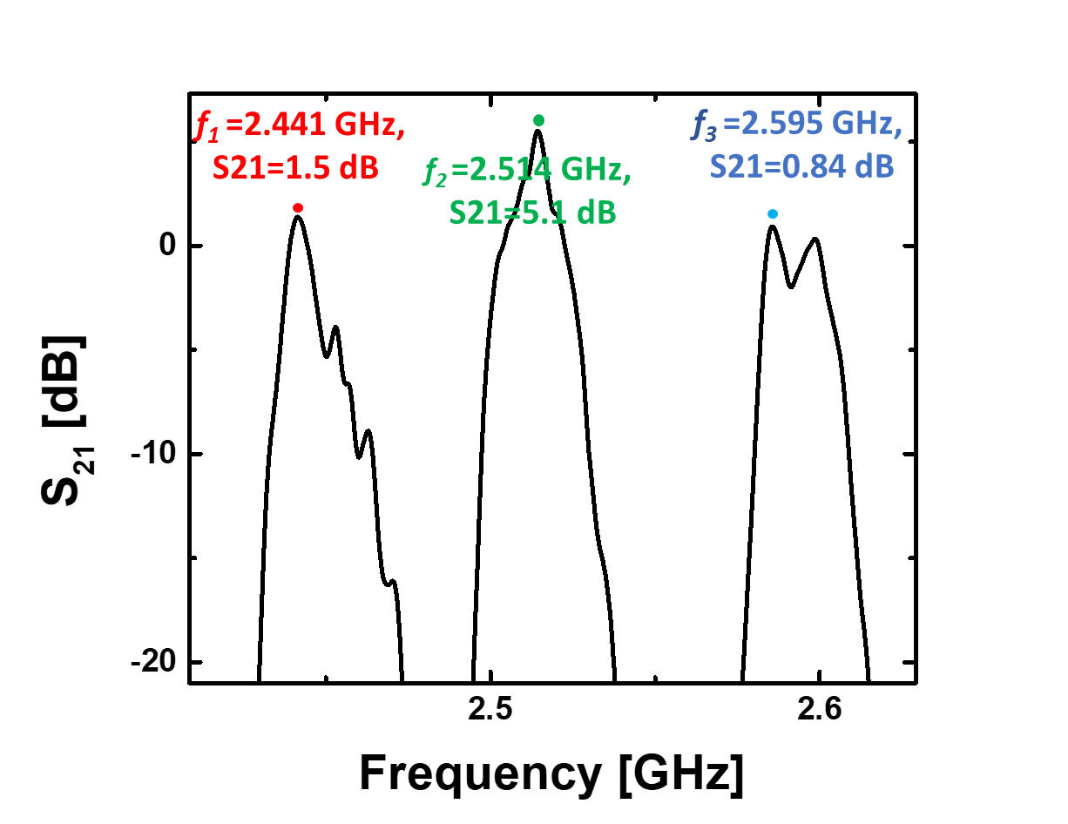

Figure [s3]: Experimental data: Transmission of the mesh for the three routes. Data are taken with VNA. The mesh is not connected to the electric part (i.e., no amplification)

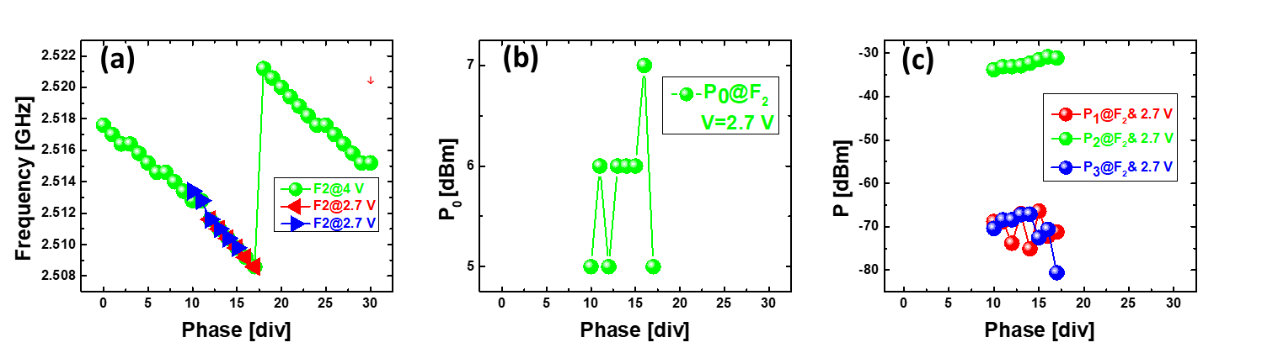
Figure [s4]: Experimental data: Auto-Oscillations in the Active Ring Circuit. Magnetic mesh is connected to the electric part. Auto-oscillations are observed for certain levels of amplification and the external phase shifter. The gain in the circuit is set to +13.5 dB.
(a) Frequencies of the auto-oscillations depending on the external phase shifter. One div is equivalent to π/30 radians (b) Total power in the active ring circuit depending on the external phase. (c) Power of the auto-oscillations in different propagation routes.

