Supplemental Methods
7-loci Amplification Procedure
DNA extractions were done using the protocol provided with a Promega Wizard Genomic DNA Purification kit. Extracted DNA was re-hydrated in 100 µl of water and stored at -20°C prior to being used for PCR amplification of microsatellite DNA alleles.
Forward primers for each locus were fluorescently labeled with tetramethyl rhodamine (TET). The 25.5 µl PCR reaction mix for each sample consisted of 1.5 µl of the hydrated DNA extraction, 1.0 µl (10 pmol/µl) each of labeled forward and unlabelled reverse primers, 0.6 µl dNTP (10 mM of each dNTP: Roche Diagnostics), 0.15 µl Taq polymerase (New England Biolabs), 2.5 µl homemade PCR Buffer [each ml consisted of 25 µl 1M MgCl_{2,} 100 µl 1M Tris (pH 8.3), 500 µl 1M KCl, 80 µl Bovine Serum Albumin (BSA: 10 mg/mL: Sigma), 50 µl 2% gelatin (Sigma), 245 µl water], and 18.75 µl water. The PCR reaction was initiated with a 1 min denaturation at 94º C followed by 30 cycles of 94°C (45 sec) / annealing temperature of 56°C [Atex102, Atex141], 57°C [AjeD94, AjeD346, AjeD422, Atex74] or 58°C [AjeD283] (45 sec) / 72°C extension (30 sec). PCR products were electrophoresed on vertical, 6 % denaturing polyacrylamide gels alongside a GenescanTM-350 TAMRA size standard ladder. Gels were scanned with an Hitachi FMBioIII imager and the PCR products (bands) were scored relative to the ladder using Hitachi FMBioIII imaging software. PCR reactions of the same samples were repeated, and the position of the samples on the gel was changed to minimize possible scoring errors.

14-loci Amplification Procedure
DNA extractions were done following a standard ethanol precipitation procedure. Extracted DNA was re-hydrated in 200 µl of water and stored at -20°C prior to being used for PCR amplification of microsatellite DNA alleles.
In addition to the previous seven loci used in the 7-loci procedure, seven more loci were chosen to further enhance genotype resolution. Of the additional loci, Atex102 and AmaD321 were A. texanum specific; AmaD42, AmaD367, and AcroD315 were A. laterale specific; AjeD23 and AjeD75 were monomorphic in A. texanum and varied in A. laterale; and AmmH123 had multiple alleles for both hosts. AmaD321 appears to have undergone a duplication event as diploid A. texanum regularly had three, and sometimes four, distinct alleles. Atex141 was found to primarily have 2-bp long stutter bands with some alleles having 4-bp stutter bands, though do not appear to be from different locations on the genome – these traits were considered informative and identified for each sample. Allele size ranges and overall allele richness are provided in Supp. 2.
Forward primers for each locus were fluorescently tagged with one of four labels: NED, HEX, 6-FAM, or ROX. Four multiplex reactions (detailed in Supp 2) were developed and optimized based on protocols provided by QIAGEN Multiplex Kit (cat. 206145) to avoid allele size overlap of loci with identical tags (Supp. 2). All multiplexes were initiated with a 15 min denaturation at 94°C, followed by 40 cycles of 94°C (30 sec) / annealing temperature of 53°C [multiplex 3], 55°C [multiplex 1], or 56°C [multiplexes 2 and 4] (90 sec)/ 72°C extension (60 sec). A final extension step was run at 72°C for 30 min. PCR outputs were read using an Applied Biosystems 3730xl sequence analyzer with either GeneScan™ 500 ROX™ size standard [multiplexes 1 and 2] or GeneScan™ 500 LIZ™ size standard [multiplexes 3 and 4]. Trace reads were screened using Geneious 2022.2.

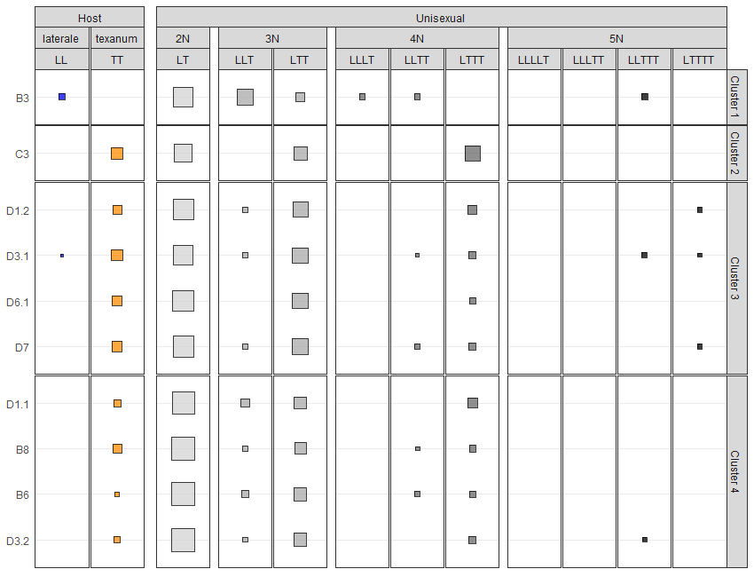
Figure 1. Relative abundances of both hosts (A. laterale, LL; A. texanum, TT) and the unisexual genomotypes (LT, LLT, LTT, and LTTT) by site arranged in cluster groups.

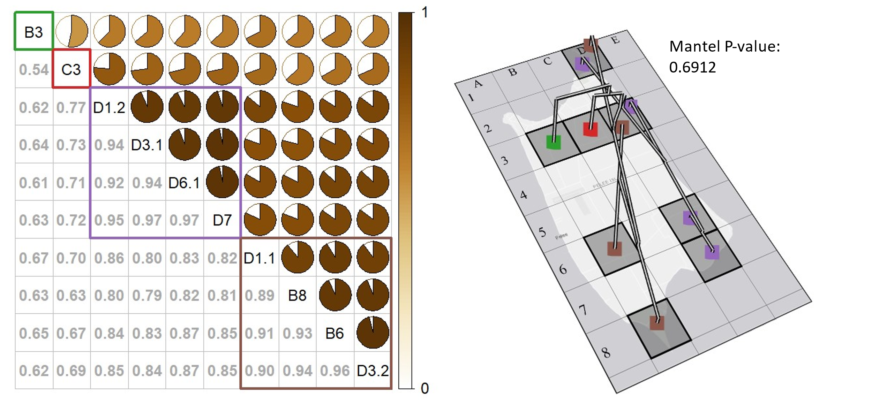
B)
A)
Figure 2. Corrplot (A) of all Bray-Curtis similarities (1 - dissimilarity) displayed as pie charts above diagonal and numeric values below diagonal. Site clusters are enclosed in squares. Bray-Curtis dendrogram aligned to map (B) along with geographic Mantel test result. Site clusters are colored following the scheme from the corrplot (A).

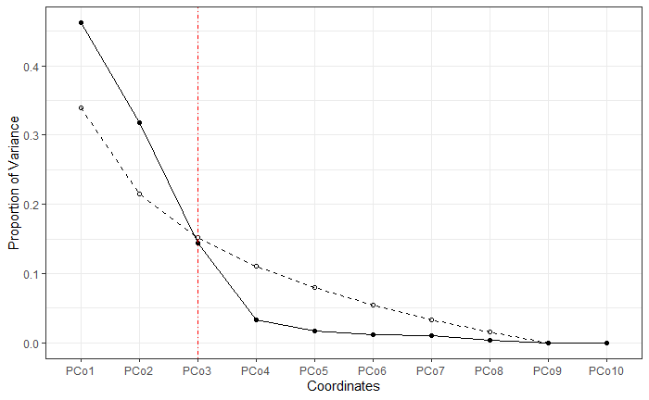
Figure 3. Screeplot of PCoA proportion of explained variances (solid) and comparative broken stick (dashed) with red line where explained variance fall below broken stick indicating loss of informative value.

