
Additional information

Extended Data Figures
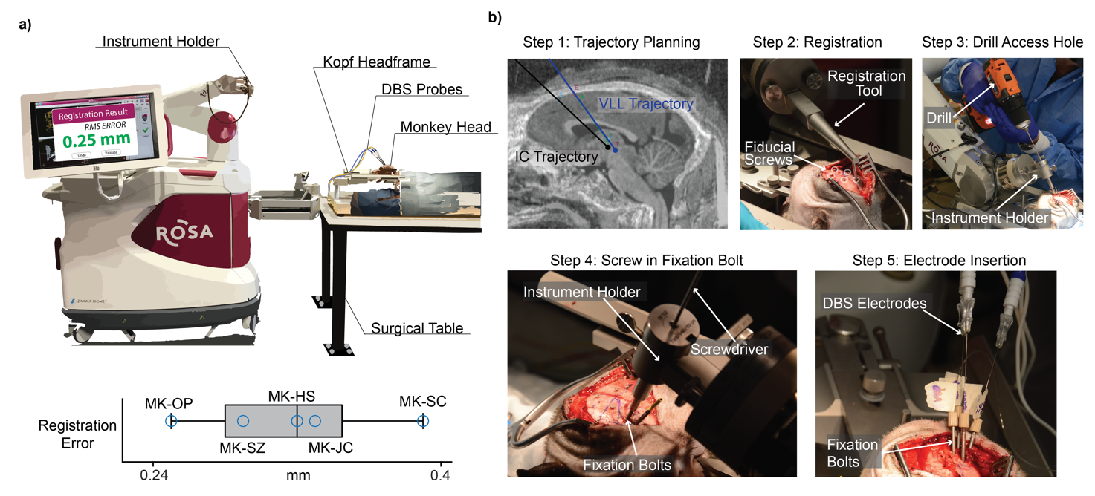
Extended Data Fig. 1 | ROSA Setup/Implantation Steps. (a) Top: Rosa robot surgery setup. This panel was adapted from³⁶. Bottom: Root mean squared registration error after registration using the fiducial screws for n=4 animals. (b) Step 1: we plan the trajectories of each DBS probe in the ROSA One Brain planning software. Step 2: using the Rosa registration tool, we register the position of the brain with fiducial screws in the skull. Step 3: an access hole is drilled into the skull along the trajectory of the probe. Step 4: fixation bolts are screwed into the skull along the probe trajectory. Step 5: DBS and IC electrodes are inserted into fixation bolts at target depth.

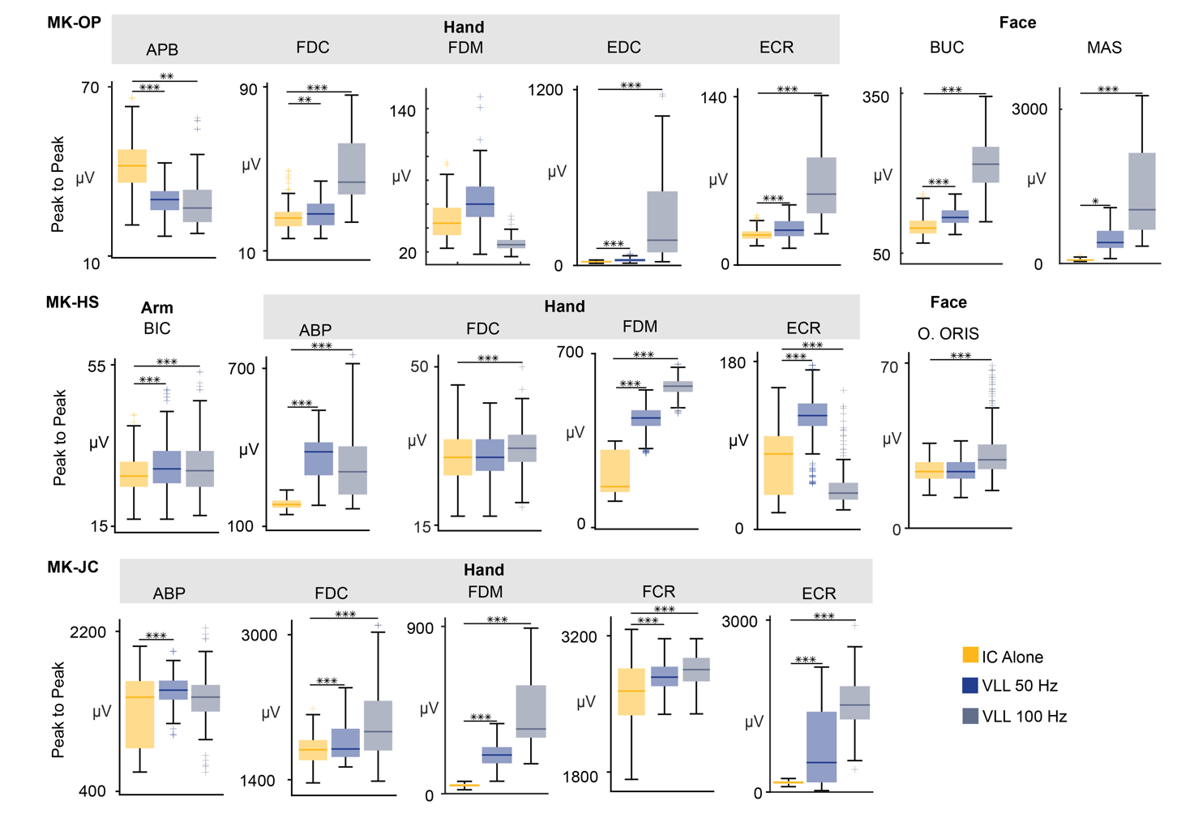
Extended Data Fig. 2 | VLL Stimulation amplifies MEP across arm, hand, and face muscles. Boxplots of peak to peak amplitude of MEPs across multiple muscles (APB: Abductor Pollicis Brevis, FDC: Flexor Digitorum Communis, FDM: Flexor Digiti Minimi, EDC: Extensor Digitorum Communis, ECR: Extensor Carpi Radialis, BIC: Biceps, Buc: Buccinator, Mas: Masseter, O. Oris: Orbicularis Oris) in n=3 animals (MK-OP, MK-HS, MK-JC) where EMG recordings were performed. MEPs were recorded during IC stimulation alone and then paired with VLL stimulation at 50 Hz and 100 Hz. For all boxplots, the whiskers extend to the maximum spread not considering outliers, central, top, and bottom lines represent median, 25th, and 75th percentile, respectively. For all panels, statistical significance was assessed with one-tail bootstrapping with Bonferroni correction: p<0.05 (*), p<0.01 (**), p<0.001(***).

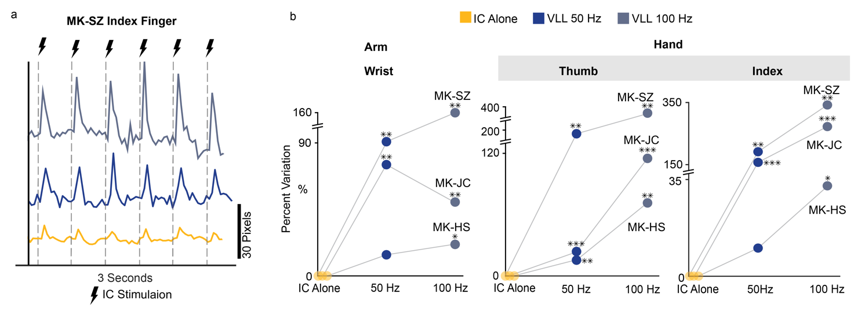
Extended Data Fig. 3 | VLL stimulation potentiates movements of the arm and hand. (a) Example kinematic trace from MK-SZ with IC alone and paired with VLL stimulation at 50 Hz and VLL at 100 Hz. (b) Scatter plots for the arm (wrist marker) and hand (thumb and index marker), representing the percentage variation of the peak to peak amplitude, in n=3 animals (MK-SZ, MK-HS, MK-JC). Kinematics were recorded during IC stimulation alone and then with paired VLL stimulation at 50 Hz and 100 Hz. For all panels, statistical significance was assessed with one-tail bootstrapping with Bonferroni correction: p<0.05 (*), p<0.01 (**), p<0.001(***).

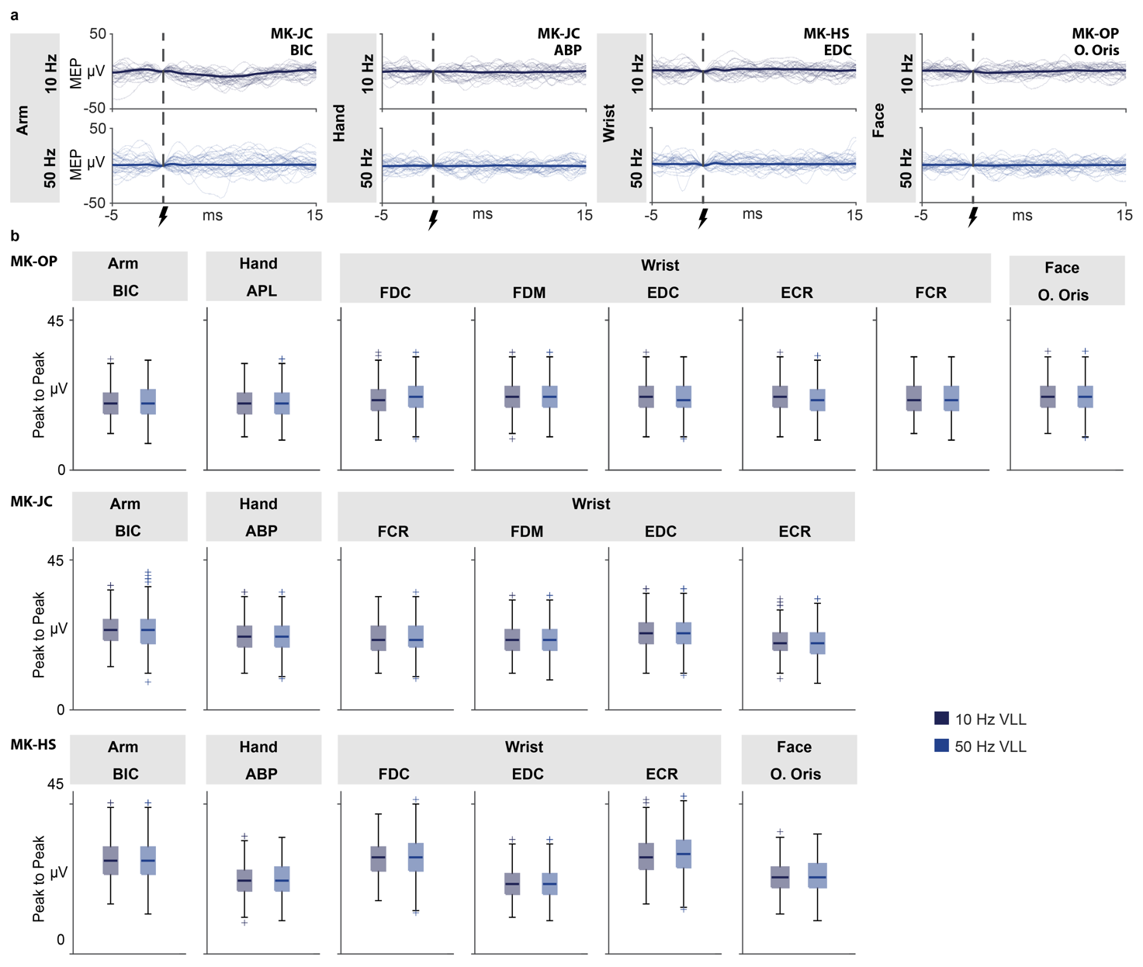
Extended Data Fig. 4 | MEP responses from VLL stimulation. (a) Example MEPs (30 traces for each plot) of one arm, hand, wrist, and face muscle elicited by VLL stimulation at either 10 Hz (top row) or 50 Hz (bottom row). (b) Boxplots of the peak to peak MEP responses to VLL stimulation at 10 and 50 Hz for arm (BIC: Bicep), hand (ABP: Abductor Pollicis Brevis and APL: Aductor pollicis longus), wrist (ECR: Extensor Carpi Radialis, EDC: Extensor Digitorum Communis, FCR: Flexor Carpi Radialis, FDC: Flexor digitorum superficialis, and FDM: Flexor digiti minimi brevis), and face (O. Oris: Orbicularis oris) muscles for three animals (MK-OP, MK-JC, MK-HS). For all boxplots, the whiskers extend to the maximum spread not considering outliers, central, top, and bottom lines represent median, 25th, and 75th percentile, respectively.

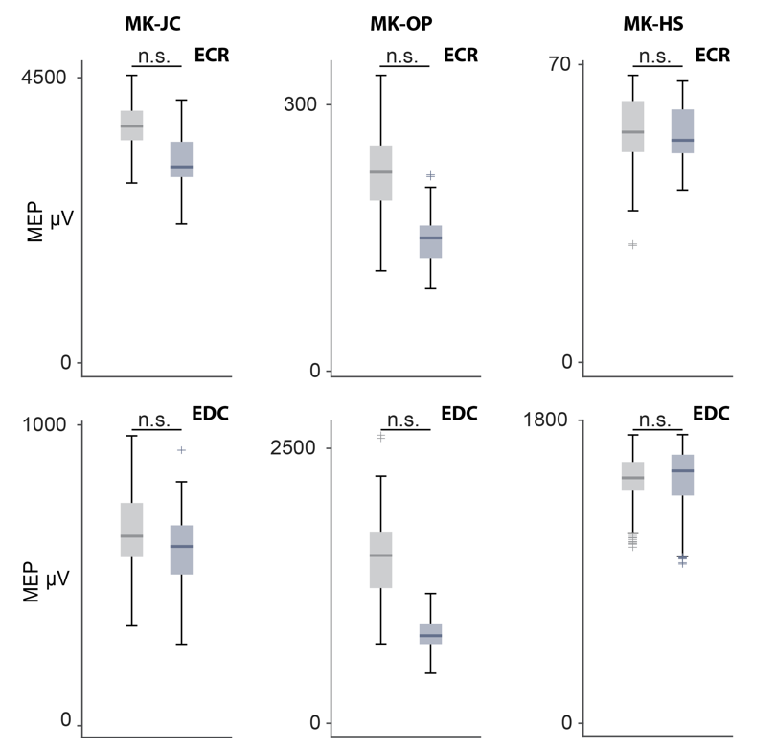
Extended Data Fig. 5 | Radial nerve MEPs. Boxplots of the peak to peak amplitudes of the EMG reflexes for ECR (top row) and EDC (bottom row) elicited by radial nerve stimulation alone and radial nerve stimulation paired with continuous VLL stimulation at 50 Hz for 3 animals (MK-JC, MK-OP, MK-HS). For all boxplots, the whiskers extend to the maximum spread not considering outliers, central, top, and bottom lines represent median, 25th, and 75th percentile, respectively. For all panels, statistical significance was assessed with one-tail bootstrapping with Bonferroni correction, however, in all cases the results were not significant.

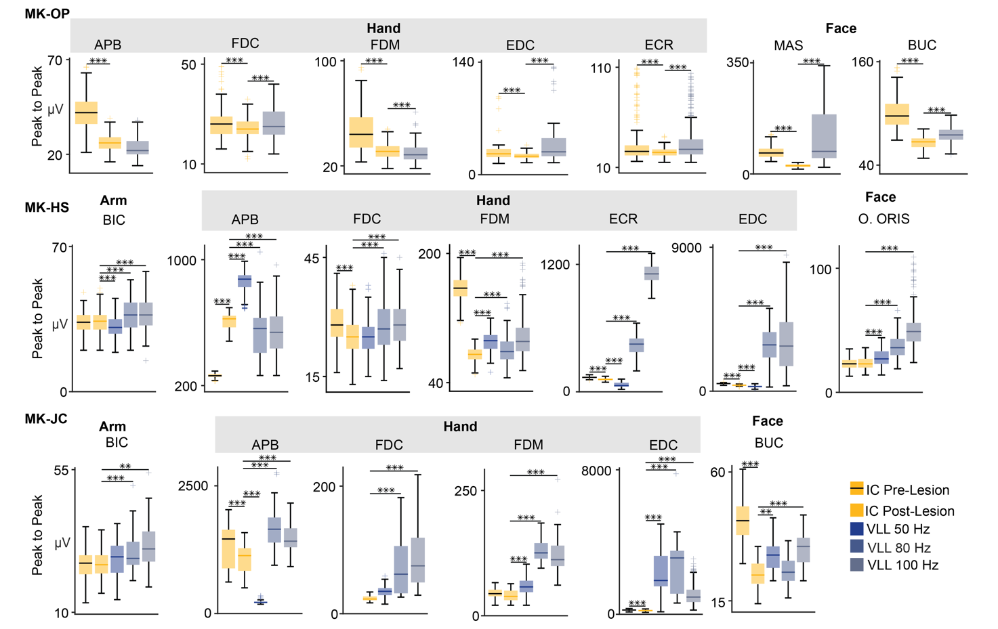
Extended Data Fig. 6 | Potentiation of MEP persists after CST Lesion across arm, hand, and face muscles. Boxplots of peak to peak amplitudes of MEPs across multiple muscles (APB: Abductor Pollicis Brevis, FDC: Flexor Digitorum Communis, FDM: Flexor Digiti Minimi, EDC: Extensor Digitorum Communis, ECR: Extensor Carpi Radialis, BIC: Biceps, Buc: Buccinator, Mas: Masseter, O. Oris: Orbicularis Oris) in n=3 animals (MK-OP, MK-HS, MK-JC) where EMG recordings were performed after lesion of the CST. MEPs were recorded during IC stimulation alone before and after the CST lesion and then with paired VLL stimulation at 50, 80, and 100 Hz. For all boxplots, the whiskers extend to the maximum spread not considering outliers, central, top, and bottom lines represent median, 25th, and 75th percentile, respectively. For all panels, statistical significance was assessed with one-tail bootstrapping with Bonferroni correction: p<0.05 (*), p<0.01 (**), p<0.001(***).

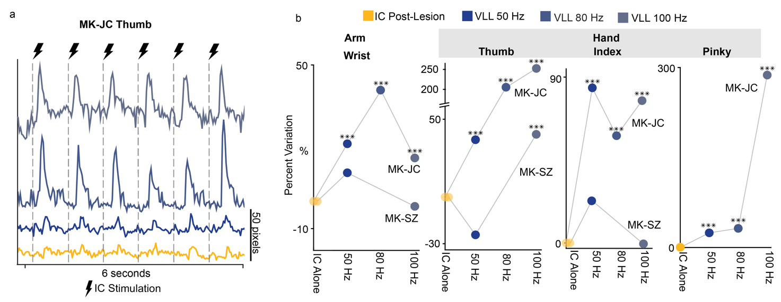
Extended Data Fig.7 | Potentiation of movements persists after CST Lesion. (a) Example kinematic trace from MK-JC with IC alone and paired with VLL at 50, 80, and 100 Hz after lesion of the CST. (b) Scatter plots for the arm (wrist marker) and hand (thumb, index, and pinky marker), representing the percentage variation of the peak to peak amplitude, in n=2 animals (MK-SZ and MK-JC). Traces were created in DeepLabCut with markers placed on the thumb, index finger, pinky finger, and wrist. Kinematics was recorded during IC stimulation alone and IC stimulation paired with VLL stimulation at 50, 80, and 100 Hz. For all panels, statistical significance was assessed with one-tail bootstrapping with Bonferroni correction: p<0.05 (*), p<0.01 (**), p<0.001(***).

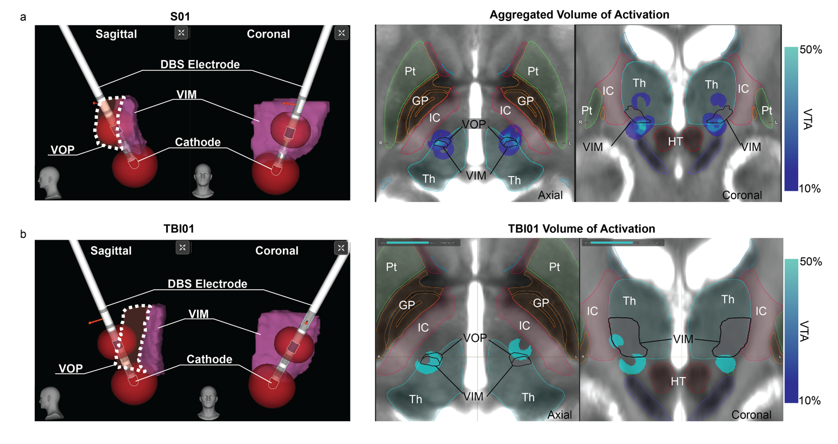
Extended Data Fig. 8 | Human DBS Volume of Tissues Activation. (a) Left: Reconstructions of the VIM/VOP deep brain stimulation (DBS) electrode from one subject (S01). Simulated volume of tissue activation (VTA) at the cathode and anode (bipolar stimulation). Right: Aggregation of VTAs from n=4 human participants (S01, S02, S03, S04). (b) Left: Reconstructions of VIM/VOP DBS electrodes and VTA from TBI01. Right: modeled VTA from VIM/VOP DBS for TBI01.

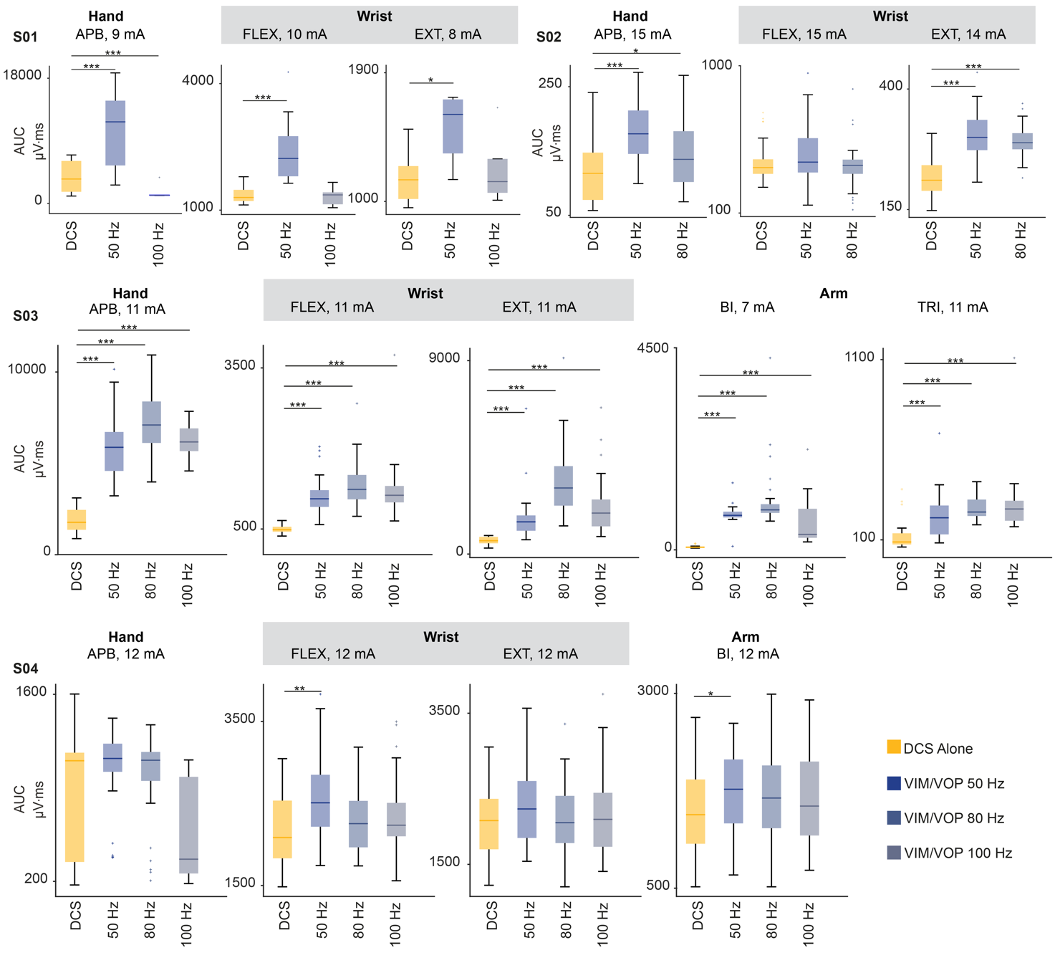
Extended Data Fig. 9 | DBS potentiates MEPs across arm, wrist and hand muscles in humans. Box plots of MEPs AUC amplitudes of different muscles with DCS alone and DCS paired with VIM/VOP stimulation at 50, and/or 80 Hz and/or 100 Hz. All subjects (S01, S02, S03 and S04) are reported. Amplitudes refer to the current amplitudes for DCS. APB, abductor pollicis brevis, FLEX, flexors; EXT, extensors; BI, biceps; TRI, triceps. For all boxplots, the whiskers extend to the maximum spread not considering outliers, central, top, and bottom lines represent median, 25th, and 75th percentile, respectively. For all panels, statistical significance was assessed with one-tail bootstrapping with Bonferroni correction: p<0.05 (*), p<0.01 (**), p<0.001(***).

SUPPLEMENTARY TABLES:

Animal ID | Species | Sex | Age (Yr) | Weight | Experiments
MK-SC | Macaca Fascicularis | M | 4 | 5.4  kg | Cortical Evoked Potentials/Spike Counts
MK-SZ | Macaca Fascicularis | M | 4 | 5.9  kg | Cortical Spike Counts  Kinematic Recording (pre/post lesion)
MK-OP | Macaca Fascicularis | F | 6 | 6  kg | Cortical Evoked Potentials  Antidromic Potentials  EMG Recordings (pre/post lesion)  Kinematic Recording (pre/post lesion)  Radial Nerve Control  Frequency Analysis
MK-HS | Macaca Mulatta | M | 7 | 12  kg | Cortical Evoked Potentials/Spike Counts  Antidromic Potentials  EMG Recordings (pre/post lesion)  Kinematic Recording (pre/post lesion)  Radial Nerve Control  Frequency Analysis
MK-JC | Macaca Fascicularis | M | 6 | 8.2kg | Cortical Evoked Potentials  Antidromic Potentials  EMG Recordings (pre/post lesion)  Kinematic Recording (pre/post lesion)  Radial Nerve Control  Frequency Analysis  Force Measurements (pre/post lesion)
Supplementary Table 1 | Summary of monkey demographic and experiments performed.

Animal ID | IC Stimulation Parameters (Amplitude, Pulse Width) | VLL Stimulation Parameters (Amplitude, Pulse Width) | VLL Burst Parameters (Amplitude, Pulse Width) | Radial Nerve Stimulation Parameters (Amplitude, Pulse Width)
MK-SC | – | 4.8 mA, 2 ms | – | –
MK-SZ | 800 µA, 800 µs | 1 mA, 2 ms | – | –
MK-OP | 2 mA, 3ms | 1.5 mA, 100 µs | 1 mA, 100 µs | 120 µA, 100 µs
MK-HS | 1 mA, 1 ms | 2 mA, 300 µs | 2 mA, 300 µs | 90 µA, 100 µs
MK-JC | 2 mA, 1 ms | 2 mA, 300 µs | 2 mA, 300 µs | 105 µA, 100 µs
Supplementary Table 2 | Simulation parameters for IC, VLL, and radial nerve. – indicates that that stimulation was not performed in that particular animal

Animal ID | Temperature | Time
MK-SC | 90℃ | 60 seconds
MK-SZ | 75℃ | 60 seconds
MK-OP | 80℃ | 60 seconds
MK-HS | 80℃ | 60 seconds
MK-JC | 80℃ | 30 seconds
Supplementary Table 3 | Temperature and time used to create a lesion of the CST within the internal capsule.

Subject | DCS amplitude | VIM/VOP frequency
S01 | 8 mA, 9 mA, 10 mA | 50 Hz, 100 Hz
S02 | 13 mA, 14 mA, 15 mA | 50 Hz, 80 Hz
S03 | 7 mA, 11 mA | 50 Hz, 80 Hz, 100 Hz
S04 | 8 mA, 10 mA, 12 mA | 50 Hz, 80 Hz, 100 Hz
Supplementary Table 4 | Stimulation parameters for DCS and VIM/VOP in humans. The amplitude of stimulation of the VIM/VOP was always at 3mA and within contact -1 and +8.

