Supplementary Material
Details regarding Magnetic field configuration (as mentioned in Gold & Hoyle 1960, see ref.(31) for the twisted magnetic flux tube configuration) utilized in the code and supplementary materials are provided here:-
- Magnetic Field Configuration in Simulations:-
The three magnetic field components of the initial magnetic flux rope are:
$${B_{x}}^{tube}(x, y, z)= \frac{B_{0}}{(1+q^{2}{r_{t}}^{2})} ,$$
$${B_{y}}^{tube}(x, y, z)= \frac{{-qB}_{0}(z-z_{tube})}{(1+q^{2}{r_{t}}^{2})} ,$$
$${B_{z}}^{tube}(x, y, z)= \frac{{qB}_{0}(y-y_{tube})}{(1+q^{2}{r_{t}}^{2})} ,$$
Where ${r_{t}}^{2}={(y-y_{tube})}^{2}+{(z-z_{tube})}^{2} .$
Dimensionless units are used, see Extended Data Table 1. The initial, twisted magnetic flux tube configuration is a force free field with a non-constant-α, where, typically $∇×B=αB$. The initial twist (q) in magnetic flux rope is considered to be uniform and set to 0.2. The value of B₀ = 15, $y_{tube}=0,$ $z_{tube}=-10$. The initial pressure distribution of the magnetic flux rope is given by:
$$p=\left(\frac{{B_{0}}^{2}}{8π}\right)\left(\frac{1}{1+q^{2}{r_{t}}^{2}}\right) .$$
Coronal magnetic field (inside flux rope)
$B_{x }= {B_{z}}^{tube}$
$B_{y }= {B_{y}}^{tube}$
$B_{z }= {B_{z}}^{tube}+{B_{z}}^{background}$
Coronal magnetic field (outside flux rope)
$B_{x }= 0,$
$B_{y }= 0,$
$B_{z }={B_{z}}^{background}$,
where ${B_{z}}^{background}=1.$

- Numerical Settings of Solar Atmosphere:-
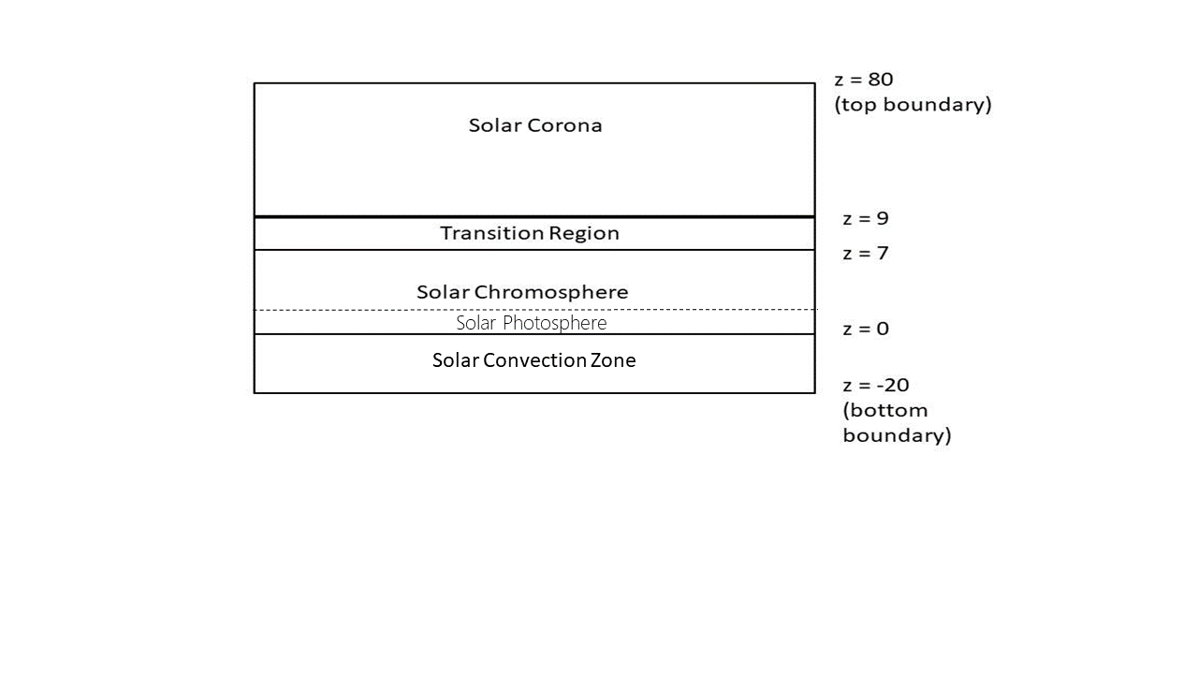
The numerical settings utilize Yokoyama & Shibata (1996, see ref. 32) for the development of the hydrostatic distribution for the solar atmosphere. The simulation box size is X=200, Y=100, Z=100 with grid points in x-direction (number of grid points=400), y-direction (number of grid points=200), and z-direction (number of grid points=400). The spatial resolution is therefore 0.5. The bottom boundary is at $z=-20$ whereas the solar photosphere (PH) is at $z=z_{PH}=0$, transition region (TR) is between ${z=z}_{TR0}=7$ and ${z=z}_{TR1}=9$ and top of the corona (CR) is at $z=80$. The quantities mentioned here are in dimensionless units (see Table 1). The solar chromosphere is also present. A schematic diagram is provided below to show the solar atmosphere and the top and bottom boundaries in z-direction.

$${(z}_{TR1})$$
$${(z}_{TR0})$$

$${(z}_{PH})$$

Various quantities are defined using ${z_{PH},z_{TR1}, z}_{TR2}$, temperature of photosphere and corona and it can be summarized here:
Temperature of the photosphere: $T_{PH}=1$
Temperature of the solar corona: $T_{CR}=100$
Ratio of specific heats: $γ=5/3$
Pressure at the solar photosphere: $p_{PH}=1/γ$
Density at the solar atmosphere: $ρ_{PH}=1$
Height of photosphere: $z_{PH}=0$
Height of transition region: between $z_{TR0}=7$ and $z_{TR1}=9$

The Pressure and density distributions are provided below:-
Convection Zone:- The solar convection zone is present. However, the flux rope is triggered not through the process of convection. Pressure and density distribution in the solar convection zone ($z≤z_{PH}$)
$$p\left(z\right)=p_{PH}{\left(1+\frac{A_{CN}\left(z-z_{PH}\right)}{T_{PH}}\right)}^{-\frac{1}{A_{CN}}}$$
$$ρ\left(z\right)=ρ_{PH}{\left(1+\frac{A_{CN}\left(z-z_{PH}\right)}{T_{PH}}\right)}^{-\frac{1}{A_{CN}}-1}$$
where $A_{CN}=-1.025\left(1-1/γ\right)$, and T_{PH} = H_{PH} (pressure scale height) in the non-dimensional unit.
PH and CH:- Pressure and density distribution at the solar photosphere and chromosphere ($z_{PH}<z≤z_{TR0}$)
$$p\left(z\right)=p_{PH}\exp\left(-\frac{z-z_{PH}}{T_{PH}}\right)$$
$$ρ\left(z\right)=\frac{γp\left(z\right)}{T_{PH}}$$
TR:- Pressure and density distribution in the transition region ($z_{TR0}<z≤z_{TR1}$)
$$p_{TR0}=p_{PH}\exp\left(-\frac{z_{TR0}-z_{PH}}{T_{PH}}\right)$$
$$p\left(z\right)=pr_{TR0}{\left(\frac{S_{α}z+S_{β}}{S_{α}z_{TR0}+S_{β}}\right)}^{-\frac{1}{S_{α}}}$$
$$ρ\left(z\right)=\frac{γp\left(z\right)}{S_{α}z+S_{β}}$$
where $S_{α}=\left(T_{CR}-T_{PH}\right)/\left(Z_{TR1}-Z_{TR0}\right)$ and $S_{β}=\left(T_{PH}z_{TR1}-T_{CR}z_{TR0}\right)/\left(Z_{TR1}-Z_{TR0}\right)$,
CR:- Pressure and density distribution in the solar corona ($z_{TR1}<z$)
$$p_{TR1}=p_{TR0}{\left(\frac{T_{CR}}{T_{PH}}\right)}^{-\frac{1}{S_{α}}}$$
$$p\left(z\right)=p_{TR1}\exp\left(-\frac{z-z_{TR1}}{T_{CR}}\right)$$
$$ρ\left(z\right)=\frac{γp\left(z\right)}{T_{CR}}$$
With the help of above parameters, it would be possible to invoke magnetic flux rope in the MHD simulations and solve the MHD equations through numerical computation (see Method section and Extended Data Table 1).
- i. About Fig. 4: We have provided the fig. 4 for enhanced understanding. Fig. 4a provides the details of magnetic fields at a particular instant of time (1.94 × 10³ s). These field lines include reconnected field lines, field lines of the magnetized solar atmosphere, plasmoid, flux rope and reconnection region. Fig 4b provide the velocity fields around the x-point and help also in understanding the plasma flow structure away from the x-point. Fig. 4c to Fig. 4j provide the schematic diagram for the jets.
ii. About Fig. 4c to Fig. 4j: Schematic diagram to show the formation of evolution of jets. The magnetic flux rope is a three dimensional, twisted magnetic field and the magnetic fields of the flux rope will offer multiple field line connectivity during the upward rising in the magnetized solar atmosphere. Many small-scale jets could emanate from the entire body of the flux rope. The oblique view (Fig. 4c to Fig.4f) and axial view (Fig. 4g to Fig. 4j) are shown in the diagram and the sign ‘x’ shows the reconnection point, the flux rope magnetic field is shown in orange color and the ambient magnetic field is shown by the green color. A weakly twisted magnetic flux rope carries azimuthal as well as axial magnetic fields and these magnetic field components participate gradually in the reconnection. At first the magnetic field lines reconnect and the main jet (Jet1) is formed. After the formation of the main jet, the nearby field lines reconnect and the secondary jets (e.g. Jet2) are formed. The jets appear during the rising process and the presence of a small guide field during the magnetic reconnection helps in connecting the neighbouring field lines leading to many small-scale successive jet ejections from the bright knots hosting the jets.
- The details related with extended data table, extended data figures and online movies are provided below:-
Extended Data Table 1- Typical physical values used for normalization in 3D MHD simulations are provided.
Extended Data Figure 1- The image having initial configuration used in 3D MHD simulations are provided. The arrows provide the information about the magnetic field direction. Lines with blue colour refers to coronal magnetic field and lines with red colour refers to magnetic flux rope.
Extended Data Figure 2- The initial density and temperature as a function of height in 3D MHD simulation. The lines with blue colour refers to coronal magnetic field and lines with red colour refers to magnetic flux rope.
Extended Data Figure 3- The initial plasma beta (plasma-β) as a function of height in 3D MHD simulation. . The lines with blue colour refers to coronal magnetic field and lines with red colour refers to magnetic flux rope.
Extended Data Figure 4- The initial velocity distribution of Alfvén speed as a function of height in 3D MHD simulation. . The lines with blue colour refers to coronal magnetic field and lines with red colour refers to magnetic flux rope.
Details Related with Online Movies :-
Online movie 1 and movie 2- Note that the images derived from the observations are provided in Figs. 1b, 1c and 1d. The regions are selected and movies are prepared accordingly. The Calcium filtergram (FG) movie along with the running difference movie to show the launching of small-scale jets from the bright knots, as observed from Solar Optical Telescope aboard Hinode satellite on 20/11/2006. The leftmost panel in the online movie 1 shows the time evolution of jets obtained through the Calcium FG data of Solar Optical Telescope aboard Hinode, the middle panel shows the time evolution obtained through the process of unsharp masking, and the rightmost panel shows the time evolution of the jets obtained by subtracting the intensity of the two consecutive images. The left panel of online movie 2 shows the time evolution of jets from the Calcium FG data and the right panel of online movie 2 shows the time evolution of jets obtained from the unsharp masking. The online movie 2 is provided for better clarity.
Online movie 3 and 4 - The movies provide the time variation of density distributions for Fig. 2a and Fig. 2b, respectively. Movie 3 (yz-plane), Movie 4 (yz and xz planes)
Online movie 5 and 6- The movies provide the time variation of temperature distributions are shown in Fig. 2a and Fig. 2b respectively. Movie 5 (yz-plane), Movie 6 (yz and xz planes)
Online movie 7 – The online movie provides the time variation of the absolute velocity of the jet in yz-plane. Note that fig. 2c and fig. 2d provide the snapshot of absolute velocity of the jet.
Online movie 8 - The time variations of B_{z} and V_{z} components on the xy-plane are provided in movie where the blue solid line on the xy-plane corresponds to the vertical velocity i.e. V_{z} = 20 km/s ((in vertically upward direction)) and red dotted line corresponds to V_{z} = -20 km/s (in vertically downward direction). Magnetic field is measured at z=0 but the velocities are measured in corona.
Online movie 9- The time variation of magnetic field and velocity field in yz-plane is provided, while, Fig. 4b provides the details of magnetic field and velocity field at t = 1.94 ×10³ s.

