Supplementary
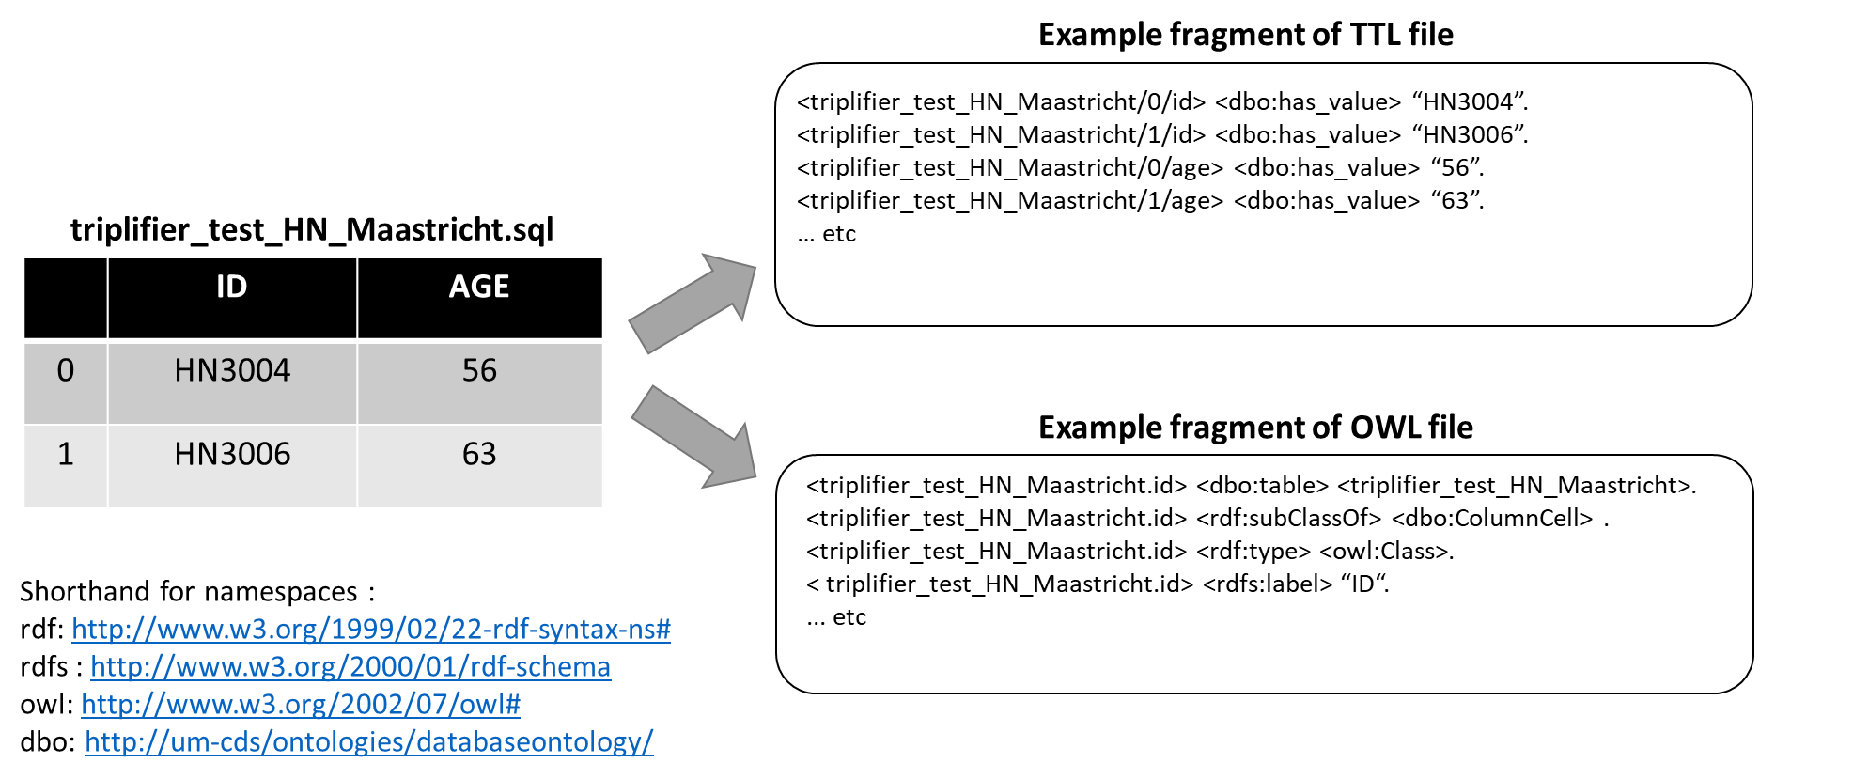
Fig S1. Example showing the expected output of triplifier processing. A hypothetical input table is shown on the left. Namespace aliases (bottom left) are used to simplify and improve readability of the figure. A fragment of the serialized database contents is shown top right in the TTL file, and a part of the database schema is shown with a database-specific ontology in the OWL file at bottom right.

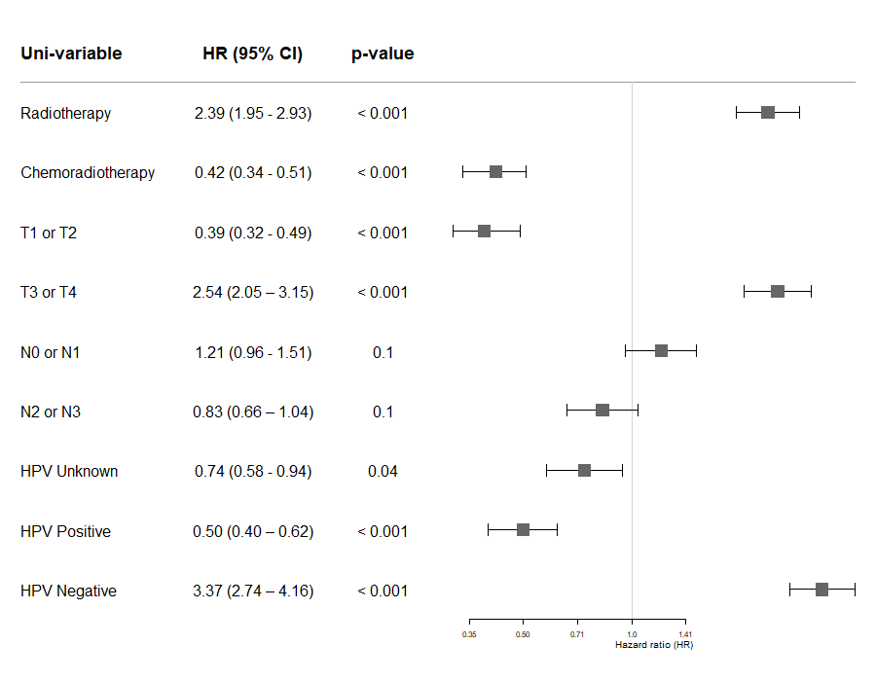
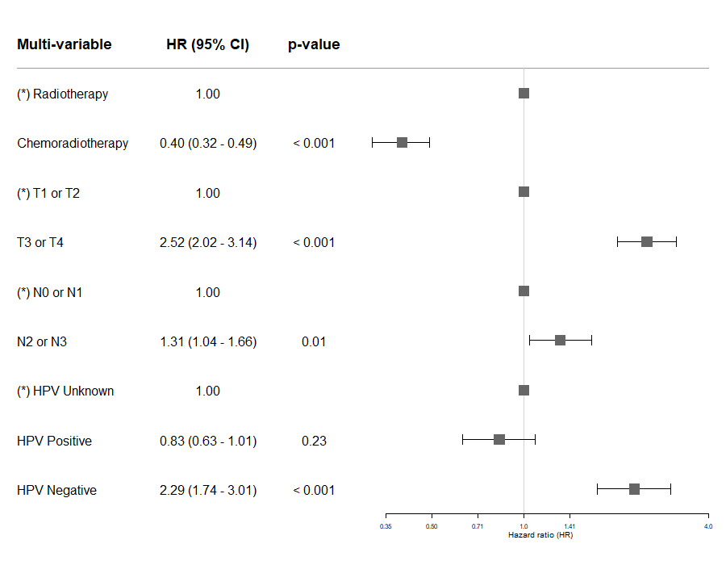
Fig S2. Uni-variable (upper inset) and multi-variable Federated Cox regression with Clinical predictors only. Results are fitted over all 5 HNC datasets, indicating hazard ratio (HR) and 95% confidence intervals of the HR. First line treatment type, T stage and N stage were independently predictive of OS in the final C-Model. Human papilloma virus (HPV) tests were not consistently done for all OPC patients, hence there was a large proportion of “unknown” HPV status which obscured the prognostic importance of HPV positive versus HPV negative. For categorical predictors, the prefix (*) indicated which category was assumed as the reference value for the predictor.

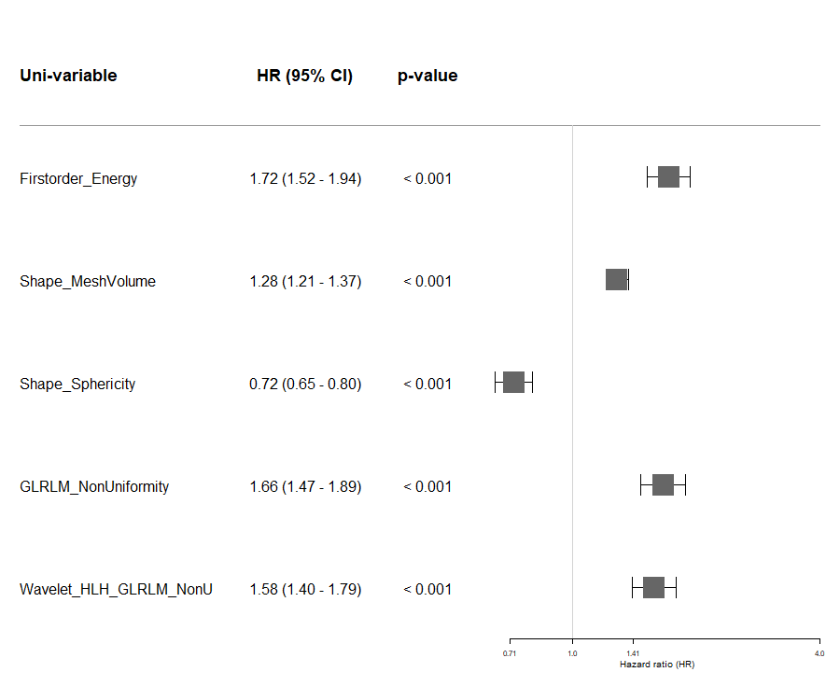
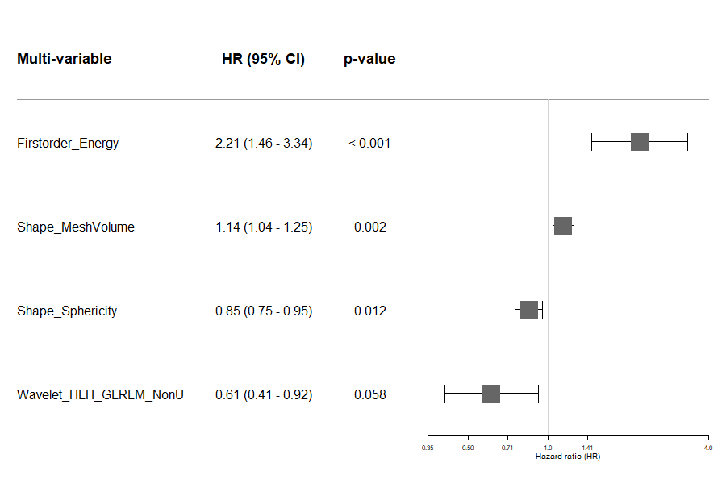
Fig S3. Uni-variable (upper inset) and multi-variable Federated Cox regression with Radiomics predictors only. Results are fitted over all 5 HNC datasets, indicating hazard ratio (HR) and 95% confidence intervals of the HR. In the multi-variable fit, radiomics feature “GLRLM_NonUniformity” was clearly not an independent predictor and was thus dropped from the final multi-variable model. All radiomics features were continuous numerical variables.
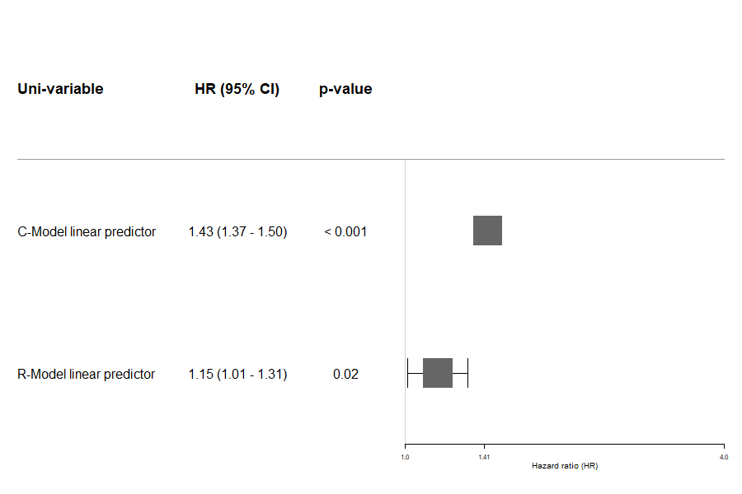
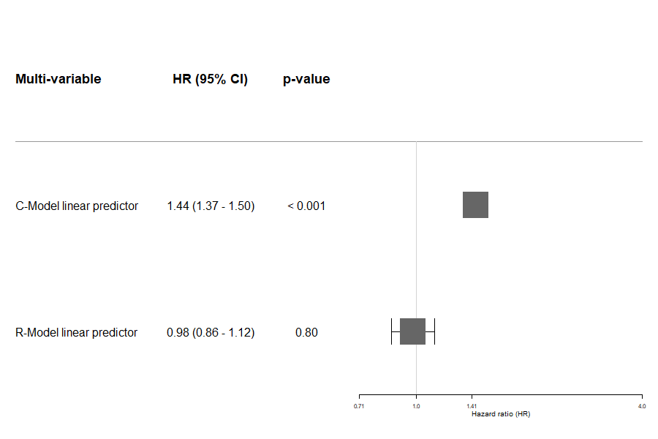
Fig S4. Uni-variable (upper inset) and multi-variable Federated Cox regression using the linear predictors (LPs) from the C-Model and R-Model previously obtained. Results are fitted over all 5 HNC datasets, indicating hazard ratio (HR) and 95% confidence intervals of the HR. While the LPs of the individual models do support survival stratification by themselves, in combination it is found that the R-Model linear predictors are not an independent predictor for survival and do not have added value for prediction in the CR-Model.

Dataset | HCI : C-Model | HCI : R-Model | HCI : CR-Model
HN1 | 0.73 (0.72) | 0.63 (0.63) | 0.72 (0.72)
HNSCC | 0.63 (0.63) | 0.68 (0.68) | 0.64 (0.64)
HN-PET-CT | 0.62 (0.62) | 0.61 (0.60) | 0.60 (0.59)
OPC | 0.72 (0.72) | 0.65 (0.65) | 0.73 (0.73)
HN3 | 0.66 (0.66) | 0.65 (0.65) | 0.66 (0.66)

Table S1. Harrell concordance indices (HCIs) computed on each distributed dataset using the multivariable models C, R and CR. In bold, the model was fitted on all datasets and then tested in the one dataset indicated in the leftmost column. To estimate magnitude of over-optimistic model performance, we fitted the coefficients for the selected features in 4 other datasets, then computed the HCI in the one dataset left out. The number in parentheses represents the HCI where the one dataset left out is indicated in the leftmost column. Therefore the divergence between the value in bold and the value in the adjacent parentheses is an estimate of the over-optimism.

Additional files
Example SPARQL query

The following query is built to retrieve patient’s ID and age from an annotated RDF database in the following manner. The query first looks for the instances of classes that include the predicates P100061 and P100000 (which resolves to has_identifier and has_age from ROO respectively), which is added on top of the common dbo predicate “has_column” (as seen in the OWL) in the annotation graph. Following that, it finds the cells for those instances by matching them to the dbo predicate has_cell and finally the values in those cells are fetched by using the dbo predicate has_value. The namespace “dbo” is in the structure of the output TTL file and can be viewed using the OWL schema.
PREFIX dbo: <http://um-cds/ontologies/databaseontology/>
PREFIX roo: <http://www.cancerdata.org/roo/>
SELECT ?patientID ?agevalue
WHERE
{
?tablerow roo:P100061 ?ID. #returns instances with predicates roo:P100061 (has_identifier)
?ID dbo:has_cell ?IDcell. #returns the triples with cells for those instances
?IDcell roo:P100042 ?patientID. #gets the values in those cells, which gives the patient IDs
?tablerow roo:P100000 ?age. #returns instances with predicates roo:P100000 (has_age)
?age dbo:has_cell ?agecell. #returns the triples with cells for those instances
?agecell roo:P100042 ?agevalue. #gets the values in those cells, which gives the age values
}

