Appendix S4. Conservation Planning Based on Current and Future Critical Habitat for Canada Warbler and Wood Thrush

Methods
The conservation planning software Zonation 4.0 (Moilanen et al. 2014) was used to run conservation planning scenarios that prioritized and visualized locations of potential current and future habitat in two management units for Canada Warbler (northern Nova Scotia, Al-Pac Forest Management Area in northeastern Alberta) and across individual eastern provinces for Wood Thrush (Ontario, Quebec, New Brunswick, Nova Scotia) (Appendix S3). Zonation is a spatial prioritization software package which analyzes raster data on selected features in a study area such as species occurrences, distribution data, habitat quality, anthropogenic disturbance, and any other features of interest. The Zonation algorithm systematically ranks each cell according to its absolute value (how much of that feature it contributes on the landscape) and its benefit to connectivity (how connected it is to other instances of the same feature, or other features considered desirable) (Lehtomäki and Moilanen 2013).

The algorithm first calculates the overall value of each cell in a raster by totaling the presence of desirable features in each cell, subtracting the presence of undesirable features, and then connecting the area to other cells of high value. The user can weight the value of features as well as the importance of connectivity. Zonation then removes the cell with the lowest value on the entire landscape. Zonation then recalculates the value of all the remaining cells and removes the next least valuable cell. This proceeds iteratively over the landscape until all cells have been removed and ranked. The cells removed last represent the highest value both for retaining desirable features on the landscape and ensuring their connectivity. The output integer raster displays the most valuable cells as closer to ‘1’ and the least valuable as closer to ‘0’. Areas with high values can then be prioritized by users for conservation or management.

The parameters which govern which cells are removed are set by the operator (Moilanen et al., 2014). We used the ‘core-area Zonation’ (CAZ) parameter which first removes cells that have common and low-weighted features. Eventually, features that were once common become rarer, and then are prioritized so that cells containing other, now more common, features are removed. The model output of a CAZ scenario will preserve core areas for each species and may therefore prioritize areas that have relatively low predicted density but maintain the species on the landscape over time (Moilanen et al., 2014).

To value areas of connectivity, we applied the distribution smoothing (DS) parameter. DS essentially adjusts a cell’s value so that it is more valuable if connected to other cells which contain features representing the species (Moilanen and Wintle 2006; Moilanen et al. 2006). For each species, it is necessary to provide a quantitative expression that indicates whether two instances of that indicator are ‘connected’. For species and species groups, this is measured as an estimate for dispersal. Dispersal is an important determinant of whether a species selects or colonizes a habitat and is also critical in determining its response to climate change (i.e., the ability to move from current to future suitable habitats).

For each species for each management unit, we ran a series of scenarios based on current and predicted future distributions using 250m rasters. For each species in each management unit, we ran a scenario that prioritized locations based on predicted current distribution (Appendices S2-S3) alone. We also developed scenarios which prioritized areas based on both current and future distributions (and the connectivity between them). For management units where predicted future distribution was developed using LANDIS models (Appendix S3), we developed three scenarios: best-case (largest future population), medium-case (scenario with median future population size), and worst-case (smallest future population). For management units where predicted future distribution was developed using ALCES (Appendix S3), we only developed one modelling scenario using forecasting data.

For each scenario, we used run-time data to determine what proportion of the predicted current (2020) population of the species of interest remained as pixels in the study area were “removed” from the landscape. Custom run-time plots were then generated showing the amount and location of lands to conserve up to 50, 75, 90, and 100% of the current population as habitat for each scenario. We also generated custom maps from the rank raster maps where each pixel was reclassified according to if the pixel was prioritized for conserving at least 50, 75, 90, or 100% of the current population of a species. These latter maps enable estimation of the conservation efficiency of each Zonation scenario. It should be noted that if the future predicted population was smaller than the current population, it was not possible to use Zonation to identify enough land to protect 100 % of the current population.

Canada Warbler

All scenarios used the CAZ cell-removal method to iteratively assign relative values to cells that increased with mean density and decreased with increasing prediction uncertainty, then removed the least valuable cells in each iteration. Using distribution smoothing, we also assigned higher values to cells in each iteration if they were close to other cells with high Canada Warbler densities. The distribution kernel assigned was, aggregating cells together through distributive smoothing, using α= 0.0004 based on a natal dispersal distance of 5 km for Canada Warbler (Westwood et al. 2020). We chose this natal distance because it resulted in more efficient solutions (larger proportions of current and future predicted Canada Warbler populations protected by the least amount of land set aside) in previous conservation-planning scenarios of Westwood et al. (2020).

Nova Scotia Scenarios
We ran four Zonation scenarios for Canada Warbler in northern Nova Scotia. Input features for all scenarios included a set of known Canada Warbler occurrence locations in Nova Scotia, the current predicted mean density (males/ha) layer for Canada Warbler in northern Nova Scotia (Appendix S3), and an uncertainty layer (standard deviation in predicted densities from the bootstraps from the same area), used in distribution discounting (Moilanen and Wintle 2006; Moilanen et al. 2006).

The first scenario consisted of only the current population distribution in northern Nova Scotia; thus, sites were prioritized solely on where Canada Warbler was predicted to be most abundant with the lowest uncertainty. The other three scenarios also included a prediction layer for the Canada Warbler population in 2100 from one of three Landis scenarios: a best-case scenario where the predicted future population was highest; a worst-case scenario where the predicted future population was lowest; and a medium-case scenario where the predicted future population was lower than half of the scenarios and greater than in the other half of the scenarios. The best-case scenario (baseline climate / high clearcut) predicted 64,430 Canada Warbler in northern Nova Scotia, whereas the medium-case scenario (RCP 4.5 / ecosystem-based forest management) predicted 46,057 Canada Warbler and the worst-case scenario predicted 38,220 Canada Warbler – slightly lower than the study area’s current population estimate - by 2100. In scenarios that considered future distribution, we assigned a higher weight to the current density layer (1.0) and lower weight (0.75) to the future density layer being considered due to greater uncertainty about future distribution than present distribution (Appendix S3).

Alberta Zonation Scenarios

We ran four Zonation scenarios within the harvestable uplands in the Al-Pac FMA, setting up the four scenarios as we did for northern Nova Scotia. The best-case scenario (baseline climate / no new clearcut) predicted 14,785 Canada Warbler in northern Nova Scotia, whereas the medium-case scenario (baseline climate / 6 % annual clear-cut) predicted 12,597 Canada Warbler and the worst-case scenario (RCP 4.5 / 6 % annual clear-cut) predicted 10,518 Canada Warbler by 2100. These population estimates were respectively 41.54 %, 35.39 %, and 29.55 % of the current population. Thus, while we could visualize areas to protect 50, 75, 90, and 100 % of the current population in the Zonation scenario that only considered the current population, we could only visualize some of these areas in the current + future population scenarios (Appendix S3).

Wood Thrush

Quebec, New Brunswick, and Nova Scotia Zonation Scenarios

There were four Zonation scenarios for Wood Thrush in each province where there was Landis output (Quebec, New Brunswick, Nova Scotia), setting up the four scenarios as we did for the Canada Warbler scenario in the AlPac FMA and northern Nova Scotia. Cells were assigned higher ranks via the CAZ cell-removal method when closer to other cells with high Wood Thrush densities, using α= 0.0057 based on a natal dispersal distance of 70 km for Wood Thrush (Tittler et al. 2006). The first Zonation scenario in each Landis study area consisted of only the current population distribution in each province; thus, sites were prioritized solely on where Wood Thrush was predicted to be most abundant with the lowest uncertainty. The other three Zonation scenarios used in each study area also included a prediction layer and the uncertainty layer for that prediction layer for Wood Thrush distribution in 2100. from one of three Landis scenarios: a best-case scenario where the predicted future population was highest; a worst-case scenario where the predicted future population was lowest; and a medium-case scenario where the predicted future population was lower than half of the scenarios and greater than in the other half of the scenarios.

In Quebec, the best-case Landis scenario (RCP 8.5 / no harvest) predicted 1,959,455 Wood Thrush in southern Quebec, the medium-case scenario (RCP 8.5 / harvest) predicted 1,899,649 Wood Thrush, and the worst-case scenario (baseline climate / no harvest) predicted 1,815,598 Wood Thrush by 2100. In New Brunswick, the best-case Landis scenario (RCP 8.5 / harvest) predicted 458,950 Wood Thrush, the medium-case scenario (RCP 4.5 / harvest) predicted 325,133 Wood Thrush, and the worst-case scenario (baseline climate / harvest) predicted 260,676 Wood Thrush by 2100. In Nova Scotia, the best-case scenario (RCP 8.5 / high clearcut) predicted 268,721 Wood Thrush, the medium-case scenario (baseline climate / high clearcut) predicted 205,326 Wood Thrush, and the worst-case scenario (RCP 4.5/ no harvest) predicted 199,405 Wood Thrush – by 2100 (Appendix S3).

Ontario Zonation Scenarios

In Ontario, where only a single ALCES Online scenario was run, the Wood Thrush study area was split into two regions, corresponding to the Wood Thrush’s Ontario range within Forest Management Units (FMUs) in the west versus the rest of its Ontario range southeast of the FMUs in agricultural and urban landscapes. The reason for this split was because the ALCES Online scenario had been run at a finer-scale resolution (200 m) than Landis scenarios, so prediction rasters from the ALCES Online scenario were at 200 m resolution as well. We ran into memory issues with Zonation if we tried running scenarios using the entire range of the Wood Thrush in Ontario. Thus, two Zonation scenarios were run in each Ontario region - one based on current predicted density alone and one that additionally considered the 2070. population density from the ALCES Online scenario.

Results
Locations were generally assigned higher ranks if locations supported higher predicted densities in a current and/or future density layer or if there was greater confidence (lower standard deviation) in the density estimates at a location. Other output from each Zonation scenario included data for generating a runtime plot showing what proportion of the total summed values of a given feature (current or future density layer) remained as an increasing proportion of cells in the study area was “removed” from consideration. Cells with higher ranks remained in study areas the longest (e.g., rank > 0.9 = remaining 10 % of cells when 90 % of cells are removed from a study area) and the rank of a cell indicates the proportion of cells in the study area with lower ranks that will be removed before that cell. Thus, it was possible to know what proportion of the current or future population remained as more land was “removed” and determine the amount and location of lands necessary to protect a certain proportion of the current or future population.

Although the total current or future population starts to decrease when the first cells are removed during a Zonation scenario, predicted density in some parts of the study area was low enough that some lands were “removed” before the current or future population started dropping significantly below 100%.

It should be noted that while areas with higher predicted current and/or future density generally received higher ranks, ranks are not equivalent to density. Locations with predicted similar densities can receive different ranks based on densities in nearby locations or differences in prediction uncertainty at each location. Conversely, the same locations in different Zonation scenarios can have different predicted future densities but receive the same relative ranks, i. e., a location may be treated as good habitat under different future scenarios, therefore will receive the same or a similar rank under different scenarios. However, if densities are higher in some locations in a specific scenario, then less land may be required to support the same population in that scenario. Finally, it should be noted that we defined best-case, medium-case, and worst-case Zonation scenarios based on the predicted 2100 population sizes in the best-case, medium-case, and worst-case LANDIS scenarios. The best-case scenario could have a larger 2100 population in the study area, but if another scenario has higher predicted densities than the best-case scenario in certain locations, less land could be required in that scenario than the best-case scenario for maintaining the current population. Indeed, we observed higher maximum predicted densities of Canada Warbler in some locations in the medium-case LANDIS scenario for northern Nova Scotia than the best-case LANDIS scenario for northern Nova Scotia, which may explain why slightly less land was required for maintaining the current population in the corresponding medium-case Zonation scenario than the best-case Zonation scenario.

Canada Warbler

Nova Scotia Zonation Scenarios

All Zonation scenarios in northern Nova Scotia identified inland areas as having highest priority for conservation or management as Canada Warbler habitat (Fig. 5). Lands with the highest priority as critical habitat generally occurred outside of existing protected areas. Habitat for the whole current population occurs on about 16 % of the study area (ha). When the future population from the best-case Landis scenarios is also considered, the whole current population could be maintained by protecting 15 % of the study area – a slight increase in conservation efficiency. In contrast, when future populations from the medium-case and worst-case Landis scenarios are considered instead, respectively 25 and 74 % of the study area would have to be protected to maintain the entire current population (Fig. 5). However, the percentages of the study area required for protecting just 50 % of the Canada Warbler population are more comparable among all four scenarios: 7.4 % (current population alone), 5.2 % (current population + best-case population), 7.3 % (current population + medium-case population), and 7.7 % (current population + worst-case population) (Fig. S4.1).

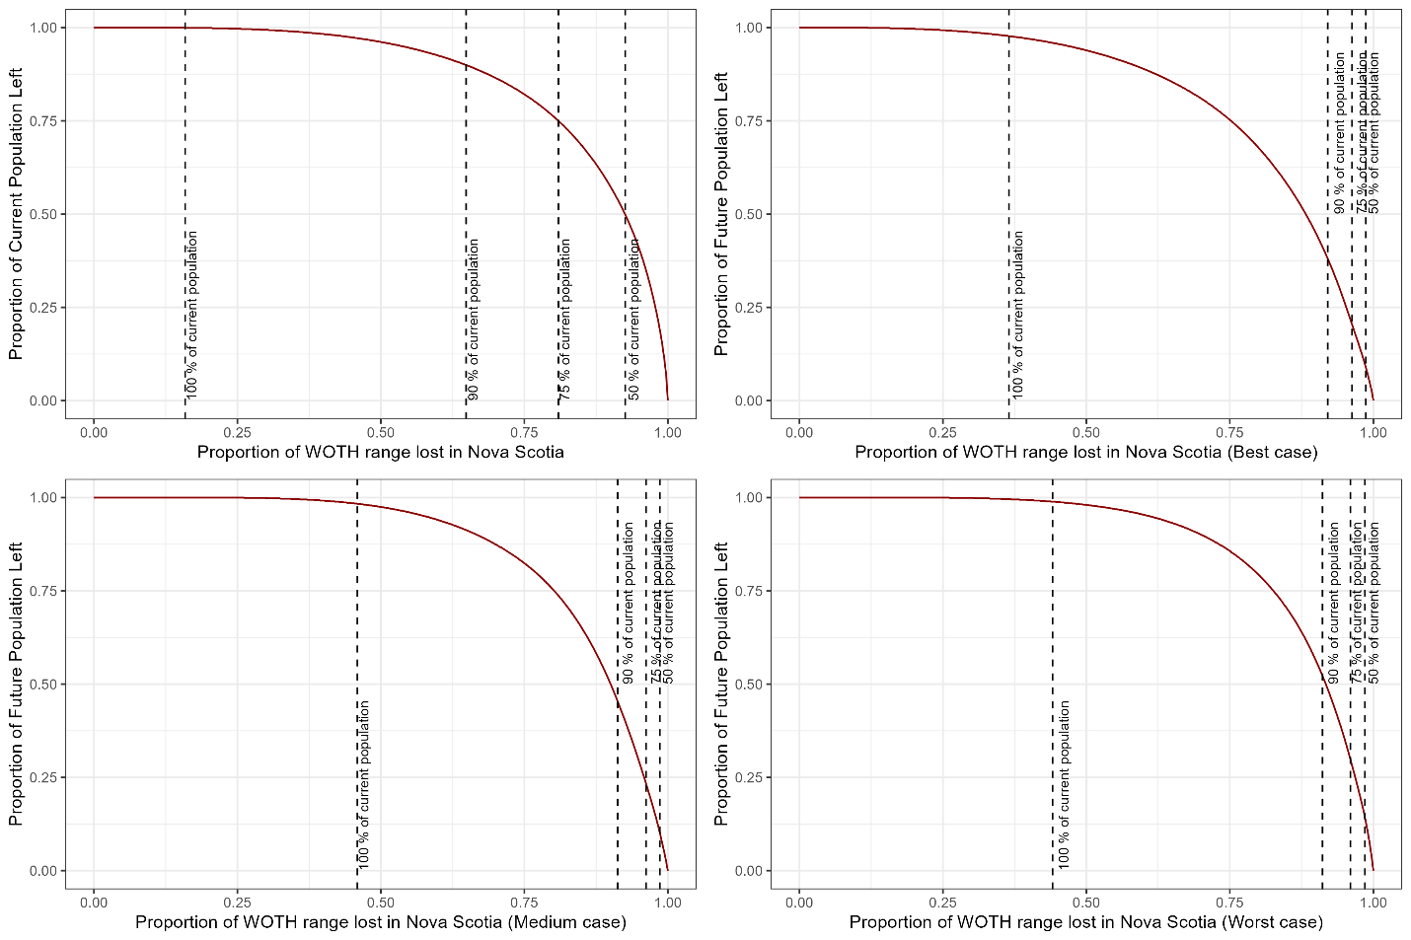
Figure S4.1. Runtime plots showing the proportion of the current and future Canada Warbler population remaining in its current range in northern Nova Scotia as lands (250-m cells) are removed from consideration for conservation or management as important Canada Warbler habitat, under four Zonation scenarios. Zonation scenarios: Current = based on current population density alone; Best = based on current density + 2100 population from the best-case Landis scenario; Medium = based on current density + 2100 population from the medium-case Landis scenario; Worst = based on current density + 2100 population from the worst-case Landis scenario. As the 2100 population was projected to be higher than the current population in northern Nova Scotia, less land was required to maintain various percentages of the current population levels, when future distribution of the Canada Warbler was also used to prioritize lands as important habitat. Since population projections were similar across different Landis scenarios, the amount of land that can be removed barely differed in Zonation scenarios based on the best, medium, and worst-case scenarios.

Alberta Zonation Scenarios

All Zonation scenarios in northeastern Alberta in the Al-Pac Forest Management Area’s harvestable uplands identified lands along the Athabasca River and in the Stony Mountain Wildland south of Fort McMurray, as having highest priority for conservation or management as Canada Warbler habitat. Lands with the highest priority as critical habitat generally occurred outside of existing protected areas, but there were few protected areas included within simulated areas of the Al-Pac FMA. Habitat for the whole current population occurs on about 23 % of the study area. All populations in 2100 from the Landis scenarios are less than 50 % of the current population, so not even protecting 100 % of the study area in the Landis scenarios would protect enough habitat to maintain the current population as it is. To protect just 50 % of the current Canada Warbler population, the percentage of the study area (6,400,000 ha) required is 8.9 % (current population alone) but increases to 36.9 % to protect 41.54 % of the current population by 2100, when the best-case Landis scenario is considered. Similarly, 40.4 % of the study area is required to protect 35.39 % of the current population under the medium-case scenario and 42.0 % of the study area is required to protect 29.55 % of the current population by 2100. under the worst-case scenario (Figs. S4.2-S4.3).

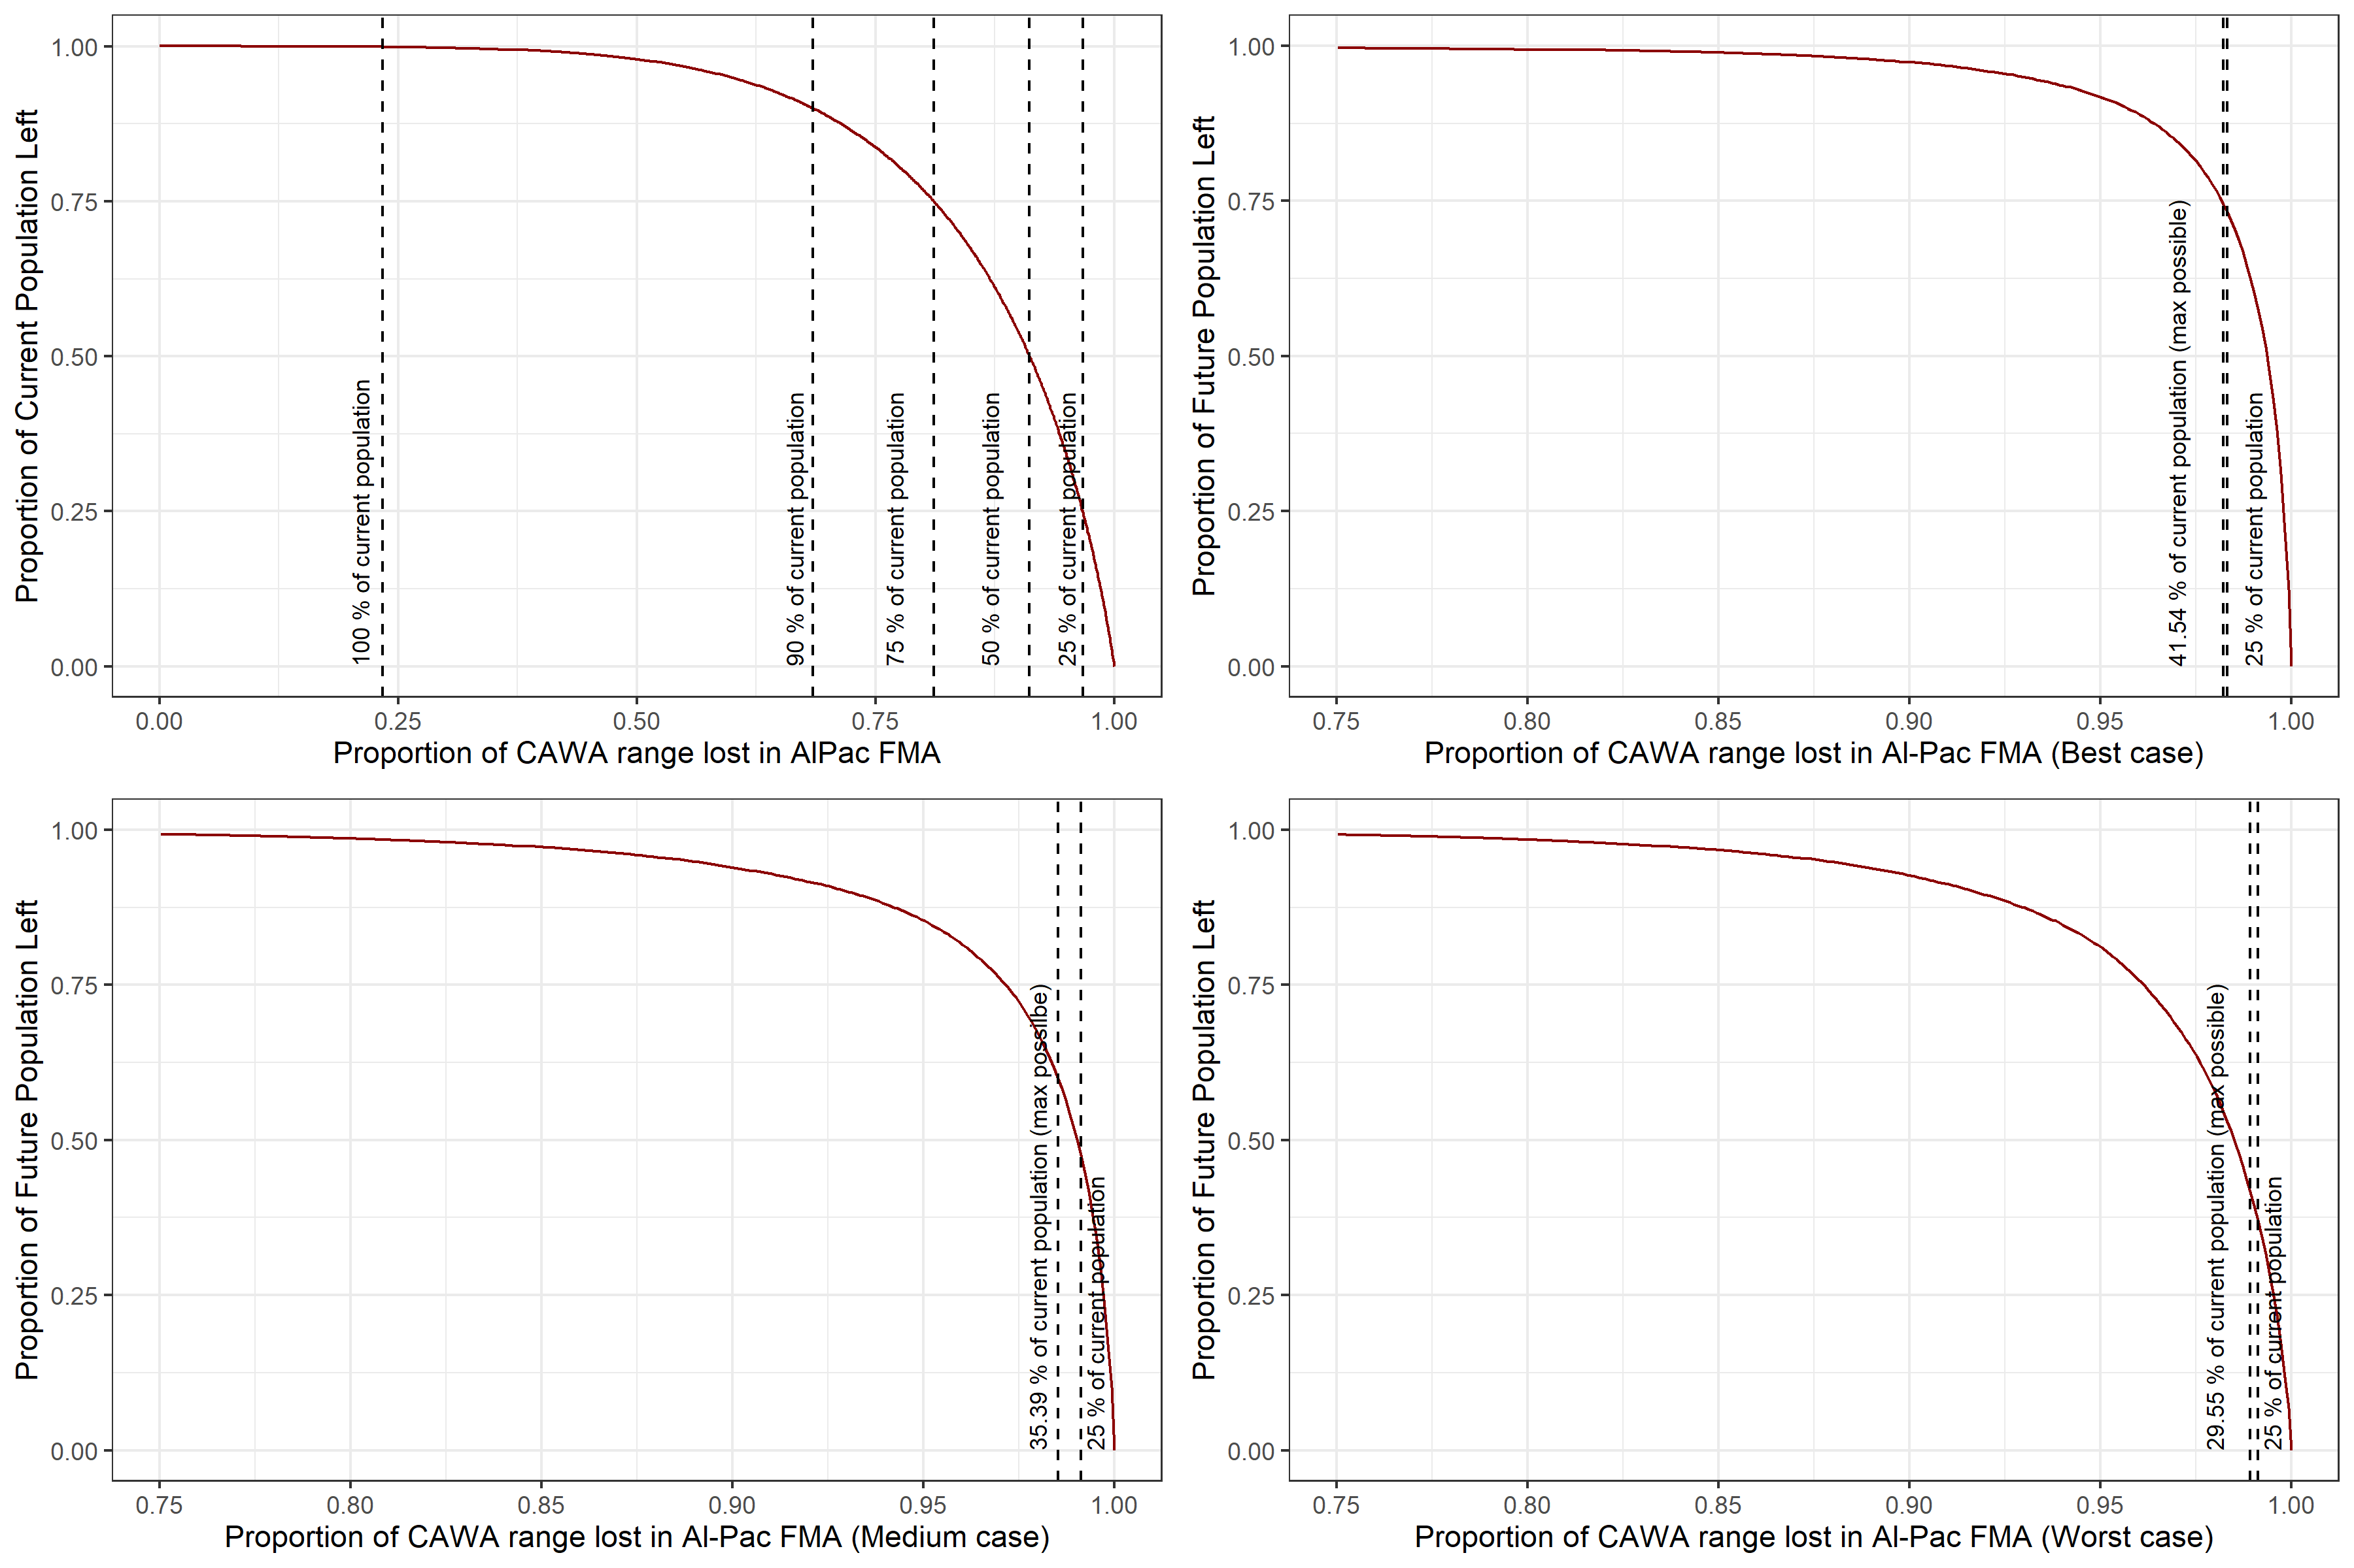
Figure S4.2. Runtime plots showing the proportion of the current and future Canada Warbler population remaining in its current range in the Alberta-Pacific Forest Management Area (Al-Pac FMA) in northeastern Alberta as lands (250-m cells) are removed from consideration for conservation or management as important Canada Warbler habitat, under four Zonation scenarios. Zonation scenarios: Current = based on current population density alone; Best = based on current density + 2100 population from the best-case Landis scenario; Medium = based on current density + 2100 population from the medium-case Landis scenario; Worst = based on current density + 2100 population from the worst-case Landis scenario. As the 2100 population was projected to be higher than the current population in the Al-Pac FMA, less land was required to maintain various percentages of the current population levels, when future distribution of the Canada Warbler was also used to prioritize lands as important habitat. Since population projections were similar across different Landis scenarios, the amount of land that can be removed barely differed in Zonation scenarios based on the best, medium, and worst-case scenarios.
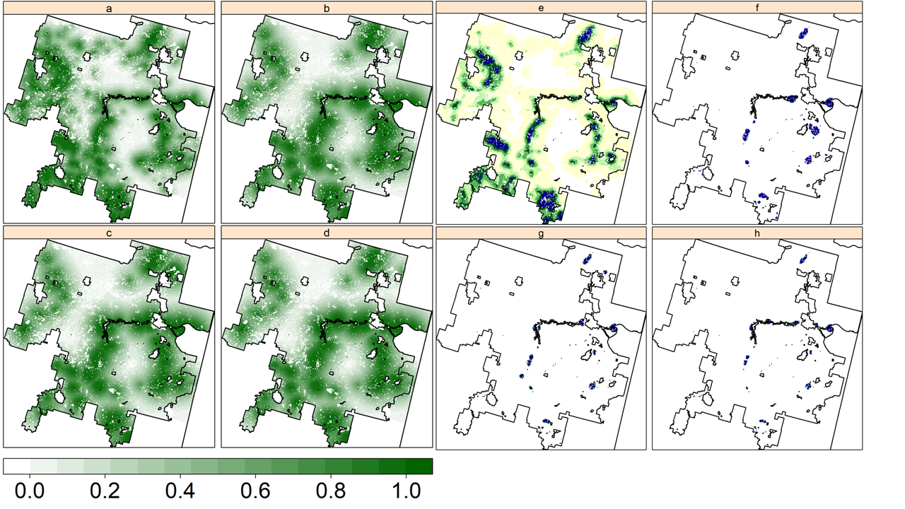
Figure S4.3. Priority areas for four scenarios for Canada Warbler in the Alberta-Pacific Forest Management Area (Al-Pac FMA) in northeastern Alberta. Maps a-d indicate priority rankings (0=lowest priority and 1=highest priority) for the (a) current distribution, (b) current + best-case 2100 distribution, (c) current + medium-case 2100 distribution, and (d) current + worst-case distribution in LANDIS scenarios,whereas colors in e-h indicate the area necessary to maintain specified percentages of the 2019 population under the (e) current, (f) best-case, (g) medium-case, and (h) worst-case scenarios. In panels e-h, areas colored in blue, blue + dark green , blue + dark green + light green and blue + dark green + light green + yellow indicate the cumulative areas necessary to maintain up to 50, 75%, 90%, and 100% of the current population, respectively. White areas do not contribute meaningfully to population goals. Existing protected areas are outlined in gray.

Wood Thrush

Quebec, New Brunswick, and Nova Scotia Zonation Scenarios
In the Landis and Zonation study areas in southern Quebec, pixels receiving higher ranks and prioritization were similar across the four Zonation scenarios in each study area. However, the amount of land required to maintain the current Wood Thrush population was very different across the four scenarios. When only the current population was considered, 15, 39, 66, and >99 % of the study area (12,258,363 ha) would be required to maintain 50, 75, 90, and 100 % of the current Wood Thrush population (612,380 males). The best-case, medium-case, and worst-case Landis scenarios predicted a larger Wood Thrush population in 2100 than the current population (respectively 106, 95, and 91 % more males). The corresponding Zonation scenarios that also considered future population estimated that less land needs to be prioritized for protection or management in the corresponding Zonation scenarios (best case: 10, 23, 43, and 88 %; medium case: 9, 23, 43, and 88 %; worst case: 9, 23, 43, and 88 %) to maintain 50, 75, 90, and 100 % of the current Wood Thrush population (Figs. S4.4 - S4.6).
.
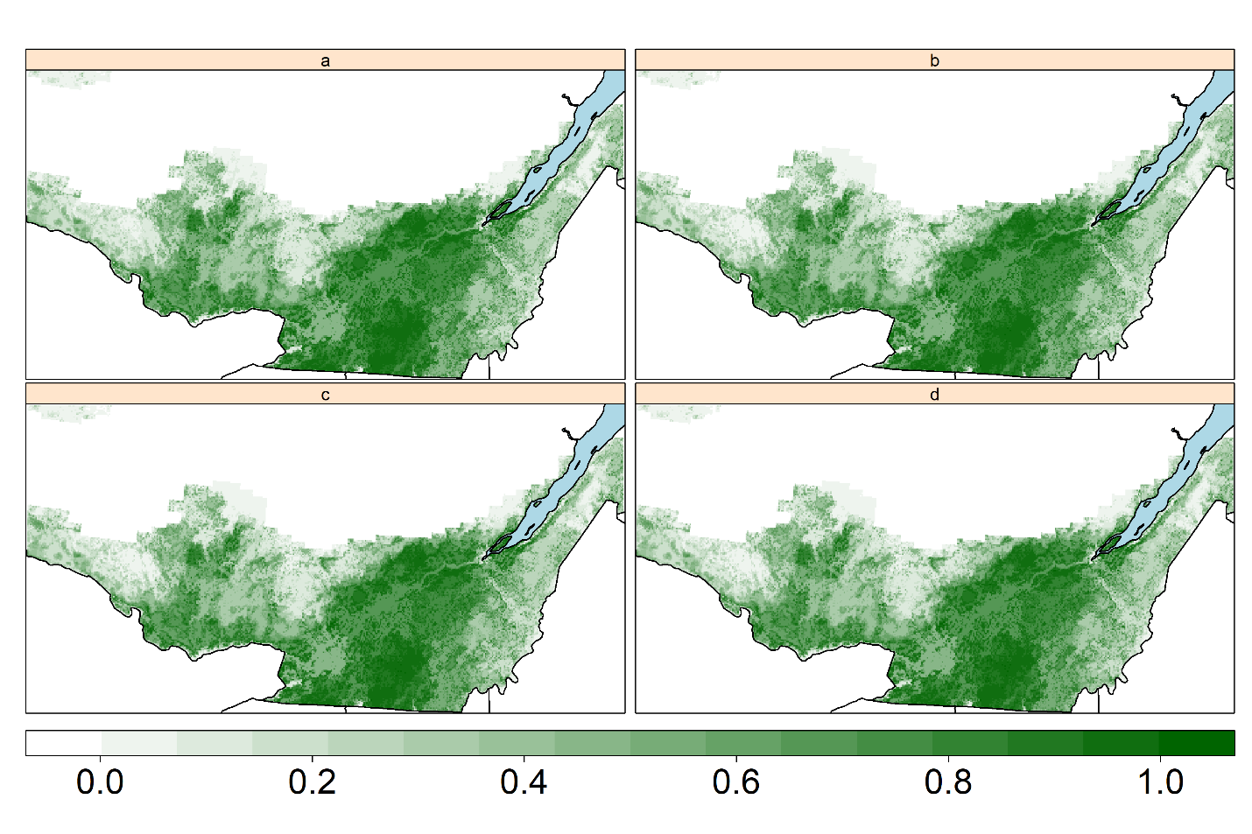

Figure S4.4. Maps of southern Quebec in which individual locations (250-m cells) are coloured according to their priority for conservation or management as important Wood Thrush habitat under present and future environmental conditions. Darker colours indicate locations with higher priority (on a scale from 0 to 1) as critical habitat for Wood Thrush. Zonation scenarios: a) based on current population density alone; b) based on current density + 2100 population from the best-case Landis scenario; c) based on current density + 2100 population from the medium-case Landis scenario; d) based on current density + 2100 population from the worst-case Landis scenario. As the 2100 population was projected to be higher than the current population in southern Quebec, less land was required to maintain various percentages of the current population levels when future distribution of the Wood Thrush was also used to prioritize lands as important habitat.

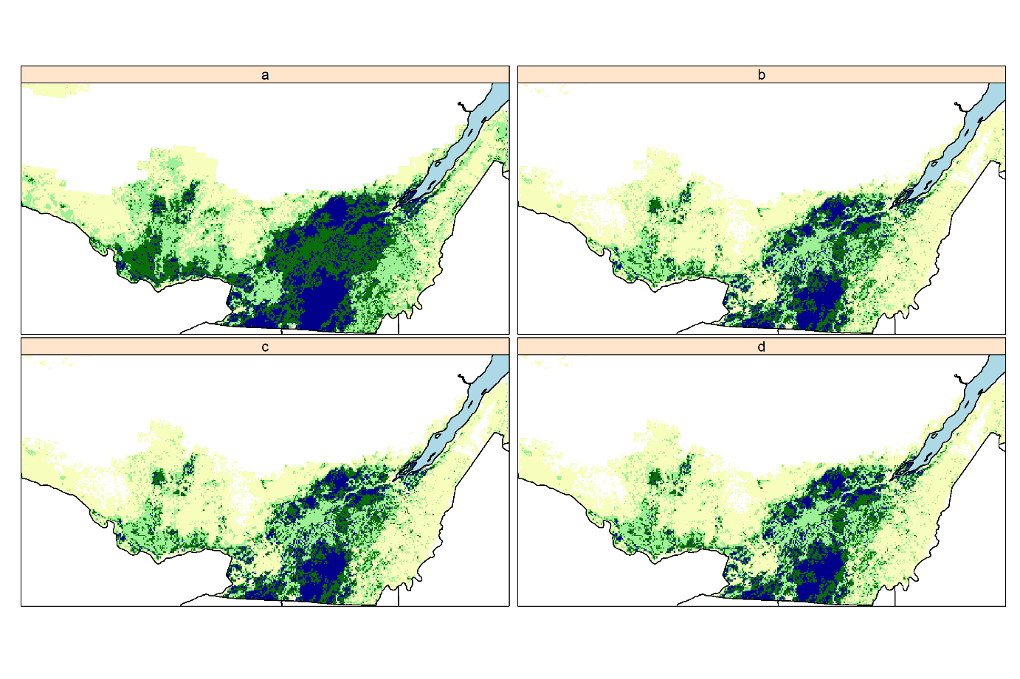

Figure S4.5. Multi-colour maps indicating what areas to prioritize as important habitat for different percentages of the current Wood Thrush population in southern Quebec. Dark blue indicates the highest ranked areas that are necessary to maintain 50% of the current population as of 2019. Dark green, light green and yellow areas are additional areas necessary to maintain up to 75%, 90%, and 100% of the current population, respectively. Zonation scenarios: a) based on current population density alone; b) based on current density + 2100 population from the best-case Landis scenario; c) based on current density + 2100 population from the medium-case Landis scenario; d) based on current density + 2100 population from the worst-case Landis scenario. As the 2100 population was projected to be higher than the current population in southern Quebec, less land was required to maintain various percentages of the current population levels when future distribution of the Wood Thrush was also used to prioritize lands as important habitat.

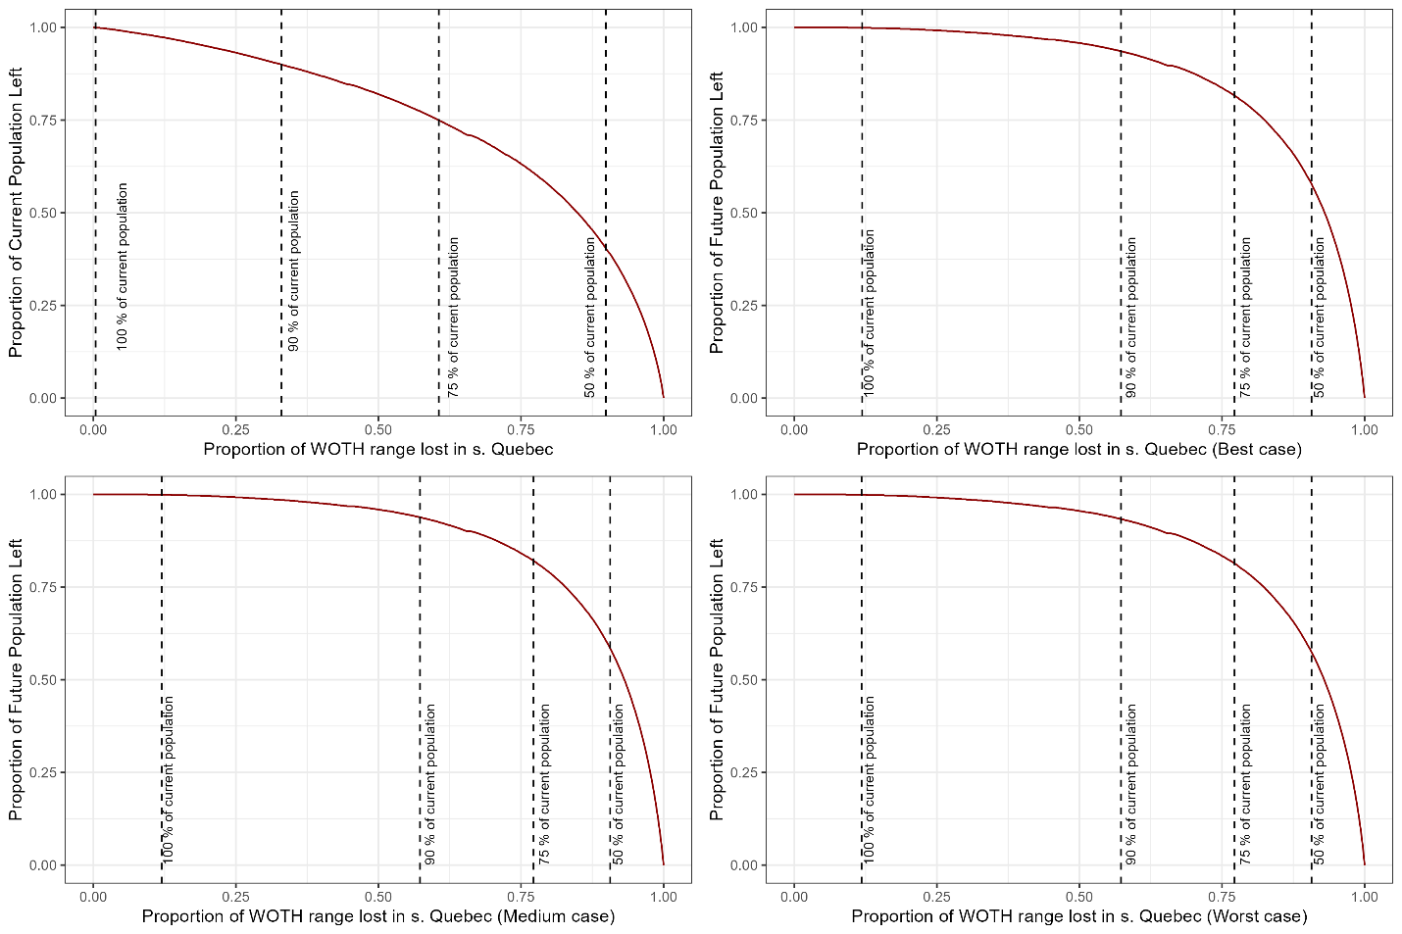

Figure S4.6. Runtime plots showing the proportion of the current and future Wood Thrush population remaining in its current range in southern Quebec as lands (250-m cells) are removed from consideration for conservation or management as important Wood Thrush habitat, under four Zonation scenarios. Zonation scenarios: Current = based on current population density alone; Best = based on current density + 2100 population from the best-case Landis scenario; Medium = based on current density + 2100 population from the medium-case Landis scenario; Worst = based on current density + 2100 population from the worst-case Landis scenario. As the 2100 population was projected to be higher than the current population in southern Quebec, less land was required to maintain various percentages of the current population levels, when future distribution of the Wood Thrush was also used to prioritize lands as important habitat. Since population projections were similar across different Landis scenarios, the amount of land that can be removed barely differed in Zonation scenarios based on the best, medium, and worst-case scenarios.

In southern New Brunswick, when only the current population was considered, 18, 42, 68, and >99 % of the study area (6,431,194 ha) would be required to maintain 50, 75, 90, and 100 % of the current Wood Thrush population (169,926 males). The best-case, medium-case, and worst-case Landis scenarios predicted a larger Wood Thrush population in 2100 than the current population (respectively 126, 64, and 30 % more males). The corresponding Zonation scenarios that also considered future population estimated that less land needs to be prioritized for protection or management in the corresponding Zonation scenarios (best case: 7, 18, 31, and 80 %; medium case: 7, 18, 31, and 79 %; worst case: 7, 18, 31, and 79 %) to maintain 50, 75, 90, and 100 % of the current Wood Thrush population (Figs. S4.7 - S4.9).
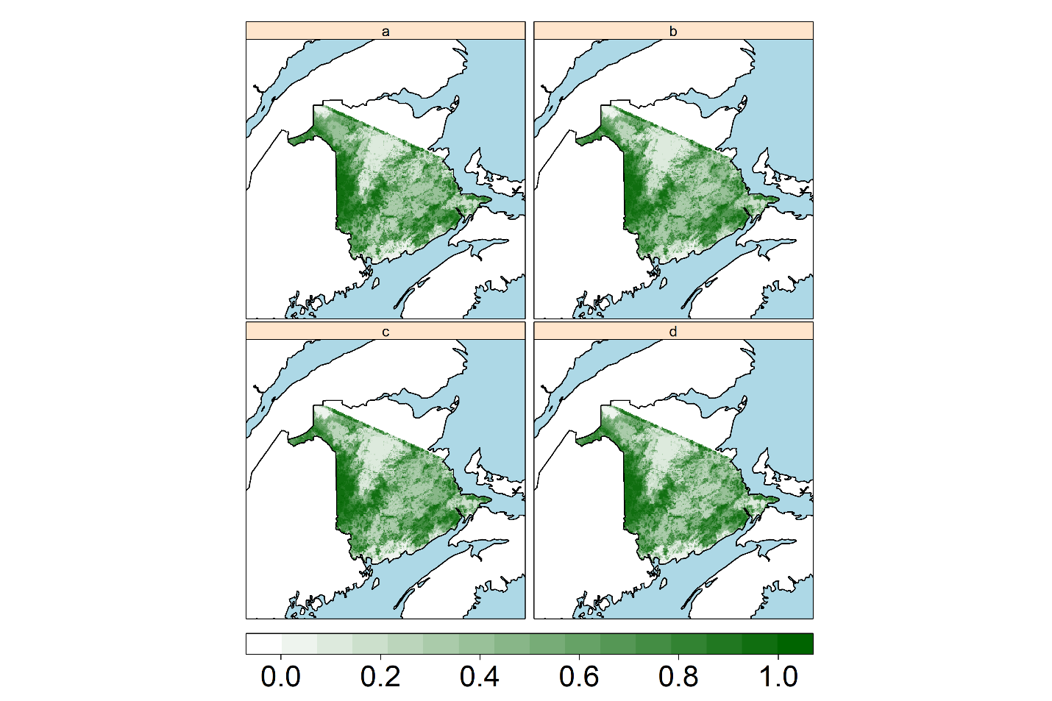

Figure S4.7. Maps of southern New Brunswick in the current estimated range of the Wood Thrush, which individual locations (250-m cells) are coloured according to their priority for conservation or management as Wood Thrush habitat under present and future environmental conditions. Darker colours indicate locations with higher priority (on a scale from 0 to 1) as critical habitat for Wood Thrush. Zonation scenarios: a) based on current population density alone; b) based on current density + 2100 population from the best-case Landis scenario; c) based on current density + 2100 population from the medium-case Landis scenario; d) based on current density + 2100 population from the worst-case Landis scenario. As the 2100 population was projected to be higher than the current population in southern New Brunswick, less land was required to maintain various percentages of the current population levels when future distribution of the Wood Thrush was also used to prioritize lands as habitat.

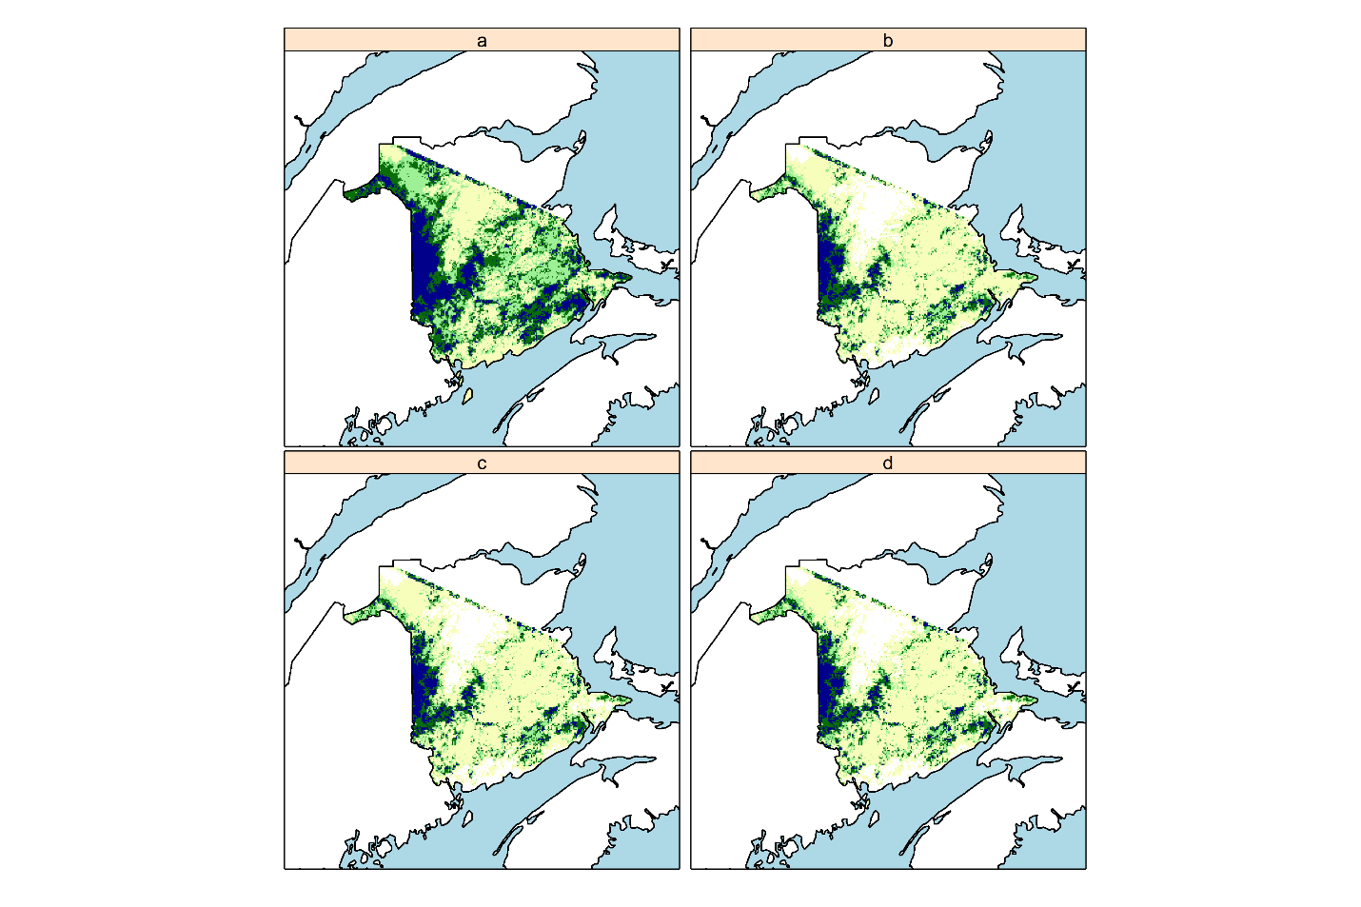

Figure S4.8. Multi-colour maps indicating what areas to prioritize as important habitat for different percentages of the current Wood Thrush population in its current estimated range in southern New Brunswick. Dark blue indicates the highest ranked areas that are necessary to maintain 50% of the current population as of 2019. Dark green, light green and yellow areas are additional areas necessary to maintain up to 75%, 90%, and 100% of the current population, respectively. Zonation scenarios: a) based on current population density alone; b) based on current density + 2100 population from the best-case Landis scenario; c) based on current density + 2100 population from the medium-case Landis scenario; d) based on current density + 2100 population from the worst-case Landis scenario. As the 2100 population was projected to be higher than the current population in southern New Brunswick, less land was required to maintain various percentages of the current population levels when future distribution of the Wood Thrush was also used to prioritize lands as habitat.

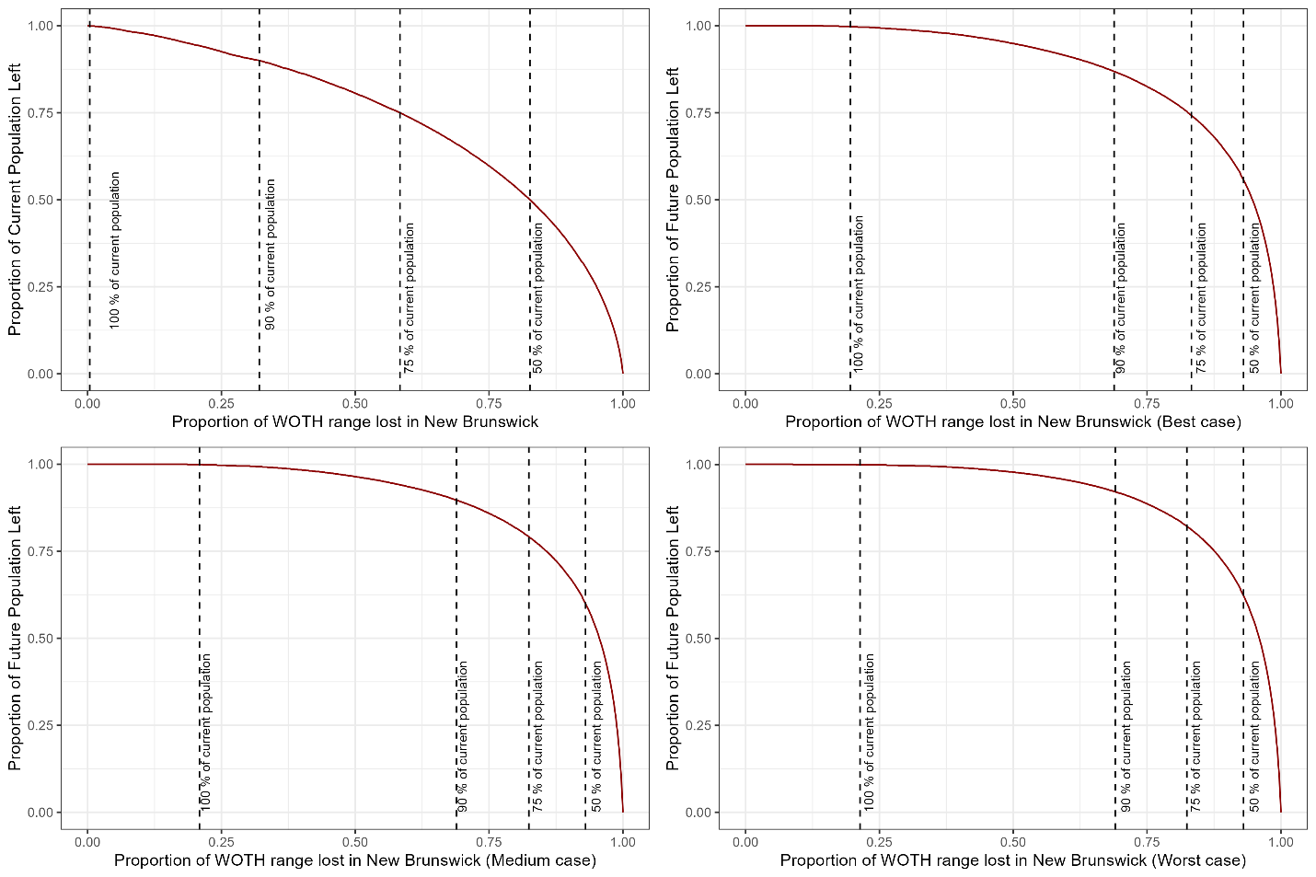

Figure S4.9. Runtime plots showing the proportion of the current and future Wood Thrush population remaining in its current range in southern New Brunswick as lands (250-m cells) are removed from consideration for conservation or management as Wood Thrush habitat, under four Zonation scenarios. Zonation scenarios: Current = based on current population density alone; Best = based on current density + 2100 population from the best-case Landis scenario; Medium = based on current density + 2100 population from the medium-case Landis scenario; Worst = based on current density + 2100 population from the worst-case Landis scenario. As the 2100 population was projected to be higher than the current population in southern New Brunswick, less land was required to maintain various percentages of the current population levels, when future distribution of the Wood Thrush was also used to prioritize lands as habitat.

In southern Nova Scotia, when only the current population was considered, 18, 43, 67, and >99 % of the study area (5,085,488 ha) would be required to maintain 50, 75, 90, and 100 % of the current Wood Thrush population (71,533 males). The best-case, medium-case, and worst-case Landis scenarios predicted a larger Wood Thrush population in 2100 than the current population (respectively 275, 187, and 179 % more males). The corresponding Zonation scenarios that also considered future population estimated that less land needs to be prioritized for protection or management in the corresponding Zonation scenarios (best case: 3, 8, 16, and 50 %; medium case: 3, 8, 15, and 50 %; worst case: 2, 8, 15, and 49 %) to maintain 50, 75, 90, and 100 % of the current Wood Thrush population (Figs. S4.10 - S4.12).

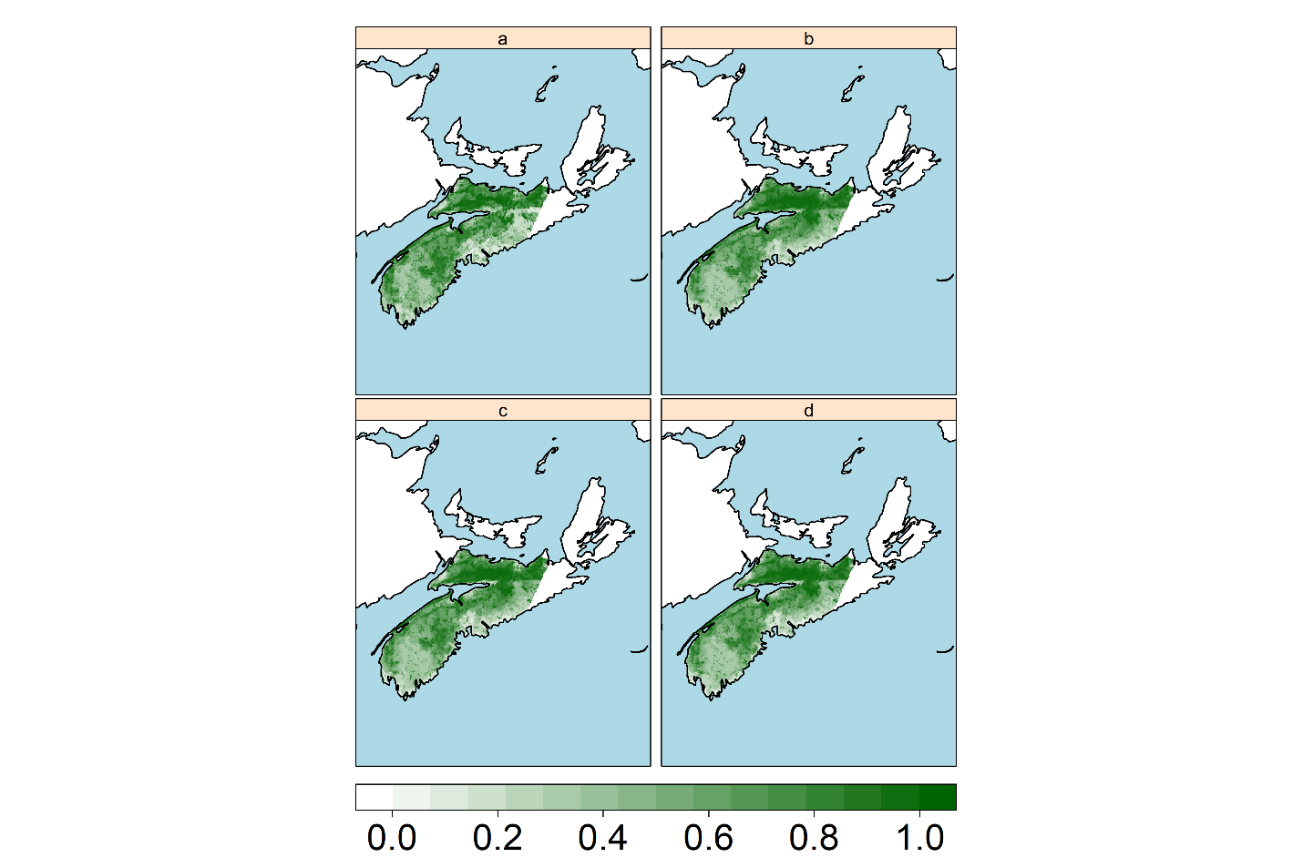

Figure S4.10. Maps of southern Nova Scotia in the current estimated range of the Wood Thrush, which individual locations (250-m cells) are coloured according to their priority for conservation or management as Wood Thrush habitat under present and future environmental conditions. Darker colours indicate locations with higher priority (on a scale from 0 to 1) as critical habitat for Wood Thrush. Zonation scenarios: a) based on current population density alone; b) based on current density + 2100 population from the best-case Landis scenario; c) based on current density + 2100 population from the medium-case Landis scenario; d) based on current density + 2100 population from the worst-case Landis scenario. As the 2100 population was projected to be higher than the current population in southern Nova Scotia, less land was required to maintain various percentages of the current population levels when future distribution of the Wood Thrush was also used to prioritize lands as habitat.

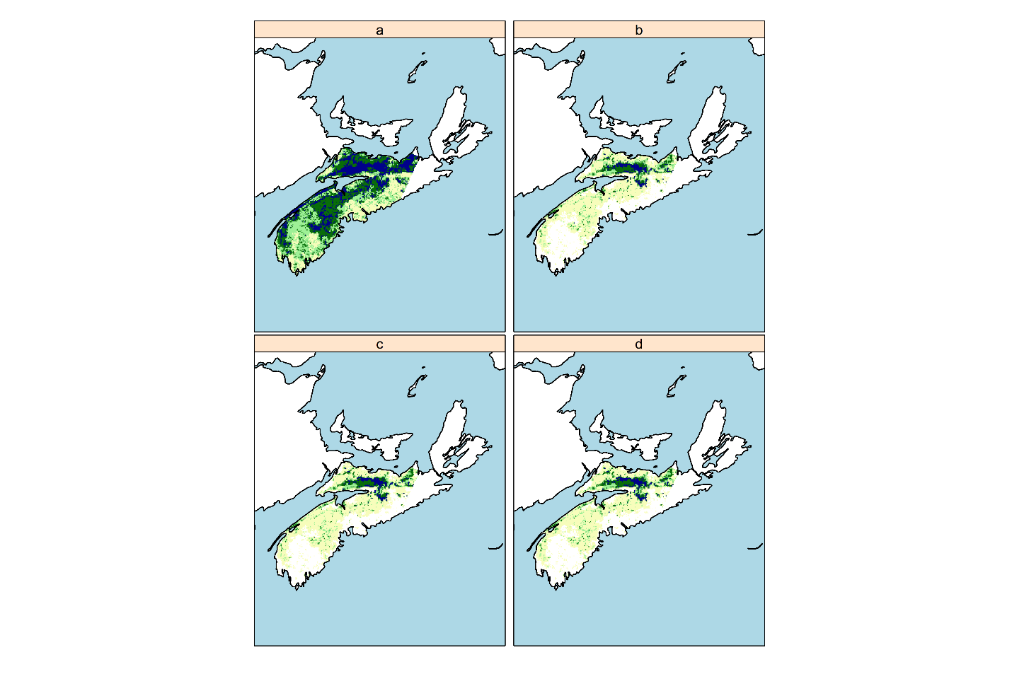

Figure S4.11. Multi-colour maps indicating what areas to prioritize as habitat for different percentages of the current Wood Thrush population in its current estimated range in southern Nova Scotia. Dark blue indicates the highest ranked areas that are necessary to maintain 50% of the current population as of 2019. Dark green, light green and yellow areas are additional areas necessary to maintain up to 75%, 90%, and 100% of the current population, respectively. Zonation scenarios: a) based on current population density alone; b) based on current density + 2100 population from the best-case Landis scenario; c) based on current density + 2100 population from the medium-case Landis scenario; d) based on current density + 2100 population from the worst-case Landis scenario. As the 2100 population was projected to be higher than the current population in southern Nova Scotia, less land was required to maintain various percentages of the current population levels when future distribution of the Wood Thrush was also used to prioritize lands as habitat.

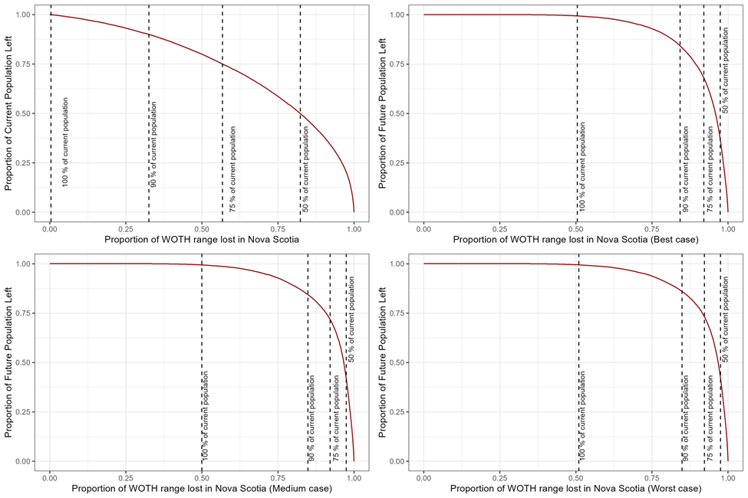

Figure S4.12. Runtime plots showing the proportion of the current and future Wood Thrush population remaining in its current range in southern Nova Scotia as lands (250-m cells) are removed from consideration for conservation or management as Wood Thrush habitat, under four Zonation scenarios. Zonation scenarios: Current = based on current population density alone; Best = based on current density + 2100 population from the best-case Landis scenario; Medium = based on current density + 2100 population from the medium-case Landis scenario; Worst = based on current density + 2100 population from the worst-case Landis scenario. As the 2100 population was projected to be higher than the current population in southern Nova Scotia, less land was required to maintain various percentages of the current population levels, when future distribution of the Wood Thrush was also used to prioritize lands as habitat.

Ontario Zonation Scenarios
In Ontario, the highest-ranking locations for Wood Thrush habitat were assigned to lands northeast of Lake Huron. Within the FMUs in western Ontario, when only the current population was considered, 25, 49, 71, and >99 % of the study area (17,087,944 ha) would be required to maintain 50, 75, 90, and 100 % of the current Wood Thrush population (254,841 males). The Wood Thrush population was predicted to be 30 % higher in 2070 than the current population, and the Zonation scenario that also considered future population estimated that 7, 15, 25, and 58 % of the study area would be required to maintain 50, 75, 90, and 100 % of the current Wood Thrush population (Fig. S4.13). Within parts of the Wood Thrush range in Ontario southeast of the FMUs, when only the current population was considered, 18, 42, 68, and >99 % of the study area (12,638,406 ha) would be required to maintain 50, 75, 90, and 100 % of the current Wood Thrush population (255,597 males) (Fig. S4.14). The Wood Thrush population was predicted to be 16 % higher in 2070 than the current population, and the Zonation scenario that also considered future population estimated that 10, 24, 41, and 83 % of the study area would be required to maintain 50, 75, 90, and 100 % of the current Wood Thrush population (Fig. S4.15).

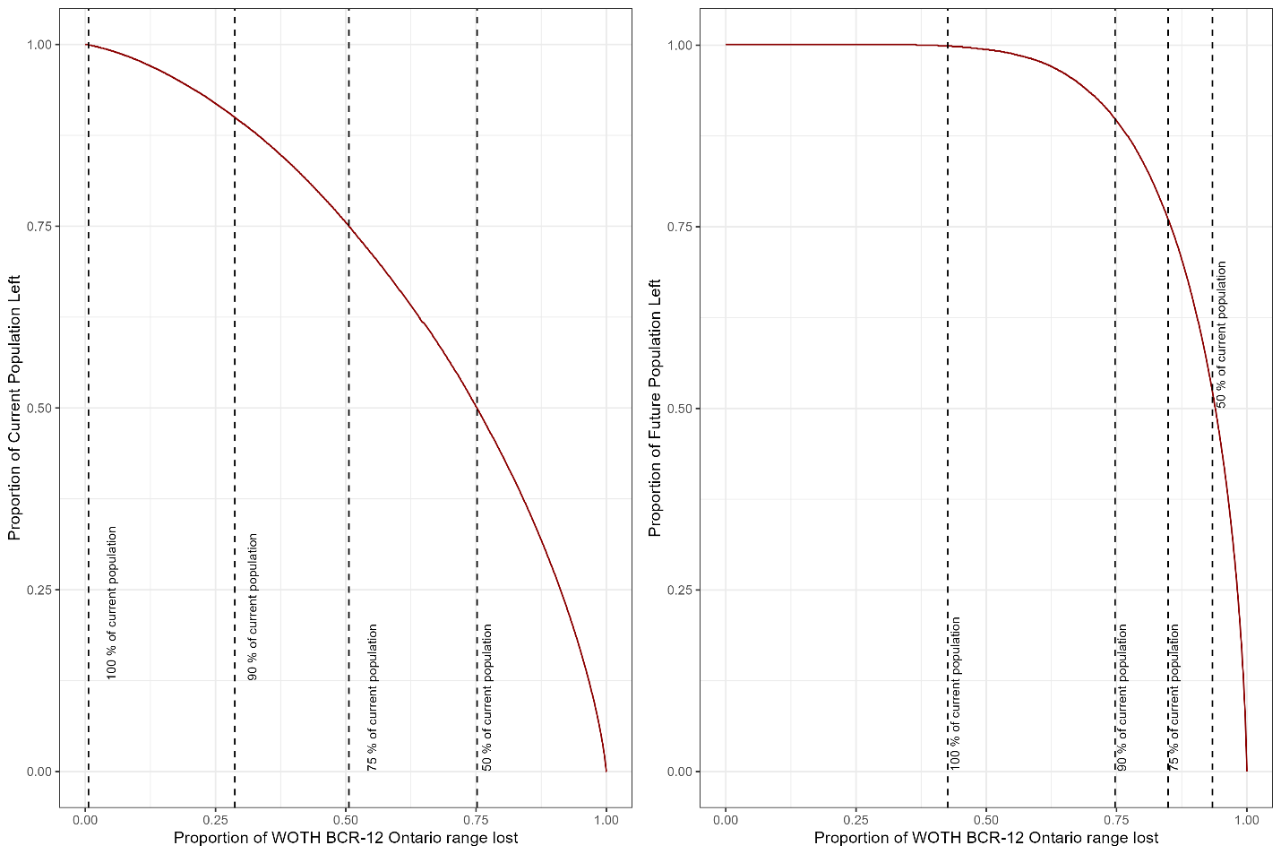

Figure S4.13. Runtime plots showing the proportion of the current and future Wood Thrush population remaining in Forest Management Units in western Ontario as lands (200-m cells) are removed from consideration for conservation or management as important Wood Thrush habitat, under two Zonation scenarios. Zonation scenarios: Left panel = based on current population density alone; right panel = based on current density + 2070 population from baseline ALCES Online scenario. As the 2070 population was projected to be higher than the current population in western Ontario, less land was required to maintain various percentages of the current population levels, when future distribution of the Wood Thrush was also used to prioritize lands as important habitat.

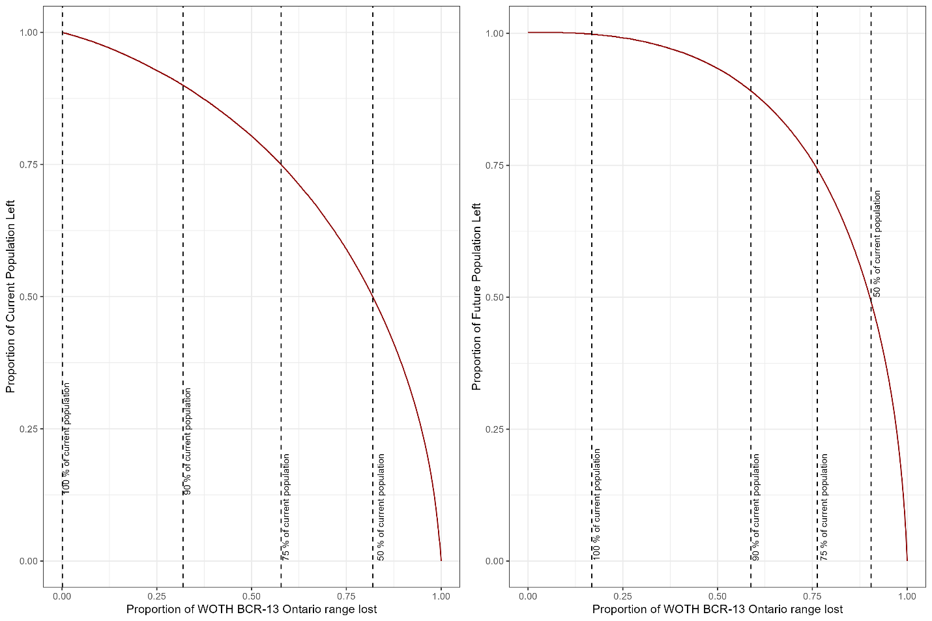

Figure S4.14. Runtime plots showing the proportion of the current and future Wood Thrush population remaining in southeastern Ontario outside of Forest Management Units as lands (200-m cells) are removed from consideration for conservation or management as important Wood Thrush habitat, under two Zonation scenarios. Zonation scenarios: Left panel = based on current population density alone; right panel = based on current density + 2070 population from baseline ALCES Online scenario. As the 2070 population was projected to be higher than the current population in southeastern Ontario, less land was required to maintain various percentages of the current population levels, when future distribution of the Wood Thrush was also used to prioritize lands as important habitat.
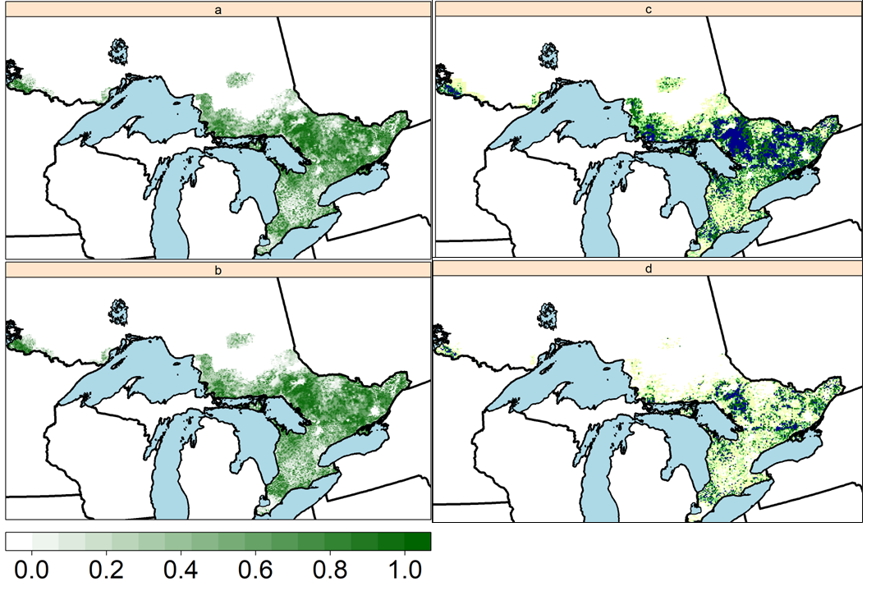
Figure S4.15. Priority areas for two Zonation exercises for Wood Thrush in Ontario. Maps: a) ranks of locations based on predicted density of current population in 2020 along with connectivity between locations with higher predicted densities; b) ranks of locations based on predicted density of current population in 2020, predicted density of future population in 2070, and connectivity between locations with higher predicted densities; c) locations in plot a have been recoloured to indicate what locations should be prioritized for protection or management to maintain 50% of the current population (dark blue), 75% (dark green), 90% (light green), and 100% of the current population (yellow); d) locations in plot b have been recoloured to indicate what locations to prioritize for maintaining 50, 75, 90, and 100% of the current population, based on both the current population and on increases in future population. Higher ranks in plots a and b are assigned to sites with higher predicted density and/or connectivity. White areas within the Wood Thrush’s Ontario range do not contribute meaningfully to population objectives.

References
Lehtomäki J, Moilanen A (2013) Methods and workflow for spatial conservation prioritization using Zonation. Environ Model Softw 47:128–137. https://doi.org/10.1016/j.envsoft.2013.05.001
Moilanen AJ, Pouzols FM, Meller L, Veach V, Arponen A, Leppänen J, Kujala H (2014) Spatial conservation planning methods and software: ZONATION 4.0 User Manual; Version 4; Conservation Biology Informatics Group, University of Helsinki: Helsinki, Finland, 2014; ISBN 9789521099199.

Moilanen A, Runge MC, Elith J, et al (2006) Planning for robust reserve networks using uncertainty analysis. Ecol Model 199:115–124. https://doi.org/10.1016/j.ecolmodel.2006.07.004
Moilanen A, Wintle BA (2006) Uncertainty analysis favours selection of spatially aggregated reserve networks. Biol Conserv 129:427–434. https://doi.org/10.1016/j.biocon.2005.11.006
Tittler R, Fahrig L, Villard M-A (2006) Evidence of Large-Scale Source–Sink Dynamics and Long-Distance Dispersal Among Wood Thrush Populations. Ecology 87:3029–3036. https://doi.org/10.1890/0012-9658(2006)87[3029:EOLSDA]2.0.CO;2
Westwood AR, Lambert JD, Reitsma LR, Stralberg D (2020) Prioritizing Areas for Land Conservation and Forest Management Planning for the Threatened Canada Warbler (Cardellina canadensis) in the Atlantic Northern Forest of Canada. Diversity 12:61. https://doi.org/10.3390/d12020061

