Appendix S2 – Regional Species Distribution Models for Canada Warbler and Wood Thrush

Methods
Boosted regression trees (hereafter, “BRT”s) (Elith and Leathwick 2009) were used to build regional models of Canada Warbler and Wood Thrush abundance and distribution. The “rpart” (Therneau and Atkinson 2019), “gbm” (Greenwell et al. 2020), and “dismo” packages (Hijmans et al. 2020) were used to construct BRTs and the raster package was used to create prediction layers of Canada Warbler and Wood Thrush density under each BRT. As some areas in each species’ modeling regions had more point counts than other areas (Figure 2 in main manuscript), areas with more point counts could unduly influence results if all point count data were used in modelling. To account for spatial correlation in the data and create random sample data sets for training and cross-validating each BRT, cross-validation (blockCV package [Valavi et al. 2018]) was used to partition study regions into blocks sharing overall similarity in BRT predictor values that were independent of the values in other blocks. Training and testing data were drawn evenly from the blocks. Five-fold cross-validation (Leathwick et al. 2006) was used both to select the number of trees that minimized residual deviance in the final BRT model and to evaluate predictive ability of the final BRT model (Bühlmann and Yu 2003; Hastie et al. 2009). There were 5 initial models of 50 trees each, a tree complexity of 3, a learning rate of 0.01, and a bag fraction of 0.5 (the proportion of data in each subset used to train the model as opposed to the out-of-bag 50 % of data used to test the model). Prediction error (PE or residual deviance) was calculated for each BRT for tree sizes 1 to 3 from the “out-of-bag” data and pooled across the 5 boosted trees, then the number of trees in each model was augmented by 50 trees and the process was repeated.
Predictive ability of the BRT models run for both Canada Warbler and Wood Thrush was compared by examining 5-fold cross validation correlation in the test data and by examining the intercept and slope values from a regression of predicted versus observed density. Better predictive ability is indicated by higher correlation, intercepts closer to 0, and slopes closer to 1. Once a final BRT for predicting density was selected based on its predictive accuracy, that selected BRT was rerun on 250 random sample data sets to obtain 250 sets of model regression trees. Each set of regression trees can be used to generate a predicted density raster. We predicted the mean, standard deviation, and 90 % confidence interval estimates of density of each species in each management unit where a species was modelled. We also used these regression trees to predict future density of each species from land use simulation outputs run in Landis-II and for Wood Thrush also in ALCES Online (Appendix S4).
We measured the relative influence of predictors in the final selected BRT model for each species. Relative influence refers to the number of times a specific predictor is used to classify or split sample point counts into smaller groups within the boosted regression tree model’s individual regression trees. This number is weighted by the improvement to the model due to that predictor, averaged across all individual trees, then scaled so that relative influences add up to 1. We generated partial dependence plots showing the effect of each predictor on predicted density of Canada Warbler and Wood Thrush after averaging other predictors’ values.

Point Count Data
For the BRT models, 15,059 surveys in northern Nova Scotia and 123,996 surveys in Alberta (1% of surveys in each region with detections) were available for Canada Warbler and 316,241 surveys (5% with detections) were available for Wood Thrush (Figure 2, Appendices S1-S2).
We ran separate BRTs for Canada Warbler in northern Nova Scotia and Alberta, based on management units identified by geographically weighted models (“GWR models”). In contrast, we ran BRTs across the entire range of the Wood Thrush as we did not find biological evidence for differential habitat use within this range from GWR models. Point counts that were available for Canada Warbler from GWR models were available for BRTs if those point counts occurred within the region of a specific BRT. For Wood Thrush however, since some of the eastern Canadian point counts from GWR models occurred north of the known range of the Wood Thrush, we used point counts with least one Wood Thrush detection to calculate a Wood Thrush range boundary within Canada based on kernel density estimation methods (Lichti and Swihart 2011), using the “ks” package in R (Duong 2021). The range boundary corresponded to the 99 % line. We then used this range boundary as the study area for the Wood Thrush BRTs, excluding point counts in Prince Edward Island, and northern parts of New Brunswick, Nova Scotia, Ontario, and Quebec (Appendix S1, Fig. 2 in main manuscript).

Predictor Data
Predictors used in Canada Warbler BRTs were generally similar in Alberta and northern Nova Scotia. For vegetation, we use satellite data from 2001 and 2011 at 250-m resolution (Beaudoin et al. 2014), clipped to each region and extracted to point counts based on survey year (1993-2005 [N=418, 337]; 2006-2014 [N=400, 780]). Predictors included the proportion of each cell dominated by different tree species in each region; total live above-ground vegetation biomass in each cell; and stand age. We used the compound topographic index (CTI) described in Appendix S2 as a measure of soil moisture based on slope and catchment area: areas with low CTI values have small catchment areas with steep slopes (Ball et al. 2016). To measure the amount of flooding in possible Canada Warbler habitat in Nova Scotia, we used a raster layer for the mean number of metres each 250-m cell was above or below the water table (https://novascotia.ca/natr/forestry/gis/wamdownload.asp). In Nova Scotia, we used the proportion of each cell occupied by urban/ agricultural land, roads, and open water. In Alberta, we used a wider range of human footprint types that were prevalent in Alberta boreal forests. Proportions of rural industrial land, mines, pipelines, paved roads, narrow (3-d) seismic lines, wide (2-d) seismic lines, transmission lines, agriculture, and open water in each 250-m cell were obtained from provincial layers produced by the Alberta Biodiversity Monitoring Institute (ABMI 2019) (Table S2.1).
We quantified forest structure predictors, mean elevation relative to the water table, and compound topographic index in Nova Scotia and Alberta at three spatial extents: the original value assigned to each 250-m cell (“local”) and mean values at two landscape scales (within 250 m and 750 m of each cell) in a moving window analysis via Gaussian filtering (“focalweight” function in the “raster” package [Hijmans et al. 2012]) (Chandler and Hepinstall-Cymerman 2016).

Table S2.1. Description and sources of predictor variables used in boosted regression tree models of Canada Warbler density (#males per ha) in northern Nova Scotia (NNS) and Alberta (AB).
Variable | Description | Region(s) | Citation
Tree species cover | National layers of percent cover of individual tree species found in each region (resolution of 250 m) based on 2005 Moderate Resolution Imaging Spectroradiometer (MODIS) satellite imagery combined with forestry permanent sample plots. | NNS, AB | Beaudoin et al. 2014
Live above-ground biomass | National layers of total live above-ground biomass (tonnes per ha) (resolution of 250 m) based on 2005 Moderate Resolution Imaging Spectroradiometer (MODIS) satellite imagery combined with forestry permanent sample plots. | NNS, AB | Beaudoin et al. 2014
Forest age | National layers of forest stand age (years) (resolution of 250 m) based on 2005 Moderate Resolution Imaging Spectroradiometer (MODIS) satellite imagery combined with forestry permanent sample plots. | NNS, AB | Beaudoin et al. 2014
Roads | Whether a point count was within a pixel (resolution of 250 m) classified as containing a road or the proportion of land within 250 or 750 m containing pixels classed as roadside pixels. | NNS | CEC 2005
Urban or agricultural | Proportional cover of non-forest (urban or agricultural) (resolution of 250 m) based on 2005 Moderate Resolution Imaging Spectroradiometer (MODIS) satellite imagery. | NNS | CEC 2005
Human footprint classes | Proportional cover of 8 different human footprint classes (resolution of 250 m) derived from provincial shapefile layer, rasterized and resampled to 250-m resolution. | AB | ABMI 2019
ARU | A binary variable to indicate if a survey was conducted by a human observer (0) or an acoustic recording unit (1). | NNS, AB | Van Wilgenberg et al 2015; Sólymos et al 2020
Compound Topographic Index (CTI) | Measure of soil moisture based on slope and catchment area, resampled to 250-m resolution. | NNS, AB | Global Land Cover Facility 2014
Wet areas | Mean local elevation relative to water table | NNS, AB | https://novascotia.ca/natr/forestry/gis/wamdownload.asp (NNS);

For Wood Thrush BRTs, categorical land cover data were obtained from Landsat satellite data (30-m resolution) by Agriculture Canada (AAFC 2021) for the years 2011, 2015, 2020. These land cover data were used because of their recent origin and greater accuracy in representing forest and shrubland cover within agricultural and urban areas of eastern Canada. To get a “local” estimate for each land cover type of interest (barren ground, coniferous forest, all cultivated land, deciduous forest, grassland, mixed-wood forest, orchards, shrubland, urban land, open water, all wetland), binary rasters were generated for each land cover type and Gaussian filtering (“focalweight” function in “raster” package [Hijmans et al. 2015]) was used to estimate the proportion of each land cover type within 150 m of each pixel (Chandler and Hepinstall-Cymerman 2016). These proportions were then resampled and averaged at coarser resolution (150 m) to speed up processing, then additional Gaussian filtering was performed to obtain average land cover proportions within 250, 1000, and 2000 m of each pixel. Finally, land cover proportions at 150, 250, 1000, and 2000 m were resampled to 250-m resolution to enable stacking of these raster layers with other layers. The spatial scales at which land cover was averaged were based on the scales at which Wood Thrush was observed to respond to forest structure and cover in previous studies (Burke and Nol 2000; Austen et al. 2001; Lee et al. 2002; Driscoll et al. 2005; Richmond et al. 2012; Bonnot et al. 2013) (Table S2.2).
Wood Thrush will use swamps as habitat separate from other wetland types, and the Agriculture Canada Landsat products may misidentify swamps as shrubland. Thus, a 30-m swamp raster layer was generated from separate provincial sources in which swamps could be distinguished from other wetland types. Depending on the source (Table S2.2), pixels were classified as swamps in the original raster (Ontario Land Cover Compilation v.2.0 2016) or forested wetlands shapefiles (New Brunswick Department of Environment and Local Government 2021) or swamps were identified as locations where forested shapefile polygons intersected with wetland polygons (Nova Scotia Forest Inventory 2021, Nova Scotia Wetlands Inventory 2021). Once a 30-m raster layer was generated for each province in ArcGIS, then the same Gaussian filtering operations were performed on each provincial swamp raster as done for the Agriculture Canada Layers to generate raster layers of the proportions of swamp within 150, 250, 1000, and 2000 m of each pixel at 250-m resolution. These proportions were independent of the land cover proportions measured at each spatial scale (Table S2.2).
Forest stand age and biomass (branch, foliage, woody stem, bark, total dead, total live aboveground) were extrapolated from satellite data from 2001 and 2011 at 250-m resolution (Beaudoin et al. 2014), clipped to each region and extracted to point counts based on survey year (1993-2005 [N=145,957]; 2006-2020 [N=170,284]). The “local” estimates for stand age (#years since stand origin) and different fractions of live aboveground and dead biomass (tonnes/ha) were extracted from each 250-m pixel, then Gaussian filtering was used to estimate the average stand age and biomass within approximately 250, 1000, and 2000 m of each pixel (Table S2.2).

Models
For Canada Warbler, separately in Alberta and northern Nova Scotia, we ran 5 BRT models differing in the potential predictors that were used. One BRT (the “full model”) included predictors at all three spatial scales. Output from the full-model BRT was examined to determine the scale for each predictor that had the largest relative importance in predicting abundance of each species in the point counts. The second BRT (the “selected scales model”) used just the single most important scale for each vegetation or terrain variable. The third BRT (the “cell level model”) just used the cell-level predictor for each vegetation or terrain variable, while the fourth and fifth BRTs (the “GF250 model” and “GF750 model”) just used respectively the landscape scale predictors for each vegetation or terrain variable resulting from the 250-m and 750-m Gaussian filters.
For Wood Thrush throughout eastern Canada, we first ran 6 BRT models differing in the potential predictors that were used. One BRT (the “full model”) included land cover, forest age, forest biomass, and swamp predictors at four spatial scales (cell-level, 250, 1000, 2000 m). Output from the full-model BRT was examined to determine the scale for each predictor that had the largest relative importance in predicting abundance of each species in the point counts. The second BRT (the “selected scales model”) used just the single most important scale for each land cover, forest age, forest biomass, and swamp variable. The third BRT (the “local model”) just used the cell-level predictor for each land cover, forest age, forest biomass, and swamp variable, while the fourth, fifth, and sixth BRTs (the “GF250 model”, “GF1000 model” and “GF2000 model”) just used respectively the landscape scale predictors for each land cover, forest age, forest biomass, and swamp variable resulting from the 250, 1000, and 2000-m Gaussian filters. All BRTs also included elevation, slope, TRI, TPI, whether a point count was within 150 m of any road, and whether a point count was within 150 m of a major road (Table 2). The final BRT model selected from these models was used to predict current Wood Thrush density and distribution in southern Quebec, New Brunswick, and Nova Scotia, along with changes in density and distribution over time in Landis II land use scenarios (Leston 2022).
The Wood Thrush also occurs in southern Ontario where we lacked the necessary parameters for Landis-II to simulate changes in tree species biomass within the Wood Thrush’s range in southern Ontario. Instead, we used another program called ALCES Online (https://www.online.alces.ca/) to simulate land use change in Ontario without accounting for tree species biomass or effects on forest succession and disturbance due to climate change (Carlson et al. 2014; Carlson and Stelfox 2014; Carlson et al. 2019; Leston et al. 2020).
The final BRT model that was selected for predicting future Wood Thrush density and distribution elsewhere in eastern Canada was modified in two ways to predict future Wood Thrush density and distribution in Ontario. First, live aboveground biomass was excluded as a predictor, since that variable cannot currently be modeled within ALCES Online. Second, as ALCES Online currently can simulate environmental variables at several resolutions but not at 250-m resolution, all other predictor variables used in the BRT were resampled to 200-m resolution (the closest available resolution in ALCES Online to 250 m), prior to extracting data to point counts and running the BRT (“ALCES 200”) for making predictions from ALCES Online outputs. The same point count data that were available for the final BRT used elsewhere in eastern Canada were potentially available for the “ALCES 200” BRT, meaning that while ALCES Online simulations were only run in Ontario, point counts from the Wood Thrush range in Quebec, New Brunswick and Nova Scotia were also used in the model.
For both Canada Warbler and Wood Thrush, once a final BRT model was selected for predicting density of each species in a specific landscape (Alberta and Nova Scotia management units for Canada Warbler; individual provinces in Eastern Canada for Wood Thrush), that model was rerun 250 times by resampling available point counts for that model. Resampling was done to reduce effects of a particular random sample on model results. Replicate samples were used to make spatial predictions on stacked spatial data representing a current landscape or a future landscape. These prediction maps were then summarized (mean, standard deviation, confidence interval) across all replicates for each species and landscape. Current and future populations were estimated as the summed product of predicted density per cell * cell area, across all cells in a landscape.

Table S2.2. Description and sources of predictor variables used in boosted regression tree models of Wood Thrush abundance in Canada.

Variable | Description | Abbreviation | Citation
Land cover | Eleven land cover classes for individual Canadian provinces – Quebec, Ontario, New Brunswick, Nova Scotia - (30 m resolution) based on Landsat satellite imagery in 2011, 2015, and 2020; used to create binary land cover rasters resampled to 250 m resolution. | Land cover | AAFC 2021
Forest stand age | Local stand age since last disturbance (years) extracted from forest vegetation layers (250 m resolution) in 2001 and 2011. Stand age layer processed with Gaussian filtering to estimate mean stand age within 250, 1000, and 2000 m. | Stand age | Beaudoin et al. 2014
Forest stand live above-ground biomass (branch, foliage, woody stem, bark, total live) | Different fractions of live above-ground biomass (tonnes per ha) extracted from forest vegetation layers (250 m resolution) in 2001 and 2011. Stand biomass layer processed with Gaussian filtering to estimate mean stand biomass within 250, 1000, and 2000 m. | Stand biomass | Beaudoin et al. 2014
Roadside status | Roadside150 = whether a point count was within 150 m of any roadside (1) or not (0)  MajorRoad150 = whether a point count was within 150 m of a heavy traffic road (arterial road, expressway, highway, freeway, ramp, rapid transit road) (1) or not (0). | Road | CanVec 2021
Elevation | 1-km elevation raster associated with the climate raster geodatabase used in Step 2 of CHID framework (geographically weighted regression models) | Elev | Wang et al. 2016
Topographic Position Index | The difference between the elevation of a focal cell and the mean of its 8 surrounding cells. Positive and negative values correspond to ridges and valleys, respectively, while zero values correspond generally to flat areas (except a special case where a focal cell with a value 5 can have surrounding cells with values of 4×1 and 4×9, resulting in a TPI of 0). | TPI | Amatulli et al. 2018
Terrain Ruggedness Index | The mean of the absolute differences in elevation between a focal cell and its 8 surrounding cells. It quantifies the total elevation change across the 3×3 cells. Flat areas have a value of zero whereas mountain areas with steep ridges have positive values, which can be greater than 2000m in the Himalaya area. | TRI | Amatulli et al. 2018
Slope | 0 – 41.5 degrees | Slope | Amatulli et al. 2018
Swamp – New Brunswick | Wetland shapefile filtered to swamps only, rasterized to a 30-m swamp layer, then resampled to 250 m (proportion of land within swamps locally – 150 m), then processed with Gaussian filtering to estimate mean proportion of land within swamps within 250, 1000, and 2000 m. | Swamp | New Brunswick Department of Environment and Local Government 2021
Swamp – Nova Scotia | Wetland shapefile intersected with merged Forest Inventory shapefiles from all of Nova Scotia, filtered to polygons with 25 % or greater tree cover, rasterized to a 30-m swamp layer, then resampled to 250 m (proportion of land within swamps locally – 150 m), then processed with Gaussian filtering to estimate mean proportion of land within swamps within 250, 1000, and 2000 m. | Swamp | Nova Scotia Department of Lands and Forestry 2021
Swamp - Ontario | 30-m Ontario Land Cover v.2.0 raster layer resampled to 250 m (proportion of land within swamps locally – 150 m), then processed with Gaussian filtering to estimate mean proportion of land within swamps within 250, 1000, and 2000 m. | Swamp | Ontario Land Cover Compilation v.2.0 2016
Swamp - Quebec | Wetland shapefile data compiled by Ducks Unlimited from different regions in southern Quebec from 2010 – 2015. Shapefile filtered to swamps only, then rasterized to 30-m swamp layer, then resampled to 250 m (proportion of land within swamps locally – 150 m), then processed with Gaussian filtering to estimate mean proportion of land within swamps within 250, 1000, and 2000 m. | Swamp | Ducks Unlimited 2015

Results

Canada Warbler
The BRT containing predictors at the 750-m landscape scale had the best overall predictive ability for Canada Warbler in Nova Scotia (Table S2.3). Predictors with greatest relative influence on Canada Warbler abundance in Nova Scotia were proportion of red pine (21.37 %), proportion of red maple (9.67 %), CTI (8.40 %), proportions of all birch (8.25 %), balsam fir (6.75 %), red spruce (5.52 %), eastern hemlock (5.43 %), white spruce (4.54 %), and total live above ground biomass (4.23 %). Canada Warbler increased with CTI values: thus, Canada Warbler was more abundant in larger catchment areas with shallow slopes. Canada Warbler also increased with proportions of balsam fir, red pine, and red spruce and declined with increasing red maple, birch, and above ground biomass (Fig. S2.1, Table 1). We estimated that there was habitat to support a current potential population of 45,894 (27,996 ‒71,628) Canada Warblers in Nova Scotia.
The BRT with the best overall predictive ability for Canada Warbler in Alberta contained predictors at different spatial scales (Table S2.3). Predictors with greatest relative influence on Canada Warbler abundance in Alberta were CTI at 250 m (26.80 %), proportion of birch at 750 m (11.30 %), trembling aspen at 250 m (9.58 %), larch at 250 m (8.74 %) proportions of wider seismic lines (8.54 %) and transmission lines (7.32 %) per 250-m cell, proportion of jack pine at 750 m (6.22 %), and total live above ground biomass at 250 m (4.83 %). In contrast to Nova Scotia, Canada Warbler densities in Alberta decreased with CTI values: thus, in Alberta Canada Warbler was more abundant in small catchment areas with steeper slopes. Unlike in Nova Scotia, Canada Warbler also increased with above ground biomass and proportions of deciduous trees like birch, tamarack, and trembling aspen. Canada Warbler densities also increased with the proportions of jack pine, balsam fir, and wider seismic lines and decreased with proportion of transmission lines in Alberta (Fig. S2.2, Table 1). We estimated that there was habitat to support a current potential population of 274,176 (165,447 ‒442,813) Canada Warbler males in Alberta.

Table S2.3. Comparison of predictive accuracy and explanatory power among boosted regression models of Canada Warbler density in Alberta and northern Nova Scotia and Wood Thrush in eastern Canada. In these management units, the full model contained land cover, forest structure, footprint, and topography predictors at multiple spatial scales (which differed in each species). The selected scales model contained those predictors but only at the spatial scale where each predictor had the highest relative influence on assignment of point counts within regression trees. The 250 m, 750 m, 1000 m, and 2000 m models contained predictors whose values were averaged respectively within 250, 750, 1000, or 2000 m of cells before extracting spatial data to point counts. Deviance = 5-fold cross-validation deviance. Correlation, intercept, and slope = 5-fold cross-validation correlation, y-intercept, and slope of predicted vs. observed density.
Species | Management Unit | Prediction Area | BRT model | Deviance | Correlation | Intercept | Slope
Canada Warbler | Alberta | northeast Alberta | full | 0.72 (0.37 - 1.08) | 0.13 (0.1 - 0.16) | -0.05 (-1.52 - 1.42) | 0.91 (0.62 - 1.2)
 |  |  | selected scales | 0.68 (0.38 - 0.98) | 0.15 (0.11 - 0.19) | -0.25 (-1.48 - 0.98) | 0.85 (0.65 - 1.05)
 |  |  | local | 0.72 (0.49 - 0.95) | 0.13 (0.09 - 0.16) | -0.38 (-1.36 - 0.61) | 0.85 (0.65 - 1.05)
 |  |  | 250 m | 0.67 (0.26 - 1.07) | 0.13 (0.08 - 0.17) | -0.25 (-1.23 - 0.73) | 0.83 (0.63 - 1.02)
 |  |  | 750 m | 0.66 (0.58 - 0.74) | 0.13 (0.12 - 0.14) | -0.5 (-0.99 - -0.01) | 0.85 (0.7 - 1)
Canada Warbler | northern Nova Scotia | northern Nova Scotia | full | 1.88 (1.52 - 2.23) | 0.03 (0.01 - 0.05) | 1.5 (-1.05 - 4.05) | 1.37 (0.64 - 2.11)
 |  |  | selected scales | 1.9 (1.6 - 2.19) | 0.04 (0.03 - 0.05) | 2.2 (0.24 - 4.16) | 1.5 (1.01 - 1.99)
 |  |  | local | * | * | * | *
 |  |  | 250 m | 1.88 (1.49 - 2.27) | 0.05 (0.03 - 0.08) | 2.7 (-0.24 - 5.64) | 1.67 (0.94 - 2.41)
 |  |  | 750 m | 1.79 (1.46 - 2.13) | 0.09 (0.07 - 0.11) | 0.8 (0.21 - 1.39) | 1.13 (1 - 1.25)
Wood Thrush | eastern Canada | outside Ontario | full | 4.45 (1.25 - 7.65) | 0.24 (0.12 - 0.35) | -0.1 (-0.49 - 0.29) | 0.95 (0.75 - 1.15)
 |  | , | selected scales | 5.03 (1.45 - 8.61) | 0.23 (0.17 - 0.3) | -0.15 (-0.74 - 0.44) | 0.85 (0.56 - 1.14)
 |  |  | local | 3.97 (1.67 - 6.26) | 0.18 (0.08 - 0.28) | -0.5 (-1.09 - 0.09) | 0.88 (0.68 - 1.08)
 |  |  | 250 m | 4.09 (1.29 - 6.89) | 0.19 (0.09 - 0.29) | -0.4 (-0.79 - -0.01) | 0.93 (0.73 - 1.13)
 |  |  | 2000 m | 5.04 (1.67 - 8.41) | 0.23 (0.17 - 0.3) | -0.05 (-0.74 - 0.64) | 0.88 (0.48 - 1.27)
 |  |  | 1000 m | 4.21 (1.68 - 6.75) | 0.16 (0.07 - 0.24) | -0.6 (-1.29 - 0.09) | 0.78 (0.58 - 0.98)
Wood Thrush | eastern Canada | Ontario | ALCES Online | 5.1 (1.4 - 8.8) | 0.22 (0.15 - 0.3) | -0.15 (-0.54 - 0.24) | 0.85 (0.65 - 1.05)

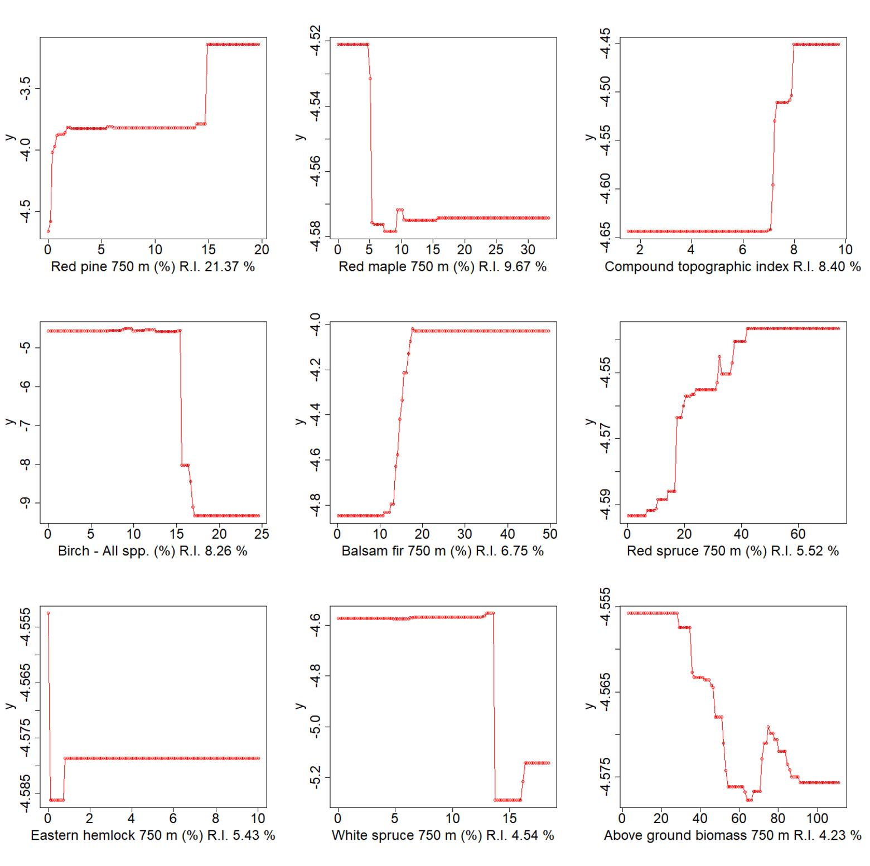
Figure S2.1. Partial dependence plots showing the relationship between y(predicted log[Canada Warbler density]) and each of the 9 most important variables from boosted regression trees predicting this species’ density in northern Nova Scotia. Relative influence of predictors is ordered from higher to lower, top to bottom and left to right.
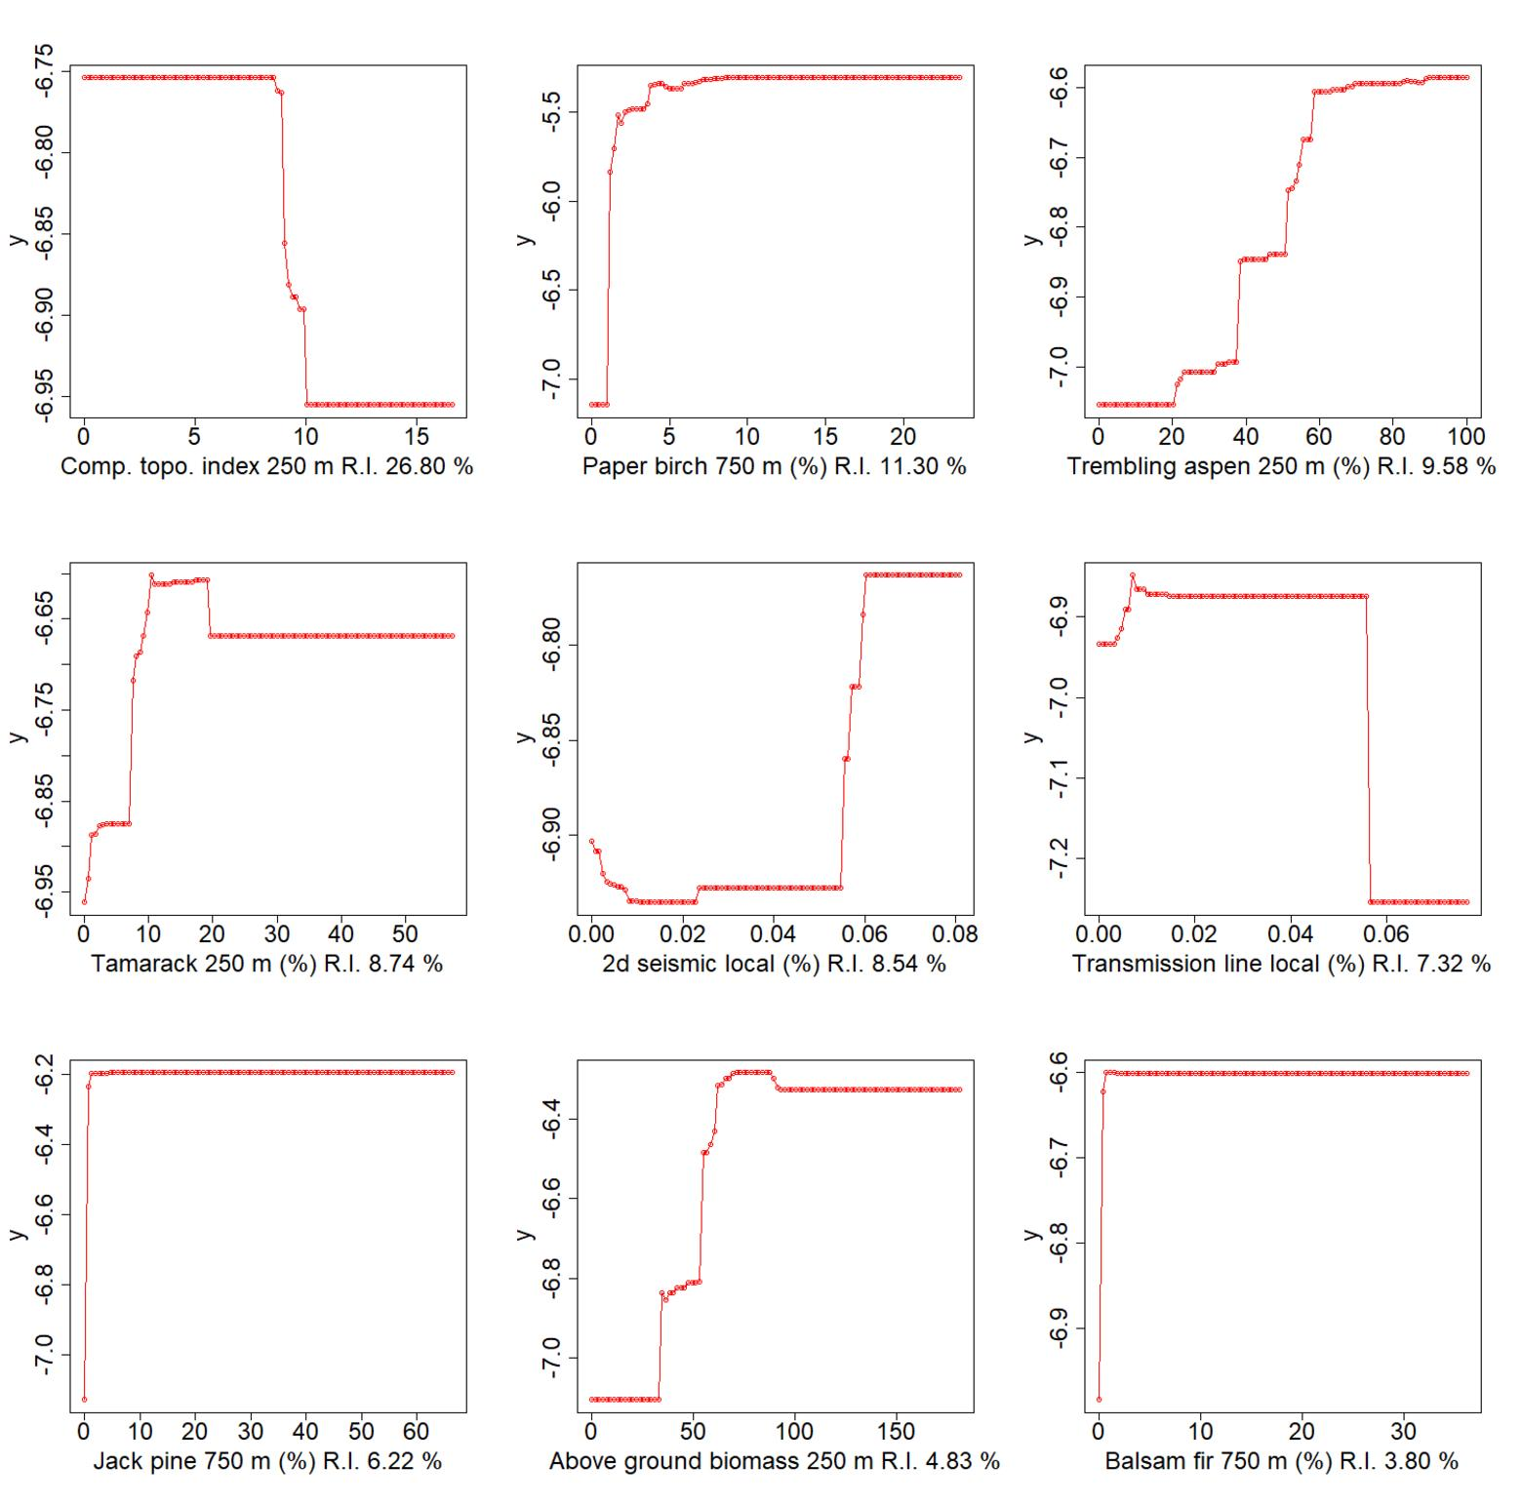
Figure S2.2. Partial dependence plots showing the relationship between y(predicted log[Canada Warbler density]) and each of the 9 most important variables from boosted regression trees predicting this species’ density in Alberta. Relative influence of predictors is ordered from higher to lower, top to bottom and left to right.

Wood Thrush
We chose the selected-scales BRT as the final BRT to use for modeling present and future Wood Thrush densities due to the combination of higher cross-validation correlation, calibration intercept closer to 0, and slope closer to 1 (Table S2.3). Predictors with greatest relative influence in this BRT were proportions of (land within 150 - 2000 m consisting of) deciduous forest, swamp, shrubland, cultivated lands, and coniferous forest; whether a point count was within 150 m of any road and separately within 150 m of a major traffic road; mean point-level forest age and biomass within 2000 m; and elevation. Wood Thrush were on average most abundant when up to 80 % of land within 150 m consisted of swamps, when shrublands or coniferous forests comprised no more than 20 % of land within 2000 m, and with increasing deciduous forest cover within 150 m. Cultivated land and grassland were less important, but Wood Thrush increased with % cultivated lands within 1000 m, suggesting that they will use agricultural landscapes. Wood Thrush were less abundant at point counts within 150 m of roads in general, but the decrease was smaller within 150 m of major traffic roads: after accounting for roads, urban land within 2000 m had negligible influence on Wood Thrush. Wood Thrush were most abundant between 100 and 500 m above sea level. Wood Thrush declined when mean forest age within 2000 m was 20 – 60 years old, increased in forests < 20 years old, but generally increased with mean stand age and live aboveground biomass within 2000 m (Figure S2.3, Table 1).

When the final BRT was modified for predicting future Wood Thrush densities in Ontario, Wood Thrush were on average most abundant when deciduous forests comprised about 60 % of land within 150 m of point counts, up to 70 % of land within 150 m consisted of swamps, and when shrublands comprised no more than 20 % of land within 2000 m. Wood Thrush were more abundant within 150 m of major traffic roads, but after accounting for this influence were less abundant at point counts within 150 m of roads in general. Wood Thrush increased with elevation to 200 m above sea level, then declined with further increases in elevation. Wood Thrush were most abundant in forests that were at least 50 years old and increased with mean stand age within 2000 m but were slightly more abundant in shrublands (mean stand age 2000 m < 20 years old) than in forests 20 – 60 years old (mean stand age 2000 m = 20 – 60 years old) (Figure S2.4, Table 1). Higher current densities of Wood Thrush are predicted by BRTs in southwestern Ontario and southern Quebec than in New Brunswick or Nova Scotia (Figure S2.5). We estimated that there was habitat to support a current potential Wood Thrush population of 135,887 (78,570 ‒ 195,204) in Ontario, 612,380 (577,207 ‒ 647,552) in Quebec, 169,926 (159,611 ‒ 180,242) in New Brunswick, and 84,885 (78,570 ‒ 91,510) in Nova Scotia.

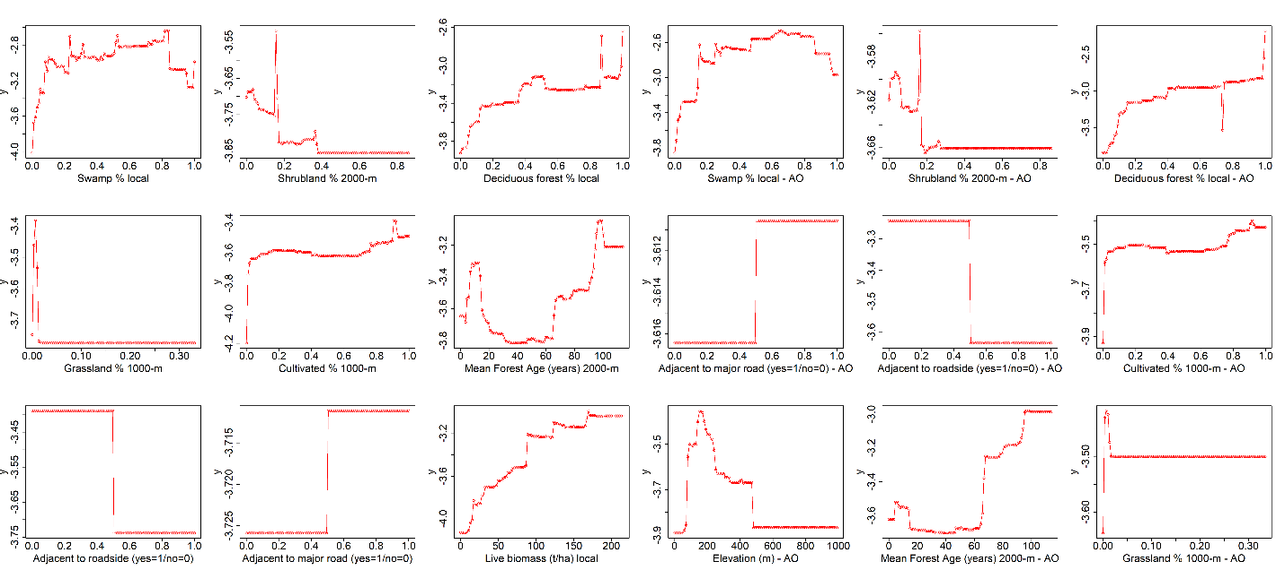
Figure S2.3. Partial dependence plots showing the relationship between y (predicted log[Wood Thrush density]) and each of the most important variables from the final boosted regression tree (BRT) model predicting current Wood Thrush density in Quebec, New Brunswick, and Nova Scotia , along with future density and distribution in Landis-II land use and climate change scenarios. Relative influence of predictors is ordered from higher to lower, top to bottom and left to right.
Figure S2.4. Partial dependence plots showing the relationship between y (predicted log[Wood Thrush density]) and each of the most important variables from the final boosted regression tree (BRT) model predicting current Wood Thrush density in Ontario along with future density and distribution in an ALCES Online land use scenario (AO = "ALCES Online model”). Relative influence of predictors is ordered from higher to lower, top to bottom and left to right.

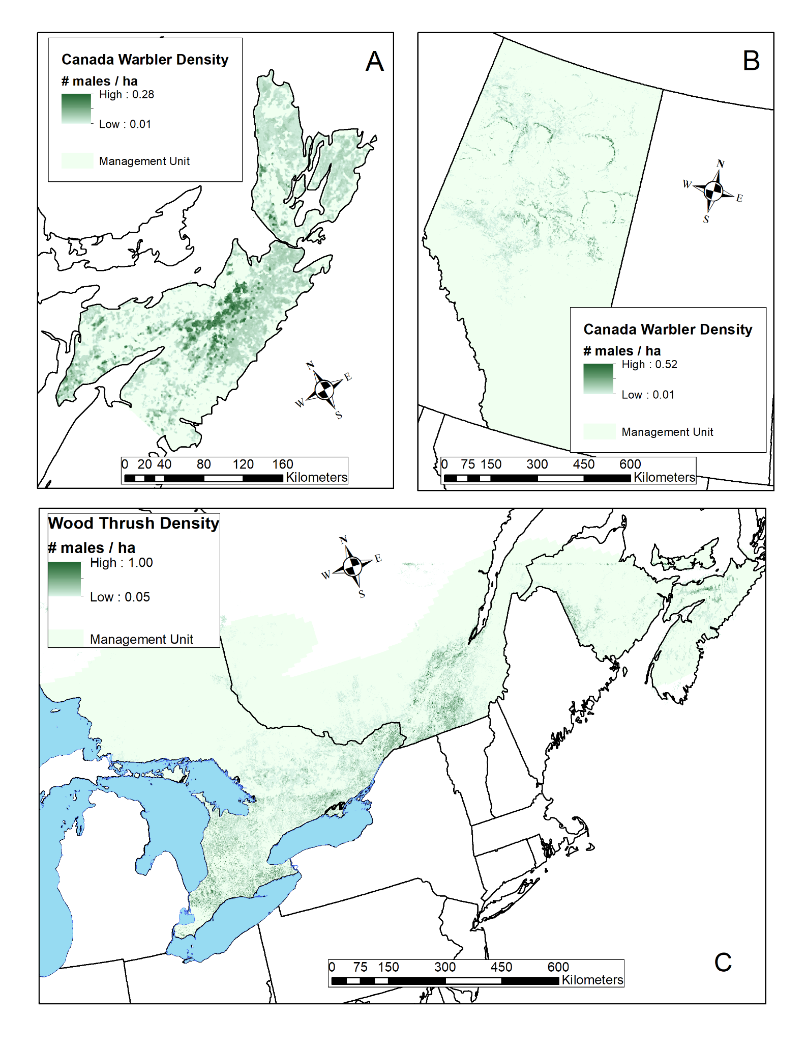
Figure S2.5. Mean predicted densities for Canada Warbler (# males per ha) in northern Nova Scotia (0 - 0.28) (A) and Alberta (0 - 0.52 males per ha) (B) and for Wood Thrush across eastern Canada (0 - 1.00 males per ha) (C). Predicted densities shown are mean density predictions from 250 boosted regression tree (BRT) model runs for each species in each study area, with separate prediction rasters generated from each BRT run.

References
[AAFC] Agriculture and Agri-Food Canada. 2021. Annual Crop Inventory. https://open.canada.ca/data/en/dataset/ba2645d5-4458-414d-b196-6303ac06c1c9. Accessed January 1, 2021.
[ABMI] Alberta Biodiversity Monitoring Institute. 2019. Alberta Biodiversity Monitoring Institute. 2019. Wall-to-Wall Human Footprint Inventory. https://abmi.ca/home/data-analytics/da-top/da-product-overview/Human-Footprint-Products/HF-inventory.html. Accessed September 1, 2019.
Amatulli G, Domisch S, Tuanmu MN, Parmentier B, Ranipeta A, Malczyk J, Jetz W (2018) A suite of global, cross-scale topographic variables for environmental and biodiversity modeling. Sci. Data, 5, 180040. https://doi.org/10.1038/sdata.2018.40.
Austen MJW, Francis CM, Burke DM, Bradstreet MSW (2001) Landscape Context and Fragmentation Effects on Forest Birds in Southern Ontario. The Condor 103:701–714. https://doi.org/10.1093/condor/103.4.701
Ball J, Sólymos P, Schmiegelow F, et al (2016) Regional habitat needs of a nationally listed species, Canada Warbler (<em>Cardellina canadensis</em>), in Alberta, Canada. Avian Conserv Ecol 11:. https://doi.org/10.5751/ACE-00916-110210
Beaudoin A, Bernier PY, Guindon L, et al (2014) Mapping attributes of Canada’s forests at moderate resolution through kNN and MODIS imagery. Can J For Res 44:521–532. https://doi.org/10.1139/cjfr-2013-0401
Bonnot TW, Thompson FR, Millspaugh JJ, Jones-Farrand DT (2013) Landscape-based population viability models demonstrate importance of strategic conservation planning for birds. Biol Conserv 165:104–114. https://doi.org/10.1016/j.biocon.2013.05.010
Bühlmann P, Yu B (2003) Boosting With the L2 Loss. J Am Stat Assoc 98:324–339. https://doi.org/10.1198/016214503000125
Burke DM, Nol E (2000) Landscape and Fragment Size Effects on Reproductive Success of Forest-Breeding Birds in Ontario. Ecol Appl 10:1749–1761. https://doi.org/10.1890/1051-0761(2000)010[1749:LAFSEO]2.0.CO;2
CanVec (2021) Transport Networks in Canada – CanVec Series – Transport Features. https://open.canada.ca/data/en/dataset/2dac78ba-8543-48a6-8f07-faeef56f9895. Accessed January 1, 2021.

Carlson M, Browne D, Callaghan C (2019) Application of land-use simulation to protected area selection for efficient avoidance of biodiversity loss in Canada’s western boreal region. Land Use Policy 82:821–831. https://doi.org/10.1016/j.landusepol.2019.01.015
Carlson M, Stelfox JB (2014) Alberta Oil Sands Development and Risk Management of Canadian Boreal Ecosystems. In: Gates JE, Trauger DL, Czech B (eds) Peak Oil, Economic Growth, and Wildlife Conservation. Springer, New York, NY, pp 219–244
Carlson M, Stelfox B, Purves-Smith N, Straker J, Berryman S, Barker T, Wilson B (2014) “ALCES Online: Web-delivered scenario analysis to inform sustainable land-use decisions,” in Proceedings of the 7th International Congress on Environmental Modelling and Software. Eds. D.P. Ames, N.W.T. Quinn and A.E. Rizzoli (San Diego, CA: International Environmental Modelling and Software Society), 1-8. https://www.alces.ca/publications/download/406/Carlson%20et%20al%202014.pdf. Accessed January 1, 2020.

[CEC] Commission for Environmental Cooperation (CEC) (2005) Land Cover of North America at 250 meters. Edition: 3.0. http://www.cec.org/north-american-environmental-atlas/land-cover-2005-modis-250m. Accessed October 1, 2018.

Chandler R, Hepinstall-Cymerman J (2016) Estimating the spatial scales of landscape effects on abundance. Landsc Ecol 31:1383–1394. https://doi.org/10.1007/s10980-016-0380-z
Driscoll MJL, Donovan T, Mickey R, et al (2005) Determinants of Wood Thrush Nest Success: A Multi-Scale, Model Selection Approach. J Wildl Manag 69:699–709. https://doi.org/10.2193/0022-541X(2005)069[0699:DOWTNS]2.0.CO;2
Ducks Unlimited (2015) https://www.concordia.ca/library/guides/geospatial-data/geodata.html. Accessed January 1, 2021.

Duong T (2021) ks: Kernel Smoothing. R package version 1.12.0. https://CRAN.R-project.org/package=ks. Accessed January 1, 2021.
Elith J, Leathwick JR (2009) Species Distribution Models: Ecological Explanation and Prediction Across Space and Time. Annu Rev Ecol Evol Syst 40:677–697. https://doi.org/10.1146/annurev.ecolsys.110308.120159
Global Land Cover Facility. 2014. GLSDEM (Global Land Survey Digital Elevation Model) https://rivix.com/DEM_Info/GLSDEM.php
Greenwell B, Boehmke B, Cunningham J (2020) gbm: Generalized Boosted Regression Models. R package version 2.1.8. https://CRAN.R-project.org/package=gbm. Accessed October 1, 2018.
Hastie T, Tibshirani R, Friedman J (2009) Boosting and Additive Trees. In: The Elements of Statistical Learning. Springer New York, New York, NY, pp 337–387
Hijmans RJ, Phillips S, Leathwick J, Elith J (2020) dismo: Species Distribution Modeling. R package version 1.3-3. https://CRAN.R-project.org/package=dismo. Accessed October 1, 2018.
Hijmans RJ, Van Etten J, Cheng J, Mattiuzzi M, Sumner M, Greenberg JA, Lamigueiro OP, et al. (2015) "Package ‘raster’." R package 734. https://cran.r-project.org/web/packages/raster/index.html. Accessed October 1, 2018.
Leathwick JR, Elith J, Francis MP, et al (2006) Variation in demersal fish species richness in the oceans surrounding New Zealand: an analysis using boosted regression trees. Mar Ecol Prog Ser 321:267–281. https://doi.org/10.3354/meps321267
Lee M, Fahrig L, Freemark K, Currie DJ (2002) Importance of patch scale vs landscape scale on selected forest birds. Oikos 96:110–118. https://doi.org/10.1034/j.1600-0706.2002.960112.x
Leston L, Bayne E, Dzus E, et al (2020) Quantifying Long-Term Bird Population Responses to Simulated Harvest Plans and Cumulative Effects of Disturbance. Front Ecol Evol 8:
Leston L (2022) Modeling framework to support critical habitat identification for the Wood Thrush in Canada. Zenodo. https://doi.org/10.5281/zenodo.7153499. Canadian Wildlife Service Contract #EC3000713776.
Lichti NI, Swihart RK (2011) Estimating utilization distributions with kernel versus local convex hull methods. J Wildl Manag 75:413–422. https://doi.org/10.1002/jwmg.48
New Brunswick Department of Environment and Local Government (2021) Data catalogue. Wetlands. http://www.snb.ca/geonb1/e/DC/catalogue-E.asp.
Nova Scotia Department of Lands and Forestry (2021) Wetlands Inventory. https://novascotia.ca/natr/wildlife/habitats/wetlands.asp.
Ontario Land Cover Compilation v.2.0 (2016) Ontario Data Catalogue. https://www.arcgis.com/home/item.html?id=1cd492c45f1145daa49b19cc541d0a0c
Richmond S, Nol E, Burke D (2012) Local- versus landscape-scale effects on the demography of three forest-breeding songbirds in Ontario, Canada. Can J Zool 90:815–828. https://doi.org/10.1139/z2012-051
Sólymos P, Matsuoka SM, Bayne EM, Lele SR, Fontaine P, Cumming SG, Stralberg D, Schmiegelow FKA, Song SJ (2013) Calibrating indices of avian density from non-standardized survey data: making the most of a messy situation. Meth. Ecol. Evol. 4, 1047-1058. https://doi.org/10.1111/2041-210X.12106.
Sólymos P, Toms JD, Matsuoka SM, Cumming SG, Barker NKS, Thogmartin WE, Stralberg D, Crosby AD, Dénes FV, Haché S, Mahon CL, Schmiegelow FKA, Bayne EM (2020) Lessons learned from comparing spatially explicit models and the Partners in Flight approach to estimate population sizes of boreal birds in Alberta, Canada. Condor 122, 1–22. https://doi.org/10.1093/condor/duaa007.

Therneau T, Atkinson B, Ripley B (2015) Package ‘rpart’. http://cran.ma.ic.ac.uk/web/packages/rpart/rpart.pdf. Accessed October 1, 2020.
Valavi R, Elith J, Lahoz-Monfort JJ, Guillera-Arroita G (2018) blockCV: an R package for generating spatially or environmentally separated folds for k-fold cross-validation of species distribution models. 357798
Van Wilgenburg S, Beck E, Obermayer B, Joyce T, Weddle B (2015) Biased representation of disturbance rates in the roadside sampling frame in boreal forests: Implications for monitoring design. Avian Cons. Ecol. 10(2). http://dx.doi.org/10.5751/ACE-00777-100205.
Wang T, Hamann A, Spittlehouse D, Carroll C (2016) Locally downscaled and spatially customizable climate data for historical and future periods for North America. PLoS ONE 11, e0156720. https://doi.org/10.1371/journal.pone.0156720.

