Appendix S1 – Using Geographically Weighted Regression Models to Identify Management Units for Canada Warbler Cardellina canadensis and Wood Thrush Hylocichla mustelina

Methods
We used geographically weighted regression models (hereafter, “GWR model”) with a Poisson error distribution (Fotheringham et al. 2003) from the “GWmodel” package (Gollini et al. 2014; Lu et al. 2014) in R to examine how effect sizes of environmental variables on abundance of two songbird species (Canada Warbler Cardellina canadensis, Wood Thrush Hylocichla mustelina) changed across the species’ ranges in Canada and nearby parts of the United States. Management units were evaluated across study regions that encompassed each species’ potential range in Canada and nearly parts of the United States. This type of model is suited for situations when data are not described well by some global model, but where there are spatial regions where a suitably localised calibration, obtained with a moving window weighting technique, provides a better description (Gollini et al. 2014). The output of the method includes model coefficients for each predictor that vary across data point locations, rather than a single model coefficient for each predictor as in typical statistical models. In the second step, we employed a multivariate clustering algorithm (“mclust” package in R; Fraley and Raftery 2002; Fraley et al. 2012) on a subset of the GWR model coefficients representing habitat associations to identify geographic patterns (i.e., areas with low internal variability but that differ among each other). In the third step, we overlaid the limits of Canadian provinces on these regions and separated them according to jurisdictional boundaries (Fig. S1.1).
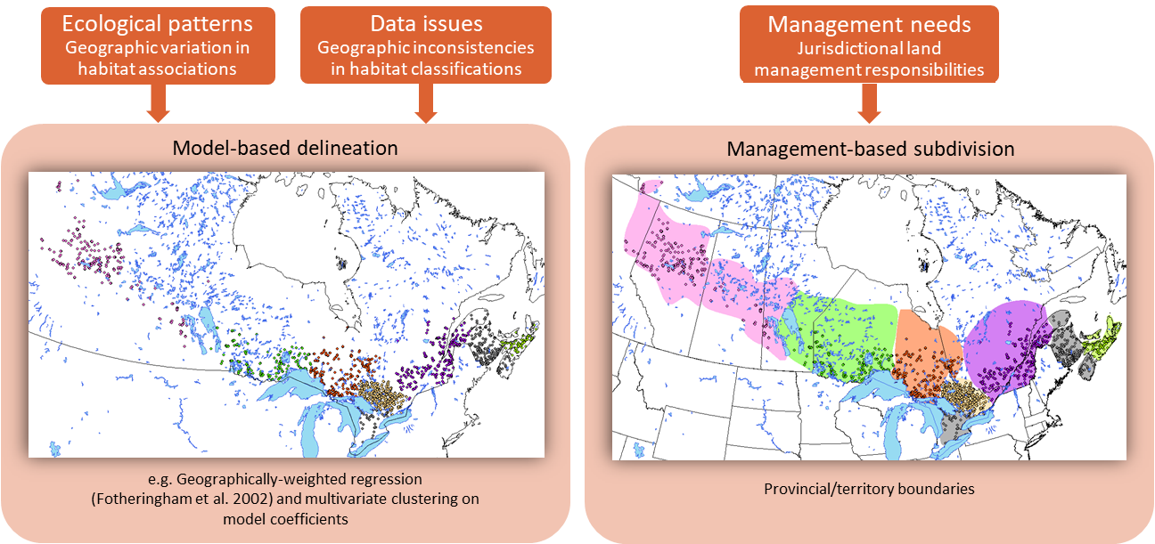
Figure S1.1. Conceptual model for the use of geographically weighted regression (GWR) models in the delineation of management units for critical habitat of a species. At each location, GWR models calculate a separate effect size for one or more environmental variables predicting abundance of a species. Locations are then classified by cluster analysis. If locations assigned to the same cluster are located closer together in space than to point counts assigned to a different cluster, it shows that a species responds to the same environmental variable(s) differently in different parts of the species’ range.

Point Count Data
We obtained point counts within the breeding ranges of both Canada Warbler and Wood Thrush in Canada and adjacent northeastern U. S. states. There were 403,005 point count surveys for Canada Warbler and 399,016 surveys for Wood Thrush for GWR models. We used multiple sources, but most of the point count data came from the Boreal Avian Modelling Project (http://www.borealbirds.ca) and the North American Breeding Bird Survey (https://www.pwrc.usgs.gov/bbs/; USGS 2020). In addition to these sources, for the Wood Thrush analyses we obtained point count data from the U.S. node of the Avian Knowledge Network (http://avianknowledge.net/) and other data sources in forested landscapes in eastern Canada (New Brunswick, Nova Scotia, Ontario, Prince Edward Island, Québec) and the midwestern and northeastern United States (Connecticut, Illinois, Indiana, Maine, Maryland, Massachusetts, Michigan, Minnesota, New Hampshire, New Jersey, New York, Ohio, Pennsylvania, Vermont, Wisconsin, West Virginia), within the breeding distribution of Wood Thrush. We included data from the United States in GWR models to reduce the possibility of estimating extreme habitat responses by Canada Warbler or Wood Thrush to environmental variables at point count locations at the southern limit of their ranges in Canada (Fig. S1.2, Table S1.1).
To use surveys collected from independent studies in the same analysis, a statistical offset variable based on removal and distance sampling methods was calculated for each survey. This variable accounts for differences in survey methodology and covariates on detectability (e.g., time of day and day of year on the probability of availability given presence, and land cover type on the probability of detection given availability) among surveys (QPAD approach in R; https://github.com/psolymos/QPAD/; Sólymos et al. 2013). For each bird survey visit, an offset variable was calculated and included within models to account for detection probability differences among surveys due to survey time, time of season, type of surrounding vegetation, and survey methods from a particular study. The QPAD method also enabled us to estimate an effective detection radius for each point count survey and predict densities of Canada Warbler and Wood Thrush from models including the offsets.
Table S1.1. Description and sources of point count data that were available for subsampling and use within geographically weighted regression models of Canada Warbler (CAWA) and Wood Thrush (WOTH) abundance in Canada and the United States.
Data Source | Description | Years | Species
Atlantic Canada Conservation Data Centre | 3 minute unlimited distance point counts collected in Chignecto and Tintamarre National Wildlife Areas, Nova Scotia | 2015 | WOTH only
Atlantic Canada Conservation Data Centre | 5 minute unlimited distance point counts divided into intervals collected in Acadian Research Forest, New Brunswick | 2016 | WOTH only
Atlantic Canada Conservation Data Centre | 5 minute unlimited distance point counts collected in Belle Isle National Wildlife Areas, Nova Scotia | 2018 | WOTH only
Avian Knowledge Network (U.S.) | Georeferenced point counts collected on multiple National Wildlife Refuges by several different methods. | 1992 - 2019 | WOTH only
Bird Studies Canada (Nature Counts) | Georeferenced 5 min. point counts, information combined with NB, NS and PEI Forest Resource Inventory data (Maritimes Breeding Bird Atlas). | 2006 - 2010 | WOTH only
Bird Studies Canada (Nature Counts) | Georeferenced 5 min. point counts (Ontario Breeding Bird Atlas) | 1981 – 1985; 2001 - 2005 | WOTH only
Bird Studies Canada (Nature Counts) | Georeferenced 5 min. point counts (Quebec Breeding Bird Atlas) | 2010 - 2014 | WOTH only
Boreal Avian Modelling Project | Georeferenced point counts collected from dozens of smaller independent bird studies across boreal and hemiboreal forest regions using a variety of point count methods. | 1993 - 2018 | CAWA, WOTH
Boundary Waters Canoe Area, Superior National Forest, Minnesota | 10-minute point counts, all birds observed recorded within distance and time intervals. Collected by Gerald Niemi and Edmund Zlonis (researchers) | 2010 - 2016 | WOTH only
Bird Conservancy of the Rockies National Ecological Observatory Network (US) | 6-minute 150-m point counts arranged in clusters, part of Breeding Landbird Point Counts study in BART, HARV, SERC, STEI, TREE, UNDE Bird Conservation Regions | 2015 - 2019 | WOTH only
CWS-Québec, Environment and Climate Change Canada (ECCC) | 20-minute 75-m point counts at Grand Marais and Lake St. Francis Wildlife Management Areas | 2004 - 2006 | WOTH only
Forest Bird Monitoring Program | 10 minute georeferenced point counts, unlimited distance in earlier years, 100-m point counts in later years. Collected by Ontario provincial government. | 1987 - 2019 | WOTH only
Long Term Ecological Research (LTER) Network | 10-minute 50-m point counts in the Parker River National Wildlife Refuge, Plum Island estuary, Massachusetts. Collected by N. Pau (researcher). | 1994 - 2002 | WOTH only
Long Term Ecological Research (LTER) Network | 10-minute 50-m point counts collected in forest openings in Harvard Forest, Massachusetts by David King (researcher) as part of Bird Communities in Forest Openings study. | 2014 - 2015 | WOTH only
Natural Resources Research Institute | 10-minute unlimited distance point counts for Minnesota Breeding Bird Atlas and in Superior and Chippewa National Forests. Collected by Alexis Grinde (researcher). | 2009 - 2019 | WOTH only
North American Breeding Bird Survey (Environment and Climate Change Canada (ECCC)) | Georeferenced 3 min. point count (presence/absence) data collected by volunteers and professionals; survey routes w/i lat./long. degree blocks. | 1993 - 2019 | CAWA, WOTH
North American Breeding Bird Survey (United States Geological Survey (USGS)) | Georeferenced 3 min. point count (presence/absence) data collected by volunteers and professionals; survey routes w/i lat./long. degree blocks. | 1993 - 2019 | CAWA, WOTH
Northeast Temperate Network and Vermont Center for Ecostudies | 10-minute 50-m point counts collected from 6 New England states. Collected by Steve Faccio (researcher) | 2005 - 2011 | WOTH only
Study: Breeding Bird Response to the Loss and Fragmentation of the Forest Cover in Eastern Ontario | Point count data collected by Remi Torrenta (graduate student) | 2014 - 2015 | WOTH only
Study: Forested Wetland Birds | 10 minute unlimited distance point counts. Collected by John Brazner and Laura Achenbach (researchers) | 2015 - 2016 | WOTH only

Model predictors consisted of land cover, topography, and climate layers covering Canada and the United States since there were point counts from both countries in the GWR models (Table S1.2). For Canada Warbler models, we generated a compound topographic index (CTI) across the study area to describe topography-induced wetness. It was created from a composite 3 arc second (90-m) Global Land Survey Digital Elevation Model (DEM) provided by the Global Land Cover Facility (2014). This DEM included data from the Canadian Digital Elevation Dataset above 60 °N latitude and the Shuttle Radar Topography Mission below 60 degrees. The CTI was calculated as the log of the catchment area (km) divided by the tangent of the slope of a cell (Moore et al. 1991). We used SAGA-GIS and the “RSAGA” package, version 0.93-6 (Brenning et al. 2018), to calculate a version of CTI based on a modified catchment area calculation. CTI values can be only positive, and higher values represent wetter areas. We also calculated the slope in radians (SLOPE) using a second-order polynomial interpolation method (Zevenbergen and Thorne 1987) within the RSAGA package (Table S1.2). Predictors for Wood Thrush included the same land cover, road, and forest height layers as for Canada Warbler, but GWR models for Wood Thrush included elevation and canopy cover, omitted CTI and a quadratic term for forest height, and considered a smaller number of climate variables as covariates; otherwise, predictors (variables that were not strongly correlated with each other, i.e., |r| < 0.7) were similar.

Table S1.2. Description and sources of predictor variables used in geographically weighted regression models of Canada Warbler (CAWA) and Wood Thrush (WOTH) abundance in Canada and the United States.
Variable | Description | Species | Data Source
Land cover | Nineteen land cover classes for North America (resolution of 250 m) based on 2005 Moderate Resolution Imaging Spectroradiometer (MODIS) satellite imagery. | CAWA, WOTH | CEC 2005
Forest height | Forest canopy height (1 km resolution) defined as the distance between the beginning and the lidar ground peak of the recorded waveform. | CAWA, WOTH | Simard et al. 2011
Tree cover | Percent tree cover (30 m resolution) from Global 30 m Landsat Tree Canopy layer version 4 | WOTH only | NASA Landsat Science 2019
Roadside status | A binary variable to indicate a roadside (1) or offroad (0) survey location. | CAWA, WOTH | Van Wilgenberg et al 2015; Solymos et al 2020
Acoustic recording unit | A binary variable to indicate if a survey was conducted by a human observer (0) or an acoustic recording unit (1). | CAWA only | Van Wilgenberg et al 2015; Solymos et al 2020
Compound topographic index (CTI) | Measure of soil moisture based on slope and catchment area, resampled to 250-m resolution. | CAWA only | Global Land Cover Facility 2014
Elevation (elev) | 1-km elevation raster associated with the climate raster geodatabase | WOTH only | Wang et al. 2016
Extreme Minimum Temperature (CMT) | Extreme minimum temperature over 30 years | CAWA only | Wang et al. 2016
Degree days below 0°C (DD0) | Number of degree-days below 0°C | CAWA only | Wang et al. 2016
Degree days above 5°C (DD5) | Number of degree-days above 5°C | CAWA only | Wang et al. 2016
Temperature difference (TD) | The difference between the mean temperatures of the warmest and coldest months | CAWA only | Wang et al. 2016
Mean Warmest Month Temperature (MWMT) | Average daily temperature in warmest month of the year in each location | WOTH only | Wang et al. 2016
Mean Summer Precipitation (MSP) | Average monthly precipitation (mm) for summer months | CAWA, WOTH | Wang et al. 2016
Averaged annual Climate Moisture Index (CMI) | Averaged annual climate moisture index, which is the difference between annual precipitation and potential evapotranspiration | CAWA, WOTH | Wang et al. 2016
Climate Moisture Index averaged for June-August (CMIJJA) | Climate Moisture Index, which is the difference between monthly precipitation and potential evapotranspiration, averaged for June-August | CAWA only | Wang et al. 2016

GWR models are computationally intensive, and we were unable to fit a single model for the entire point count dataset for either species due to numerical constraints (i.e., the model matrix exceeded the size limit in R). We therefore used a stratified subsampling approach, in which we divided the study area for each species into quadrants defined by 60 latitude and 100 longitude intervals and obtained 20 random draws from each quadrant. Because it was possible to obtain only points where Canada Warblers were absent among these 20 draws, we complemented (i.e., set union) the sample by randomly drawing four sites from among those where the species was present, in the same quadrant. This procedure allowed us to thin the data while maintaining its spatial structure. Importantly, because we were interested in the estimated values of predictor variable coefficients rather than absolute predicted values of the response variable, the difference in the presence-absence ratios of the original and the sampled dataset is not an issue. Moreover, the subsampling benefited the analysis by balancing the number of southern and northern data points across the range, reducing the sampling bias present in our original dataset.
Prior to thinning, there were 403,005 point count surveys available across the Canada Warbler’s range in Canada and adjacent states for GWR models, from which 22,345 points (1,815 with Canada Warbler detections) were selected during thinning for actual use in GWR models. We then reran the same GWR model on this dataset, varying the kernel shape (whether to down-weight more distant point counts using a gaussian or exponential curve), band width (neighborhood distance or number of “neighborhood” points to use in spatial weighting), and whether or not the band width was fixed or adaptive. We evaluated combinations of size and type of band width of kernel shape by looking at the AIC statistic associated with model runs, selecting the combination from the model with the lowest AIC value. We determined that an adaptive exponential kernel function of 449 m was better suited for irregularly spaced data such as ours and we ran a single GWR model across the whole study area.
The mean coefficient values at each grid cell location were then used in model-based cluster analysis (“mclust” package in R; Fraley and Raftery 2002, Fraley et al. 2012). For Canada Warbler, cluster analyses considered the mean effect sizes of land cover categories (agricultural/barren/developed/shrubland; coniferous; deciduous/mixed-wood; grassland; wetland), forest height, and CTI.
In the initial GWR model and cluster analysis for Canada Warbler, we identified three distinct habitat pattern regions, only one of which was in eastern Canada (east of 90 W in Ontario: see Results). As a literature review suggested different habitat selection across within eastern North America (e. g., Grinde and Niemi 2016), we ran additional GWR models and cluster analyses for Canada Warbler, restricted to point counts in Canada and the United States east of 90 W. There were 198,467 point count surveys available for modeling prior to thinning. We generated 10 random data sets from these points (N = 15,971 - 15,994 surveys per data set).
Prior to thinning, there were 399,016 point count surveys available across the Wood Thrush’s range in Canada and adjacent states for GWR models, from which we generated 10 sample data sets during thinning for actual use in GWR models. Each data set contained exactly 16,359 surveys (in each data set, 418 - 469 with Wood Thrush detections). An initial round of modelling was done on one Wood Thrush sample data set to identify the best kernel shape, band width, and whether to use a fixed or adaptive band width. Based on this initial modelling round, a non-adaptive exponential kernel of 157 m was chosen and we ran a GWR model with this kernel on ten random sample data sets.
For Wood Thrush, cluster analyses considered the GW coefficients for elevation; land cover categories (agricultural; barren/shrubland; coniferous forest; deciduous forest; mixed-wood forest/grassland; developed/wetland), tree cover, forest height, and roadside. Rather than model how effect sizes of individual variables affected abundance across the range of each species, we used cluster analysis to examine if the overall effect of these environmental variables on Canada Warbler and Wood Thrush abundance varied sharply in different parts of the species’ range. In such a case, then locations with similar overall effect sizes of multiple environmental variables will be assigned to the same cluster and locations within the same cluster will be located closer together in space than locations assigned to different clusters. If locations assigned to different clusters are well separated across each species’ range, then there could be a biological basis for modelling and/or managing habitat differently for each species in separate regions defined by these clusters. We ran analyses with 3 to 14 clusters to see if clusters in certain regions were more frequently isolated from other clusters. We also generated plots showing the mean and range of coefficient values for each predictor in different sample data sets from the 3-, 5-, and 7-cluster analyses to see where coefficient values significantly differed among clusters.
For all cluster analyses and sample data sets, values for each model coefficient at each point count location were calculated. We created a 1-km-resolution raster for each sampling data set’s model coefficients and generated mean values for each model coefficient for the cells containing sample point counts with 1 or more detections in each species’ analyses. We then overlaid the sample data set raster layers for each model coefficient and calculated mean coefficient values at each grid cell with detections of a species.
Analysis scripts and links to point count and environmental data used in GWR models for Canada Warbler and Wood Thrush, along with results from these models are located at https://github.com/LionelLeston/GWmodel-CanadaWarbler (Canada Warbler) and at https://github.com/LionelLeston/GWmodel-WoodThrush (Wood Thrush).

Results
The initial round of GWR models and subsequent cluster analyses of GWR model coefficients across the whole study area suggested that Canada Warblers in western Canada (Northwest Territories to western Manitoba), central Canada (eastern Manitoba to western Ontario), and further eastward responded differently to land cover, forest height, and CTI (Fig. 2 in main manuscript). However, the literature review done for Canada Warbler suggested that there should be some differences in habitat use in Ontario and Quebec from habitat use in the Maritime provinces and Atlantic states. Because of this, another round of GWR models was run with point counts east of 90 W in Canada (Ontario, Quebec, New Brunswick, Nova Scotia, Prince Edward Island) and the United States. Further GWR models and cluster analyses were run on ten sample data sets in eastern North America. Across different cluster analyses and sample data sets for Canada Warbler limited to eastern North America, point counts in northern Nova Scotia were separated from other clusters and mean GWR model coefficient values for northern Nova Scotia differed from values of those coefficients in other clusters. There were no stable clusters or significant differences among GWR model coefficients in different clusters across the Wood Thrush analysis.
For the ten GWR models run on both Canada Warbler and Wood Thrush sample data sets in eastern North America, boundaries and membership in different clusters varied among sample data sets used in GWR models, suggesting that cluster identity was strongly influenced by chance and random sampling. The exception was that Canada Warblers in northern Nova Scotia were consistently assigned to a separate cluster from Canada Warblers elsewhere in eastern North America, across all sample data sets and cluster analyses with 3, 5, or 7 clusters. Likewise, model coefficients for Canada Warbler in northern Nova Scotia also significantly differed from coefficients for other Canada Warbler clusters across sample data sets, while model coefficients did not significantly differ among other Canada Warbler clusters. These results indicated biological evidence that Canada Warblers in northern Nova Scotia responded differently to habitat from elsewhere in eastern North America. In contrast, no Wood Thrush cluster boundaries remained constant across sample data sets or cluster analyses, suggesting that differences among clusters were due to chance rather than to differential habitat selection (Figs. S1.2 - S1.3).
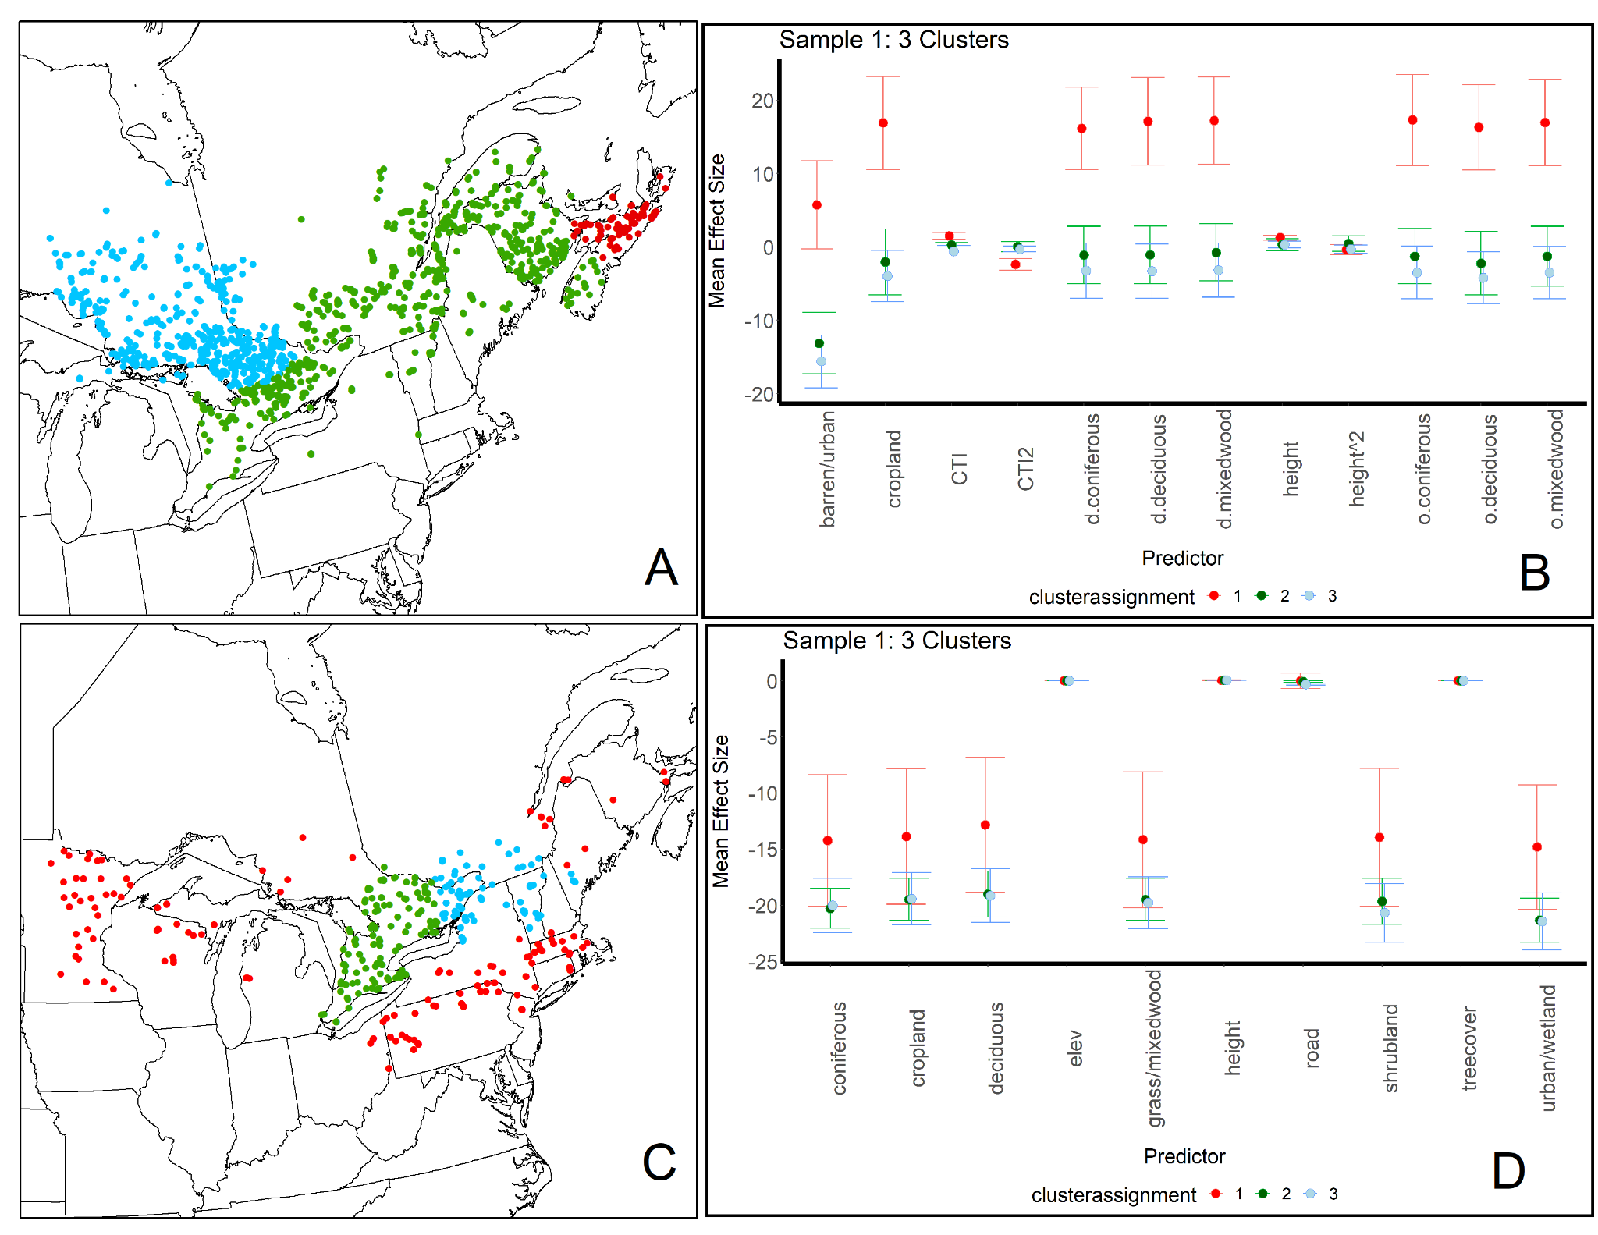
Figure S1.2. Cluster analysis results from one geographically weighted (GW) model run on one random sample data set for Canada Warbler (data set #1: A, B) and Wood Thrush (data set #1: C, D) in eastern Canada and adjacent American states. In both analyses, point counts were assigned to 1 of 3 clusters (coded red, green and blue) based on values of the GWR model coefficients. The dot-and-whisker plots show the mean +/- standard deviation for each model coefficient in each cluster. Similar results (not shown here) were obtained for each of the other nine randomly sampled data sets on which GWR models and cluster analyses were run for each species in eastern North America. GWR model coefficient abbreviations: height = Forest height (m); height^2 = forest height²; CTI = compound topographic index; CTI^2 = compound topographic index²; tree cover = canopy cover; road = whether a point count is next to a road; Elev = elevation (m). Land cover class modifiers: o. = open; . d. = dense.

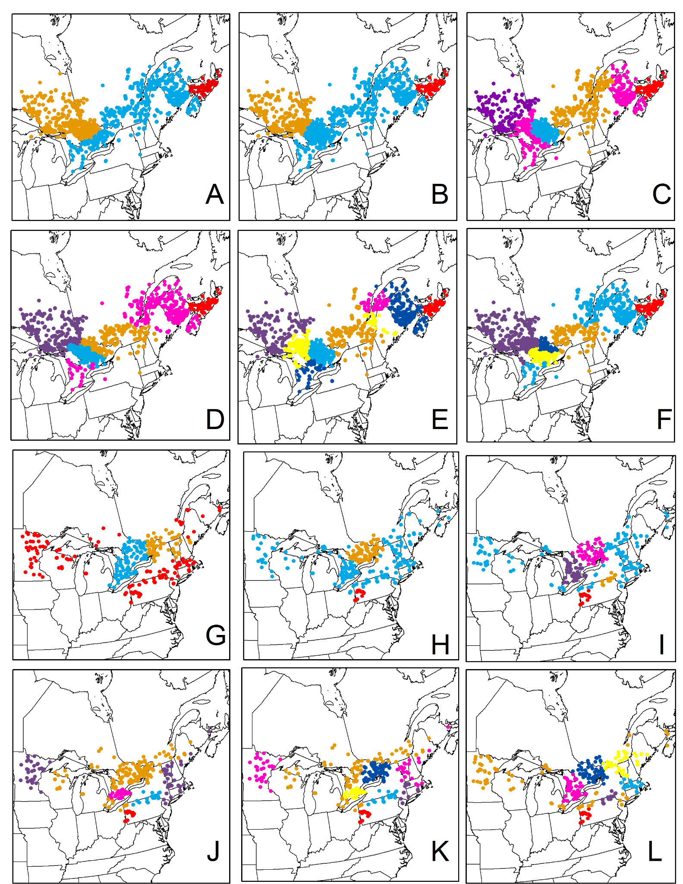
Figure S1.3. Cluster analysis results from multiple geographically weighted (GW) models run on Canada Warbler (A - F) and Wood Thrush (G - L) sample datasets in eastern Canada and adjacent American states. This figure shows sensitivity of cluster assignment in different random sampling data sets and cluster analyses for each species. After each GWR model was run for each data set and species, point counts where a species was detected were assigned to one of 3, 5, or 7 clusters based on values of the GWR model coefficients at each point count. Across different cluster analyses and sample data sets for Canada Warbler, point counts in northern Nova Scotia were separated from other clusters, but there were no stable clusters across the Wood Thrush analysis. Canada Warbler: A = set 1, 3 clusters. B = set 5, 3 clusters. C = set 1, 5 clusters. D = set 5, 5 clusters. E = set 1, 7 clusters. F = set 5, 7 clusters. Wood Thrush: G = set 1, 3 clusters. H = set 5, 3 clusters. I = set 4, 5 clusters. J = set 2, 5 clusters. K = set 2, 7 clusters. L = set 4, 7 clusters.

References
Brenning A, Bangs D, Becker M (2018) RSAGA: SAGA Geoprocessing and Terrain Analysis. R package version 1.3.0. https://CRAN.R-project.org/package=RSAGA
[CEC] Commission for Environmental Cooperation (2005) Land Cover of North America at 250 meters. Edition: 3.0. http://www.cec.org/north-american-environmental-atlas/land-cover-2005-modis-250m
Fotheringham AS, Brunsdon C, Charlton M (2003) Geographically Weighted Regression: The Analysis of Spatially Varying Relationships. John Wiley & Sons
Fraley C, Raftery AE (2002) Model-Based Clustering, Discriminant Analysis, and Density Estimation. J Am Stat Assoc 97:611–631. https://doi.org/10.1198/016214502760047131
Fraley C, Raftery AE, Murphy TB, Scrucca L (2012) mclust version 4 for R: normal mixture modeling for model-based clustering, classification, and density estimation (Vol. 597, p. 1). Technical report No. 97, Department of Statistics, University of Washington, USA.
Global Land Cover Facility (2014) GLSDEM (Global Land Survey Digital Elevation Model) https://rivix.com/DEM_Info/GLSDEM.php
Gollini I, Lu B, Charlton M, et al (2014) GWmodel: an R Package for Exploring Spatial Heterogeneity using Geographically Weighted Models
Grinde AR, Niemi GJ (2016) Influence of landscape, habitat, and species co-occurrence on occupancy dynamics of Canada Warblers. The Condor 118:513–531. https://doi.org/10.1650/CONDOR-15-168.1
Lu B, Harris P, Charlton M, Brunsdon C (2014) The GWmodel R package: further topics for exploring spatial heterogeneity using geographically weighted models. Geo-Spat Inf Sci 17:85–101. https://doi.org/10.1080/10095020.2014.917453
Moore ID, Grayson RB, Ladson AR (1991) Digital terrain modelling: A review of hydrological, geomorphological, and biological applications. Hydrol Process 5:3–30. https://doi.org/10.1002/hyp.3360050103
NASA Landsat Science (2019) Global 30m Landsat Tree Canopy Version 4. https://landsat.gsfc.nasa.gov/article/global-30m-landsat-tree-canopy-version-4-released. Accessed October 1, 2020.
Simard M, Pinto N, Fisher J, Baccini A (2011) Mapping forest canopy height globally with spaceborne lidar. Journal of Geophysical Research 116:G04021.
Sólymos P, Matsuoka SM, Bayne EM, et al (2013) Calibrating indices of avian density from non-standardized survey data: making the most of a messy situation. Methods Ecol Evol 4:1047–1058. https://doi.org/10.1111/2041-210X.12106
USGS (United States Geological Survey) Patuxent Wildlife Research Center. 2020. North American Breeding Bird Survey. https://www.pwrc.usgs.gov/bbs/results/. Accessed October 1, 2020.
Wang T, Hamann A, Spittlehouse D, Carroll C (2016) Locally Downscaled and Spatially Customizable Climate Data for Historical and Future Periods for North America. PLoS ONE 11(6): e0156720.
Zevenbergen LW, Thorne CR (1987) Quantitative analysis of land surface topography. Earth Surf Process Landf 12:47–56. https://doi.org/10.1002/esp.3290120107

