Appendix S3 – Projecting Future Canada Warbler and Wood Thrush Density and Abundance Under Different Climate and Harvest Scenarios

Methods
We used the forest landscape change model LANDIS-II (hereafter, “LANDIS”) (Scheller and Mladenoff 2004; Scheller et al. 2007) to predict how Canada Warbler in Alberta and Nova Scotia and Wood Thrush in Quebec, New Brunswick, and Nova Scotia might change in population size and distribution under different climate and land use scenarios in each management unit.
For Wood Thrush in Ontario, we also used another land use simulator called ALCES Online (https://www.online.alces.ca/) to simulate how future habitat for Wood Thrush is affected by disturbances like harvest, budworm outbreaks, and fire (Carlson et al. 2014, Carlson and Stelfox 2014; Carlson et al. 2019; Leston et al. 2020). We used ALCES Online because there is currently insufficient data available in part of the Wood Thrush range (southern Ontario) - particularly the deciduous forests - for LANDIS to model how individual tree species - hence, forest habitat for Wood Thrush - respond to climate and other environmental variables. As with LANDIS-II, we projected variations in forest age and composition as a function of harvest and other disturbance rates.

LANDIS
LANDIS runs a forest succession model (e.g., the forest gap model PICUS version 1.5; http://picus.boku.ac.at) describing shade tolerance, age of a tree species’ sexual maturity, dispersal distance, reproduction on-site after fire, and responses of either individual trees or cohorts of different tree species to new forest openings created by disturbances. In PICUS, different species-age cohorts occur within square 100-m² cells which interact with each other, in which propagules from sexually mature trees in one cell can disperse to and potentially colonize newly disturbed adjacent cells within dispersal distance. As simulations run, individual species’ cohorts age with each time step. Alternative forest succession models to PICUS can be used with LANDIS. Together, the forest succession model and the spatial environment components make LANDIS a forest landscape model (FLM) that has been widely used to project future forest habitat available to wildlife (e.g., Tremblay et al. 2018; Cadieux et al. 2019, 2020; Boulanger and Pascual Puigdevall 2021). Present-day forest landscapes in LANDIS were initialized using vegetation data derived from multiple sources, including stand age cohort data from provincial forest inventory plots, harvest data from forestry companies, private conservation research organization GIS products, and the Canadian National Forest Inventory (NFI; nfi.nfis.org). Cell resolution was set at 250 m and time steps for simulations were set at 10 years (Alberta) or 20 years (Nova Scotia). Cells were assigned to a “land type” with homogeneous soil and climate conditions (Mansuy et al. 2014).
First, we used a modified version of the Biomass Succession module (Scheller and Mladenoff 2004) to simulate growth, succession, and mortality of tree species’ cohorts. The Biomass Succession module enables multiple cohorts to occupy and compete for growing spaces within the 6.25 ha forest cells. Three dynamic parameters are needed for this extension which are maximum biomass (maxAGB; g/m2), maximum aboveground net primary productivity (maxANPP; g m−2 year−1) and species establishment probability (SEP). These are estimated from PICUS by running monospecific stand simulations for each combination of species, climate conditions and land type. Following these simulations, a bias correction procedure was undertaken to make initial biomass in LANDIS as close as possible to the one estimated from remote sensing. This latter procedure is described in Tremblay et al. (2018).
Second, we used the Biomass Harvest module (Gustafson et al. 2000) to simulate harvest plans. Input files for this module outline management areas, individual forest stands within management areas, and a text file containing harvest prescriptions and implementations for each management area and stand. The Biomass Harvest module permits the simulation of partial thinning and specifying what percentage of a cohort to harvest. In Alberta, we also used the Biomass Harvest module to simulate drought-related mortality of tree species (details in Cadieux et al. 2020).
Third, we used the Base Fire module (He and Mladenoff 1999) and Base Wind module (Mladenoff and Baker 1999) to simulate fire and wind disturbances, dividing our study areas into current and future predicted Canadian Homogeneous Fire Regime Zones (Boulanger et al. 2014), or collections of cells with the same fire parameters (ignition probability, and maximum, minimum, and mean fire size). Finally, we used the Biological Disturbance Agent (BDA) module (Sturtevant et al. 2004) to simulate the effect of spruce budworm (Choristoneura fumiferana) outbreaks on coniferous forests in eastern Canada but not in Alberta.
Beyond the basic LANDIS model and its extensions, future landscape scenarios are conceived by investigators interested in projecting how forest variables change over time under a specific set of disturbances. Scenarios can be varied according to: 1) the types of disturbance modelled; 2) the probability, amount, severity, and spatial arrangement of disturbances; 3) whether specific disturbance types are affected by climate variables and if so, how those climate variables change over time; 4) whether one type of disturbance influences the probability, amount, severity, and spatial arrangement of other disturbance types; and 5) how growth rates, survival rates, succession and cohort biomass are affected by disturbance or presence of other tree species.
We developed future landscape scenarios in which forest structure changed under different combinations of climate and harvest, up to 2100. Baseline climate scenarios assume present day levels of atmospheric CO₂, temperatures and precipitation affecting growth rates of tree species and probabilities of natural forest disturbances. Climate change scenarios assume that increases in atmospheric CO₂ due mainly to human activities occur, described by Representative Concentration Pathway (RCP) values (e.g., 2.6, 4.5, and 8.5). RCP values are estimates of the change in energy flux measured in Watts/m² and increases in atmospheric CO₂ are associated with higher RCP values (Moss et al. 2010; van Vuuren et al. 2011). In the southern boreal forest region, mean annual temperatures are predicted to rise from 3.5 °C. (RCP 2.6) to 7.5 °C. (RCP 8.5) by 2100 relative to 2000, while average precipitation is predicted to rise by 10-25 per cent (CanESM2; Arora et al. 2011). Increasing temperatures are predicted to increase the frequency and intensity of fires (Boulanger et al. 2014, 2016, 2017; Stralberg et al. 2018), drought (Michaelian et al. 2011), and outbreaks of insect pests and pathogens of tree species (Pureswaran et al. 2018) within Canada’s boreal forests. Increases in these natural disturbances in combination with higher CO₂ concentrations are predicted to negatively affect slower-growing coniferous tree species more than faster-growing broadleaf tree species, leading to either younger-on-average, deciduous-dominated boreal forests or conversion of boreal forests (Mahon et al. 2014; Boulanger et al. 2016; Mekonnen et al. 2019) to parkland or grassland (Stralberg et al. 2018).
To create our climate scenarios, we merged 30-year monthly climate normals for 1961-1990 interpolated from climate station records (McKenney et al. 2013) with projected future monthly changes predicted from the Canadian Earth System Model version 2, up to 2100 (CanESM2; Arora et al. 2011). We downloaded RCP scenarios 4.5 and 8.5 from the World Climate Research Program (WCRP) Climate Model Intercomparison Project Phase 5 (CMIP5) archive. The climate normals influence forest succession in LANDIS through their impacts on parameters in the forest succession model (in our scenarios, PICUS) as well as on fire regimes.
We examined outputs from scenarios previously run in Alberta (Cadieux et al. 2020), Quebec (Boulanger and Pascual Puigdevall 2021), New Brunswick and Nova Scotia, rather than creating new scenarios specifically for Canada Warbler and Wood Thrush. The specific scenarios used in New Brunswick and Nova Scotia have not yet been published, although other simulations from those provinces have been (Taylor et al. 2017). We predicted how total area in different disturbance types, stand age, and tree species in each 250-m cell changed over time in 10-year increments, then used the 250-m raster layer outputs of these variables as inputs to the models run for Canada Warbler and Wood Thrush in each species’ management units. From these prediction layers, we produced raster layers of mean density and of standard deviation in density within 250-m cells for each time step, scenario, and study area. To reduce the influence of a specific simulation run on projected numbers of each species, we ran the LANDIS scenarios in each study area five times, each time retaining 250 density predictions, a mean density layer, and a standard deviation layer for density in each time step, scenario, and study area.

Alberta LANDIS Scenarios (Canada Warbler)
In northeastern Alberta, we examined 9 combinations of 3 climate scenarios (baseline, RCP 4.5, RCP 8.5) and 3 harvest scenarios (no new harvest, baseline clear-cut [applied to 0.3 % of harvestable upland per year], high-intensity clear-cut [applied to 0.6 % of harvestable upland per year]) (Table 2). We used the Alberta-Pacific Forest Industries Ltd. Forest Management Area (Al-Pac FMA) to define the scenario area (~6,400,000 ha). We only simulated clear-cutting as it is the most frequently used harvest strategy in the Al-Pac FMA (https://alpac.ca/index.php/forest-sustainability/forest-planning). Only stands in harvestable upland areas (~2,000,000 ha) older than 60 years old were harvested. When harvested, clear-cutting was simulated to remove all age cohorts present except for the 0- to 10-year age cohort. Mean harvested patch size and total harvested area were summarized by forest management units (FMUs). Harvesting parameters were held constant throughout the simulations. In addition to harvest, we simulated effects of fire, wind, and drought on tree species cohort mortality, and allowed parameters for these disturbances to vary under different climate scenarios. More details of these scenarios in Alberta can also be found in Cadieux et al. (2020).

Nova Scotia LANDIS Scenarios (Canada Warbler)
We examined 18 combinations of 3 climate scenarios (baseline, RCP 4.5, RCP 8.5) and 6 harvest scenarios (no new harvest, low [50 % historic] partial harvest, low [50 % historic] clear-cut, high [historic] partial harvest, ecosystem-based forest management, high [historic] clear-cut) (Table 1). These scenarios also simulated natural disturbance by fire, windthrow, and spruce budworm outbreaks, which varied under different climate scenarios. Both “low” and “high clear-cut” assumed a minimum stand age of 60 years, equal probability of selection for harvesting across tree species, and 90% removal of all tree species within a harvested stand. A maximum of 6% of each 250-m pixel occurred in harvested stands in “low clear-cut” scenarios, while a maximum of 12% of each 250-m pixel occurred in harvested stands in “high clear-cut” scenarios. Both “low” and “high partial-cut” assumed a minimum stand age of 50 years, equal probability of selection for harvesting across tree species, and 40% removal of all tree species within a harvested stand. A maximum of 6% of each 250-m pixel occurred in harvested stands in “low partial-cut” scenarios, while a maximum of 12% of each 250-m pixel occurred in harvested stands in “high partial-cut” scenarios. In “Ecosystem-based forest management” scenarios, harvest consisted of a mixture of clear-cuts (harvestable stands up to 8% of each 250-m pixel) and partial-cutting (harvestable stands up to 2% of each 250-m pixel). Up to 40 % and 90% of trees were removed within partial-cut and clear-cut stands, respectively, with a minimum stand age of 30-80 years depending on the species. Harvest rates under ecosystem-based forest management were higher than in other harvest scenarios except for high clear-cut.

Quebec LANDIS Scenarios (Wood Thrush)
For the Wood Thrush study, six LANDIS scenarios were used from southern Quebec; these scenarios are described in detail in Boulanger and Puigdevall (2021). The six scenarios in Quebec consisted of combinations of three climate scenarios (baseline, RCP 4.5, RCP 8.5) and two harvest scenarios (harvest vs. no new harvest) in which the harvest regime consisted of ecosystem-based forest management. Depending on location, five different harvest strategies were used: 1) up to 18.75% of each 250-m pixel available for harvest with up to 40% of trees removed and a minimum stand age of 60 (“CPIF”); 2) up to 30% of each 250-m pixel available for harvest with up to 25% of trees removed and a minimum stand age of 60 (“JARD”); 3) harvest dominated by clear-cut (90% of trees removed on 7.5% of each 250-m pixel) and secondarily by partial-cut (40% of trees removed on 2.5% of each 250-m pixel) (“CT/CPIR”); 4) harvest dominated by partial-cut (40% of trees removed on 12.5% of each 250-m pixel) and secondarily by clear-cut (90% of trees removed on 4.2% of each 250-m pixel) (“CT/CPIR”); and 5) 40 % of trees removed on 12.5% of each 250-m pixel.

New Brunswick LANDIS Scenarios (Wood Thrush)
Three scenarios were used from New Brunswick, consisting of a harvest scenario (1 % clear-cut per year) under three different climate scenarios (baseline, RCP 4.5, RCP 8.5). Up to 10% of each 250-m pixel was available for harvest with 90% of trees removed within stands, respectively, with a minimum stand age of 60 years.

Nova Scotia LANDIS Scenarios (Wood Thrush)
For Nova Scotia, there were 9 combinations of 3 climate scenarios (baseline, RCP 4.5, RCP 8.5) and 3 harvest scenarios (no new harvest, ecosystem-based forest management, and the high [historic] clear-cut scenarios used for Canada Warbler in northern Nova Scotia) run. We used some of the Nova Scotia LANDIS scenarios as those used for Canada Warbler, except that we extracted future land cover predictions for southern Nova Scotia rather than northern Nova Scotia, due to differences in the regional model boundaries for each species. Besides harvest, these scenarios also simulated disturbance by fire and spruce budworm outbreaks, which varied under different climate scenarios.
Outputs from the LANDIS scenarios included raster layers showing how total area in different disturbance types, stand age, and tree species changed over time in 10-year increments. To reduce the influence of a specific simulation run on projected Wood Thrush numbers, each LANDIS scenario was run in each study area five times, resulting in a new set of raster layers. These raster outputs were then used as inputs to the 250 BRTs for Wood Thrush in each study region to get 250 prediction layers of Wood Thrush densities for each time step, scenario, and simulation run. From these prediction layers, raster layers of mean Wood Thrush density and of standard deviation in density at 250-m resolution were produced for each scenario, simulation run, and study area. Due to time constraints, the Wood Thrush study used prediction outputs from 2100. As LANDIS only simulated change and predicted Wood Thrush density in forested areas, the output rasters were filled in using predicted Wood Thrush density mean and standard deviation for non-forested areas from a current density layer. Density predictions > 1 male/ha (<<< 1 % of pixels in all LANDIS study areas) were reset to 1 male/ha before generating population estimates and identifying LANDIS outputs to use in conservation planning. This threshold value was used based on reported densities of Wood Thrush in the literature (Gauthier and Aubry 1995, Evans et al. 2020).
The current population of Wood Thrush was estimated in the parts of each study area that were subject to LANDIS simulations, by generating 250 prediction layers of current Wood Thrush density in each study area, then calculating mean and standard deviation from those predictions in each location (250-m pixel). The five mean density layers from each LANDIS scenario in each time step were used to obtain a population estimate in 2100 for the Wood Thrush’s range in Quebec, New Brunswick, and Nova Scotia. The five mean density layers from each LANDIS scenario in each time step were used to obtain a population estimate in 2100 for the Wood Thrush’s range in each province, starting with Quebec and Nova Scotia. Population estimates were made after adjusting unusually high density estimates to a threshold of 1 male/ha based on density observations for Wood Thrush in the literature (Gauthier and Aubry 1995, Evans et al. 2020).

ALCES Online

Ontario ALCES Online Scenario (Wood Thrush)
As in the LANDIS scenarios, ALCES Online was used to create a single scenario in which forest age was set back temporarily by disturbance. Harvest was the primary disturbance, but depending on the Forest Management Unit, mean forest age, and percentage of coniferous forest, spruce budworm outbreaks and fire were also simulated. All disturbances were temporary and did not result in permanent habitat conversion. Due to time, labour, and financial constraints, only a single land use scenario was developed. Growth rates and spread of individual tree species were not simulated in ALCES Online, nor were differences in disturbance rates due to climate change.
Natural land cover and human footprint layers at 200-m resolution were obtained from the Ontario Ministry of Natural Resources. There was both a set of summarized land cover and footprint layers and a set of detailed land cover and footprint layers. Within each set of layers, the percent covers of all footprint and land cover types added up to 100 % of each pixel. Harvest and other disturbances were simulated within deciduous, mixed-wood, coniferous, and undifferentiated forests and in plantations but not in treed wetlands or non-forest land cover types.
We created a forest age raster layer (as of 2020: year 0 of the ALCES Online scenarios) at 200-m resolution in the program R, using a forest stand age layer from 2011 (Beaudoin et al. 2014) resampled to 200-m resolution. After adding 9 to each pixel’s value to obtain the default stand age as of 2020, we rasterized and overlaid harvest shapefile data (Ontario Ministry of Natural Resources’ Forest Research Institute 2021) to correct stand age within cut-blocks as of 2020. Similarly, we rasterized and overlaid insect outbreak and fire shapefile data (Ontario Forest Resource Inventory 2021) to correct stand age as of 2020 within outbreak areas described as tree mortality events and within burns. Finally, we used recent land cover layers for Ontario in 2020 (AAFC 2021) to correct stand age in areas where forests were replaced by non-forestry land uses since 2011 (wherever total forest cover = 0).
We ran the ALCES Online scenario separately for each Ontario FMU within the Wood Thrush’s range in Ontario, since the entire range of the Wood Thrush in Ontario was too large to run scenarios at 200-m resolution. Part of the Wood Thrush’s southeastern Ontario range occurs outside of the FMUs in urban and agricultural landscapes. In this area, most forestry occurs on private woodlots.
Harvest on Crown lands was estimated from GIS data for FMUs from the Ontario Ministry of Natural Resources’ Forest Research Institute (OMNDMNRF 2021). In ArcGIS, separate shapefiles were compiled for clear-cut, shelterwood, and selective logging polygons representing cut-blocks harvested from 1990 – 2019, then intersected with an FMU boundary shapefile clipped to the Wood Thrush’s range in Ontario. The attribute table of each intersection was exported and in R, the harvest polygons were filtered to those harvested from 2010-2019. Total decadal harvest area, mean harvest size, and maximum harvest polygon size were summarized separately for each FMU and the Wood Thrush range in Ontario southeast of the FMUs for each harvest type (clear-cutting, shelterwood, selective logging). Due to the large number of FMUs in which the scenario was separately run, mean harvest size and total area disturbed per decade were used rather than a size class distribution to model disturbances in each FMU, to make analyses more reproducible.
Clear-cutting from 2010-2019 was commonplace in FMUs in western Ontario but was negligible (~0%) in the easternmost FMUs. Simulated clear-cuts were assumed to remove up to 90 % of trees (36,000 m²) of a fully forested 200-m pixel, reset mean stand age to 10 years (since on-site shrubs and saplings up to 10 years old would remain), and be conducted in pixels with a minimum stand age of 60 years where total coniferous, deciduous, and undifferentiated tree cover was 50 % or more. Simulated clear-cuts did not occur in forested wetlands or mixed-wood forests. Clear-cutting is often recommended for boreal coniferous trees and some faster-growing, shade-intolerant deciduous trees (e. g. aspen, poplar), so would be likelier to be practiced in stands classified as coniferous or deciduous but not mixed-wood.
Shelterwood harvesting was virtually confined to eastern FMUs. Simulated shelterwood harvest was assumed to remove up to 50 % trees (20,000 m²) within a fully forested pixel, reset mean stand age to 20 years due to the presence of remaining overstory trees, and be conducted in pixels with a minimum stand age of 60 years where total deciduous and mixed-wood tree cover was 50 % or more.
Selective logging on Crown Lands was virtually confined to eastern FMUs, but was assumed to be the harvest method used in private woodlots southeast of the FMUs. Simulated selective harvest was assumed to remove a maximum of 25 % trees (10,000 m²) within a fully forested pixel, reset mean stand age to 60 years, and be conducted in pixels with a minimum stand age of 80 years where deciduous tree cover was 50 % or more. We assumed that removing trees by selective logging reduced average stand age but keeping many older trees standing kept the average stand age well above 0.
GIS-based harvest data were not available for most lands southeast of the FMUs, so harvest within woodlots was simulated based on summary data within reports. Harvest within private woodlots in southern Ontario was estimated using data from Kim (2020). Due to some overlap between the study area in Kim (2020) and the easternmost FMUs, the simulation of woodlot harvest was confined to southeastern Ontario outside of any FMUs. In contrast to the FMUs, size class distributions were used to set harvest within BCR 13 because there were existing estimates of proportion of total harvest area per decade (543,100 ha: diameter-limited cutting and good forestry practices methods combined) in different forest types (coniferous [18 %], deciduous [46 %], mixed-wood [21 %], plantations [7 %]). Separate harvest allocations were modelled for woodlots to maintain these proportions among future harvests in the baseline scenario. A size class distribution for woodlots was obtained from Watkins (2011): 0-10 ha (95.6 %), 10-99 ha (4.2 %), 100+ ha (0.2 %) and was used for each forest type. Selective forestry was used to maintain woodlots while harvesting, with up to a maximum of 10 % of a stand being removed by selective logging, stand age reset to 60 years, and a minimum stand age of 80 years for harvest to occur.
Spruce budworm outbreaks were simulated using shapefile data of insect outbreaks (1990 – 2020) in the Ontario Forest Resource Inventory (FRI) from the Ontario Ministry of Natural Resources’ Forest Research Institute (Ontario Forest Resource Inventory 2021). Information contained in the shapefile included outbreak severity: we treated events described as a “Mortality” as removal of sufficient numbers of live trees to reset forest succession to 0. For each FMU, due to the large number of FMUs, we used mean outbreak size and total area disturbed per decade to simulate budworm outbreaks. In contrast, we used a size class distribution for simulating budworm outbreaks southeast of the FMUs.
Fire was not considered to be a significant disturbance within the LANDIS coverage in the Wood Thrush’s Ontario range (Chao 2011) but was simulated in the Boundary Waters Forest, Missinaibi Forest, and Pic Forest FMUs so that forest age did not invariably and unrealistically increase in those FMUs throughout the scenario runs. Fire data was obtained and summarized by FMU in a similar way to budworm outbreak data, by intersecting shapefile data for recent fire disturbances (Ontario Forest Resource Inventory 2021) with an FMU shapefile clipped to the Wood Thrush’s Ontario range. In the exported attribute table of this intersected shapefile, the year of a given fire disturbance was used to filter to the most recent 10 years of fire, after which total decadal burn, mean burn size and maximum burn size were summarized for each FMU.
While some forest is permanently converted to other habitats by urban or agricultural land (631 ha/year) and permanent roads (470 ha/year) (https://www.ontario.ca/page/deforestation), permanent habitat conversion was not simulated, to make the ALCES Online scenario more comparable to LANDIS scenarios run in eastern Canada. Unlike LANDIS, simulations in ALCES Online cannot be run for more than 50 years at the current time. Thus, there is not as much time to observe large effects of climate change in ALCES Online as in LANDIS. However, some disturbances that are projected to increase with global warming (e. g. fire, insect outbreaks) could be modelled within other scenarios by increasing the decadal amount of those disturbances, either evenly or increasing over time.
A single baseline scenario was run separately for each FMU within the Wood Thrush’s Ontario range and outside the FMUs, five times to obtain separate outputs to reduce the effect of any one set of random simulation events on results. Within each baseline scenario run in each FMU and outside the FMUs, there were separate, multiple actions, which are different types of simulated disturbances like harvest, fire, insect outbreaks, or human footprint. Forest cover was assumed to only be set back in age and disturbances were assumed to not change the pre-existing forest type. A given type of disturbance can have one or more actions associated with it. For example, there were separate “harvest” actions for clear-cut, shelterwood, and selective logging within FMUs and logging within private woodlots southeast of the FMUs. Separate actions were created for each harvest type in the FMUs because there was enough data to simulate each harvest type separately (area disturbed, distribution of disturbance size classes, in what forest type and at what forest stand age and where in Ontario the harvest type should occur). In contrast, a single harvest action was used southeast of the FMUs for woodlot harvest (Table S3.2).
The amount of different types of simulated harvest was specified for each decade of the simulation, as opposed to being based on “natural dynamics” (triggered by a condition, in which case the disturbance may or may not occur at all in a given time step or the amount is completely dependent on other conditions), and all disturbance actions in the baseline were added to the landscape rather than subtracted. Since harvest and outbreaks are only simulated as removing trees but allow forests to grow back, we reset forest age to 0 – 10 years in disturbed areas (age dependent on the harvest type: 0 for fire, 10 for clear-cutting, 20 for shelterwood or spruce budworm mortality, 60 for selective logging) and changed forest origin to “cut” after harvest, to “pest” after a spruce budworm outbreak, to “fire” after fire.
For each disturbance action, one or more disturbance allocations were set up, telling ALCES Online the size or size class distribution of that disturbance to simulate (in m²), how that disturbance is propagated in the landscape (e.g., random, clustered, linear), the maximum amount of a 200-m pixel (in m²) that can be affected by a disturbance, and any pixel conditions that determine whether a disturbance occurs in a pixel. A single allocation based on mean disturbance size was used for each harvest, fire, and/or budworm outbreak actions in the FMUs due to the number of FMUs. Usually, mean disturbance size was greater than a 200-m pixel so a clustered allocation was used. When mean disturbance size was smaller than a 200-m pixel, a random allocation was used for that disturbance action in a few FMUs. Outside of the FMUs, we used a size class distribution when simulating harvest and budworm outbreaks.
Some kinds of harvest or other disturbances were negligible or not present in certain FMUs or outside of the FMUs, so they were not simulated as actions in those areas. Some actions were only likely to occur in certain kinds of forest (e.g., spruce budworm outbreaks in coniferous forest; clear-cutting in coniferous or deciduous forest; shelterwood logging in deciduous or mixed-wood forest; selective logging in deciduous forest only) or within forests of a minimum stand age (e.g., 60 years old for clear-cuts and shelterwood logging, 80 years old for selective logging). Some actions (e.g., fire in three of the FMUs) may vary in probability of occurrence (e.g., higher probability as % conifer or forest age increases). Within southeastern Ontario, disturbances were only simulated in the portion occurring outside the FMUs, since disturbances were already accounted for when running the baseline scenario in those FMUs.
The ALCES Online scenario was run five times within each FMUs and outside the FMUs, after which raster layers from each spatial unit, simulation run, and time step were downloaded and used to generate raster layers for predicting Wood Thrush abundance from the boosted regression tree (BRT) model developed for use with ALCES Online (Appendix S2). As with the LANDIS scenarios, density predictions > 1 male/ha (<<< 1 % of pixels in both ALCES Online study areas) were reset to 1 male/ha before generating mean density raster layers to use in conservation planning, based on Gauthier and Aubry (1995) and Evans et al. (2020). Further details of the ALCES Online simulations run for Wood Thrush are described in a technical report and appendix (Leston 2022).

Results

LANDIS

Trends in tree species biomass
Climate change explained more changes than harvest in the overall tree species biomass in the Canada Warbler’s Al-Pac FMA study area in Alberta. Small differences between forest management scenarios arose from the fact that the overall harvesting rate was rather low when considering both uplands, where harvesting was possible, and lowlands. Climate-induced increases in fire activity considerably reduced total biomass with increasing anthropogenic climate forcing. Biomass of all tree species was similarly and negatively impacted by climate change.
As in Alberta, climate change scenarios had the most important impacts on tree species biomass in the study areas in eastern Canada. In fact, very small differences scenarios were simulated between forest management, with lower harvesting scenarios generally resulting in slightly higher biomass, notwithstanding climate scenarios. One exception was red spruce for which biomass was most negatively affected by clear cut rates but mostly under high anthropogenic climate forcing. Climate change impacts were most important under the RCP 8.5 climate scenario which resulted in strong decrease in boreal conifer species such balsam fir and red spruce biomass while boosting mesophytic species such as red maple and american beech biomass. Gain in mesophytic species biomass did not compensate for boreal species biomass loss, resulting in net total biomass loss of 10-18% in 2100 under RCP 8.5 relative to biomass simulated under the baseline climate (Figures S3.2 – S3.4). While the scenarios from New Brunswick and Nova Scotia have not yet been published, their projected results for different tree species are consistent with existing published simulations from those regions (Taylor et al. 2017).

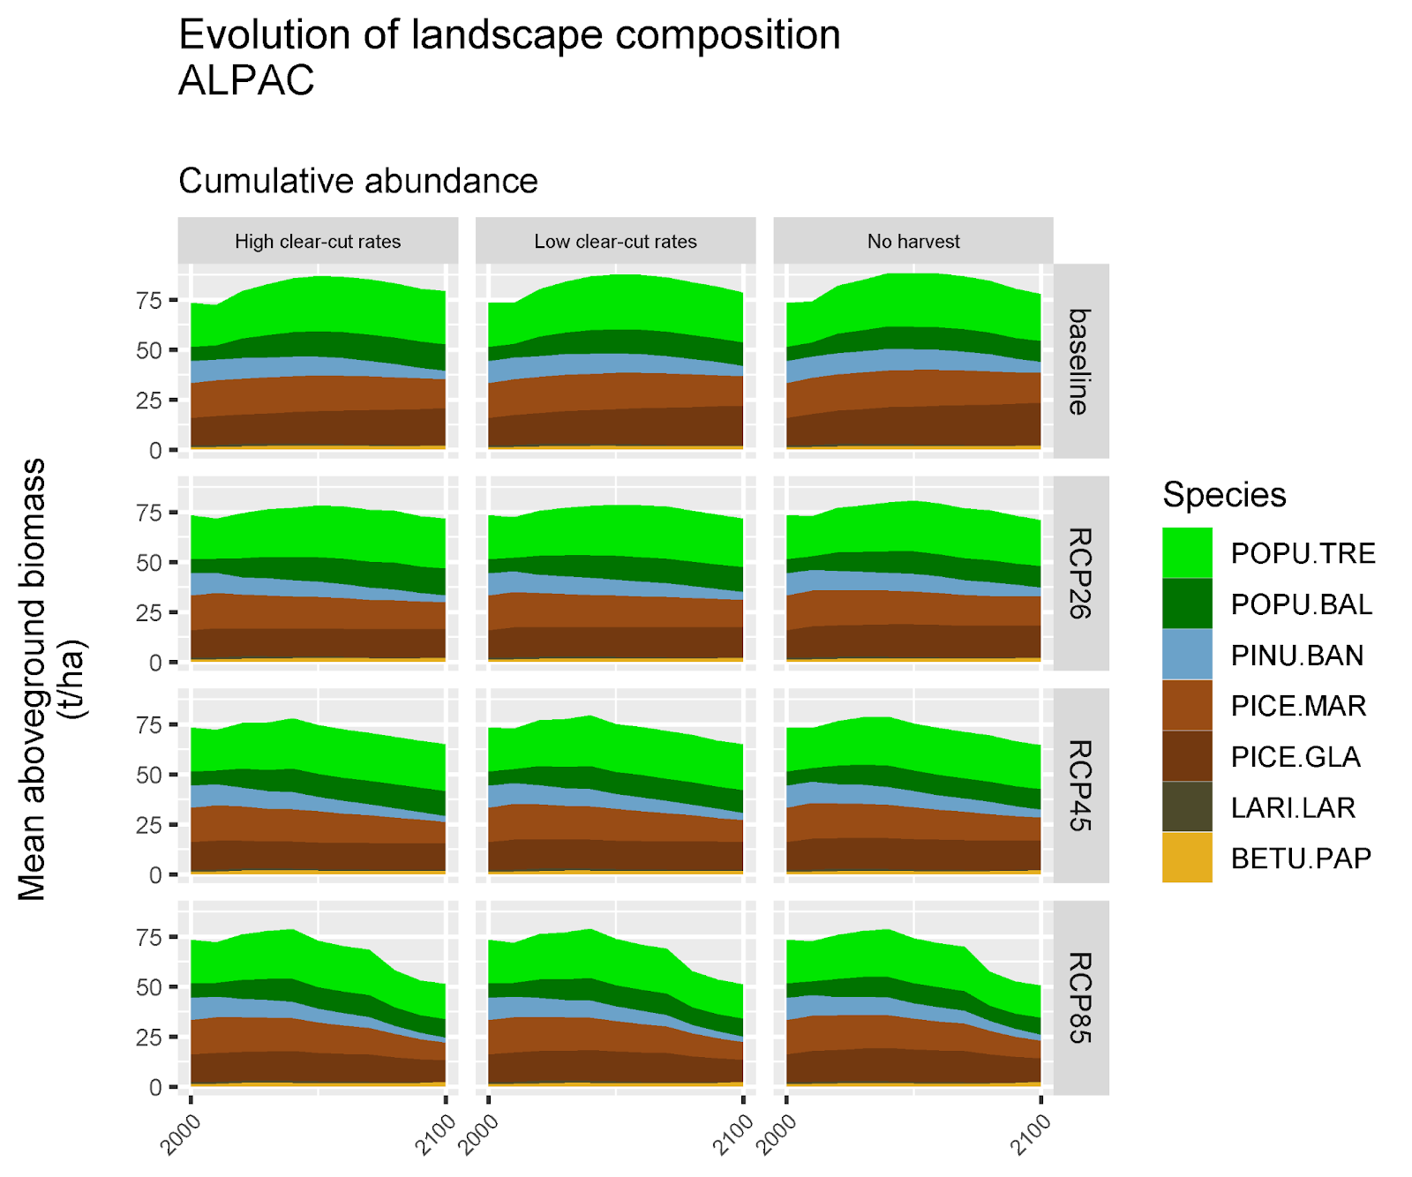

Figure S3.1. Trends in tree species biomass in the ALPAC study area for Canada Warbler according to the three climate change (baseline, RCP 4.5 and RCP 8.5) and the three forest management scenarios. BETU.PAP: white birch; LARI.LAR: larch; PICE.GLA: white spruce; PICE.MAR: black spruce; PINU.BAN: jack pine; POPU.BAL: balsam poplar; POPU.TRE: trembling aspen. Note: the RCP 2.6 climate change scenarios were not used to predict Canada Warbler density and distribution in our study.
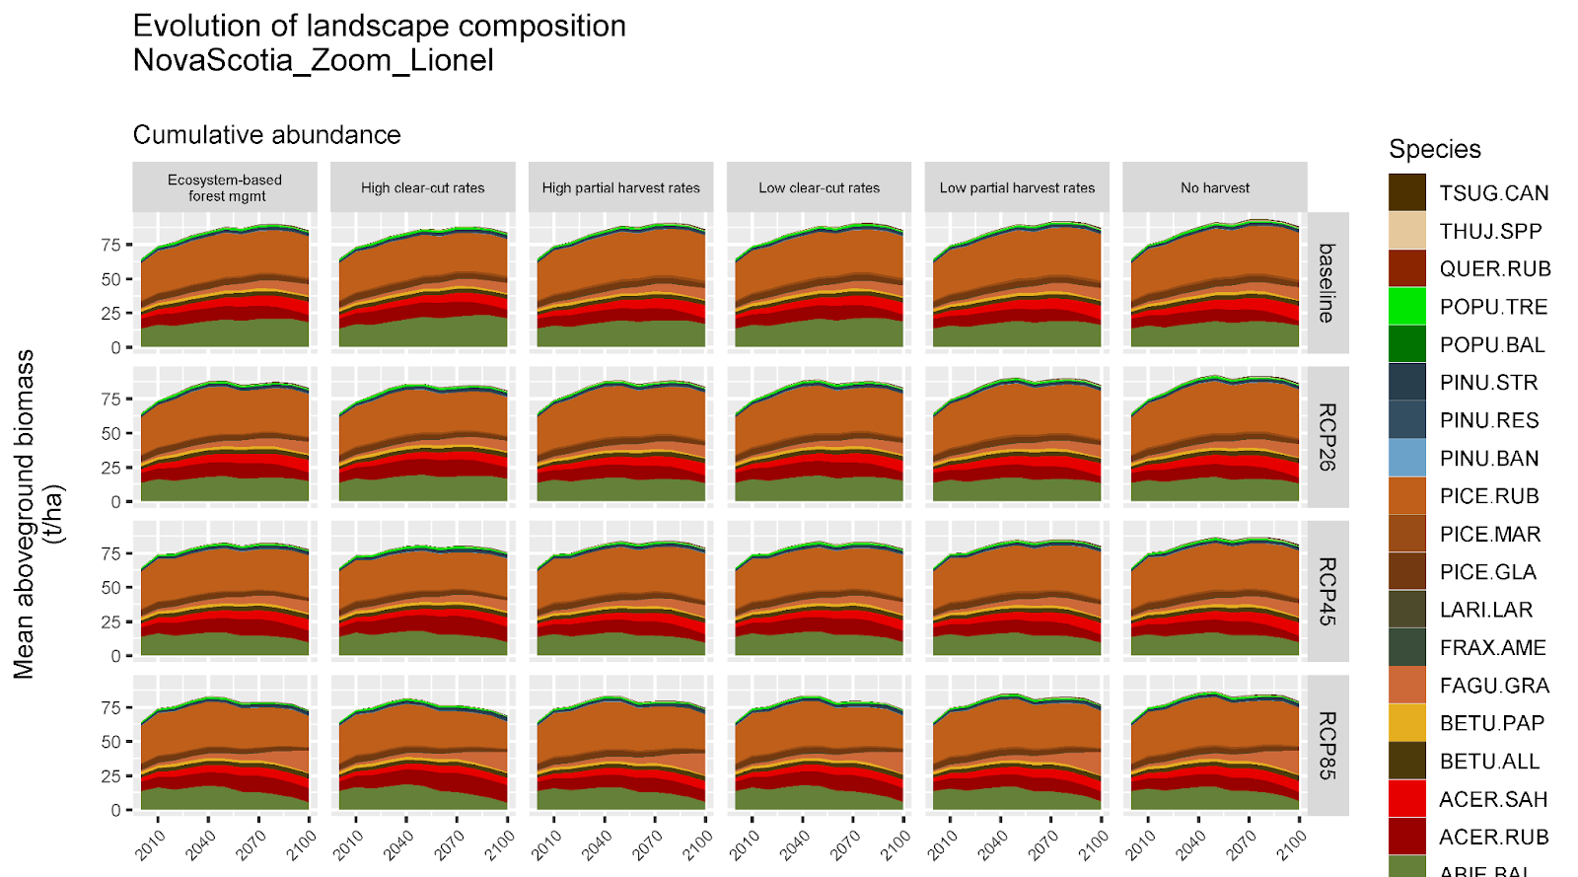
Figure S3.2. Trends in tree species biomass in the Nova Scotia study areas for Canada Warbler and Wood Thrush, according to the three climate change (baseline, RCP 4.5 and RCP 8.5) and the six forest management scenarios. ABIE.BAL: balsam fir; ACER.RUB: red maple; ACER.SAH: sugar maple; BETU.ALL: yellow birch; BETU.PAP: white birch; FAGU.GRA: American beech; FRAX.AME: white ash; LARI.LAR: larch; PICE.GLA: white spruce; PICE.MAR: black spruce; PICE.RUB: red spruce; PINU.BAN: jack pine; PINU.RES: red pine; PINU.STR: white pine; POPU.BAL: balsam poplar; POPU.TRE: trembling aspen; QUER.RUB: red oak; THUJ.SPP: white cedar; TSUG.CAN: eastern hemlock. Note: the RCP 2.6 climate change scenarios were not used to predict Canada Warbler or Wood Thrush density and distribution in our study.

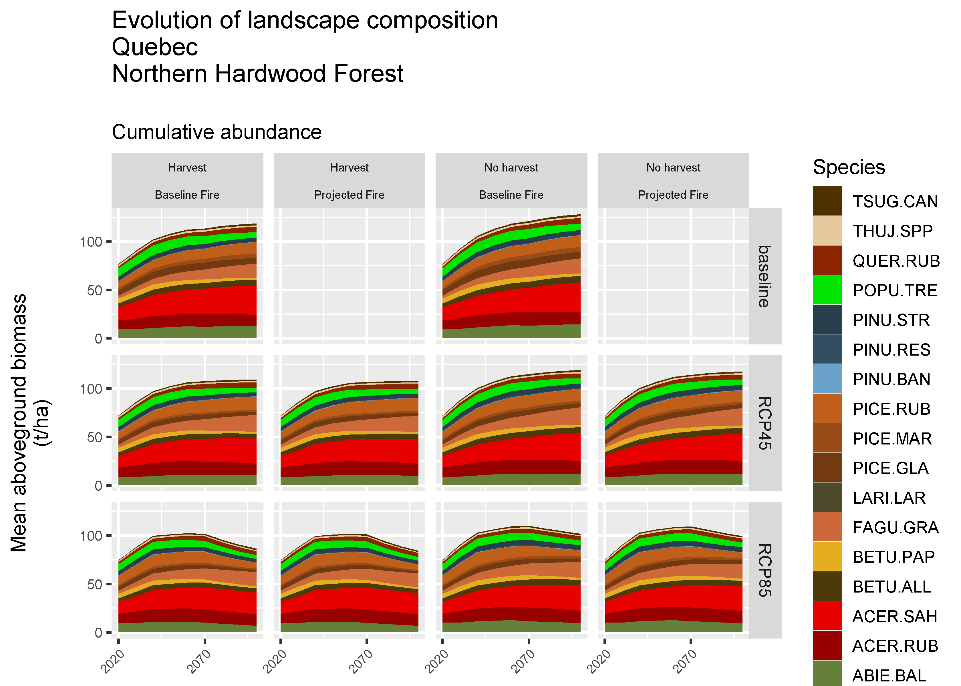
Figure S3.3. Trends in tree species biomass in the Quebec study area for Wood Thrush according to the three climate change (baseline, RCP 4.5 and RCP 8.5) and the two forest management scenarios. ABIE.BAL: balsam fir; ACER.RUB: red maple; ACER.SAH: sugar maple; BETU.ALL: yellow birch; BETU.PAP: white birch; FAGU.GRA: American beech; FRAX.AME: white ash; LARI.LAR: larch; PICE.GLA: white spruce; PICE.MAR: black spruce; PICE.RUB: red spruce; PINU.BAN: jack pine; PINU.RES: red pine; PINU.STR: white pine; POPU.BAL: balsam poplar; POPU.TRE: trembling aspen; QUER.RUB: red oak; THUJ.SPP: white cedar; TSUG.CAN: eastern hemlock. Note: some of these scenarios (baseline fire X RCP 4.5; baseline fire X RCP 8.5) were not used to predict Wood Thrush density and distribution in our study.
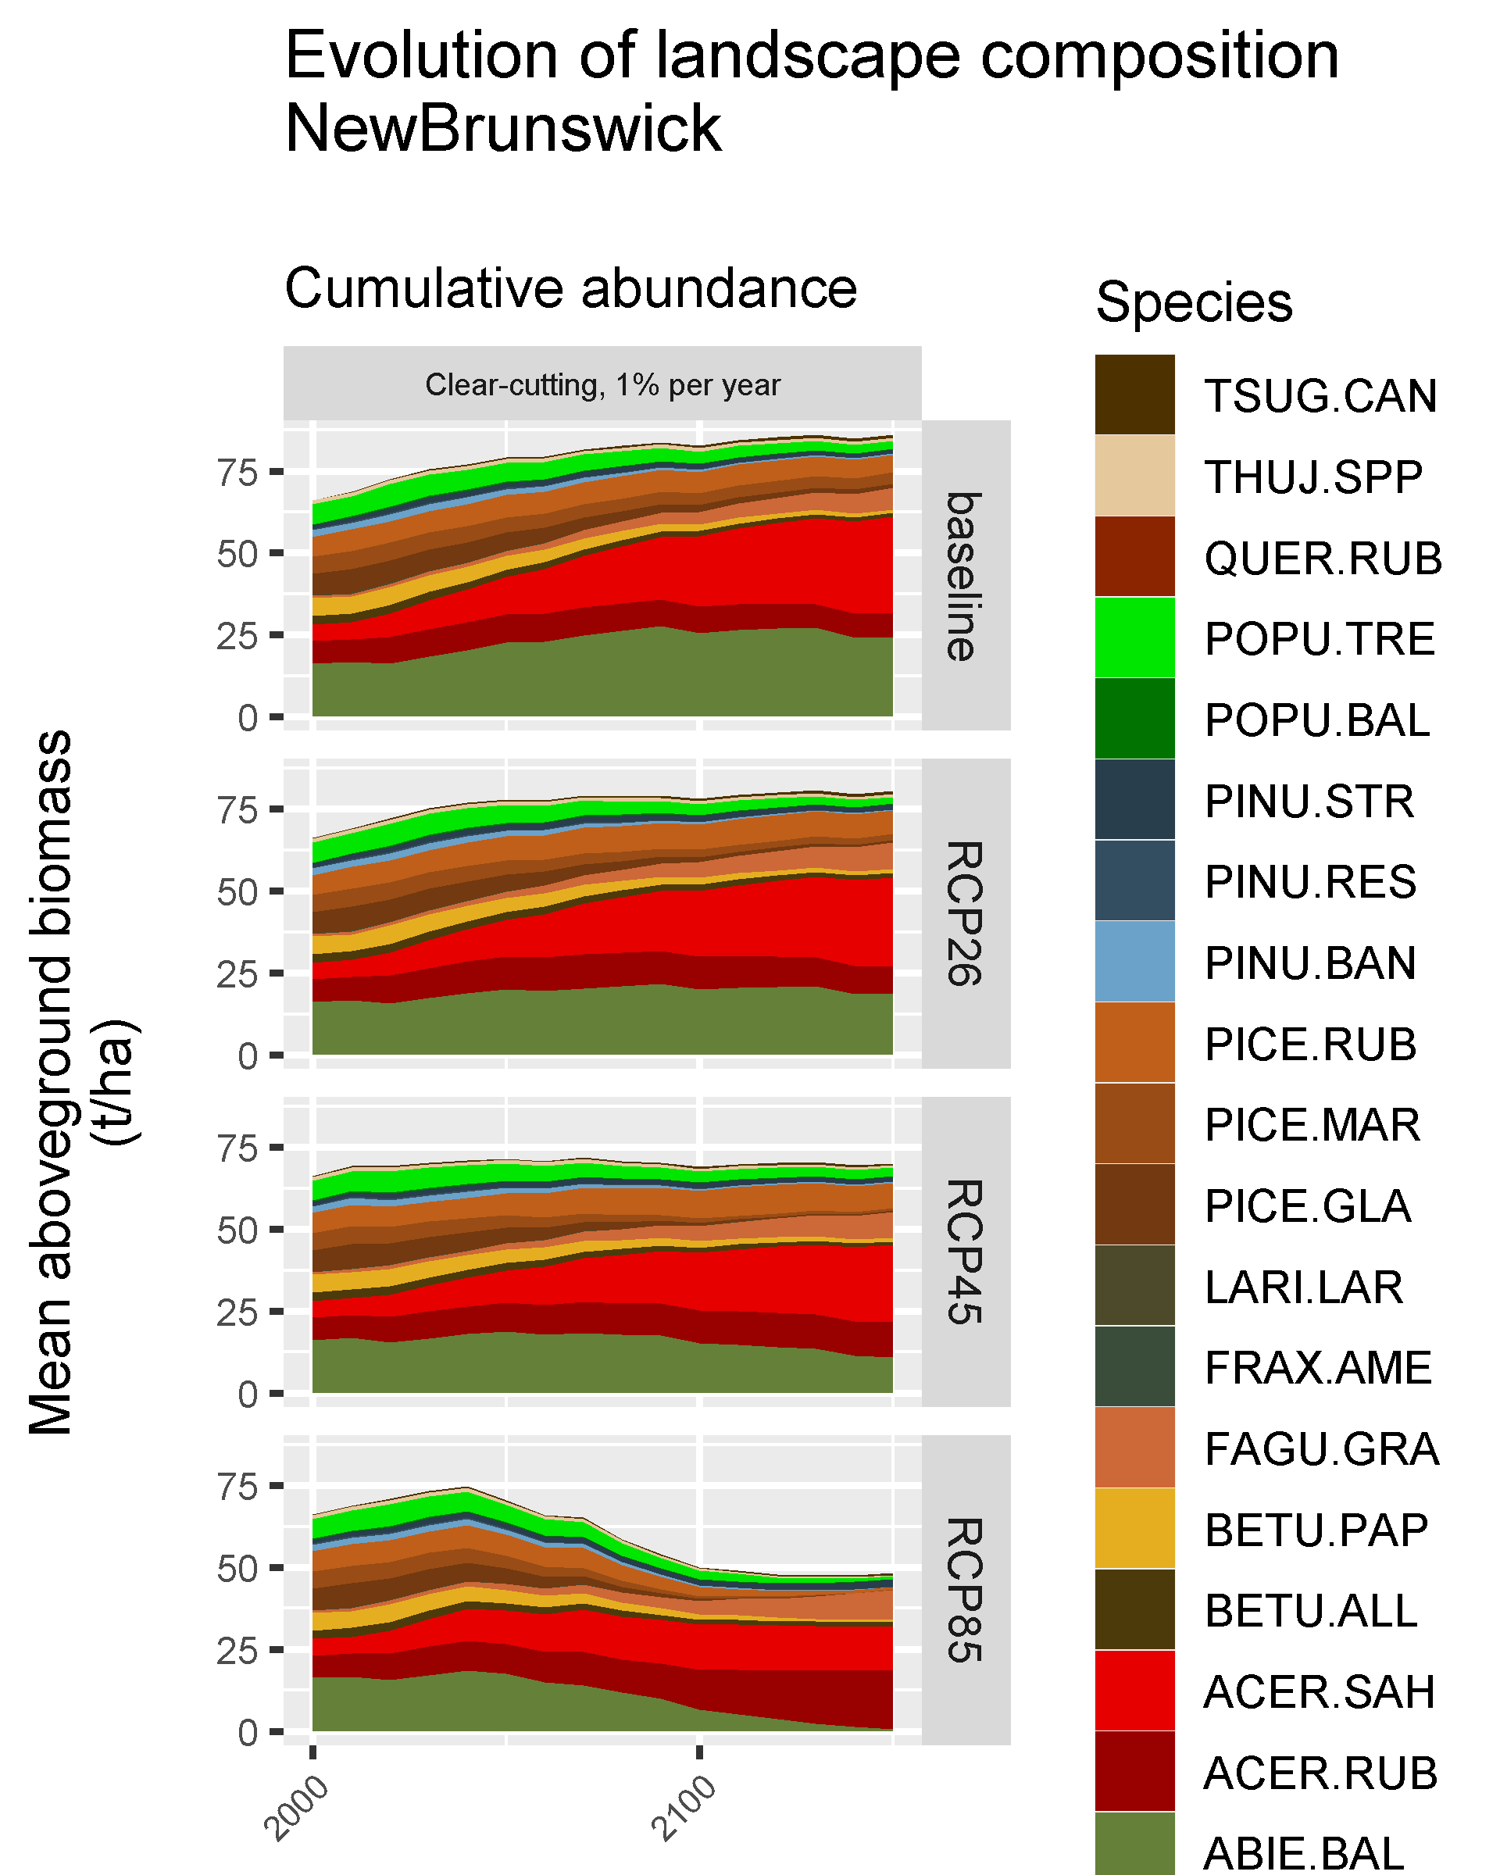
Figure S3.4. Trends in tree species biomass in the New Brunswick study area for Wood Thrush according to the three climate change (baseline, RCP 4.5 and RCP 8.5) and the one forest management scenario. ABIE.BAL: balsam fir; ACER.RUB: red maple; ACER.SAH: sugar maple; BETU.ALL: yellow birch; BETU.PAP: white birch; FAGU.GRA: American beech; FRAX.AME: white ash; LARI.LAR: larch; PICE.GLA: white spruce; PICE.MAR: black spruce; PICE.RUB: red spruce; PINU.BAN: jack pine; PINU.RES: red pine; PINU.STR: white pine; POPU.BAL: balsam poplar; POPU.TRE: trembling aspen; QUER.RUB: red oak; THUJ.SPP: white cedar; TSUG.CAN: eastern hemlock. Note: the RCP 2.6 climate change scenarios were not used to predict Wood Thrush density and distribution in our study.

Alberta LANDIS Scenarios (Canada Warbler)
We estimated the 2019 population size for the LANDIS-simulated area in northeastern Alberta to be 38,466 Canada Warblers (90 % C. I.: 24,597 — 59,886). Under the LANDIS scenarios run in northeastern Alberta, average forest age and relative amount of coniferous forests decreased over time with increasing global warming and with increasing annual harvest rates. Deciduous tree species cover was less affected by climate change or harvest than coniferous tree species, but open lands (i.e., shrublands) were projected to increase at the expense of total forest amount (Cadieux et al. 2020). In contrast to northern Nova Scotia, in the “best case scenario”, Canada Warbler decreased the least from 2019 – 2100 under a baseline climate with no new harvest. The median trend was observed for a baseline scenario with 6 % annual harvest (the highest simulated amount of harvest), which we then used for our “medium-case” scenario. The “worst-case” scenario with the most negative Canada Warbler trend was an RCP 4.5 scenario with 6 % annual harvest. Populations in 2100 under the three scenarios were 14,785 (best case: 41.54 % of 2019 population), 12,597 (medium case: 35.39 % of current population), and 10,518 (worst case: 29.55 % of current population). Thus, both a warming climate and increasing rates of harvest are predicted to decrease habitat for and populations of Canada Warbler in Alberta (Figure S3.5, Table S3.3).

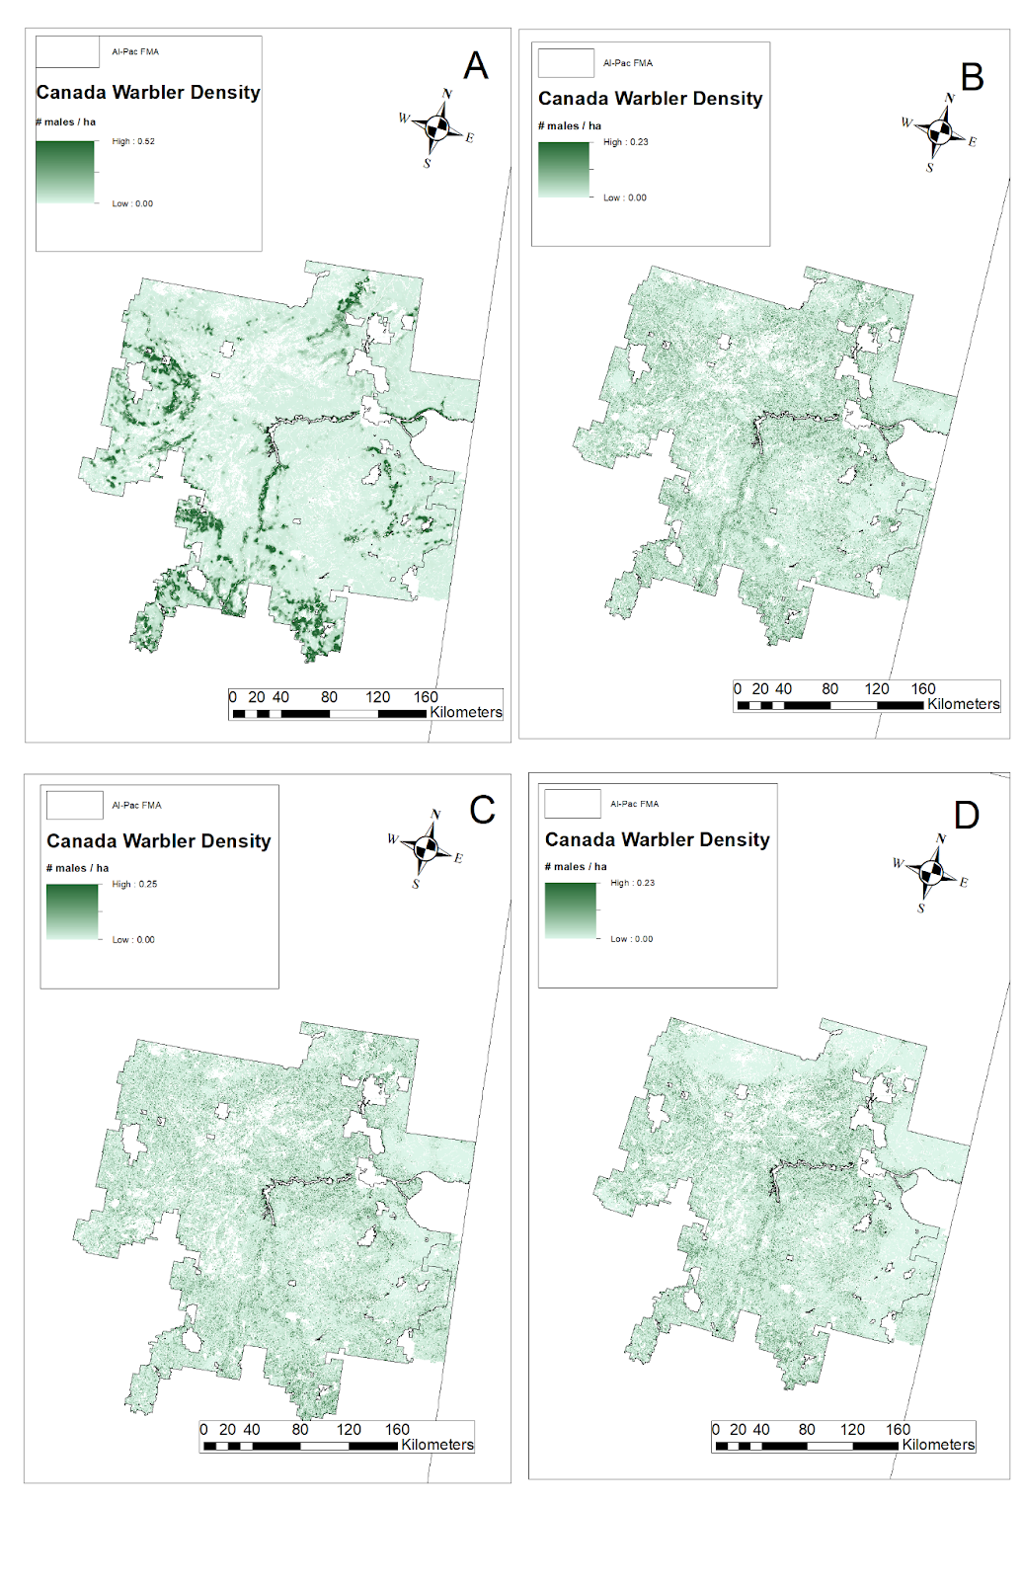
Figure S3.5. Predicted distribution of Canada Warbler within the LANDIS-II scenarios in the Alberta-Pacific Forest Management Area (Al-Pac FMA), Alberta, Canada. A = current distribution, as of 2019. B = distribution in 2100 under the best-case scenario. C = distribution in 2100 under the medium-case scenario. D = distribution in 2100 under the worst-case scenario.

Nova Scotia LANDIS Scenarios (Canada Warbler)
We estimated the 2019 population size for the LANDIS-simulated area in northern Nova Scotia to be 38,282 Canada Warblers (90 % C. I.: 21,198 — 55,367). LANDIS scenarios predicted increasing Canada Warbler populations in 2050 relative to 2019 (Fig. 1), with projected populations increasing from RCP 8.5 through RCP 4.5 to baseline climate scenarios. LANDIS scenarios also generally predicted positive population trends from 2019 – 2100 for Canada Warbler in northern Nova Scotia, with higher probability of a positive trend for baseline climate scenarios. In the “best case scenario”, Canada Warbler increased with a large amount of clear-cutting from 2019 – 2100 under a baseline climate. The median trend was observed for an RCP 4.5 scenario with ecosystem-based forest management, which we then used for our “medium-case” scenario. The “worst-case” scenario with the least positive Canada Warbler trend was an RCP 8.5 scenario with ecosystem-based forest management. Populations in 2100 under the three scenarios were 64,430 (best case), 46,057 (medium case), and 38,220 (worst case). Thus, high amounts of harvest were associated with positive effects on future habitat for Canada Warbler under Nova Scotia’s current climate, but harvest effects became negative under global warming (Figure S3.6, Table S3.3).

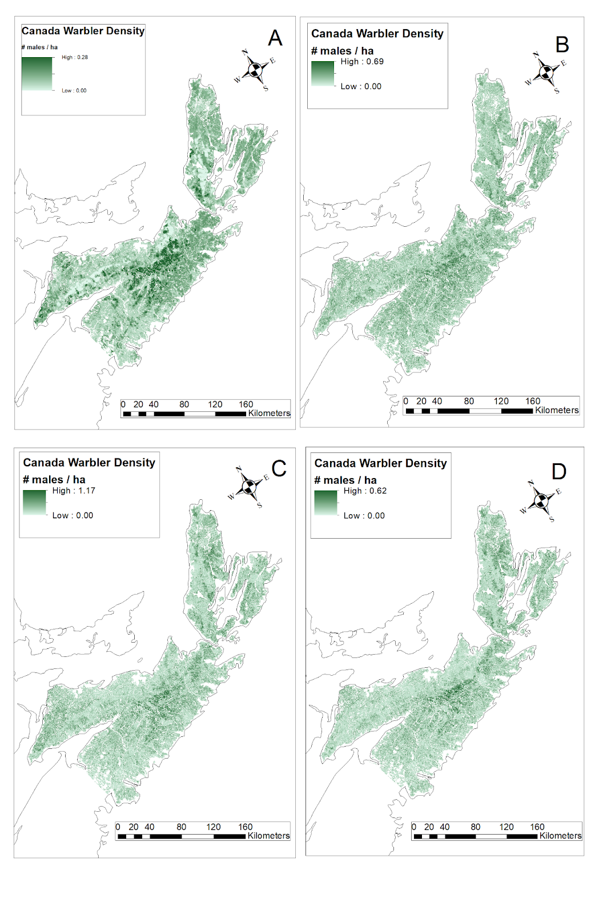
Figure S3.6. Predicted distribution of Canada Warbler within the LANDIS-II scenarios in the northern Nova Scotia management unit used in regional modeling, Canada. A = current distribution, as of 2019. B = distribution in 2100 under the best-case scenario. C = distribution in 2100 under the medium-case scenario. D = distribution in 2100 under the worst-case scenario.

Quebec, New Brunswick, Nova Scotia LANDIS Scenarios (Wood Thrush)
The Wood Thrush was projected to double from 2019 – 2100 within its range in southern Quebec, New Brunswick, and Nova Scotia, under all LANDIS scenarios that were run. In its Quebec range, Wood Thrush increased from 612,380 (577,207 — 647,552) males in 2019 to 1,170,333 - 1,281,868 males in 2100, depending on the scenario, with smaller increases in harvest scenarios and greater increases with moderate amounts of climate change (RCP 45 scenarios). In its New Brunswick range, Wood Thrush increased from 169,926 (159,611 — 180,242) to 261,693 - 461,209 males, with greater projected increases in warmer climate change scenarios. In its Nova Scotia range, Wood Thrush increased from 71,533 (66,106 — 76,960) males in 2019 to 199,405 – 268,721 males, with greater increases in warmer climate change scenarios and harvest scenarios (Figures S3.7 – S3.9, Table S3.3).

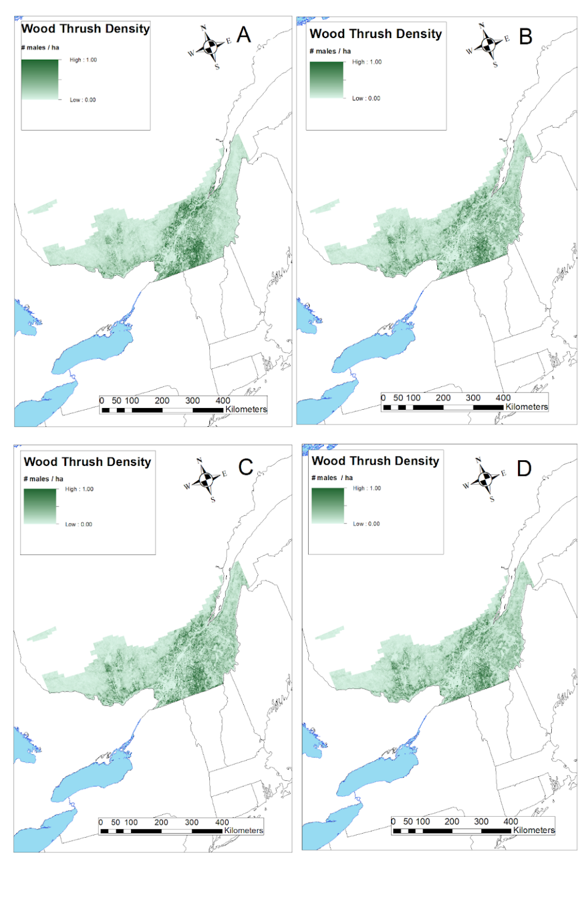
Figure S3.7. Predicted distribution of Wood Thrush within the LANDIS-II scenarios within the Wood Thrush range in Quebec, Canada. A = current distribution, as of 2020. B = distribution in 2100 under the best-case scenario. C = distribution in 2100 under the medium-case scenario. D = distribution in 2100 under the worst-case scenario.

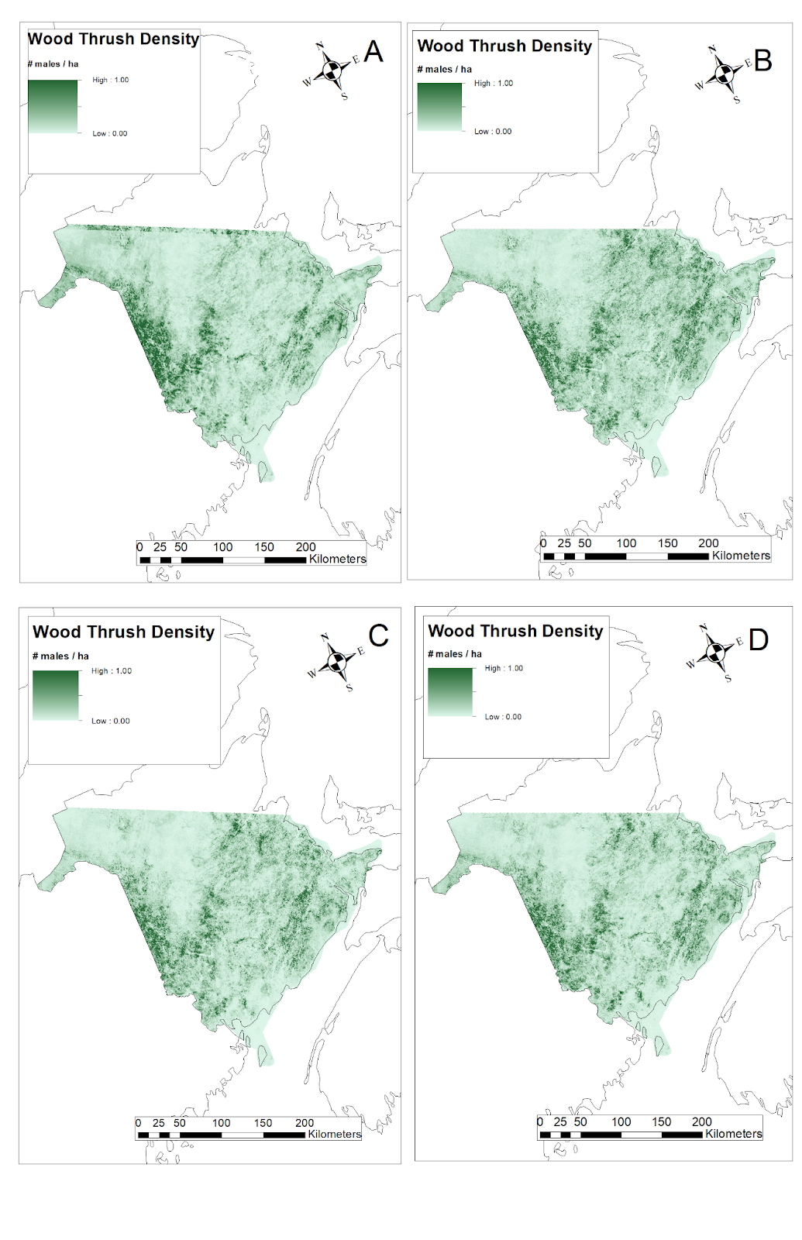
Figure 8. Predicted distribution of Wood Thrush within the LANDIS-II scenarios within the Wood Thrush range in New Brunswick, Canada. A = current distribution, as of 2020. B = distribution in 2100 under the best-case scenario. C = distribution in 2100 under the medium-case scenario. D = distribution in 2100 under the worst-case scenario.
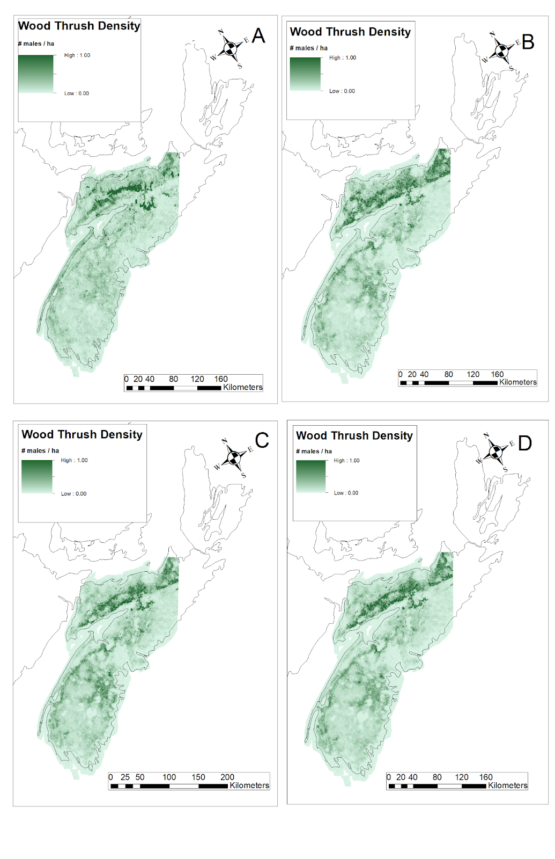
Figure S3.9. Predicted distribution of Wood Thrush within the LANDIS-II scenarios within the Wood Thrush range in Nova Scotia, Canada. A = current distribution, as of 2020. B = distribution in 2100 under the best-case scenario. C = distribution in 2100 under the medium-case scenario. D = distribution in 2100 under the worst-case scenario.

ALCES Online

Ontario ALCES Online Scenario (Wood Thrush)
The Wood Thrush was projected to increase within its Ontario range, albeit non-significantly with high uncertainty, based on the ALCES Online scenario that was run. Wood Thrush increased from an estimated population of 547,548 (407,614 — 719,014) males in 2019 to 627,322 (12,678 — 1,365,852) males in 2070 (Figure S3.10, Table S3.3).

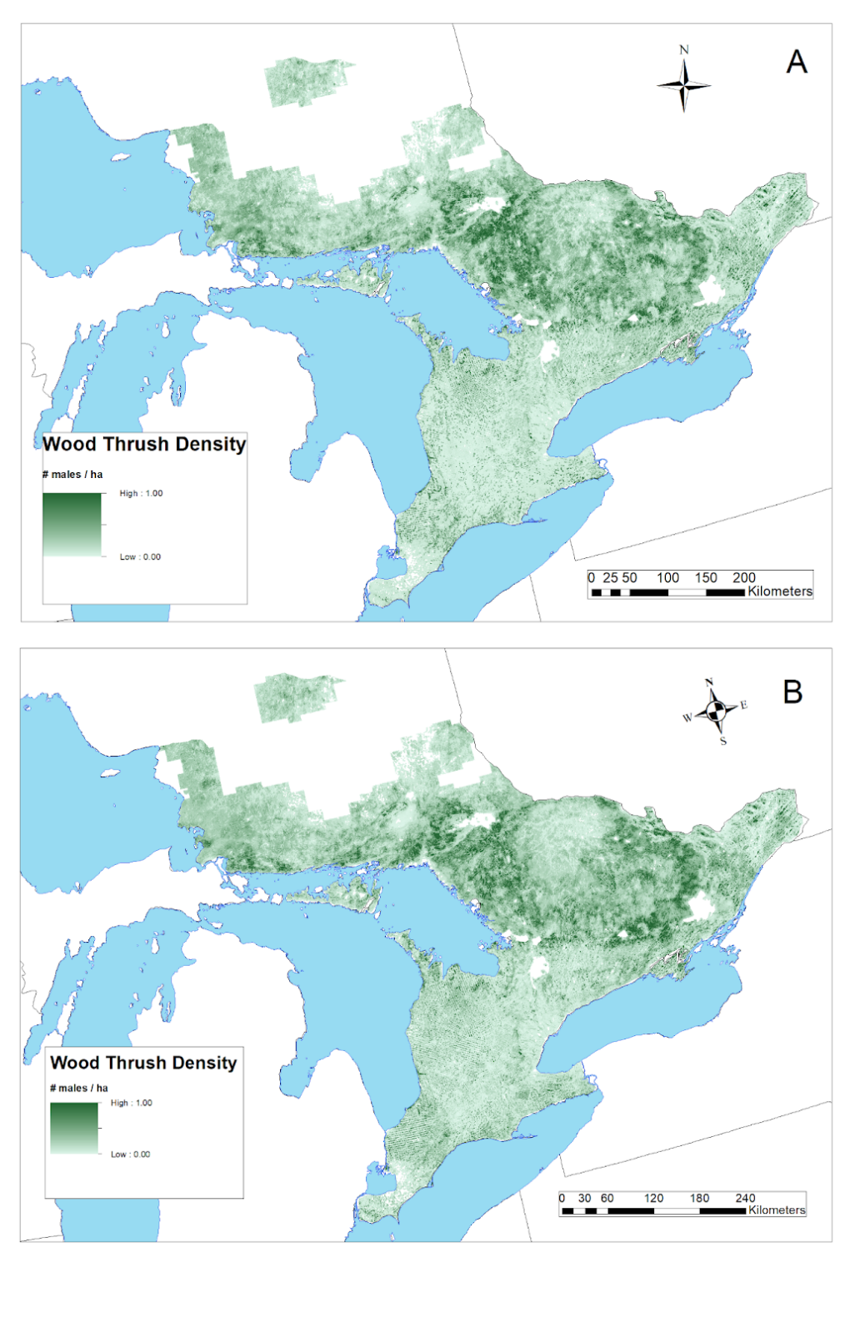
Figure S3.10. Predicted distribution of Wood Thrush within the ALCES Online scenario within the Wood Thrush range in Ontario, Canada. A = current distribution, as of 2020. B = distribution in 2070 under the ALCES Online scenario.

Table S3.1. Annual harvest area (ha/yr) under different LANDIS scenarios for Canada Warbler (CAWA) in northern Nova Scotia and Alberta, and for Wood Thrush (WOTH) in southern Quebec, New Brunswick, and southern Nova Scotia. EBFM = Ecosystem-based forest management. AB = Alberta. NS = Nova Scotia. NB = New Brunswick. QUE = Quebec.

Species | Region | Region Area | No Harvest | Low Partial-cut | High Partial-cut | Low Clear-cut | EBFM | High Clear-cut | Moderate Clear-cut (AB) (0.3%) | High Clear-cut (AB) (0.6%)
CAWA | AB | 5,103,581 | 0 | - | - | - | - | - | 6,000 | 12,000
CAWA | NS | 2,610,300 | 0 | 7,786 | 15,571 | 17,517 | 29,156 | 35,035 | - | -
WOTH | NB | 6,431,194 | - | - | - | - | - | 59,403 | - | -
WOTH | NS | 5,085,488 | 0 | - | - | - | 40,572 | 41,343 | - | -
WOTH | QUE | 12,258,363 | - | - | - | - | 59,160 | - | - | -

Table S3.2. Annual harvest area (ha/yr) simulated within different Forest Management Units (FMUs) and outside FMUs in Ontario in the ALCES Online scenario for Wood Thrush.

Forest Management Unit | FMU Area (within Wood Thrush range) | Clear-cut Harvest Rate | Shelterwood Harvest Rate | Selective Forestry Harvest Rate | Budworm Mortality Rate | Burn Rate | Total Harvest | Percent Harvested Annually
Abitibi Forest | 999,361 | 3,317 | 0 | 0 | 3 | 0 | 3,317 | 0.3319
Algoma Forest | 1,220,467 | 515 | 977 | 1573 | 12 | 0 | 3,065 | 0.2512
Algonquin Forest | 784,466 | 199 | 2,744 | 2,758 | 0 | 0 | 5,700 | 0.7266
Bancroft-Minden Forest | 1,026,007 | 662 | 659 | 912 | 0 | 0 | 2,234 | 0.2177
Black Spruce Forest | 28,475 | 245 | 0 | 0 | 0 | 0 | 245 | 0.8621
Boundary Waters Forest | 766,832 | 0 | 0 | 0 | 0 | 45 | 0 | 0.0000
French-Severn Forest | 1,314,277 | 109 | 2,185 | 1,576 | 126 | 0 | 3,870 | 0.2944
Gorden Cosens Forest | 154,157 | 992 | 0 | 0 | 280 | 0 | 992 | 0.6433
Hearst Forest | 103,928 | 564 | 0 | 0 | 0 | 0 | 564 | 0.5431
Kenora Forest | 153,448 | 17 | 0 | 0 | 0 | 0 | 17 | 0.0109
Lakehead Forest | 387,925 | 501 | 0 | 0 | 0 | 0 | 501 | 0.1291
Mazinaw-Lanark Forest | 1,009,794 | 125 | 662 | 450 | 0 | 0 | 1,237 | 0.1225
Missinaibi Forest | 269,679 | 0 | 0 | 0 | 0 | 172 | 0 | 0.0000
Nagagami Forest | 342,234 | 1,942 | 0 | 0 | 0 | 0 | 1,942 | 0.5675
Nipissing Forest | 1,101,993 | 1,793 | 1,060 | 164 | 1,758 | 0 | 3,017 | 0.2738
Northshore Forest | 1,260,135 | 2,278 | 834 | 116 | 5 | 0 | 3,227 | 0.2561
Ottawa Forest | 827,497 | 895 | 705 | 204 | 0 | 0 | 1,804 | 0.2180
Pic Forest | 194,680 | 0 | 0 | 0 | 0 | 27 | 0 | 0.0000
Pineland Forest | 237,084 | 999 | 3 | 0 | 18 | 0 | 1,002 | 0.4225
Romeo Malette Forest | 409,366 | 2,229 | 0 | 0 | 21 | 0 | 2,229 | 0.5446
Spanish Forest | 272,085 | 1,527 | 8 | 0 | 0 | 0 | 1,535 | 0.5642
Sudbury Forest | 1,043,054 | 1,326 | 442 | 13 | 3,353 | 0 | 1,781 | 0.1707
Temagami Forest | 459,567 | 447 | 1 | 1 | 171 | 0 | 448 | 0.0976
Timiskaming Forest | 134,877 | 578 | 0 | 0 | 0 | 0 | 578 | 0.4287
White River Forest | 572,458 | 1,834 | 0 | 0 | 0 | 0 | 1,834 | 0.3204
Outside FMUs (eastern Ontario) | 12,638,406 | 0 | 0 | 54,310 | 1,750 | 0 | 54,310 | 0.4297

Table S3.3. Mean + 90 % confidence interval for population projections (2070 or 2100) for Canada Warbler and Wood Thrush from different land use simulators, scenarios (harvest, climate), and management units in Canada.

Species | Management Unit | Harvest | Climate | End Date | Projected Population
Canada Warbler | Al-Pac FMA, Alberta | None | Baseline | 2100 | 14,801 (14,768 — 14,835)
 |  | 3 % Cut | Baseline | 2100 | 13,510 (13,485 — 13,535)
 |  | 6 % Cut | Baseline | 2100 | 12,548 (12,528 — 12,567)
 |  | None | RCP 4.5 | 2100 | 13,766 (13,734 — 13,798)
 |  | 3 % Cut | RCP 4.5 | 2100 | 11,628 (11,578 — 11,679)
 |  | 6 % Cut | RCP 4.5 | 2100 | 10,497 (10,483 — 10,512)
 |  | None | RCP 8.5 | 2100 | 12,938 (12,899 — 12,978)
 |  | 3 % Cut | RCP 8.5 | 2100 | 12,334 (12,307 — 12,361)
 |  | 6 % Cut | RCP 8.5 | 2100 | 12,099 (12,071 — 12,126)
Canada Warbler | northern Nova Scotia | None | Baseline | 2100 | 61,434 (61,199 — 61,669)
 |  | Low Partial Cut | Baseline | 2100 | 62,084 (61,748 — 62,421)
 |  | High Partial Cut | Baseline | 2100 | 62,318 (62,170 — 62,466)
 |  | Low Clearcut | Baseline | 2100 | 64,147 (64,038 — 64,256)
 |  | Historic Clearcut | Baseline | 2100 | 66,248 (65,918 — 66,578)
 |  | EBFM Harvest | Baseline | 2100 | 61,390 (61,081 — 61,700)
 |  | None | RCP 4.5 | 2100 | 45,978 (45,891 — 46,065)
 |  | Low Partial Cut | RCP 4.5 | 2100 | 45,881 (45,678 — 46,083)
 |  | High Partial Cut | RCP 4.5 | 2100 | 45,189 (44,905 — 45,472)
 |  | Low Clearcut | RCP 4.5 | 2100 | 47,439 (47,222 — 47,656)
 |  | Historic Clearcut | RCP 4.5 | 2100 | 48,365 (48,108 — 48,622)
 |  | EBFM Harvest | RCP 4.5 | 2100 | 45,936 (45,799 — 46,073)
 |  | None | RCP 8.5 | 2100 | 40,860 (40,700 — 41,020)
 |  | Low Partial Cut | RCP 8.5 | 2100 | 40,631 (40,242 — 41,021)
 |  | High Partial Cut | RCP 8.5 | 2100 | 39,851 (39,713 — 39,989)
 |  | Low Clearcut | RCP 8.5 | 2100 | 39,874 (39,695 — 40,052)
 |  | Historic Clearcut | RCP 8.5 | 2100 | 38,841 (38,694 — 38,988)
 |  | EBFM Harvest | RCP 8.5 | 2100 | 38,071 (37,835 — 38,307)
Wood Thrush | Quebec | None | RCP 4.5 | 2100 | 1,281,868 (0 — 2,583,360)
 |  | None | RCP 8.5 | 2100 | 1,264,308 (17,376 — 2,511,239)
 |  | None | Baseline | 2100 | 1,251,238 (0 — 2,579,269)
 |  | Harvest | RCP 4.5 | 2100 | 1,202,985 (0 — 2,434,657)
 |  | Harvest | RCP 8.5 | 2100 | 1,196,494 (50,054 — 2,342,934)
 |  | Harvest | Baseline | 2100 | 1,170,333 (0 — 2,431,534)
Wood Thrush | New Brunswick | Harvest | RCP 8.5 | 2100 | 458,950 (456,103 — 461,797)
 |  | Harvest | RCP 4.5 | 2100 | 325,133 (320,508 — 329,757)
 |  | Harvest | Baseline | 2100 | 260,676 (256,874 — 264,478)
Wood Thrush | Nova Scotia | Historic Clearcut | RCP 8.5 | 2100 | 268,721 (265,889 — 271,553)
 |  | EBFM Harvest | RCP 8.5 | 2100 | 244,551 (243,221 — 245,881)
 |  | Historic Clearcut | RCP 4.5 | 2100 | 231,126 (229,934 — 232,318)
 |  | EBFM Harvest | RCP 4.5 | 2100 | 219,570 (218,112 — 221,027)
 |  | Historic Clearcut | Baseline | 2100 | 205,326 (204,544 — 206,108)
 |  | None | Baseline | 2100 | 204,783 (202,958 — 206,607)
 |  | None | RCP 8.5 | 2100 | 204,357 (202,846 — 205,868)
 |  | EBFM Harvest | Baseline | 2100 | 201,058 (199,989 — 202,126)
 |  | None | RCP 4.5 | 2100 | 199,405 (198,761 — 200,049)
Wood Thrush | Ontario | FMU-specific Harvest Rates (Appendix I, Leston 2022) | Baseline | 2070 | 627,322 (12,678 — 1,365,852)

References
[AAFC] Agriculture and Agri-Food Canada (2021) Annual Crop Inventory. https://open.canada.ca/data/en/dataset/ba2645d5-4458-414d-b196-6303ac06c1c9. Accessed January 1, 2021.
Algonquin Forestry Authority (2021) Forest Management Plan for the Algonquin Park Forest Management Unit, Pembroke District, Southern Region, Algonquin Forestry Authority for the 10-year period from July 1, 2021 to March 31, 2031 https://nrip.mnr.gov.on.ca/s/published-submission?language=en_US&recordId=a0z3g000000ofQ2AAI. Accessed October 18, 2021.

Arora VK, Scinocca JF, Boer GJ, et al (2011) Carbon emission limits required to satisfy future representative concentration pathways of greenhouse gases. Geophys Res Lett 38:. https://doi.org/10.1029/2010GL046270
Bancroft Minden Forest Company (2021) Forest Management Plan for the Bancroft Minden Forest Management Unit # 220 2021 to 2031. https://nrip.mnr.gov.on.ca/s/published-submission?language=en_US&recordId=a0z3g000000yyFUAAY. Accessed October 18, 2021.
Beaudoin A, Bernier PY, Guindon L, et al (2014) Mapping attributes of Canada’s forests at moderate resolution through kNN and MODIS imagery. Can J For Res 44:521–532. https://doi.org/10.1139/cjfr-2013-0401
Boulanger Y, Gauthier S, Burton PJ (2014) A refinement of models projecting future Canadian fire regimes using homogeneous fire regime zones. Can J For Res 44:365–376. https://doi.org/10.1139/cjfr-2013-0372
Boulanger Y, Gray DR, Cooke BJ, De Grandpré L (2016) Model-specification uncertainty in future forest pest outbreak. Glob Change Biol 22:1595–1607. https://doi.org/10.1111/gcb.13142
Boulanger Y, Pascual Puigdevall J (2021) Boreal forests will be more severely affected by projected anthropogenic climate forcing than mixedwood and northern hardwood forests in eastern Canada. Landsc Ecol 36:1725–1740. https://doi.org/10.1007/s10980-021-01241-7
Boulanger Y, Taylor AR, Price DT, et al (2017) Climate change impacts on forest landscapes along the Canadian southern boreal forest transition zone. Landsc Ecol 32:1415–1431. https://doi.org/10.1007/s10980-016-0421-7
Cadieux P, Boulanger Y, Cyr D, et al (2019) Spatially explicit climate change projections for the recovery planning of threatened species: The Bicknell’s Thrush (Catharus Bicknelli) as a case study. Glob Ecol Conserv 17:e00530. https://doi.org/10.1016/j.gecco.2019.e00530
Cadieux P, Boulanger Y, Cyr D, et al (2020) Projected effects of climate change on boreal bird community accentuated by anthropogenic disturbances in western boreal forest, Canada. Divers Distrib 26:668–682. https://doi.org/10.1111/ddi.13057
Carlson M, Browne D, Callaghan C (2019) Application of land-use simulation to protected area selection for efficient avoidance of biodiversity loss in Canada’s western boreal region. Land Use Policy 82:821–831. https://doi.org/10.1016/j.landusepol.2019.01.015
Carlson M, Stelfox JB (2014) Alberta Oil Sands Development and Risk Management of Canadian Boreal Ecosystems. In: Gates JE, Trauger DL, Czech B (eds) Peak Oil, Economic Growth, and Wildlife Conservation. Springer, New York, NY, pp 219–244
Carlson M, Stelfox B, Purves-Smith N, Straker J, Berryman S, Barker T, Wilson B (2014) “ALCES Online: Web-delivered scenario analysis to inform sustainable land-use decisions,” in Proceedings of the 7th International Congress on Environmental Modelling and Software. Eds. D.P. Ames, N.W.T. Quinn and A.E. Rizzoli (San Diego, CA: International Environmental Modelling and Software Society), 1-8. https://www.alces.ca/publications/download/406/Carlson%20et%20al%202014.pdf. Accessed January 1, 2020.

Chao L (2011) Ch. 7 Fire regimes and their simulation with reference to Ontario. in Ajith H. Perera, David L. Euler, Ian D. Thompson, eds., Ecology of a Managed Terrestrial Landscape: Patterns and Processes of Forest Landscapes in Ontario. UBC Press, Nov. 1, 2011 - Nature - 346 pages.
Evans M, Gow E, Roth RR, Johnson MS, Underwood TJ (2020) Wood Thrush (Hylocichla mustelina), version 1.0. In Birds of the World (A. F. Poole, Editor). Cornell Lab of Ornithology, Ithaca, NY, USA. https://doi.org/10.2173/bow.woothr.01.
Gauthier J, Aubry Y (eds) (1995) The Breeding Birds of Québec: Atlas of the breeding birds of southern Québec. Association québécoise des groupes d’ornithologues, Bird Protection Québec, Canadian Wildlife Service, Environment Canada, Quebec Region, Montréal, xviii + 1295 p.
Gouvernement du Québec (2020) Quebec Timber Production Strategy. https://mffp.gouv.qc.ca/the-forests/quebec-timber-production-strategy/?lang=en. Accessed October 18, 2021.

Gustafson EJ, Shifley SR, Mladenoff DJ, et al (2000) Spatial simulation of forest succession and timber harvesting using LANDIS. Can J For Res 30:32–43. https://doi.org/10.1139/x99-188
He HS, Mladenoff DJ (1999) Spatially Explicit and Stochastic Simulation of Forest-Landscape Fire Disturbance and Succession. Ecology 80:81–99. https://doi.org/10.1890/0012-9658(1999)080[0081:SEASSO]2.0.CO;2
Kim H (2020) The Economic Value of Private Woodlots in Southern Ontario. A research paper submitted in conformity with the requirements for the degree of Master of Forest Conservation. Faculty of Forestry, University of Toronto. https://hdl.handle.net/1807/99033.

Leston L, Bayne E, Dzus E, et al (2020) Quantifying Long-Term Bird Population Responses to Simulated Harvest Plans and Cumulative Effects of Disturbance. Front Ecol Evol 8:
Leston L (2022) Modeling framework to support critical habitat identification for the Wood Thrush in Canada. Zenodo. https://doi.org/10.5281/zenodo.7153499. Canadian Wildlife Service Contract #EC3000713776.

Mahon CL, Bayne EM, Sólymos P, et al (2014) Does expected future landscape condition support proposed population objectives for boreal birds? For Ecol Manag 312:28–39. https://doi.org/10.1016/j.foreco.2013.10.025
Mansuy N, Thiffault E, Paré D, et al (2014) Digital mapping of soil properties in Canadian managed forests at 250m of resolution using the k-nearest neighbor method. Geoderma 235–236:59–73. https://doi.org/10.1016/j.geoderma.2014.06.032
McKenney D, Pedlar J, Hutchinson M, et al (2013) Spatial climate models for Canada’s forestry community. For Chron 89:659–663. https://doi.org/10.5558/tfc2013-118
Mekonnen ZA, Riley WJ, Randerson JT, et al (2019) Expansion of high-latitude deciduous forests driven by interactions between climate warming and fire. Nat Plants 5:952–958. https://doi.org/10.1038/s41477-019-0495-8
Michaelian M, Hogg EH, Hall RJ, Arsenault E (2011) Massive mortality of aspen following severe drought along the southern edge of the Canadian boreal forest. Glob Change Biol 17:2084–2094. https://doi.org/10.1111/j.1365-2486.2010.02357.x
Mladenoff DJ, Baker WL (1999) Spatial Modeling of Forest Landscape Change: Approaches and Applications. Cambridge University Press
Moss RH, Edmonds JA, Hibbard KA, et al (2010) The next generation of scenarios for climate change research and assessment. Nature 463:747–756. https://doi.org/10.1038/nature08823
Ontario Forest Resource Inventory (2021) Forest Resources Inventory Packaged Products - Version 2. https://geohub.lio.gov.on.ca/datasets/9de0dad6f1b3435eb46df8ee49f4ecfd. Accessed July 23, 2021.
[OMNDMNRF] Ontario Ministry of Northern Development, Mines, Natural Resources and Forestry (2021) https://drive.google.com/file/d/1TClNmbcLU_mwx051DT9jwRIPJtf3Pe6v/view. Accessed July 13, 2021.
Pureswaran DS, Roques A, Battisti A (2018) Forest Insects and Climate Change. Curr For Rep 4:35–50. https://doi.org/10.1007/s40725-018-0075-6
Scheller RM, Domingo JB, Sturtevant BR, et al (2007) Design, development, and application of LANDIS-II, a spatial landscape simulation model with flexible temporal and spatial resolution. Ecol Model 201:409–419. https://doi.org/10.1016/j.ecolmodel.2006.10.009
Scheller RM, Mladenoff DJ (2004) A forest growth and biomass module for a landscape simulation model, LANDIS: design, validation, and application. Ecol Model 180:211–229. https://doi.org/10.1016/j.ecolmodel.2004.01.022
Stralberg D, Wang X, Parisien M-A, et al (2018) Wildfire-mediated vegetation change in boreal forests of Alberta, Canada. Ecosphere 9:e02156. https://doi.org/10.1002/ecs2.2156
Sturtevant BR, Gustafson EJ, Li W, He HS (2004) Modeling biological disturbances in LANDIS: a module description and demonstration using spruce budworm. Ecol Model 180:153–174. https://doi.org/10.1016/j.ecolmodel.2004.01.021
Taylor AR, Boulanger Y, Price DT, et al (2017) Rapid 21st century climate change projected to shift composition and growth of Canada’s Acadian Forest Region. For Ecol Manag 405:284–294. https://doi.org/10.1016/j.foreco.2017.07.033
Tremblay JA, Boulanger Y, Cyr D, et al (2018) Harvesting interacts with climate change to affect future habitat quality of a focal species in eastern Canada’s boreal forest. PLOS ONE 13:e0191645. https://doi.org/10.1371/journal.pone.0191645
van Vuuren DP, Edmonds JA, Kainuma M, et al (2011) A special issue on the RCPs. Clim Change 109:1. https://doi.org/10.1007/s10584-011-0157-y
Watkins L (2011) The forest resources of Ontario 2011. Ontario Ministry of Natural Resources, Sault Ste. Marie Ontario, Forest Evaluation and Standards Section, Forests Branch 270 p. https://www.ontario.ca/document/forest-resources-ontario-2011. Accessed on July 18, 2021.

