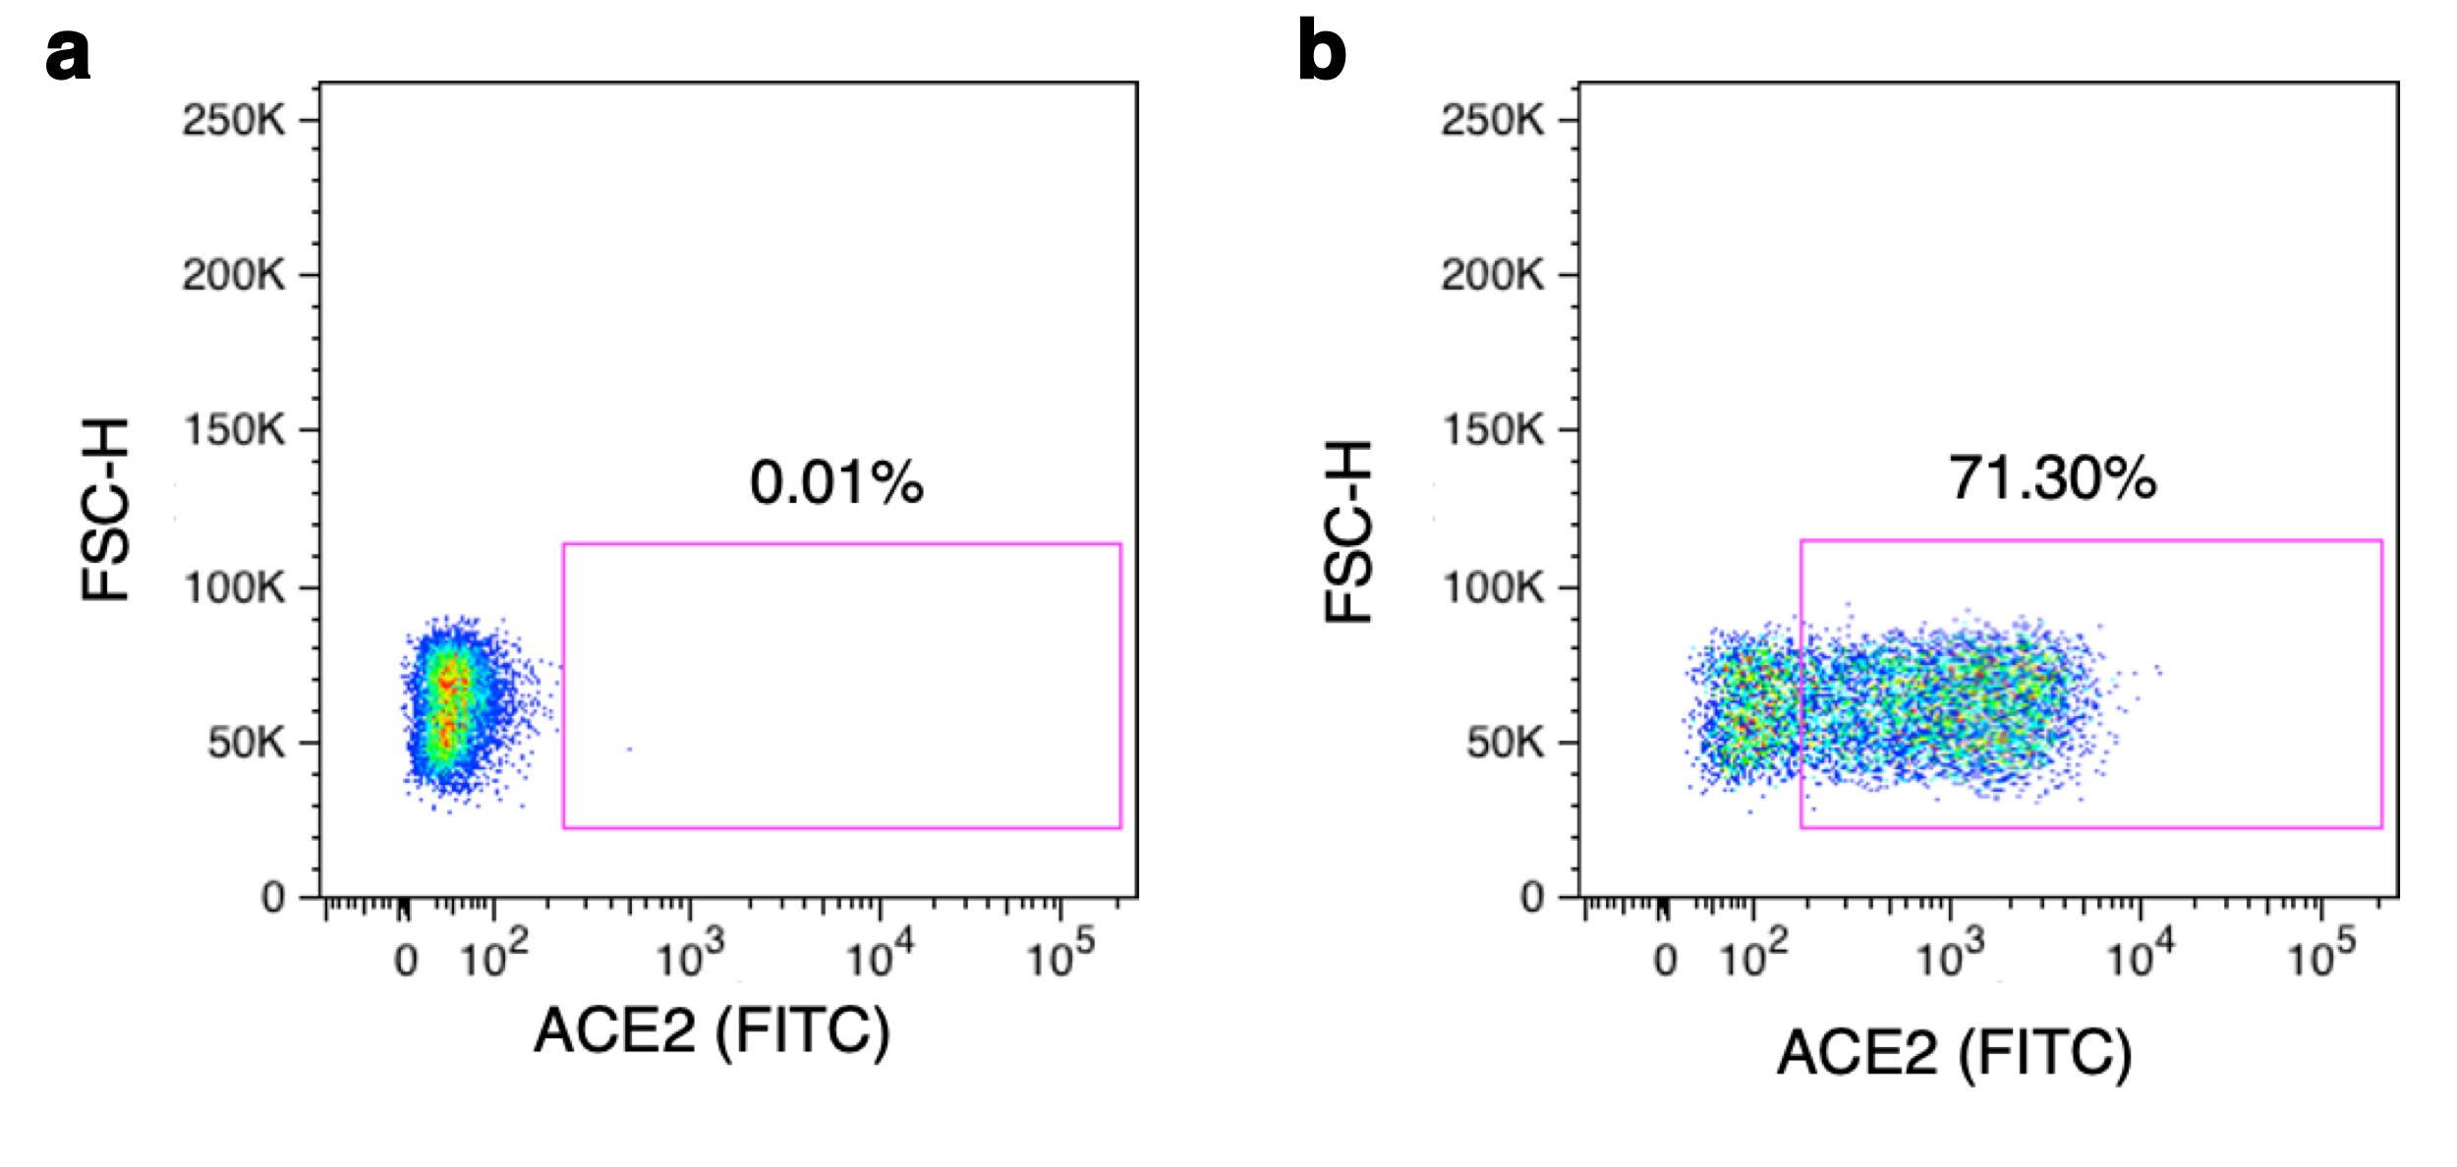
Supplementary Figure S1. Surface expression of Angiotensin-converting enzyme 2 (ACE2). Target cells were stained with FITC-conjugated anti-myc-tag and ACE2 (FITC) positive cells detected by flow cytometry. Data was analyzed using FlowJo software. The left panel correspond to a control sample with 293T-cells. The right panel correspond to 293TACE2 target cells. FITC: Fluorescein isothiocyanate. FSC-H: Forward Scatter Height.

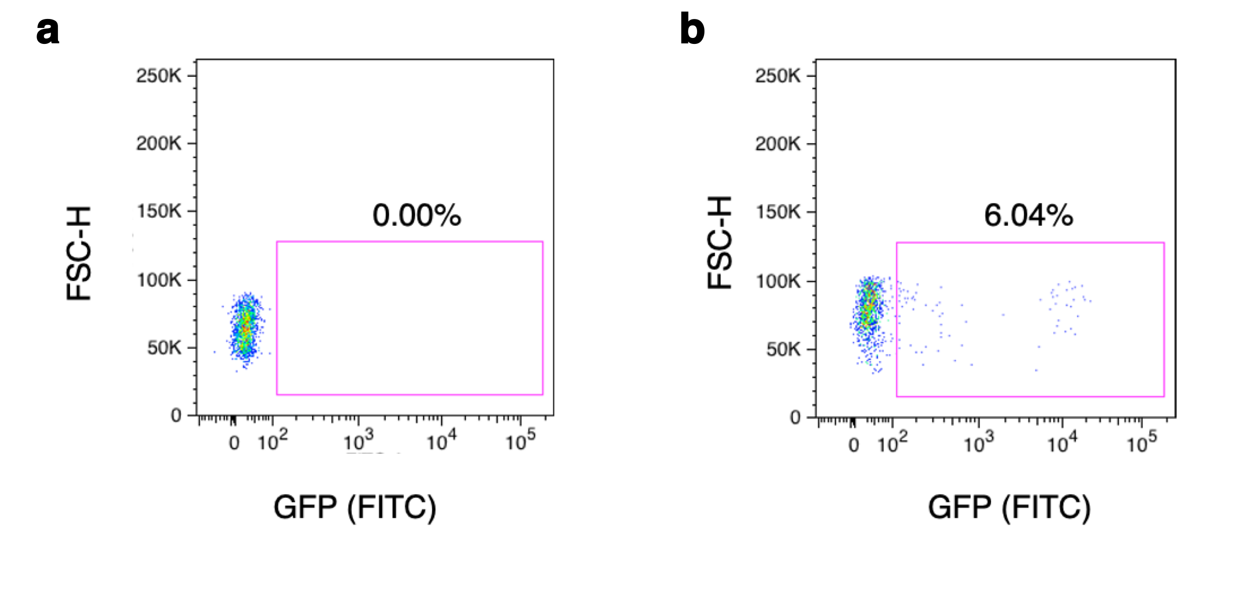
Supplementary Figure S2. Pseudovirus titration using 293-ACE2 target cells. Cells were infected with serial dilutions of the pseudovirus preparation. The number of infectious units (IU) correspond to the percentage of GFP positive cells. The left panel represents a control sample with no virus addition. The right panel correspond a 2x dilution of this pseudovirus preparation. GFP: Green Fluorescent Protein. FITC: Fluorescein isothiocyanate. FSC-H: Forward Scatter Height.
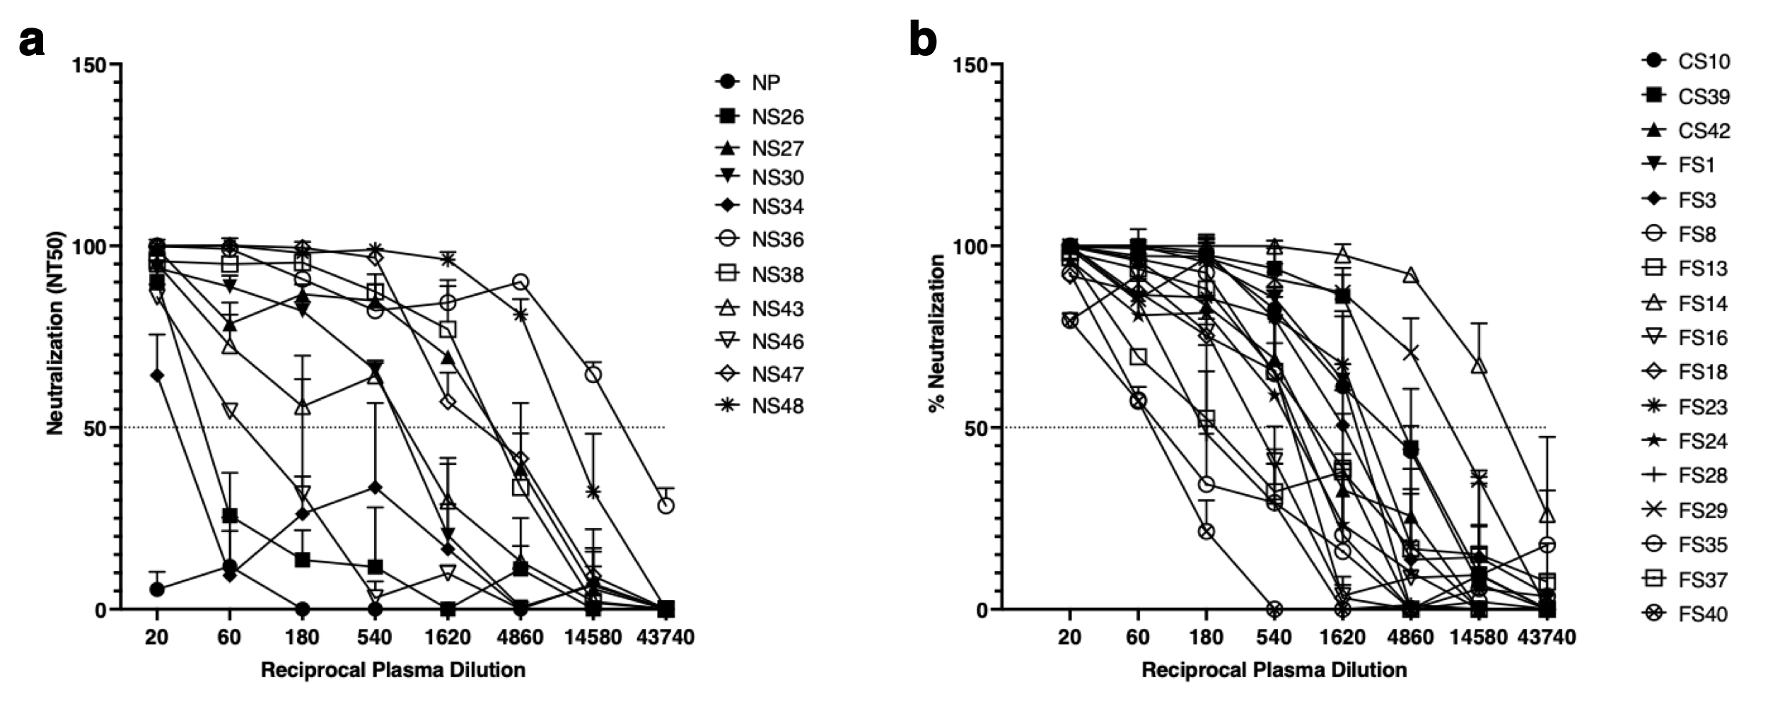

Supplementary Figure S3. Plasma neutralization antibody assay. Serial dilutions of patient plasmas were tested for neutralization of SARS-CoV-2 pseudovirus preparation. The plasma dilutions were incubated with equal amount of pseudovirus and tested for a single round infection of 293T-ACE2 target cells. Data are representative of two independent experiments. Patients who never smoked are presented in panel “a” and smokers (former and current) are presented in panel “b”. Dotted lines represent 50% neutralization. A pool of 10 naïve plasma “NP” from pre-pandemic non-infected individual was used as a negative control.

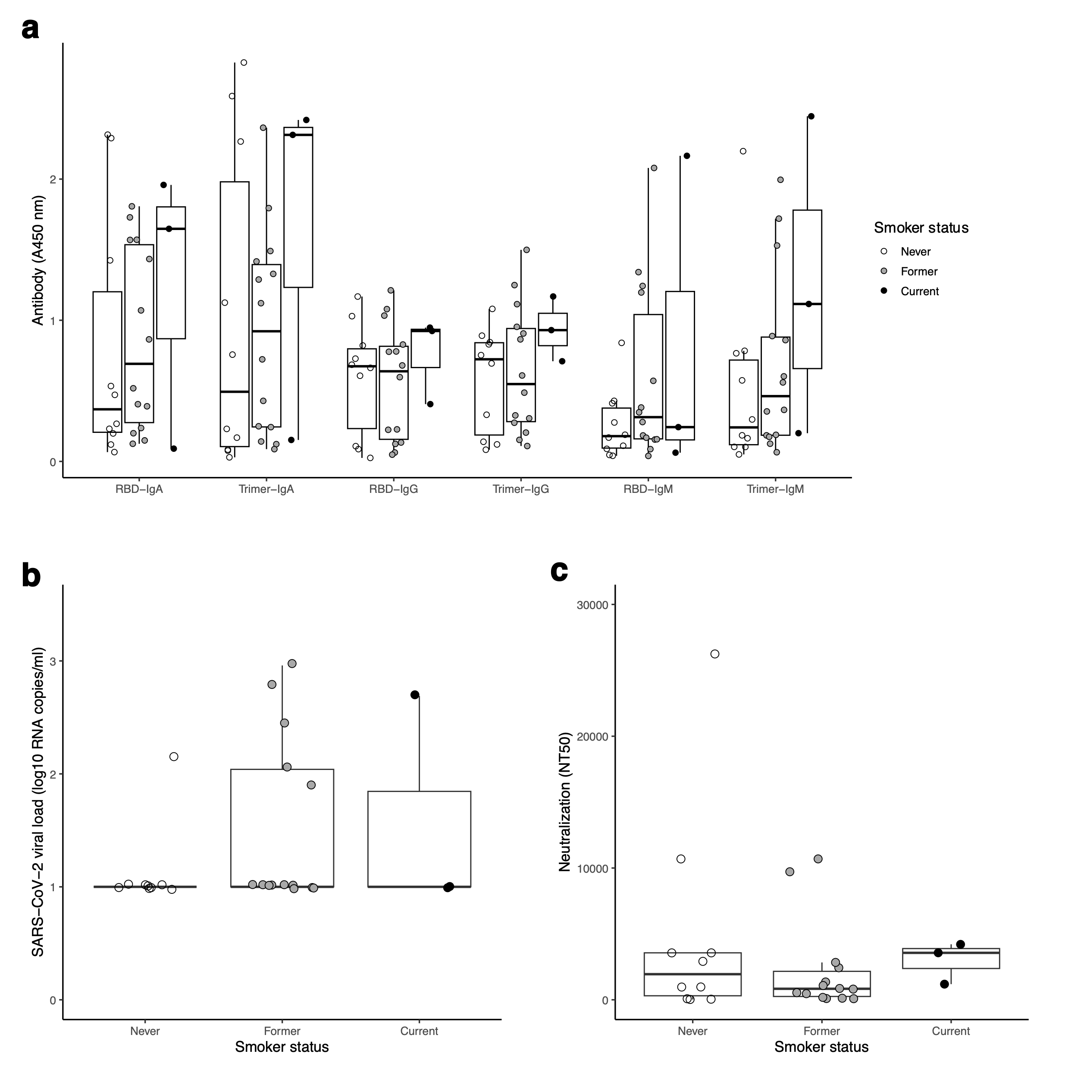

Supplementary Figure S4. Associations between antibodies and viral load with smoking status parsed by former and current smokers. (a) Antibody responses (anti-RBD and anti-Trimer IgM, IgA, IgG) in patients with and without CVD. (b) SARS-CoV-2 plasma viral load of patients with or without CVD. (c) Neutralization antibody titers for patients with and without CVD. Comparisons based on CVD status were made using nonparametric Mann-Whitney U-tests, with adjustments for multiple tests using the false discovery rate. All tests were not significant (Q > 0.05).

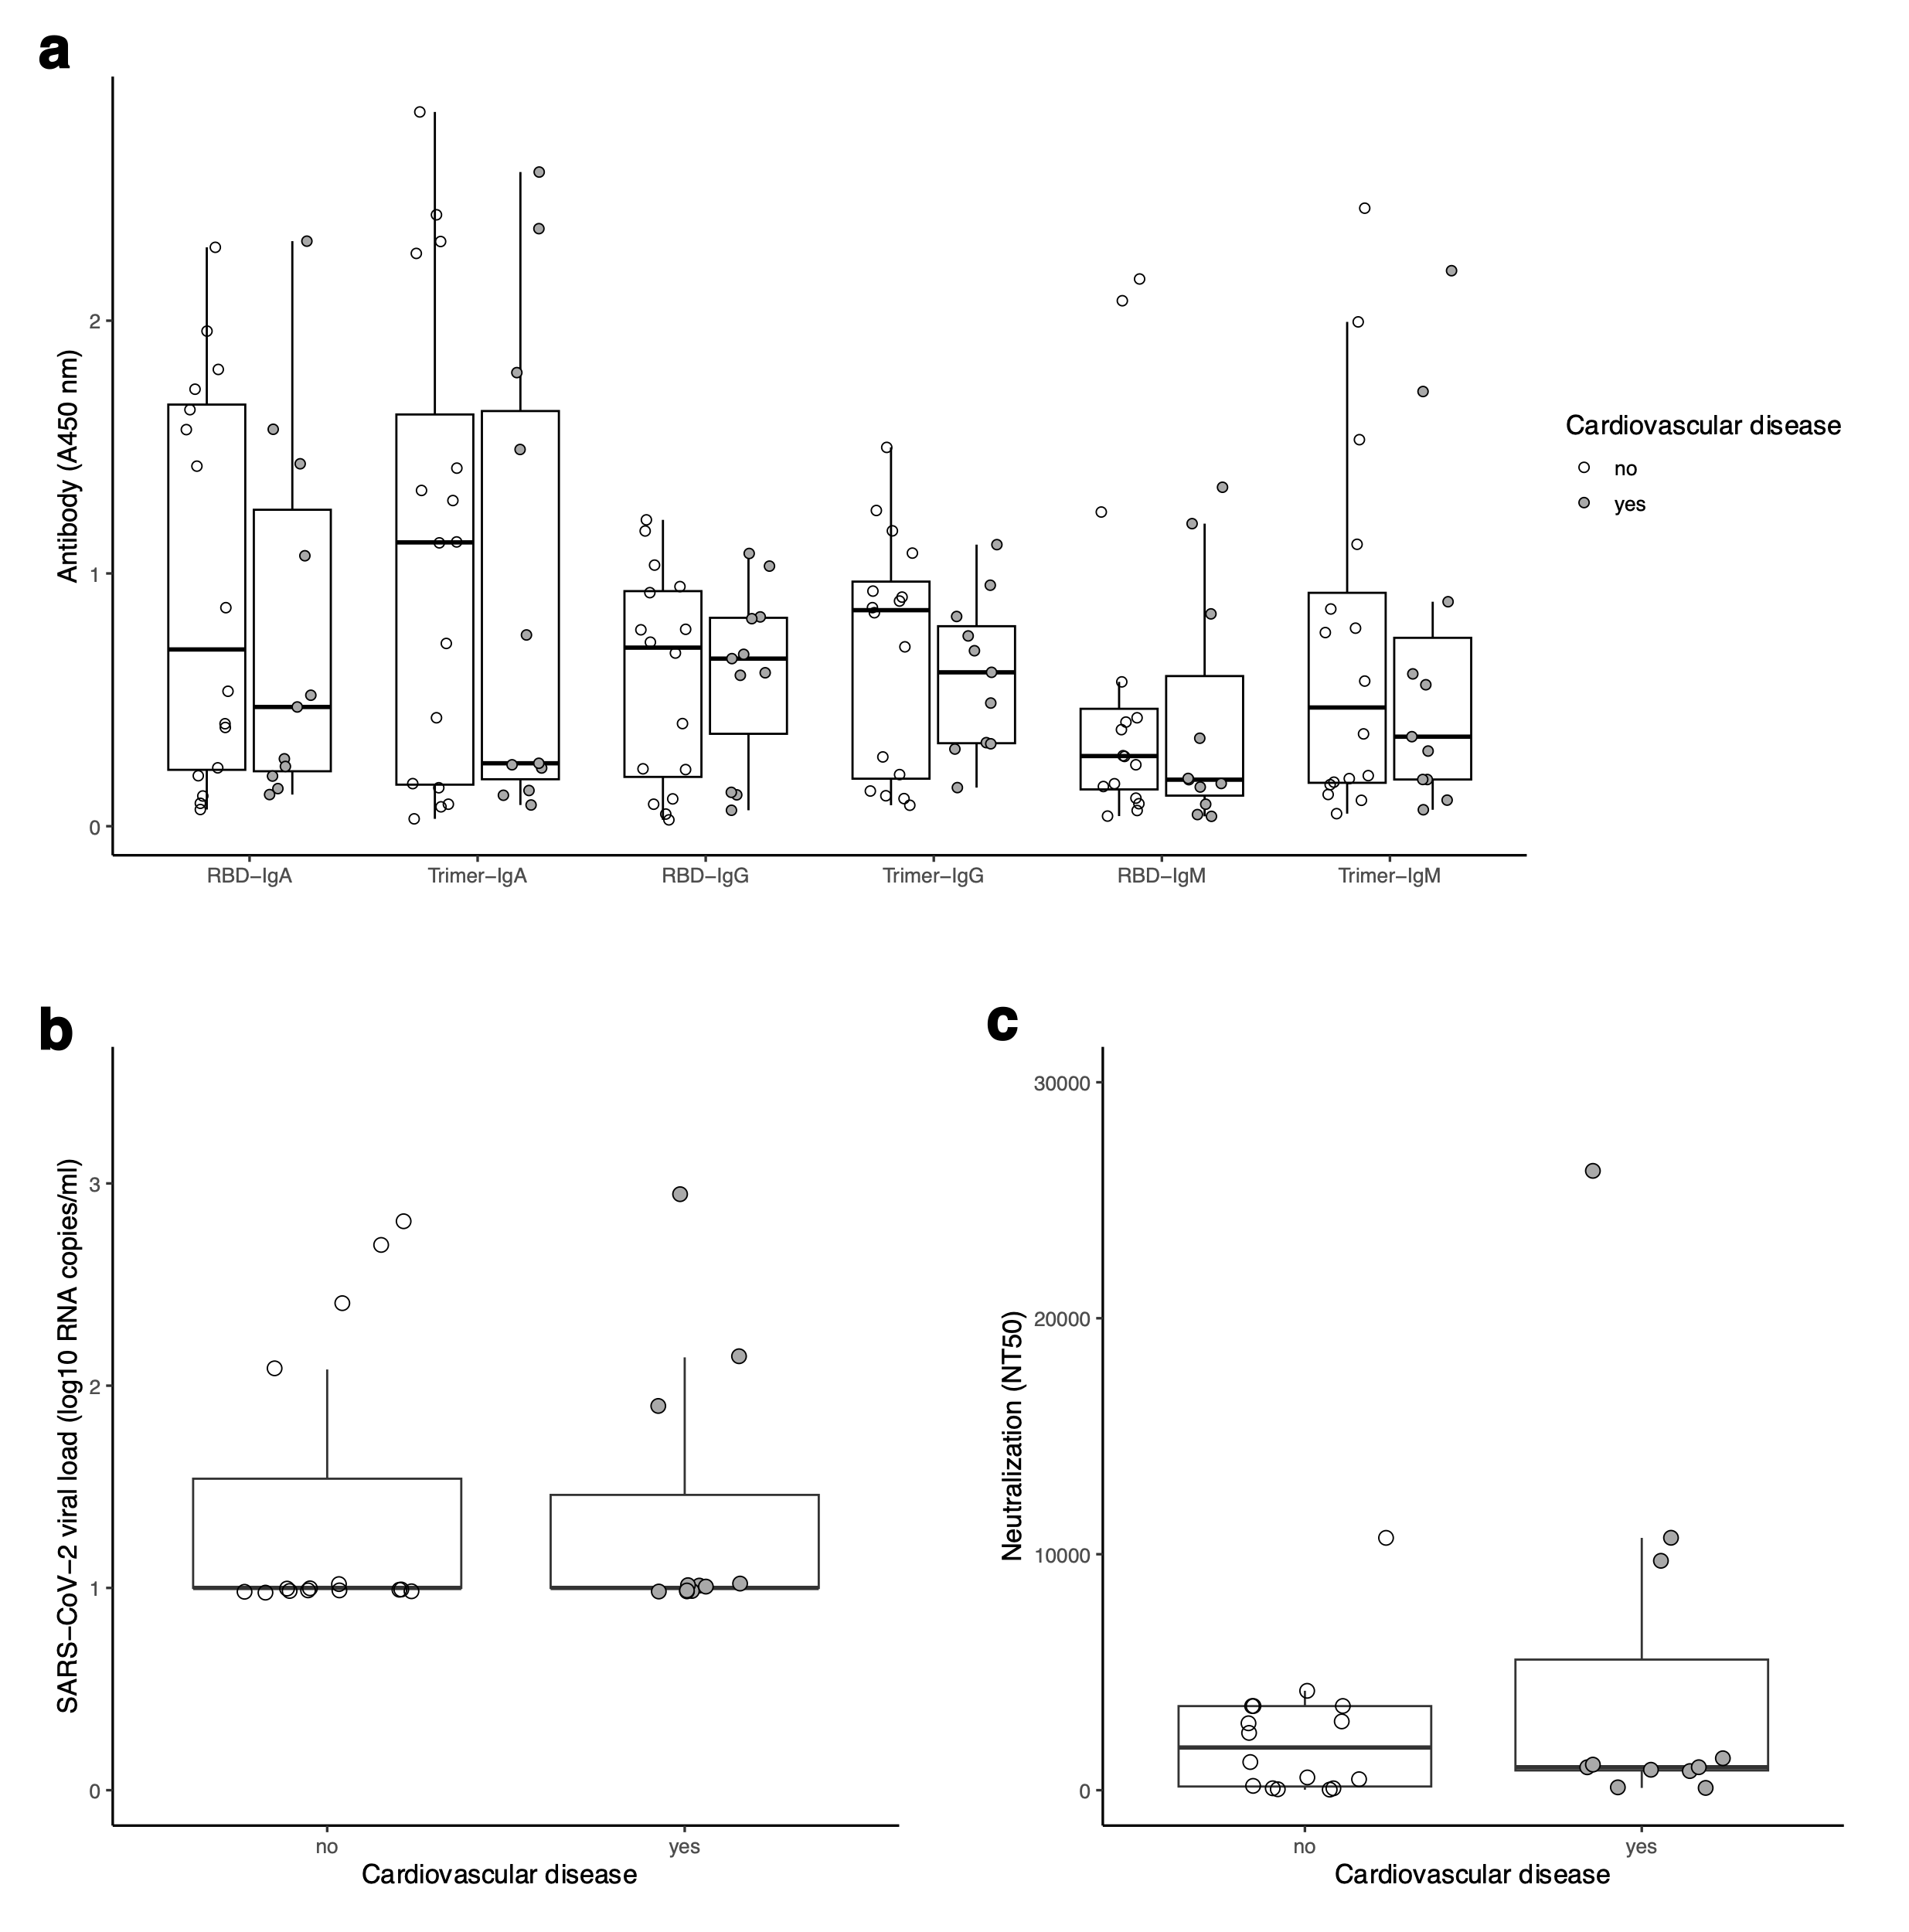
Supplementary Figure S5. No association between cardiovascular disease (CVD) and viral load or antibodies. (a) Antibody responses (anti-RBD and anti-Trimer IgM, IgA, IgG) in patients with and without CVD. (b) SARS-CoV-2 plasma viral load of patients with or without CVD. (c) Neutralization antibody titers for patients with and without CVD. Comparisons based on CVD status were made using nonparametric Mann-Whitney U-tests, with adjustments for multiple tests using the false discovery rate. All tests were not significant (Q > 0.05).

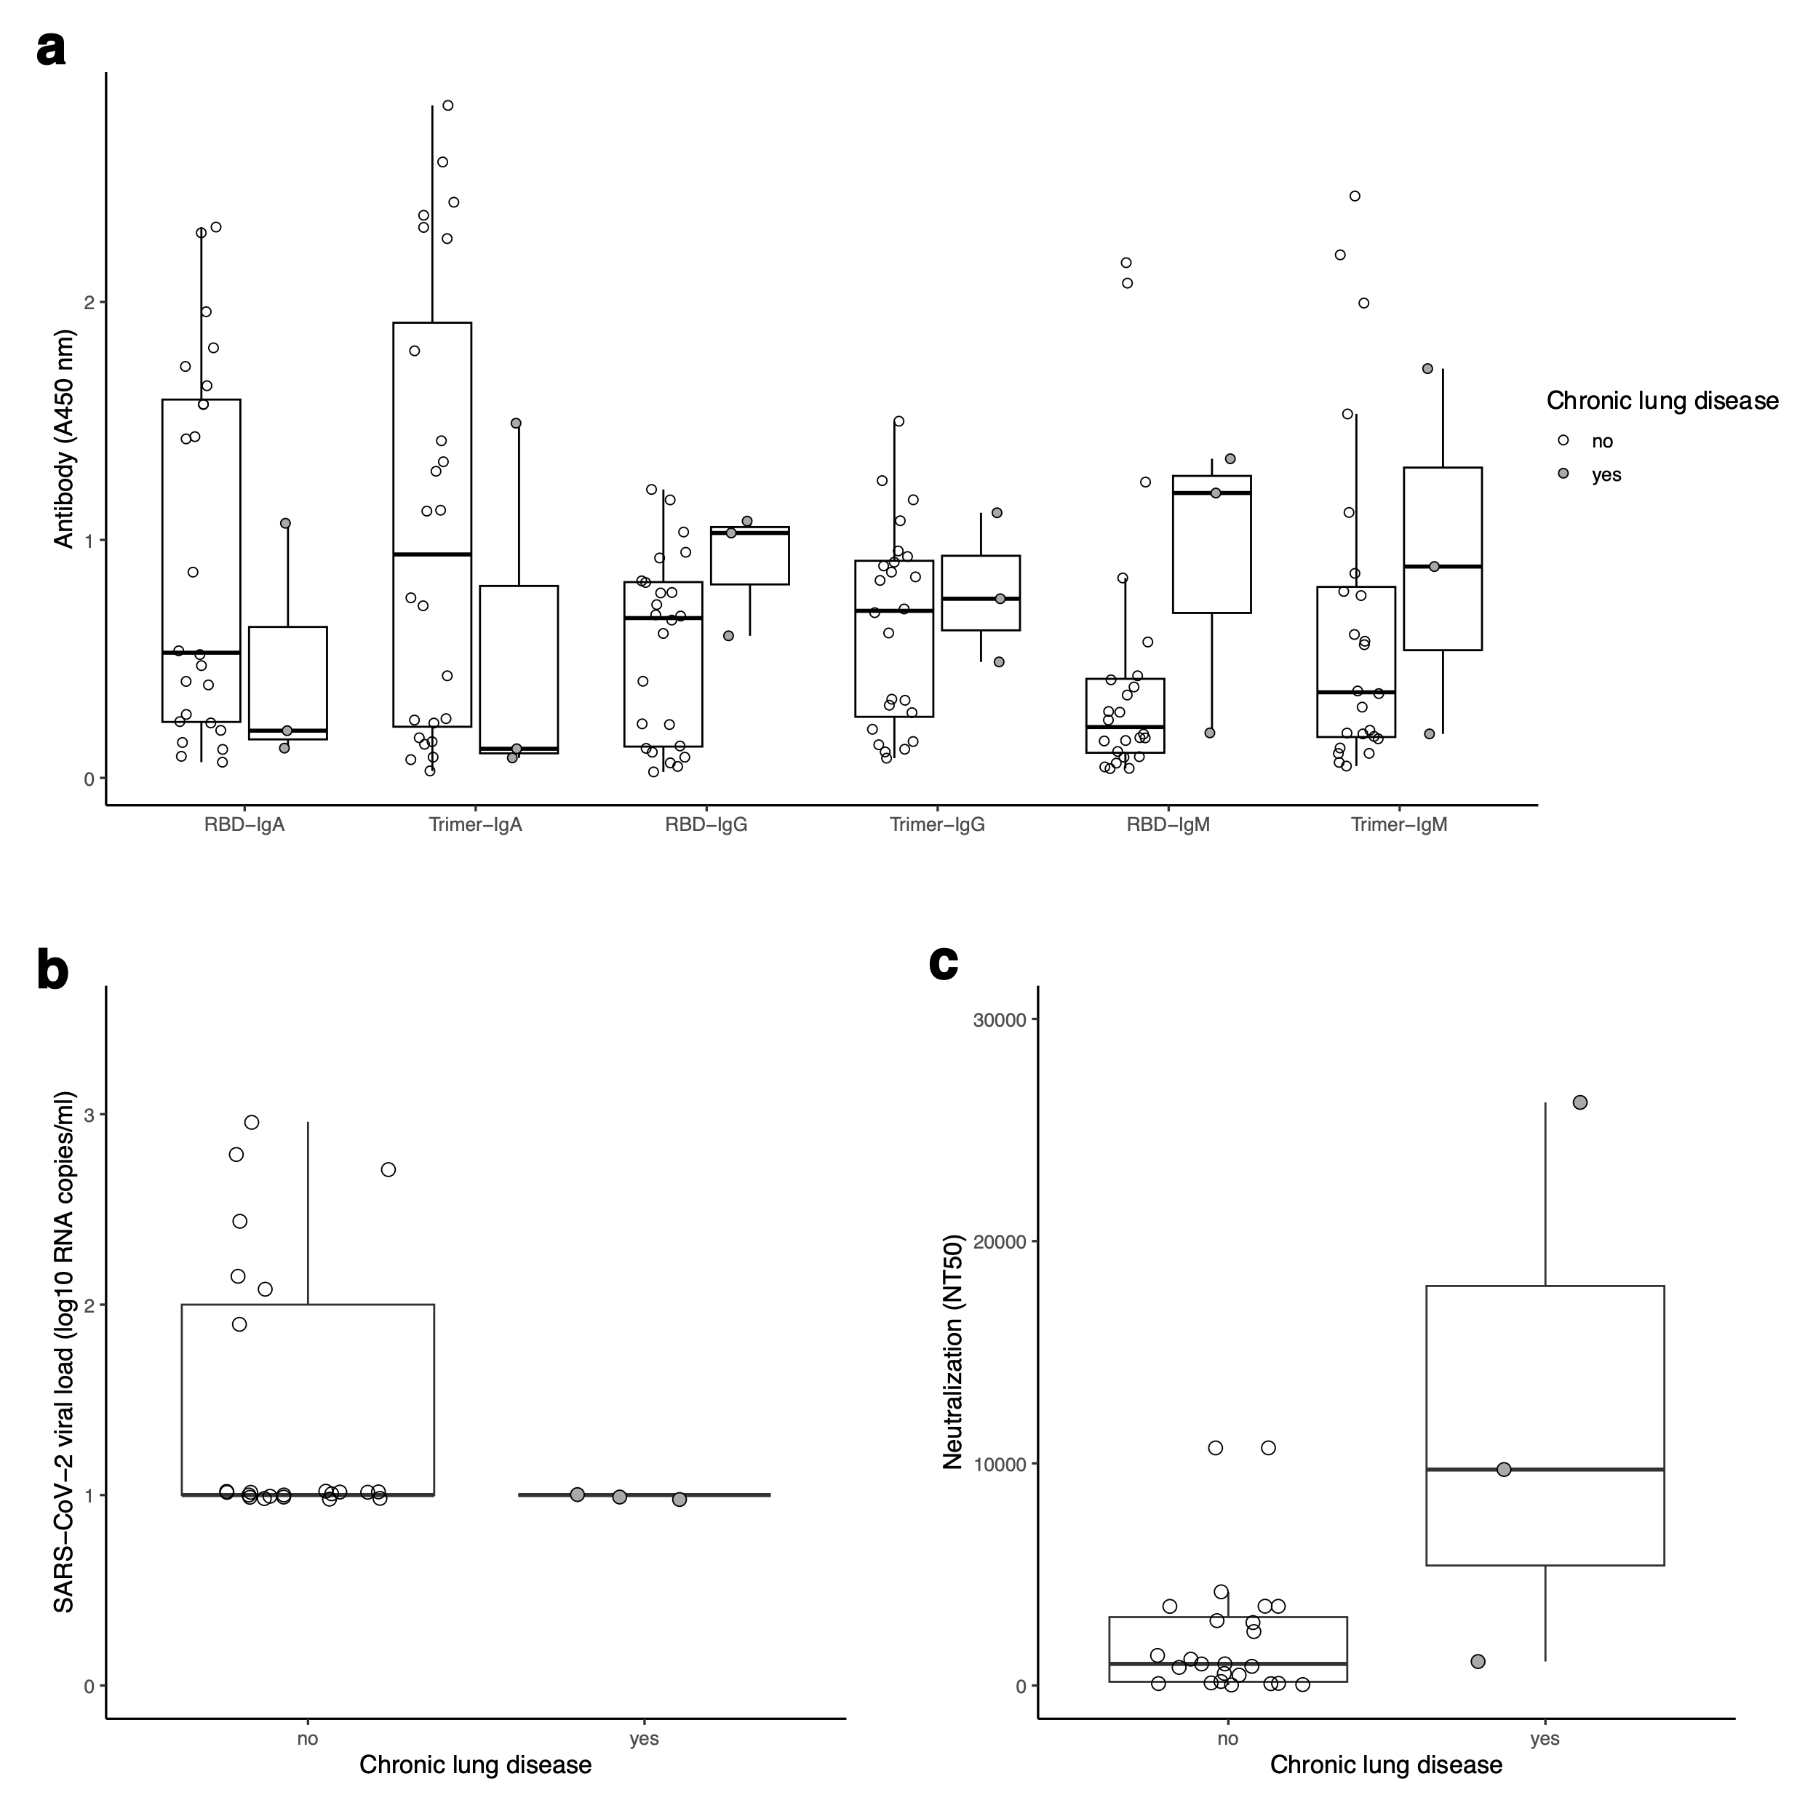
Supplementary Figure S6. No association between chronic lung disease (CLD) and viral load or antibodies. (a) Antibody responses (anti-RBD and anti-Trimer IgM, IgA, IgG) in patients with and without CLD. (b) SARS-CoV-2 plasma viral load of patients with or without CVD. (c) Neutralization antibody titers for patients with and without CLD. Comparisons based on CLD status were made using nonparametric Mann-Whitney U-tests, with adjustments for multiple tests using the false discovery rate. All tests were not significant (Q > 0.05).

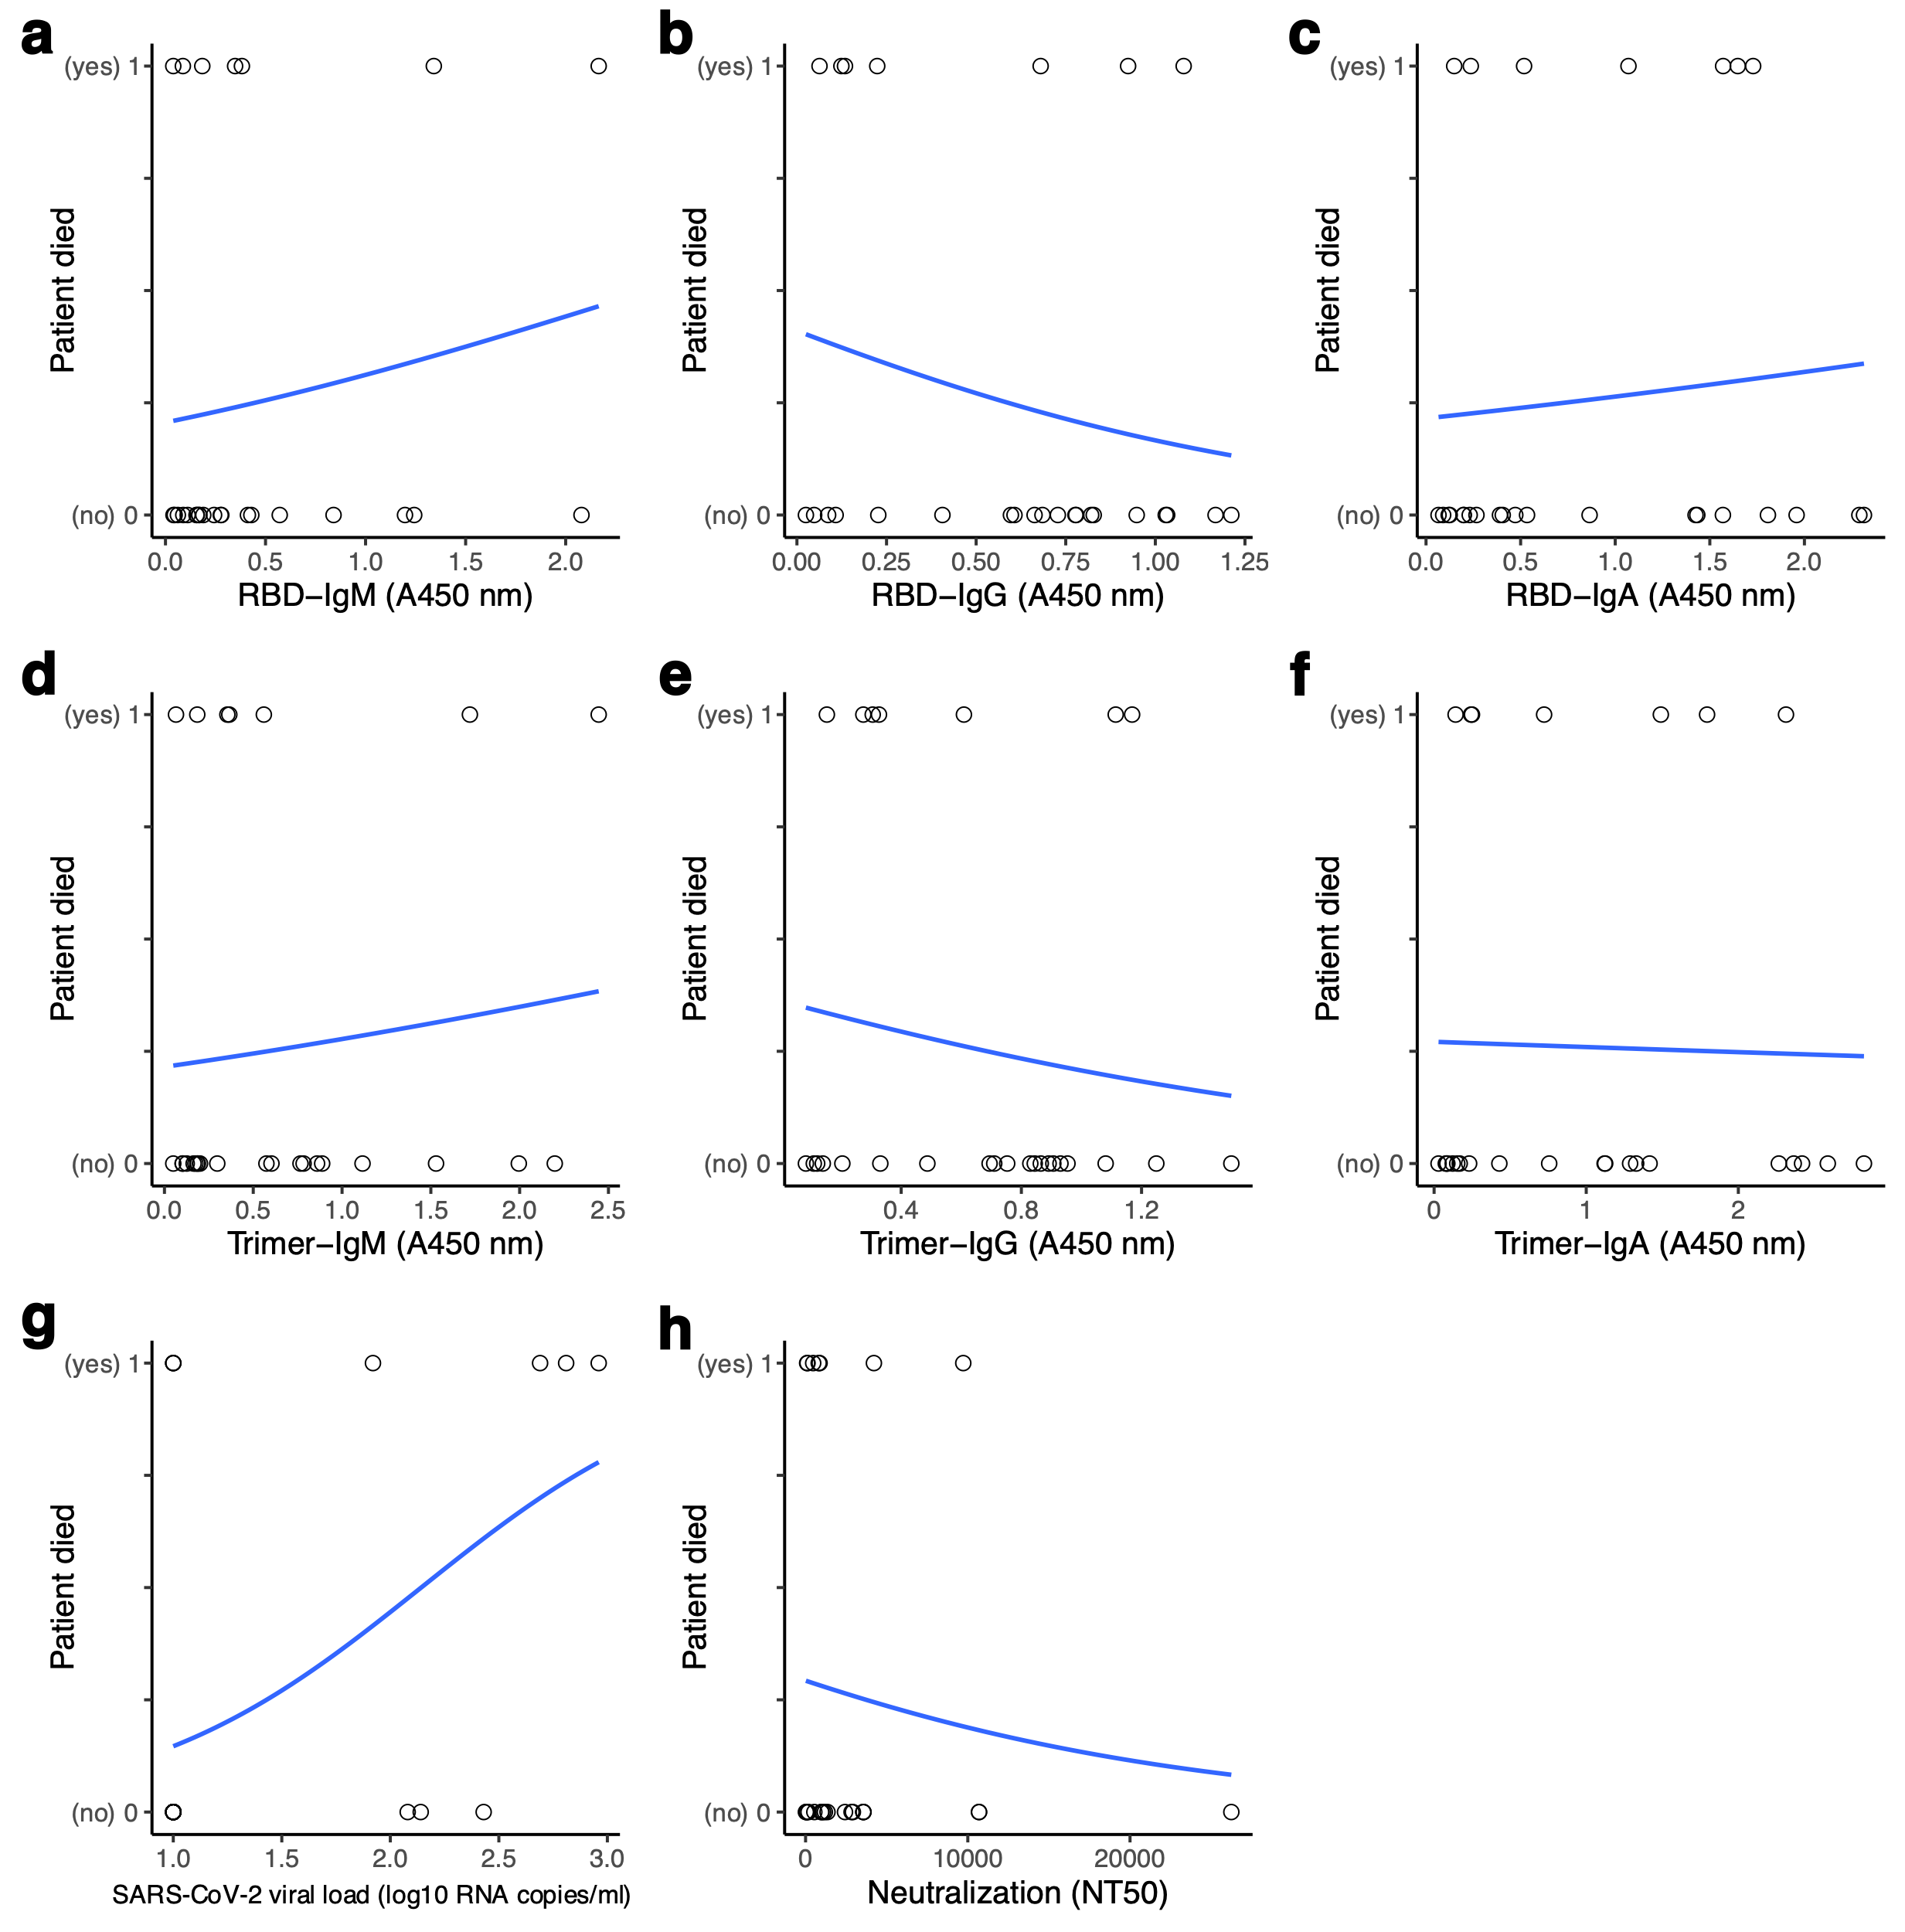
Supplementary Figure S7. Associations between patient death and antibodies or viral load. Logistic regression relationships between whether patients survived or died and (a-c) anti-RBD antibody levels, (d-f) anti-Trimer antibody levels, (g) SARS-CoV-2 plasma viral load, and (f) neutralization antibody titers. The slope of the linear regression analyzing the relationship between death and SARS-CoV-2 plasma viral load was significant (P = 0.03), but after adjusting for running multiple tests all slopes were not significant (Q > 0.05).

