Supplementary Information
Radionuclide therapy based on accumulated urease-powered nanobots in the bladder tumor of an orthotopic murine model
Cristina Simó^{1#}, Meritxell Serra-Casablancas^{2#}, Ana C. Hortelao², Valerio Di Carlo², Sandra Guallar-Garrido³, Sandra Plaza-Garcia¹, Pedro Ramos-Cabrer^{1,4}, Balbino Yagüe¹, Laura Aguado^{1,5}, Lídia Bardía⁶, Sébastien Tosi⁶, Vanessa Gómez-Vallejo¹, Abraham Martín^{4,5}, Tania Patiño^{2,7}, Esther Julián³, Julien Colombelli^{6*}, Jordi Llop^{,1*}, Samuel Sánchez^{2,8*}

¹ Center for Cooperative Research in Biomaterials (CIC biomaGUNE), Basque Research and Technology Alliance (BRTA), Paseo de Miramon 194, 20014, Donostia-San Sebastián, Spain.
² Institute for Bioengineering of Catalonia (IBEC), The Barcelona Institute for Science and Technology (BIST), Baldiri Reixac 10-12, 08028 Barcelona, Spain.
³ Departament de Genètica i de Microbiologia, Facultat de Biociències, Universitat Autònoma de Barcelona, 08193, Bellaterra, Barcelona, Spain
⁴ IKERBASQUE, Basque Foundation for Science, 48013 Bilbao, Spain
⁵ Laboratory of Neuroimaging and biomarkers of inflammation, Achucarro Basque Center for Neuroscience, Science Park UPV/EHU, Sede building B. Sarriena, 48940 Leioa, Spain.
⁶ Institute for Research in Biomedicine (IRB Barcelona), The Barcelona Institute of Science and Technology (BIST). Baldiri Reixac 10, 08028 Barcelona, Spain.
⁷ Biomedical Engineering Department, Institute for Complex Molecular Systems, Technische Universiteit Eindhoven, Het Kranenveld 14, 5612 AZ Eindhoven, The Netherlands
⁸ Institució Catalana de Recerca i Estudis Avançats (ICREA), Passeig de Lluís Companys, 23, 08010 Barcelona, Spain.

Supplementary Video 1 caption:
Enhanced diffusion of urease nanobots in PBS. Video was recorded at 25 fps with a Hamamatsu high-speed CCD camera and a 1.25X objective.
Supplementary Video 2 caption:
Swarming behaviour of urease nanobots in the presence of 300 mM urea. Video was recorded at 25 fps with a Hamamatsu high-speed CCD camera and a 1.25X objective.
Supplementary Video 3 caption:
3D localization of nanobots in urea inside a tumoral bladder, and penetration analysis into the tumor.
The video is a sequence of 8 steps. 0:00-0:03: Rotating view of surface rendering of the bladder followed by Maximum intensity projection (MIP) of scattered signal of the entire sample; 0:04-0:15: slice per slice view of autofluorescence (Bone LUT) and scattered signal (Glow LUT); 0:16-0:21: slice per slice view of nanobots scattered signal (Glow LUT) inside a masked volume that exclude a 500um layer to exclude agarose and muscles; 0:16-0:28: Rotating MIP of the previous nanobots signal showing their distribution in the internal parts of the bladder with tumor; 0:29-0:43: slice per slice view of nanobots scattered signal (Glow LUT) and autofluorescence, together with segmented layers (4 colors: yellow, orange and red in tumor, cyan in urothelium) inside which intensity quantification was made; 0:44-0:51: Rotating view of segmented layers (same layers, 4 colors) to show the concentric layers at the surface of the tumor, and the urothelium “healthy” layer inside the bladder cavity; 0:52-0:57: Rotating view of the scattered signal inside the 4 layers; 0:58-1:06: Summary views, medley of the previous.

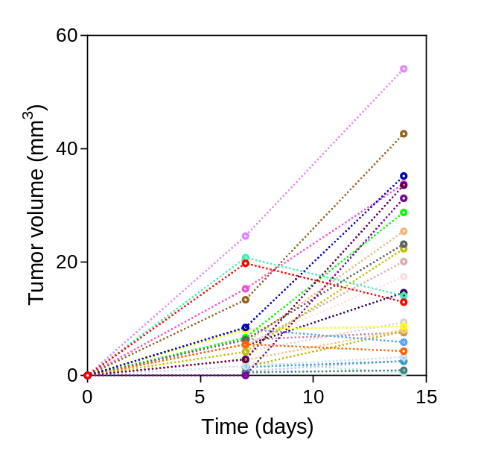
Figure S1: Tumor volume evolution over time determined by MRI for all animals developing tumor (n=27) at day 7 and 14 from cell implantation. Each colour represents an individual animal.

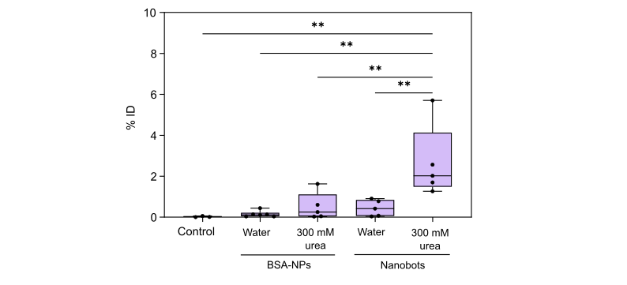
Figure S2: Radioactivity accumulation in the tumor for control (healthy) animals, and animals included in all groups (determined by PET). Results are expressed as percentage of injected dose (% ID) in box and whiskers. Statistical analysis performed with one-way ANOVA.

Figure S3: Confocal microscopy in ex vivo bladders
Representative sections of three animal conditions (middle cut in the organ) are shown: A-C tumoral bladder without nanobots; D-F with nanobots in water; G-K with nanobots in urea. A, D, G: Image in the far red channel (660-836nm) to target nanobots by antiFITC Alexa647. B, E, H: Image in the green channel (494-602nm) to target nanobots by FITC. C, F, J, K: insets of Regions of Interest (ROI) drawn in B, E, H with, from left to right: Far red, Green, DAPI, Green (in green) with Far red (magenta), and Green (in green) with DAPI (in magenta). ROI2 shows necrotic tissues (with diffuse DAPI label) belonging to the intralumen tumour edge, ROI1 and ROI3 show regions where intensity features in the green channel are well above tissue background. No correlation between Green and Far red channel was detected. Scale bar in C: 200 µm.
.

Supplementary Discussion on Confocal imaging of nanobots in ex-vivo bladders
To overcome the resolution of PET imaging, insufficient to obtain in-depth radioactivity profiles in the tumors, we made use of confocal fluorescence microscopy of FITC-urease nanobots to try to determine their distribution within the body of urinary bladder and penetration to the tumor. Additionally, hypothesizing that FITC would conflict with tissue autofluorescence, nanobots were further labelled with a secondary far red Alexa647 fluorophore. 10 female mice were inoculated intravesically with MB49 cells, and tumor growth was monitored at days 7 and 14 after cell implantation by MRI, following the same procedure described above. For confocal fluorescence microscopy, animals were randomized in three groups: (1) FITC-urease nanobots administered in ultrapure water; (2) FITC-urease nanobots administered in 300 mM urea solution in water; and (3) absence of nanobots (control). The procedure of administration of FITC-nanobots was the same described for PET imaging studies (1 h incubation). After 3 h post-administration, animals were sacrificed, and the bladders were collected, frozen and analyzed by confocal fluorescence microscopy.
Representative confocal images of thin (10 µm) histological slices (middle plane of the organ) of the three cases are displayed in Supp. Fig. S3. Nanobots were stained with a secondary anti-FITC Alexa Fluor 647. to circumvent the high tissue autofluorescence, which interferes with the direct staining of FITC positive nanobots, as shown in Supp. Fig. S3 A,D,G. All histological sections were labelled identically, and three sections per animal (caudal, middle and cranial cuts) were imaged for all animals treated (4 animals for nanobots with urea, 4 with nanobots in water, 2 controls without nanobots). Comparison of image channels targeted to FITC and Alexa647 unfortunately did not reveal any signal correlation in the three cases (shown in Supp. Fig. S3, color panels in C, F, J, K: with urea, with water, without nanobots). In particular, by qualitatively analysing the highest intensity areas in images (i.e. above background, represented in Supp. FigS3 insets C, F, J, K), we observed, on one hand, that high levels of autofluorescence are induced in important portions of tumor tissues, in all conditions, where DAPI labelling seemed to fail, hence suggesting the presence of necrotic tissue that may shield the sensitivity of the imaging in the green channel, precisely where FITC-nanobots were hoped to be detected. On the other hand, no significant correlation between green (for FITC) and far red (for antiFITC) channels could be visualized, suggesting that none of the high intensities could be attributed to nanobots, in all sections, In particular, the comparison of control animals without nanobots to other animals with nanobots yielded similar observations, hence confirming that fluorescence imaging did not enable to detect nanobots specifically with sufficient confidence. From this outcome, we sought an alternative label free optical technique to detect nanobots, on one hand to circumvent the low fluorescence levels issues, and on the other hand to improve on the potential issue of sparse nanobots localization in 2D histological sections, for which those preliminary results did not encourage us to pursue the costly pipeline of labelling and imaging all sections of bladders.

Figure S4: Polarized Scattered Lightsheet (sLS) microscopy with nanobots in vitro and in healthy bladder tissues. A-E) Gold-coated FITC-labelled silica nanoparticles (FITC-nanobots, 450 nm diameter) and commercial red silica beads (1µm diameter) mounted in a cleared agarose block imaged at 9.6x with lightsheet microscopy. Top: scheme of lightsheet illumination with different represented particles (see also N) and combinations of laser lines and filters detection; Bottom: maximum intensity projections (MIP) over a small area of 125 µm depth. FITC-nanobots and red beads are imaged across three spectrally different channels: green bandpass (A), green/red longpass (B) and red bandpass (D), and with sLS induced at laser lines 561 nm laser (C) or 638 nm (E). Both particles are detected by sLS, as pointed with green (nanobots) and red (red beads) arrowheads. Dark grey arrowheads point at unlabeled particles or larger agarose crystals that generate scattered signal. In A, faint signal originates from crosstalk of red beads into the green channel. F-G) in the same sample, over a small area of 57.5 µm depth, strong photobleaching of FITC particles is shown from F (first time imaged) to G (imaged 6 times) as shown by the relative intensity of FITC-nanobots pointed by orange arrowheads. H-J) Red beads before and after 6 repeated stacks. K-M) MIP of sLS signal of the same volume induced by 638 nm, as in E, with horizontally polarized illumination (H-LS, in K), vertically polarized (V-LS, in L) with two different pixel intensity scales reported below the images. N) Scheme of polarized sLS: a half-wave plate (HWP) tunes the polarization orientation of the lightsheet (H-LS or V-LS: horizontal means parallel to the plane of incidence), and a polarizer is combined with the fluorescence filter to select the detected polarization by the camera (named H-CAM or V-CAM). The grey box reports symbols for elements shown in A-E and N. O-P) A cleared healthy bladder tissue (without tumor, without particles) visualized by autofluorescence (AF): middle plane O, zoomed in P from dashed rectangle in O. Q-X) sLS in the same plane with combinations of H-LS and H-CAM, and V-LS and V-CAM. All images shown at the same intensity scale. H-LS induces strong scattering from the whole tissue and from the external agarose block, while V-LS induces a weaker response, but with drastically reduced scattered signal, where in practice only the urothelium and some locations in the detrusor muscles generate weak signal. Scale bars and look-up tables (LUT, from ImageJ/Fiji): A, 20µm with “ICA” LUT integrated applied to O-P, Q-R, U-V: Grey LUT; A-E, F-M, S-T, W-X: “biop12colors” LUT; O: 1 mm; Q-T: 500 µm, U-X: 1 mm. Integrated LUT in scale bars: Grey in Q-R, U-V, “biop12colors” in S-T, W-X.

Figure S5: Polarized scattered lightsheet (sLS) microscopy reveals nanobots in bladder tissues with tumors. Scattered imaging applied to bladders with tumor, with nanobots (A-F) and without (H-M). A) Autofluorescence in the midplane of the bladder, also shown in Figure 5. B, C) H-LS illumination with H-CAM detection shows strong scattered response in the tumor and in the external agarose block. D) Zoomed from dashed area in B. E, F) V-LS illumination with V-CAM detection shows drastically reduced scattered response in agarose and tumor, but a strongly maintained scattered signal where nanobots are located (as shown in G, zoomed from dashed are in E). H-M) In the control bladder with tumor but without nanobots, H-LS with H-CAM similarly generates strong signal in the tumor and agarose block, but V-LS with V-CAM extinguishes most of this response to leave only residual signal from urothelium and muscles, similar to the healthy tissue control in Fig. S4. L-M: cropped images from J-K dashed area to show the background suppression in the agarose block from H-LS/H-CAM to V-LS/V-CAM, showing the specific suppression of scattered signal when compared to agar crystals, also shown in Fig. S4-C,E that maintain a strong signal. Color scales (ImageJ/Fiji), B, E: “Glow” LUT; C,D,F,G,J-M: “biop12colors” LUT. Scale bars: A,B: 300µm; E: 600µm; H: 500µm.

Supplementary discussion on Polarized Scattered Light sheet (sLS) microscopy to detect nanoparticles in ex-vivo bladder tissues
To detect 450nm-sized nanobots by sLS in whole tumoral bladders, we first optimized sLS to reveal nanobots specifically against background noise of reflected laser light. We implemented sLS imaging with polarization control both in illumination and in detection, following previous work that suggested this approach as a way to enhance image quality and signal-to-noise-ratio (SNR) for label-free sLS imaging. Herein and in Supplementary Figures S4-S5, we refer to lightsheet illumination with horizontal (H-LS) and vertical (V-LS) polarizations, respectively, and to H-CAM and V-CAM for a horizontally and vertically polarized detection (CAM: Camera). For convenience, we report the use of two configurations that we name H-H for horizontally polarized illumination and detection, and V-V for vertical polarized illumination and detection, as shown with the optical configuration in Fig. Supp S4 N. Here, we aimed to find the best polarization combination that could enhance nanobots detection in vitro in cleared agarose blocks, and we demonstrate that “vertically-oriented” polarization, both in illumination and detection (V-LS and V-CAM, respectively, or V-V, in Supp. Fig S4N), yields imaging in tissues with the lowest laser background noise conditions.
We started with comparing sLS detection efficiency with FITC-labelled nanobots (450nm in size) and commercial red-fluorescent silica particles (1µm) mounted in agarose blocks, cleared prior to imaging. We could show (Supp. Fig. S4A-E) that even at moderate magnification (9.6x), both types of particles were detectable in fluorescence (Supp Fig S4 A, B, D, F-G) and sLS (Supp Fig S4-C, E, K-M), although FITC nanobots featured a very high instability with fast photobleaching after few frames in a short time lapse (6 time points: Supp. Fig. S4 F-G). We also showed that V-LS illumination enables to decrease scattered signal from the agarose, and to increase the specific Signal-to-noise-ratio (SNR) of nanobots (Supp. Fig. S4K-M).
Next we characterized cleared bladder tissues under sLS, with and without tumor, and with and without nanobots. In a healthy bladder tissue (Supp. Fig. S4O-X), we observed that sLS imaging provides a label-free image, complementary to autofluorescence imaging, and that the scattered signal is much stronger with H-H than with V-V. However, a careful comparison of the two conditions showed that the bladder tissues, here without nanoparticles, answer in a complex way to changes in polarization: the background sLS signal does not simply decrease uniformly with the change of illumination polarization, but rather follows a tissue-specific response. More specifically, we show that H-H induces the collection of strong sLS signal both in the tissue and the surrounding agarose (Supp. Fig. S4S,W), while the V-V configuration attenuates most of this signal, but leaves residual sLS signal emanating from the urothelium and muscle tissues (Supp. Fig. S4,Q-X).
The explanation of this phenomenon is beyond the scope of this study, but we conclude here that polarization control in sLS may enable, on one hand, to enhance the response of nanoparticles by decreasing nonspecific background scattered light (as shown in agarose (Supp. Fig. S3,K-M), and on the other hand that a similar signal enhancement could be obtained in cleared tissues, keeping in mind that other structures may also display a polarization-specific response.
Next, we addressed whether this effect can be exploited to improve the detection of nanobots in bladder tissues with and without tumors. The H-H to V-V sLS signal comparison in a bladder with tumor showed (Supp. Fig. S5, H-M) that H-H signal emanating specifically from a tumor tissue is actually even stronger than in the surrounding healthy tissue. However, using V-V configuration we could show that tumor-specific signal can be totally damped (Supp. Fig. S5K), while residual sLS signal from urothelium and detrusor muscles are still visible, similar to the case of healthy bladder (previously in Supp Fig S4). When repeating the experiment in a bladder with tumor and injected urease nanobots, we now observed that, again, the strong sLS response of the tumour visible in H-H is greatly attenuated with V-V (in Supp. Fig. S5, compare D and G), however with the striking difference that specific signal from nanobots remains observable. This is shown in Supp Fig. S5B-F, in a single optical section, where enriched signal emanates from the tumor surface, while scattered signal heavily drops from H-H to V-V in the tumor body, the Lamina propria and the surrounding agarose. Noteworthy, as shown previously with nanobots in Agarose blocks (Supp. Fig S4), foci of scattered signal in Agarose do remain visible with V-V while the background in the agarose damps (Supp. Fig. S5L,M), suggesting that the polarization dependence of the scattered signal could be conditioned by the characteristic scale and local structure of the scatterers.
To confirm that V-V sLS imaging enables to enhance nanobots scattered signal, we then compared the total 3D intensity of scattered signal in bladder tissues with tumor and Urease-nanobots in urea- (Fig. 4A,B), with tumor and urease nanobots in water (Fig. 4C,D), with tumor and without nanobots (Fig. 4E,F), in a healthy bladder without tumor and particles (Fig. 4J,K), and in healthy bladder with nanobots in urea (Fig. 4G,H). Importantly, we analyzed the scattered signal in a masked volume (see Methods) that includes bladder inner tissues (urothelium, Lamina propria, tumor when present) but that excludes the inner cavity and the Detrusor muscles, as the latter were shown to induce specific scattered signal (in Supp Fig. S4). Intensity profiles in Fig. 4L,M clearly show that the presence of nanobots in urea induces very high levels of measured signal, both in a bladder with or without tumor, while tissue without particles show consistently similar distributions of very low intensities. Comparing nanobots in urea in bladder with tumor and without, we clearly observed foci of high intensities in both, but a vastly more enriched distribution around the tumor. Interestingly, in the bladder with tumor and nanobots in water (Fig. 4C,D), the intensity distribution was similar to that of tissues without particles, with no observable foci standing out from the background signal of the tissue.
In summary, we showed that a suitable polarization configuration enables to almost completely extinguish the dominant laser scattered background from both tissue and surrounding agarose, in healthy bladders (Supp. Fig. S4O-X) and in particular in tumoral bladder (Supp. Fig. S5H-K), whereas unsuitable, uncontrolled or random polarization configurations may generate a very high scattered light response in the tumor, hence summing to the particles signal and making them undetectable specifically. In turn, we could show that in bladders with nanobots, an enhanced nanobot-specific scattered signal can be revealed while most of the background signal of tissue or tumor can be damped (Supp. Fig. S5). From this consistent outcome, we conclude that the V-V polarization configuration in scattered lightsheet microscopy enables to detect nanobots in whole bladders by enhancing their response into clearly visible foci of scattered light that stands out from tissue background signal.

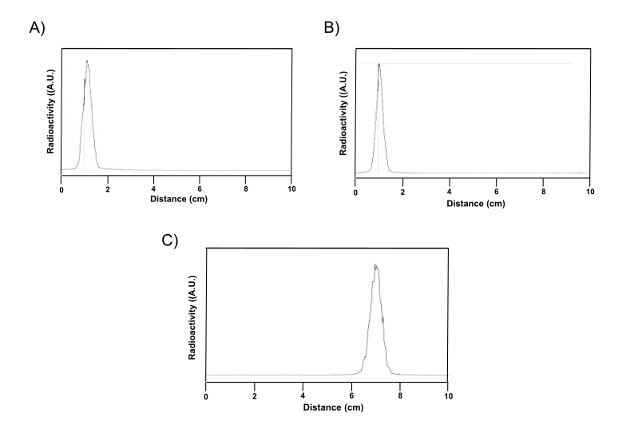
Figure S6. Thin layer chromatography profiles obtained after analysis of ¹³¹I-nanobots incubated in (A) water and (B) 300 mM aqueous solution of urea for 1 h at 37°C. The presence of a single peak at the seeding point confirms the stability of the labelled nanobots. A control analysis corresponding to free ¹³¹I-iodide is shown in (C).

Di Battista D, Merino D, Zacharakis G, et al. Enhanced Light Sheet Elastic Scattering Microscopy by Using a Supercontinuum Laser. (2019) Methods Protoc 2(3), 57

