Mapping brain structural differences and neuroreceptor correlates in Parkinson’s disease visual hallucinations: a mega-analysis
Supplemental Information

S1. The ComBat harmonisation method and its application on this dataset.
As noted in the Methods section, this algorithm was first developed for genomics analyses requiring to pool together data from different datasets (Johnson, Li and Rabinovic, 2007) and has been recently adapted to other measures, such as cortical thickness (Fortin et al., 2018). ComBat applies empirical Bayes (EB) estimation to account for site-specific variance by using an error with a multiplicative scaling factor that is scanner specific. The model allows to retain biological variance, such as that related to age, gender and disease (in our case, hallucinators and non hallucinators), variables that are entered the model as a vector. The algorithm is used on segmented and parcellated data, before running any other statistical analysis and has proven extremely reliable for this type of analyses as described in Fortin et al., 2018 and more recently by Radua et al., 2020. Hierarchical Bayes (HB) is also being proposed to harmonise data from different sites (Kia et al., 2020¹). However, we chose to use EB and as the purpose of this study was not to assess the suitability of harmonisation models but to build on such harmonisation to develop models for the understanding of the mechanisms underlying visual hallucinations in PD. Secondly, EB is less dependent on the hyper-parameter settings and thus uses data more directly, which for our purposes was the most suitable choice, as HB would possibly be more suitable for approaches whereby a careful specification of hyper-parameters is crucial, as is the case for normative modelling (Kia et al., 2020¹).
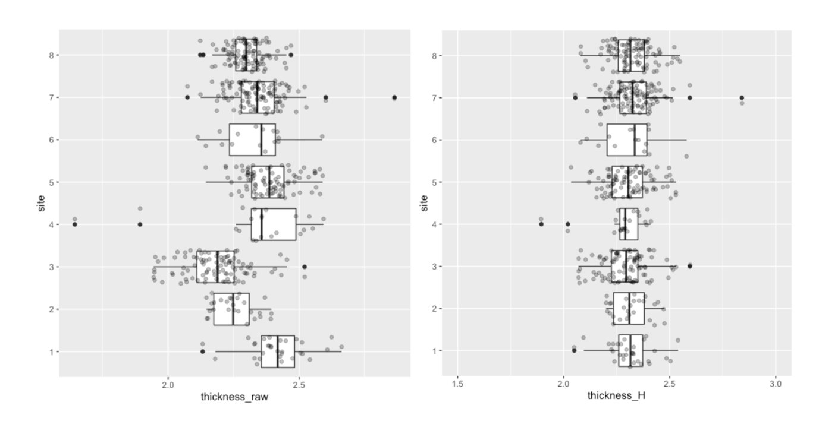Figure S1. Mean thickness before (thickness_raw) and after harmonisation (thickness_H). On the X axis thickness values, on the Y axis the numbers correspond to the different sites. Sites: 1 = University of Lille; 2 = Hong Kong University; 3 = Yonsei University; 4 = Newcastle University; 5 = University of Sydney; 6 = KCL (Dr. ffytche); 7 = University College London ; 8 = Oxford Discovery Cohort.
S2. Additional information on the full sample.
Meta-analysis to determine whether participants in the full sample (N=493) are matched on the relevant demographic and clinical variables. As we did not have raw data for all groups for all relevant variables, we tested whether our participants were overall matched for age, onset, MMSE, UPDRS and LED. The analysis was carried out with R package ‘metafor’. Results show that participants are overall matched for age, PD motor severity as assessed by the UPDRS-III total score, onset and levodopa equivalent daily dose (LED). The model shows a trend towards significant driven by the KCL dataset (N= 15) for the MMSE variable.

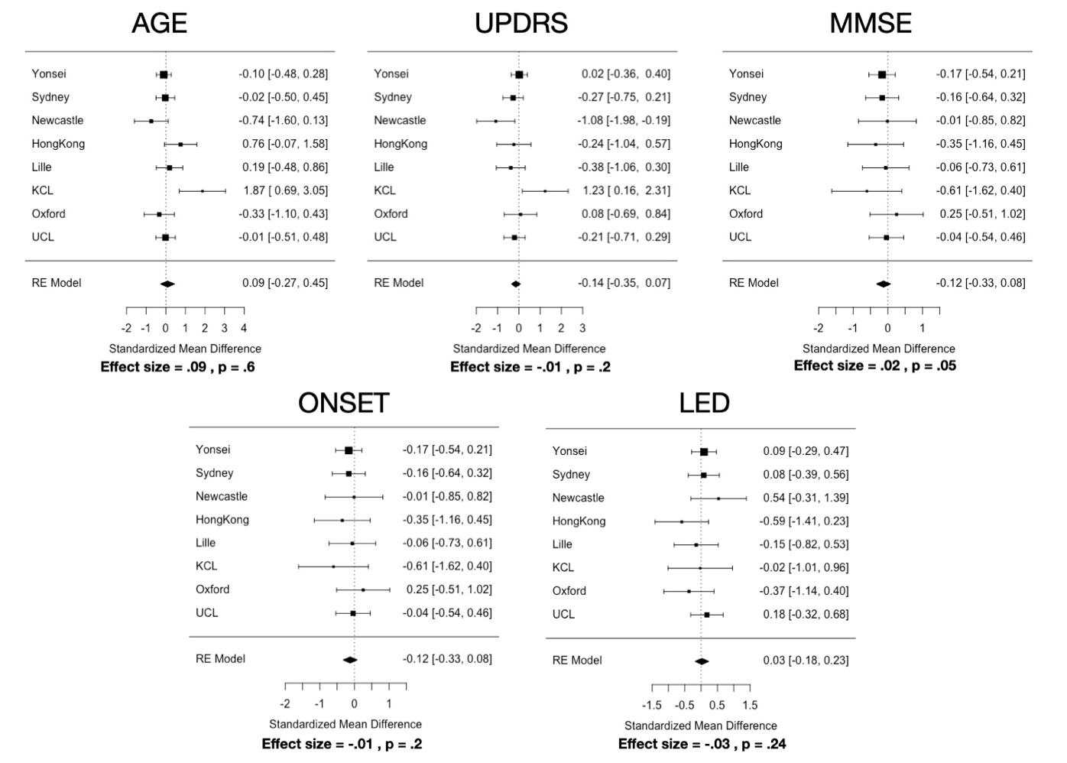
Information on values for brain volume, total intracranial volume (TIV), total gray matter volume (GM) and age differences in the full sample. Brain vol. (seg) describes the volume of all voxels in the aparc+aseg.mgz based on which the morphometric information were extracted. This includes voxels that are not background or brainstem, and includes vessel, optic chiasm and CSF segmentations. PD-VH did not significantly differ in TIV from PD-noVH (PD-VH, 1488363.39 ± 192038.64, PD-noVH, 1512273.57 ± 216293.33, p = .84), in the segmented brain volume (PD-VH =0.74 ± 0.05, PD-noVH = 0.74± 0.06, p = .12) but did differ in terms of gray matter volume (PD-VH 559525.16± 63591.98, PD-noVH 584869.68± 71580.08, p = .02).

S3. Table for thickness, surface area and volume differences in PD with VH vs. PD no VH patients. Regions are reported in descendent order of significance (p value).

Cortical thickness MANCOVA (covariates: age, gender, TIV)
Region | df | Mean Square | F | p | Partial Eta Squared
R_precuneus | 1, 488 | 0.456 | 16.330 | 0.000 | 0.032
L occipitotemporal | 1, 488 | 0.402 | 15.570 | 0.000 | 0.031
R_planumtemp | 1, 488 | 0.589 | 14.878 | 0.000 | 0.030
L_sup_par | 1, 488 | 0.397 | 14.624 | 0.000 | 0.029
R_ips | 1, 488 | 0.246 | 13.016 | 0.000 | 0.026
R_parietalS | 1, 488 | 0.318 | 12.189 | 0.001 | 0.024
L_ips | 1, 488 | 0.207 | 11.994 | 0.001 | 0.024
R_occAnt_sul | 1, 488 | 0.394 | 11.724 | 0.001 | 0.023
L_STempSul | 1, 488 | 0.195 | 11.464 | 0.001 | 0.023
L_occAnt_sulc | 1, 488 | 0.424 | 11.420 | 0.001 | 0.023
R_supTempsul | 1, 488 | 0.203 | 11.344 | 0.001 | 0.023
L_precuneus | 1, 488 | 0.307 | 10.744 | 0.001 | 0.022
L_ifg_orb | 1, 488 | 0.477 | 10.620 | 0.001 | 0.021
R_occipitotemporal | 1, 488 | 0.291 | 10.614 | 0.001 | 0.021
R_insula (short) | 1, 488 | 0.929 | 10.431 | 0.001 | 0.021
R_ifgTr | 1, 488 | 0.321 | 10.421 | 0.001 | 0.021
R_frontopolTrs | 1, 488 | 0.309 | 10.217 | 0.001 | 0.021
R_mfg | 1, 488 | 0.194 | 10.107 | 0.002 | 0.020
L_sfg | 1, 488 | 0.229 | 9.913 | 0.002 | 0.020
L_itg | 1, 488 | 0.338 | 9.699 | 0.002 | 0.019
L_cingMarg_s | 1, 488 | 0.240 | 9.647 | 0.002 | 0.019
L_ifg_op | 1, 488 | 0.234 | 9.454 | 0.002 | 0.019
L_inf_angular | 1, 488 | 0.244 | 9.385 | 0.002 | 0.019
R_precentrInf | 1, 488 | 0.230 | 9.248 | 0.002 | 0.019
L_temp_pole | 1, 488 | 0.506 | 9.193 | 0.003 | 0.018
R_subcall | 1, 488 | 1.222 | 8.688 | 0.003 | 0.017
L_cuneus | 1, 488 | 0.159 | 8.579 | 0.004 | 0.017
R_cuneus | 1, 488 | 0.164 | 8.030 | 0.005 | 0.016
L_parietoOc | 1, 488 | 0.156 | 7.819 | 0.005 | 0.016
R_occsupG | 1, 488 | 0.209 | 7.230 | 0.007 | 0.015
R_octemp | 1, 488 | 0.123 | 7.086 | 0.008 | 0.014
R_supFr | 1, 488 | 0.134 | 7.000 | 0.008 | 0.014
R_latFissureP | 1, 488 | 0.152 | 6.977 | 0.009 | 0.014
R_sfg | 1, 488 | 0.144 | 6.728 | 0.010 | 0.014
R_ifg_op | 1, 488 | 0.202 | 6.680 | 0.010 | 0.014
R_mtg | 1, 488 | 0.218 | 6.541 | 0.011 | 0.013
R_infang | 1, 488 | 0.153 | 6.391 | 0.012 | 0.013
R_subpar | 1, 488 | 0.203 | 6.344 | 0.012 | 0.013
L_stg_lat | 1, 488 | 0.276 | 6.341 | 0.012 | 0.013
L_ supramarg. Inf | 1, 488 | 0.164 | 6.317 | 0.012 | 0.013
R_itg | 1, 488 | 0.207 | 6.241 | 0.013 | 0.013
L_occ_s | 1, 488 | 0.198 | 6.197 | 0.013 | 0.013
L_plan_tempor_s | 1, 488 | 0.249 | 6.173 | 0.013 | 0.012
L_rectus | 1, 488 | 0.203 | 6.007 | 0.015 | 0.012
R_temporalPOle | 1, 488 | 0.357 | 5.977 | 0.015 | 0.012
L_stg | 1, 488 | 0.299 | 5.682 | 0.018 | 0.012
R_cing_marg | 1, 488 | 0.129 | 5.622 | 0.018 | 0.011
R_latfusif | 1, 488 | 0.235 | 5.606 | 0.018 | 0.011
L_ifg_triang | 1, 488 | 0.163 | 5.578 | 0.019 | 0.011
L_ifs | 1, 488 | 0.098 | 5.560 | 0.019 | 0.011
R_orbG | 1, 488 | 0.149 | 5.499 | 0.019 | 0.011
R_precentr | 1, 488 | 0.316 | 5.472 | 0.020 | 0.011
R_ifg_orb | 1, 488 | 0.301 | 5.354 | 0.021 | 0.011
R_infTempsul | 1, 488 | 0.165 | 5.253 | 0.022 | 0.011
R_precentS | 1, 488 | 0.159 | 5.248 | 0.022 | 0.011
L_precentralg | 1, 488 | 0.285 | 5.203 | 0.023 | 0.011
L_mfg | 1, 488 | 0.099 | 5.038 | 0.025 | 0.010
R_moccG | 1, 488 | 0.125 | 5.016 | 0.026 | 0.010
L_paracentral_g | 1, 488 | 0.197 | 4.893 | 0.027 | 0.010
R_frontomarg | 1, 488 | 0.200 | 4.886 | 0.028 | 0.010
L_tempTrsSul | 1, 488 | 0.301 | 4.877 | 0.028 | 0.010
R_rectus | 1, 488 | 0.206 | 4.810 | 0.029 | 0.010
L_fiss_hor_ant | 1, 488 | 0.270 | 4.777 | 0.029 | 0.010
L_fis_post | 1, 488 | 0.112 | 4.758 | 0.030 | 0.010
L_occ_m | 1, 488 | 0.116 | 4.718 | 0.030 | 0.010
R_calcarine | 1, 488 | 0.084 | 4.558 | 0.033 | 0.009
R_supTrans | 1, 488 | 0.103 | 4.441 | 0.036 | 0.009
L_sfs | 1, 488 | 0.090 | 4.356 | 0.037 | 0.009
R_stglat | 1, 488 | 0.187 | 4.276 | 0.039 | 0.009
L_octempSul_lat | 1, 488 | 0.158 | 4.263 | 0.039 | 0.009
R_octemp_Lat | 1, 488 | 0.162 | 4.205 | 0.041 | 0.009
L_trsv | 1, 488 | 0.096 | 4.195 | 0.041 | 0.009
L_collaTr_ants | 1, 488 | 0.186 | 4.184 | 0.041 | 0.009
L_central | 1, 488 | 0.070 | 4.100 | 0.043 | 0.008
L_ins_g_short | 1, 488 | 0.298 | 4.068 | 0.044 | 0.008
R_orbH | 1, 488 | 0.151 | 4.067 | 0.044 | 0.008
R_mfs | 1, 488 | 0.079 | 4.063 | 0.044 | 0.008
R_inffrontsulc | 1, 488 | 0.069 | 3.883 | 0.049 | 0.008
R_paracentr | 1, 488 | 0.152 | 3.872 | 0.050 | 0.008
R_latfissAntvert | 1, 488 | 0.320 | 3.836 | 0.051 | 0.008
R_parietoOcc | 1, 488 | 0.067 | 3.724 | 0.054 | 0.008
R_supramarg inf. | 1, 488 | 0.097 | 3.514 | 0.061 | 0.007
* in red trends are reported
Surface area
MANCOVA with gender, age and TIV as covariates
Region | df | Mean squared | F | p | Partial Eta Squared
R_occipitotemporal | 1, 488 | 796730.837 | 10.876 | 0.001 | 0.022
L_frontomarginal | 1, 488 | 93786.402 | 8.700 | 0.003 | 0.018
L_insula Ig+central | 1, 488 | 29582.402 | 6.324 | 0.012 | 0.013
L_precentral | 1, 488 | 119647.002 | 3.888 | 0.049 | 0.008
R_orbitl lat sulc | 1, 488 | 16649.104 | 3.835 | 0.051 | 0.008
L_subcallosal | 1, 488 | 61304.202 | 3.776 | 0.053 | 0.008
L_lat fiss (ant) | 1, 488 | 6391.183 | 3.682 | 0.056 | 0.007
L_insula circ. | 1, 488 | 12820.027 | 3.602 | 0.058 | 0.007
L_calcarine | 1, 488 | 357969.184 | 3.489 | 0.062 | 0.007

* in red trends are reported
Surface area MANCOVA with gender and TIV as covariates
(age violated the linearity assumption)
Region | df | Mean squared | F | p | Partial Eta Squared
lh_G_front_inf-Orbital_area | 1, 489 | 13656.353 | 5.125 | 0.024 | 0.010
rh_G_front_middle_area | 1, 489 | 851980.733 | 5.423 | 0.020 | 0.011
Rh_occipital_pole | 1, 489 | 355496.685 | 4.652 | 0.032 | 0.009
rh_G_front_sup_area | 1, 489 | 1155724.296 | 4.431 | 0.036 | 0.009
rh_calcarine_S | 1,489 | 448355.197 | 5.007 | 0.026 | 0.010
lh_calcarine_S | 1,489 | 541601.042 | 5.165 | 0.023 | 0.010
rh_G&S_occipital_inf_area | 1, 489 | 70740.397 | 3.652 | 0.057 | 0.007

Subcortical volumes MANCOVA with age, gender and TIV as covariates
Region | df | Mean squared | F | p | Partial Eta Squared
Left-Cerebellum-WM | 1, 488 | 25136509.462 | 4.803 | 0.029 | 0.010
L amygdala | 1, 488 | 349741.740 | 6.664 | 0.010 | 0.013
R amygdala | 1, 488 | 278036.600 | 5.335 | 0.021 | 0.011

S4. NPI subgroup custom MANCOVAs with binary score (PD-VH vs. PD-noVH) and correlation analysis (VH only) with LED as covariate.

The NPI subgroup (146 patients, 79 PD-noVH, 67 PD-VH) is the group for which we had the richest clinical dataset, as for most of these patients we have not only age and gender, but also disease onset, levo-dopa equivalent daily dose (LED) and mini mental state examination (MMSE) data, PD severity, together with the continuous NPI score. 126 had UPDRS-III scores. 20 from the same group did not have those scores. We computed the mean for the group regardless of VH and used that score in our model.
Patients are matched for gender (35 females PD-noVH, 27 females PD-VH) (χ2 = .238, p = 0.62), age (PD-VH=70.39 ± 6.82, PD-noVH = 69.64 ± 6.45) [F(1,144) = 0.47, MSE = 20.39, p = .5], disease onset (PD-VH=5.86 ± 5.40, PD-noVH = 4.64 ± 5.22) [F(1,144) = 1.91, MSE = 53.85, p = .17], levodopa equivalent daily dose (LED) (PD-VH=575.86 ± 366.43 mg, PD-noVH =502.17± 327.34 mg) [F(1,144) =1.60, MSE =191615.74, p = .21], and MMSE score (PD-VH=26.28±2.69, PD-noVH =26.81±2.51), [F(1,113)=1.49, MSE = 10.05, p = .22)].
Patients were matched for UPDRS-III within each study. However, when carrying out a one-way ANOVA using the mean to fill the 20 missing values (N PD-VH =7 , N PD-noVH = 13) they were not matched for UPDRS-III, with PD-VH having a higher score [F(1,113)=6.9, MSE = 1187.07, p = .01)].
We ran a custom multivariate ANOVA model with MMSE, gender, age, TIV, UPDRS-III, LED and onset as covariates, controlling also for the interaction of those covariates that correlated with each other (age * LED + age * MMSE + onset * LED + onset * UPDRS3 +LED * MMSE).

Demographics

Group | Age | MMSE | LED | Onset | UPDRS-III
PD-VH | 70.39 (SD=6.82) | 26.28 (SD =2.69) | 575.86 mg (SD =366.43) | 5.86 (SD =5.40) | 30.32 (SD =15.25)
(N=67, 27 F)
 | p = .49 | p = .22 | p = .21 | p = .17 | p = .01
PD-noVH | 69.64 (SD =6.45) | 26.81(SD =2.51) | 503.17 mg (SD =327.34) | 4.64 (SD =5.22) | 24.61 (SD =10.93)
(N=79, 35 F)

Cortical thickness
Region | df | Mean squared | F | p | Partial Eta Squared
r planum tempo | 1,145 | 0.59 | 16.96 | 0.00 | 0.98
L cing marg | 1,145 | 0.29 | 13.75 | 0.00 | 0.96
R STS | 1,145 | 0.22 | 13.01 | 0.00 | 0.95
R subcentral | 1,145 | 0.38 | 12.74 | 0.00 | 0.94
r SMG | 1,145 | 0.28 | 10.61 | 0.00 | 0.90
R IPS | 1,145 | 0.18 | 10.37 | 0.00 | 0.89
L STS | 1,145 | 0.17 | 10.35 | 0.00 | 0.89
L occtemp ML | 1,145 | 0.24 | 10.30 | 0.00 | 0.89
L sup par | 1,145 | 0.26 | 10.02 | 0.00 | 0.88
R jensen | 1,145 | 0.38 | 9.41 | 0.00 | 0.86
L tempo pole | 1,145 | 0.45 | 9.29 | 0.00 | 0.86
L coll tran ant | 1,145 | 0.37 | 9.04 | 0.00 | 0.85
r occtemp ML | 1,145 | 0.21 | 8.70 | 0.00 | 0.83
R ITS | 1,145 | 0.25 | 8.20 | 0.00 | 0.81
r parietal sucl | 1,145 | 0.20 | 8.04 | 0.01 | 0.80
L IPS | 1,145 | 0.13 | 7.75 | 0.01 | 0.79
r precuneus | 1,145 | 0.18 | 7.66 | 0.01 | 0.78
L IFS | 1,145 | 0.12 | 7.62 | 0.01 | 0.78
R MTG | 1,145 | 0.23 | 7.40 | 0.01 | 0.77
R precentral inf | 1,145 | 0.18 | 7.28 | 0.01 | 0.76
R m occ g | 1,145 | 0.17 | 7.10 | 0.01 | 0.75
L oocctemp sulc | 1,145 | 0.27 | 7.09 | 0.01 | 0.75
R occ ant sulc | 1,145 | 0.21 | 6.68 | 0.01 | 0.73
R lat fiss | 1,145 | 0.14 | 6.58 | 0.01 | 0.72
R trans post | 1,145 | 0.26 | 6.57 | 0.01 | 0.72
R cuneus | 1,145 | 0.12 | 6.28 | 0.01 | 0.70
L fiss hor ant | 1,145 | 0.32 | 6.18 | 0.01 | 0.69
R IFS | 1,145 | 0.11 | 6.15 | 0.01 | 0.69
R ifg op | 1,145 | 0.19 | 6.05 | 0.02 | 0.68
R ifg orb | 1,145 | 0.38 | 5.95 | 0.02 | 0.68
L_paracentral_g | 1,145 | 0.24 | 5.91 | 0.02 | 0.67
L precuneus | 1,145 | 0.16 | 5.89 | 0.02 | 0.67
r inf angular | 1,145 | 0.12 | 5.80 | 0.02 | 0.67
L occ ant sulc | 1,145 | 0.20 | 5.63 | 0.02 | 0.65
r ITG | 1,145 | 0.17 | 5.61 | 0.02 | 0.65
R ifg tri | 1,145 | 0.18 | 5.59 | 0.02 | 0.65
R parietocc | 1,145 | 0.09 | 5.53 | 0.02 | 0.65
L ITG | 1,145 | 0.18 | 5.46 | 0.02 | 0.64
L planum polar sup | 1,145 | 0.45 | 5.30 | 0.02 | 0.63
L coll tr post | 1,145 | 0.18 | 5.14 | 0.02 | 0.61
R occtemplat fus | 1,145 | 0.20 | 5.13 | 0.03 | 0.61
L ITS | 1,145 | 0.13 | 4.97 | 0.03 | 0.60
R MFG | 1,145 | 0.10 | 4.94 | 0.03 | 0.60
r insula sup | 1,145 | 0.11 | 4.87 | 0.03 | 0.59
L precentral | 1,145 | 0.26 | 4.83 | 0.03 | 0.59
L occ m | 1,145 | 0.11 | 4.72 | 0.03 | 0.58
L lunauts | 1,145 | 0.11 | 4.63 | 0.03 | 0.57
R subpar | 1,145 | 0.12 | 4.53 | 0.04 | 0.56
L ifg triang | 1,145 | 0.12 | 4.49 | 0.04 | 0.56
L jensen | 1,145 | 0.44 | 4.42 | 0.04 | 0.55
L ifg orb | 1,145 | 0.18 | 4.32 | 0.04 | 0.54
R frontpolar | 1,145 | 0.12 | 4.30 | 0.04 | 0.54
L suborb | 1,145 | 0.27 | 4.21 | 0.04 | 0.53
L parietocc | 1,145 | 0.09 | 4.09 | 0.05 | 0.52
L SMG | 1,145 | 0.10 | 4.00 | 0.05 | 0.51
R temporal pole | 1,145 | 0.21 | 3.93 | 0.05 | 0.50
R oocc inf | 1,145 | 0.19 | 3.92 | 0.05 | 0.50
L_ifg_op | 1,145 | 0.08 | 3.58 | 0.06 | 0.47
R Sup transv | 1,145 | 0.09 | 3.57 | 0.06 | 0.47
L insula ant | 1,145 | 0.17 | 3.55 | 0.06 | 0.46
L sfg | 1,145 | 0.07 | 3.50 | 0.06 | 0.46
r precentral | 1,145 | 0.20 | 3.50 | 0.06 | 0.46

Surface Area
Region | df | Mean squared | F | p | Partial Eta Squared
lh_S_precentral-inf-part_area | 1,145 | 149160.25 | 6.22 | 0.01 | 0.70
lh_G_Ins_lg&S_cent_ins | 1,145 | 18462.45 | 5.49 | 0.02 | 0.64
lh_S_circular_insula_sup | 1,145 | 55107.36 | 5.11 | 0.03 | 0.61
rh_G_oc-temp_med-Lingual_area | 1,145 | 266848.02 | 4.59 | 0.03 | 0.57
rh_S_oc_middle&Lunatus_area | 1,145 | 56153.57 | 3.39 | 0.07 | 0.45

Subcortical volumes
Region | df | Mean squared | F | p | Partial Eta Squared
L amygdala | 1,145 | 240574.72 | 7.77 | 0.01 | 0.79
L Hippoocampus | 1,145 | 721840.97 | 6.68 | 0.01 | 0.73
WM hypointensities | 1,145 | 59267855.43 | 5.46 | 0.02 | 0.64
R caudate | 1,145 | 844168.41 | 4.67 | 0.03 | 0.57
R hippocampus | 1,145 | 582591.89 | 3.73 | 0.06 | 0.48

Table S4. Demographics. First, we present a summary of the demographics and clinical information of this subsample; for UPDRS-III values, we report the scores including the N=20 subjects with missing values; for original UPDRS-III scores for each group see Table 1 in the main text (study: Yonsei University; University of Newcastle; University of Lille). Cortical thickness. Multivariate analysis results for cortical thickness differences in PD+VH vs. PD noVH patients. Surface area. Multivariate analysis results for SA differences in PD+VH vs. PD noVH patients. Subcortical volumes. Multivariate analysis results for subcortical volume differences in PD+VH vs. PD noVH patients. Regions are sorted by p value. * values greater for PD with VH; * trends are indicated in red.

For thickness, no significant main effect of gender, age, TIV, MMSE, LED, UPDRS, onset, age * LED + age * MMSE + onset * LED + onset * UPDRS-III + LED * MMSE was observed.
For SA, no significant main effect of gender, age, TIV, MMSE, LED, UPDRS, onset, age * LED + age * MMSE + onset * LED + onset * UPDRS-III + LED * MMSE was observed.
For subcortical volumes, we observed a main effect of age* LED [F(1,115)=1.53, p=.04], onset* LED [F(1,115)=1.66, p=.02], onset* UPDRS-III [F(1,115)=1.70, p=.02], gender [F(1,115)=3.23, p<.001], onset [F(1,115)=1.73, p=.01], TIV [F(1,115)=2584.07, p<.001] , UPDRS-III [F(1,115)=1.82, p =.008] , but not of MMSE, LED, age, LED*MMSE, age * MMSE.

Finally, we carried out the same correlational analysis described in the main text, but with LEDD as a covariate, as it might be related to severity of VH, obtaining the same results: negative correlations were found for the right superior temporal sulcus (r = -.26, p = .03), the right inferior parietal sulcus (r = -.24, p = .05), the right Jensen sulcus (r = -.28, p = .02) and the right cingulum marginalis (r = -.24, p = .056), which was a trend in this case. In addition there was the positive correlation reported also in the main text with the right frontomarginal gyrus (r = .26, p = .04).

S5. Subgroup analysis with ordinal VH score.
An additional sensitivity analysis was carried out for a large subgroup, that is all those patients for which we had additional information about the degree of hallucinations, levodopa equivalent dose (LED) and onset date. Overall, the 128 PD-VH patients (64 mild, 47 moderate, 17 severe) were matched for age [F(2,125)=1.59, p=0.21], onset [F(2,125)=0.18, p=0.84], gender (X²=.87, p=.65) and TIV [F(2,125)=0.07, p=0.93] (we did not have enough LED or cognition data to check for these variables).
Patients with mild VH had a mean age of 66.71± 8.20, those with moderate VH 69.10 ± 7.37 and those with severe VH 69.34 ± 7.30. Those with mild VH had a disease duration of 5.29± 4.06 years, those with moderate VH 5.57± 5.58 and those with severe 4.79 ± 4.05. Finally, patients with mild VH had a mean TIV of 1477284.73 ±178401.32, patients with moderate VH 1490485.07 ±188476.12, patients with severe VH 1480473.38 ±195998.02.

As there is not a specific criterion to do so, in order to create an ordinal variable, for patients we had UPDRS scoring we have retained that (0 = no hallucinations or delusions, 1= illusions or non formed hallucinations, 2 = Formed hallucinations independent of environmental stimuli, 3= Formed hallucinations with loss of insight, 4= patient has delusions or paranoia (but no patients had a UPDRS 4 score or a NPI, NEVHI, MIAMI equivalent). We have “translated” the NPI continuous score to such a scale, with scores ranging from 1 to 3 categorised as “minor/mild VH”, scores raging from 4 to 8 as “moderate” and scores above 9 as “severe”; for the MIAMI we have used a similar procedure, as the scale ranges from 0 to 14. Finally, for the NEVHI, we have used the raw data from the interviews to determine whether the person had mild, moderate or severe visual hallucinations.

To isolate regions where there was some difference between the groups in order to create a multi-region ordinal regression model, we ran a multivariate ANOVA for each morphometric measure (subcortical volumes, SA, cortical thickness) was ran with degree of hallucinations as between subjects factor on hallucinators only (McCrum-Gardner, 2008) and with age, onset, gender, TIV as covariates.

For thickness we used age [F(2,121)=1.25, p=0.62], gender[F(2,121)=1.95, p=0.52], onset [F(2,121)=.3.91, p=0.37], and TIV[F(2,121)=.455, p=.86], as covariates, finding no main effect for any of these factors except for TIV. Participants differed in thickness in the left temporal pole, left insula, left collateralis transversalis posterior, left suborbital gyrus, right frontomarginal gyrus (as in the NPI correlational analysis) and in the right lateral horizontal fissure, with severe and moderate hallucinators having higher thickness in these regions. We speculate that greater thickness in these regions may constitute a pre-existing risk factor for aggravation of VH severity but additional data would be needed to further explore this hypothesis.
For SA the covariates age [F(2,121)=.42, p=0.87], gender[F(2,121)=5.25, p=0.34], onset [F(2,121)=.88, p=0.68], TIV [F(2,121)=4.64, p=0.36] showed no main effect. Participants differed in SA in the occipitotemporal gyri and in the precuneus bilaterally, calcarine fissure, insula and precentral gyrus; SA was reduced in severe hallucinators if compared to mild and moderate hallucinators.
For subcortical volumes we found a main effect of age [F(2,121)=2.91, p<.001], gender[F(2,121)=2.02, p=0.003], and TIV[F(2,121)=769.44, p<.001], but not of onset [F(2,121)=1.37, p=0.11]. Participants differed in volume in the bilateral inferior lateral ventricles, with moderate hallucinators having greater ventricle volume than mild hallucinators.

We entered the regions emerged as significant in ordinal logistic regression models carried out with R package MASS. For thickness, the intercepts for mild vs. moderate hallucinators (t =1.87, st.error = 3.41, intercept = 6.37, p=.06) showed a trend towards significant and was significant for moderate vs. severe (t =2.42, st.error = 3.45, intercept = 8.36, p =.01), were significant with residual deviance = 241.43, AIC = 257.43. Interestingly, thickness in these regions is greater in the moderate and severe hallucinators overall, recalling how the right frontomarginal thickness positively correlated with the NPI score in the smaller sample. However, none of the regions significantly predicted the hallucinations ordinal score (all t values < ±1.5 and all ps>.05).
For surface area mild vs. moderate hallucinators (t = -1529.65, st.error = 0.001, intercept = -1.71, p <.0001) was significant, but not for moderate vs. severe (t =1.44, st.error = 0.28, intercept = 0.41, p =.15), were significant with residual deviance = 231.47, AIC = 253.47, with the coefficients for the left occipitotemporal fusiform gyrus being above the ~2 threshold for the t value (t =-2.33, p =.001) and being greater in mild vs. moderate, and the left insula circularis showing the opposite pattern (t =2.87, p =.004). The lack of significance when considering the comparison with those with a ‘severe’ score may be due to different reasons, with one being that the different PDP scales used in the different studies have slightly different criteria, but also that patients with higher scores may have delusions as well, which may as well be in the same continuum as visual hallucinations, but this does not necessarily imply a graver atrophy in the same regions underlying VH. Finally, the three groups have very different sample sizes, and this might as well affect the analyses, as one can notice the large variability within each group.

S6. Additional models and details about receptor density maps.

a) Additional models for thickness and surface area.
We used bootstrapping to estimate the confidence intervals of the regression models that resulted significant and that are reported in the main text.
For cortical thickness the estimation of the CI of the significant regression model with 5-HT2_{A} as predictor and the difference of the means between PD-VH and PD-noVH for regions which differed between groups (β =-.252, t = -2.2, p =.03) shows the model for the coefficients was significant p = .004, CI (-.0003, -.00005). A similar pattern is observed for 5-HT1_{A} (β = -.26, t =-2.25, p = 0.03), with bootstrapping returning a significant model for the coefficients was significant p = .005, CI (-.0003, -.00006) and for the D2/D3 model (β =-.35, t =-3.14, p = 0.002), with p <.001, CI (-.67, -.38).
For surface area, as mentioned in the Methods, we used regions that resulted different in PD-VH vs. PD-noVH from an exploratory one-way ANOVA, as the number of regions resulting different in the basis of the MANCOVAs performed and reported in S3 were too small in number to carry out a well powered model. We estimated the CI of the regression model with 5-HT2_{A} as predictor and the difference of the means between PD-VH and PD-noVH for regions which differed between groups (β =-.22, t = 2.1, p =.038), finding that the model for the coefficients was significant p = .003, CI (.08, .41). For the same significant regression model with 5-HT1_{A} (β =.27, slope= 0.22, t = 2.2, p =.01), we found that the model for the coefficients was significant p = .012, CI (.09, .35). For the D2/D3 model (β = .31, t = 3.038, p = .003) the estimation of the CI was significant, p < .001 , CI (112.8, 617.7).
In addition, since both 5-HT1_{A} (β =.181 , t = 2.07, p = .04) and D2/D3 (β =.277, t = 3.24, p = .001) resulted as significant predictors also when considering all regions, we repeated the same procedure, finding that the bootstrap for the coefficients resulted significant for 5-HT1_{A,} p = .008, CI (0.06, .40) and for D2/D3 p < .001, CI (180.08, 516.77).
For regions where there was a relationship between receptor density and structural morphometrics for all regions, additional analyses were conducted to assess whether this was simply the same effect as the relationship of the regions that differed or a feature of the whole brain by examining the non-significant regions.
Cortical Thickness. The models with 5-HT2_{A} binding potential per region as predictor and the mean difference per region (considering only the regions where no difference between groups was observed) as dependent variable resulted not significant for regions that did not differ (β = -.013 , t=-.09 p=0.93); a similar result was obtained for 5-HT1_{A} (β =.05 , t=.35, p= 0.72) and D2/D3 (β =.24 , t=1.72, p= .09) for the same regions.
Surface Area. The models with 5-HT2_{A} binding potential per region as predictor and the mean difference per region (considering only the regions where no difference between groups was observed) as dependent variable resulted not significant for regions that did not differ (β =-.013 , t = -.067 p = .5); a similar result was found for 5-HT1_{A} (β =-.05 , t = -1.18, p = .3), whereas D2/D3 was a significant predictor also for this model (β =.243, t =2.91, p =.001).
Slope comparisons. For thickness we compared the slopes for 5-HT2_{A,} 5-HT1_{A} and D2/D3 for the differing regions, finding that the three slopes did not differ (p> .05). For surface area we observed a similar result (p > .05).

b) Receptors binding potentials models for volumes models results.
Regression models were carried out to estimate the relationship between subcortical volumes (N=19) mean differences between hallucinators and non-hallucinators and receptor density profiles. As significantly differing regions were just the hippocampi and the amygdala, we ran separate models for each receptor using all regions’ subcortical volumes. The models resulted not significant when 5-HT2_{A} binding potential per region was used as predictor (β = -.14, t = -0.6, p = .5) , when 5-HT1_{A} (β = -.24, t = -1.01, p = .32) and D2/D3 (β = .06, t = .24 , p = .82) were used as predictors.

c) In order to better understand these results, we ran Pearson’s correlations between each receptor’s density maps at the cortical level, finding that 5-HT2A and D2/D3 did now show a significant correlation (r =.15 p = .07), whereas 5-HT2A and 5-HT1A did (r =.92, p <.001) and also 5-HT1A and D2/D3 (r =.27, p =.002).

S7. PCA scree plots.

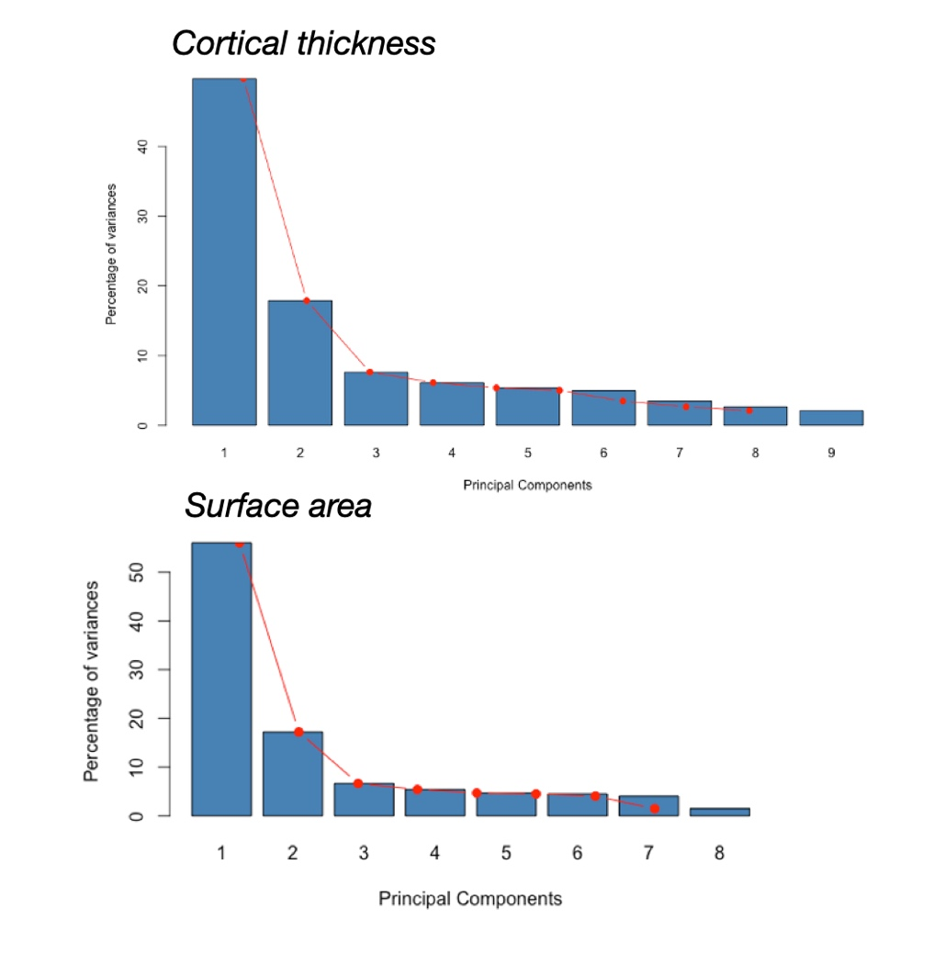

Figure 7.2.a) Scree Plot for Cortical thickness data. On the y axis, the % of variance explained by each component, on the y axis the components number. Following the criterion of picking only components with eigenvalues >1, PC 1 and 2 were selected.b) Scree Plot for Surface area data. On the y axis, the % of variance explained by each component, on the y axis the components number. Following the criterion of picking only components with eigenvalues >1, PC 1 and 2 were selected.

S8. Structural covariance.

Differences in inter-regional correlations between PD-VH and PD-noVH represented with a correlogram. Covariance matrices computed on the GLM residuals used for the structural covariance analysis were used to compute the difference in the inter-regional correlation coefficients in [PD-VH – PDnoVH] patients (Figure S8; those depicted are the difference in the coefficients). A cell by cell comparison of the correlation coefficients with the cocor package for R was computed to investigate regions that showed the highest covariance in PD-VH and in PD-noVH. In purple, inter-regional correlation coefficients that were greater for PD-VH, in yellow those greater for PD-noVH. The analysis on the z scores (Fischer) highlighted that the most significant regions with the most inter-regional correlation with other regions for VH patients were the left caudal MFG, left cuneus, left IPL, left ITG, left iCC, left LOG, left middle orbitofrontal gyrus, left paracentral gyrus, left IFG opercularis, left temporoparietal, right parahippocampal gyrus, right iFG opercularis, right IFG triangular, right temporoparietal. In particular the left cMFG highly correlated with parieto-occipital regions (IPL, cuneus. Lateral occipital gyrus, SPL, STG) and frontal (SFG), on both hemispheres; the left LOG with left SFG, MFG, STG, SMAR, and right IFG (all subdivision); the right PHG with temporal (left TP and STG), parietal (left precuneus, precentral) and occipitotemporal (right enthorinal, fusiform, inferior temporal) regions, mainly.
For PD-noVH patients, we found an overall greater significant of inter-regional correlation coefficients in the left and right pericallosal area, in the right lingual gyrus, and in the right superior frontal gyrus.

Figure S8.1. Correlogram showing the difference in inter-regional correlation coefficients in PD–VH vs. PD-noVH patients for cortical thickness. The yellow squares indicate inter-regional coefficients that were greater for PD-noVH; of those, only some were significant, mainly those in the left and right pericallosal column, in the right lingual column. For significant differences in inter-regional coefficients (z score) a .csv attachment will be made available upon publication on https://osf.io/fv2k7/registrations.)

The same procedure was carried out for surface area. However, we did not find any region where the correlation coefficient was greater for PD-noVH than for PD-VH. As for cortical thickness, regions with significant regions with the most inter-regional correlation with other regions were the left caudal MFG, left cuneus , left fusiform, right temporal transverse, right IFG triangualris, bilateral IFG opercularis and insula, IPL, SFG.

Figure S8.2. Correlogram showing the difference in inter-regional correlation coefficients in PD–VH vs PD-noVH patients for cortical surface area. The red squares indicate inter-regional coefficients that were greater for PD-noVH, with only the inter-regional coefficients for the left IFG orbitalis with the left PGH, left lingual gyrus and left frontopolar area were significant. (For significant differences in inter-regional coefficients (z score) a .csv attachment will be made available upon publication on https://osf.io/fv2k7/registrations.)

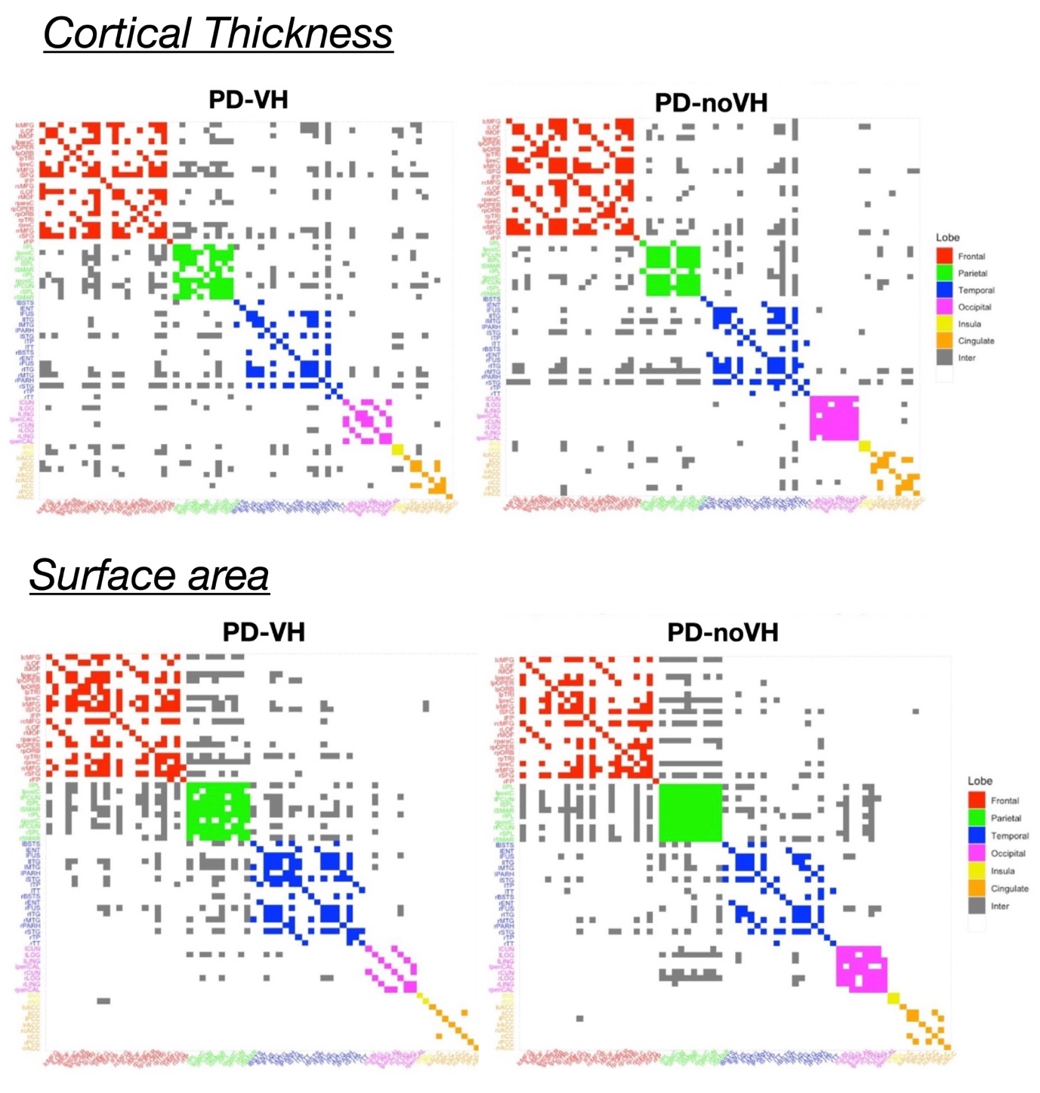

Figure S8.3. Community plot by lobe for cortical thickness (top row), surface area (bottom row). Legend: Red = frontal: bilateral caudal middle frontal gyrus, lateral orbital frontal gyrus, middle orbital frontal gyrus, paracentral gyrus, inferior frontal gyrus orbital, opercularis, triangular, precentral gyrus, middle frontal gyrus, superior frontal gyrus, frontopolar. Green = parietal: bilateral inferior parietal lobe, postcentral gyrus, precuneus, superior parietal lobe, supra marginal gyrus. Blue = temporal: banks superior temporal, enthorinal, fusiform gyrus, inferior temporal gyrus, middle temporal gyrus, parahippocampal gyrus, superior temporal gyrus,temporoparietal, temporal transverse. Pink = occipital: cuneus, lateral occipital gyrus, lingual gyrus, pericallosal. Yellow = Insula. Orange = cingulate: anterior, isthmus, posterior.

