Supporting Information
Citric acid cross-linked regenerated bacterial cellulose as biodegradable and biocompatible film for food packaging

Qingqing Yu¹, Luyu Yang¹, Shujun Wang², Lei Zhang¹*, and Dongping Sun¹*

¹Institute of Chemicobiology and Functional Materials, School of Chemistry and Chemical Engineering, Nanjing University of Science and Technology, 200 Xiao Ling Wei, Nanjing 210094, China.
²Department of Blood Transfusion, Jinling Hospital, Nanjing University School of Medicine, Nanjing 210002, China

*Corresponding author, E-mail:
leizhang@njust.edu.cn (Lei Zhang);
sundpe301@163.com (Dongping Sun).

Fig. S1. XPS spectrogram of CA_{15%}-RC.

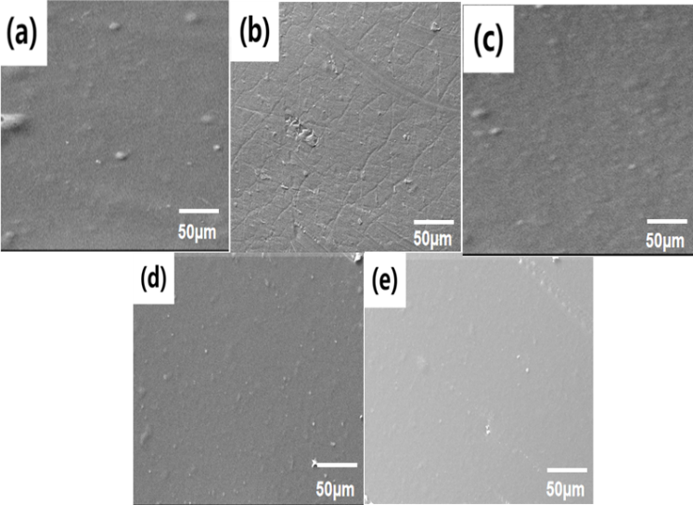
Fig. S2. SEM image of the surface of the RC, CA_{5%}-RC, CA_{10%}-RC, CA_{15%}-RC, and CA_{20%}-RC.

Fig. S3. Comparing the degradation time of CA_{15%}-RC and other degradable materials previously reported.

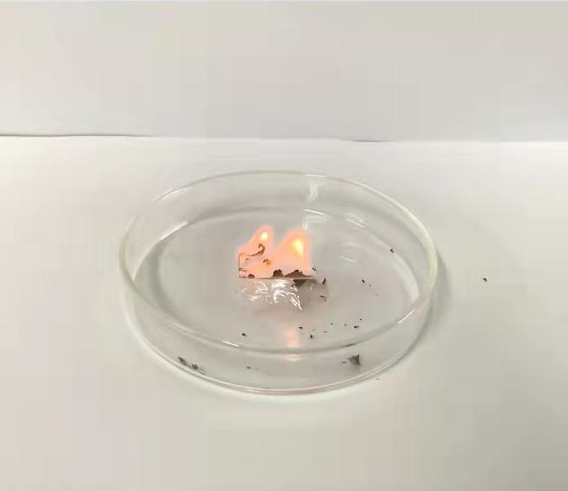
Fig. S4. Combustion experiment of CA_{15%}-RC shows it is ignitable.

Table S1. The O₂ permeability and water vapor permeability of RC, CA_{5%}-RC, CA_{10%}-RC, CA_{15%}-RC, and CA_{20%}-RC.

Samples | RC | CA_{5%}-RC | CA_{10%}-RC | CA_{15%}-RC | CA_{20%}-RC*
O₂ permeability (m³.m/m².s.Pa) |  | 1.71E-17 | 1.29E-17 | 2.13E-17
water vapor permeability (g m⁻² day⁻¹) | 1698 | 1630 | 1624 | 1687 | 1646
*The O₂ permeability of RC and CA_{20%}-RC sample was not successful due to the smallest tensile strain.

Fig. S5. Stress - strain curve of CA_{15%}-RC.

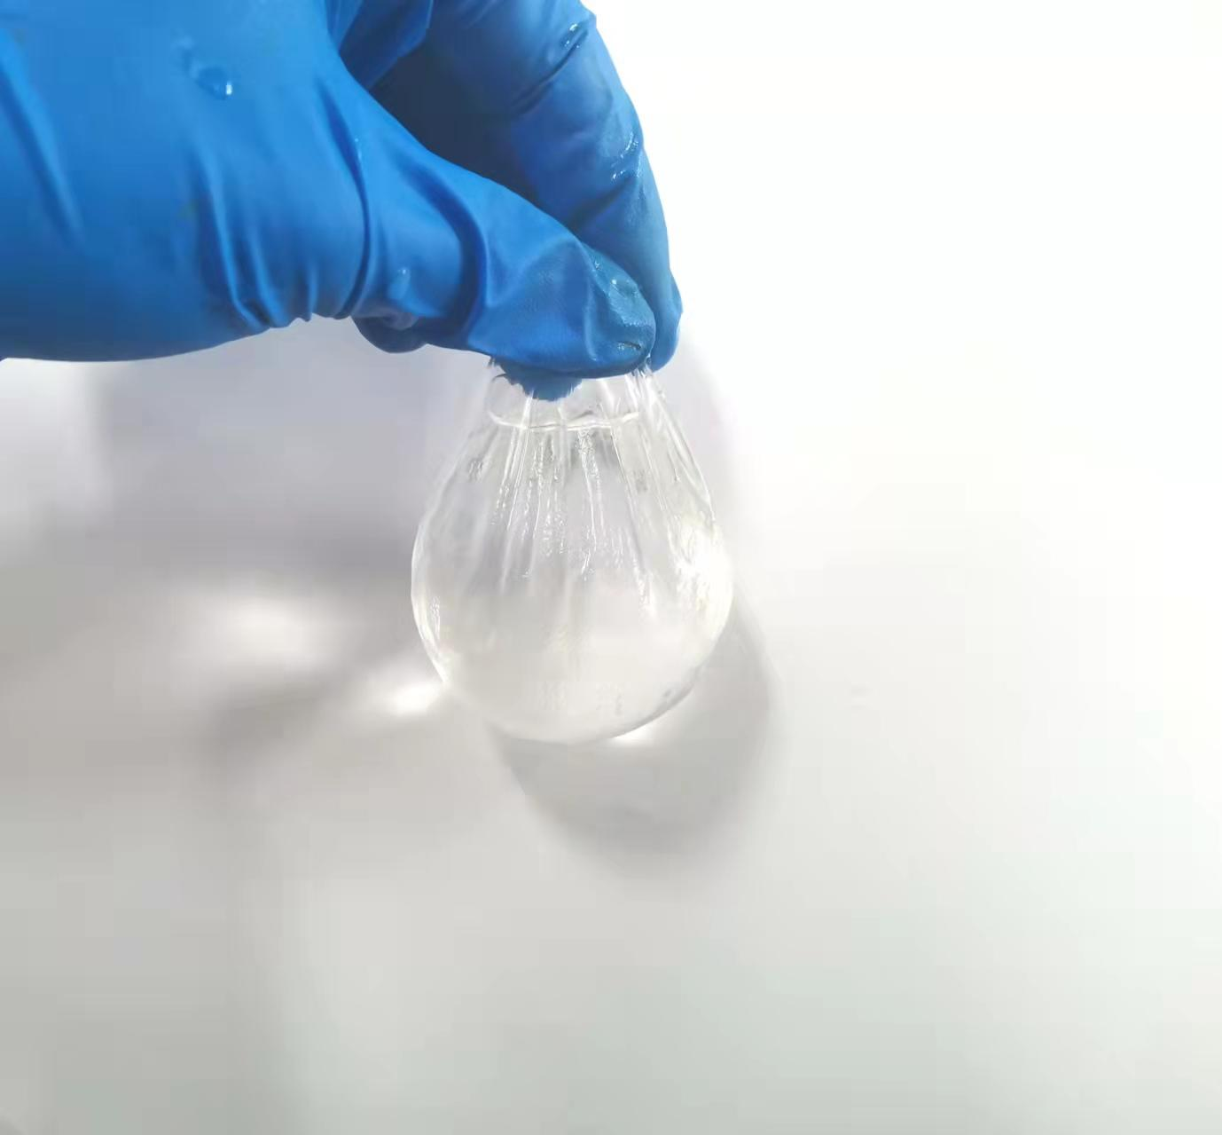
Fig. S6. CA_{15%}-RC can be used to make a water balloon without any water leakage.

Fig. S7. Bar chart showing the hemolysis rates of RC, CA_{5%}-RC, CA_{10%}-RC, CA_{15%}-RC, and CA_{20%}-RC.

