Supplementary Information for

Sequential Glycosylations at the Multibasic Cleavage Site of SARS-CoV-2 Spike Protein Regulate Viral Activation, Assembly, and Infection
Shengjun Wang^{1, 7, #}, Wei Ran^{2, #}, Lingyu Sun^{1, #}, Qingchi Fan¹, Yuanqi Zhao¹, Bowen Wang³, Jinghong Yang², Yuqi He¹, Ying Wu¹, Yuanyuan Wang⁴, Luoyi Chen¹, Arpaporn Chuchuay¹, Xinhai Zhu⁵, Yanqun Wang², Yao-Qing Chen⁴, Yanqiu Yuan^{1,} *, Jincun Zhao^{2, 6,} *, Yang Mao^{1,} *

*Correspondence: Yanqiu Yuan, Jincun Zhao, Yang Mao
Email: yuanyq8@mail.sysu.edu.cn (Y.Y.), zhaojincun@gird.cn (J.Z.), maoyang3@mail.sysu.edu.cn (Y.M.)

Supplementary information Contents:
Supplementary Table 1: Primers used in this study.

Supplementary Fig. 1: Summary of reported O-GalNAc sites (T676, T678 and S686) near the furin site of the spike protein of SARS-CoV-2.

Supplementary Fig. 2: Purified GalNAc-Ts analyzed by SDS-PAGE and Coomassie staining.

Supplementary Fig. 3: MALDI-TOF analysis of GalNAcylation reactions catalyzed by purified GalNAc-Ts on a synthetic Muc1-derived peptide (HGVTSAPDTRPAPGSTAPPA).

Supplementary Fig. 4: LC-MS analysis of doubly-glycosylated peptide products of GalNAc-T3 and T7 reactions.

Supplementary Fig.5: Quantitative analysis of the processing of spike protein and its mutants overexpressed in HEK293T WT and GALNT7 KO cells.

Supplementary Fig. 6: CRISPR-based knockout (KO) of GALNT7 in HEK293T cells.

Supplementary Fig.7: Validation of GALNT KI in HEK293T cells.

Supplementary Fig.8: Quantitative analysis of the processing of spike protein overexpressed in HEK293T WT and GALNTs KI cells.

Supplementary Fig.9: Quantitative analysis of the processing of spike protein with P681H or P681H/ N679K mutations in HEK293T WT and GALNTs KI cells.

Supplementary Fig.10: Validation of GALNT3 and/or GALNT7 overexpression in Calu-3 cells.

Supplementary Fig.11: GalNAc-T3 and T7 Inhibit the Replication of SARS-CoV-2 in Calu-3 Cells.

Supplementary Fig.12: Sequential glycosylation near the furin site of FGF23 and SARS-CoV-2 spike protein.
Supplementary Table 1. Primers used in this study
Purpose | Primers | Sequences
Construction of pcDNA6B SARS-CoV-2 S | S-Forward | AAAAAAAAGCTTGCCACCATGTTCGTCTTC
Construction of pcDNA6B SARS-CoV-2 S | S-Reversed | AAAAAACTCGAGTCAGGTGTAATGCAGCTTCAC
Mutagenesis in Spike protein furin site | S-T678A-Forward | GGGAGAGTTTGCCTGGGTCTGG
Mutagenesis in Spike protein furin site | S-T678A-Reversed | CCAGACCCAGGCAAACTCTCCC
Mutagenesis in Spike protein furin site | S-R685A-Forward | GGAGGCCACGCTGGCGGCTCTTCTGG
Mutagenesis in Spike protein furin site | S-R685A-Reversed | CCAGAAGAGCCGCCAGCGTGGCCTCC
Mutagenesis in Spike protein furin site | S-S686A-Forward | GGAGGCCACGGCCCGGGCTCTTC
Mutagenesis in Spike protein furin site | S-S686A-Reversed | GAAGAGCCCGGGCCGTGGCCTCC
Mutagenesis in Spike protein furin site | S-P681H-Forward | GGCTCTTCTGTGAGAGTTTGTC
Mutagenesis in Spike protein furin site | S-P681H-Reversed | GACAAACTCTCACAGAAGAGCC
Mutagenesis in Spike protein furin site | S-N679K/P681H-Forward | AGACCCAGACAAAGTCTCACAGAAGA
Mutagenesis in Spike protein furin site | S-N679K/P681H-Reversed | TCTTCTGTGAGACTTTGTCTGGGTCT
Mutagenesis in the biosensor furin site | Biosensor-T678A-Forward | TCTTACCAGACCCAGGCAAACTCTCCCAGAAGA
Mutagenesis in the biosensor furin site | Biosensor-T678A-Reversed | TCTTCTGGGAGAGTTTGCCTGGGTCTGGTAAGA
Mutagenesis in the biosensor furin site | Biosensor-P681H-Forward | CCCAGACAAACTCTCACAGAAGAGCCCGGAG
Mutagenesis in the biosensor furin site | Biosensor-P681H-Reversed | CTCCGGGCTCTTCTGTGAGAGTTTGTCTGGG
Mutagenesis in the biosensor furin site | Biosensor-R685A-Forward | CTCCCAGAAGAGCCGCGAGCGTGGCCTCCC
Mutagenesis in the biosensor furin site | Biosensor-R685A-Reversed | GGGAGGCCACGCTCGCGGCTCTTCTGGGAG
Mutagenesis in the biosensor furin site | Biosensor-S686A-Forward | CAGAAGAGCCCGGGCCGTGGCCTCCCAGTC
Mutagenesis in the biosensor furin site | Biosensor-S686A-Reversed | GACTGGGAGGCCACGGCCCGGGCTCTTCTG
Construction of pcDNA3.1 SARS-CoV-2 M | M-Forward | AAAAAA AAGCTTGCCACCATGGCCGAC
Construction of pcDNA3.1 SARS-CoV-2 M | M-Reversed | AAAAAACTCGAGTCACTGCACGAGCAGGGC
Mutagenesis in M protein -EE- motif | M-E11A-Forward | GCACAATTACAGTGGCCGAGCTGAAGAAGCTG
Mutagenesis in M protein -EE- motif | M-E11A-Reversed | CAGCTTCTTCAGCTCGGCCACTGTAATTGTGC
Mutagenesis in M protein -EE- motif | M-E12A-Forward | CACAATTACAGTGGCCGCCCTGAAGAAGCTGTTAG
Mutagenesis in M protein -EE- motif | M-E12A-Reversed | CTAACAGCTTCTTCAGGGCGGCCACTGTAATTGTG
gRNA targeting human AAVS1 site | AAVS1-gRNA-Forward | CACCGGTCACCAATCCTGTC-CCTAG
gRNA targeting human AAVS1 site | AAVS1-gRNA-Reversed | AAACCTAGGGACAGGATTGGTGACC
Construction of pSec-Tag2A-GALNT1-Sol | pSec-Tag2A-GALNT1-F | CGCGGATCCACCTGGAGAAATGGGAAAGC
Construction of pSec-Tag2A-GALNT1-Sol | pSec-Tag2A-GALNT1-R | CCGCTCGAGCAAAGATTTCAGGAAGTGTC
Construction of pSec-Tag2A-GALNT2-Sol | pSec-Tag2A-GALNT2-F | CGCGGATCCCGGAGAAGAGAAGGCTCAGT
Construction of pSec-Tag2A-GALNT2-Sol | pSec-Tag2A-GALNT2-R | CCGCTCGAGGCTGCTGCAGGTTAAGTGTAA
Construction of pSec-Tag2A-GALNT3-Sol | pSec-Tag2A-GALNT3-F | CGCGGATCCAAGGATGGAAAGGAACATGAA
Construction of pSec-Tag2A-GALNT3-Sol | pSec-Tag2A-GALNT3-R | CCGCTCGAGCATCATTTTGGCTAAGTATCC
Construction of pSec-Tag2A-GALNT4-Sol | pSec-Tag2A-GALNT4-F | CGCGGATCCCTTTCATGCCTCCGCAGGAGC
Construction of pSec-Tag2A-GALNT4-Sol | pSec-Tag2A-GALNT4-R | CCGCTCGAGGTTTCTCAAAACTCCAAATTT
Construction of pSec-Tag2A-GALNT5-Sol | pSec-Tag2A-GALNT5-F | CGCGAATTCGCTTTAACTGGAGGGCTAGA
Construction of pSec-Tag2A-GALNT5-Sol | pSec-Tag2A-GALNT5-R | CCGCTCGAGGGCTTCATAATATTTTTCAA
Construction of pSec-Tag2A-GALNT7-Sol | pSec-Tag2A-GALNT7-F | CCCAAGCTTGcggccggacgacccaagccc
Construction of pSec-Tag2A-GALNT7-Sol | pSec-Tag2A-GALNT7-R | CCGCTCGAGCaacactatggatgttattca
Construction of pSec-Tag2A-GALNT11-Sol | pSec-Tag2A-GALNT11-F | CGCGAATTCAGTGAAGTGACTCAGCCACT
Construction of pSec-Tag2A-GALNT11-Sol | pSec-Tag2A-GALNT11-R | CCGCTCGAGACCTTCCAAATGCCACTGCT
Construction of pSec-Tag2A-GALNT18-Sol | pSec-Tag2A-GALNT18-F | CGCGGATCCTCTGAAGATTATTGAGCGGC
Construction of pSec-Tag2A-GALNT18-Sol | pSec-Tag2A-GALNT18-R | CCGCTCGAGGGGACGCGAGGCTCCTCAGGA
Construction of pCDNA3.1-GALNT1-full | pCDNA3.1-GALNT1-F | AAAAAGGATCCGCCACCATGAGAAA
Construction of pCDNA3.1-GALNT1-full | pCDNA3.1-GALNT1-R | AAAAACTCGAGTCAAAGATCTTCTT
Construction of pCDNA3.1-GALNT3-full | pCDNA3.1-GALNT3-F | AAAAAGGATCCGCCACCATGGCCCACCTGAAGAGACT
Construction of pCDNA3.1-GALNT3-full | pCDNA3.1-GALNT3-R | AAAAACTCGAGTCACAGGTCCTCCTCGCTGATCA
Construction of pCDNA3.1-GALNT7-full | pCDNA3.1-GALNT7-F | AAAAAAGCTAGCCACCatgaggctgaagattggatt
Construction of pCDNA3.1-GALNT7-full | pCDNA3.1-GALNT7-R | CCGCTCGAGCaacactatggatgttattca
gRNA for GALNT7 KO | gRNA-GALNT7-Forward | GATGAAGATGGGTATGCCCGAGG
gRNA for GALNT7 KO | gRNA-GALNT7-Reversed | CCTCGGGCATACCCATCTTCATC
GALNT7 KO confirmation | GALNT7-KO-Forward | AGCTGACCGGCAGCAAAATTGGGGTCCATACATACGCTTCCA
GALNT7 KO confirmation | GALNT7-KO-Reversed | AGGTTAGCAGCAACTGGAGAAA

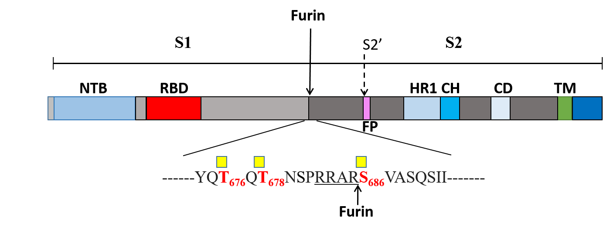

Supplementary Fig.1 Summery of reported O-GalNAc sites (T676, T678 and S686) near the furin site of the spike protein of SARS-CoV-2.

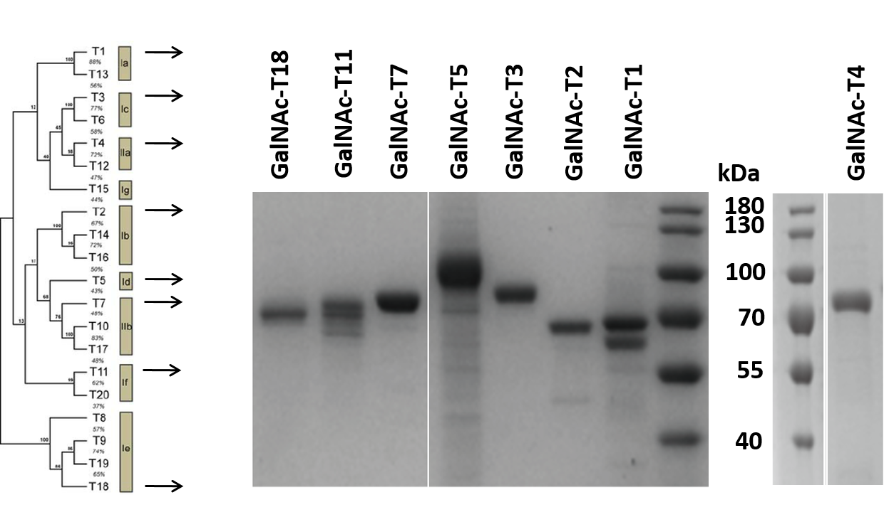

Supplementary Fig.2 Purified GalNAc-Ts analyzed by SDS-PAGE and Coomassie staining. Soluble GalNAc-T1, T2, T3, T4, T5, T7, T11 and T18 were overexpressed in FreeStyleTM 293-F cells and purified by Ni-NTA chromatography.

Supplementary Fig.3 MALDI-TOF analysis of GalNAcylation reactions catalyzed by purified GalNAc-Ts on a synthetic Muc1-derived peptide (HGVTSAPDTRPAPGSTAPPA). Reactions were performed and analyzed as described in the Methods. An increase of 203 Da corresponds to addition of one GalNAc residue to the peptide.

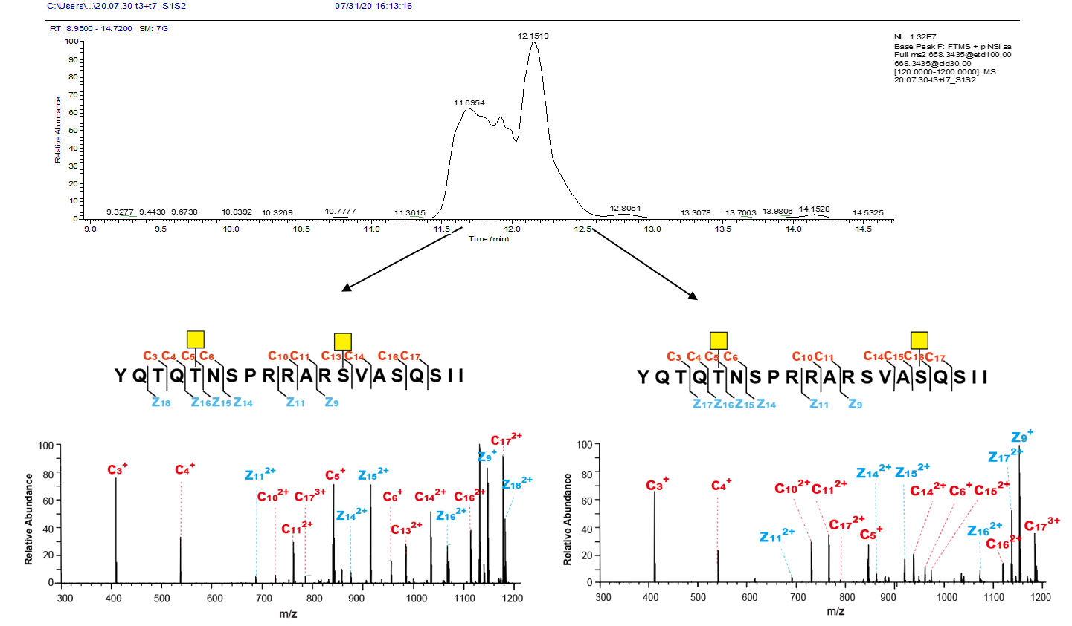
Supplementary Fig.4 LC-MS analysis of doubly-glycosylated peptide products of GalNAc-T3 and T7 reactions. The extracted ion chromatogram (XIC) shows that the doubly-glycosylated peptide products elute as a broad peak at 11.5-12.5 min, with a pronounced shoulder at ~12.15 min (top panel). The glycosites of the peptides in the main peak and in the shoulder were separately determined from ETD spectra (bottom panel). The mass of c- and z- fragment ions in the ETD spectra indicated that the main product carries GalNAc modifcations at positions corresponding to T678/Ser686 of the spike protein, and the minor product at T678/Ser689. The glycosylated residues are denoted as yellow squares according to Consortium for Functional Glycomics (CFG) standard.

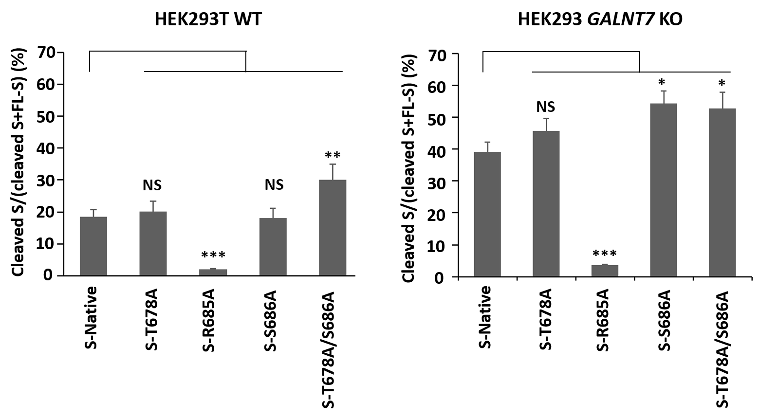
Supplementary Fig.5 Quantitative analysis of the processing of spike protein and its mutants overexpressed in HEK293T WT and GALNT7 KO cells. Quantification was performed on western blots exemplified in Fig. 2d by densitometry with Image J program.
.

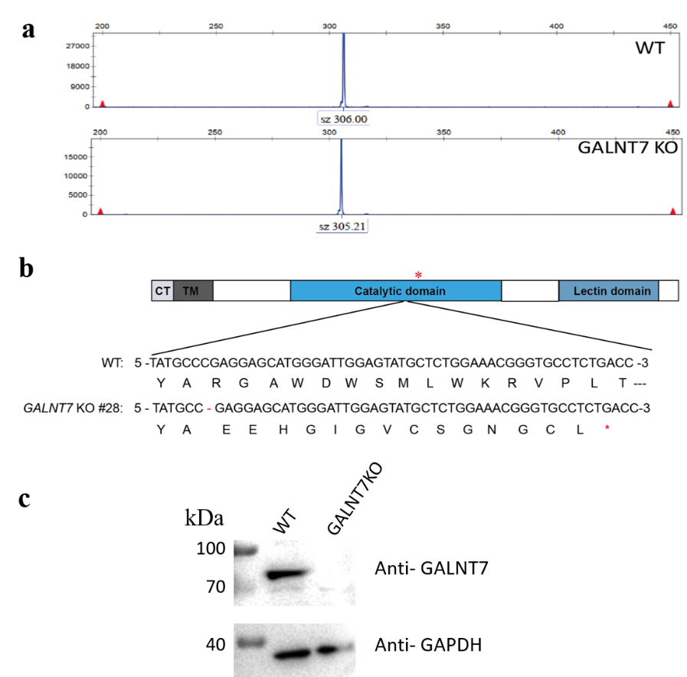

Supplementary Fig.6 CRISPR-based knockout (KO) of GALNT7 in HEK293T cells. Analysis of the Insertion and Deletion (Indel) of the KO clone by amplicon size analysis (a), amplicon sequencing (b) and western blot (c). Selected KO clone demonstrated deletion of one base pair in the catalytic domain in both alleles, causing frame shift and early termination as denoted by a red star (*).

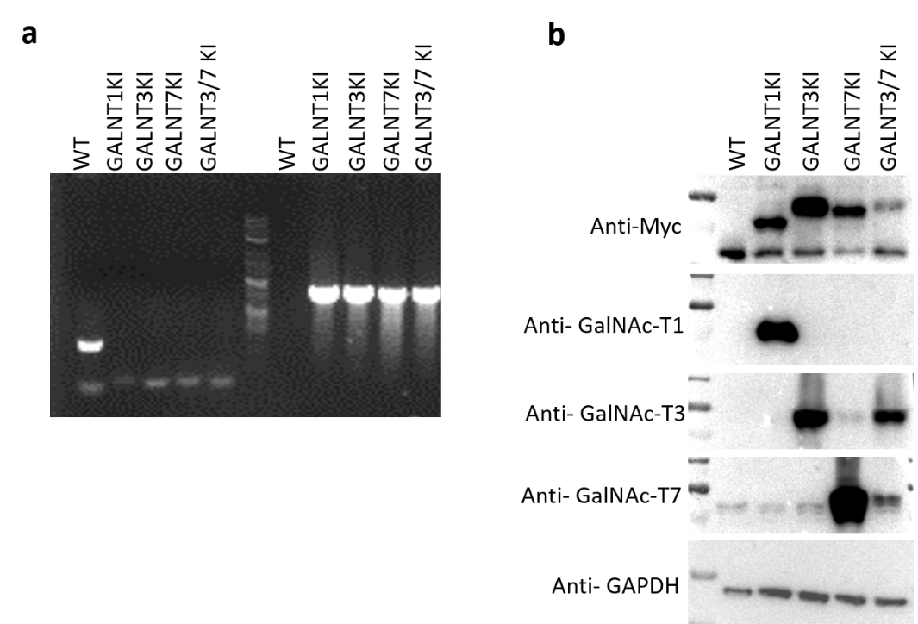

Supplementary Fig.7 Validation of GALNT KI in HEK293T cells. a, Analysis of targeted integration of GALNTs into the AAVS1 loci of HEK293T by WT PCR (left) and junction PCR (right). WT PCR primers are designed to amplify the unmodified AAVS1 site before integration. Junction PCR primers are designed to amplify the junction of the GALNT expression cassette with the AAVS1 site to confirm the site-specific integration. The results indicated that the KI clones of GALNT1, GALNT3, GALNT7, and GALNT3/7 all have the gene(s) correctly integrated into the AAVS1 loci on both alleles. b, Western blot analysis showing GalNAc-T1, GalNAc-T3 or GalNAc-T7 expression in HEK293T KI clones. The WT and KI clones of HEK293T cells were detected with anti-myc antibody (myc-tags were fused to GalNAc-Ts in the expression cassette), or antibodies to the GalNAc-Ts.

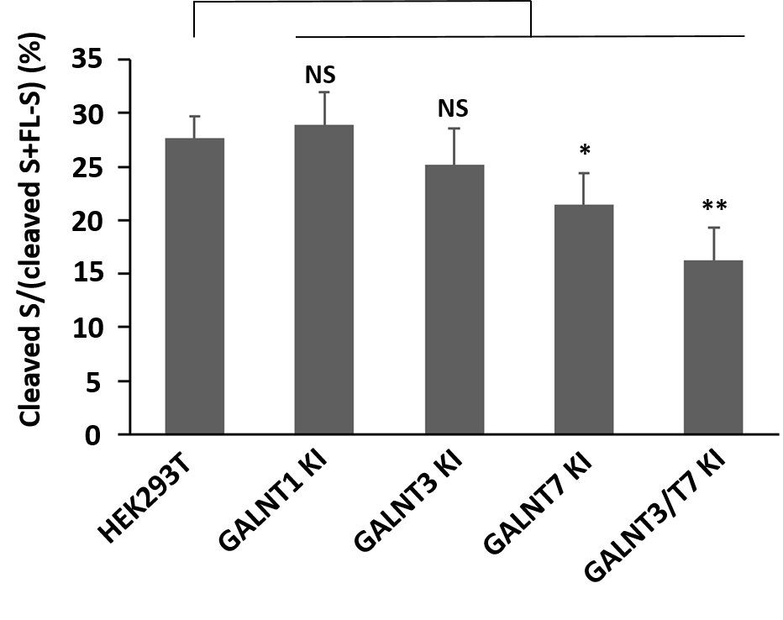
Supplementary Fig.8 Quantitative analysis of the processing of spike protein overexpressed in HEK293T WT and GALNTs KI cells. Quantification was performed on western blots exemplified in Fig. 2e by densitometry with Image J program.

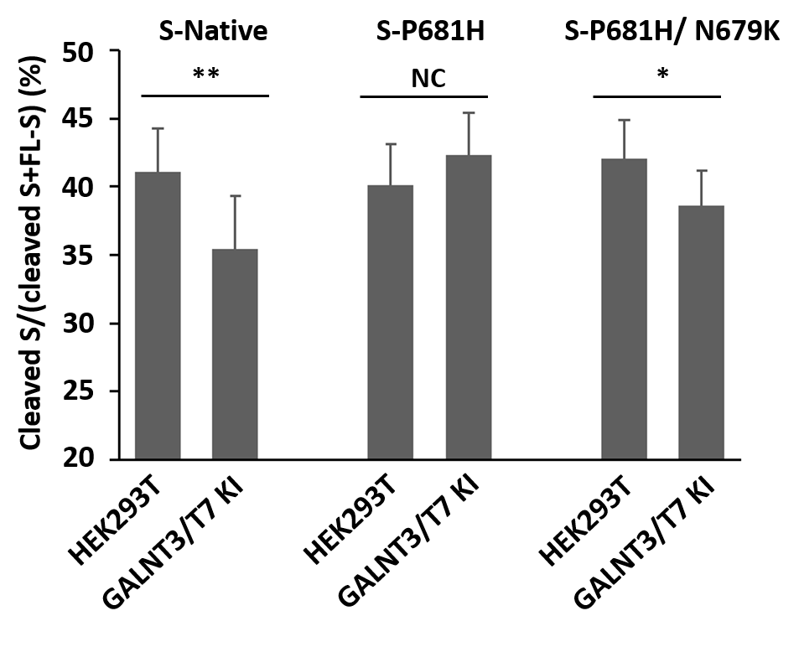
Supplementary Fig.9 Quantitative analysis of the processing of spike protein with P681H and P681H/ N679K mutations in HEK293T WT and GALNTs KI cells. Quantification was performed on western blots exemplified in Fig. 4c by densitometry with Image J program.

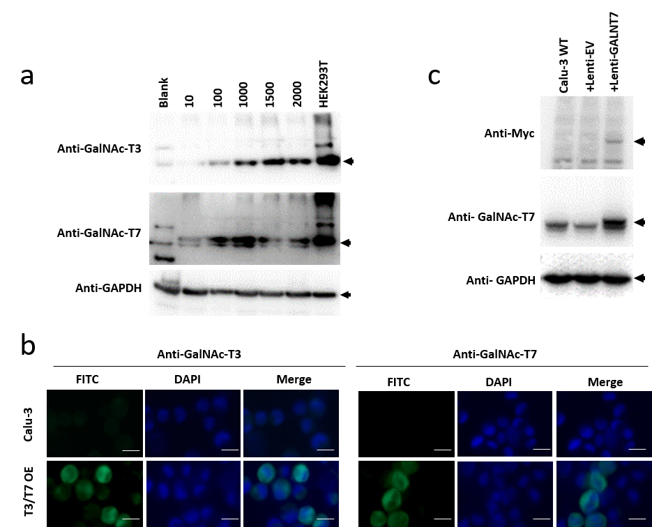

Supplementary Fig.10 Validation of GALNT3 and/or GALNT7 overexpression in Calu-3 cells. a, Western blot analysis of GalNAc-T3 and GalNAc-T7 overexpression in Ad5-T3/T7 transduced Calu-3 cells with varying MOI. The Ad5-T3/T7 transduced HEK293T cells was used as a positive control. b, Immunofluorescence staining of GalNAc-T3 and GalNAc-T7 overexpressed in AdV-T3/T7 transduced Calu-3 cells. Calu-3 cells with or without transduction of Ad5-T3/T7 were stained with DAPI (blue) and immuno-stained with anti-GalNAc-T3 or GalNAc-T7 antibody (green).c, Western blot analysis of GalNAc-T7 overexpression in Lenti-GALNT7 transduced Calu-3 cells.

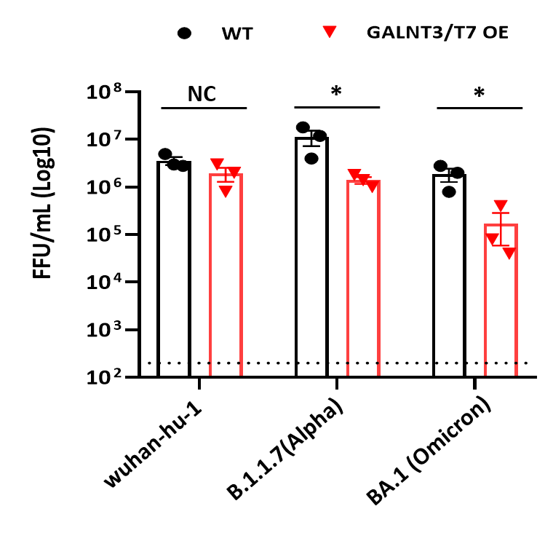

Supplementary Fig.11 GalNAc-T3 and T7 Inhibit the Replication of SARS-CoV-2 in Calu-3 Cells. Viral titers from Calu-3 cells infected with SARS-CoV-2 wuhan-hu-1, alpha variant or omicron variant at an MOI of 0.01, with or without GalNAc-T3 and T7 overexpression (n = 3).

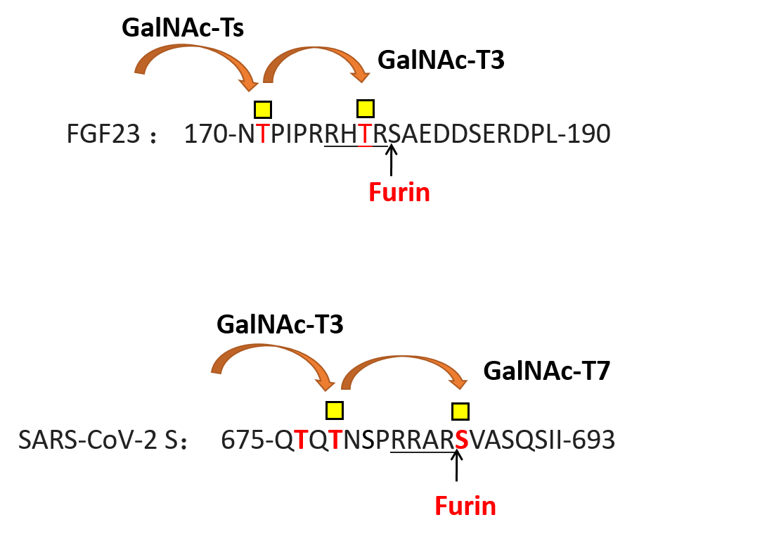

Supplementary Fig.12 Sequential glycosylation near the furin site of FGF23 and SARS-CoV-2 spike protein. The glycosylation at T178 of FGF23 (within the furin recognition sequence) by GalNAc-T3 requires prior glycosylation at T171 by other GalNAc-Ts. The glycosylation at S686 of SARS-CoV-2 spike protein (right next to the furin site) by GalNAc-T7 requires prior glycosylation at T678 by GalNAc-T3.

