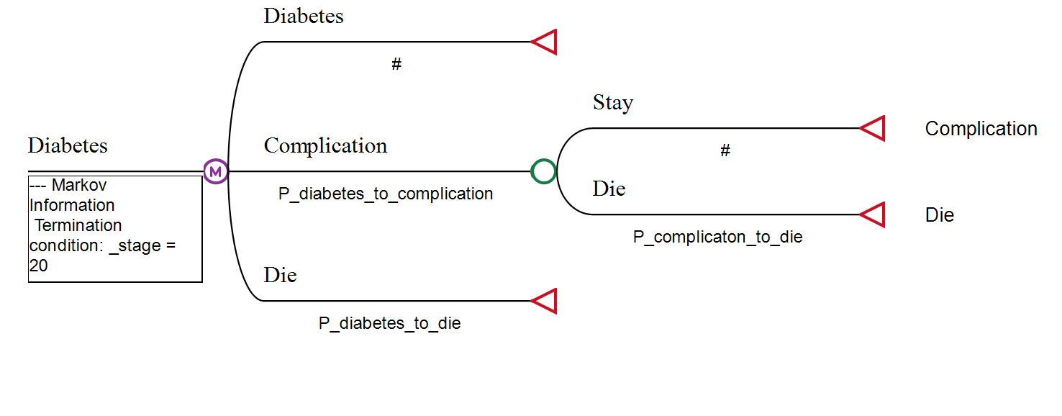

Fig.S1 Partial transfer chain diagram of Markov model

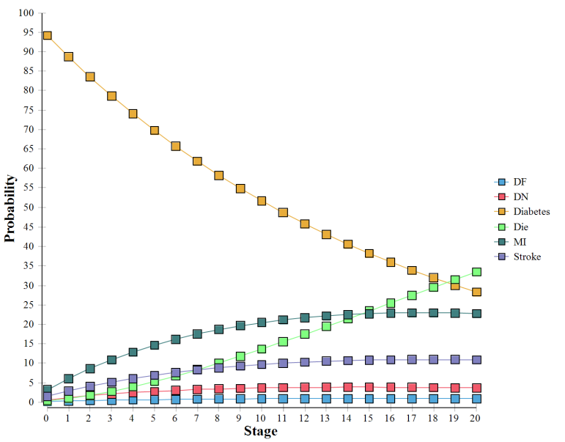
Fig.S2Probability distribution of each state of Markov model in intervention group
MI myocardial infarction , DF Diabetic Nephropathy , DN Diabetic Foot

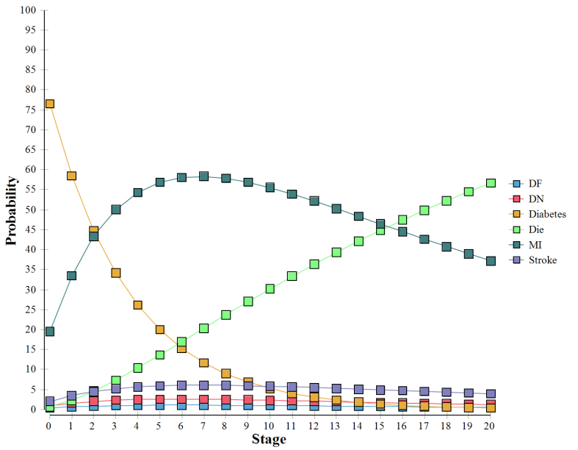

Fig.S3Probability distribution of each state in Markov model of control group
MI myocardial infarction , DF Diabetic Nephropathy , DN Diabetic Foot

