Supplemental Table 1. List of 54 myeloid neoplasm-relevant genes studied in targeted NGS sequencing
Gene name | Target region (exon) | Gene name | Target region (exon)
ABL | 4-6 | JAK3 | 13
ASXL1 | 12 | KDM6A | full
ATRX | 8-10 and 17-31 | KIT | 2, 8-11, 13+17
BCOR | full | KRAS | 2+3
BCORL1 | full | MLL | 5-8
BRAF | 15 | MPL | 10
CALR | 9 | MYD88 | 3-5
CBL | 8+9 | NOTCH1 | 26-28, 34
CBLB | 9, 10 | NPM1 | 12
CBLC | 9, 10 | NRAS | 2+3
CDKN2A | full | PDGFRA | 12, 14, 18
CEBPA | full | PHF6 | full
CSF3R | 14-17 | PTEN | 5+7
CUX1 | full | PTPN11 | 3+13
DNMT3A | full | RAD21 | full
ETV6 | full | RUNX1 | full
EZH2 | full | SETBP1 | 4 (partial)
FBXW7 | 9+10+11 | SF3B1 | 13-16
FLT3 | 14+15+20 | SMC1A | 2, 11, 16+17
GATA1 | 2 | SMC3 | 10, 13, 19, 23, 25+28
GATA2 | 2-6 | SRSF2 | 1
GNAS | 8+9 | STAG2 | full
HRAS | 2+3 | TET2 | 3-11
IDH1 | 4 | TP53 | 2-11
IDH2 | 4 | U2AF1 | 2+6
IKZF1 | full | WT1 | 7+9
JAK2 | 12+14 | ZRSR2 | full

Supplemental Table 2. Clinical characteristics of patients (n=649) with myelodysplastic syndromes, categorized by the IPSS-M
Clinical characters | Very low  (n=18) | Low  (n=132) | Moderate low  (n=95) | Moderate  high  (n=92) | High  (n=121) | Very high  (n=191) | P value
Sex |  |  |  |  |  |  | 0.277
Female | 7 (38.9%) | 47 (35.6%) | 44 (46.3%) | 38 (41.3%) | 39 (32.2%) | 65 (34.0%)
Male | 11 (61.1%) | 85 (64.4%) | 51 (53.7%) | 54 (58.7%) | 82 (67.8%) | 126 (66.0%)
Age* | 61.5  (33.1-83.3) | 69.1  (20.6-94.5) | 67.1  (18.5-87.9) | 59.2  (19.3-94.2) | 63.9  (18.4-93.1) | 68.4  (23.6-94.1) | 0.018
Laboratory data*
WBC, ×10⁹ /L | 3.25  (1.25-15.82) | 4.17  (0.73-32.39) | 3.16  (0.66-26.31) | 2.80  (0.75-15.55) | 2.79  (0.72-32.39) | 3.31  (0.60-23.60) | 0.001
ANC, ×10⁹ /L | 1.72  (0.44-8.39) | 2.20  (0.05-10.76) | 1.75  (0-15.65) | 1.30  (0.96-12.02) | 1.29  (0.01-23.48) | 1.11  (0.16-17.01) | <0.001
Hb, g/dL | 12.8  (10.7-17.1) | 9.1  (5.7-14.4) | 8.1  (4.5-13.6) | 7.7  (4.2-14.6) | 7.9  (3.2-13.5) | 7.6  (2.6-12.7) | <0.001
Platelet, ×10⁹ /L | 134  (20-370) | 156  (4-499) | 77 (7-471) | 88 (3-721) | 63 (1-655) | 63 (1-931) | <0.001
BM blast (%) | 2.0  (0.4-5.0) | 1.8  (0-8.2) | 1.8  (0-12.0) | 3.0  (0-17.3) | 6.2  (0-18.0) | 11.8  (0.5-19.5) | <0.001
PB blast (%) | 0 (0-1) | 0 (0-9) | 0 (0-4) | 0 (0-8) | 0 (0-9) | 1 (0-9) | <0.001
Treatment
HMA | 0 (0.0%) | 10 (7.6%) | 11 (11.6%) | 19 (20.7%) | 36 (29.8%) | 80 (41.9%) | <0.001
Intensive chemotherapy | 0 (0.0%) | 1 (0.8%) | 2 (2.1%) | 3 (3.3%) | 2 (1.7%) | 12 (6.3%) | 0.057
Clinical trial | 2 (7.1%) | 4 (3.1%) | 4 (4.3%) | 2 (2.2%) | 5 (4.2%) | 10 (5.3%) | 0.501
HSCT | 3 (16.7%) | 14 (10.6%) | 8 (8.4%) | 16 (17.4%) | 27 (22.3%) | 35 (18.3%) | 0.034
Supportive care | 11 (61.1%) | 75 (58.6%) | 57 (60.6%) | 40 (43.5%) | 43 (36.1%) | 60 (31.6%) | <0.001
Other treatment† | 6 (33.3%) | 37 (28.9%) | 21 (22.3%) | 29 (31.5%) | 25 (21.0%) | 27 (14.2%) | 0.006
P values of <0.05 are statistically significant.
*Median (range).
†Other treatment: include low-dose cytarabine, rabbit-derived anti-thymocyte globulin, cyclosporine, danazol, eltrombopag, erythropoietin-stimulating agents, thalidomide, steroid, venetoclax-based therapy and oral chemotherapy.
Abbreviations: ANC, absolute neutrophil count; BM, bone marrow; Hb, hemoglobin; HMA, hypomethylating agent; HSCT, allogeneic hematopoietic stem cell transplantation; PB, peripheral blood; WBC, while blood cell count.

Supplemental Table 3. Distribution of the IPSS-M, IPSS-R and IPSS in patients with myelodysplastic syndromes, or myelodysplastic syndromes/acute myeloid leukemia, categorized by 2022 International Consensus Classification
Variables | MDS  (n=485/74.7%) | MDS/AML  (n=164/25.3%) | P value
IPSS-M |  |  | <0.001
Very low | 18 (3.7%) | 0 (0.0%) | 0.010
Low | 132 (27.2%) | 0 (0.0%) | <0.001
Moderate low | 91 (18.8%) | 4 (2.4%) | <0.001
Moderate high | 84 (17.3%) | 8 (4.9%) | <0.001
High | 92 (19.0%) | 29 (17.7%) | 0.715
Very high | 68 (14.0%) | 123 (75.0%) | <0.001
IPSS-R |  |  | <0.001
Very low | 22 (4.5%) | 0 (0.0%) | 0.002
Low | 170 (35.1%) | 0 (0.0%) | <0.001
Intermediate | 162 (33.4%) | 11 (6.7%) | <0.001
High | 78 (16.1%) | 63 (38.4%) | <0.001
Very high | 53 (10.9%) | 90 (54.9%) | <0.001
IPSS |  |  | <0.001
Low | 106 (21.9%) | 0 (0.0%) | <0.001
Intermediate-1 | 297 (61.2%) | 5 (3.0%) | <0.001
Intermediate-2 | 82 (16.9%) | 85 (51.8%) | <0.001
High | 0 (0.0%) | 74 (45.1%) | <0.001
Note: Data presented in number (%).
P values of <0.05 are statistically significant.
Abbreviations: IPSS, International Prognostic Scoring System; IPSS-M, Molecular International Prognostic Scoring System; IPSS-R, Revised International Prognostic Scoring System; MDS, myelodysplastic syndromes; MDS/AML, myelodysplastic syndromes/acute myeloid leukemia.

Supplemental Table 4. Distribution of the IPSS-M, IPSS-R and IPSS in patients with different subtypes of myelodysplastic syndromes, based on 2022 International Consensus Classification
Variables | del(5q)  (n=4) | mutated SF3B1  (n=52) | NOS,  SLD  (n=111) | NOS,  MLD  (n=152) | EB  (n=141) | mutated TP53  (n=25) | P value
IPSS-M |  |  |  |  |  |  | <0.001
Very low | 0 (0.0%) | 2 (3.8%) | 5 (4.5%) | 9 (5.9%) | 2 (1.4%) | 0 (0.0%)
Low | 0 (0.0%) | 34 (65.4%) | 44 (39.6%) | 46 (20.3%) | 8 (5.7%) | 0 (0.0%)
Moderate low | 0 (0.0%) | 12 (23.1%) | 29 (26.1%) | 33 (21.7%) | 17 (12.1%) | 0 (0.0%)
Moderate high | 2 (50.0%) | 4 (7.7%) | 20 (18.0%) | 31 (20.4%) | 27 (19.1%) | 0 (0.0%)
High | 1 (25.0%) | 0 (0.0%) | 11 (9.9%) | 23 (15.1%) | 57 (40.4%) | 0 (0.0%)
Very high | 1 (25.0%) | 0 (0.0%) | 2 (1.8%) | 10 (6.6%) | 30 (21.3%) | 25 (100%)
IPSS-R |  |  |  |  |  |  | <0.001
Very low | 0 (0.0%) | 7 (13.5%) | 9 (8.1%) | 6 (3.9%) | 0 (0.0%) | 0 (0.0%)
Low | 1 (25.0%) | 35 (67.3%) | 55 (49.5%) | 66 (43.4%) | 13 (9.2%) | 0 (0.0%)
Intermediate | 3 (75.0%) | 10 (19.2%) | 39 (35.1%) | 57 (37.5%) | 53 (37.6%) | 0 (0.0%)
High | 0 (0.0%) | 0 (0.0%) | 6 (5.4%) | 18 (11.8%) | 52 (36.9%) | 2 (8.0%)
Very high | 0 (0.0%) | 0 (0.0%) | 2 (1.8%) | 5 (3.3%) | 23 (16.3%) | 23 (92.0%)
IPSS |  |  |  |  |  |  | <0.001
Low | 0 (0.0%) | 27 (51.9%) | 48 (43.2%) | 24 (15.8%) | 7 (5.0%) | 0 (0.0%)
Intermediate-1 | 4 (100%) | 25 (48.1%) | 59 (53.2%) | 116 (76.3%) | 93 (66.0%) | 0 (0.0%)
Intermediate-2 | 0 (0.0%) | 0 (0.0%) | 4 (3.6%) | 12 (7.9%) | 41 (29.1%) | 25 (100%)
High | 0 (0.0%) | 0 (0.0%) | 0 (0.0%) | 0 (0.0%) | 0 (0.0%) | 0 (0.0%)
Note: Data presented in number (%).
P values of <0.05 are statistically significant.
Abbreviations: EB, excess blasts; IPSS, International Prognostic Scoring System; IPSS-M, Molecular International Prognostic Scoring System; IPSS-R, Revised International Prognostic Scoring System; MLD, multi-lineage dysplasia; NOS, not otherwise specified; SLD, single lineage dysplasia.

Supplemental Table 5. Distribution of the IPSS-M, IPSS-R and IPSS in patients with different subtypes of myelodysplastic syndromes/acute myeloid leukemia, based on 2022 International Consensus Classification
Variables | mutated TP53  (n=37) | MDS-related gene mutations  (n=94) | MDS-related cytogenetics  (n=12) | NOS  (n=21) | P value
IPSS-M |  |  |  |  | <0.001
Very low | 0 (0.0%) | 0 (0.0%) | 0 (0.0%) | 0 (0.0%)
Low | 0 (0.0%) | 0 (0.0%) | 0 (0.0%) | 0 (0.0%)
Moderate low | 0 (0.0%) | 3 (3.2%) | 0 (0.0%) | 1 (4.8%)
Moderate high | 0 (0.0%) | 2 (2.1%) | 1 (8.3%) | 5 (23.8%)
High | 0 (0.0%) | 18 (19.1%) | 3 (25.0%) | 8 (38.1%)
Very high | 37 (100%) | 71 (75.5%) | 8 (66.7%) | 7 (33.3%)
IPSS-R |  |  |  |  | <0.001
Very low | 0 (0.0%) | 0 (0.0%) | 0 (0.0%) | 0 (0.0%)
Low | 0 (0.0%) | 0 (0.0%) | 0 (0.0%) | 0 (0.0%)
Intermediate | 0 (0.0%) | 7 (7.4%) | 0 (0.0%) | 4 (19.0%)
High | 0 (0.0%) | 52 (55.3%) | 3 (25.0%) | 8 (38.1%)
Very high | 37 (100%) | 35 (37.2%) | 9 (75.0%) | 9 (42.9%)
IPSS |  |  |  |  | <0.001
Low | 0 (0.0%) | 0 (0.0%) | 0 (0.0%) | 0 (0.0%)
Intermediate-1 | 0 (0.0%) | 4 (4.3%) | 0 (0.0%) | 1 (4.8%)
Intermediate-2 | 2 (5.4%) | 65 (69.1%) | 1 (8.3%) | 17 (81.0%)
High | 35 (94.6%) | 25 (26.6%) | 11 (91.7%) | 3 (14.3%)
Note: Data presented in number (%).
P values of <0.05 are statistically significant.
Abbreviations: IPSS, International Prognostic Scoring System; IPSS-M, Molecular International Prognostic Scoring System; IPSS-R, Revised International Prognostic Scoring System; NOS, not otherwise specified.

Supplemental Table 6. Distribution of the IPSS-M in comparison to the IPSS-R (n=649).
 | IPSS-M
 | Very low  (n=18) | Low  (n=132) | Moderate low  (n=95) | Moderate high  (n=92) | High  (n=121) | Very high  (n=191)
IPSS-R
Very low (n=22) | 9 (40.9%) | 13 (59.1%) | 0 (0.0%) | 0 (0.0%) | 0 (0.0%) | 0 (0.0%)
Low (n=170) | 9 (5.3%) | 96 (56.5%) | 41 (24.1%) | 14 (8.2%) | 9 (5.3%) | 1 (0.6%)
Intermediate (n=173) | 0 (0.0%) | 23 (13.3%) | 48 (27.8%) | 54 (31.2%) | 40 (23.1%) | 8 (4.6%)
High (n=141) | 0 (0.0%) | 0 (0.0%) | 6 (4.3%) | 23 (16.3%) | 48 (34.0%) | 64 (45.4%)
Very high (n==143) | 0 (0.0%) | 0 (0.0%) | 0 (0.0%) | 1 (0.7%) | 24 (16.8%) | 118 (82.5%)
Note: Data presented in number (%).
Abbreviations: IPSS-M, Molecular International Prognostic Scoring System; IPSS-R, Revised International Prognostic Scoring System.

Supplemental Table 7. Univariable Cox regression analyses for leukemia-free survival and overall survival
Variables | LFS |  | OS
Variables | HR (95% CI) | P value | HR (95% CI) | P value
Age* | 1.024 (1.017-1.032) | <0.001 | 1.027 (1.019-1.034) | <0.001
Female | 0.684 (0.543-0.862) | 0.001 | 0.663 (0.523-0.840) | 0.001
ICC
Low-risk MDS† | Reference | - | Reference | -
MDS with EB | 2.773 (2.093-3.674) | <0.001 | 2.490 (1.870-3.316) | <0.001
MDS/AML‡ | 3.974 (2.970-5.317) | <0.001 | 3.562 (2.648-4.792) | <0.001
Mutated TP53§ | 14.674 (10.117-21.285) | <0.001 | 17.823 (12.148-26.149) | <0.001
Ferritin*(X 10² ng/mL) | 1.011 (1.007-1.016) | <0.001 | 1.012 (1.007-1.017) | <0.001
LDH* (U/L) | 1.030 (0.971-1.093) | 0.329 | 1.026 (0.966-1.090) | 0.403
IPSS-M
Very low/low | Reference | - | Reference | -
Moderate low | 1.905 (1.191-3.044) | 0.007 | 1.906 (1.191-3.049) | 0.007
Moderate high | 2.711 (1.751-4.196) | <0.001 | 2.467 (1.579-3.856) | <0.001
High | 4.010 (2.695-5.965) | <0.001 | 3.911 (2.627-5.824) | <0.001
Very high | 10.933 (7.503-15.931) | <0.001 | 10.048 (6.886-14.661) | <0.001
IPSS-R
Very low/low | Reference | - | Reference | -
Intermediate | 1.854 (1.326-2.592) | <0.001 | 1.725 (1.228-2.421) | 0.002
High | 3.565 (2.569-4.947) | <0.001 | 3.401 (2.446-4.728) | <0.001
Very high | 6.280 (4.548-8.671) | <0.001 | 6.096 (4.403-8.439) | <0.001
IPSS
Low | Reference | - | Reference | -
Intermediate-1 | 1.801 (1.199-2.705) | 0.004 | 1.701 (1.131-2.558) | 0.010
Intermediate-2 | 5.089 (3.359-7.712) | <0.001 | 4.702 (3.098-7.136) | <0.001
High | 7.201 (4.505-11.508) | <0.001 | 6.813 (4.249-10.925) | <0.001
HSCT | 0.776 (0.543-1.110) | 0.165 | 1.048 (0.771-1.425) | 0.765
Note: Only 18 patients (2.7%) were categorized as IPSS-M very low risk and there was no inter-group difference between IPSS-M very low and low risk subgroups in both OS and LFS; accordingly, we put IPSS-M very low and low groups together.
P values of <0.05 are statistically significant.
*As continuous variables analysis.
†Low-risk MDS includes MDS with del(5q), MDS-SF3B1, and MDS, NOS with SLD or MLD.
‡MDS/AML includes MDS/AML with MDS-related gene mutations, MDS/AML with MDS-related cytogenetic abnormalities, or MDS/AML, not otherwise specified
§MDS or MDS/AML with mutated TP53
Abbreviations: CI, confidence interval; EB, excess blasts; HR, hazard ratio; HSCT, allogeneic hematopoietic stem cell transplantation; ICC, International Consensus Classification; IPSS, International Prognostic Scoring System; IPSS-M, Molecular International Prognostic Scoring System; IPSS-R, Revised International Prognostic Scoring System; LFS, leukemia-free survival; MDS, myelodysplastic syndromes; MDS/AML, myelodysplastic syndromes/acute myeloid leukemia; OS, overall survival.

Supplemental Table 8. Time-dependent Cox regression subgroup analysis for the impact of allogeneic hematopoietic stem cell transplantation on leukemia-free survival and overall survival.
IPSS-M | LFS |  | OS
IPSS-M | HR (95% CI) | P value | HR (95% CI) | P value
Very low/low | 0.449 (0.106-1.898) | 0.276 | 0.950 (0.330-2.737) | 0.925
Moderate low | 0.540 (0.072-4.036) | 0.548 | 0.763 (0.178-3.273) | 0.716
Moderate high | 0.534 (0.356-1.955) | 0.660 | 0.956 (0.424-2.154) | 0.914
High | 0.425 (0.223-0.813) | 0.101 | 0.524 (0.289-0.951) | 0.033
Very high | 0.266 (0.143-0.497) | <0.001 | 0.429 (0.259-0.712) | 0.001
P values of <0.05 are statistically significant.
Abbreviations: CI, confidence interval; HR, Hazard ratios; IPSS-M, Molecular International Prognostic Scoring System; LFS, leukemia-free survival; OS, overall survival.

Supplemental Table 9. Clinical and laboratory characteristics of Taiwanese, Chinese, IWG-PM (discovery) and Moffitt Cancer Center cohorts
Characteristic | Taiwanese cohort  （n=649） | Junying Wu’s cohort（n=852） | IWG-PM  （n=2,957） | Moffitt Cancer Center cohort  （n=2,355）
2022 ICC
MDS | 485 (74.7) | NA | NA | NA
MDS/AML | 164 (25.3) | NA | NA | NA
2016 WHO
MDS-SLD/MLD | 238 (36.7) | 407 (47.8) | 921 (32) | 788 (33.5)
MDS-RS-SLD/MLD | 71 (10.9) | 54 (6.3) | 461 (16) | 347 (14.7)
EB1/2 | 329 (50.7) | 358 (42.0) | 887 (31) | 847 (35.9)
5q- syndrome | 4 (0.6) | 12 (1.4) | 142 (4.9) | 97 (4.1)
MDS-Unclassified | 7 (1.1) | 21 (2.5) | 85 (3.0) | 48 (2)
CMML | 0 (0) | 0 (0) | 272 (9.5) | 0 (0)
MDS/MPN-RS-T | 0 (0) | 0 (0) | 42 (1.5) | 0 (0)
MDS/MPN-U | 0 (0) | 0 (0) | 51 (1.8) | 0 (0)
other | 0 (0) | 0 (0) | 10 (0.3) | 228 (9.7)
(Missing) | 0 | 92 | 86 | 0
Type
Primary | 649 (100%) | 852 (100%) | 2,641 (89.3%) | 1879 (79.8)
Secondary | 0 | 0 | 234 (8.1%) | 475 (20.2)
(Missing) | 0 | 0 | 82 | 1
Age (years) * | 67 (53-75) | 56 (44-64) | 72 (63-78) | 70
(Missing) | 0 | 0 | 20 | NA
Sex n (%)
Male | 409 (63) | 550 (64.6) | 1776 (60) | 1484 (63)
Female | 240 (37) | 302 (35.4) | 1181 (40) | 871 (37)
BM blasts (%) * | 4.4 (2-10) | 2.5 (1-7) | 3 (1-6) | 4
(Missing) | 0 | 1 | 104 | NA
Hemoglobin (g/L) * | 81 (70-93) | 79 (66-95) | 100 (80110) | 95
(Missing) | 0 | 0 | 105 | NA
Platelets (×10⁹/L) * | 77 (37-150) | 60 (31-119) | 130 (69-236) | 101
(Missing) | 0 | 0 | 118 | NA
ANC (×10⁹/L) * | 1.5 (0.8-3) | 1 (0.7-2) | 2 (1-3) | 1.4
(Missing) | 0 | 0 | 179 | NA
IPSS-R karyotype
Very good | 13 (2.0) | 10 (1.2) | 119 (4.6) | 54 (2.3)
Good | 414 (63.8) | 427 (50.1) | 1786 (69) | 1296 (55.0)
Intermediate | 98 (15.1) | 186 (21.8) | 356 (14) | 344 (14.6)
Poor | 29 (4.5) | 42 (4.9) | 121 (4.7) | 182 (7.7)
Very poor | 95 (14.6) | 95 (11.2) | 206 (8.0) | 446 (18.9)
(Missing) | 0 | 92 | 369 | 33
IPSS-R
Very low | 22 (3.4) | 28 (3.3) | 489 (18) | 295 (12.5)
Low | 170 (26.2) | 185 (21.7) | 1078 (39) | 671 (28.5)
Intermediate | 173 (26.7) | 241 (28.3) | 562 (20) | 442 (18.8)
High | 141 (21.7) | 175 (20.5) | 355 (13) | 381 (16.2)
Very high | 143 (22.0) | 131 (15.4) | 269 (9.8) | 544 (23.1)
(Missing) | 0 | 92 | 204 | 22
Treatment
HMA | 163 (24.6) | NA | 551 (18.6) | NA
Intensive chemo | 21 (3.2) | NA | 60 (2.0) | NA
HSCT | 89 (13.4) | NA | 270 (9.1) | NA
Reclassification rate | 43 | 41 | 46 | 45
IPSS-M
Very low | 18 (2.8) | 21 (2.5) | 381 (14.1) | 96 (4.1)
Low | 132 (20.3) | 138 (16.2) | 889 (32.9) | 560 (23.8)
Moderate low | 95 (14.6) | 125 (14.7) | 302 (11.1) | 327 (13.9)
Moderate high | 92 (14.2) | 113 (13.3) | 281 (10.4) | 258 (11.0)
High | 121 (18.6) | 170 (20.0) | 379 (14.0) | 454 (19.3)
Very high | 191 (29.4) | 192 (22.5) | 469 (17.4) | 660 (28.0)
(Missing) | 0 | 93 | 256 | 0
Median LFS (years) | P<0.001 | P<0.001 | P<0.001 | NA
Very low | 13.0 | NA | 9.7 | 12.3
Low | 15.5 | NA | 6. | 6.9
Moderate low | 7.1 | NA | 4. | 3.6
Moderate high | 4.2 | NA | 2.3 | 2.2
High | 2.1 | NA | 1.5 | 1.4
Very high | 0.7 | NA | 0 | 0.5
Median OS (years) | P<0.001 | P<0.001 | P<0.001 | NA
Very low | 13.0 | NA | 10.6 | 11.7
Low | 15.5 | NA | 6.0 | 7.1
Moderate low | 7.1 | NA | 4.6 | 4.4
Moderate high | 4.8 | NA | 2.8 | 3.1
High | 2.6 | NA | 1.7 | 2.3
Very high | 1.0 | NA | 1.0 | 1.3
*Median (inter-quartile ranges).
Abbreviations: ANC, absolute neutrophil count; BM, bone marrow; CMML, chronic myelomonocytic leukemia; chemo, chemotherapy; EB, excess blasts; HMA, hypomethylating agents; HSCT, allogeneic hematopoietic stem cell transplantation; IWG-PM, International Working Group for Prognosis in MDS; ICC, International Consensus Classification; IPSS-M, Molecular International Prognostic Scoring System; IPSS-R, Revised International Prognostic Scoring System; LFS, leukemia-free survival; MDS, myelodysplastic syndromes; MDS/AML, myelodysplastic syndromes/acute myeloid leukemia; MPN, myeloproliferative neoplasm; MLD, multilineage dysplasia; MDS/MPN-RS-T, MDS/MPN with ring sideroblasts and thrombocytosis; MDS/MPN-U, MDS/MPN-unclassifiable; OS, overall survival; RS, ring sideroblasts; SLD, single-lineage dysplasia; WHO, World Health Organization
Supplemental Figure 1. Distribution of the IPSS-M, IPSS-R and IPSS based on myelodysplastic syndromes or myelodysplastic syndromes/acute myeloid leukemia
(a-c) Distribution of the IPSS-M (a)/IPSS-R (b)/IPSS (c) in patients with MDS or MDS/AML
(d-f) Distribution of the IPSS-M (d)/IPSS-R (e)/IPSS (f) in patients with different subtypes of MDS per International Consensus Classification
(g-i) Distribution of the IPSS-M (g)/IPSS-R (h)/IPSS (i) in patients with different subtypes of MDS/AML per International Consensus Classification
(a) | (b) | (c)
(d) | (e) | (f)
TP53  SF3B1 | SF3B1  TP53 | SF3B1  TP53
(g) | (h) | (i)
TP53 | TP53 | TP53
Abbreviations: EB, excess blasts; IPSS, International Prognostic Scoring System; IPSS-M, Molecular International Prognostic Scoring System; IPSS-R, Revised International Prognostic Scoring System; MDS, myelodysplastic syndromes; MDS/AML, myelodysplastic syndromes/acute myeloid leukemia; MLD, multi-lineage dysplasia; NOS, not otherwise specified; SLD, single lineage dysplasia.
Supplemental Figure 2. Mutation frequencies for patients who may receive disease-modifying treatments after reclassification by the IPSS-M.

Supplemental Figure 3. Kaplan-Meier curves for leukemia-free survival and overall survival in patients with myelodysplastic syndromes or myelodysplastic syndromes/acute myeloid leukemia, categorized by the IPSS-M
(a,b) Leukemia-free survival (a) and overall survival (b) for patients with MDS, categorized by the IPSS-M
(c,d) Leukemia-free survival (c) and overall survival (d) for patients with MDS/AML, categorized by the IPSS-M
(a) | (b)
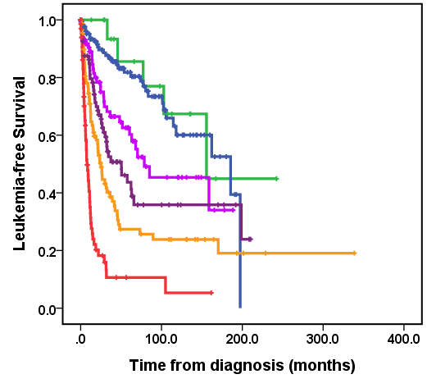  Moderate high-risk IPSS-M, n=84  Low-risk IPSS-M, n=132  High-risk IPSS-M, n=92  Very low-risk IPSS-M, n=18  Very high-risk IPSS-M, n=68  Moderate low-risk IPSS-M, n=91  P = 0.546  P = 0.003  P = 0.114  P = 0.046  P < 0.001 | 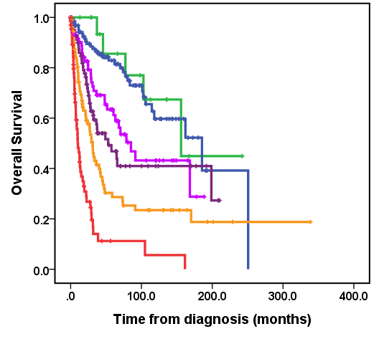  Moderate high-risk IPSS-M, n=84  Low-risk IPSS-M, n=132  High-risk IPSS-M, n=92  Very low-risk IPSS-M, n=18  Very high-risk IPSS-M, n=68  Moderate low-risk IPSS-M, n=91  P = 0.680  P = 0.004  P = 0.288  P = 0.020  P < 0.001
(c) | (d)
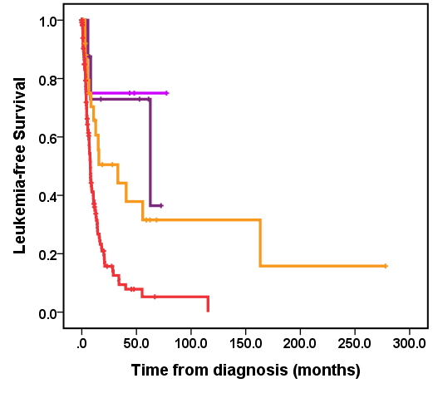  Moderate high-risk IPSS-M, n=8  High-risk IPSS-M, n=29  Very high-risk IPSS-M, n=123  Moderate low-risk IPSS-M, n=4  P = 0.086  P = 0.288  P = 0.001 | 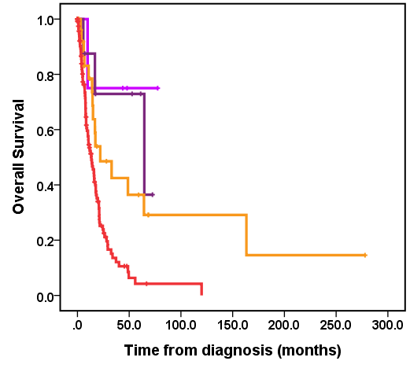  Moderate high-risk IPSS-M, n=8  High-risk IPSS-M, n=29  Very high-risk IPSS-M, n=123  Moderate low-risk IPSS-M, n=4  P = 0.674  P = 0.301  P = 0.002
Abbreviations: IPSS-M, Molecular International Prognostic Scoring System; MDS, myelodysplastic syndromes; MDS/AML, myelodysplastic syndromes/acute myeloid leukemia.

Supplemental Figure 4. Kaplan-Meier curves of leukemia-free survival and overall survival for patients with myelodysplastic syndromes, reclassified by the IPSS-M (down-stage vs. unchanged vs. up-stage) within each IPSS-R group
(a,b) Leukemia-free survival (a) and overall survival (b) for patients with very low/low-risk IPSS-R
(c,d) Leukemia-free survival (c) and overall survival (d) for patients with intermediate-risk IPSS-R
(e,f) Leukemia-free survival (e) and overall survival (f) for patients with high-risk IPSS-R
(g,h) Leukemia-free survival (g) and overall survival (h) for patients with very high-risk IPSS-R
(a) | (b)
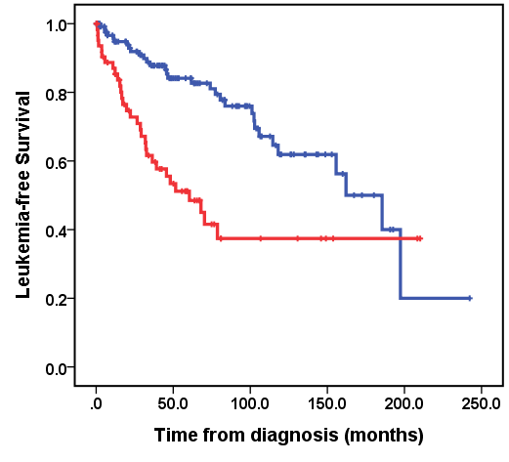  Unchanged, n=127  Up-stage, n=65  P < 0.001 | Unchanged, n=127  Up-stage, n=65  P < 0.001
(c)  Down-stage, n=23  Unchanged, n=102  Up-stage, n=48  P = 0.161  P < 0.001 | (d)  Down-stage, n=23  Unchanged, n=102  Up-stage, n=48  P = 0.241  P < 0.001
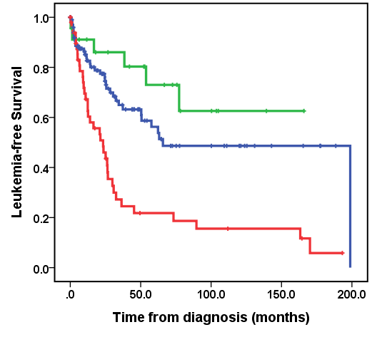 | 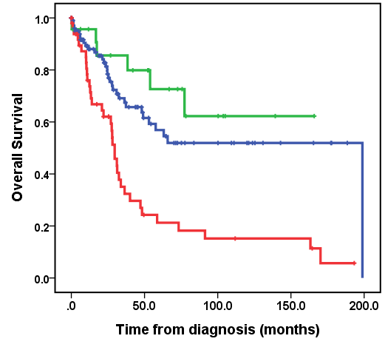
(e) | (f)  Down-stage, n=29  Unchanged, n=48  Up-stage, n=64  P = 0.075  P < 0.001
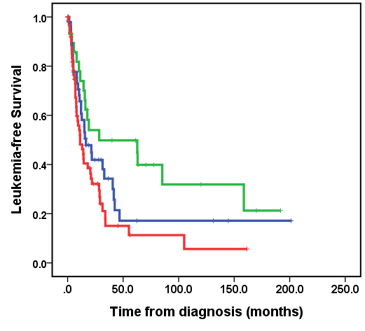  Down-stage, n=29  Unchanged, n=48  Up-stage, n=64  P = 0.186  P = 0.089 | 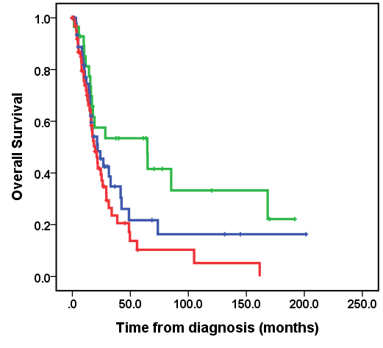

(g) | (h)
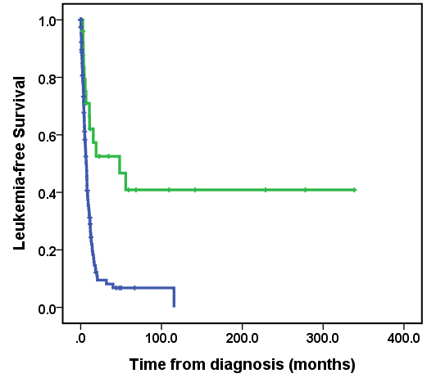  P < 0.001  Unchanged, n=118  Down-stage, n=25 | 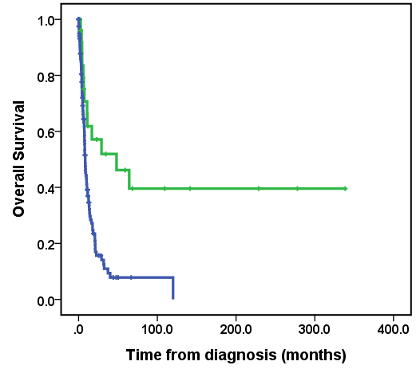  P < 0.001  Unchanged, n=118  Down-stage, n=25
Abbreviations: IPSS-M, Molecular International Prognostic Scoring System; IPSS-R, Revised International Prognostic Scoring System.

Supplemental Figure 5. Impacts of stem cell transplantation on leukemia-free survival and overall survival in patients with high or very high-risk IPSS-M
(a,b) Leukemia-free survival (a) and overall survival (b) of patients receiving or not receiving stem cell transplant in those with high-risk IPSS-M
(c,d) Leukemia-free survival (c) and overall survival (d) of patients receiving or not receiving stem cell transplant in those with very high-risk IPSS-M
(a) | (b)
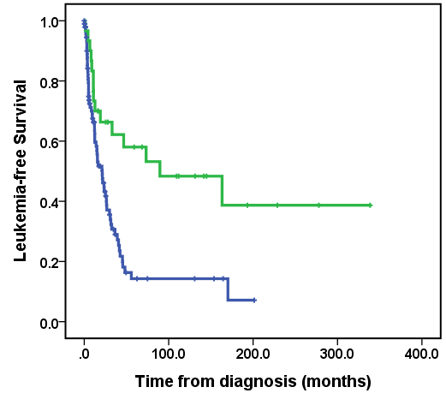  P = 0.001  HSCT (-), n=95  HSCT (+), n=27 | 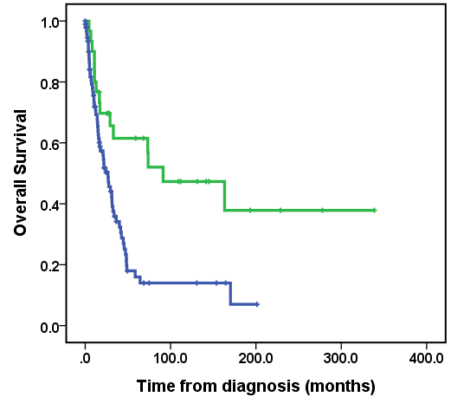  P = 0.001  HSCT (-), n=95  HSCT (+), n=27
(c) | (d)
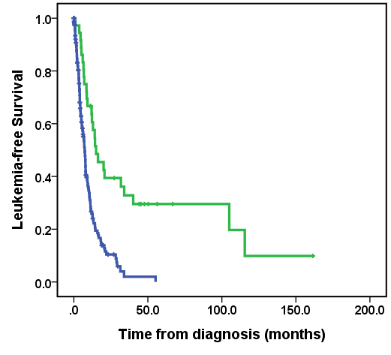  P < 0.001  HSCT (-), n=156  HSCT (+), n=35 | 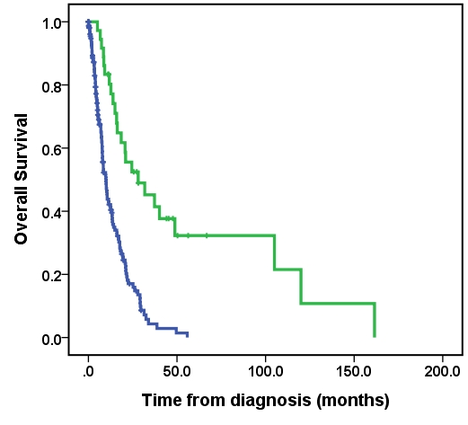  P < 0.001  HSCT (-), n=156  HSCT (+), n=35
Abbreviations: HSCT, allogeneic hematopoietic stem cell transplantation; IPSS-M, Molecular International Prognostic Scoring System; IPSS-R, Revised International Prognostic Scoring System

Supplemental Figure 6. Kaplan-Meier curves for leukemia-free survival and overall survival, stratified based on SF3B1 mutation status
(a) Leukemia-free survival, stratified by SF3B1 mutation status
(b) Overall survival, stratified by SF3B1 mutation status
(a)  Wild type SF3B1, n=558  SF3B1^{α}, n=70  SF3B1^{β}, n=18  SF3B1^{5q}, n=2  P = 0.016  P = 0.004  P = 0.042 | (b)  Wild type SF3B1, n=558  SF3B1^{α}, n=70  SF3B1^{β}, n=18  SF3B1^{5q}, n=2  P = 0.038  P = 0.012  P = 0.042
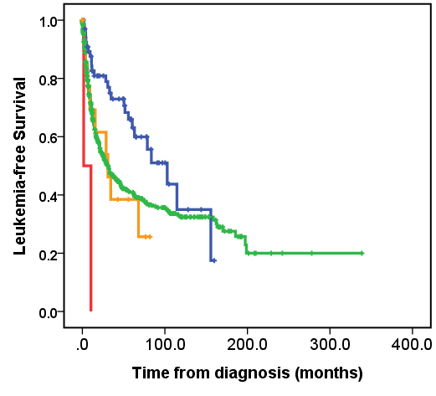 | 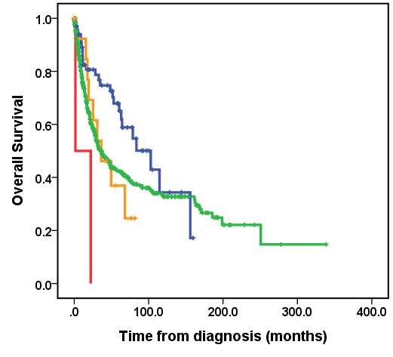
Note: SF3B1^{5q}: concomitant presence with isolated del(5q); SF3B1^{β}: comutation between SF3B1 and any gene from BCOR, BCORL1, NRAS, RUNX1, SRSF2, or STAG2; SF3B1^{α}: as any other mutant SF3B1

