Preparation of magnetized carrageenan-metformin as a new bio-inspired heterogeneous nanocatalyst for the synthesis of dihydropyrano[2,3-c]pyrazoles
Forouzan Heydari¹, Mohsen Bakhtiarian¹, Mohammad Mehdi Khodaei^{1,2}*
¹Department of Organic Chemistry, Razi University, 67149-67346 Kermanshah, Iran
²Nanoscience and Nanotechnology Research Center (NNRC), Razi University, 67149-67346 Kermanshah, Iran
Content | Page
Fig. S1. ¹H-NMR Spectrum of 6-amino-3-methyl-4-phenethyl-1,4-dihydropyrano[2,3-c]pyrazole-5-carbonitrile (6g). | 2
Fig. S2. ¹³C-NMR Spectrum of 6-amino-3-methyl-4-phenethyl-1,4-dihydropyrano[2,3-c]pyrazole-5-carbonitrile (6g). | 3
Fig. S3. ¹H-NMR Spectrum of 6-amino-3-methyl-4-(naphthalen-1-yl)-1,4-dihydropyrano[2,3-c]pyrazole-5-carbonitrile (6i). | 4
Fig. S4. ¹³C-NMR Spectrum of 6-amino-3-methyl-4-(naphthalen-1-yl)-1,4-dihydropyrano[2,3-c]pyrazole-5-carbonitrile (6i). | 5
Fig. S5. ¹H-NMR Spectrum of 6-amino-3-methyl-4-phenyl-1,4-dihydropyrano[2,3-c]pyrazole-5-carbonitrile (6j). | 6
Fig. S6. ¹³C-NMR Spectrum of 6-amino-3-methyl-4-phenyl-1,4-dihydropyrano[2,3-c]pyrazole-5-carbonitrile (6j). | 7
Calculation of number of active sites, turnover number (TON), and turnover frequency (TOF) | 8
Fig. S7. EDX of reused catalyst after 5 run. | 9

Fig. S1. ¹H-NMR Spectrum of 6-amino-3-methyl-4-phenethyl-1,4-dihydropyrano[2,3-c]pyrazole-5-carbonitrile (6g).

Fig. S2. ¹³C-NMR Spectrum of 5-amino-1, 3-diphenyl-1H-pyrazole-4-carbonitrile (6g).

Fig. S3. ¹H-NMR Spectrum of 6-amino-3-methyl-4-(naphthalen-1-yl)-1, 4-dihydropyrano[2,3-c]pyrazole-5-carbonitrile (6i).
Fig. S4. ¹³C-NMR Spectrum of 6-amino-3-methyl-4-(naphthalen-1-yl)-1, 4-dihydropyrano[2,3-c]pyrazole-5-carbonitrile (6i).

Fig. S5. ¹H-NMR Spectrum of 6-amino-3-methyl-4-phenyl-1, 4-dihydropyrano[2,3-c]pyrazole-5-carbonitrile (6j).

Fig. S6. ¹³C-NMR Spectrum of 6-amino-3-methyl-4-phenyl-1, 4-dihydropyrano[2,3-c]pyrazole-5-carbonitrile (6j).

Calculation of number of active sites, turnover number (TON), and turnover frequency (TOF)
The effectiveness of a catalyst is defined by turnover number (TON) parameter.
$$TON=\frac{Yield ×mole of reactants}{mole\% of catalyst}$$
$$TOF=\frac{TON}{Time (h)}$$
- From titration the amount of acid sites will be = 0.76 mmol/g and amount of basic sites will be 0.56 mmol/g.
- Hence, the amount of active sites will be 1.32 mmol/g.
- Since we used 0.03 g of Carr-Met-MNPs under optimized conditions, the amount of active sites will be 0.0396 mmol.
- The mol% of sulfonic acid groups will be: (0.0396/0.0396 +1) × 100 = 3.8 mol%, where 1 is the mmol of limiting reactant.
For the model reaction:
$$TON=\frac{94×4}{3.8}=98.94$$
$$TOF=\frac{98.94}{0.25}=395.8$$
Using this method, TON and TOF were calculated for all reactions and the results are collected in Table 3.

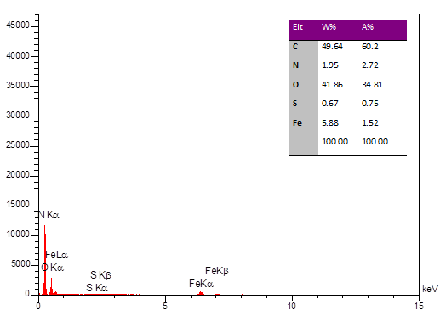
Fig. S7. EDX of reused catalyst after 5 run.

