Table S1 Summary of basic information of 50 accident cases
Case ID | Case ID abbreviation |  | Gender | Age | Height | Head injury recodes* | MAIS level
XMUT03161221.1 | C1 | Male |  | 74 | 165 | STH | 2
XMUT03163371.1 | C2 | Male |  | 69 | 168 | CH, SDH, SAH,  STH, DAI | 4
XMUT03170651.1 | C3 | Female |  | 79 | 158 | SDH, SAH, SF, STH | 4
XMUT03153021.1 | C4 | Female |  | 73 | 142 | SDH, SAH,  CCL, ICH, BS | 5
XMUT05170025.1 | C5 | Female |  | 80 | 154 | Concussion | 2
XMUT04164861.1 | C6 | Male |  | 80 | 166 | DAI, CCL, SA | 4
XMUT04153471.1 | C7 | Male |  | 53 | 157 | SAH, ICH, IH | 3
XMUT03164041.3 | C8 | Male |  | 80 | 168 | BC | 3
XMUT03171912.3 | C9 | Female |  | 68 | 159 | SAH, BHS, IH | 5
XMUT03145112.3 | C10 | Male |  | 78 | 174 | BC, SL | 5
XMUT03172111.3 | C11 | Male |  | 56 | 162 | SAH, CCL, STH, SF | 3
XMUT03180151.3 | C12 | Female |  | 66 | 160 | BC | 5
XMUT03171961.3 | C13 | Male |  | 49 | 169 | PSI | 5
XMUT03172821.3 | C14 | Female |  | 49 | 150 | PSI | 5
XMUT03181871.3 | C15 | Male |  | 46 | 170 | BC, BS | 5
XUMT03144041.2 | C16 | Male |  | 67 | 170 | SA, CH | 4
XMUT03180131.3 | C17 | Male |  | 59 | 164 | SAH | 3
XMUT03184212.2 | C18 | Female |  | 73 | 156 | SDH, SAH,  SF, STH, BH | 5
XMUT03183622.4 | C19 | Male |  | 50 | 165 | SDH, SAH, BS, SF | 5
XMUT04174441.3 | C20 | Female |  | 60 | 160 | No injury | 0
XMUT04170211.3 | C21 | Male |  | 69 | 171 | SDH, SAH, SF, DAI, BH | 5
XMUT04164421.2 | C22 | Male |  | 90 | 164 | SF | 3
XMUT04161721.3 | C23 | Male |  | 64 | 164 | STH, SL | 4
XMUT04163671.3 | C24 | Male |  | 58 | 167 | SDH, SAH, STH | 4
XMUT04155042.3 | C25 | Male |  | 37 | 170 | STH | 6
XMUT04154151.3 | C26 | Male |  | 50 | 176 | SDH, CCL, SAH,  SF, EH, TBH | 4
XMUT04161931.3 | C27 | Female |  | 29 | 170 | BS, PCAT, FB | 5
XMUT05180065.3 | C28 | Male |  | 72 | 165 | PCAT, FB | 4
XMUT05190086.3 | C29 | Female |  | 29 | 173 | Concussions | 2
XMUT05180050.3 | C30 | Male |  | 58 | 170 | No injury | 0
XMUT05190021.3 | C31 | Female |  | 51 | 154 | No injury | 0
XMUT05190115.3 | C32 | Female |  | 32 | 162 | Concussion | 2
XMUT05190009.4 | C33 | Male |  | 66 | 160 | SAH, SDH, SF, STH | 4
XMUT05180032.4 | C34 | Male |  | 70 | 170 | No injury | 0
XMUT07200025.3 | C35 | Male |  | 80 | 160 | SAH, SDH, ICH,  SF, PM, BH | 5
XMUT07200098.3 | C36 | Female |  | 64 | 154 | SL, SF, FB, CH | 5
XMUT06190003.1 | C37 | Female |  | 56 | 160 | SA | 3
XMUT06190004.1 | C38 | Female |  | 63 | 160 | SL | 1
XMUT05180018.3 | C39 | Male |  | 47 | 160 | FC | 1
XMUT06180002.3 | C40 | Male |  | 64 | 162 | SDH, SAH, SF, BH | 4
XMUT06190009.1 | C41 | Male |  | 75 | 160 | SL, CCL, SH | 3
XMUT06190017.2 | C42 | Female |  | 71 | 160 | SH | 1
XMUT06200023.1 | C43 | Male |  | 66 | 165 | SDH, SAH,  ICH, CCL, SF | 4
XMUT06200025.1 | C44 | Female |  | 38 | 158 | SL, CH | 5
XMUT06200026.1 | C45 | Female |  | 60 | 155 | SDH, SF, TBH, SL | 5
XMUT06190027.1 | C46 | Male |  | 73 | 170 | SF, SAH, SL, CI | 4
XMUT07200344.3 | C47 | Male |  | 62 | 166 | SDH, SAH, SF, PM | 5
XMUT07200376.3 | C48 | Male |  | 74 | 166 | SDH, SAH, SL, SF, CCL, STH, PM | 5
XMUT04140642.1 | C49 | Male |  | 79 | 165 | SH | 1
XMUT05190129.3 | C50 | Female |  | 56 | 170 | Concussion | 2
*SDH: subdural hematoma, SAH: subarachnoid hematoma, STH: soft tissue hematoma, DAI: Diffuse axonal injury, SF: skull fracture, CCL: cerebral contusion/laceration, ICH: intracranial hematoma, SL: Scalp laceration, CH: Cerebral hematoma, BH: Brain herniation, SH: Traumatic brain herniation.

Table S2 Summary of head injury reconstruction results for 50 accident cases
Case ID | Global kinematic-based injury criteria* |  |  |  |  |  |  |  | Brain tissue level-based injury criteria*
Case ID | Ang_vel  (rad/s) | Ang_acc  (rad/s2) | Lin_acc  (g) | HIC | HIP  (kw) | GAMBIT | BRIC | BrIC | VM stress  (kPa) | S stress  (kPa) | C.P  (kPa) | C.C.P  (kPa) | MPS | CSDM0.15 | CSDM0.25 | DDM
XMUT03161221.1 | 20.5 | 6080 | 137 | 321 | 10.2 | 0.58 | 0.52 | 0.38 | 10.9 | 6.3 | 344 | -537 | 0.65 | 0.18 | 0.009 | 0.0002
XMUT03163371.1 | 68.3 | 31382 | 411 | 2162 | 89 | 2.18 | 2.51 | 1.12 | 21.5 | 12.1 | 1198 | -693 | 1.64 | 0.95 | 0.659 | 0.045
XMUT03170651.1 | 63.1 | 12693 | 216 | 1423 | 25.6 | 0.95 | 0.82 | 0.41 | 29 | 16.5 | 1313 | -224 | 2 | 0.975 | 0.847 | 0.0002
XMUT03153021.1 | 85.7 | 14052 | 394 | 3998 | 78 | 1.8 | 2.2 | 3.5 | 28.8 | 16.5 | 1480 | -512 | 2.46 | 0.96 | 0.614 | 0.0012
XMUT05170025.1 | 115 | 40465 | 366 | 4522 | 99.2 | 1.83 | 3.5 | 1.79 | 43.2 | 22.3 | 1097 | -77 | 1.84 | 0.986 | 0.858 | 0
XMUT04164861.1 | 68.03 | 26528 | 176.8 | 1170.4 | 57 | 1.2 | 2.13 | 1.26 | 12.12 | 7.0 | 479.4 | -119.2 | 0.755 | 0.412 | 0.097 | 0.209
XMUT04153471.1 | 25 | 8608 | 173 | 442 | 33.8 | 0.74 | 0.76 | 0.4 | 9.5 | 5.4 | 480 | -156 | 0.56 | 0.137 | 0.0064 | 0.0001
XMUT03164041.3 | 20.4 | 11702 | 370 | 1808 | 69.9 | 1.51 | 0.73 | 0.31 | 22.1 | 12.4 | 240.2 | -108 | 1.22 | 0.633 | 0.243 | 0
XMUT03171912.3 | 89.42 | 45909 | 406.21 | 5810 | 98.1 | 2.24 | 3.06 | 2.13 | 29.5 | 17 | 1542.4 | -758.4 | 1.69 | 0.982 | 0.893 | 0.00054
XMUT03145112.3 | 70.1 | 24614 | 279 | 1841 | 92.1 | 1.39 | 2.13 | 1.06 | 20 | 11.5 | 2638 | -980 | 1.387 | 0.831 | 0.699 | 0.196
XMUT03172111.3 | 24.3 | 20370 | 404 | 3403 | 45.4 | 1.73 | 1.04 | 0.45 | 7.2 | 4.1 | 605 | -141 | 0.37 | 0.034 | 0.0004 | 0.0053
XMUT03180151.3 | 51 | 31859 | 530 | 2897 | 126 | 2.34 | 1.9 | 0.99 | 15.95 | 9 | 3618 | -453 | 0.77 | 0.888 | 0.494 | 0
XMUT03171961.3 | 34.8 | 20600 | 359 | 2816 | 48.6 | 1.57 | 1.27 | 0.55 | 26.9 | 14.2 | 942 | -185 | 1.51 | 0.874 | 0.481 | 0.0001
XMUT03172821.3 | 47.4 | 17810 | 270 | 1872 | 45.9 | 1.22 | 1.47 | 0.67 | 20.87 | 12.04 | 1018 | -238 | 1.31 | 0.734 | 0.263 | 0.007
XMUT03181871.3 | 55.7 | 31600 | 582 | 12720 | 137 | 2.52 | 1.99 | 0.87 | 34.04 | 19.01 | 2925 | -537 | 2.4 | 0.94 | 0.866 | 0.00002
XUMT03144041.2 | 70.05 | 37823 | 295.7 | 2630.3 | 99.38 | 1.8 | 2.46 | 1.18 | 12.97 | 7.49 | 195.1 | -208.8 | 0.822 | 0.53 | 0.183 | 0.0004
XMUT03180131.3 | 45.74 | 8801 | 116.55 | 1464.2 | 26.7 | 0.55 | 1.21 | 0.78 | 10.25 | 5.92 | 163.2 | -232 | 0.885 | 0.763 | 0.589 | 0.058
XMUT03184212.2 | 48.9 | 36688 | 513 | 2989 | 126.1 | 2.37 | 1.98 | 0.81 | 15.1 | 8.6 | 3587 | -916 | 0.729 | 0.855 | 0.467 | 0.0002
XMUT03183622.4 | 41.7 | 20124 | 263 | 2425 | 45.8 | 1.24 | 1.4 | 0.78 | 25.85 | 14.37 | 1808 | -399 | 2.06 | 0.941 | 0.747 | 0.00006
XMUT04174441.3 | 25 | 5550 | 160 | 214 | 13 | 0.66 | 0.68 | 0.71 | 10.4 | 6 | 319 | -285 | 0.77 | 0.561 | 0.189 | 0.003
XMUT04170211.3 | 52.6 | 33469 | 372 | 3399 | 55 | 1.49 | 1.98 | 0.55 | 31.91 | 18.37 | 1467 | -407 | 2.165 | 0.937 | 0.592 | 0.0002
XMUT04164421.2 | 43.5 | 17093 | 230 | 1817 | 46.2 | 1.08 | 1.37 | 0.66 | 16.7 | 9.7 | 637 | -153 | 0.8 | 0.619 | 0.231 | 0.00001
XMUT04161721.3 | 48.7 | 29500 | 388 | 4238 | 88.5 | 1.83 | 1.79 | 0.91 | 28.2 | 16.2 | 1123 | -833 | 2.02 | 0.906 | 0.603 | 0.057
XMUT04163671.3 | 38.2 | 37200 | 346 | 4304 | 72.4 | 1.9 | 1.64 | 0.65 | 24.6 | 14 | 1469 | -614 | 1.55 | 0.868 | 0.439 | 0.0026
XMUT04155042.3 | 47.2 | 18733 | 552 | 9697 | 113.7 | 2.27 | 1.49 | 0.87 | 40.9 | 22.6 | 2115 | -173 | 2.25 | 0.88 | 0.69 | 0.00007
XMUT04154151.3 | 41.3 | 16608 | 281 | 2246 | 40.6 | 1.24 | 1.31 | 0.77 | 20.7 | 11.9 | 1771 | -397 | 1.49 | 0.867 | 0.155 | 0.0001
XMUT04161931.3 | 97.4 | 74718 | 542.5 | 6621.5 | 207.5 | 3.47 | 3.98 | 1.52 | 37.93 | 21.59 | 2195 | -181 | 1.927 | 0.991 | 0.742 | 0.0016
XMUT05180065.3 | 66.2 | 21629 | 213 | 1153 | 38.1 | 1.13 | 1.97 | 1.05 | 25.3 | 14.4 | 971 | -43 | 2.248 | 0.961 | 0.755 | 0
XMUT05190086.3 | 34.41 | 20997 | 259.7 | 1138 | 30 | 1.25 | 1.27 | 0.77 | 22.57 | 12.82 | 203.3 | -801 | 1.18 | 0.528 | 0.152 | 0.0015
XMUT05180050.3 | 35.6 | 7424 | 48.4 | 52.8 | 9.43 | 0.06 | 0.95 | 0.4 | 3.7 | 4.24 | 153.9 | 0 | 0.385 | 0.138 | 0.01 | 0
XMUT05190021.3 | 19.03 | 10643 | 163.08 | 432.4 | 6.16 | 0.73 | 0.68 | 0.3 | 21.36 | 12.33 | 297.3 | -281.8 | 1.348 | 0.468 | 0.122 | 0.00012
XMUT05190115.3 | 32.53 | 14802 | 246 | 1200 | 5.6 | 1.09 | 1.07 | 0.81 | 29.45 | 18.85 | 372.9 | -248.6 | 1.71 | 0.683 | 0.304 | 0.0003
XMUT05190009.4 | 38.61 | 34428 | 254.69 | 1440 | 20.1 | 1.61 | 1.62 | 0.83 | 31.5 | 18 | 708.7 | -287.2 | 2.047 | 0.802 | 0.412 | 0.008
XMUT05180032.4 | 17.12 | 6730.8 | 157.89 | 377.5 | 6.225 | 0.66 | 0.54 | 0.31 | 12.93 | 8.92 | 177.71 | -158.4 | 0.966 | 0.621 | 0.282 | 0.0042
XMUT07200025.3 | 19.1 | 24900 | 530.33 | 2389 | 92.83 | 2.24 | 1.04 | 1.34 | 45.11 | 23.98 | 1128.5 | -900.7 | 1.822 | 0.739 | 0.392 | 0.0003
XMUT07200098.3 | 35.84 | 25817 | 290.8 | 1217 | 33.36 | 1.45 | 1.42 | 0.61 | 24.23 | 13.97 | 803.8 | -475.4 | 1.884 | 0.714 | 0.376 | 0.0003
XMUT06190003.1 | 34.72 | 10646.6 | 169.19 | 1072.4 | 41.37 | 0.75 | 1.02 | 1.14 | 38 | 21.21 | 879.5 | -147.2 | 1.882 | 0.977 | 0.867 | 0.0025
XMUT06190004.1 | 65.29 | 35981 | 313.98 | 3406.9 | 66.43 | 1.78 | 2.31 | 1 | 12.8 | 7.392 | 188.6 | -204.1 | 0.848 | 0.443 | 0.139 | 0.0002
XMUT05180018.3 | 39.62 | 17152 | 284.83 | 1833 | 28.47 | 1.26 | 1.29 | 0.74 | 9.28 | 5.36 | 814.8 | -74.8 | 0.55 | 0.362 | 0.285 | 0
XMUT06180002.3 | 43.4 | 23263 | 330.32 | 3031 | 47.93 | 1.52 | 1.52 | 0.7 | 17.75 | 10.24 | 2160 | -802 | 0.964 | 0.842 | 0.425 | 0.00008
XMUT06190009.1 | 35.24 | 27137.9 | 298.67 | 1476.2 | 29.93 | 1.51 | 1.44 | 0.64 | 21.33 | 12.3 | 815.1 | -500.2 | 1.228 | 0.919 | 0.602 | 0.00021
XMUT06190017.2 | 34.73 | 10615.1 | 154.9 | 759.9 | 16.11 | 0.71 | 1.02 | 0.52 | 4.616 | 2.663 | 78.44 | -65.65 | 0.322 | 0.037 | 0.001 | 0
XMUT06200023.1 | 73.57 | 19083.5 | 188.61 | 1403.8 | 85.88 | 1 | 2.07 | 1.36 | 28.53 | 16.45 | 719.5 | -288.1 | 1.367 | 0.989 | 0.807 | 0.0031
XMUT06200025.1 | 59.15 | 13401 | 228.03 | 2459.4 | 74.89 | 1 | 1.61 | 0.89 | 28.68 | 16.21 | 763.3 | -104.7 | 1.578 | 0.991 | 0.93 | 0.0022
XMUT06200026.1 | 51.46 | 13995.1 | 228.09 | 1930.5 | 56.94 | 1.01 | 1.46 | 0.8 | 39.83 | 21.94 | 1680 | -232.7 | 1.065 | 0.988 | 0.827 | 0.145
XMUT06190027.1 | 27.54 | 14337 | 358.23 | 2916 | 81.33 | 1.489 | 0.954 | 0.452 | 38.98 | 22.04 | 936.7 | -332.7 | 1.889 | 0.974 | 0.813 | 0.0015
XMUT07200344.3 | 37.52 | 25603.2 | 176.08 | 1103.8 | 43.06 | 1.17 | 1.45 | 0.61 | 29.62 | 16.51 | 612.3 | -233.9 | 1.91 | 0.942 | 0.752 | 0.0008
XMUT07200376.3 | 15.16 | 12802.1 | 163.75 | 486.7 | 21.1 | 0.78 | 0.65 | 0.32 | 18.41 | 10.62 | 591.9 | -419.2 | 1.47 | 0.856 | 0.491 | 0.0035
XMUT04140642.1 | 71.55 | 21376.9 | 169.28 | 1025.7 | 39.61 | 1.02 | 2.08 | 1.09 | 20.16 | 10.96 | 621.6 | -407.8 | 1.016 | 0.61 | 0.36 | 0.00134
XMUT05190129.3 | 24.29 | 14633.1 | 80.75 | 65.21 | 56.94 | 0.64 | 0.89 | 0.79 | 19.41 | 12.64 | 530.3 | -464.6 | 1.055 | 0.683 | 0.412 | 0.0017
*Ang_vel: Angular velocity; Ang_acc: Angular acceleration; Lin_acc: Linear acceleration; VM stress: Von Mises stress; S stress: Shear stress; C.P: Coup pressure; C.C.P: Countercoup pressure

Table S3 Summary of basic information for another 10 accident cases
Basic Information |  |  |  |  |  | Head injury reconstruction results
Case ID | Case ID abbreviation | Gender | Age | Height | MAIS level | Ang_acc  (rad/s2) | HIC | C.P  (kPa) | MPS
XMUT04190111.3 | VC1 | Female | 60 | 160 | 6 | 14169 | 8870 | 4197 | 1.776
XMUT04144641.1 | VC2 | Female | 74 | 152 | 5 | 40711 | 3854 | 1061 | 1.64
XMUT03183242.5 | VC3 | Male | 53 | 168 | 4 | 57188 | 1233 | 903.7 | 1.177
XMUT04160341.3 | VC4 | Female | 30 | 148 | 4 | 16500 | 2485 | 894 | 2.05
XMUT0510190079.3 | VC5 | Female | 51 | 158 | 1 | 12800 | 85.24 | 834.8 | 1.43
XMUT0410170032.5 | VC6 | Male | 49 | 170 | 2 | 16900 | 529.7 | 1061.9 | 1.08
XMUT07100003.3 | VC7 | Male | 65 | 170 | 6 | 40572 | 10460 | 1463 | 1.72
XMUT07100485.3 | VC8 | Male | 54 | 165 | 4 | 57715 | 4683 | 1852 | 1.97
XMUT07100808.3 | VC9 | Female | 64 | 156 | 5 | 45443 | 4782 | 2704 | 1.41
XMUT07100079.3 | VC10 | Male | 88 | 169 | 5 | 37906 | 2000 | 931 | 1.51

Figure S1 VRUs kinematic response of 50 accident cases used to establish WIC₄
Case ID: XMUT03161221.1
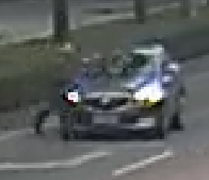 | 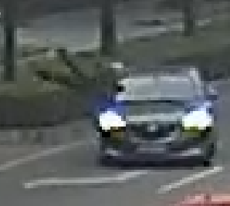 | 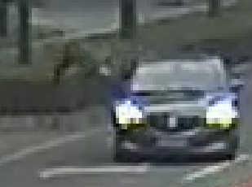 | 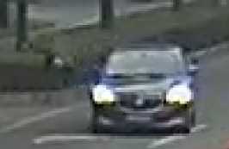 | 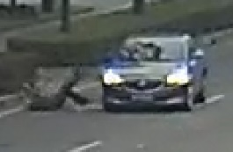
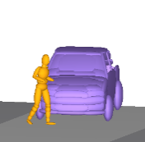 | 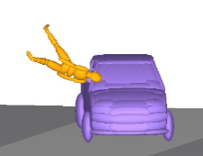 | 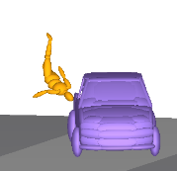 | 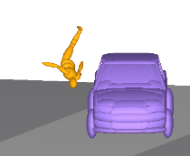 | 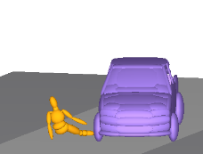
0ms | 320ms | 520ms | 600m | 1280m

Case ID: XMUT03163371.1
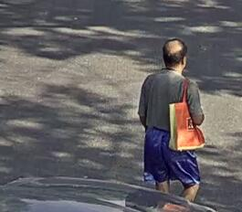 | 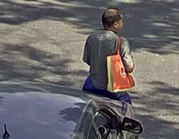 | 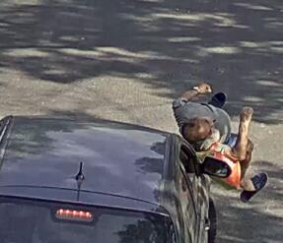 | 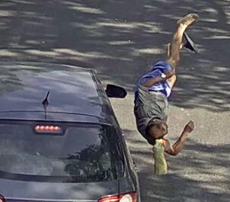 | 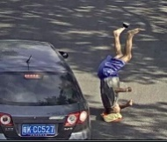
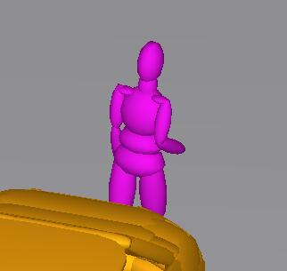 | 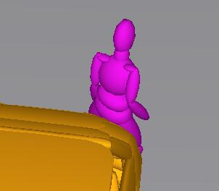 | 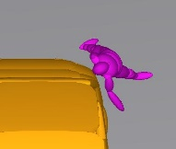 | 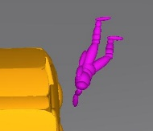 | 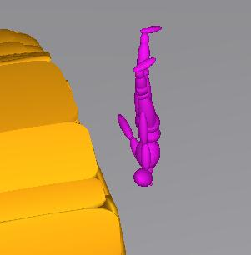
0ms | 120ms | 240ms | 360m | 480m

Case ID: XMUT03170651.1
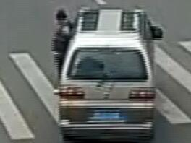 | 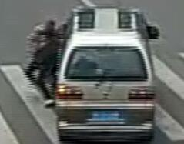 | 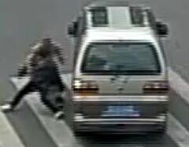 | 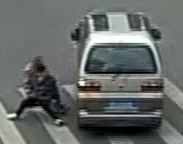 | 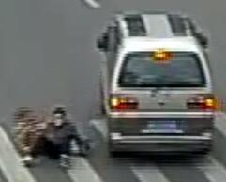
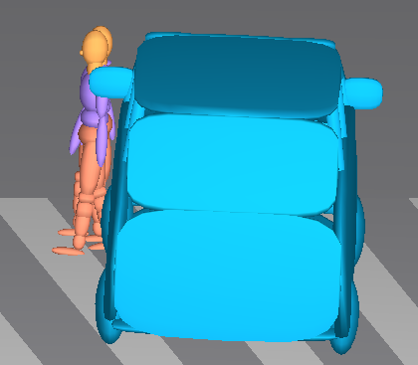 | 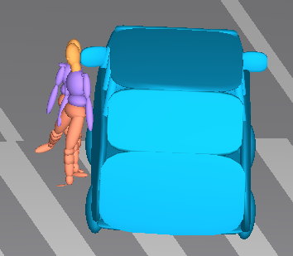 | 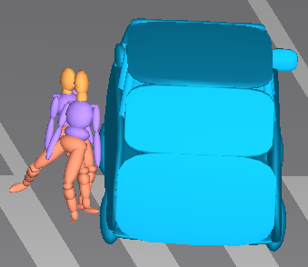 | 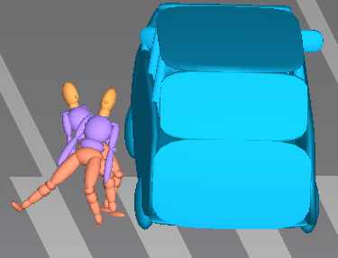 | 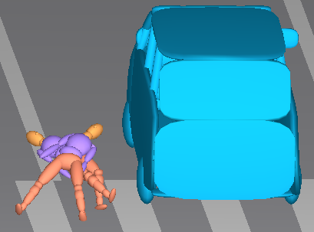
0ms | 120ms | 280ms | 400m | 560m

Case ID: XMUT03153021.1
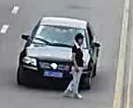 | 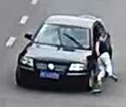 | 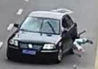 | 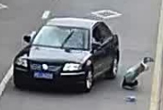 | 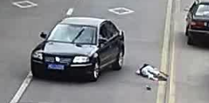
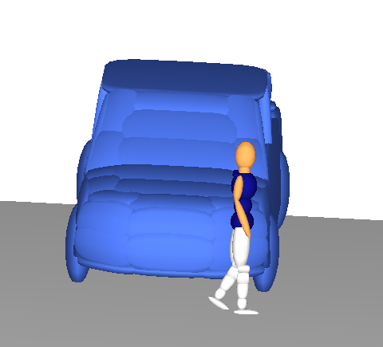 | 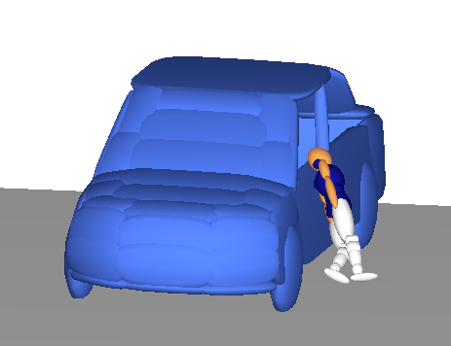 | 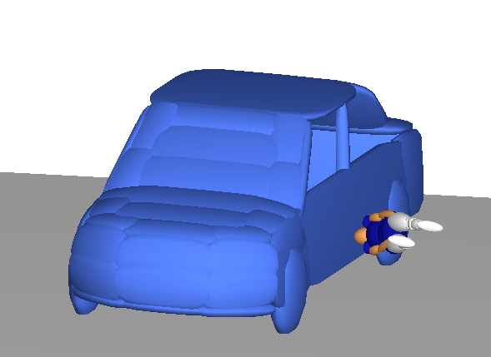 | 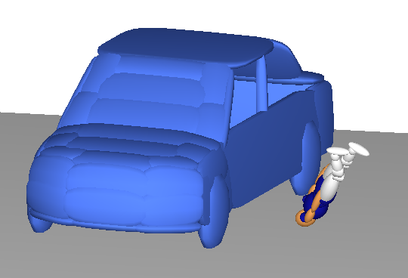 | 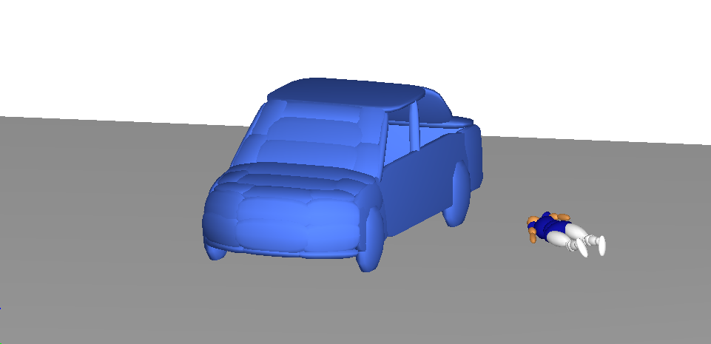
0ms | 180ms | 280ms | 370m | 780m

Case ID: XMUT05170025.1
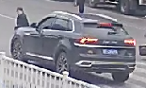 | 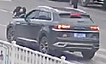 | 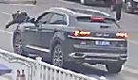 |  | 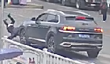
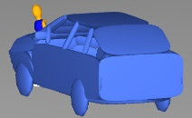 | 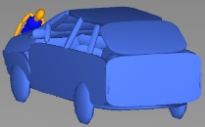 | 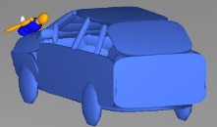 | 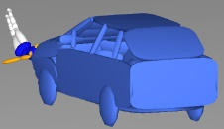 | 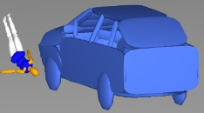
0ms | 112ms | 208ms | 417m | 489m

Case ID: XMUT04164861.1
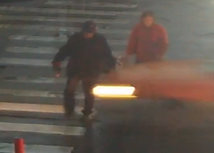 | 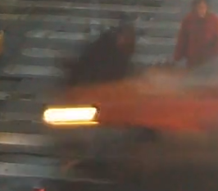 | 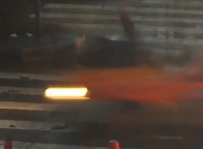
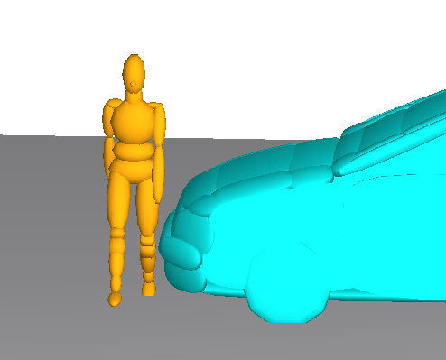 | 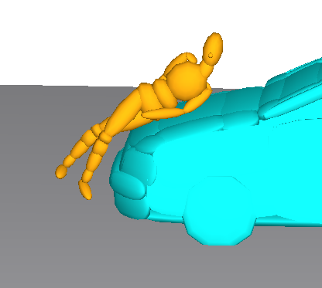 | 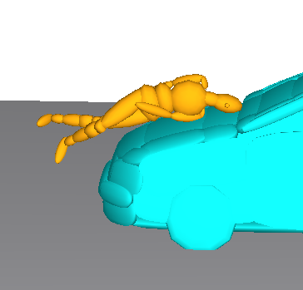
0ms | 80ms | 114m

Case ID: XMUT04153471.1
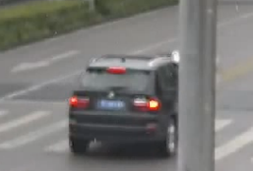 | 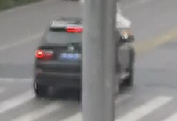 | 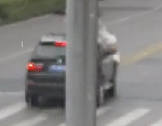 | 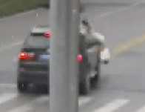 | 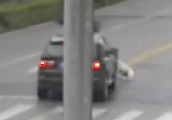
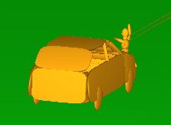 | 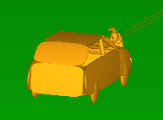 | 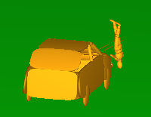 | 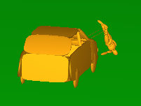 | 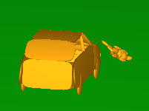
0ms | 133ms | 200ms | 267m | 467m

Case ID: XMUT03164041.3
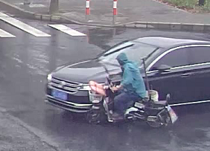 | 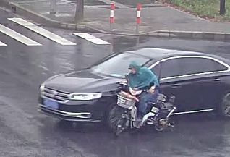 | 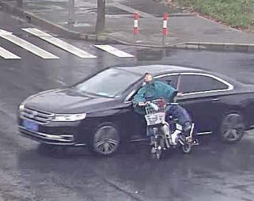 | 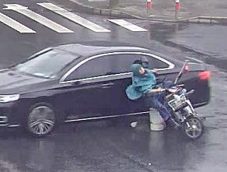 | 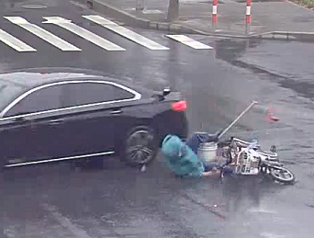
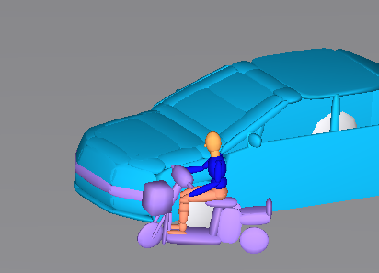 | 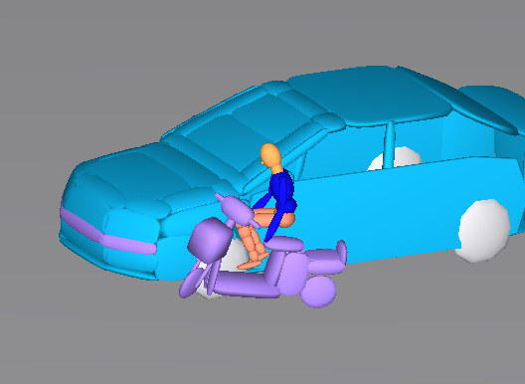 | 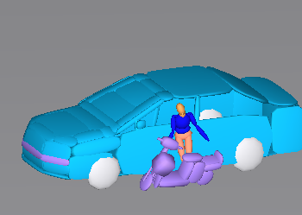 | 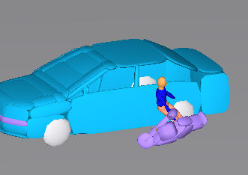 | 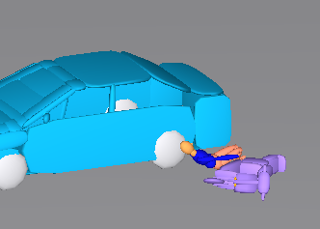
0ms | 80ms | 200ms | 360m | 520m

Case ID: XMUT03171912.3
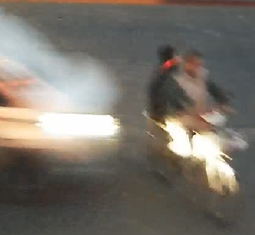 | 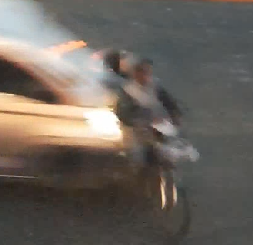 | 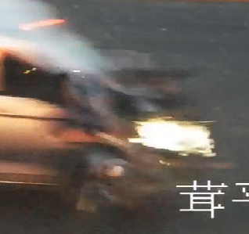 | 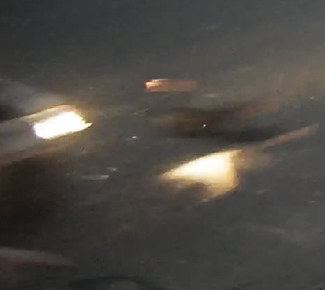 | 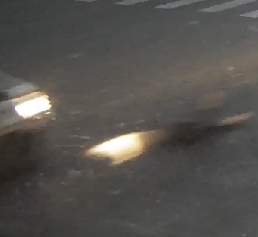
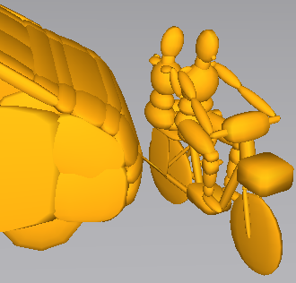 | 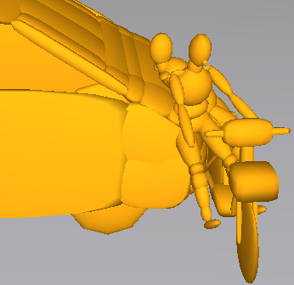 | 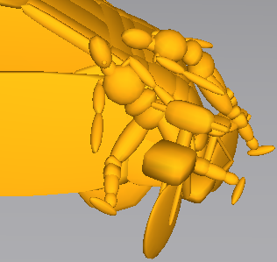 | 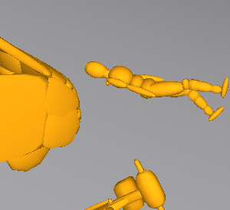 | 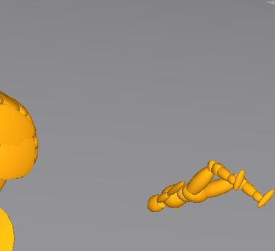
0ms | 80ms | 160ms | 520m | 640m

Case ID: XMUT03145112.3
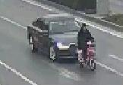 | 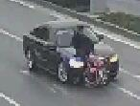 | 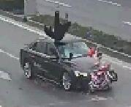 | 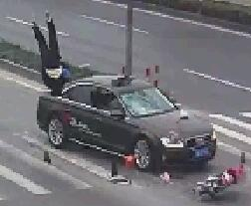 | 
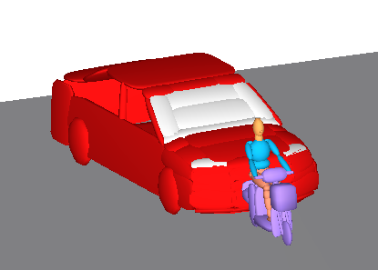 | 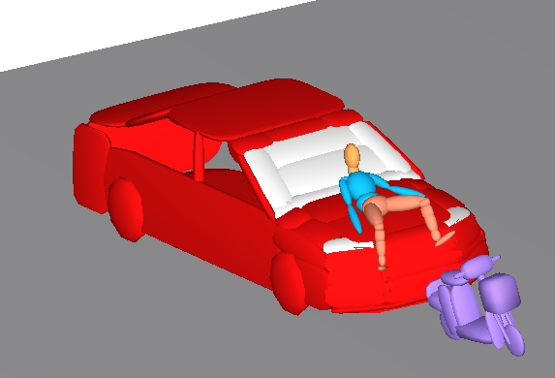 | 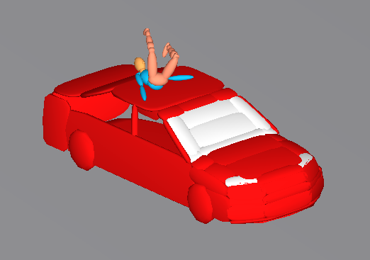 | 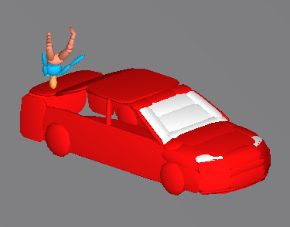 | 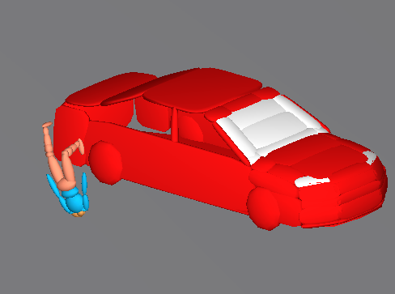
0ms | 80ms | 240ms | 480m | 760m

Case ID: XMUT03172111.3
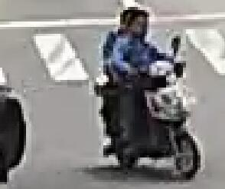 | 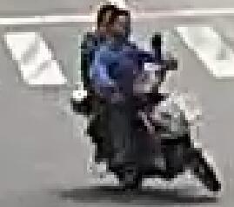 | 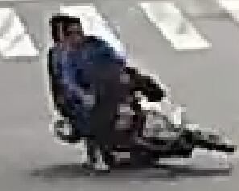 | 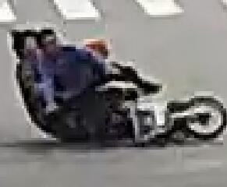 | 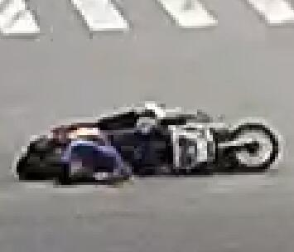
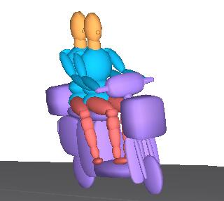 | 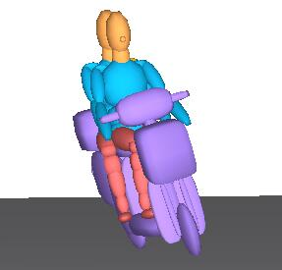 | 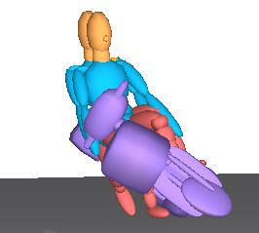 | 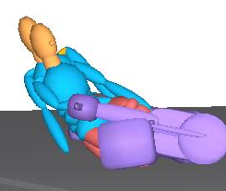 | 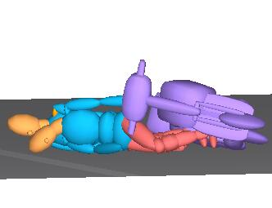
0ms | 80ms | 280ms | 440m | 640m

Case ID: XMUT03180151.3
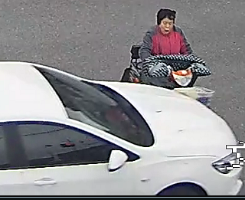 | 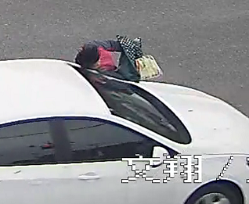 | 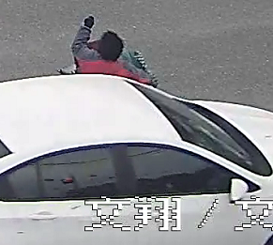 | 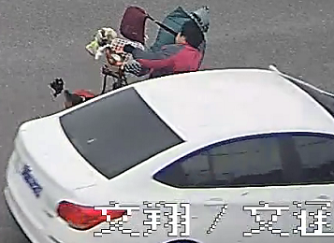 | 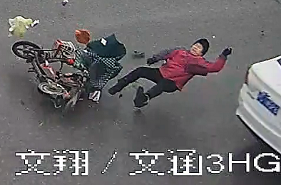
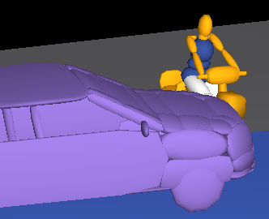 | 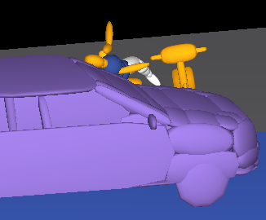 | 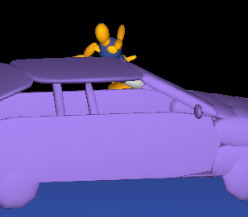 | 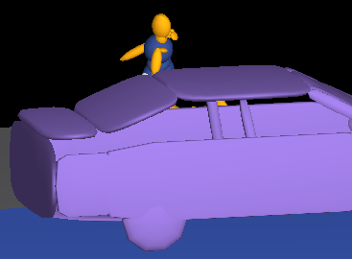 | 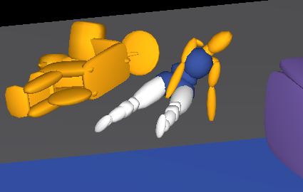
0ms | 126ms | 258ms | 525m | 850m

Case ID: XMUT03171961.3
 |  |  | 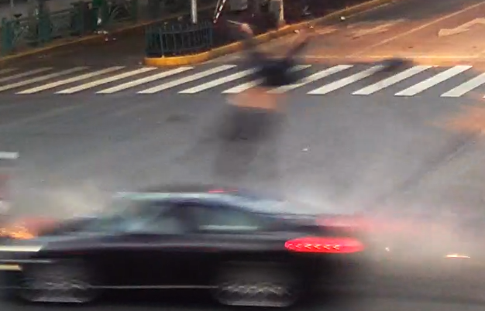 | 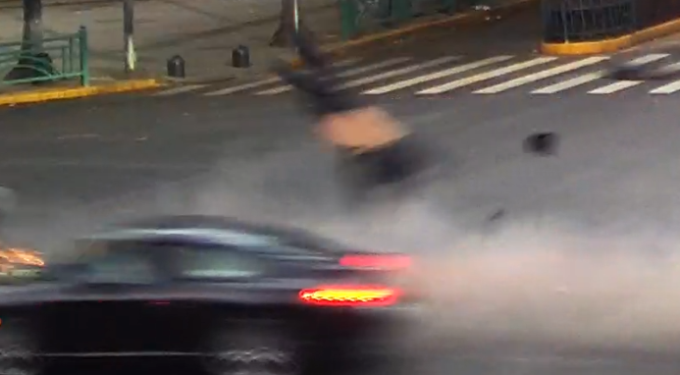
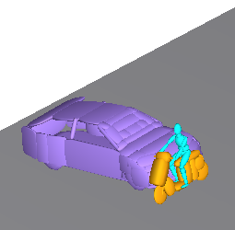 | 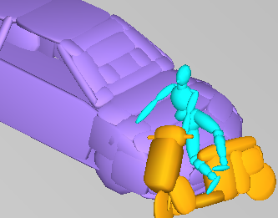 | 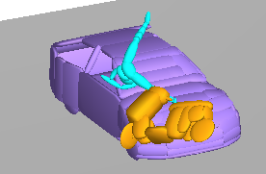 | 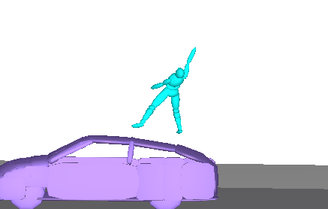 | 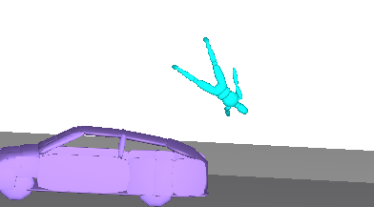
0ms | 58ms | 141ms | 511m | 724m

Case ID: XMUT03172821.3
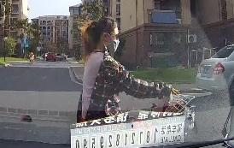 | 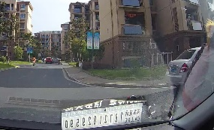
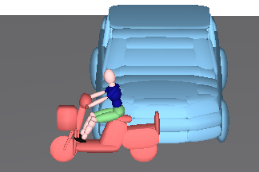 | 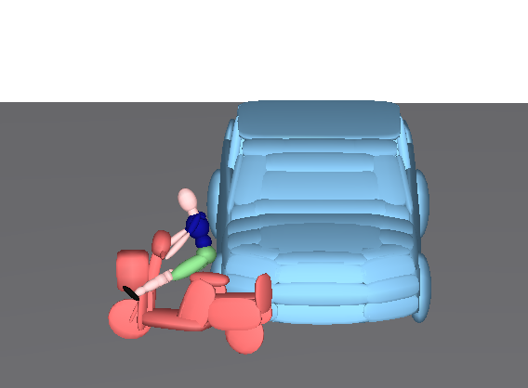
0ms | 80ms

Case ID: XMUT03181871.3
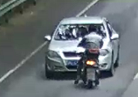 | 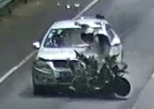 | 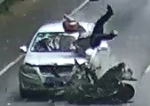 | 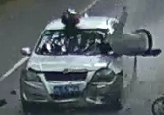 | 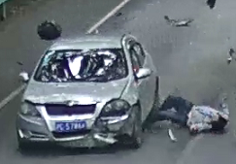
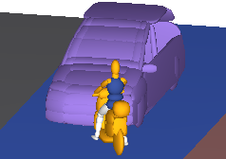 | 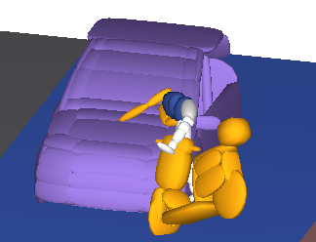 | 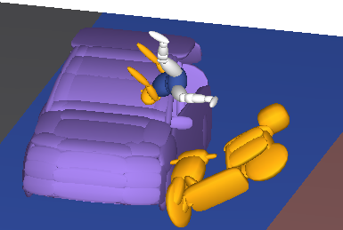 | 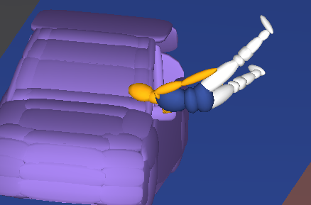 | 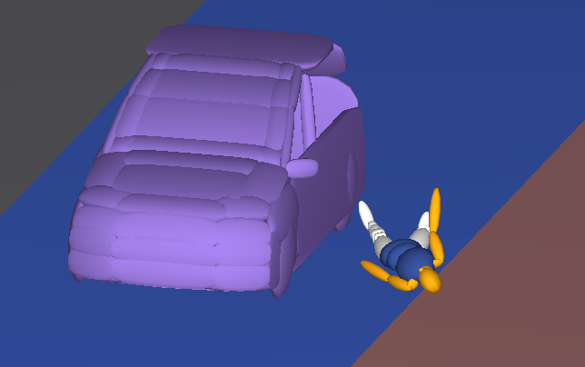
0ms | 146ms | 330ms | 850m | 1400m

Case ID: XMUT03144041.2
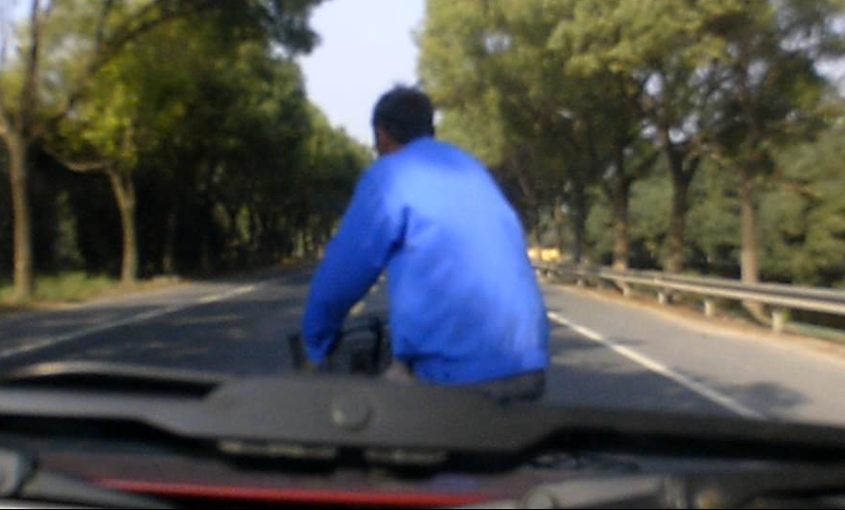 | 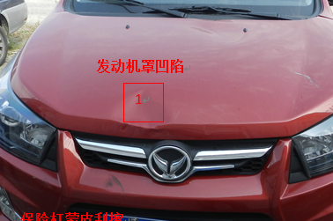 | 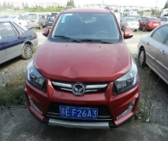
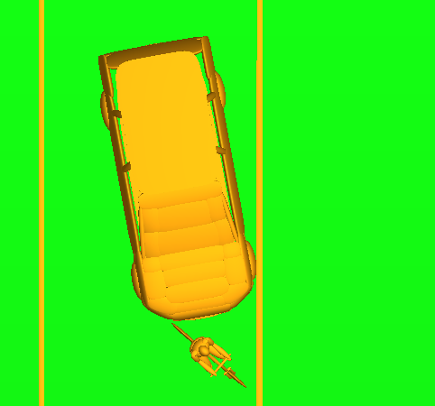 | 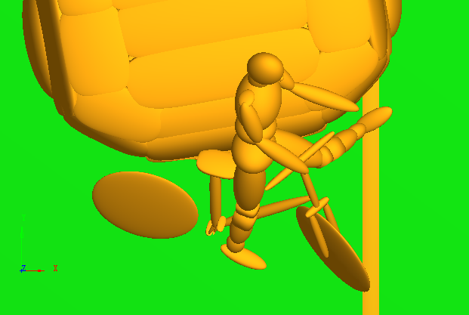 | 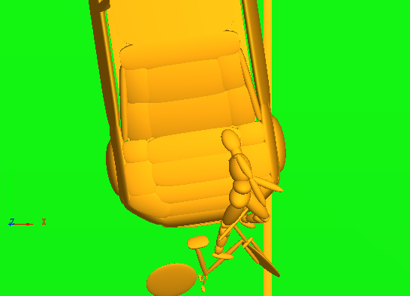
0ms | 32ms | 164ms

Case ID: XMUT03180131.3
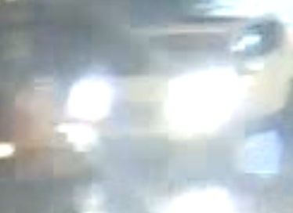 | 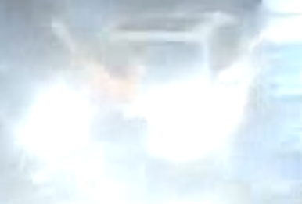 | 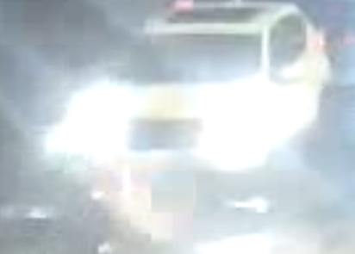 | 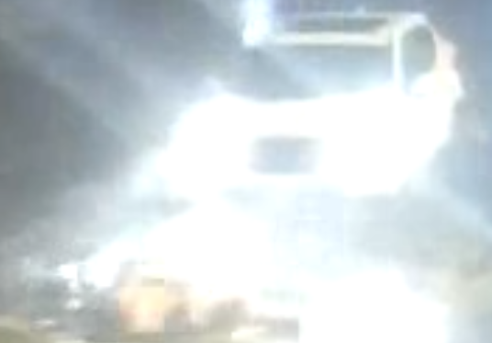 | 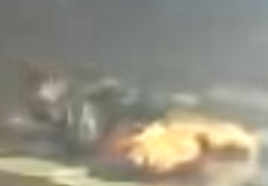
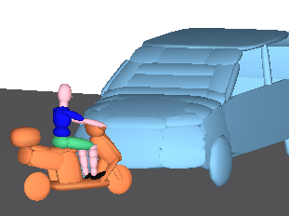 | 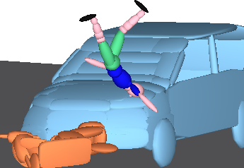 | 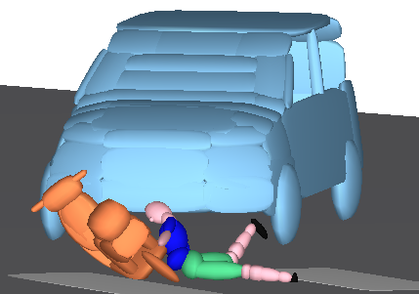 | 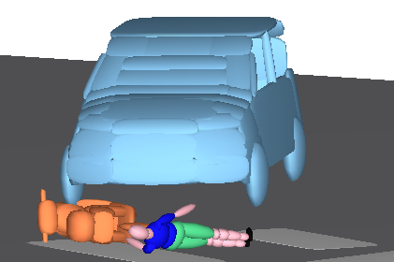 | 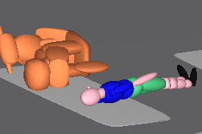
0ms | 450ms | 950ms | 1550m | 2500m

Case ID: XMUT03184212.2
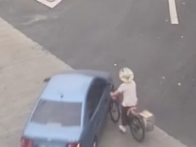 | 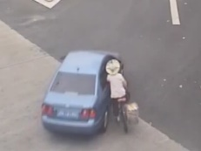 | 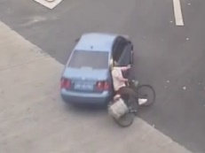 | 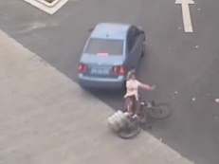 | 
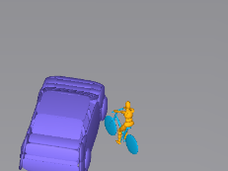 | 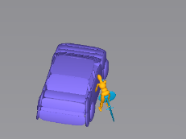 | 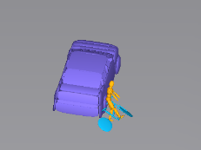 | 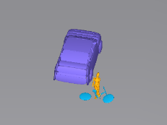 | 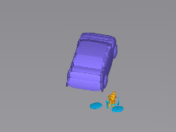
0ms | 240ms | 480ms | 720m | 840m

Case ID: XMUT03183622.4
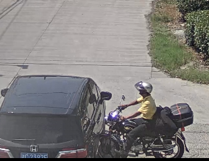 | 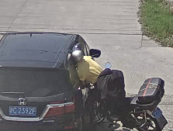 | 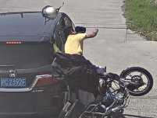 | 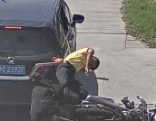 | 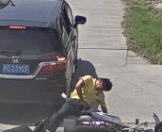
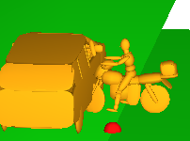 | 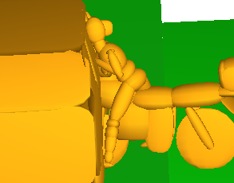 | 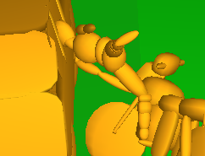 | 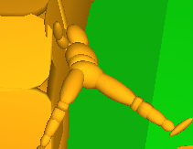 | 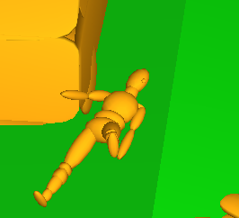
0ms | 94ms | 294ms | 534m | 734m

Case ID: XMUT04174441.3
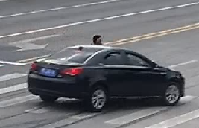 | 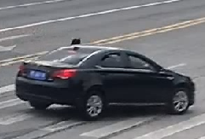 | 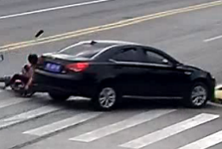 | 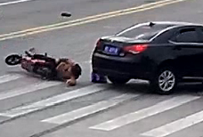 | 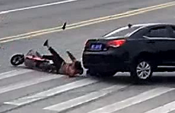
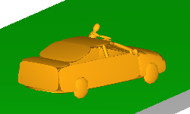 | 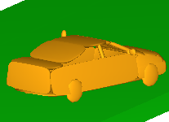 | 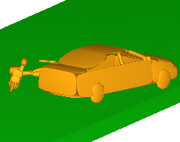 | 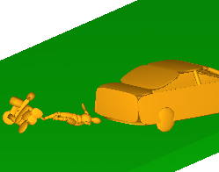 | 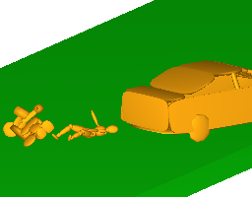
0ms | 252ms | 574ms | 850m | 872m

Case ID: XMUT04170211.3
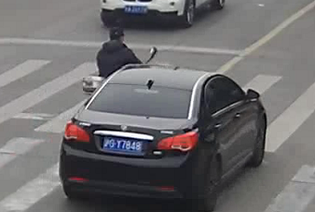 | 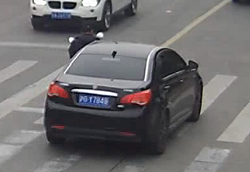 | 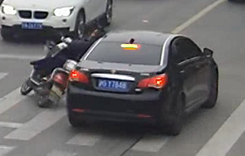 | 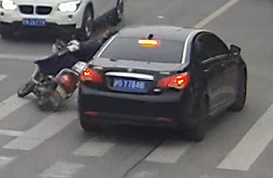 | 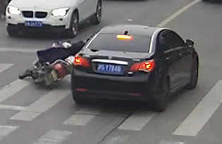
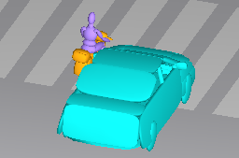 | 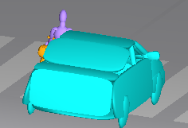 | 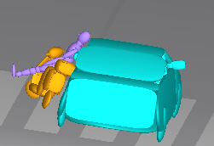 | 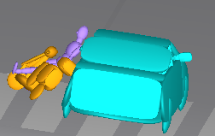 | 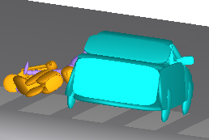
0ms | 104ms | 204ms | 514m | 674m

Case ID: XMUT04164421.2
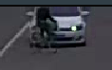 | 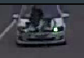 | 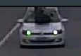 | 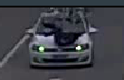 | 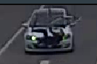
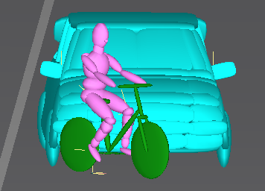 | 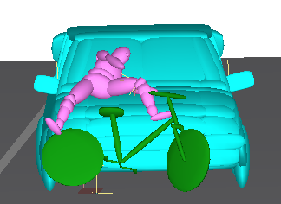 | 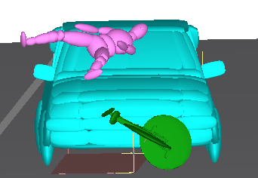 | 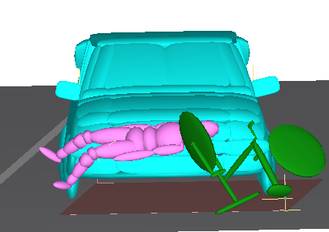 | 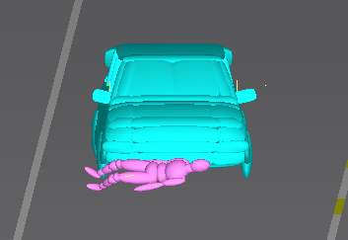
0ms | 135ms | 451ms | 1042m | 1229m

Case ID: XMUT04161721.3
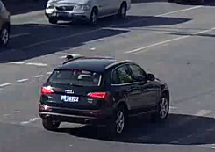 | 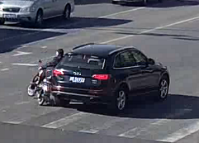 | 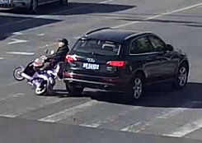 | 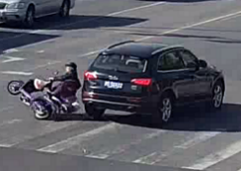 | 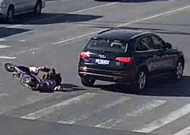
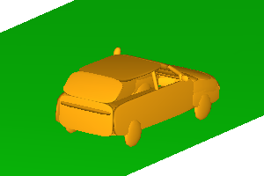 | 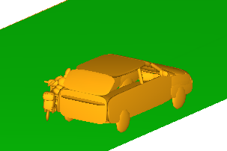 | 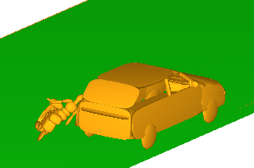 | 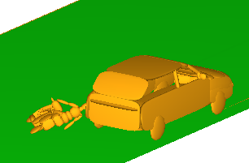 | 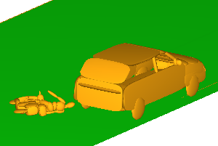
0ms | 200ms | 490ms | 530m | 740m

Case ID: XMUT04163671.3
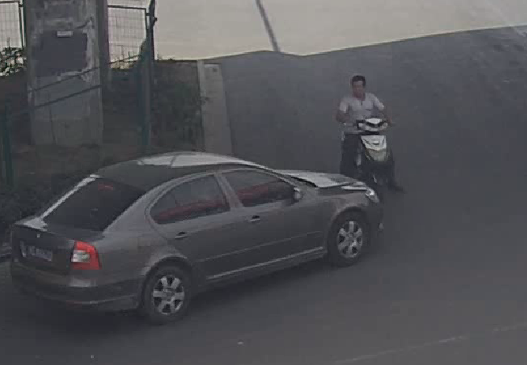 | 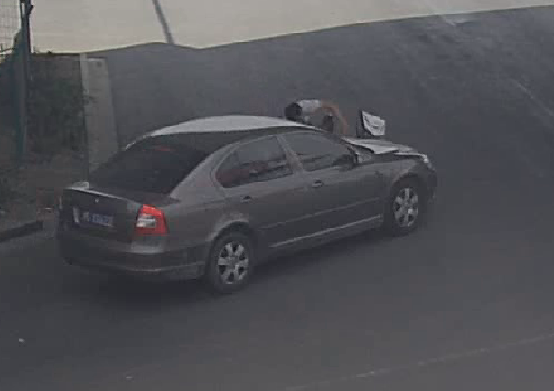 | 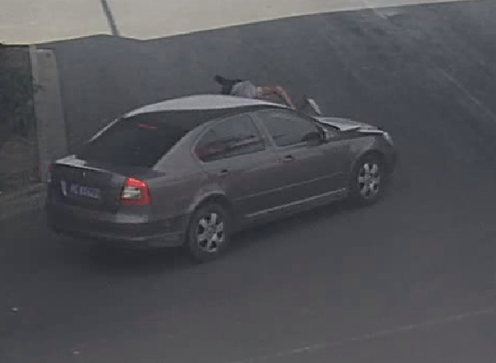 | 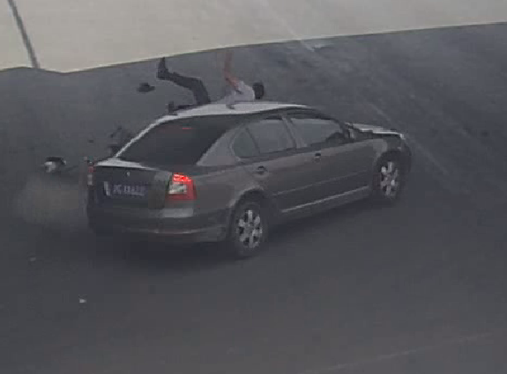 | 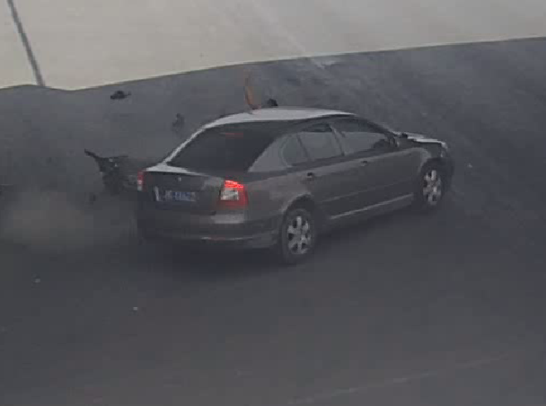
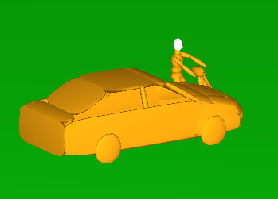 | 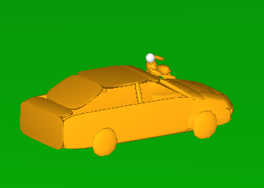 | 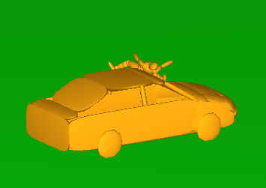 | 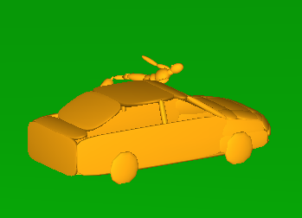 | 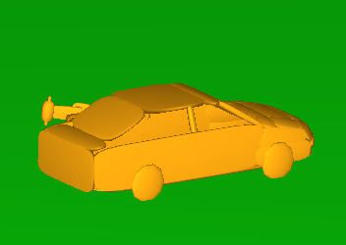
0ms | 200ms | 360ms | 620m | 880m

Case ID: XMUT04155042.3
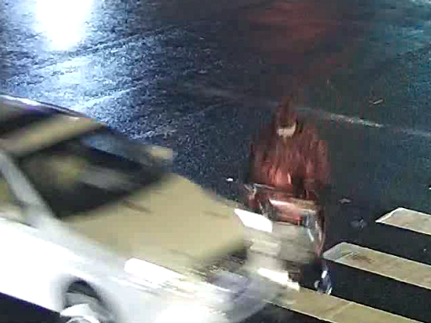 | 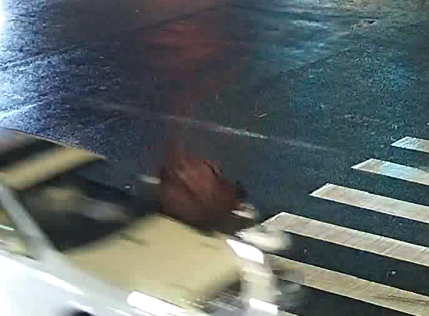 | 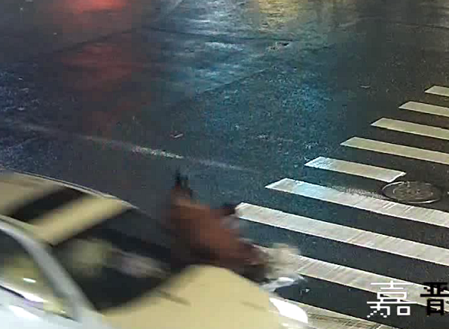 | 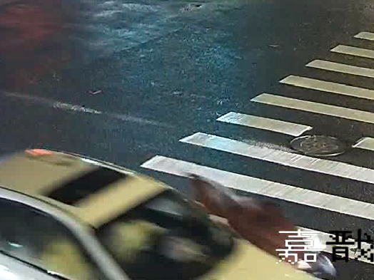 | 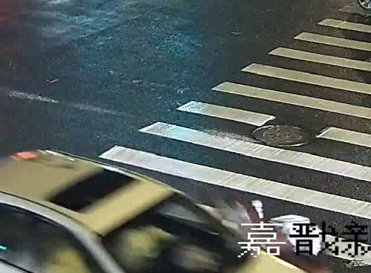
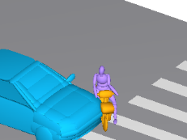 | 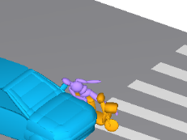 | 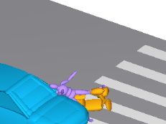 | 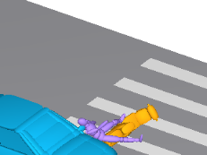 | 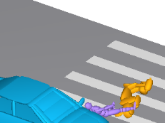
0ms | 120ms | 240ms | 440m | 560m

Case ID: XMUT04154151.3
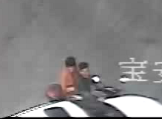 | 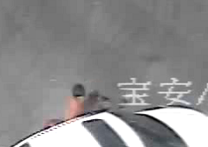 | 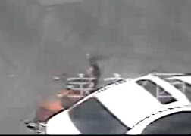 | 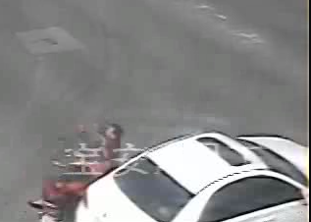 | 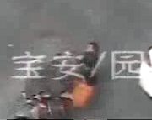
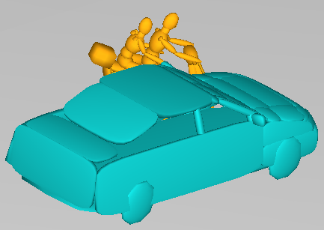 | 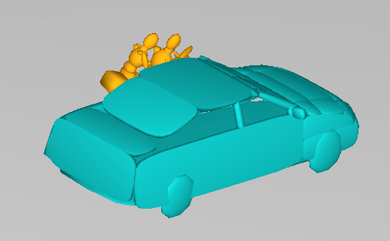 | 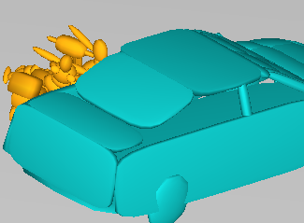 | 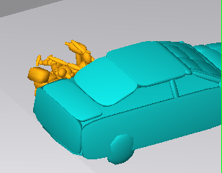 | 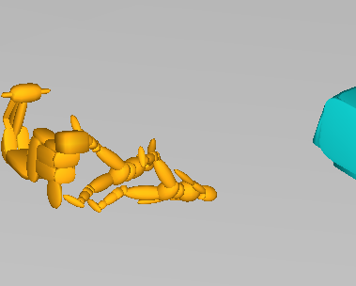
0ms | 98ms | 244ms | 269m | 784m

Case ID: XMUT04161931.3
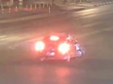 | 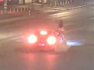 | 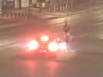 | 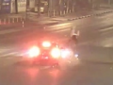 | 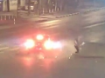
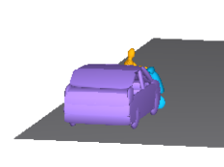 | 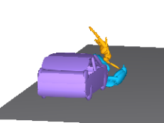 | 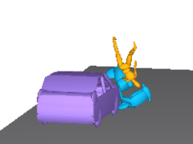 | 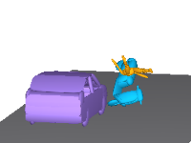 | 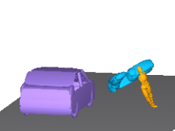
0ms | 280ms | 400ms | 560m | 840m

Case ID: XMUT05180065.3
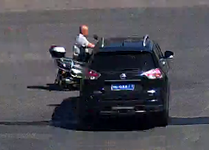 | 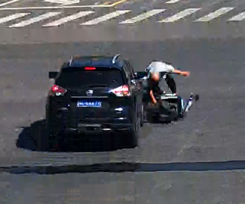 | 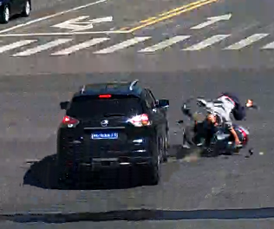 | 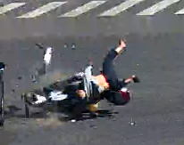 | 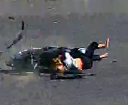
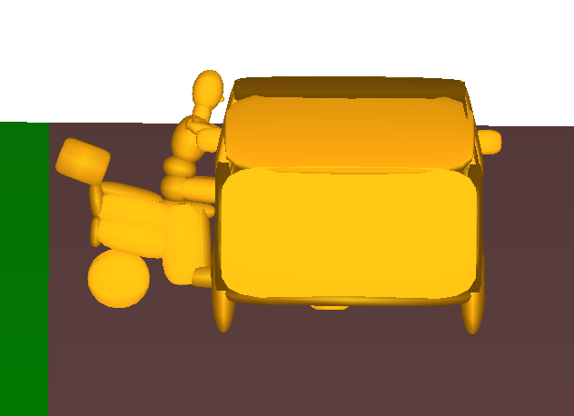 | 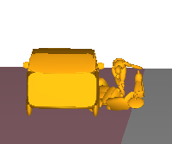 | 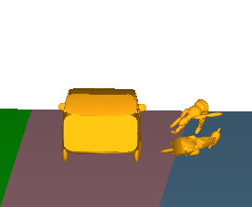 | 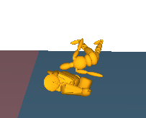 | 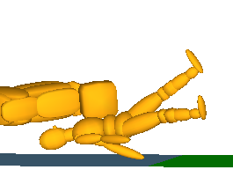
0ms | 100ms | 200ms | 350m | 575m

Case ID: XMUT05190086.3
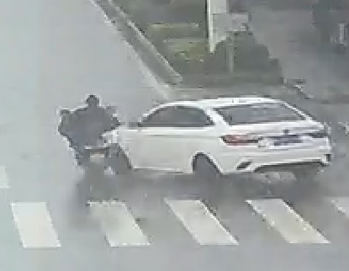 | 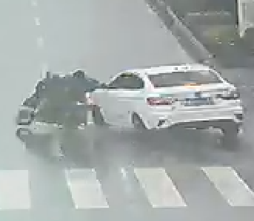 | 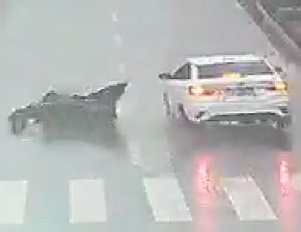 | 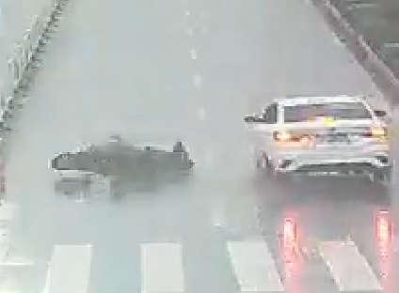 | 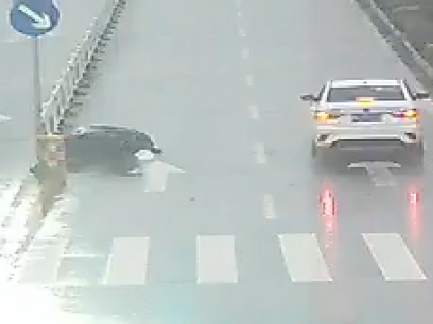
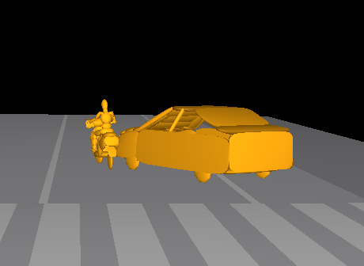 | 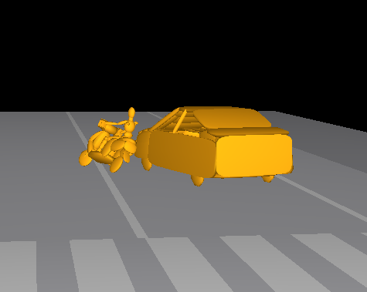 | 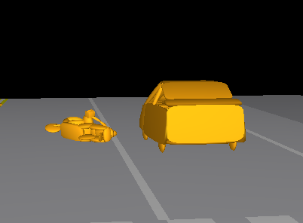 | 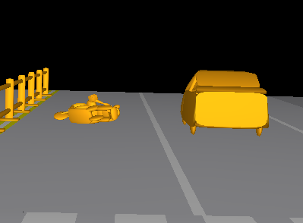 | 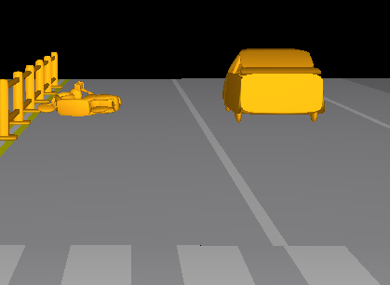
0ms | 250ms | 600ms | 1000m | 1500m

Case ID: XMUT05180050.3
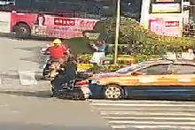 | 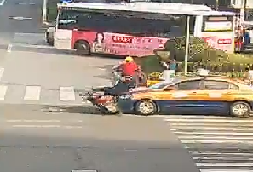 | 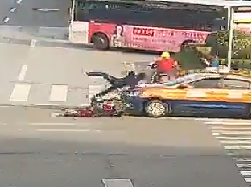 | 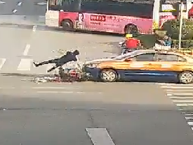 | 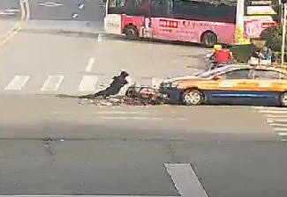
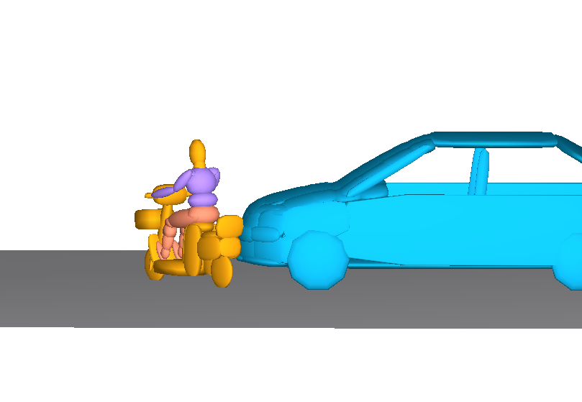 | 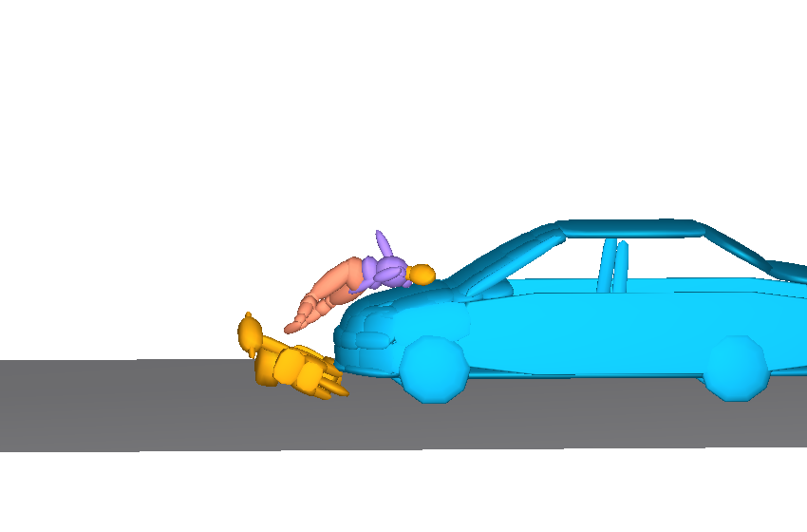 | 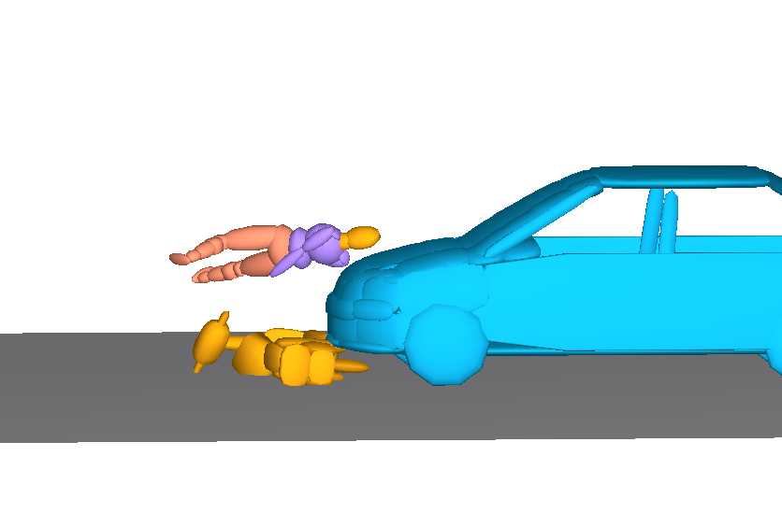 | 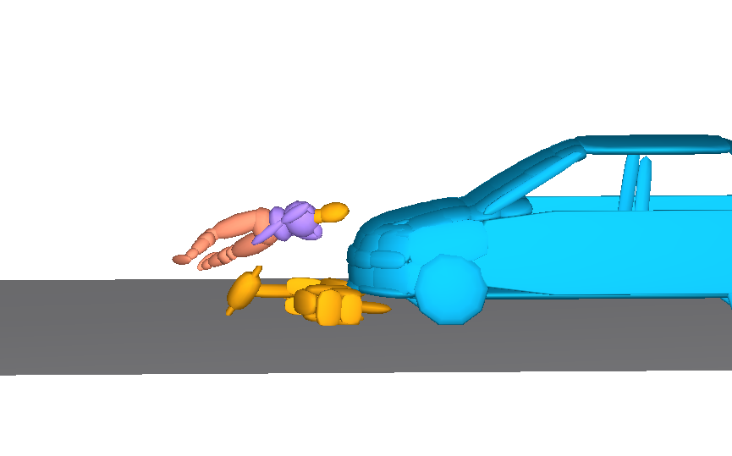 | 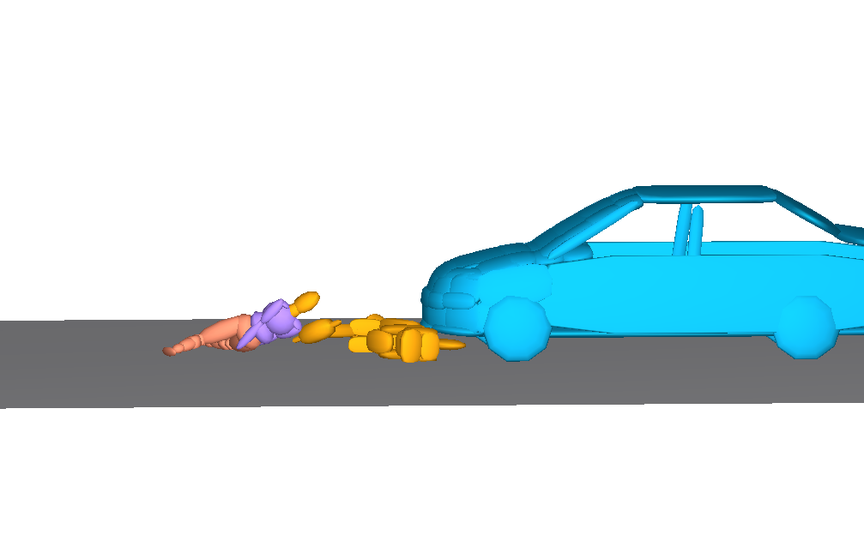
0ms | 260ms | 568ms | 708m | 878m

Case ID: XMUT05190021.3
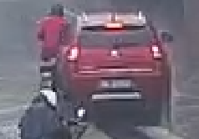 | 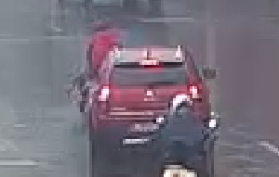 | 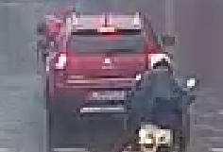 | 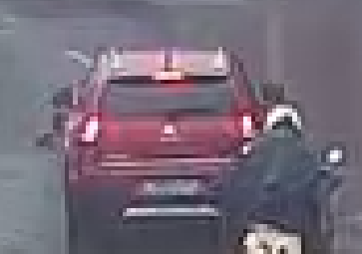 | 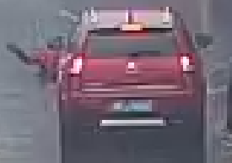
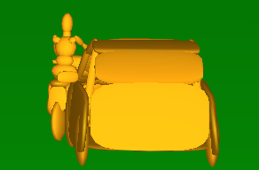 | 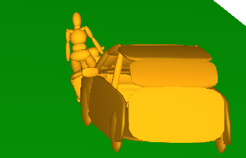 | 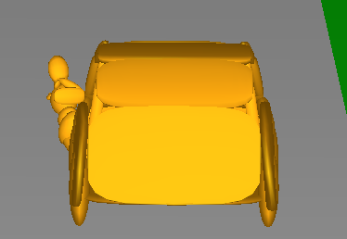 | 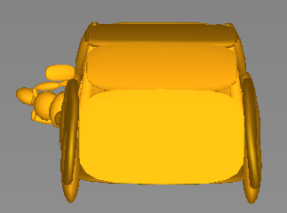 | 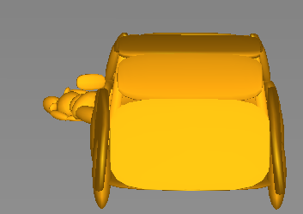
0ms | 280ms | 630ms | 735m | 1185m

Case ID: XMUT05190115.3
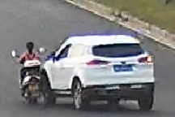 | 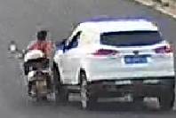 | 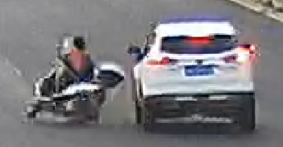 | 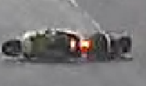 | 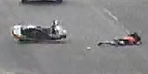
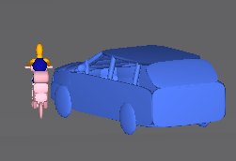 | 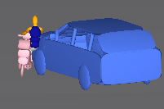 | 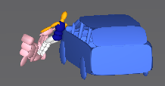 | 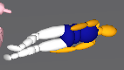 | 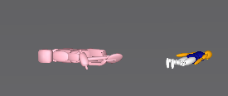
0ms | 80ms | 25ms | 916m | 2000m

Case ID: XMUT05190009.4
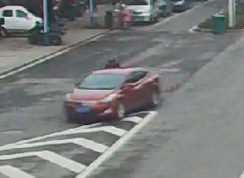 |  |  |  | 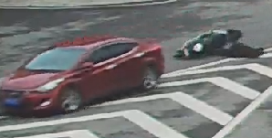
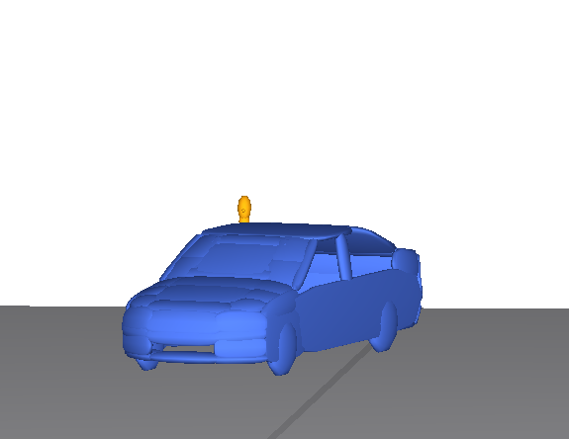 | 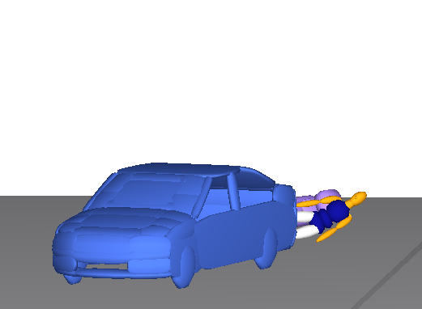 | 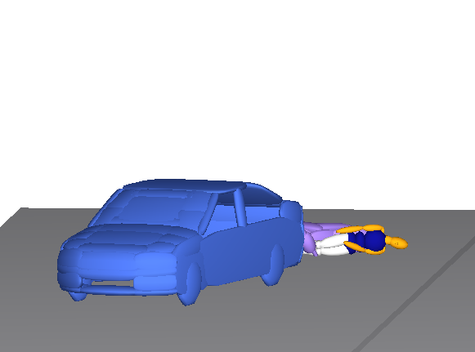 | 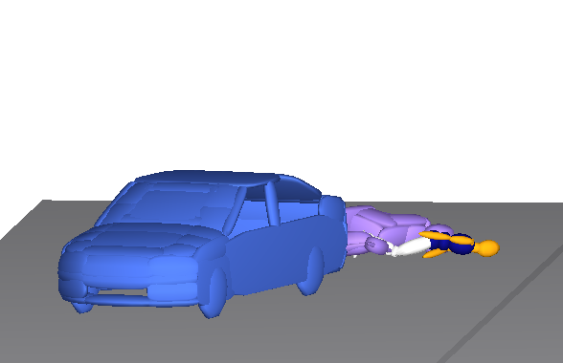 | 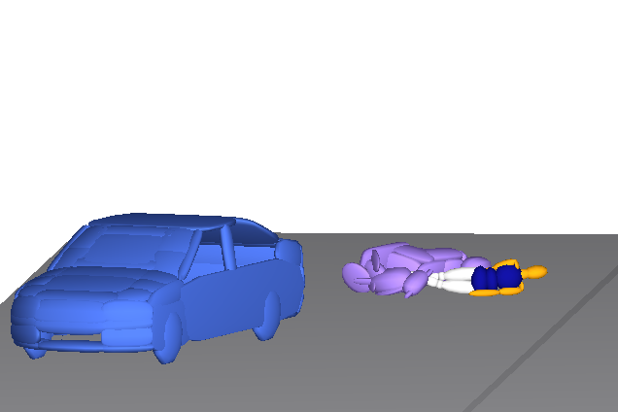
0ms | 120ms | 160ms | 250m | 350m

Case ID: XMUT05180032.4
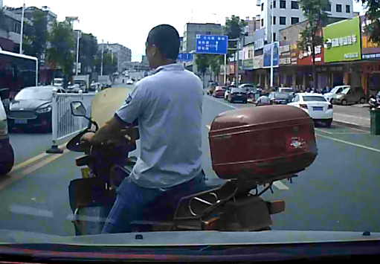 | 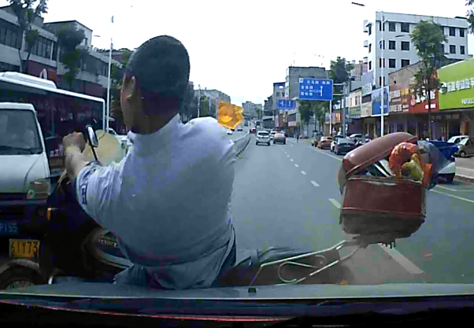 | 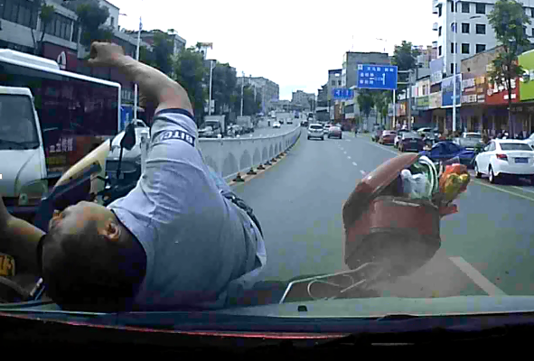 | 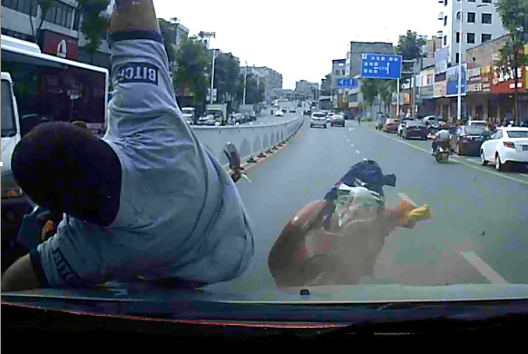 | 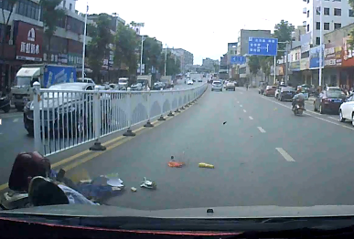
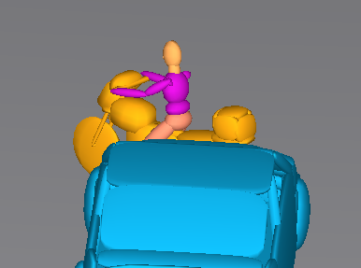 | 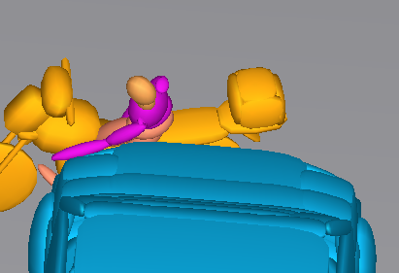 | 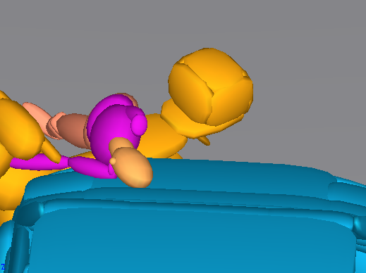 | 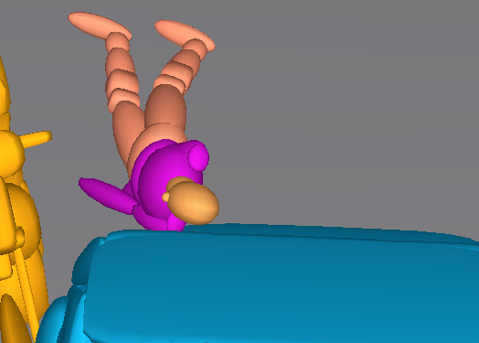 | 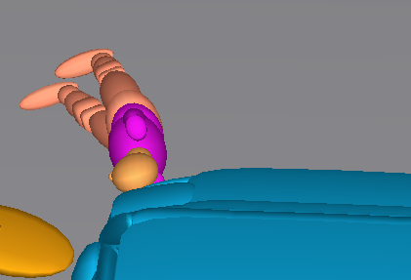
0ms | 193ms | 298ms | 504m | 844m

Case ID: XMUT07200025.3
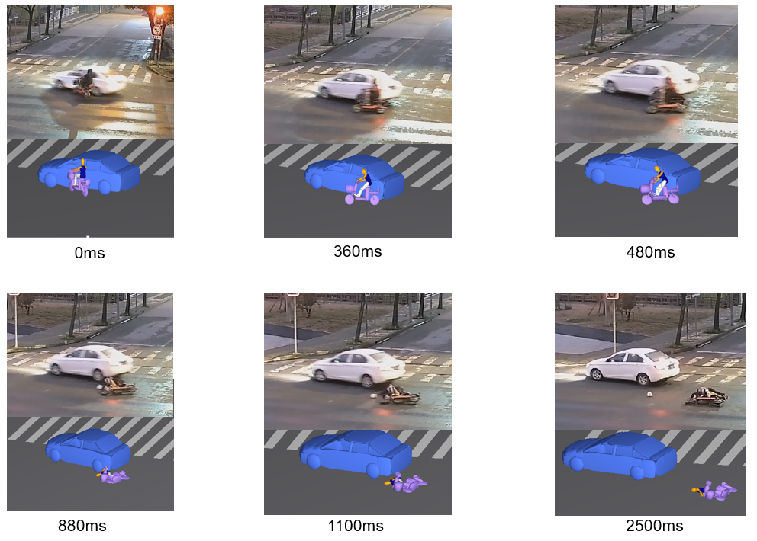
0ms | 380ms | 480ms | 880m | 1100m

Case ID: XMUT07200098.3
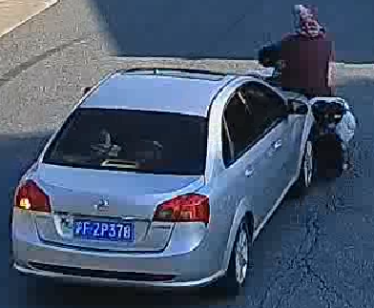 | 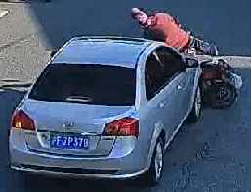 | 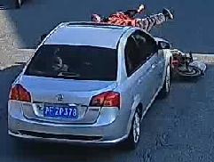 | 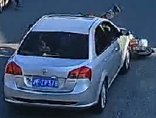 | 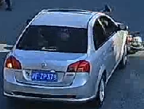
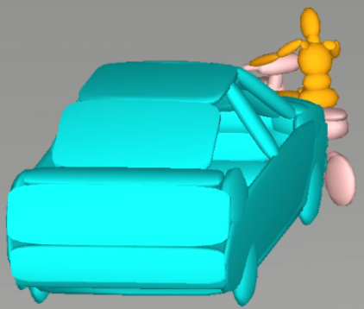 | 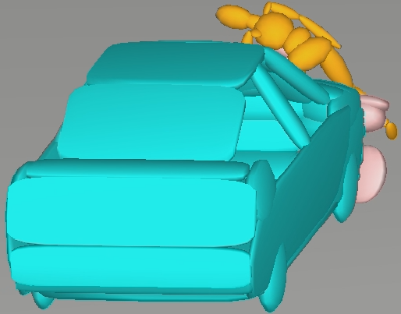 | 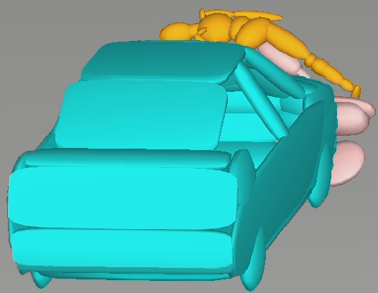 | 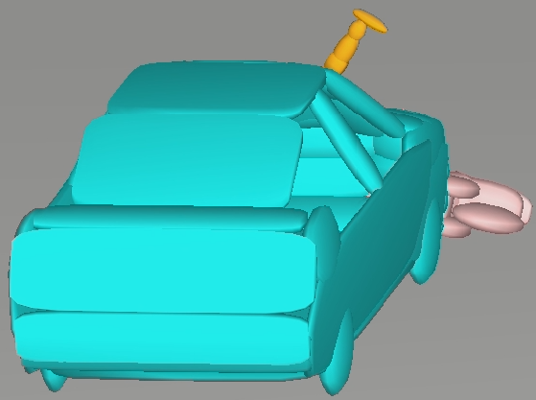 | 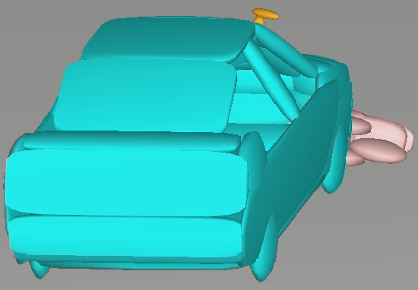
0ms | 130ms | 238ms | 466m | 550m

Case ID: XMUT06190003.1
 | 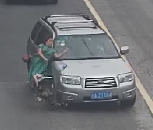 | 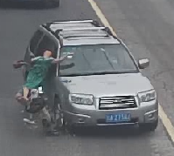 |  | 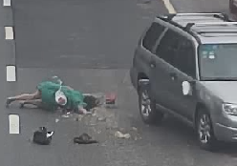
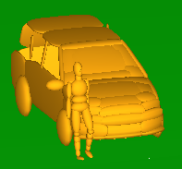 | 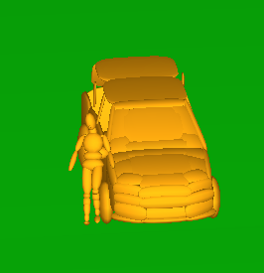 | 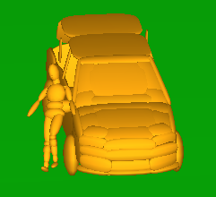 | 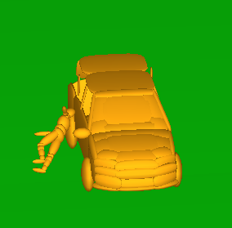 | 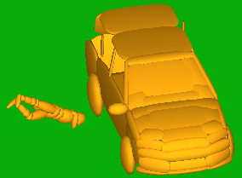
0ms | 66ms | 132ms | 264m | 437m

Case ID: XMUT06190004.1
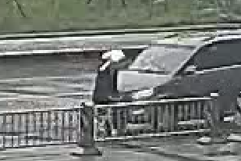 | 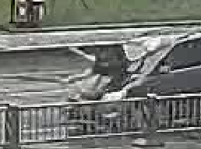 | 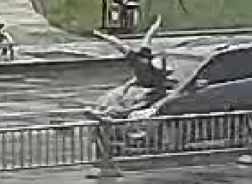 | 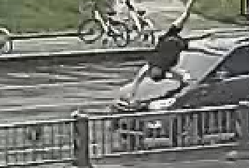 | 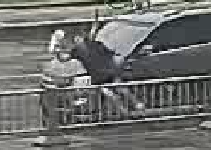
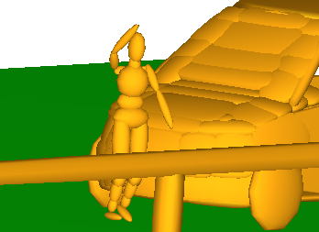 | 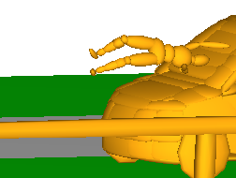 | 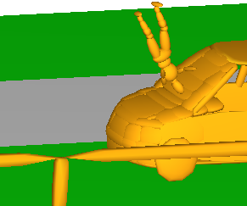 | 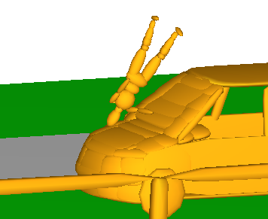 | 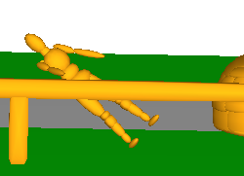
0ms | 210ms | 420ms | 600m | 975m

Case ID: XMUT05180018.3
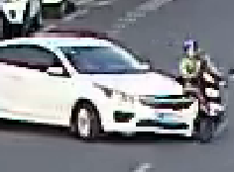 | 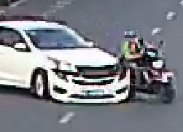 | 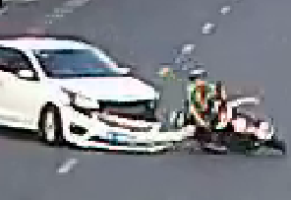 | 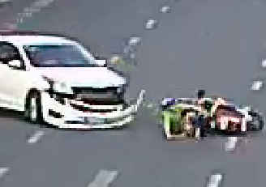 | 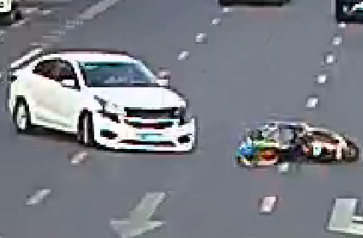
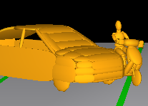 | 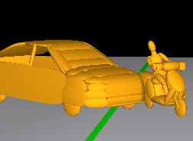 | 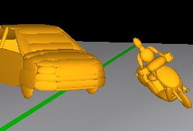 | 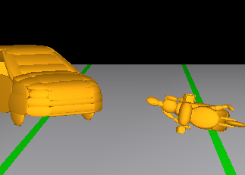 | 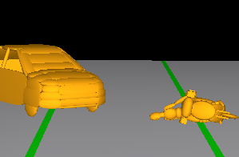
0ms | 200ms | 400ms | 600m | 800m

Case ID: XMUT06180002.3
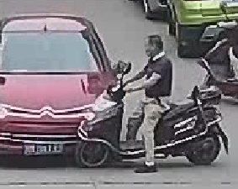 | 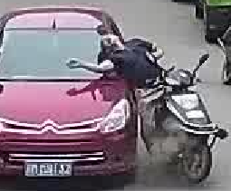 | 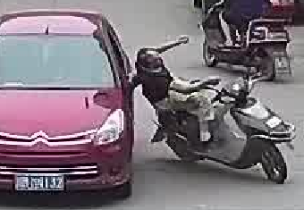 | 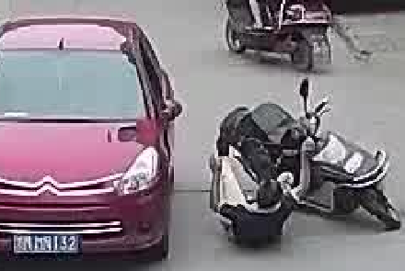 | 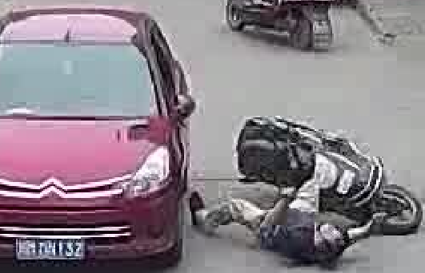
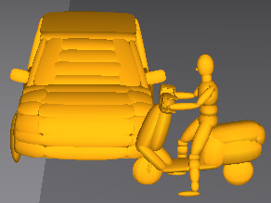 | 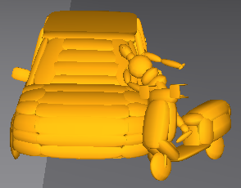 | 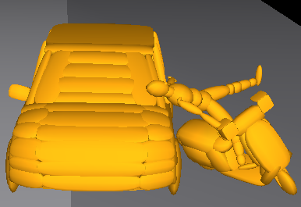 | 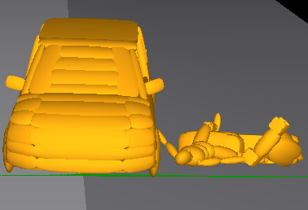 | 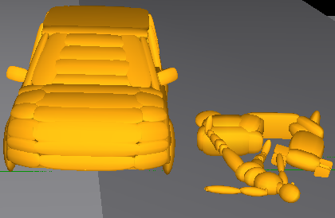
0ms | 185ms | 407ms | 666m | 814m

Case ID: XMUT06190009.1
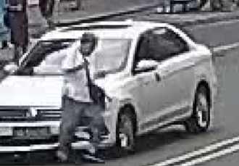 | 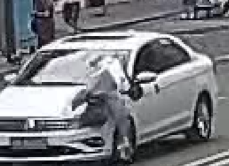 | 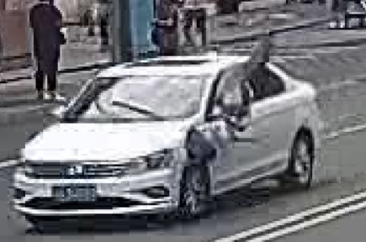 | 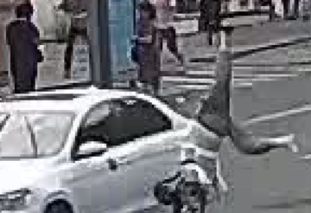 | 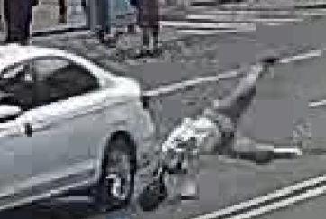
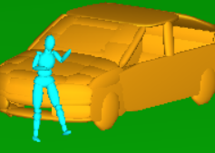 | 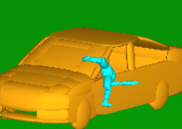 | 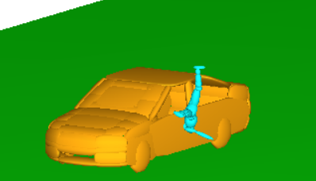 | 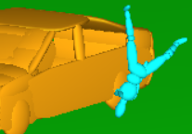 | 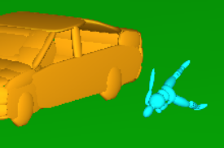
0ms | 180ms | 270ms | 380m | 540m

Case ID: XMUT06190017.2
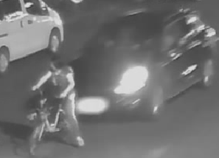 | 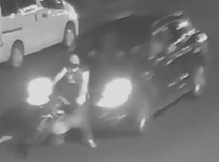 | 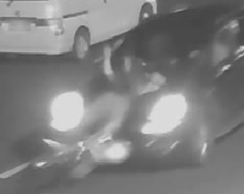 | 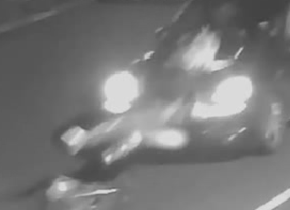 | 
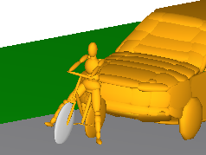 | 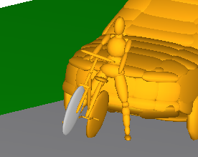 | 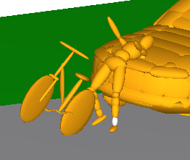 | 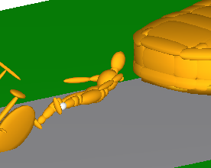 | 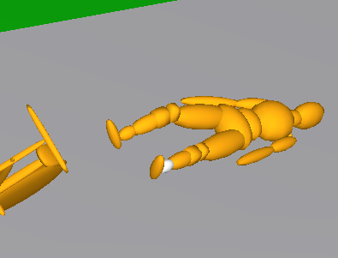
0ms | 115ms | 285ms | 495m | 640m

Case ID: XMUT06200023.1
 |  | 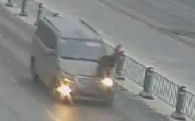 | 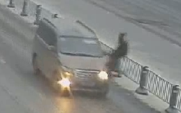 | 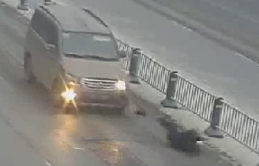
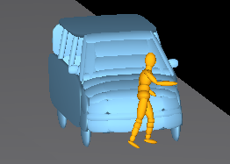 | 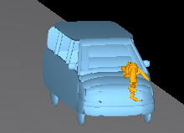 | 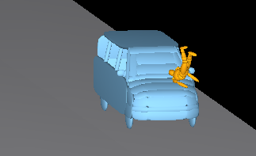 | 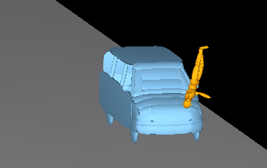 | 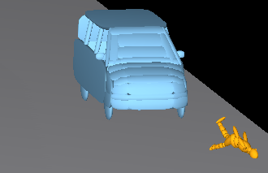
0ms | 160ms | 280ms | 560m | 1080m

Case ID: XMUT06200025.1
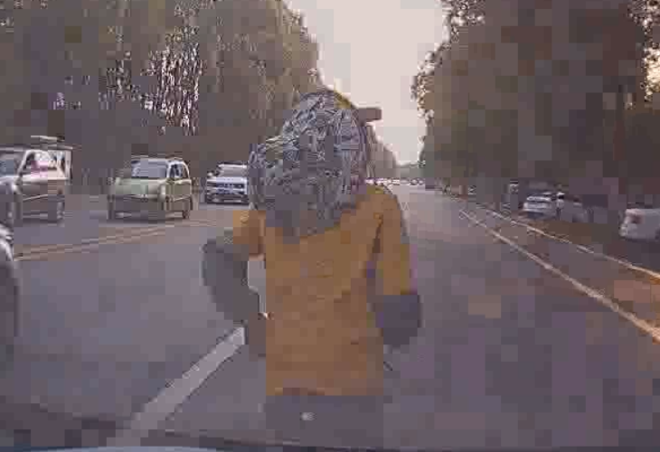 | 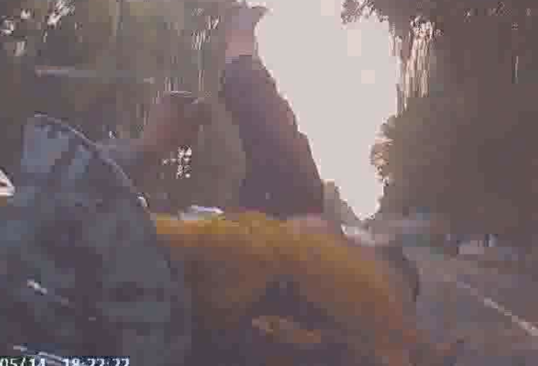 | 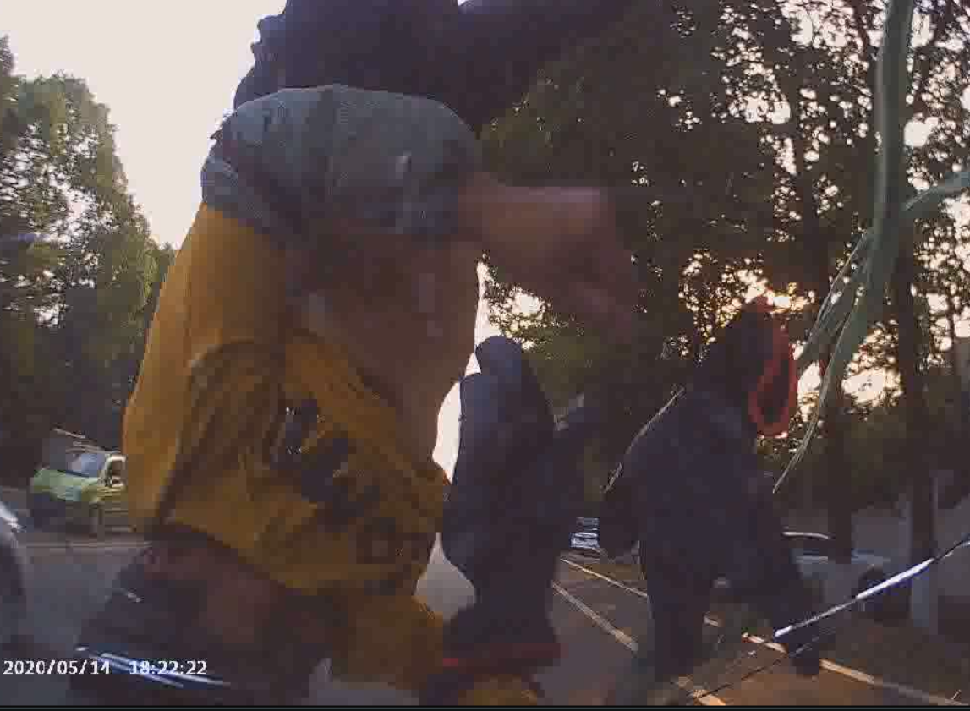 | 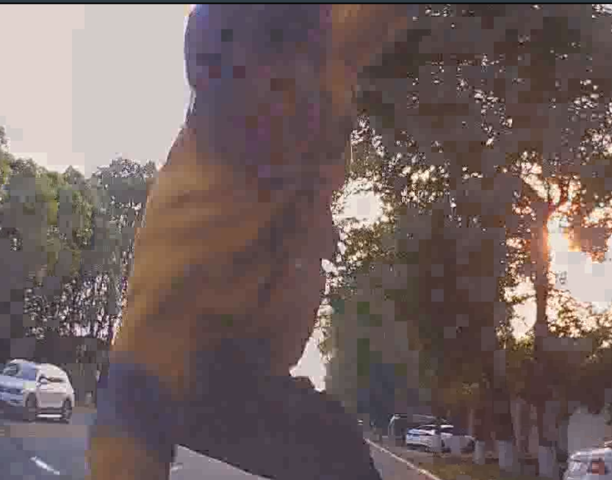 | 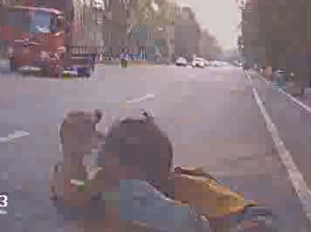
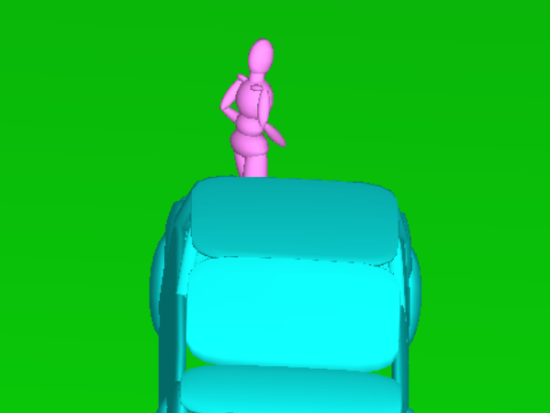 | 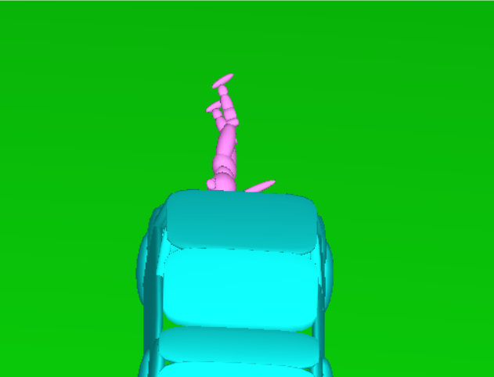 | 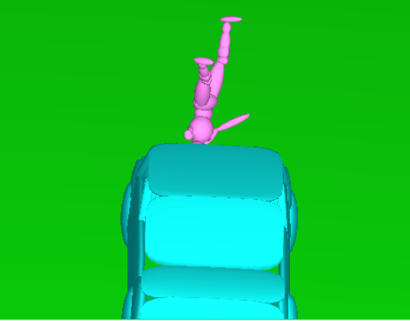 | 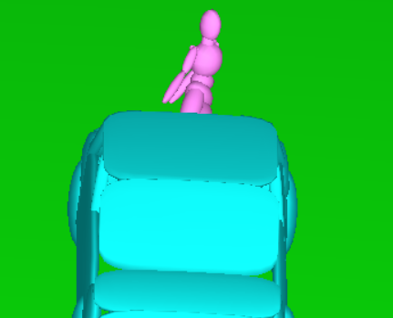 | 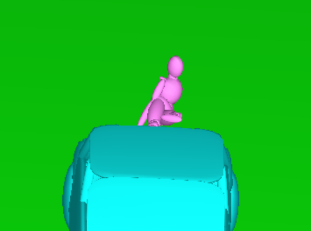
0ms | 160ms | 480ms | 760m | 1080m

Case ID: XMUT06200026.1
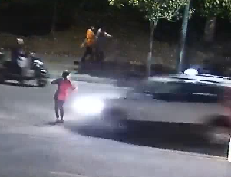 | 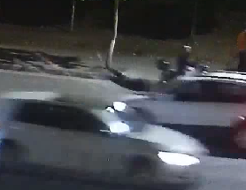 | 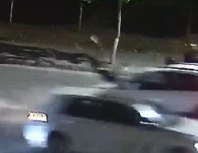 | 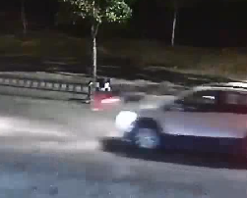 | 
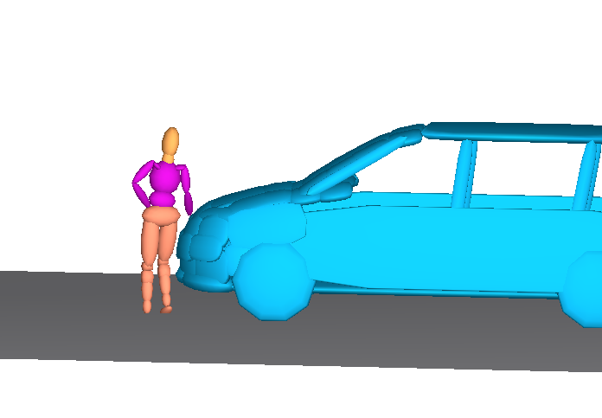 | 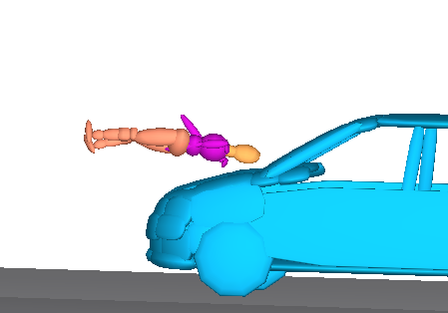 | 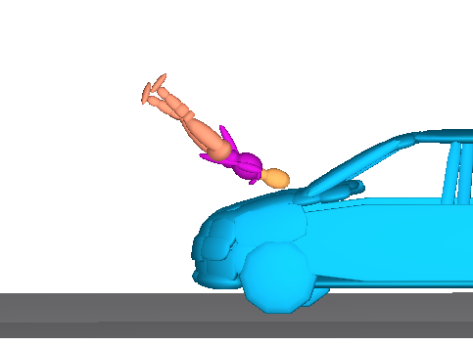 | 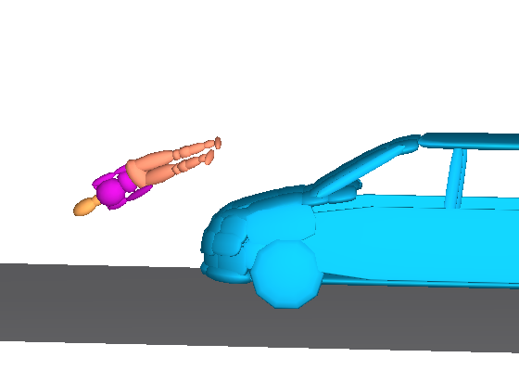 | 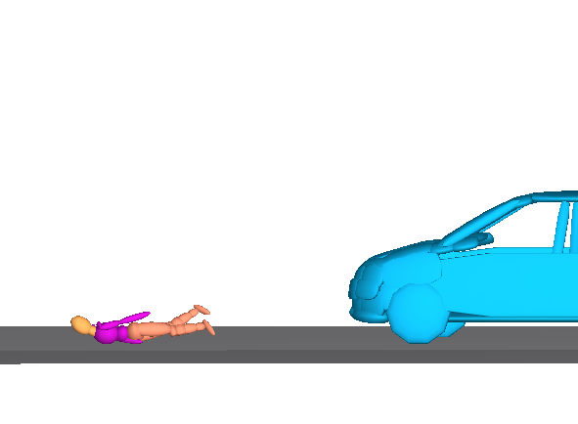
0ms | 192ms | 276ms | 672m | 1060m

Case ID: XMUT06190027.1
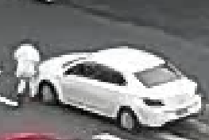 | 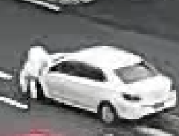 | 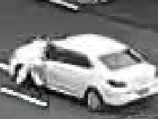 | 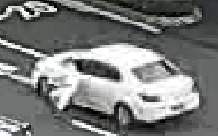 | 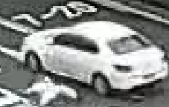
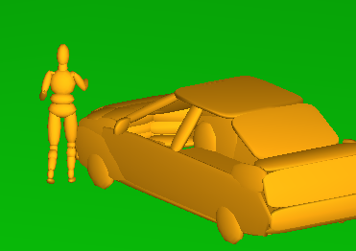 | 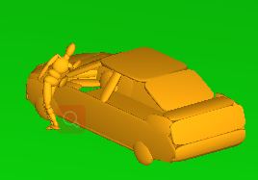 | 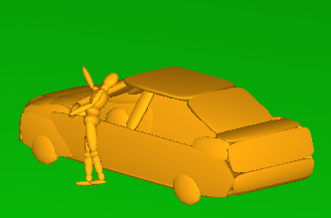 | 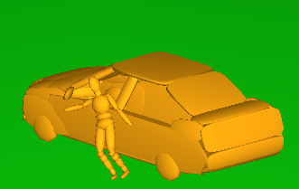 | 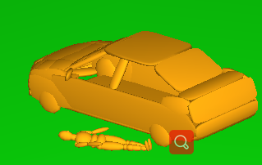
0ms | 115ms | 220ms | 390m | 660m

Case ID: XMUT07200344.3
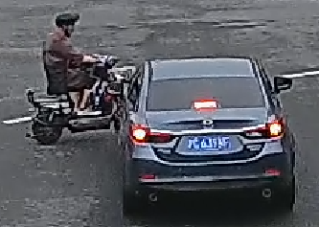 | 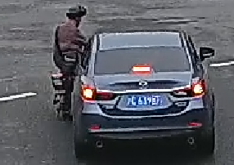 | 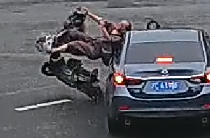 | 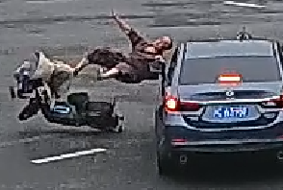 | 
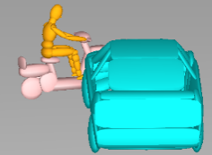 | 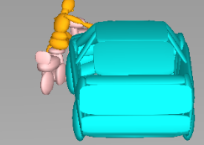 | 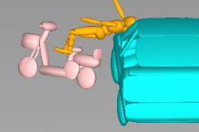 | 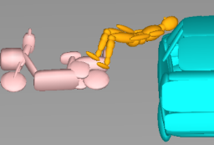 | 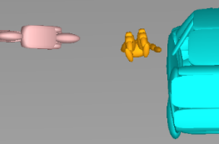
0ms | 114ms | 41ms | 630m | 858m

Case ID: XMUT07200376.3
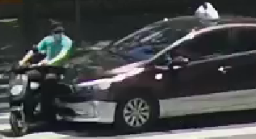 | 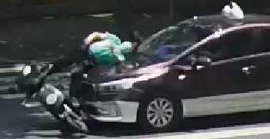 | 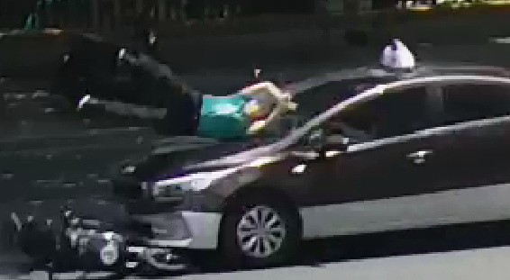 | 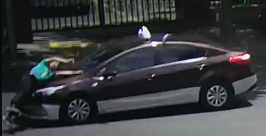 | 
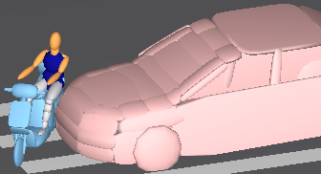 | 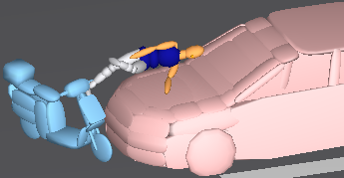 | 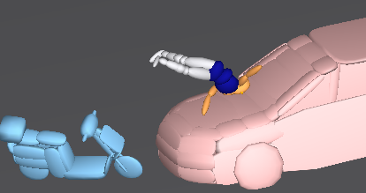 | 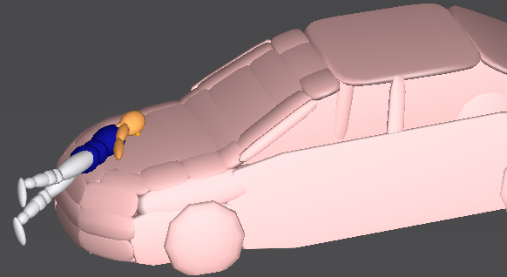 | 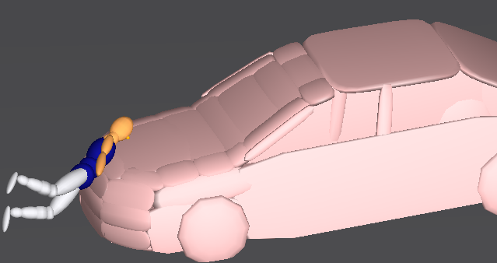
0ms | 173ms | 310ms | 820m | 1065m

Case ID: XMUT04140642.1
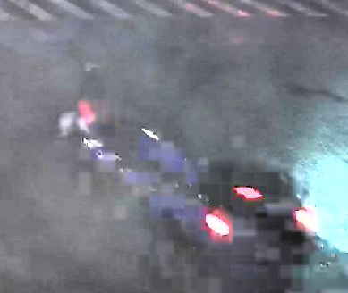 | 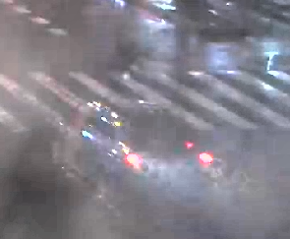 | 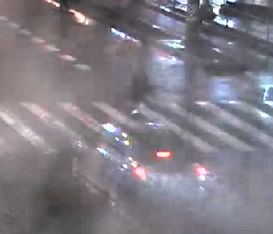 | 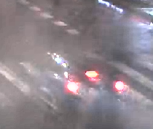 | 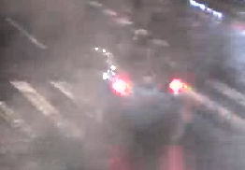
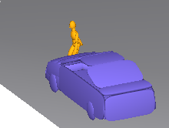 | 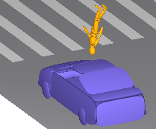 | 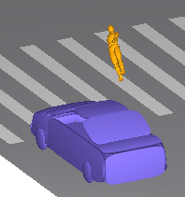 | 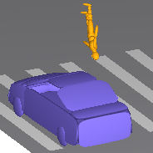 | 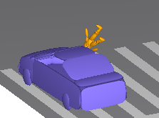
0ms | 323ms | 582ms | 911m | 1272m

Case ID: XMUT05190129.3
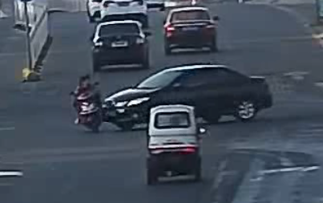 | 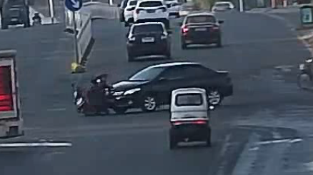 | 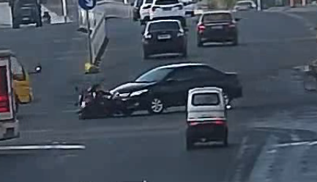 | 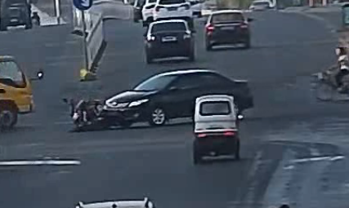 | 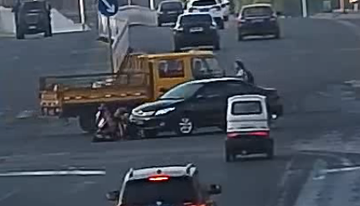
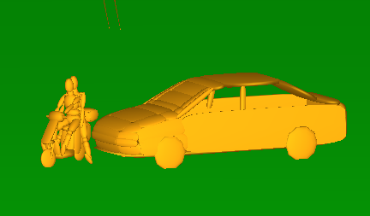 | 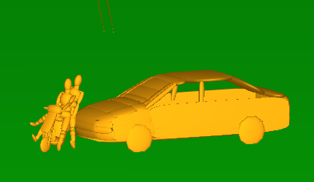 | 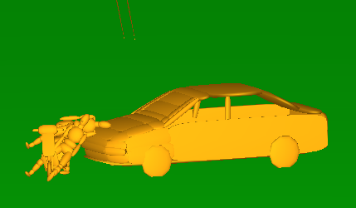 | 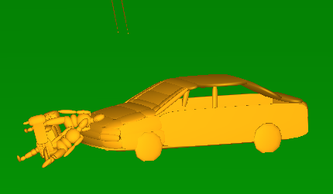 | 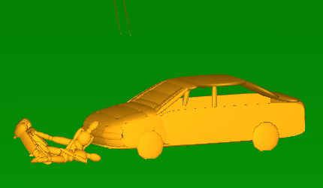
0ms | 200ms | 280ms | 400m | 600m

Figure S2 VRUs kinematic response of another 10 accidents used to validate WIC₄
Case ID: XMUT040190111.3
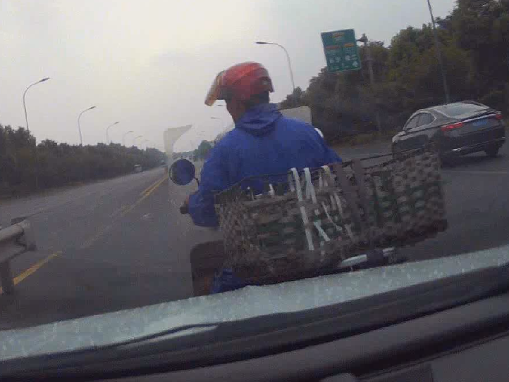 | 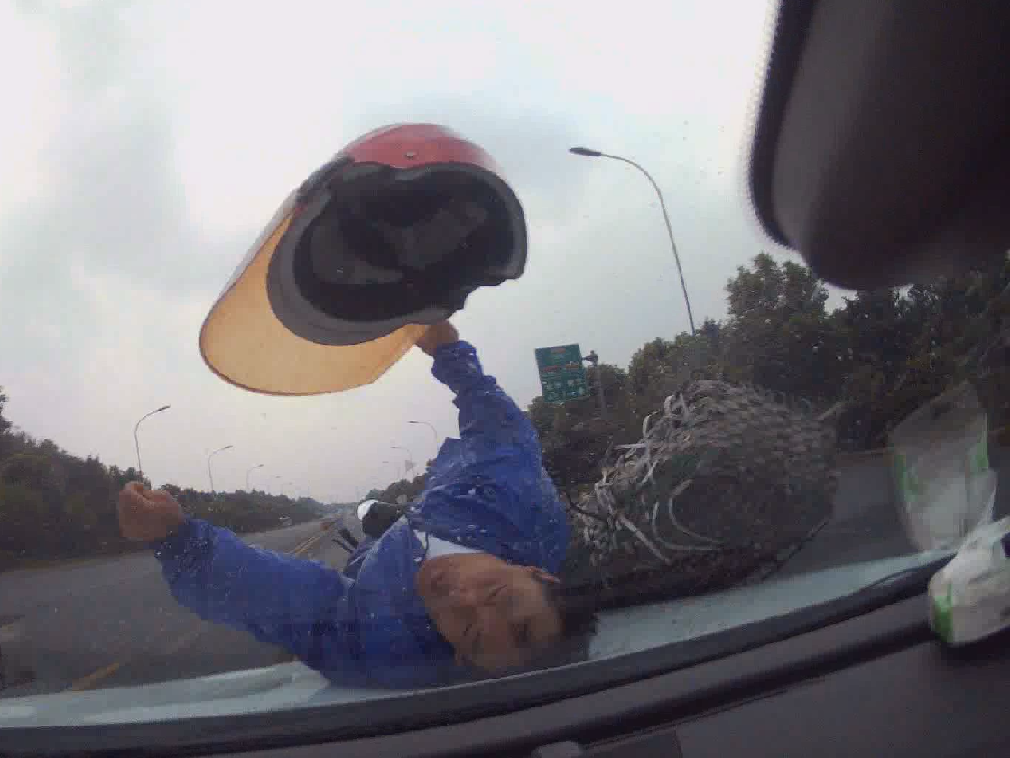 | 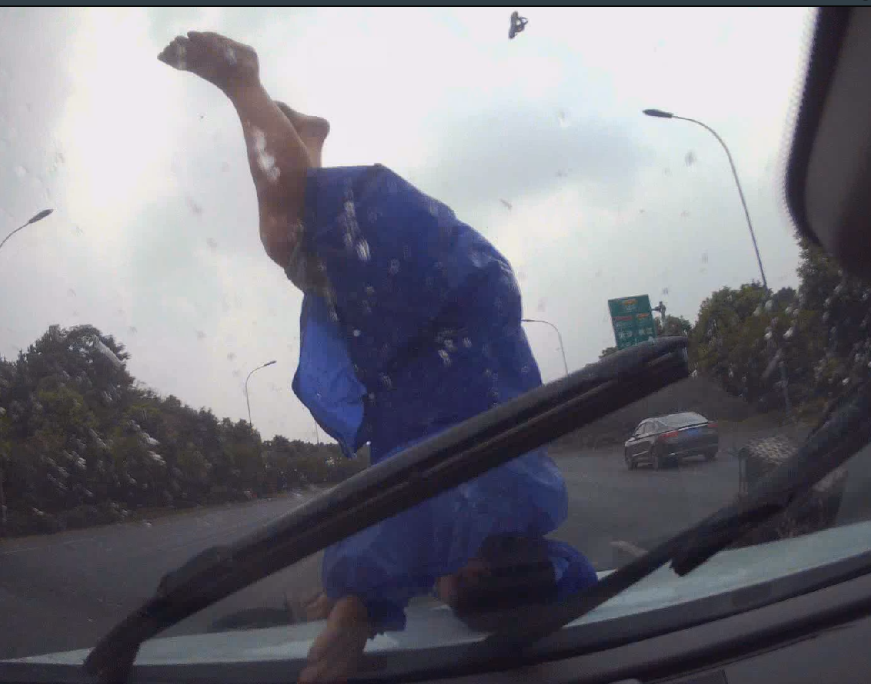 | 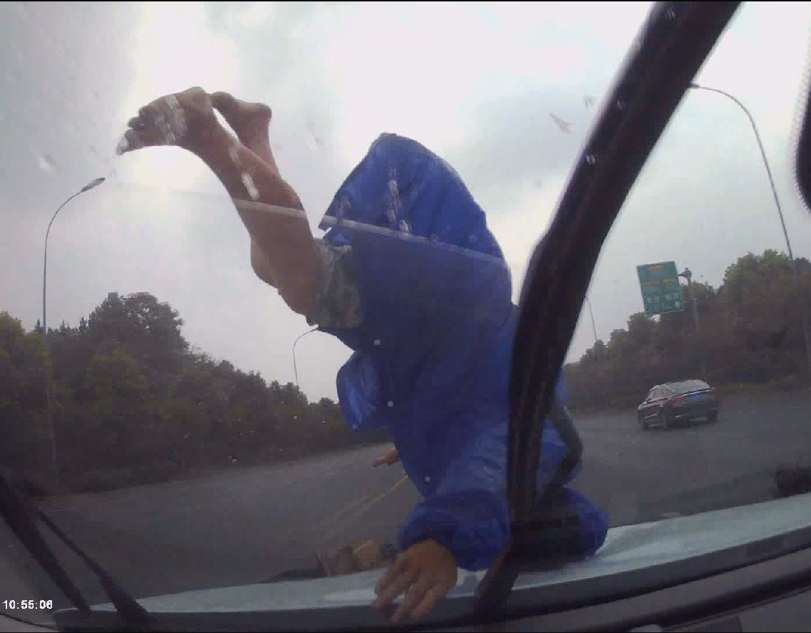 | 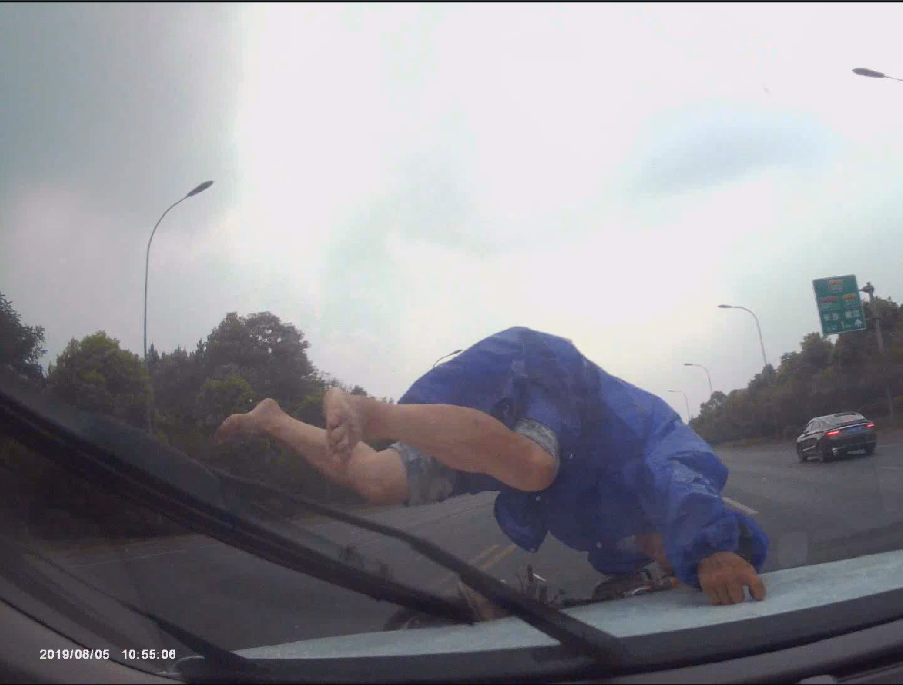
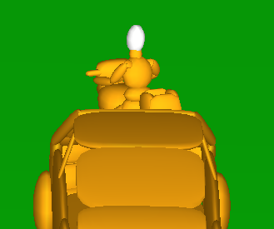 | 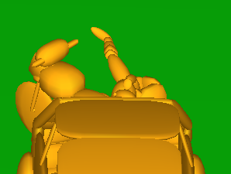 | 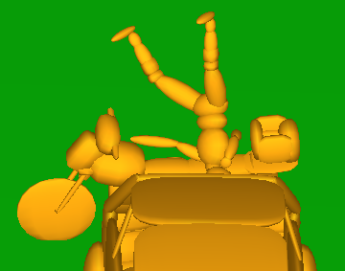 | 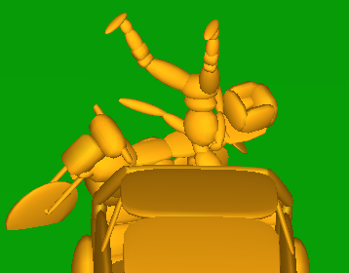 | 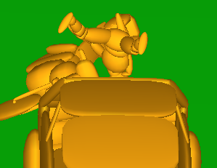
0ms | 210ms | 330ms | 450ms | 750ms

Case ID: XMUT04144641.1
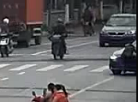 | 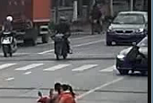 | 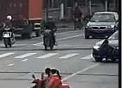 | 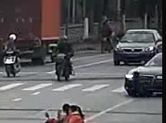 | 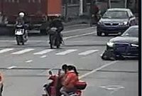
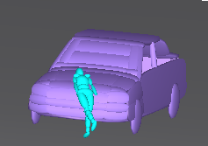 | 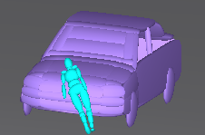 | 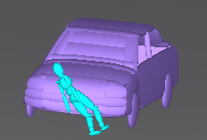 | 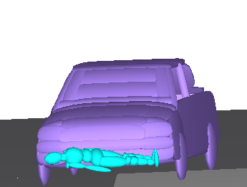 | 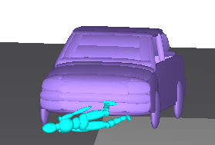
0ms | 80ms | 160ms | 240ms | 400ms

Case ID: XMUT03183242.5
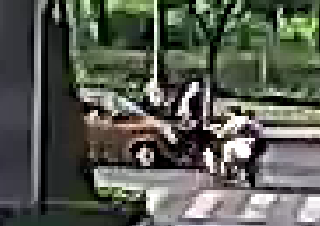 | 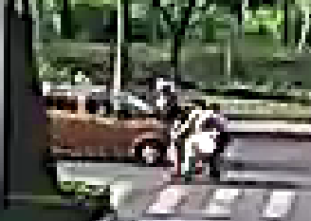 | 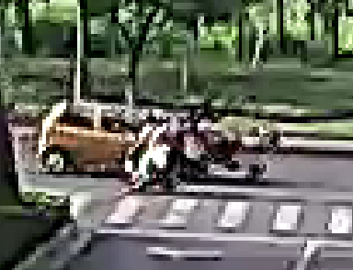 | 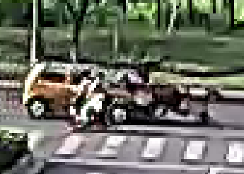 | 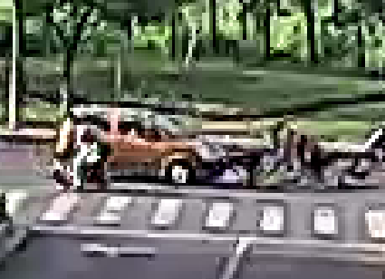
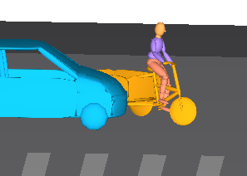 | 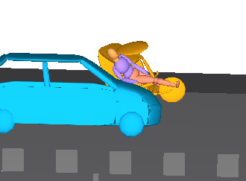 | 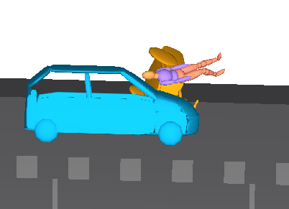 | 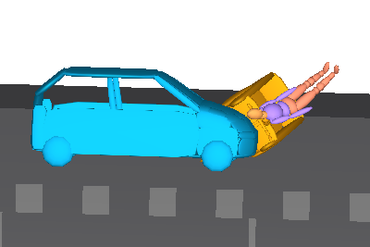 | 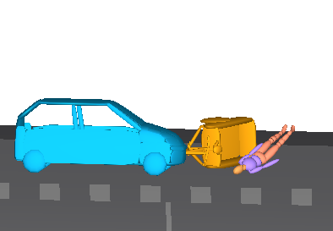
0ms | 160ms | 280ms | 440ms | 800ms

Case ID: XMUT04160341.3
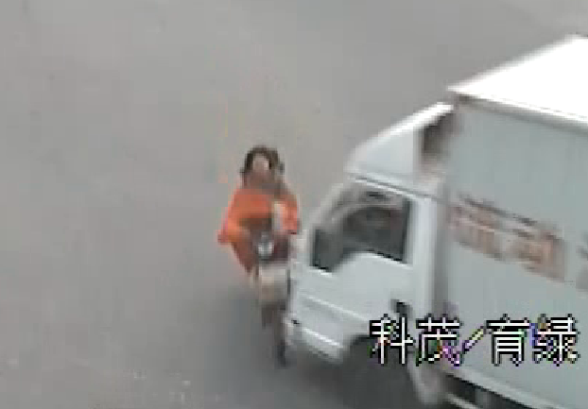 | 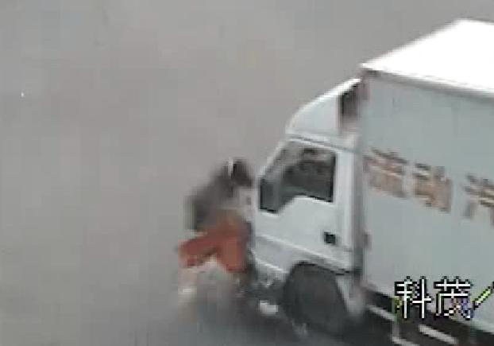 | 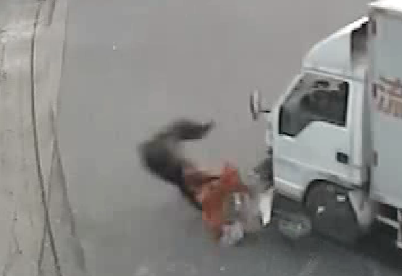 |  | 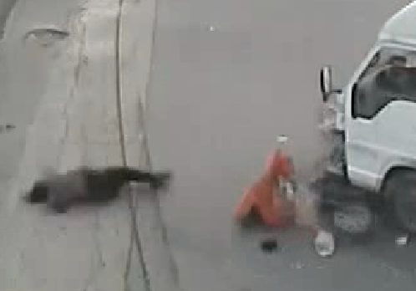
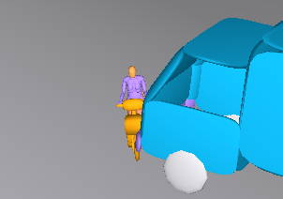 | 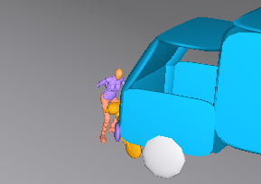 | 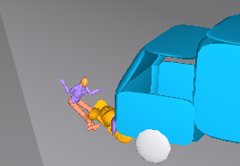 | 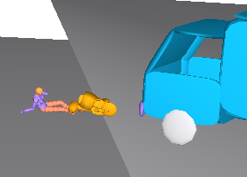 | 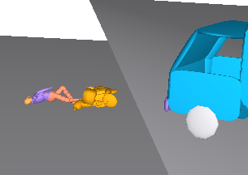
0ms | 240ms | 440ms | 680ms | 1040ms

Case ID: XMUT0510190079.3
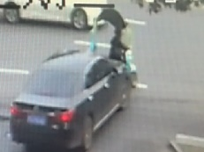 | 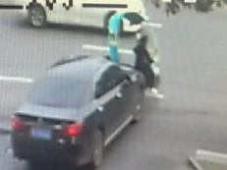 | 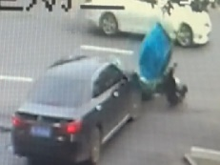 | 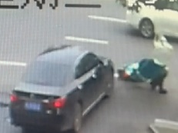 | 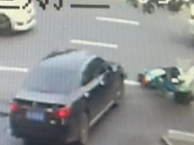
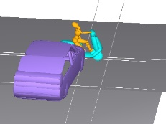 | 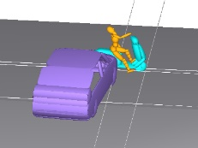 | 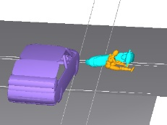 | 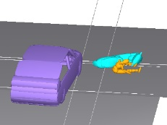 | 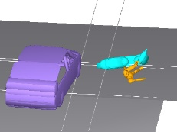
0ms | 300ms | 800ms | 920ms | 1430ms

Case ID: XMUT0410170032.5
 | 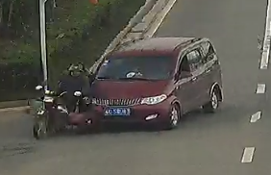 |  |  | 
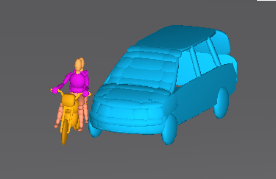 | 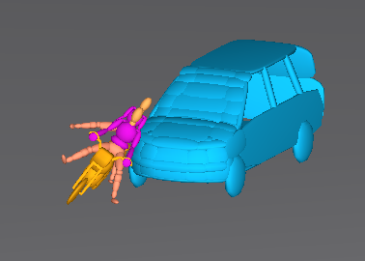 | 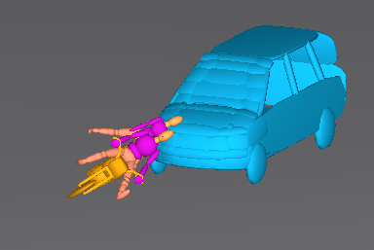 | 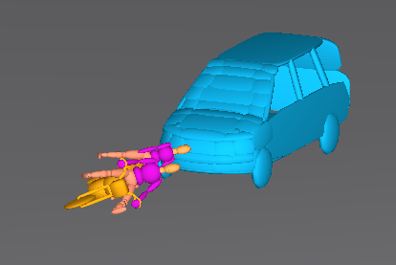 | 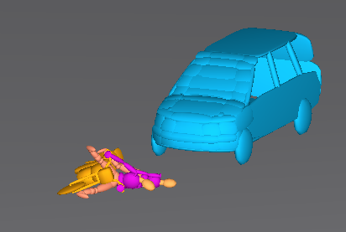
0ms | 208ms | 343ms | 403ms | 553ms

Case ID: XMUT07100003.3
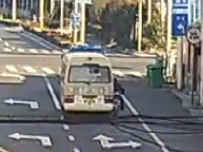 | 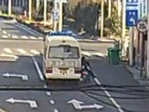 | 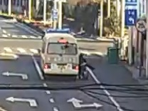 | 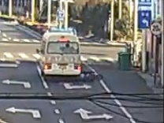 | 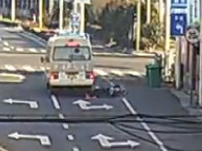
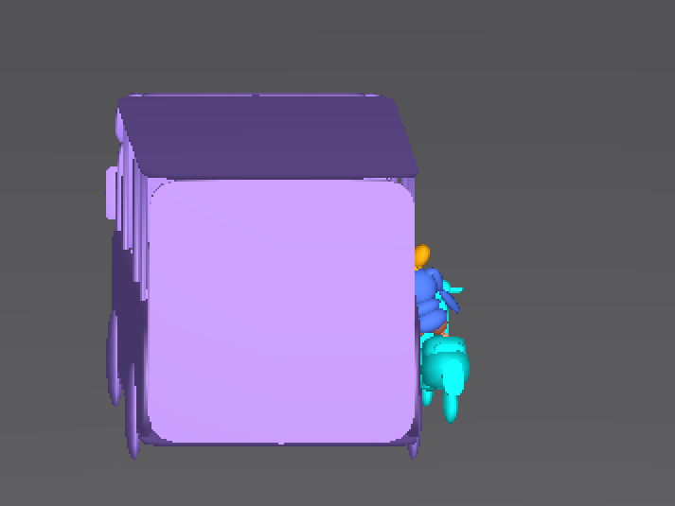 | 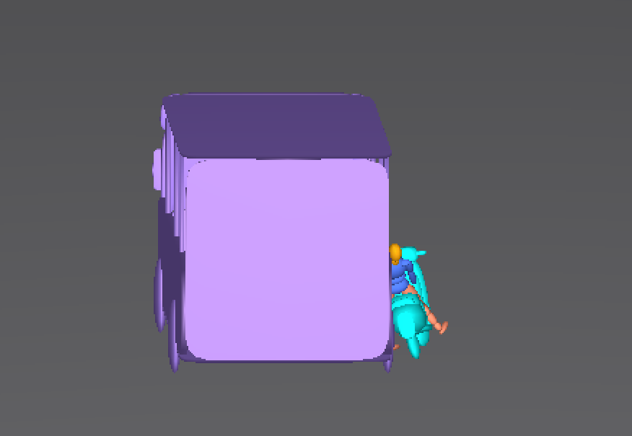 | 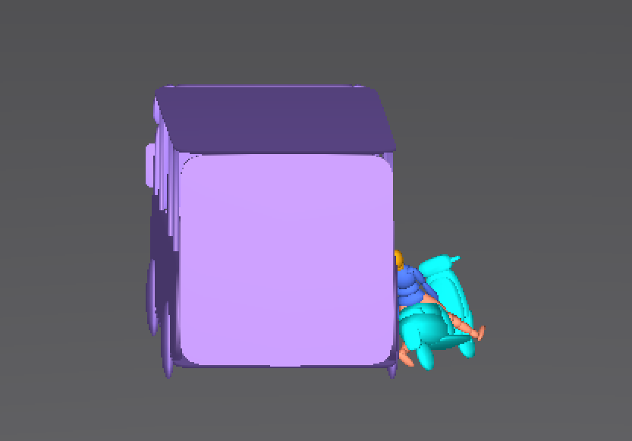 | 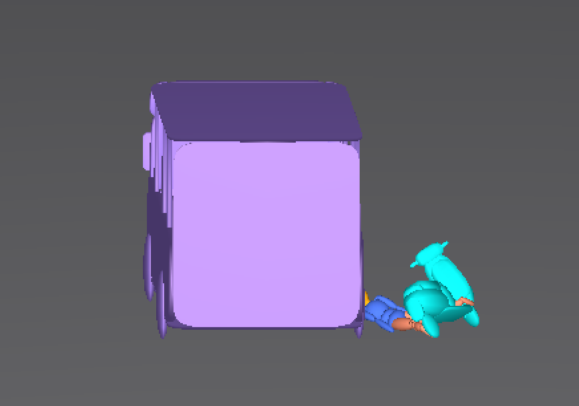 | 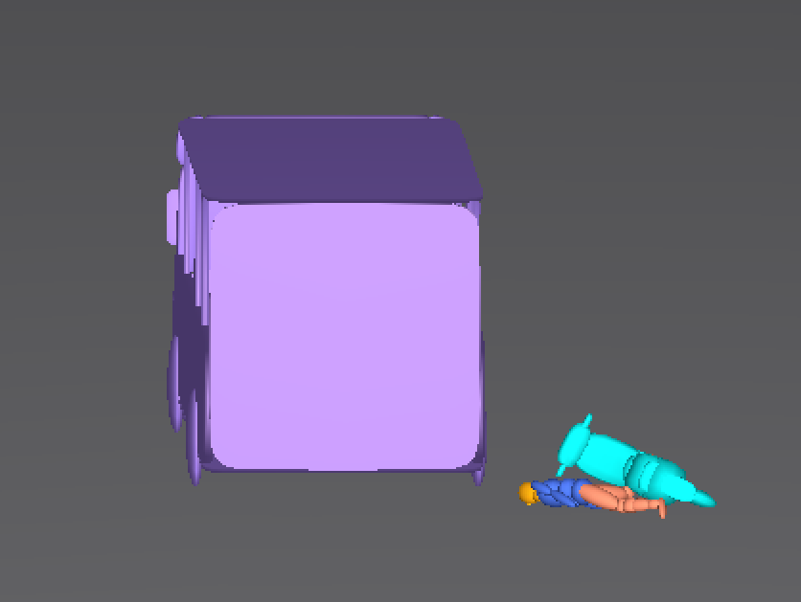
0ms | 485ms | 689ms | 1011ms | 2146ms

Case ID: XMUT07100485.3
 |  | 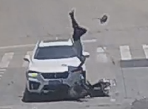 |  | 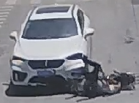
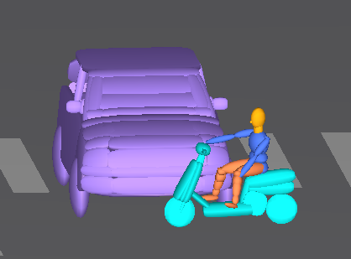 | 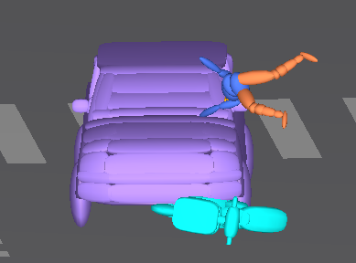 | 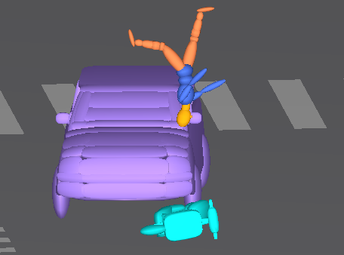 | 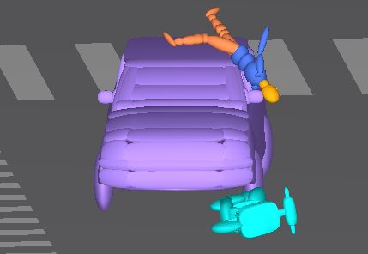 | 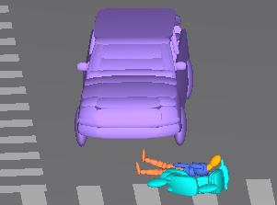
0ms | 237ms | 561ms | 691ms | 1273ms

Case ID: XMUT07100808.3
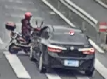 | 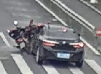 | 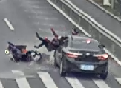 | 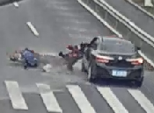 | 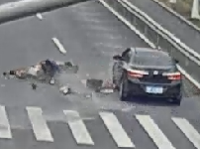
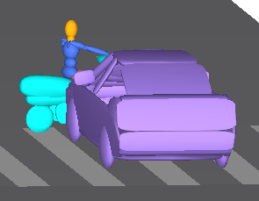 | 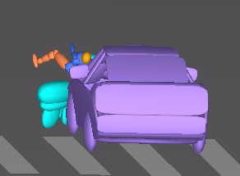 | 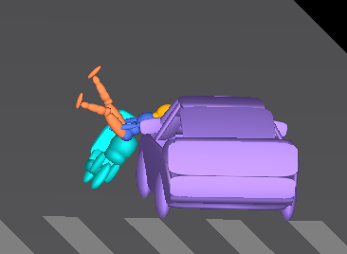 | 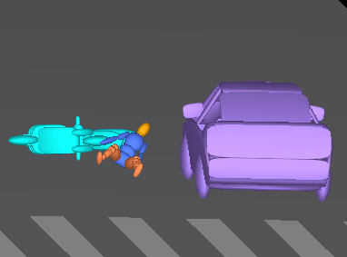 | 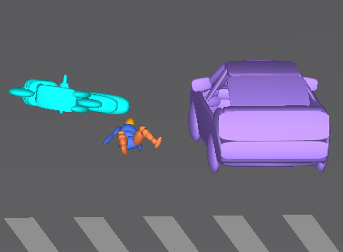
0ms | 186ms | 416ms | 740ms | 818ms

Case ID: XMUT07100079.3
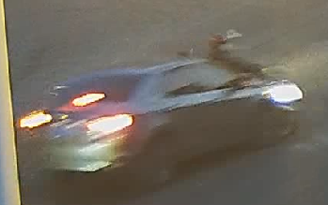 | 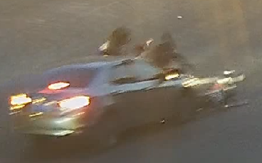 | 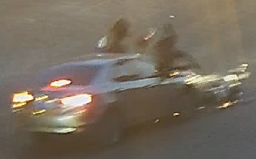 | 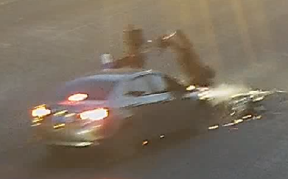 | 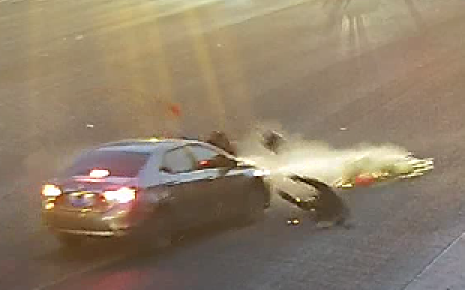
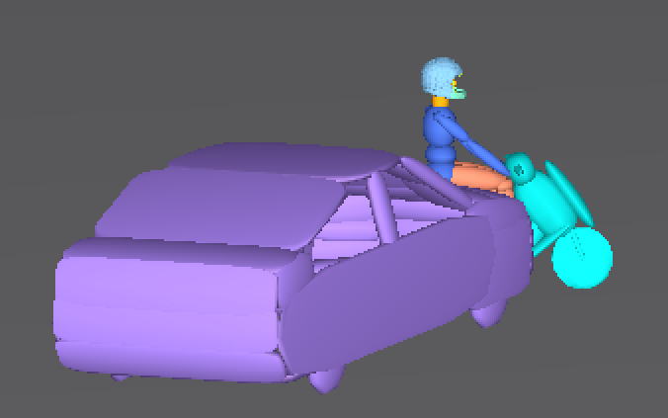 | 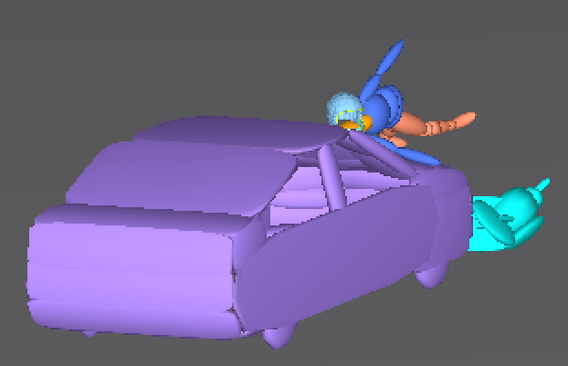 | 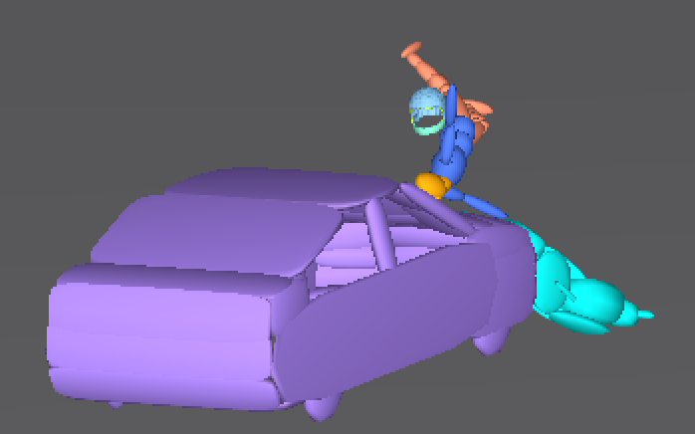 | 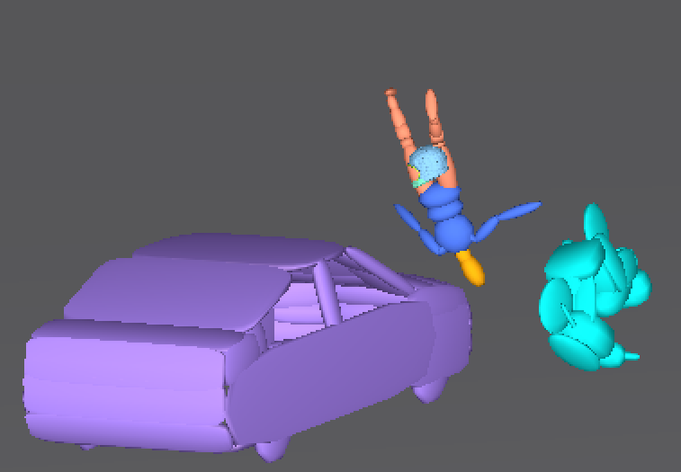 | 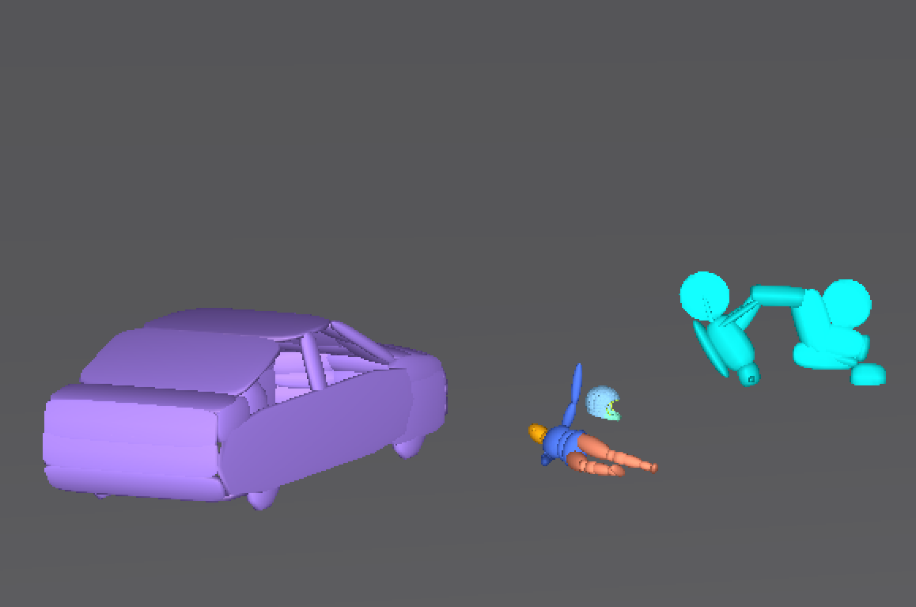
0ms | 152ms | 270ms | 486ms | 820ms

