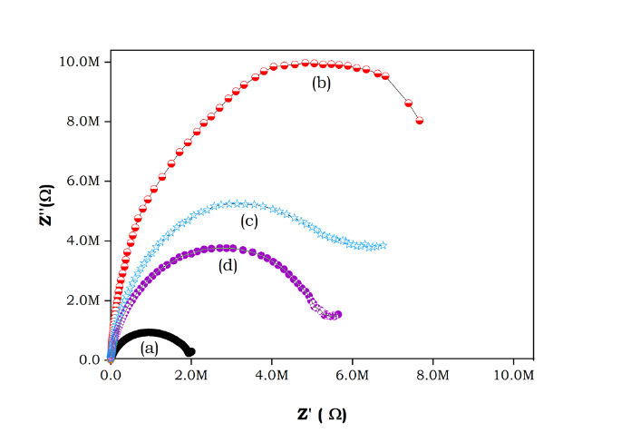
Figure : Complex impedance plots at RT for (a) Pure Guar gum, (b) Guar gum+ ZnSO₄.7H₂O (90:10), (c) Guar gum+ ZnSO₄.7H₂O (80:20) (d) Guar gum+ ZnSO₄.7H₂O (70:30).

